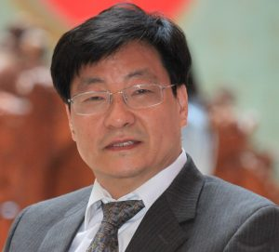
Dr. Cheng-Zhong Xu, IEEE Fellow, is a Chair Professor of Computer Science and the Dean of Faculty of Science and Technology, University of Macau, Macau SAR, China. Prior to that, he was in the faculty of Wayne State University and Shenzhen Institutes of Advanced Technology of CAS. His recent research interests are in cloud and distributed computing, systems support for AI, smart city and autonomous driving. He published two research monographs and more than 400 journal and conference papers, received more than 15K citations with an H-index of 59. He was a Best Paper Awardee or Nominee of conferences, including HPCA’2013, HPDC’2013, Cluster’2015, ICPP’2015, GPC’2018, UIC’2018, and HPBD&IS’2019. He was also a co-inventor of more than 120 patents and a co-founder of Shenzhen Baidou Applied Technology Co. with dedication to smart city technologies. Dr. Xu received the "President's Awards for Excellence in Teaching" of Wayne State University in 2002. He serves or served on a number of journal editorial boards, including IEEE TC, IEEE TCC, IEEE TPDS, JPDC, Science China, and ZTE Communication. Dr. Xu was the Chair of IEEE Technical Committee on Distributed Processing from 2015 to 2020. He obtained B.Sc. and M.Sc. degrees from Nanjing University in 1986, and 1989, respectively, and a Ph.D. degree from the University of Hong Kong in 1993, all in Computer Science and Engineering.
这是译文&这是译文.

