**CAMPUS NETWORK DESIGN USING CISCO PACKET TRACER**

Nimerta Wadhwani

Computer Systems Department

Sukkur IBA University

Sukkur, Pakistan

***Abstract - This document puts forward a plan and implementation of Campus Network at Sukkur IBA to ensure uninterrupted connectivity and secure communication for the main campus, EDC branch campus, and to an external cloud server. For traffic management and sharing, the network has VLAN, for dynamic routing is RIP v2 while for automatic IP address allocation is DHCP. Operations address infrastructure design regarding scalability, security, and dependability of the academic and administrative entities. The successful evaluation of the network confirms the possibility of using the created network in practical application and stresses the potential for further improvements.***

***Keywords—IOT technology, Cisco Packet Tracer, Campus Network, VLAN Configuration, Dynamic Routin, Cloud Server Integration.***

1. INTRODUCTION

The use of technology in the learning institutions requires the incorporation of the contemporary network technologies suitable for learning and organizational purposes. This project mainly deals with an organized networking layout of Sukkur IBA to integrate its several departments, two physically distinct campuses, and an external internet server of a cloud. This ensures smooth running of day to day activities such as use of the internet and sharing of resources among the faculty, staff and the student fraternity.

The network spans two campuses: the main campus and the EDC branch, each connecting departments, servers, and devices within it. An email server that is in the middle is used to facilitate the organization’s communication with external entities since it is in the cloud. To achieve efficient network operation and improve security, traffic has been separated logically while dynamic routing has been adopted.

The key objectives of the project are:

* So that they could easily design a logical and hierarchical more campus network.
* For improving network security and performance, departments should be logically divide.
* To support routing and IP assignment that is autonomic and can change on demand in order to decrease manual adjustment.
* To facilitate effective and efficient communication of the email server with the several campuses.
* To set up a firm base on which further developments could be added in the future.

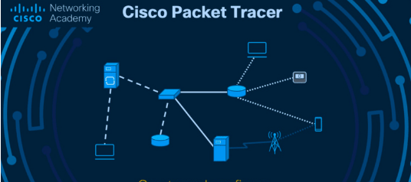

1. LITERATURE REVIEW

Campus networks have been analyzed extensively because of the numerous institutional efficiencies they used to initiate. The VLANs (Virtual Local Area Networks) have been noted to be important in building separate protected subnets on the common physical basis. Research also reveals the advantages of RIP v2 protocol in multi-campus networks management since new routes are propagated and old ones withdrawn automatically.

Further study reinforces the advantages of automatic IP allocation by DHCP in preferable to manual configuration that may involve mistakes. The strategy formulated below was useful in the Sukkur IBA Campus Network because it provided guidelines based on best practices around the world, as well as for institutions of learning.

1. METHODOLGY

The approach used through the project was structural and comprised of the following steps; Evaluation of the Network requirements The design of the Network The implementation of the Networks The testing of the Network The deployment of the Network.

* Requirement Analysis:

First, it identified the need of Sukkur IBA in total number of departments, devices and connectivity with outside world. Surveys were conducted on both campuses with specific attention to the physical distribution of area and extent of coverage needed.

* Design Phase:

The decision was made concerning the hierarchical and modular organization of the concerned firm with major focus on the scalability and the departmental division of the working body. There was use of VLANs to subdivide departmental traffic in order to enhance security and performance.

* Implementation:

The routers and switches were programmed in a way that facilitates dynamic method of routing, auto assignment of IP addresses and campus connectivity. An external communication cloud server was incorporated to aid the cloud server.

* Testing and Validation:

This was done in order to check whether the network design supports the communication of the devices in the network, resource sharing among the devices and access to the cloud server. Some changes were made depending on the test results to acheive the best results.

1. CAMPUS NETWORK DEVELOPMENT

*Main Campus*

Academic and administrative departments include several buildings forming the main campus of the college. in an effort to ensure orderliness, as a result of decentralization, each department was given its own logical network. This not only enhances the quality of security because every department’s traffic is kept different from another, but also because it enhances the bandwidth usage by maximizing the usage space available.

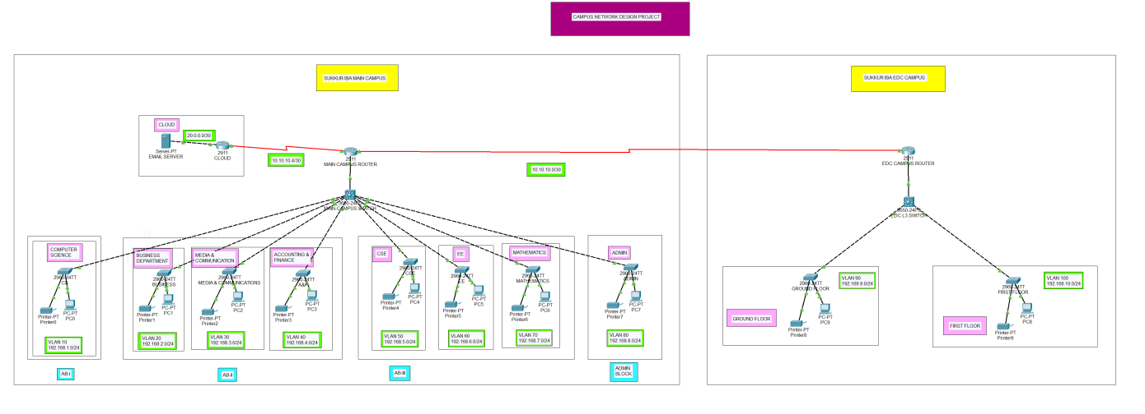

For the departmental devices to be connected, centralized switches were established in each building and a traffic aggregation switch to send the information to the building router or the main campus router in the case of the main building. This router also enabled connectivity between the main campus, the EDC branch and the other external cloud server.

*EDC Campus*

The whole EDC is divided in two floors and each floor has different operational requirements. The same paradigm was followed herein and assigned specific virtual networks for each floor separately. These connect to a core switch which relays the traffic to the branch router used in communicating with the main campus as well as cloud resources.

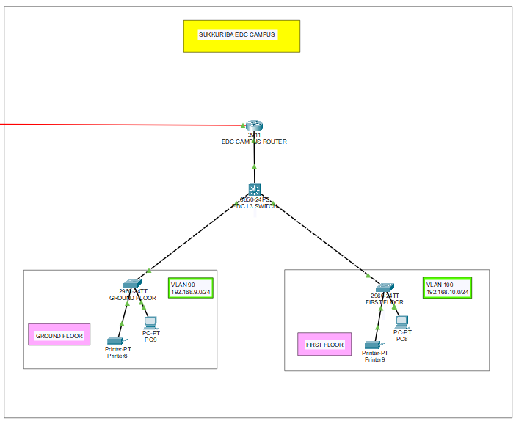

*Protocols & Configurations*

Several protocols and technologies were employed to enhance the performance and reliability of the network:

* Traffic Segmentation: VLANs where employed to separate departmental flows logically in an effort to decrease the flow density and uphold security.

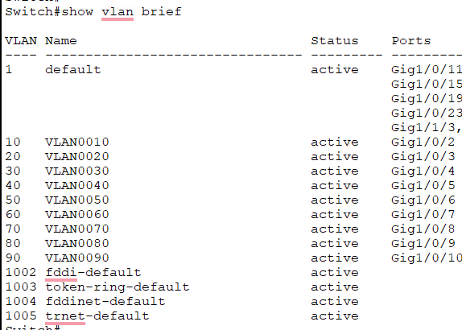

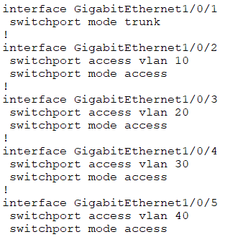

* Dynamic Routing: It was to route updates automatically between campuses and the cloud that RIP v2 was introduced.

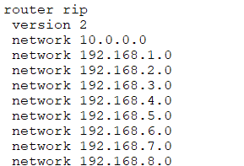

* IP Address Management: Devices were setup to use DHCP so that network administrators could easily manage the address that was assigned to each device.

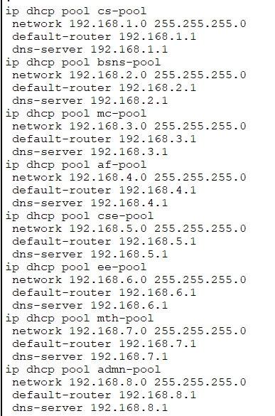

* Trunking: Transferring multiple VLAN traffic on a single, physical link involved the use of trunking on the inter-switch connections.

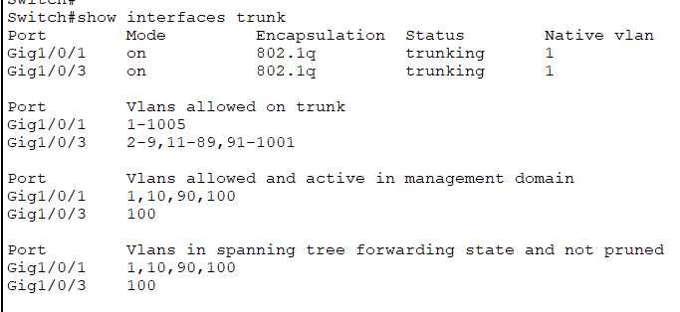

1. RESULTS

The network was put in place and the tests ran through. The following outcomes were observed:

* Inter-Department Communication: There was possibility to observe the communication between all the devices belonging to different VLANs.

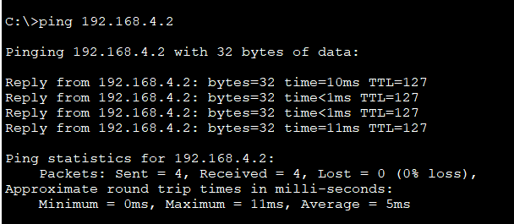

* Dynamic IP Assignment: Devices were able to obtain the IP addresses assigned by the DHCP server as a confirmations of successful configuration.

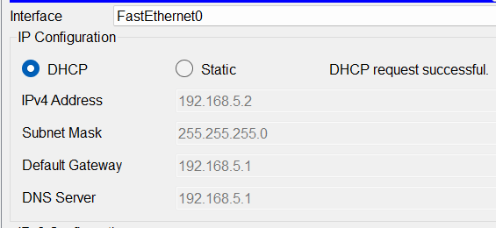

* Inter-Campus Connectivity: In addition, connection between the main and EDC campuses was created to provide improved collaboration and sharing of resources.
* External Server Access: Individual devices within the network could connect to the cloud based email server intending to be interrupted.

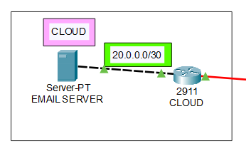

The goals of the project show that the network met all the requirements specified allowing its deployment.

1. CONCLUSION AND FUTURE WORK

*Conclusion*

The proposed implementation of the Sukkur IBA Campus Network fulfilled the needs of the operation of the institution including security and scalability for academic and administrative use. Implementing VLAN and dynamic routing helped in proper flow of traffic while adoption of a cloud server in communication with the outside world.

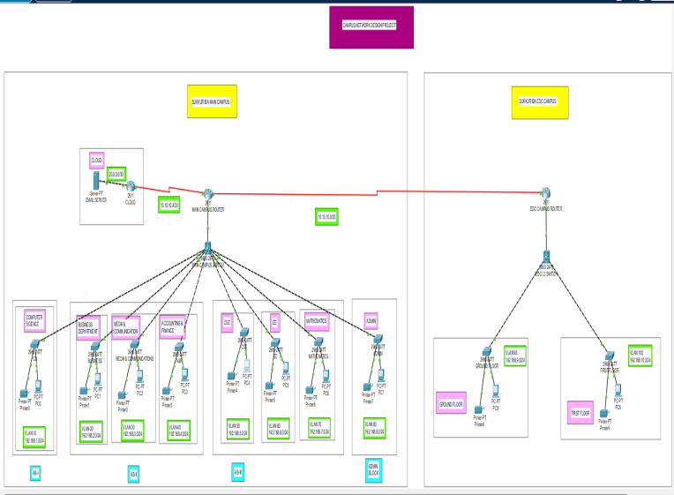

*Future Work*

To further improve the network, the following steps are recommended:

* Implement HSRP that helps to add redundancy and make up for the lack of fail safety.
* Find out how QoS can be applied to help define the order of non-shaping technique priority.
* Assess the possibility of IPv6 adoption to enable a network infrastructure design to be ready for the future .
* Introduction of network aggregated monitoring tools for real time monitoring and troubleshooting of issues.

1. REFRENCES
2. Cisco Networking Academy. (n.d.). Networking basics. Retrieved from [https://www.cisco.com](https://www.cisco.com" \t "_new)
3. YouTube. (n.d.). Campus Network Design using Cisco Packet Tracer. Retrieved from [YouTube](https://www.youtube.com" \t "_new) [https://youtu.be/qIbhkmTB8Q8?si=u0\_fop0M30oZW35yhttps://youtu.be/qIbhkmTB8Q8?si=u0\_fop0M30oZW35y](https://youtu.be/qIbhkmTB8Q8?si=u0_fop0M30oZW35yhttps:/youtu.be/qIbhkmTB8Q8?si=u0_fop0M30oZW35y)
4. Google Search Engine. Available at [https://www.google.com](https://www.google.com" \t "_new).
5. Salahaddin University Campus Network Design. "An Optimized Salahaddin University New Campus IP-Network Design using OPNET." International Journal of Advanced Computer Science and Applications (IJACSA), Vol. 8, No. 12, 2017. This research paper discusses campus network design principles using VLANs and advanced IP configurations. [The Science and Information Organization](https://thesai.org/Downloads/Volume8No12/Paper_61-An_Optimized_Salahaddin_University.pdf" \t "_blank)