**Extra Credit Assignment**

Ok. I’m a fan of wordle. If you’ve not played, it is really easy. Rules are here:

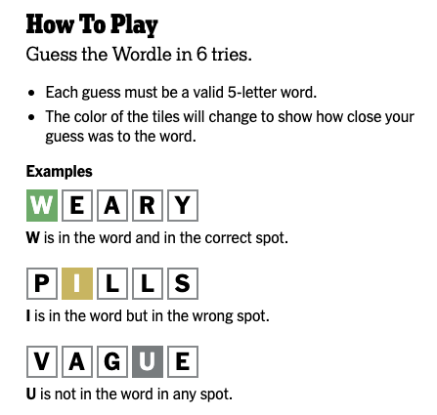

I’d like you to create a wordle game in Matlab? How? Good question. Here’s how to get started.

1. I have provided a text file containing five letter words. The first step of your program is to open this file, read it in, and select a word at random. So, each time the game is played a new word will be chosen.
2. You then need to have some back and forth with the user at the command window. Your first instruction to the user could be like: “thanks for playing, please guess a five letter word.” You can use commands like ‘input’ to accept text input from the user. You should, of course, check to ensure that what they have entered is indeed a FIVE letter word. And letters only…no symbols or numbers… (see ‘isletter’ function, for example).
3. Next, you need to give them feedback about their guess. See above. Of course, you can’t use color in Matlab, but you COULD use things like x and o and -. For example, say the correct word is ‘least’. And assume that the user guessed ‘angst.’ Your output to the screen after their guess could be:

>> a n g s t

>> o - - x x

1. In other words, the o indicates the letter is in the word, but wrong place, the – indicates the letter is not in the word and the x indicates the letter is in the word and in the correct place.
2. You then prompt the user for their 2nd, 3rd, guess and so on. They get 6 tries to get the word correct or lose the game. So, this assignment is a lot of good programming. String functions, programming structures, text input and output…
3. As a bonus, after each guess, you could make a list of letters NOT in the word and print this out for the user. The NY Times does this by showing you the ‘keyboard’ with letters grayed out. A simple list would suffice.

It’s worth up to 10 extra credit points if you want them! Make it look nice and fun to play.