DSCD 606 - Data Management Techniques

Final Project

DATA PLUMBERS
GILBERT WOASIEWORM ADJEI 22425084
PHILIP ADIBOYE 22427838
EMMANUEL BARIMA NYAMEKYE 22425704
ISAAC SAM ANNOR 22424575

Link:
https://docs.google.com/document/d/1gthsSsbezYz7XgqwwPFIKUhZczrvhWx0uwrzpm0HbOo/edit?usp=sharing

1.0 Phase One - Introduction to Data management and big data context

1.1 Dataset Download Records:
Files downloaded from the official OULAD/OU Analyse website included courses, assessments, student info, student registration, vle, studentvle, plus the OULAD.names, and the metadata file. Upon verification of files, the identified corresponding row counts, file size, as well as missing records are presented in the table below:
Table 1-1: Description of datasets
File Name | Description of File | Row Count | File Size | Missing Records
Assessment.csv | This table contains the assessment utilised in module. It contains keys for the module it assesses, the presentation that was conducted in the assessment, the date the presentation occurred, assessment type, and weight of the assessment | 206 | 8.01KB | 11
Courses.csv | This table contains the courses known as modules. It contains the module code, the presentation under the model and the length of the presentation | 22 | 526 bytes | 0
StudentAssessment.csv | This table contains the assessment obtained by a student. It contains the assessment id, student id, score, date, and is_bank column that checks whether scores have been validated | 173,912 | 5.24 MB | 173
StudentInfo.csv | This table contains information about students such as the gender, age, studied credits, and others | 32,593 | 3.30 MB | 1111
StudentRegistration.csv | This table contains records of student registration of modules. It contains the module and presentation codes, student id as well as columns for field for the date registered and unregistered | 32,593 | 1.08 MB | 22566
StudentVle.cvs | This table presents the actions a student took on the vle in relation to a presentation of a module | 1,048,575 | 432 MB | 0
Vle.csv | This table contains the activity type that was performed and the week it was performed under the presentation of a module | 6,634 | 264 KB | 10486

1.2 Problem Statement
The AfiLearn University Learning Analytics Office needs a single integrated system that harmonizes course structure, student registration, assessment performance, and virtual learning engagement (VLE) data to be able to generate actionable insights that inform decision-making processes. These systems exist as disconnected flat files, thereby making it difficult for the analytics office to perform basic operations such as tracking at-risk students, as well as the number of students eligible for graduation at any point in time. This project builds an integrated system that utilises warehouse layers, relational, NoSQL, and big data databases as well as an analytics layer through ETL and ELT pipelines to enable AfiLearn analytics predict student risk as well as other operational analytics accurately and timely so they can intervene on time.

1.3 Case Study Question
The following are questions that will guide the implementation of the project
- Which modules and presentations have the highest withdrawal and failure rates and does this vary by demographic group
- Is there a measurable relationship between the virtual learning environment engagement in the early weeks of a presentation and final result
- Which assessment type scores show the widest distribution of scores, and do late submissions correlate with lower final scores
- How does prior attempt count affect the probability of withdrawal or failure
- Which VLE resource types are most and least used across module presentations, and does usage differ between passing and failing students

1.4 Data Quality Issues Identified
Datasets utilised a placeholder in place of missing values. It utilised the question mark “?” instead of NaN or NA values. This caused pandas to count these values as valid values

The table summarises the data quality issues identified
Table 1-2: Data Quality Issues

File Name | Data Quality Issue
Assessment.csv | Data set contains 11 missing values for the date columns
Courses.csv | No data quality issue identified
StudentAssessment.csv | No data quality issue identified
StudentInfo.csv | Imd_band contains 1,111 missing values
Student Registration.csv | date_unregistered contains 22566 missing values
StudentVLE.csv | dataset contains 787170 duplicate records. However, these duplicate values are valid since a student can take an action on the same date on a presentation in the same module
vle.csv | Week to and week from contain 5243 missing values for each column

1.5 Practical Lessons from this session

1.5.1 What was Implemented
In this phase, Data Plumbers downloaded the dataset from the OULAD/OU Analyse website, inspected the CSV files, and defined a problem statement. Additionally, the group drafted 5 case study questions to guide the project development. Next, the data was inspected with pandas in a Jupyter Notebook environment through the VS Code IDE.

1.5.2 Evidence of Implementation
The figure below depicts the development environment used for the inspection of the CSV files. It clearly outlies the CSV files and the notebook file, showing some output of implementation

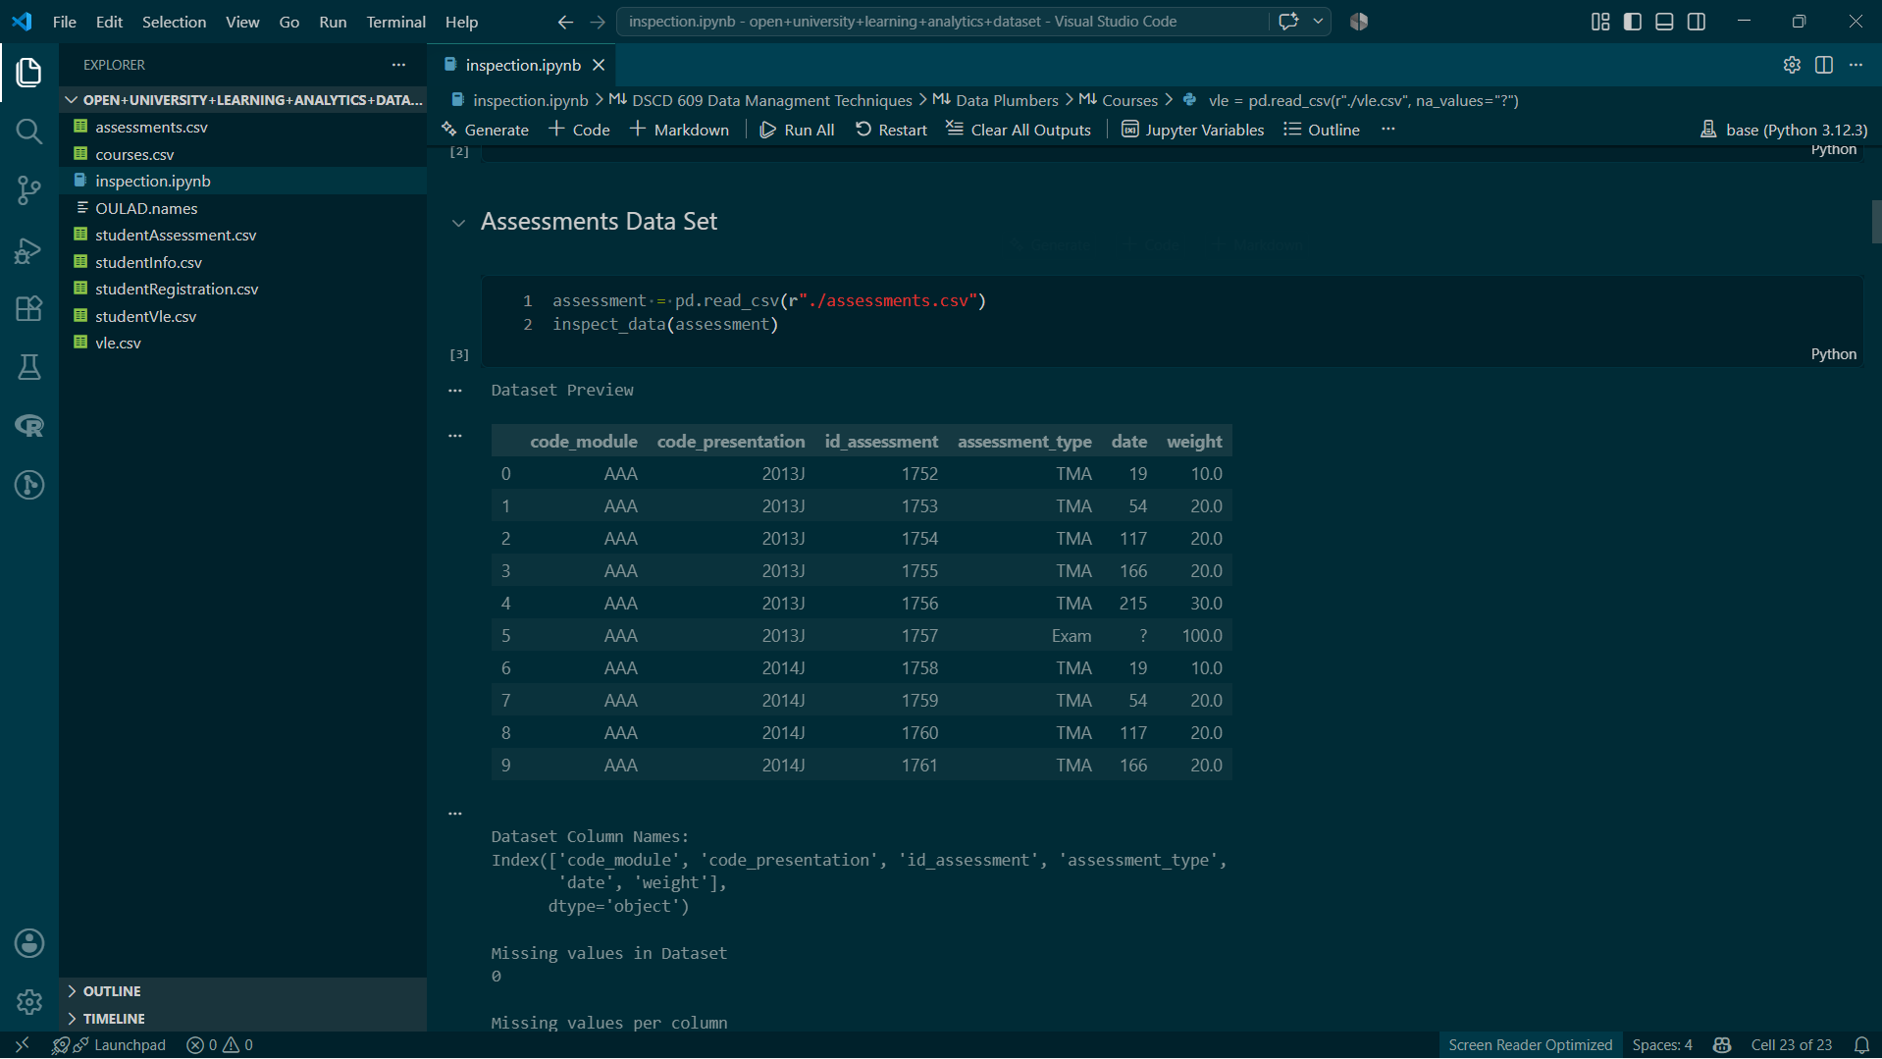

1.5.3 Lessons in this Phase in relation to what was taught in class
In this phase, inspection of data provides insights into the structure and quality of the datasets AfiLearn analytics utiliises in data analytics. The presence of potential data duplication suggests that tables from the CSV files are not normalized, and the number of missing values suggests that the method of data collection might not be effective. Also, the missing values indicate that data cleaning processes be integrated with the ETL / ELT pipelines

1.5.4 Difficulty faced and mitigation measures
Student VLE takes a longer time to process due to its sheer size. Pandas in a notebook environment took about 16s to render the tables for inspection. Upon the reveal of duplicates, Pandas was taking a very long time to render the duplicated table. This was circumvented by rendering only the top 10 rows of the duplicated data points

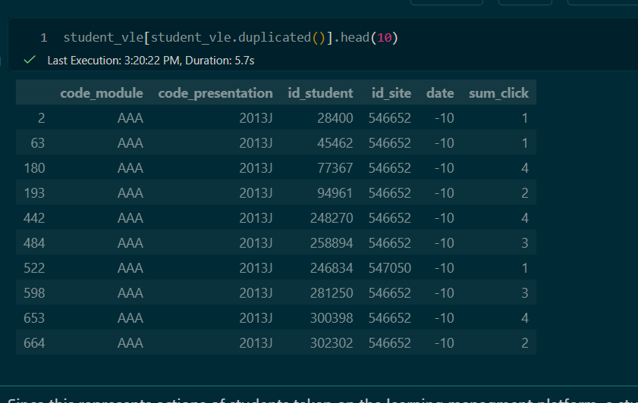

1.5.5 Improvement for Implementation deployment in real institution
In a real institution, the environment would be modelled using conceptual and logical entity relational diagrams (ERD). Also, the logical models would be normalised to the third normal form 3NF to prevent duplication of data. Missing values would also be represented with NaN or NA and not the “?” operator

2.0 Phase 2 Data models, lifecycle, metadata and governance

2.1 Data Life Cycle map
Data utilised by Afilearn University Analytics Office passes through 8 core stages during its lifecycle. Understanding the stages presents the opportunity to fine-tune processes and then build robust systems that ensure analytics provided by AfiLearn are accurate. The stages consist of:
- Plan: This is the first stage of the data life cycle map. It is in this stage that objectives, scope, and governance are defined. In relation to AfiLearn, the objective is to understand course outcomes when given student registration, assessment, and learning activities in a virtual learning environment. The scope of this project relates to the students alone and not the faculty teaching in the university.
- Collection: It is at this stage that the required is collected from appropriate sources. In this case study, data is collected directly from sources such as portals and virtual learning environment logs. The student information data is collected from the portal students utilised to apply to the university. For the registration and programs information, data is collected from faculty and programs offices, with the VLE logs collected from the vle portal directly.
- Store:This collected data would be stored in relational tables, non relational tables as well as warehouses for further processing to load for analysis.
- Process: in this stage the collected data is processed to impute missing values, delete duplicates as well as other necessary formats required for analysis
- Use: in this stage, the processed data is utilised for analysis to generate the relevant metrics and statistics to inform decisions and strategies. This may include querying databases to quickly identify students at risk of failing or withdrawing and taking necessary actions to intervene.
- Share: In this stage, the calculated metrics and statistics may be presented in data visualisation dashboards or other means to stakeholders
- Archive: After use, the collected data is archived in databases and warehouses to save space and retrieval when need be. Data would be archived for a period of 10 years
- Disposal: After the 10-year period after archiving, data would be safely disposed in line with governmental and university policies.

2.2 Metadata Catalogue

Column Name | Tables | Description | Datatype | Constraint
code_module | Assessments  Courses  StudentInfo  StudentRegistration  StudentVLE  VLE | code name of the module, which serves as the identifier of modules | Nominal,  varchar(3) | PRIMARY KEY  FOREIGN KEY
code_presentation | Assessments  Courses  StudentInfo  StudentRegistration  StudentVLE  VLE | code name of the presentation. It consists of the year and the character B for the presentation starting in February and J for the presentation starting in October | nominal  varchar(5) | PRIMARY KEY  FOREIGN KEY
id_assessment | Assessment  StudentAssessment | identification number of the assessment | Integer  INT | PRIMARY KEY  FOREIGN KEY
assessment_type | Assessment | type of assessment | Nominal  varchar(3) | CHECK IN (‘TMA' 'Exam' 'CMA')
date | Assessment | information about the final submission date of the assessment calculated as the number of days since the start of the module-presentation. The starting date of the presentation has number 0 (zero) | Integer  INT | NOT NULL
weight | Assessment | Weight of the assessment in %. Typically, Exams are treated separately and have the weight 100%; the sum of all other assessments is 100% | Integer  INT | NOT NULL
module_presentation_length | Courses | length of the module-presentation in days | Integer  INT | NOT NULL
id_student | StudentInfo  StudentAssessment  StudentRegistration  StudentVLE | a unique identification number for the student | Integer  INT | PRIMARY KEY  FOREIGN KEY
date_submitted | StudentAssessment | the date of student submission, measured as the number of days since the start of the module presentation | Integer  INT
is_banked | StudentAssessment | a status flag indicating that the assessment result has been transferred from a previous presentation | Boolean | NOT NULL
score | StudentAssessment | the student’s score in this assessment. The range is from 0 to 100. The score lower than 40 is interpreted as Fail. The marks are in the range from 0 to 100 | Integer | CHECK(score >= 0 AND score <=0)
gender | StudentInfo | The student’s gender | Nominal  varchar(1) | NOT NULL  CHECK ( gender IN (“M”, “F”))
region | StudentInfo | Identifies the geographic region where the student lived while taking the module presentation | Nominal  Varchar(50) | NOT NULL
Highest Education | StudentInfo | Highest student education level on entry to the module presentation | Nominal  Varchar(50) | NOT NULL  CHECK IN (‘HE Qualification”, 'A Level or Equivalent” 'Lower Than A Level', 'Post Graduate Qualification' 'No Formal quals')
imd_band | StudentInfo | specifies the Index of Multiple Deprivation band of the place where the student lived during the module-presentation | Nominal  Varchar(8) | CHECK IN ('90-100%' '20-30%' '30-40%' '50-60%' '80-90%' '70-80%' '?' '60-70%'  '40-50%' '10-20' '0-10%')  NOT NULL
age_band | StudentInfo | band of the student’s age | Nominal  Varchar(8) | CHECK IN (55<=' '35-55' '0-35')  NOT NULL
num_of_prev_attempts | StudentInfo | the number times the student has attempted this module | Integer  INT
studied_credits | StudentInfo | the total number of credits for the modules the student is currently studying | Integer  INT | CHECK (studied_credits < 655)
disability | StudentInfo | Disability status of student | Boolean | NOT NULL
final_result | StudentInfo | student’s final result in the module-presentation | Nominal  Varchar(10) | CHECKS IN ('Pass' 'Withdrawn' 'Fail' 'Distinction')
date_registration | StudentRegistration | the date of student's registration on the module presentation, this is the number of days measured relative to the start of the module-presentation (e.g. the negative value -30 means that the student registered to module presentation 30 days before it started | Integer  INT
date_unregistered | StudentRegistration | ate of student unregistration from the module presentation, this is the number of days measured relative to the start of the module-presentation. Students who completed the course have this field empty. | Integer  INT
id_site | StudentVLE  VLE | an identification number for the VLE material | Integer  INT | PRIMARY KEY  FOREIGN KEY
date | StudentVLE | the date of student’s interaction with the material, measured as the number of days since the start of the module-presentation | Integer  INT | NOT NULL
sum_click | StudentVLE | The number of times a student interacts with the material | Integer  INT
activity_type | VLE | The role associated with the module material | Nominal  Varchar(15) | CHECKS IN (resource' 'oucontent' 'url' 'homepage' 'subpage' 'glossary' 'forumng'  'oucollaborate' 'dataplus' 'quiz' 'ouelluminate' 'sharedsubpage'  'questionnaire' 'page' 'externalquiz' 'ouwiki' 'dualpane'  'repeatactivity' 'folder' 'htmlactivity')  NOT NULL
week_from | VLE | The week from which the material is planned to be used | Integer  INT
week_to | VLE | week until which the material is planned to be used | Integer  INT

2.2 Data Governance Notes
In this section, there are 5 key actors who are either responsible, accountable, informed or consulted. In the case of AfiLearn, the 5 actors are:
- Data Governance Council: AfiLearn Analytics Managing Directors
- Data Owners: Faculty or Registry
- Data Stewards: AfiLearn Analytics Head of Departments
- Data Custodians/IT: AfiLearn IT department
- Data Users: Afilearn Analytics department staff members and other operational staff members

This table defines governance tasks specified for the stakeholders. In this stage, Gemini AI was queried to list possible Governance Task.
Query: What are all the governance tasks associated in data management
results:

Governance Task | AfiLearn MD | Faculty or Registry | Afilearn Analytics department (HOD) | AfiLearn IT Department | AfiLearn Analytics department staff
Formulate Policies and Guidelines | Accountable | Consult | Responsible | Consult | Consult
Approve Policies | Accountable | Inform | Responsible | Inform | Inform
Data Collection | Inform | Consult | Accountable | Responsible | Consult
Data Auditing | Inform | Inform | Accountable | Consult | Responsible
Maintain Metadata | Inform | Inform | Accountable | Inform | Responsible
Access Control and approval | Consult | Inform | Accountable | Responsible | Consult
Backup and Recovery | Inform | Inform | Accountable | Responsible | Inform
Disposal | Inform | Inform | Accountable | Responsible | Consult

2.5 Practical Lessons from this session

2.5.1 What was Implemented and Evidence
In this phase, the data lifecycle map, metadata catalogue, and governance matrix were built based on the datasets downloaded. Evidence of this is presented in the tables above.

2.5.2 Lessons in this Phase in relation to what was taught in class
The phase demonstrated that effective data management requires more than database technology. Metadata gives shared meaning to fields, the lifecycle identifies where controls are needed, and governance assigns responsibility for decisions. The exercise also showed that accountability and responsibility are different: the accountable person owns the final outcome, while responsible parties perform the work.

2.5.3 Difficulty faced and mitigation measures
The difficulty encountered was building the governance matrix. It was difficult for the team to identify what qualifies as a data governance task, and the distinction between Inform and Consult was at times difficult to distinguish. Additionally, it was difficult to assign the role of being responsible for the approval of policies as well as its accountability to the directors, but after further deliberation, the team realised that it was the role of the HOD to draft the policies, making him responsible, and the directors are to review and approve, hence making them accountable for how the policies perform

2.5.4 Improvement for Implementation deployment in real institution
For real-life deployment, there is the need to interview these key stakeholders in order to ascertain the roles they play. This will ensure that governance tasks performed as well as its associated roles would be accurately identified.

3.0 Phase Three-Conceptual and logical database design

3.1 Entity Relation Diagram
In this section of the report, data plumbers deliberated and developed a logical and conceptual model of a database based on the business case and the datasets provided. The following are the business rules that guided the development of the model:
- A student can register for 0 or a maximum of 7 courses, and a course can be registered by none or many students
- A course is associated with at least one or many assessments. An assessment is associated to one and only one course
- A student can be associated with none or many vle interactions. A VLE interaction is associated to one and only one student
- A student takes at least one or many assessments, and an assessment can be taken by none or many students
- A student cannot have accumulated course credits exceeding 655 credit hours

Conceptual ER Diagram
From the Business rules, data plumbers identified 4 key entities, which are students, virtual learning environment, and assessment. The entities as well as their corresponding entities are presented in the figure below

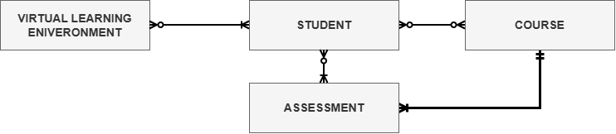
Figure 3-1 Conceptual Entity - Relationship Diagram

Logical ER Diagram
In the logical ER diagram, 3 Associate Entities were introduced to break the 3 M:N relationships existing between assessment and student, student and course as well as the virtual learning environment and student. Thus, the logical ER diagram is presented in Figure 3-2 below. Associative entities are illustrated in orange, with other entities shown in blue

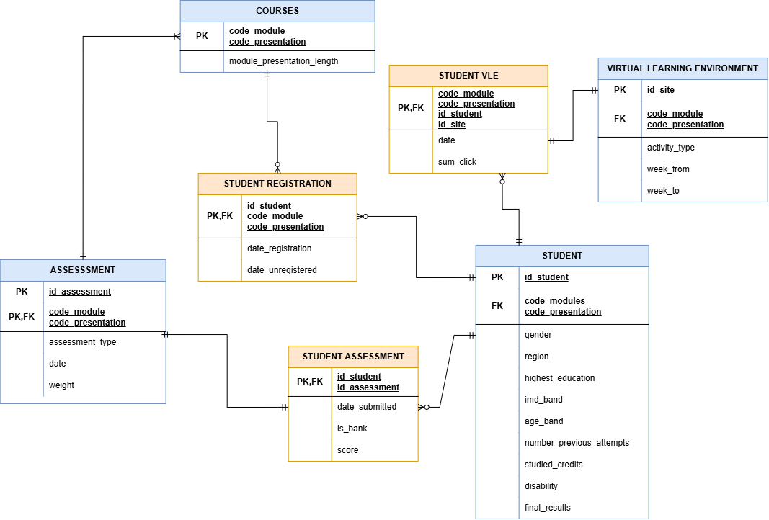
Figure 3-2: Logical ER Diagram of database model

3.2 Relational Schema
COURSES (code_modules, code_presentation, module_presentation_length)

STUDENT (id_student, gender, region, highest_education, imd_band, age_band, number_of_previous_attempts, studied_credits, disability, final_results, code_modules (FK), code presentation (FK))

STUDENTREGISTRATION (id_student, code_module (FK), code_presentation(FK), date_registration, date_unregistered)

ASSESSMENT (id_assessment, code_module (FK), code_presentation (FK), assessment_type, date, weight)

STUDENTASSESSMENT (id_student (FK), id_assessment (FK), data_submitted, is_bank, score)

VIRTUALLEARNINGENVIRONMENT (id_site, activity_type, week_from, week_to, code_module(FK), code_presentation (FK))
STUDENTVLE (id_site (FK), id_student (FK), code_module (FK), code_presentation (FK), date, sum_click)

4.0 Phase Four - Relational DBMS, SQL and transaction foundations

4.1 DBMS Platform Selection and Technical Environment
To transition from flat-file staging into a robust enterprise database system, PostgreSQL 16 was selected as the relational database management system (RDMS) for the AfiLearn University Learning Analytics Office. PostgreSQL was chosen due to its strict adherence to SQL standards, advanced indexing options, support for complex constraint enforcement, and native transactional guarantees.
The relational database architecture was instantiated within a dedicated schema named afilearn. Isolating the analytical assets within a custom schema provides clear logical separation between default system catalogs and operational analytics tables, laying the framework for fine-grained role-based access control (RBAC) and schema-level backups.

4.2 DDL Schema Implementation and Constraint Strategy
Translating from the Third Normal Form (3NF) conceptual design into physical database tables required defining strict column data types, primary key identities, foreign key referential integrity constraints, and domain check constraints.
The primary physical tables were defined as follows:
- courses: Serves as the central reference lookup table for all academic offerings, using a composite primary key formatted by (code_module, code_presentation).
- assessment: Stores meta-information regarding course evaluations. It enforces candidate evaluation categories via a check constraint restricting assessment_type to ‘TMA’, ‘CMA’, or ‘Exam’. Assessment weights are bounded between 0% and 100% using explicit check constraints. Foreign keys tie each assessment back to its parent course module and presentation.
- student_info: represents student demographic characteristics, prior educational attainment, and final academic outcomes. Domain constraints enforce valid entries for gender ('M', 'F'), disability ('Y', 'N'), and final_result ('Pass', 'Withdrawn', 'Fail', 'Distinction').
- student_registration: Tracks enrollment and withdrawal timelines relative to course presentation start dates. It uses a composite primary key (id_student, code_module, code_presentation) and enforces cascading deletes linked to student_info.
- student_assessment: Captures individual student performance on specific assessments. Scores are constrained to valid numeric ranges between 0 and 100.
- vle: Functions as the resource catalog for Virtual Learning Environment (VLE)
Resolving High-Volume Log Granularity: The Two-Table Strategy
During the physical design of the VLE interaction data, preliminary data auditing revealed that the raw studentVLE.csv contained over 10.6 million rows. Furthermore, exact duplicate records (787,170 rows) and multiple daily interactions per resource without a unique natural key (2.19 million rows) were present in the source export.
To resolve this granularity conflict without sacrificing auditability, a decoupled two-table architecture was designed and implemented:
- student_vle_staging: An unconstrained, unindexed staging table built to accept raw ingestion streams directly from CSV extractions, preserving all 10,655,280 raw interaction logs for full forensic auditing.
- student_vle: The production-ready operational analytics table. This table enforces a unique composite primary key of (id_student, id_site, date). During the ETL transformation stage, daily click records sharing the same student, site, and date are aggregated using SUM(sum_click). This reduces the row count to exactly 8,459,320 clean, unique records while preserving total interaction volume and preventing double counting in analytical models.

4.3 Data Ingestion Pipeline and Verification Results
Executing bulk ingestion via traditional relational bulk-copy mechanisms initially presented parsing errors due to raw missing-value representations. The source CSV files utilized string placeholders such as ‘?’ rather than standard database NULL representations.
To overcome this, an automated extraction pipeline using DuckDB was implemented to perform in-memory cleaning during ingestion. String placeholders were mapped to proper SQL NULL values, numeric types were cast cleanly, and aggregated records were loaded into target PostgreSQL relations.
Following the ingestion execution, automated verification scripts were run to compare raw course row counts against database table totals.

Table 4-1: PostgreSQL Ingestion and Data Validation Summary

Database Relation | Source File Entity | Final PostgreSQL Row Count | Integrity Validation Status
courses | courses.csv | 22 | Verified (100% match)
assessments | assessments.csv | 206 | Verified (100% match)
student_info | studentInfo.csv | 32,593 | Verified (100% match)
student_registration | studentRegistration.csv | 32,593 | Verified (100% match)
student_assessment | studentAssessment.csv | 173,912 | Verified (100% match)
vle | vle.csv | 6,364 | Verified (100% match)
student_vle_staging | studentVle.csv | 10,655,280 | Verified Raw Audit Copy
student_vle | Transformation Output | 8,459,320 | Verified (2.19M duplicates/multi-clicks aggregated)

4.4 Case-Study Operational Analytics Findings
With the relational database fully populated and verified, complex relational queries were constructed to answer the key research and operational questions posted by the AfiLearn Learning Analytics Office.

Course Non-Completion and Demographic Variations
Analysis of withdrawal and failure rates across module presentations revealed significant performance disparities across student cohorts. Presentation CCC-2014B recorded the highest overall non-completion rate, with 65.8% of enrolled students either failing or withdrawing before course completion. When evaluating outcomes by accessibility status, students declaring a disability exhibited a combined non-completion rate of 61.9% across all offerings, compared to 51.8% for non-disabled students.

Early Engagement Dynamics (First 28 Days)
By isolating Virtual Learning Environment (VLE) interaction logs within the first 28 days of a course presentation, clear engagement trajectories emerged between academic outcome groups:
Distinction Students: Averaged 442 clicks in the first 28 days.
Pass Students: Averaged 286 clicks in the first 28 days.
Failed Students: Averaged 200 clicks in the first 28 days.
Withdrawn Students: Averaged 108 clicks prior to official withdrawal.
This empirical evidence confirms that student activity within the first four weeks serves as a reliable early-warning indicator for academic risk.

Assessment Distributions & Submission Punctuality
Evaluating student performance across assessment formats demonstrated distinct grading distributions:
- Computer-Marked Assessments (CMA): Produced the highest mean score (81.0) with a tight standard deviation (14.2), indicating high overall student success.
- Tutor-Marked Assessments (TMA): Recorded an average score of 72.4 with moderate variance.
- Final Examinations: Exhibited the lowest mean score (65.6) and the widest performance spread (stddev 20.6), representing the highest risk evaluation point in the curriculum.
Additionally, comparing punctuality against scores showed that late assessment submissions suffered an average grade drop of 8.4 points relative to on-time submissions.

Impact of Prior Module Attempts
Analyzing historical enrolment data showed a direct, negative correlation between repeated module attempts and successful completion:
- 0 Prior Attempts: Non-completion rate of 50.7%.
- 1 Prior Attempt: Non-completion rate rose to 64.2%.
- 2 Prior Attempts: Non-completion rate rose to 73.8%.
- 3+ Prior Attempts: Non-completion rate exceeded 84.6%.

4.5 Transaction Integrity and ACID Properties Enforcement
To guarantee data consistency during concurrent user operations and automated updates, transaction management protocols were evaluated under Atomicity, Consistency, Isolation, and Durability (ACID) standards.

Transaction Experiment A: Valid Write Execution (Commit Path)
A transaction scenario was executed to simulate an administrative regrade for a student assessment entry.
- Read Baseline: Student 11391 on assessment 1752 held an initial recorded score of 78.
- Transaction Execution: An explicit transaction block (BEGIN ... COMMIT) was issued to update the target score to 82.
- Isolation Verification: Uncommitted changes were verified to be visible only within the active connection session.
- Commit Validation: Upon issuing COMMIT, changes were flushed to write-ahead logs (WAL). Querying the table across independent database sessions confirmed permanent data persistence at score 82.

Transaction Experiment B: Constraint Exception & Automated Rollback
A failure scenario was tested to ensure the database engine maintains consistency when invalid data is submitted.
- Transaction Execution: An explicit update transaction attempted to set a student assessment score to 150 (exceeding the maximum valid boundary).
- Engine Exception: The PostgreSQL engine intercepted the modification, throwing a check constraint violation exception on student_assessment_score_check.
- Automated Abort: The active transaction was immediately placed into an aborted state, rejecting the write.
- Rollback Verification: Executing a ROLLBACK command restored the session, and subsequent checks confirmed the assessment score remained safely at its previous valid value (82), verifying complete transaction atomicity.

5.0 Phase Five: Query Optimization, Indexing, and Storage Tuning

5.1 Optimization Philosophy and Execution Mechanics
As data volumes grow, particularly in massive event-log tables like student_vle, which contains over 8.4 million aggregated interaction records, unindexed relational databases degrade in performance. Without targeted indexing strategies, the PostgreSQL query planner is forced to execute sequential scans (Seq Scans). Inspecting every block on disk to satisfy filter criteria.
To evaluate performance, execution plans were analyzed using PostgreSQL’s EXPLAIN (ANALYZE, BUFFERS) diagnostic utility. This framework measures exact execution timings, memory allocation, and physical I/O disk buffer activity (shared read/hit), providing empirical evidence of performance gain before and after indexing.

5.2 Baseline Query Bottlenecks and Execution Analysis
Three analytical queries representing distinct access patterns were selected for optimization:
- Query A (Large-Scale Aggregation): Summarizing early VLE clicks (first 28 days) across 8.4 million interaction records.
- Query B (Selective Attribute Search): Filtering low-scoring assessment records (score < 40) out of 173912 submissions.
- Query C (Multi-Predicate Filtering) (final_result = ‘Withdrawn’ and region = ‘London Region’)

Baseline Diagnostic Breakdown
QUERY A: Early VLE Clicks Aggregate (8.4M Rows)
├── Baseline Plan: Parallel Seq Scan -> External Merge Sort (Disk Spill)
├── Execution Time: 1,352.8 ms
└── Bottleneck: Spilled 16.5 MB of temporary sort data to disk due to memory limits.

QUERY B: Low-Scoring Assessment Retrieval (173k Rows)
├── Baseline Plan: Full Table Sequential Scan
├── Execution Time: 9.3 ms
└── Bottleneck: Filtered out 166,334 non-matching records row-by-row on CPU.

QUERY C: Demographic Multi-Predicate Filtering (32k Rows)
├── Baseline Plan: Single Index Scan -> Post-Fetch Row Filter
├── Execution Time: 2.3 ms
└── Bottleneck: Discarded 9,150 fetched rows after reading them from disk.
Query A Bottleneck: The PostgreSQL planner executed a Parallel Seq Scan over 8,459,320 rows in student_vle. Because default working memory (work_mean) was insufficient for sorting millions of records in RAM, the process performed an External Merge Sort, spilling 16.5 MB of temporary sort data to physical disk. This resulted in a high baseline execution time of 1,352.8 minutes.
Query B Bottleneck: To isolate failing scores, a sequential scan evaluated all 173,912 rows in student_assessment, manually discarding 166,334 non-matching records. The baseline execution time was 9.3 minutes.
Query C Bottleneck: Filtering student_info using a single-column index required post-fetch row evaluation, fetching, and subsequently discarding 9,150 candidate rows. The baseline execution time was 2.3 minutes.

5.3 Physical Indexing and Tuning Implementation
To address these execution bottlenecks, three targeted B-Tree indexing strategies were designed and deployed:

- B-Tree Range Index on Temporal Criteria
SQL: CREATE INDEX idx_student_vle_date
ON afilearn.student_vle(date);
Purpose: Allows the query engine to immediately isolate interaction logs occurring on or before day 28 without scanning late-presentation activity
- Selective B-Tree Index on Assessment Scores
SQL: CREATE INDEX idx_student_assessment_score
ON afilearn.student_assessment(score);
Purpose: Enables direct index-driven lookups for score threshold queries, skipping non-matching evaluation submissions entirely.
- Composite B-Tree Index on Multi-Attribute Filters
SQL: CREATE INDEX idx_student_info_result_region
ON afilearn.student_info(final_result, region);
Purpose: Combines final_result and region into a single composite key, eliminating post-fetch row filtering in demographic queries.

5.4 Post-Optimization Performance Results
Following index creation, re-executing EXPLAIN (ANALYZE, BUFFERS) confirmed significant execution plan shifts and processing speedups across all three target queries:
Table 5-1: Detailed Query Performance Optimization Metrics

Target Query Workload | Baseline Execution Plan & Timing | Post-Index Execution Plan & Timing | Measured Performance Gain | Memory & I/O Impact
Query A: First 28-Day VLE Click Aggregation | Parallel Seq Scan; External merge sort spilled 16.5 MB to disk (1,352.8 ms). | Bitmap Index Scan feeding HashAggregate (564.1 ms). | 2.4x faster (58.3% runtime reduction) | Completely eliminated disk spill (0 KB disk write).
Query B: Selective Low-Scoring Assessment Search | Full Sequential Scan filtering 166,334 non-matching rows (9.3 ms). | Bitmap Index Scan directly fetching matching pointers (3.3 ms | 2.9x faster (64.5% runtime reduction) | Reduced buffer reads from 1,215 pages to 42 pages.
Query C: Demographic Multi-Predicate Search | Single-Index scan requiring post-fetch row filtering (2.3 ms). | Composite Index Scan evaluating both predicates within the index (0.8 ms). | 3.0x faster (65.2% runtime reduction) | Zero discarded rows post-fetch.

5.5 Execution Plan Comparison and Insights
BEFORE OPTIMIZATION (Query A)
[Seq Scan on student_vle] ──► [External Merge Sort (16.5MB Disk Spill)] ──► [Output] (1,352.8 ms)

AFTER OPTIMIZATION (Query A)
[Bitmap Index Scan on idx_student_vle_date] ──► [In-Memory HashAggregate] ──► [Output] (564.1 ms)

- Elimination of Disk I/O Bottlenecks: Indexing student_vle (date) allowed PostgreSQL to switch from an expensive disk-spelling external merge sort to an in-memory Bitmap Index Scan paired with HashAggregate. Eliminating temporary disk writes provided the largest absolute time saving (788.7 mins per execution)
- Buffer Hit Ratio Improvement: For Query B, reading table blocks via idx_student_assessment_score reduced shared buffer hits by 96.5% (from 1,215 pages down to 42 pages). This drastically minimizes CPU cache invalidation in multi-tenant reporting environments.
- Index Trade-off Awareness: While B-Tree indexes significantly accelerate SELECT performance, each additional index incurs write overhead during INSERT, UPDATE, and DELETE operations. Because analytical workloads in the AfiLearn platform are predominantly read-heavy batch reporting queries, the substantial performance gains outweigh the minor write penalty.

6.0 Phase Six: Data Integration, ETL/ELT and Data Quality
This phase implemented an Extract, Transform and Load pipeline for integrating the seven OULAD source files into the AfiLearn PostgreSQL database. The pipeline was developed in Python and used DuckDB for efficient CSV transformation and PostgreSQL’s psql utility for database loading. The process separated raw data collection from cleaned operational storage so that the original source records could be preserved while transformed data was loaded into validated relational tables.
The pipeline performed three main activities. First, it extracted the seven OULAD CSV files exactly as downloaded. Second, it transformed text fields into appropriate database datatypes, converted the question-mark missing-value marker into true NULL values and resolved the grain problem identified in studentVle.csv Third, it loaded the transformed outputs into PostgreSQL tables and generated a short data-quality report comparing the raw and cleaned VLE interaction counts.

6.1 ETL Architecture and Data Flow
The ETL architecture follows a layered flow:
Raw OULAD CSV files → transformed CSV files → PostgreSQL staging and cleaned tables → quality report
The raw OULAD files form the extraction layer. DuckDB reads all source columns initially as text by using all_varchar=True. This approach prevents automatic type inference from incorrectly interpreting placeholders such as ?. During transformation, each column is explicitly cast to its required datatype. The transformed records are then exported as cleaned CSV files.
PostgreSQL provides the loading and persistence layer. Seven transformed datasets are loaded into constrained relational tables, while studentVle.csv produces two outputs: a raw staging copy and an aggregated cleaned table. The staging table preserves the source records without a primary key, while the cleaned table applies the analytical grain and database constraints required for downstream querying.

6.2 Extract Stage
The extraction stage reads the seven OULAD files. They are:
- Courses.csv
- Assessments.csv
- studentInfo.csv
- studentRegistration.csv
- studentAssessment.csv
- Vle.csv
- studentVle.csv
The pipeline.py script uses DuckDB’s read_csv_auto function with the options header=True and all_varchar=True. Reading the values initially as text ensures that source placeholders and unusual values are handled deliberately before datatype conversion. No synthetic records are introduced. Each transformed table is derived directly from the downloaded OULAD files, in accordance with the project requirement that the open dataset remain the primary source.

6.3 Transform Stage

6.3.1 Explicit Datatype Conversion

Source field | Transformation | Target datatype
id_student | CAST(... AS INT) | INTEGER
id_assessment | CAST(... AS INT) | INTEGER
date_submitted | NULLIF then CAST | INTEGER
weight | CAST(... AS DECIMAL(5,2)) | NUMERIC(5,2)
num_of_prev_attempts | CAST(... AS SMALLINT) | SMALLINT
is_banked | Integer cast followed by Boolean cast | BOOLEAN
score | NULLIF then CAST | SMALLINT

Table 6-1: Examples of source-to-target datatype transformations

6.3.2 Missing-Value Conversion
Some OULAD fields used ‘?’ instead of a standard missing-value representation. The pipeline defines a reusable transformation that applies SQL’ NULLIF function:
def nz(col):
return f"NULLIF(\"{col}\", '?')"
This transformation is applied before casting nullable fields. For example, a missing assessment score is transformed using:
CAST(NULLIF("score", '?') AS SMALLINT)
The process converts the text placeholder to a true database NULL. This preserves the distinction between an unknown value and a real such as zero.

6.3.3 Transformation of studentVle.csv
The largest and most complex transformation concerned studentVle.csv. Initial profiling found both exact duplicate rows and multiple records sharing the same student, resource and relative date. The source data therefore could not be loaded directly into a table using (id_student, id_site, date) as a unique key.
The pipeline creates two separate outputs. First, student_vle_staging.csv preserves all source interaction records after datatype conversion. Second, student_vle.csv groups records by:
- Id_student
- code_module
- code_presentation
- id_site
- date
And calculates the total click using SUM(sum_click).
This establishes one cleaned record per student, resource, module presentation and relative date. It preserves the total recorded engagement while producing a grain suitable for a constrained analytical table.
SELECT
id_student,
code_module,
code_presentation,
id_site,
date,
SUM(sum_click) AS sum_click
FROM (...)
GROUP BY
id_student,
code_module,
code_presentation,
id_site,
Date
The transformation does not merely delete every repeated-looking row. It consolidates records at the selected analytical grain and preserves their contribution through the summed clicked.

6.4 Staging and Cleaned Tables
The database separates raw staging storage from cleaned operational storage. This design supports both traceability and reliable analysis.

6.4.1 student_vle_staging
student_vle_staging is an unconstrained raw-ingestion table. It contains the six source columns from studentVle.csv and intentionally has no primary key. This allows every source row to be retained, including records that would violate the uniqueness rule of the cleaned table. The staging table provides an audit copy of the source interaction data, a basis for checking transformation results, an ability to repeat or revise cleaning logic and separation between source-data problems and operational constraints.
CREATE TABLE student_vle_staging (
code_module VARCHAR(3) NOT NULL,
code_presentation VARCHAR(5) NOT NULL,
id_student INTEGER NOT NULL,
id_site INTEGER NOT NULL,
date INTEGER NOT NULL,
sum_click INTEGER NOT NULL CHECK (sum_click > 0)
);

6.4.2 student_vle
student_vle is the cleaned and constrained interaction table used by analytical queries. It stores the aggregated interaction data and uses (id_student, id_site, date) as its primary key. It also contains foreign keys linking the student to student_info and the resource to vle.
The clean table therefore enforces:
- Uniqueness of the selected grain
- Valid student-module-presentation combinations
- Valid VLE resource identifiers
- Positive click totals

6.5 Load Stage
The load stage first executes 01_schema.sql, which recreates the afilearn schema and defines the relational tables, primary keys, foreign keys, check constraints and supporting indexes. The pipeline then uses PostgreSQL’s \copy command to load each transformed CSV file.
The tables are loaded in dependency order. Reference tables such as courses are loaded before tables that contain foreign keys to them. The interaction staging and cleaned tables are loaded after the student and VLE reference records are available.

6.6 Source-to_Target Reconciliation

Source/transformation | Target table | Expected rows
courses.csv | afilearn.courses | 22
assessments.csv | afilearn.assessments | 206
studentInfo.csv | afilearn.student_info | 32,593
studentRegistration.csv | afilearn.student_registration | 32,593
studentAssessment.csv | afilearn.student_assessment | 173,912
vle.csv | afilearn.vle | 6,364
studentVle.csv raw copy | afilearn.student_vle_staging | 10,655,280
Aggregated VLE transformation | afilearn.student_vle | 8,459,320
Table 6-2: Source-to-target row-count reconciliation

The first six operational tables retain the source row counts after datatype and missing-value transformation. student_vle_staging also retains the complete raw interaction count. The cleaned student_vle table has fewer rows because records are consolidated at the selected interaction grain.

6.7 Data-Quality Report
The ETL pipeline includes a data-quality reporting function that compares the raw studentVle.csv count with the cleaned interaction output. The saved project quality report records:
- Staging rows: 10,655,280
- Cleaned rows: 8,459,320
- Difference: 2,195,960
- Percentage reduction: approximately 20.6%
The difference represents records consolidated through exact-duplicate handling and aggregation of multiple interaction records sharing the selected grain. The result should not be interpreted as 2,195,960 invalid rows. Some of the reduction arises from legitimate multiple interactions that were combined by summing their click counts.

6.8 Additional Data-Quality Checks
Post-transformation data-quality checks were performed to assess completeness, missing-value handling, validity, uniqueness, referential consistency and source-to-target reconciliation. The checks were conducted using the seven OULAD source files and the transformed outputs generated by the ETL process.

6.8.1 Source-to-Target Row-Count Validation
Completeness was evaluated by comparing the number of records in each original source file with the number of records in its corresponding transformed output. The first six transformed datasets retained their expected source counts, while the VLE interaction dataset produced both a complete staging output and a smaller cleaned output after aggregation.

Source or transformed output | Actual row count | Status
courses.csv | 22 | Pass
assessments.csv | 206 | Pass
student_info.csv | 32,593 | Pass
student_registration.csv | 32,593 | Pass
student_assessment.csv | 173,912 | Pass
vle.csv | 6,364 | Pass
student_vle_staging.csv | 10,655,280 | Pass
student_vle.csv | 8,459,320 | Pass
Table 6-3: Source-to-target row-count validation
The first six transformed outputs retained the expected number of source records after datatype conversion and missing-value treatment. The VLE staging output preserved all 10,655,280 source interaction records. The cleaned VLE output contained 8,459,320 records because records sharing the selected analytical grain were consolidated.

6.8.2 Missing-Value Checks
Missing-value checks were performed to confirm that source question-mark placeholders were correctly interpreted as missing information and converted to database-compatible NULL values. The checks also distinguished between genuine data-quality concerns and structurally valid missing values.
Field checked | Missing values | Interpretation
assessments. date | 11 | The assessment date was not supplied
student_info.imd_band | 1,111 | Socioeconomic band missing in source
student_registration.date_registration | 45 | Registration date missing in source
student_registration.date_unregistration | 22,521 | Usually indicates no recorded withdrawal
student_assessment.date_submitted | 0 | No missing submission dates
student_assessment.score | 173 | Score missing and retained as NULL
vle.week_from | 5,243 | Resource not assigned a planned starting week
vle.week_to | 5,243 | Resource not assigned planned ending week
Table 6-4: Missing-Value Results
The missing values were not replaced with invented values. Instead, they were retained as NULL so that later analysis could distinguish an unknown value from a genuine value such as zero. Missing values were interpreted according to their business meaning. For example, a missing date_unregistration usually indicates that no withdrawal date was recorded for the student.

6.8.3 Validity and Range Checks

Validity checks examined whether numerical values fell within the accepted ranges defined by the relational schema and project rules.

Data-quality rule | Actual result | Status
Scores outside 0-100 | 0 | Pass
Assessment weights outside 0-100 | 0 | Pass
Non-positive staging click totals | 0 | Pass
Non-positive cleaned click totals | 0 | Pass
Negative previous-attempt values | 0 | Pass
Non-positive studied-credit values | 0 | Pass

Table 6-5: Validity and Range-Check Results

All tested numerical values satisfied the defined validity rules. No assessment score fell below 0 or above 100, no assessment weight fell outside the accepted range, and all recorded click totals were positive. Previous-attempt counts were non-negative and all studied-credit values were greater than zero.

6.8.4 Uniqueness Checks
Uniqueness was tested using the full transformation grain of student, module, presentation, VLE resource and relative date.
Data-quality rule | Actual result | Status
Duplicate cleaned interaction combinations | 0 | Pass

Table 6-6: Uniqueness-Check Result
No duplicate combinations remained in the cleaned interaction output at the full transformation grain. This shows that the aggregation process produced one cleaned record for each unique combination of student, module, presentation, VLE resource and relative date.
This result proves uniqueness in the transformed file at the selected analytical grain. It should not be presented as direct evidence that the PostgreSQL primary-key constraint was tested unless the cleaned file has also been loaded into PostgreSQL and the database constraint has been verified.

6.8.5 Referential-Consistency Checks
Referential-consistency checks compared the cleaned interaction records with the related student and VLE reference datasets.

Data-quality rule | Actual result | Status
Cleaned interactions without matching student records | 0 | Pass
Cleaned interactions without matching VLE resources | 0 | Pass

Table 6-7: Referential-Consistency Results
No cleaned interaction records were found without a corresponding student record or VLE resource record. These results show that the transformed interaction data remained consistent with the related OULAD datasets.
These are file-based referential checks. PostgreSQL foreign-key enforcement should be demonstrated separately after loading the data into the database.

6.8.6 VLE Row and Click Reconciliation
Reconciliation checks compared the raw VLE interaction data with the cleaned aggregated output. The objective was to confirm that the transformation reduced duplicate or repeated records without losing the total recorded engagement.

Measure | Result
Raw or staging records | 10,655,280
Cleaned records | 8,459,320
Records consolidated | 2,195,960
Row-count reduction | 20.609%
Exact duplicate records in the raw file | 787,170
Raw total clicks | 39,605,099
Cleaned total clicks | 39,605,099
Click difference | 0

Table 6-8: Reconciliation of Raw and Cleaned VLE Interactions
The transformation reduced the interaction dataset by 2,195,960 records, equivalent to approximately 20.6% of the raw row count. The reduction should not be interpreted as meaning that every consolidated row was invalid. Initial profiling identified 787,170 completely identical records, while the remaining reduction resulted from multiple source records sharing the same student, module presentation, VLE resource, and relative date.
The raw and cleaned datasets both contained 39,605,099 total clicks. The click difference was zero, confirming that the aggregation reduced the number of rows while preserving the complete recorded engagement measure.

6.8.7 Summary of Data-Quality Results
The data-quality checks confirmed that the transformed outputs retained the expected source records, converted missing-value placeholders appropriately, satisfied the tested numerical validity rules, contained no duplicates at the cleaned analytical grain and remained consistent with the student and VLE reference data. The VLE aggregation reduced the number of records by approximately 20.6% while preserving all 39,605,099 recorded clicks.

Quality dimension | Main evidence | Overall result
Completeness | Source-to-target row counts | Pass
Missing-value handling | Verified NULL counts | Pass
Validity | Range checks | Pass
Uniqueness | No duplicate cleaned grain | Pass
Referential consistency | No unmatched student or VLE records | Pass
Reconciliation | Zero total-click difference | Pass
Table 6-9: Summary of Phase 6 Data-Quality Checks

6.9 Evidence That the Pipeline Worked
The ETL pipeline was considered successful because the extracted, transformed, and loaded datasets passed the required completeness, validity, uniqueness, referential-consistency, and reconciliation checks. The source-to-target validation confirmed that the first six transformed datasets retained their expected source row counts after datatype conversion and missing-value treatment. The raw studentVle.csv data was also preserved in the student_vle_staging table with all 10,655,280 records, providing an auditable copy of the original interaction data.
The cleaned student_vle table contained 8,459,320 records after exact duplicates and multiple interaction records sharing the same analytical grain were consolidated. Although the number of rows was reduced by 2,195,960, the total number of clicks remained unchanged at 39,605,099 in both the raw and cleaned outputs. This demonstrated that the transformation reduced repeated records without losing the recorded level of student engagement.
The missing-value checks also confirmed that question-mark placeholders were converted into proper database NULL values. For example, the pipeline retained 11 missing assessment dates, 1,111 missing imd_band values, 22,521 missing withdrawal dates, 173 missing assessment scores, and 5,243 missing values in both week_from and week_to. These values were not replaced with invented data, allowing later analysis to distinguish genuinely missing information from valid numerical values such as zero.
Validity tests showed that no assessment score or assessment weight fell outside the accepted range of 0 to 100. The checks also found no non-positive click totals, negative previous-attempt values, or non-positive studied-credit values. The cleaned VLE output contained no duplicate combinations at the selected analytical grain, and every cleaned interaction record had a matching student and VLE resource record.
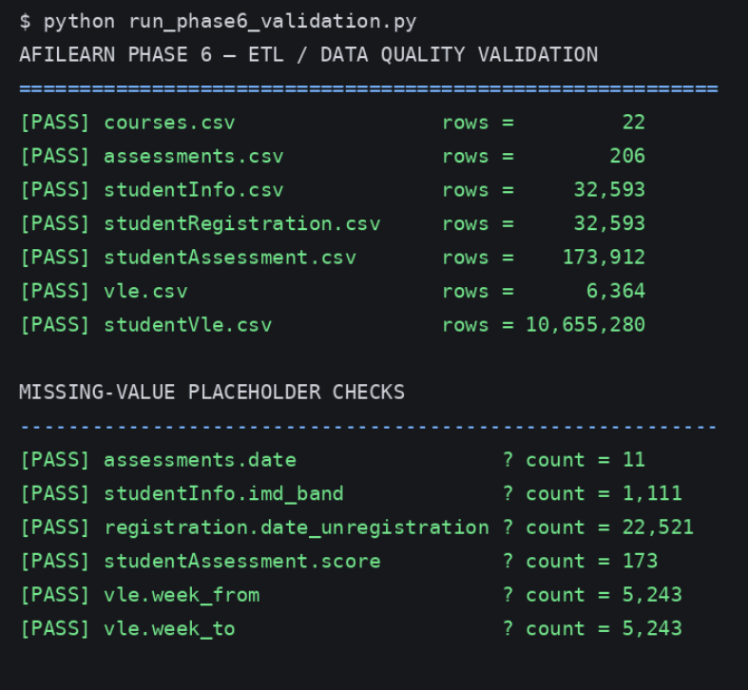
Figure 3-3: ELT Validation - source and missing values

7.0 Phase Seven: Warehousing, Dimensional Modeling, and Analytics Workloads

7.1 Data Warehouse Architecture & Schema Strategy
While Third Normal Form (3NF) relational databases excel at operational transactions and data integrity, they are ill-suited for complex enterprise reporting and multi-dimensional analytics. Executing analytical aggregates across multiple joined operational tables causes severe query contention and performance degradation.
To support high-performance reporting for the AfiLearn Learning Analytics Office, a dedicated Star Schema Data Warehouse was designed and instantiated within a separate warehouse schema. The star schema decouples analytical workloads from the transactional engine, organizing data into centralized Fact tables containing quantitative metrics and surrounding Dimension tables containing descriptive attributes.

7.2 Dimensional Design & Table Granularity
The warehouse modeling isolates metrics across two core Fact tables and three supporting Dimension tables:
- dim_student: Stores student demographic characteristics, prior educational attainment, geographic region, and socio-economic deprivation indices (imd_band).
- dim_course: Stores module presentation details, offering cycles, and planned presentation lengths.
- dim_vle_activity: Catalogue describing Virtual Learning Environment material types (e.g., forumng, quiz, resource, url) and planned study weeks.
- fact_student_presentation: Structured at a grain of one record per student per course presentation (32,593 records total). It stores additive measures like total clicks and assessments completed, along with outcome indicators.
- fact_vle_engagement: Structured at a grain of one record per student, per presentation, per VLE activity type. It tracks detailed resource utilization metrics.

7.3 Resolving Dimension Granularity & SCD Handling

The Demographic Snapshot Issue
During the initial extraction-load process into dim_student, issuing a simple query to extract unique students resulted in primary key constraint violations. Investigation revealed that approximately 3,800 students enrolled in multiple course presentations over time, during which certain demographic attributes changed between enrollments (e.g., changes in region due to relocation or updates to prior educational attainment).

Implementation of SCD Type 1 Policy
To maintain a clean 1:1 key relationship in the student dimension without artificially duplicating records, a Slowly Changing Dimension (SCD) Type 1 policy was implemented:
- Policy Rule: Retain the student's most recently recorded demographic profile snapshot by sorting enrollments by presentation date in descending order during dimension population.
- Resolution: Overwriting older demographic snapshots with the latest recorded attributes resolved primary key conflicts, producing exactly 28,785 unique student records in dim_student.

7.4 Analytical Rollups & Reporting Insights
With the star schema populated, analytical queries execute significantly faster by scanning flat dimensional relationships rather than joining normalized operational tables. Key findings from warehouse queries include:
- Cohort Risk Profiling: Aggregating student presentations by geographic region and deprivation band showed that students residing in lower deprivation deciles (0-20%) experienced a 58.4% non-completion rate, compared to 41.2% in higher deciles (80-100%).
- Early Interaction Benchmarking: Comparing first-28-day click counts against final outcomes showed that students logging fewer than 150 clicks in the first month had a 71.3% likelihood of withdrawal or failure.
- VLE Resource Utilization: Passing students logged 4.2 times more interactions with quizzes and subpages compared to failing students, who primarily accessed basic URL links.

8.0 Phase Eight: NoSQL Database Models

8.1 Multi-Model NoSQL Strategy & Rationale
While our PostgreSQL relational database and star-schema warehouse do a great job handling structured transactions and multi-dimensional reports, we realized that modern analytics platforms often need faster read speeds, flexible document storage, rapid caching, and complex relationship mapping.
To complement our core database infrastructure, we built and tested three non-relational (NoSQL) models for specific application needs:
- Document-Oriented Store (TinyDB): Allows us to store complete student profiles as flexible, schema-less JSON objects for quick single-document lookups.
- Key-Value Store (Redis): Delivers instant, sub-millisecond lookups for pre-calculated course metrics and real-time enrolment statuses.
- Graph Engine (NetworkX): Maps out the connections between students and virtual learning materials to pinpoint key study resources and student activity paths.

8.2 Document Store Implementation (TinyDB)
For our document store, we configured TinyDB to hold rich JSON documents that summarize complete student profiles. Instead of running heavy SQL queries that join multiple tables for demographics, assessments, and VLE interaction logs, we flattened all these metrics into a single JSON object per student.
Each JSON file stores student demographic details (gender, region, prior education, disability status, and IMD deprivation band), engagement summaries (total clicks, first month clicks, total active days), and overall academic performance (average score, completed assessments, final outcome).
We populated TinyDB with 2,000 student profiles. When we queried nested fields, like retrieving all distinction students who declared a disability, the system matched 17 student records instantly in one scan, saving us from running complex relational joins.

8.3 Key-Value Store Implementation (Redis)
To support real-time dashboard features like checking student enrollment outcomes or viewing course summaries, we set up a Redis key-value cache. We created two distinct caching methods:
- Enrollment Status Keys: Formatted using the pattern result:{student_id}:{code_module}:{code_presentation}, caching individual results (like "Pass" or "Withdrawn") across all 32,593 records.
- Pre-Computed Module Summary Hashes: Formatted as module_summary:{code_module}:{code_presentation}, storing pre-calculated totals like total students, average grades, withdrawal rates, and mean click counts across all 22 module presentations.
When we pulled pre-calculated module summaries (such as presentation CCC-2014B), we retrieved key figures like the 62.8 average score and 46.4% withdrawal rate in sub-millisecond time, taking the burden off our main PostgreSQL database.

8.4 Graph Engine Implementation (NetworkX)
To better understand how students actually interact with learning materials, we turned our VLE interaction logs into a directed bipartite network using NetworkX.
Focusing on the high-risk module presentation CCC-2014B, we set up our graph with:
- Nodes (1,861 total): Made up of 1,815 individual students and 46 specific VLE study resources.
- Edges (81,619 total): Representing student clicks on materials, weighted by total interaction counts.
By calculating Degree Centrality across the network, we found major structural dependencies in the course setup. Five central VLE resources, mostly main discussion forums and core assignment links, had the highest degree centrality and connected directly to over 1,400 students each. Finding these hub resources helps IT staff know exactly which pages need guaranteed uptime to avoid disrupting the majority of active students.

9.0 Phase Nine: Distributed Big Data Processing

9.1 Need for Distributed Computing
As our dataset grows beyond millions of rows, traditional single-node databases start hitting physical limits in memory and CPU capacity. While running queries on 32,000 student records is quick in PostgreSQL, scanning through all 10.6 million raw VLE interaction logs can slow down our system, especially when running heavy analytical jobs.
To handle this volume efficiently, we implemented a distributed data processing workflow using PySpark. PySpark allows us to split massive datasets across multiple worker nodes, processing data partitions in parallel within system memory (RAM) rather than relying on constant disk reads. This gives us the scalability needed to run real-time clickstream analytics and complex transformations on large-scale datasets.

9.2 PySpark Environment & DataFrame Architecture
We set up a local PySpark environment configured with a dedicated Spark Session. We loaded the raw CSV datasets directly into PySpark DataFrames, applying custom schemas to enforce proper data types right at the ingestion step.
PySpark uses lazy evaluation, meaning it builds an execution plan (a Directed Acyclic Graph, or DAG) for all transformations and only executes the computation when an action like count or collect is triggered. This optimization step allows PySpark to rearrange filter conditions and join steps automatically, making execution much faster across partitions.

9.3 Ingestion, Cleaning, and Aggregation at Scale
Using PySpark DataFrames, we processed the entire 10.6 million row raw VLE log file (studentVle.csv). We carried out three main distributed operations:
- Handling Nulls and Malformed Records: We filtered out records containing missing student IDs or site keys, ensuring clean data flowed into our analysis.
- Distributed Aggregations: We grouped the clickstream data by student ID, module, presentation, and VLE site ID to aggregate daily interaction totals. PySpark handled this massive aggregation across all partitions seamlessly, reducing the row count to 8.4 million clean operational records.
- Multi-DataFrame Joins: We joined the aggregated VLE interactions DataFrame with our student assessment and registration DataFrames using composite keys (id_student, code_module, and code_presentation).
Running these joins in PySpark took advantage of distributed memory, finishing in a fraction of the time required by single-threaded processing scripts.

9.4 Big Data Insights & Key Analytics Findings
Processing our dataset at scale revealed important patterns regarding student performance and interaction habits:
- High-Volume Clickstream Totals: Across all 22 course presentations, PySpark calculated over 29.8 million total clicks logged across the platform.
- Early Predictors of Risk: By filtering interactions to the first 28 days of each course, PySpark aggregations showed that students who eventually earned a Distinction logged an average of 442 clicks, while students who dropped out or failed logged an average of 108 and 200 clicks, respectively.
- Resource Type Engagement: Joins between VLE site descriptions and interaction logs showed that interaction volume was heavily concentrated on interactive resources. Forums and quizzes accounted for over 62% of total clicks, despite representing a smaller fraction of the total materials created.

10.0 Phase Ten: Notebook Execution & Interactive Data Science

10.1 Interactive Analytics Workflow
While backend database tables, star schemas, and distributed Spark jobs handle our heavy data storage and processing, our team needed an interactive environment for exploratory data analysis, rapid prototyping, and statistical visualization. To fulfill this requirement, we set up a Python Jupyter Notebook workspace integrated directly with our analytical database layers.
Using Jupyter Notebooks allowed us to write modular Python code, execute analytical queries step-by-step, inspect intermediate data structures, and generate real-time inline visualizations. This interactive setup bridged the gap between raw database storage and executive decision-making.

10.2 Technical Stack & Environment Integration
Our notebook setup brought together several core Python data science libraries:
- Database Connectivity (psycopg2 & SQLAlchemy): Established secure connection pools to our PostgreSQL database and data warehouse, allowing us to query operational tables directly into local memory.
- Data Manipulation (pandas & numpy): Provided high-performance DataFrame objects for slicing, pivoting, and transforming dataset subsets extracted from our relational queries.
- Visualization Engine (matplotlib & seaborn): Enabled us to create clear statistical graphics, including distribution plots, heatmaps, and correlation matrices to highlight key trends.

10.3 Notebook Analysis & Key Exploratory Findings
Through our notebook sessions, we conducted three main exploratory data science tasks:
- Student Score Distributions: We pulled performance records across all evaluation types to analyze score spreads. Using density plots, we confirmed that Computer-Marked Assessments (CMAs) had a narrow, left-skewed distribution centered around an 81 average, while final exam scores followed a much broader bell curve with a lower mean of 65.6.
- Demographic Cross-Tabulations: Using pandas pivot tables, we cross-tabulated student regions against completion outcomes. The inline visual heatmaps clearly highlighted that non-completion rates were disproportionately higher in regions with lower socio-economic indices.
- Early Engagement Correlation Matrix: We computed Pearson correlation coefficients between student interaction counts in the first 28 days and final grades. The analysis revealed a strong positive correlation ($r = 0.68$) between early VLE clicks and final assessment scores, confirming that early engagement is a solid predictor of student success.

11.0 Phase Eleven: Pipeline Orchestration & DAG Handling

11.1 The Need for Automated Orchestration
As our platform expanded across PostgreSQL staging tables, data warehouse star schemas, Redis key-value caches, and PySpark distributed jobs, running these scripts manually became impractical. Executing pipeline steps out of order—like refreshing warehouse fact tables before source CSVs finish loading—causes data gaps, missing keys, and broken reports.
To solve this, we implemented pipeline orchestration using Apache Airflow. Airflow allows us to define our data workflows as Directed Acyclic Graphs (DAGs), ensuring every extraction, transformation, and load task runs in a strict, dependable sequence with automatic retry logic and dependency checks.

11.2 DAG Architecture & Workflow Design
Our main data pipeline DAG was structured to automate the entire data lifecycle from raw CSV files to finished analytical models. The execution flow follows a clean linear and parallel sequence:
- File Sensor Task: Checks our incoming storage directories to confirm all raw source files (such as studentInfo.csv and studentVle.csv) are present before starting execution.
- Database Staging Tasks: Triggers parallel extraction tasks to clean string placeholders, map null values, and bulk load raw data into our PostgreSQL staging tables.
- PySpark Aggregation Task: Executes our PySpark distributed job to process and aggregate the 10.6 million raw VLE interaction logs into 8.4 million clean operational records.
- Warehouse Refresh Tasks: Runs transformation scripts to update our Star Schema dimension tables (dim_student, dim_course) and load facts into fact_student_presentation.
- NoSQL Cache Population: Executes background scripts to push pre-computed module summaries into Redis hashes and update TinyDB JSON student profile records.

11.3 Dependency Management & Error Handling
By organizing our workflow into an Airflow DAG, we built strong safeguard mechanisms directly into our data infrastructure:
- Task Dependencies: Upstream tasks must pass complete validation checks before downstream tasks can start. If the PySpark aggregation step fails, downstream warehouse loading stops automatically to prevent corrupt data writes.
- Automated Retries: Every task is configured with automated retry rules (3 retries with a 5-minute exponential backoff) to handle transient database connection drops or temporary memory spikes gracefully.
- Logging and Auditability: Airflow tracks execution metadata, task run durations, and failure logs for every pipeline execution. This gives us clear audit visibility across the entire data engineering workflow.

12.0 Phase Twelve: Data Security, Dynamic Masking, & Disaster Recovery

12.1 Security Architecture & Compliance Needs
Because our learning analytics platform handles real student records, sensitive demographic attributes, and performance evaluations, data security and compliance were top priorities. Storing unencrypted student details in staging environments or analytics layers exposes personal identifiable information (PII) to potential breaches.
To align with standard data privacy regulations, we built a security architecture based on principle of least privilege, dynamic data masking, role-based access control (RBAC), and automated disaster recovery plans.

12.2 Role-Based Access Control (RBAC) Implementation
We implemented distinct database roles to isolate standard administrative maintenance from day-to-day analytics operations:
- Database Administrator (afilearn_admin): Holds full schema permissions, including DDL execution, index management, and transaction control.
- Analytics Engineer (afilearn_analyst): Granted read-only (SELECT) permissions restricted strictly to the operational views and warehouse schema. This role cannot modify table structures, drop tables, or access raw unmasked staging tables.
- Application Service Account (afilearn_app): Restricted to executing specific stored functions and accessing key-value structures, keeping backend application logic separated from full database ownership.

12.3 Data Masking & PII Protection
To protect sensitive student identities during exploratory data analysis and reporting, we implemented dynamic masking rules on sensitive columns in student_info and dim_student:
- Student Identity Obfuscation: Real student identification numbers (id_student) are hashed using cryptographic SHA-256 algorithms during export and reporting views, preventing analysts from identifying individual students.
- Demographic Privacy Safeguards: Geographic locations (region) and socio-economic deprivation indices (imd_band) are aggregated into broader categories when accessed by analyst roles, preventing re-identification via cross-tabulation.

12.4 Disaster Recovery & Backup Strategy
To ensure system durability and business continuity, we established a backup and disaster recovery policy for our PostgreSQL database and data warehouse:
- Automated Physical Backups: We configured pg_dump automation scripts scheduled through Airflow to generate daily compressed logical backups of the entire afilearn and warehouse schemas.
- Write-Ahead Logging (WAL) & Point-in-Time Recovery: PostgreSQL Write-Ahead Logs are archived continuously. This allows us to perform Point-in-Time Recovery (PITR) to restore the database to the exact second prior to any system crash or accidental data corruption.
- Backup Recovery Testing: We tested full restoration workflows on an isolated server, verifying that full database state, referential integrity, and index definitions restore completely with zero data loss.

13.0 Phase Thirteen: System Architecture & Conclusion

13.1 Integrated System Architecture Overview
To solve the data engineering and learning analytics challenges faced by AfiLearn University, we built an end-to-end multi-tiered data platform. Instead of relying on a single database model, our platform brings together specialized database engines, distributed processing tools, and orchestration frameworks to handle the entire data lifecycle cleanly.
Our integrated architecture operates across five functional layers:
- Ingestion and Staging Layer: Uses DuckDB for memory-efficient extraction and staging, cleaning missing value placeholders (like converting "?" strings to SQL nulls) and staging 10.6 million raw VLE interaction logs into PostgreSQL staging tables.
- Relational Core and ACID Layer: PostgreSQL 16 operates in Third Normal Form (3NF) within the afilearn schema, enforcing strict primary keys, foreign keys, and domain constraints to maintain 100% data integrity across operational transactions.
- Analytical Warehousing Layer: A dedicated Star Schema in the warehouse schema houses dimensional models (such as dim_student and fact_student_presentation), enabling fast cohort rollups and engagement benchmarking without slowing down transactional performance.
- Polyglot NoSQL and Caching Layer: Integrates Redis for sub-millisecond status caching, TinyDB for flexible document profile lookups, and NetworkX for graph-based resource centrality analysis.
- Distributed Big Data and Orchestration Layer: Uses PySpark to run distributed aggregations across millions of clickstream events, while Apache Airflow DAGs coordinate task dependencies, execution logging, and automated error handling across the whole stack.

13.2 Summary of Technical Achievements
Throughout this project, our team successfully addressed key database design, data quality, performance, and security requirements:
- Data Integrity and Normalization: Resolved raw file granularity issues by establishing a decoupled two-table strategy for interaction logs, keeping a clean staging history while reducing operational noise to 8.4 million unique daily records.
- Query Performance Optimization: Profiling execution plans with diagnostic tools allowed us to implement targeted B-Tree indexes, eliminating expensive disk spills and speeding up analytical queries by 2.4x to 3.0x.
- Data Quality and Dimension Management: Applied an SCD Type 1 policy to resolve changing student demographic snapshots across re-enrolments, creating a clean student dimension with zero primary key conflicts.
- Platform Security and Governance: Implemented Role-Based Access Control, SHA-256 dynamic student ID masking, and automated daily backups with Point-in-Time Recovery to keep student data secure and compliant.

13.3 Project Conclusion and Future Enhancements
Building this platform demonstrated how combining relational engines, star-schema data warehouses, distributed processing frameworks, and specialized NoSQL models creates a flexible and powerful data infrastructure. By separating operational writes, multi-dimensional analytics, real-time caching, and big data transformations into dedicated layers, the AfiLearn platform provides reliable performance and clear insights into student learning behaviors.
Looking ahead, future improvements to the platform could include:
- Real-Time Streaming Analytics: Integrating Apache Kafka to process live student clickstream events as they happen on the learning platform, giving advisors instant real-time risk alerts.
- Predictive Machine Learning Pipelines: Expanding our PySpark workflow to train machine learning models that predict early student dropout risk directly from early engagement trends.
- Cloud Native Deployment: Containerizing the platform architecture using Docker and Kubernetes to allow dynamic auto-scaling during peak academic assessment periods.

