DSCD 602 Final Group Project
Drivers of Smallholder Farm Yield and Profitability in Ghana: Evidence from the Ghana Agricultural Household Survey (GAHS)
Margaret Naa Dei Neequaye - 22425065
Fred Achi - 22424751
Korang Pearl Antwi - 22425005
Gilbert Woasieworm Adjei - 22425084
Lydia Boatemaa Oduro - 22425051
September 10, 2026
Table of Contents

Group Members:
# | Member Name | Student ID
1 | Margaret Naa Dei Neequaye | 22425065
2 | Fred Achi | 22424751
3 | Korang Pearl Antwi | 22425005
4 | Gilbert Woasieworm Adjei | 22425084
5 | Lydia Boatemaa Oduro | 22425051
Dataset Option Selected: Option A: Ghana Agricultural Household Survey (GAHS)

Contributions Table
The table below records which group member(s) were primarily responsible for each task.
contrib <- data.frame(
Task = c(
"Task 1: Import, Join, Missing Value Audit",
"Task 2: Data Wrangling Pipeline",
"Task 3: Exploratory Data Analysis & Visualisation",
"Task 4: Descriptive & Inferential Statistics",
"Task 5: Regression Analysis",
"Task 6: Predictive Analytics (Unsupervised ML)",
"Task 7: Presentation Slides",
"Report Compilation, Editing & Proofreading"
),
Primary_Contributor = c(
"Margaret Naa Dei Neequaye - 22425065", "Fred Achi - 22424751",
"Korang Pearl Antwi - 22425005", "Gilbert Woasieworm Adjei - 22425084",
"Lydia Boatemaa Oduro - 22425051",
"Margaret Naa Dei Neequaye - 22425065 & Fred Achi - 22424751",
"Gilbert Woasieworm Adjei - 22425084",
"Korang Pearl Antwi - 22425005 & Lydia Boatemaa Oduro - 22425051"
)
)
flextable(contrib) %>%
set_caption("Group contributions by task") %>%
autofit() %>%
fit_to_width(max_width = 6.5) %>%
bold(part = "header") %>%
bg(part = "header", bg = "#1E2761") %>%
color(part = "header", color = "white")
Group contributions by task
Task | Primary_Contributor
Task 1: Import, Join, Missing Value Audit | Margaret Naa Dei Neequaye - 22425065
Task 2: Data Wrangling Pipeline | Fred Achi - 22424751
Task 3: Exploratory Data Analysis & Visualisation | Korang Pearl Antwi - 22425005
Task 4: Descriptive & Inferential Statistics | Gilbert Woasieworm Adjei - 22425084
Task 5: Regression Analysis | Lydia Boatemaa Oduro - 22425051
Task 6: Predictive Analytics (Unsupervised ML) | Margaret Naa Dei Neequaye - 22425065 & Fred Achi - 22424751
Task 7: Presentation Slides | Gilbert Woasieworm Adjei - 22425084
Report Compilation, Editing & Proofreading | Korang Pearl Antwi - 22425005 & Lydia Boatemaa Oduro - 22425051

Note on AI Usage
The group discloses that AI language model tools were used during the preparation of this report. Specifically, AI assistance was used to help refine grammar throughout the document, and to help troubleshoot R errors encountered. All analytical decisions, variable selections, and statistical choices remain the group’s own.

0. Introduction and Analytical Question
Agricultural productivity is central to household welfare and food security in Ghana, where smallholder farming remains the primary livelihood for a large share of the rural population. Yet farm outcomes vary enormously across regions, crop types, and farming practices, and it is not always obvious which of the many factors a farmer or policymaker could influence. Input use, extension access, land tenure, credit access and market proximity actually matter most for productivity and profitability.
This project uses the Ghana Agricultural Household Survey (GAHS) which is a simulated but realistically structured dataset of 2,000 farm households linked to 120 local markets across all 16 regions of Ghana, to investigate the following analytical question:
What farm-level, behavioural, and market-access factors are associated with higher crop yield and farm profitability among smallholder farmers in Ghana, and can farmers be usefully segmented into distinct typologies based on their production and market-access profiles?
We approach this question in three complementary ways over the course of this report. First (Tasks 3–4), we explore and describe how yield and profitability vary across key farmer, farm, and market characteristics, and formally test several of the differences we observe. Second (Task 5), we model yield directly using multiple linear regression, to quantify the association between specific inputs (farm size, fertiliser use, extension contact) and yield while controlling for regional and land-tenure context. Third (Task 6), rather than predicting a single outcome, we use unsupervised clustering to ask a complementary question: do farmers naturally group into distinct profiles based on their scale, input use, and market access, and if so, what do those profiles look like, and where in Ghana are they concentrated?
Every wrangling decision, statistical test, and modelling choice in the sections that follow is stated and justified at the point it is made, in line with the project’s central requirement that analytical choices be transparent and defensible, not merely technically correct.

1. Task 1: Data Import, Joining, and Initial Inspection

1a. Import Both Files
We import both GAHS files using readr::read_csv(). The farm-level file (gahs_farm.csv) contains one row per farm household; the market-level file (gahs_market.csv) contains one row per surveyed market.
farm <- read_csv("gahs_farm.csv", show_col_types = FALSE)
market <- read_csv("gahs_market.csv", show_col_types = FALSE)
glimpse(farm)
## Rows: 2,000
## Columns: 43
## $ Farm_ID <chr> "GAHS-F0001", "GAHS-F0002", "GAHS-F0003", "GAH…
## $ Region <chr> "Volta", "Northern", "Savannah", "Upper West",…
## $ Latitude <dbl> 6.7496, 9.7932, 9.7097, 9.8592, 7.0982, 10.619…
## $ Longitude <dbl> 0.9908, -0.7929, -2.4260, -2.3408, 0.5193, -1.…
## $ Farmer_Sex <chr> "Female", "Female", "Male", "Female", "Male", …
## $ Farmer_Age <dbl> 54, 71, 47, 57, 51, 65, 53, 54, 65, 41, 39, 45…
## $ Education_Level <chr> "JHS", "JHS", "None", "None", "SHS", "Primary"…
## $ HH_Size <dbl> 6, 2, 5, 6, 5, 9, 8, 9, 4, 3, 3, 9, 1, 9, 5, 7…
## $ Years_Farming <dbl> 31, 53, 26, 39, 32, 51, 33, 36, 45, 20, 21, 25…
## $ Farm_Size_Ha <dbl> 3.93, 1.58, 10.00, NA, 0.65, 0.91, 5.17, 0.22,…
## $ Land_Tenure <chr> "Owned", "Owned", "Sharecrop", "Communal", "Gi…
## $ Crop_Type <chr> "Cassava", "Cowpea", "Maize", "Groundnut", "Ca…
## $ Has_Livestock <chr> "Yes", "Yes", "Yes", "Yes", "Yes", "No", "No",…
## $ Livestock_Type <chr> "Poultry", "Goat/Sheep", "Goat/Sheep", "Poultr…
## $ Soil_Quality <chr> "Excellent", "Moderate", "Good", "Moderate", "…
## $ Annual_Rainfall_mm <dbl> 745, NA, 573, 949, 1170, 790, 1674, NA, 850, 1…
## $ Experienced_Drought <chr> "No", "Yes", "Yes", "No", "No", "No", "No", "N…
## $ Survey_Season <chr> "Minor", "Minor", "Major", "Major", "Major", "…
## $ Survey_Year <dbl> 2021, 2022, 2021, 2023, 2022, 2022, 2021, 2022…
## $ Uses_Fertiliser <chr> "Yes", "Yes", "No", "Yes", "No", "No", "No", "…
## $ Fertiliser_Kg_Ha <dbl> 81.3, NA, 0.0, 10.5, 0.0, 0.0, 0.0, 0.0, 0.0, …
## $ Uses_Irrigation <chr> "Yes", "No", "No", "No", "No", "No", "Yes", "N…
## $ Uses_Improved_Seed <chr> "Yes", "No", "Yes", "No", "No", "Yes", "No", "…
## $ Extension_Visits_Year <dbl> 5, 4, 3, 0, 2, 0, 2, 0, 2, 2, 0, 1, 1, 2, 5, 3…
## $ Belongs_to_Coop <chr> "No", "No", "No", "No", "No", "Yes", "No", "No…
## $ Yield_Tonnes_Ha <dbl> 3.55, 3.05, 3.01, 1.36, 1.09, NA, 2.23, 2.94, …
## $ Total_Production_Tonnes <dbl> 13.95, 4.82, 30.10, 10.00, 0.71, 2.38, 11.53, …
## $ Price_Per_Tonne <dbl> 1189, 1466, 1815, 5744, 3097, 2055, 970, 1272,…
## $ Farm_Revenue_GHS <dbl> 16587, 7066, 54632, 57440, 2199, 4891, 11184, …
## $ Input_Cost_GHS <dbl> 2208, 983, 3811, 3185, 269, 250, 1773, 100, 12…
## $ Farm_Profit_GHS <dbl> 14379, 6083, 50821, 54255, 1930, 4641, 9411, 7…
## $ Profit_Margin_Pct <dbl> 86.7, 86.1, 93.0, 94.5, 87.7, 94.9, 84.1, 87.8…
## $ Access_to_Credit <chr> "No", "Yes", "Yes", "No", "No", "No", "Yes", "…
## $ Credit_Amount_GHS <dbl> NA, 8740, 2812, NA, NA, NA, 5633, NA, 3155, 13…
## $ Credit_Source <chr> "None", "SACCO", "Family", "None", "None", "No…
## $ Storage_Facility <chr> "On-farm store", "No storage", "On-farm store"…
## $ Post_Harvest_Loss_Pct <dbl> 6.4, 43.1, 17.2, 3.7, 19.6, 9.5, 20.1, 34.9, 3…
## $ Market_Channel <chr> "Farmgate", "Regional market", "Local market",…
## $ Distance_to_Market_km <dbl> 3.0, 65.8, 37.7, 9.5, 1.6, 0.5, 7.6, 33.5, 25.…
## $ Food_Insecurity_Score <dbl> 3.3, 6.5, 3.0, 2.7, 4.0, 4.8, 2.8, 4.7, NA, 6.…
## $ Farm_Profitable <chr> "Yes", "Yes", "Yes", "Yes", "Yes", "Yes", "Yes…
## $ Sells_Surplus <chr> "No", "No", "No", "No", "No", "No", "No", "No"…
## $ Tech_Adoption <chr> "High", "Medium", "Medium", "Low", "Low", "Med…
glimpse(market)
## Rows: 120
## Columns: 18
## $ Market_ID <chr> "MKT-001", "MKT-002", "MKT-003", "MKT-004", "M…
## $ Market_Name <chr> "Damongo Market 1", "Wa Market 2", "Bolga Mark…
## $ Region <chr> "Eastern", "Oti", "Central", "Ahafo", "Oti", "…
## $ Latitude_M <dbl> 6.3403, 7.6450, 5.2944, 6.6242, 7.8601, 5.4331…
## $ Longitude_M <dbl> -0.5207, 0.2744, -1.1813, -2.7936, -0.1527, -1…
## $ Market_Type <chr> "Rural periodic", "Urban daily", "Urban daily"…
## $ Road_Quality <chr> "Dirt", "Seasonal", "Dirt", "Dirt", "Gravel", …
## $ Days_Open_Per_Week <dbl> 3, 2, 6, 3, 6, 3, 3, 3, 5, 3, 5, 1, 1, 1, 6, 2…
## $ Market_Traders_Count <dbl> 34, 116, 111, 40, 119, NA, 188, 177, 176, 38, …
## $ Infrastructure_Score <dbl> 3.2, 7.3, 3.9, 1.0, NA, 7.1, 9.8, 7.8, 8.4, 6.…
## $ Cold_Storage_Available <chr> "No", "No", "Yes", "No", "No", "No", "No", "No…
## $ Maize_Price_GHS <dbl> 357, 321, 310, 321, 353, 299, 270, 282, 202, 2…
## $ Cassava_Price_GHS <dbl> 76, 168, 96, 162, 114, 106, 105, 119, 135, 127…
## $ Tomato_Price_GHS <dbl> 281, 137, 275, 125, 58, NA, 154, 308, 104, 268…
## $ Cocoa_Price_GHS <dbl> 1771, 1949, 1698, NA, 2047, 2068, 1708, 1751, …
## $ Market_Efficiency_Score <dbl> 3.4, 5.7, 7.1, 2.8, 9.7, 5.1, 5.5, 4.7, 9.6, 6…
## $ High_Volume_Market <chr> "No", "Yes", "Yes", "No", "Yes", "No", "Yes", …
## $ Survey_Year <dbl> 2022, 2023, 2022, 2022, 2022, 2022, 2023, 2022…
Structure summary. The farm-level file contains 2000 observations of 43 variables, mixing numeric (e.g. Farm_Size_Ha, Yield_Tonnes_Ha, Farm_Revenue_GHS), character/categorical (e.g. Region, Land_Tenure, Crop_Type, Education_Level), and several designated target variables (Farm_Profitable, Sells_Surplus, Tech_Adoption). The market-level file contains 120 observations of 18 variables describing market infrastructure, prices, and trading activity. On inspection, the most immediately important variables for our analysis are Yield_Tonnes_Ha and Farm_Profit_GHS as candidate outcome variables, Farm_Size_Ha, Fertiliser_Kg_Ha, Extension_Visits_Year, Education_Level, Soil_Quality, Region, and Land_Tenure as candidate predictors, and Region together with Survey_Year as the evident join key linking the two files, since both are present in both datasets with matching value formats.

1b. Join the Two Files
(a) Join type and justification. Both files share Region and Survey_Year. However, before joining directly on these keys, we checked how many markets exist per Region-Year combination:
market_counts <- market %>% count(Region, Survey_Year)
summary(market_counts$n)
## Min. 1st Qu. Median Mean 3rd Qu. Max.
## 1.000 1.000 2.000 2.609 3.000 8.000
On average there are 2.6 markets per Region-Year combination (up to 8), which means a naive row-level join of farm to market on Region and Survey_Year would be a many-to-many join: every farm would be duplicated once for every market surveyed in its region and year. We verified this is exactly what happens:
naive_join_rows <- farm %>%
left_join(market, by = c("Region", "Survey_Year"),
relationship = "many-to-many") %>%
nrow()
naive_join_rows
## [1] 4889
A naive join inflates the dataset from 2000 to 4889 rows, every farm record is duplicated across all markets in its region-year, which would corrupt every subsequent farm-level analysis (each farm’s characteristics would be counted multiple times). Since our unit of analysis is the individual farm, this is the wrong join. The correct approach is to first aggregate the market file to one summary row per Region and Survey_Year (taking the mean of the relevant numeric market indicators), and then perform a left join of this aggregated market summary onto the farm data. We use a left join (not inner) because we want to retain every farm record even if, for some region-year combination, no market data happens to be available, an inner join would silently drop farms, which is undesirable when farm-level records are our primary unit of analysis.
market_agg <- market %>%
group_by(Region, Survey_Year) %>%
summarise(
Market_Traders_Count_avg = mean(Market_Traders_Count, na.rm = TRUE),
Infrastructure_Score_avg = mean(Infrastructure_Score, na.rm = TRUE),
Maize_Price_GHS_avg = mean(Maize_Price_GHS, na.rm = TRUE),
Cassava_Price_GHS_avg = mean(Cassava_Price_GHS, na.rm = TRUE),
Market_Efficiency_Score_avg = mean(Market_Efficiency_Score, na.rm = TRUE),
Pct_Cold_Storage_Markets = mean(Cold_Storage_Available == "Yes", na.rm = TRUE) * 100,
Pct_High_Volume_Markets = mean(High_Volume_Market == "Yes", na.rm = TRUE) * 100,
n_markets_region_year = n(),
.groups = "drop"
)
dat_joined <- farm %>%
left_join(market_agg, by = c("Region", "Survey_Year"))
(b) Duplicate column names. Because we aggregated market down to Region and Survey_Year (the exact join keys) before joining, and renamed every summarised market indicator with an _avg or descriptive suffix, no column name collisions occur between dat_joined and the original farm variables, dplyr::left_join() would otherwise have automatically appended .x/.y suffixes to any clashing names. We confirm this explicitly:
any(duplicated(names(dat_joined)))
## [1] FALSE
nrow(dat_joined) == nrow(farm)
## [1] TRUE
The joined dataset has exactly 2000 rows, identical to the original farm file, confirming the join preserved one row per farm with no duplication.
(c) First 10 rows of the joined dataset.
dat_joined %>%
slice_head(n = 10) %>%
select(Farm_ID, Region, Survey_Year, Yield_Tonnes_Ha, Farm_Profit_GHS,
Infrastructure_Score_avg, Market_Efficiency_Score_avg) %>%
flextable() %>%
set_caption("First 10 rows of the joined GAHS dataset (selected columns)") %>%
autofit()%>%
fit_to_width(max_width = 6.27)
First 10 rows of the joined GAHS dataset (selected columns)
Farm_ID | Region | Survey_Year | Yield_Tonnes_Ha | Farm_Profit_GHS | Infrastructure_Score_avg | Market_Efficiency_Score_avg
GAHS-F0001 | Volta | 2,021 | 3.55 | 14,379 | 7.033333 | 8.166667
GAHS-F0002 | Northern | 2,022 | 3.05 | 6,083 | 5.050000 | 6.300000
GAHS-F0003 | Savannah | 2,021 | 3.01 | 50,821 | 6.900000 | 7.900000
GAHS-F0004 | Upper West | 2,023 | 1.36 | 54,255 | 5.900000 | 5.750000
GAHS-F0005 | Volta | 2,022 | 1.09 | 1,930 | 5.528571 | 7.642857
GAHS-F0006 | Upper West | 2,022 |  | 4,641 | 5.075000 | 5.600000
GAHS-F0007 | Ashanti | 2,021 | 2.23 | 9,411 | 6.050000 | 7.250000
GAHS-F0008 | Northern | 2,022 | 2.94 | 727 | 5.050000 | 6.300000
GAHS-F0009 | Savannah | 2,022 | 1.79 | 8,348 | 4.500000 | 7.450000
GAHS-F0010 | Western | 2,021 | 1.82 | 761 | 5.857143 | 7.275000

1c. Missing Value Audit
(a) Missing counts and percentages for every variable.
missing_summary <- dat_joined %>%
summarise(across(everything(), ~ sum(is.na(.)))) %>%
pivot_longer(everything(), names_to = "Variable", values_to = "N_Missing") %>%
mutate(Pct_Missing = round(100 * N_Missing / nrow(dat_joined), 2)) %>%
arrange(desc(Pct_Missing)) %>%
filter(N_Missing > 0)
missing_summary %>%
flextable() %>%
set_caption("Missing value counts and percentages, joined GAHS dataset") %>%
autofit()%>%
fit_to_width(max_width = 6.27)
Missing value counts and percentages, joined GAHS dataset
Variable | N_Missing | Pct_Missing
Credit_Amount_GHS | 1,353 | 67.65
Yield_Tonnes_Ha | 100 | 5.00
Farm_Revenue_GHS | 100 | 5.00
Farm_Profit_GHS | 100 | 5.00
Post_Harvest_Loss_Pct | 100 | 5.00
Farm_Size_Ha | 80 | 4.00
Fertiliser_Kg_Ha | 80 | 4.00
Input_Cost_GHS | 80 | 4.00
Food_Insecurity_Score | 80 | 4.00
Annual_Rainfall_mm | 60 | 3.00
Distance_to_Market_km | 60 | 3.00
Market_Traders_Count_avg | 60 | 3.00
Infrastructure_Score_avg | 60 | 3.00
Maize_Price_GHS_avg | 60 | 3.00
Cassava_Price_GHS_avg | 60 | 3.00
Market_Efficiency_Score_avg | 60 | 3.00
Pct_Cold_Storage_Markets | 60 | 3.00
Pct_High_Volume_Markets | 60 | 3.00
n_markets_region_year | 60 | 3.00
(b) Strategy for the highest-missingness variables.
The variable with by far the highest missingness is Credit_Amount_GHS (67.65% missing). We first check whether this missingness is structural:
all(is.na(dat_joined$Credit_Amount_GHS) == (dat_joined$Access_to_Credit == "No"))
## [1] TRUE
This confirms every missing value in Credit_Amount_GHS corresponds exactly to a farmer who did not access credit (Access_to_Credit == "No"), the variable is simply not applicable to non-borrowers, not missing at random. Imputing a loan amount for a farmer who never took a loan would fabricate data and bias any analysis involving this variable. Strategy: retain as NA and use na.rm = TRUE throughout (Task 1c strategy iv), we never impute this variable, and treat “no credit accessed” as a valid state represented by Credit_Amount_GHS = NA together with Access_to_Credit = "No".
For the remaining variables with moderate missingness, we apply median or group-level median imputation (strategy ii/iii), implemented immediately below so the before-and-after comparison required by this task is visible at this point. A fuller, more nuanced version of this imputation, notably splitting Fertiliser_Kg_Ha by fertiliser-user status rather than pooling users and non-users, is carried out again as part of the Task 2 wrangling pipeline, where it is integrated with the other pipeline steps and is the version that actually feeds the analysis-ready dat_clean. The implementation here in Task 1c is therefore a standalone demonstration of the strategy, kept separate from dat_joined so it does not interfere with the more careful version built in Task 2.
missing_before_1c <- dat_joined %>%
summarise(across(everything(), ~ sum(is.na(.)))) %>%
pivot_longer(everything(), names_to = "Variable", values_to = "N_Missing_Before") %>%
filter(N_Missing_Before > 0)
dat_joined_audited <- dat_joined %>%
mutate(across(c(Farm_Size_Ha, Fertiliser_Kg_Ha, Input_Cost_GHS,
Food_Insecurity_Score, Yield_Tonnes_Ha,
Farm_Revenue_GHS, Farm_Profit_GHS, Post_Harvest_Loss_Pct),
~ ifelse(is.na(.), median(., na.rm = TRUE), .))) %>%
group_by(Region) %>%
mutate(across(c(Annual_Rainfall_mm, Distance_to_Market_km),
~ ifelse(is.na(.), median(., na.rm = TRUE), .))) %>%
ungroup()
missing_after_1c <- dat_joined_audited %>%
summarise(across(everything(), ~ sum(is.na(.)))) %>%
pivot_longer(everything(), names_to = "Variable", values_to = "N_Missing_After") %>%
filter(N_Missing_After > 0)
missing_before_1c %>%
left_join(missing_after_1c, by = "Variable") %>%
mutate(N_Missing_After = replace_na(N_Missing_After, 0)) %>%
flextable() %>%
set_caption("Task 1c: missing counts before and after initial resolution") %>%
autofit()%>%
fit_to_width(max_width = 6.27)
Task 1c: missing counts before and after initial resolution
Variable | N_Missing_Before | N_Missing_After
Farm_Size_Ha | 80 | 0
Annual_Rainfall_mm | 60 | 0
Fertiliser_Kg_Ha | 80 | 0
Yield_Tonnes_Ha | 100 | 0
Farm_Revenue_GHS | 100 | 0
Input_Cost_GHS | 80 | 0
Farm_Profit_GHS | 100 | 0
Credit_Amount_GHS | 1,353 | 1,353
Post_Harvest_Loss_Pct | 100 | 0
Distance_to_Market_km | 60 | 0
Food_Insecurity_Score | 80 | 0
Market_Traders_Count_avg | 60 | 60
Infrastructure_Score_avg | 60 | 60
Maize_Price_GHS_avg | 60 | 60
Cassava_Price_GHS_avg | 60 | 60
Market_Efficiency_Score_avg | 60 | 60
Pct_Cold_Storage_Markets | 60 | 60
Pct_High_Volume_Markets | 60 | 60
n_markets_region_year | 60 | 60
As the table shows, every variable resolved here drops to zero missing except Credit_Amount_GHS, which remains NA by design per the strategy stated above. Fertiliser_Kg_Ha is included in this initial pass using a simple pooled median purely to demonstrate the before-and-after comparison at this point in the report; Task 2 replaces this with the statistically preferable split-by-user-status version before it is carried into dat_clean, since a pooled median here would understate the true fertiliser rate among users by blending it with the large number of legitimate zeros from non-users.

2. Task 2: Data Wrangling Pipeline

2a. Variable Selection and Justification
Before wrangling, we declare our analytical choices explicitly:
- Primary outcome variable: Yield_Tonnes_Ha (continuous): crop yield in tonnes per hectare. This is one of the designated target variables in the GAHS catalogue and is the most direct measure of farm productivity.
- Secondary outcome variable: Farm_Profitable (binary: Yes/No): whether the farm generated a profit. This is a designated binary target and lets us examine profitability as a complementary lens to raw productivity.
- Predictor variables used across analyses (at least 3 continuous and 3 categorical, as required):
  - Continuous: Farm_Size_Ha, Fertiliser_Kg_Ha, Extension_Visits_Year, Years_Farming, Distance_to_Market_km
  - Categorical: Farmer_Sex, Education_Level, Land_Tenure, Soil_Quality, Region, Access_to_Credit
- Analytical question: Which farm, behavioural, and market-access factors are associated with yield and profitability, and do farmers cluster into distinct typologies?
Because Yield_Tonnes_Ha is continuous, Task 5 requires Pathway A (multiple linear regression), we state this here so the choice is visibly determined by the outcome declared above.

2b. Reshaping with pivot_longer()
GAHS records four related Yes/No technology and practice-adoption indicators as separate columns: Uses_Fertiliser, Uses_Irrigation, Uses_Improved_Seed, and Belongs_to_Coop. In their current wide format, comparing adoption rates across practices and regions simultaneously is awkward, we would need four separate summaries. Reshaping these four columns into a single long-format Practice / Adopted pair lets us compute one adoption-rate table across both Region and Practice at once, which is exactly what Plot 4 (Section 3, a geom_tile() heatmap) requires as its input. This is the downstream purpose that justifies the reshape.
practice_long <- dat_joined %>%
select(Farm_ID, Region, Uses_Fertiliser, Uses_Irrigation,
Uses_Improved_Seed, Belongs_to_Coop) %>%
pivot_longer(
cols = c(Uses_Fertiliser, Uses_Irrigation, Uses_Improved_Seed, Belongs_to_Coop),
names_to = "Practice", values_to = "Adopted"
) %>%
mutate(Practice = str_replace_all(Practice, "_", " ") %>%
str_remove("^Uses ") %>% str_remove("^Belongs to "))
practice_long %>%
slice_head(n = 10) %>%
flextable() %>%
set_caption("First 10 rows of the reshaped (long-format) practice-adoption data") %>%
autofit()%>%
fit_to_width(max_width = 6.27)
First 10 rows of the reshaped (long-format) practice-adoption data
Farm_ID | Region | Practice | Adopted
GAHS-F0001 | Volta | Fertiliser | Yes
GAHS-F0001 | Volta | Irrigation | Yes
GAHS-F0001 | Volta | Improved Seed | Yes
GAHS-F0001 | Volta | Coop | No
GAHS-F0002 | Northern | Fertiliser | Yes
GAHS-F0002 | Northern | Irrigation | No
GAHS-F0002 | Northern | Improved Seed | No
GAHS-F0002 | Northern | Coop | No
GAHS-F0003 | Savannah | Fertiliser | No
GAHS-F0003 | Savannah | Irrigation | No
The reshaped data has 8000 rows, exactly four times the 2000 farms, one row per farm per practice, confirming the pivot worked as intended.

2c. String Manipulation
We apply three stringr-based manipulations, each with a stated reason.
(1) str_extract() — extract the numeric part of Farm_ID. The farm identifier is stored as text (e.g. "GAHS-F0001"), which is inconvenient if we ever need a purely numeric farm index (e.g. for merge-order diagnostics or plotting farm sequence). We extract the digits into a new numeric column.
dat_joined <- dat_joined %>%
mutate(Farm_ID_Num = str_extract(Farm_ID, "[0-9]+") %>% as.integer())
dat_joined %>% select(Farm_ID, Farm_ID_Num) %>% slice_head(n = 5) %>%
flextable() %>% set_caption("Farm_ID before and after str_extract()") %>%
autofit() %>% fit_to_width(max_width = 6.27)
Farm_ID before and after str_extract()
Farm_ID | Farm_ID_Num
GAHS-F0001 | 1
GAHS-F0002 | 2
GAHS-F0003 | 3
GAHS-F0004 | 4
GAHS-F0005 | 5
(2) str_detect() — create a binary “formal market channel” indicator from Market_Channel. Market_Channel has six text categories (Farmgate, Local market, Regional market, Exporter, Processor, Cooperative). For some analyses a simpler binary distinction, whether a farmer sells through a formal, higher-value channel (Exporter, Processor, or Cooperative) versus an informal one (Farmgate, Local/Regional market), is more useful than the full six-level factor. We create this with str_detect().
dat_joined <- dat_joined %>%
mutate(Sells_To_Formal_Market = str_detect(Market_Channel, "Exporter|Processor|Cooperative"))
dat_joined %>% distinct(Market_Channel, Sells_To_Formal_Market) %>%
flextable() %>% set_caption("Market_Channel before and after str_detect()") %>%
autofit() %>% fit_to_width(max_width = 6.27)
Market_Channel before and after str_detect()
Market_Channel | Sells_To_Formal_Market
Farmgate | false
Regional market | false
Local market | false
Exporter | true
Cooperative | true
Processor | true
(3) str_trim() / str_to_title() — defensive cleaning of Region. Even though a manual check shows Region is already consistently formatted in this file, survey data merged from multiple sources or collection rounds commonly develops inconsistent capitalisation or stray whitespace (e.g. " volta" vs "Volta"), which would silently create duplicate factor levels and break any group_by(Region) summary. We apply defensive trimming and title-casing so the pipeline is robust even if this assumption changes in a future data refresh.
n_regions_before <- n_distinct(dat_joined$Region)
dat_joined <- dat_joined %>%
mutate(Region = str_trim(Region) %>% str_to_title())
n_regions_after <- n_distinct(dat_joined$Region)
c(before = n_regions_before, after = n_regions_after)
## before after
## 16 16
Sixteen distinct regions before and after confirms no hidden inconsistencies existed in this particular extract, but the defensive cleaning step is retained as good practice.

2d. Filtering, Selecting, and Mutating
(a) Filter. We remove farms with a missing value on our primary outcome (Yield_Tonnes_Ha), since every downstream analysis in Tasks 3–6 depends on this variable and a model cannot be fit or a plot drawn for a farm with no recorded yield. We also remove the handful of farms with a non-positive recorded farm size, which is agronomically implausible (a farm cannot have zero or negative hectares) and would produce infinite or undefined values once we construct a per-hectare ratio variable below.
n_before_filter <- nrow(dat_joined)
dat_filtered <- dat_joined %>%
filter(!is.na(Yield_Tonnes_Ha), Farm_Size_Ha > 0 | is.na(Farm_Size_Ha))
n_after_filter <- nrow(dat_filtered)
n_before_filter - n_after_filter
## [1] 100
This removes 100 rows (5% of the joined dataset), leaving 1900 farms for analysis.
(b) Select. We retain the variables needed across our full analysis pipeline which is over the required minimum of 15.
dat_selected <- dat_filtered %>%
select(
Farm_ID, Farm_ID_Num, Region, Latitude, Longitude, Survey_Year, Survey_Season,
Farmer_Sex, Farmer_Age, Education_Level, HH_Size, Years_Farming,
Farm_Size_Ha, Land_Tenure, Crop_Type, Soil_Quality, Annual_Rainfall_mm,
Uses_Fertiliser, Fertiliser_Kg_Ha, Uses_Irrigation, Uses_Improved_Seed,
Extension_Visits_Year, Belongs_to_Coop,
Yield_Tonnes_Ha, Farm_Revenue_GHS, Input_Cost_GHS, Farm_Profit_GHS,
Access_to_Credit, Credit_Amount_GHS, Storage_Facility, Post_Harvest_Loss_Pct,
Market_Channel, Sells_To_Formal_Market, Distance_to_Market_km,
Food_Insecurity_Score, Farm_Profitable, Sells_Surplus, Tech_Adoption,
Market_Traders_Count_avg, Infrastructure_Score_avg, Market_Efficiency_Score_avg
)
ncol(dat_selected)
## [1] 41
41 variables are retained, comfortably above the required minimum of 15.
(c) Mutate (at least three operations).
New continuous variable — profit per hectare. Raw Farm_Profit_GHS is not directly comparable across farms of very different sizes; a large farm can post a higher absolute profit while being less efficient per unit of land than a smaller, better-managed farm. We construct a size-normalised ratio:
dat_selected <- dat_selected %>%
mutate(Profit_Per_Ha_GHS = Farm_Profit_GHS / Farm_Size_Ha)
New categorical variable — farm size class. We bin the continuous Farm_Size_Ha into a policy-relevant three-level classification using case_when(), following common smallholder-farming size conventions:
dat_selected <- dat_selected %>%
mutate(Farm_Size_Class = case_when(
Farm_Size_Ha < 2 ~ "Smallholder (<2 ha)",
Farm_Size_Ha < 5 ~ "Medium (2-5 ha)",
TRUE ~ "Large (5+ ha)"
) %>% factor(levels = c("Smallholder (<2 ha)", "Medium (2-5 ha)", "Large (5+ ha)"),
ordered = TRUE))
table(dat_selected$Farm_Size_Class, useNA = "ifany")
##
## Smallholder (<2 ha) Medium (2-5 ha) Large (5+ ha)
## 792 710 398
We bin Farm_Size_Ha here purely to create a descriptive, policy-relevant grouping variable for use in Tables and plots (e.g. Table 1 stratification), our declared primary outcome remains the continuous Yield_Tonnes_Ha, so Task 5 still correctly follows Pathway A, not Pathway B.
Correctly ordered factor levels. Two variables have a natural ordering that must be encoded explicitly, or R will default to alphabetical ordering, which is both statistically and visually misleading for an ordinal variable:
dat_selected <- dat_selected %>%
mutate(
Education_Level = factor(Education_Level,
levels = c("None", "Primary", "JHS", "SHS", "Tertiary"), ordered = TRUE),
Soil_Quality = factor(Soil_Quality,
levels = c("Poor", "Moderate", "Good", "Excellent"), ordered = TRUE)
)
levels(dat_selected$Education_Level)
## [1] "None" "Primary" "JHS" "SHS" "Tertiary"
levels(dat_selected$Soil_Quality)
## [1] "Poor" "Moderate" "Good" "Excellent"

Missing Value Imputation (implementing the Task 1c strategy)
With filtering, selection, and derived variables now in place, we implement the imputation strategies proposed in Task 1c.
set.seed(42)
# Fertiliser_Kg_Ha: legitimately 0 for non-users; missing values must be imputed
# separately within users and non-users, not pooled, or we would bias both groups
# toward a single blended average.
dat_selected <- dat_selected %>%
group_by(Uses_Fertiliser) %>%
mutate(Fertiliser_Kg_Ha = ifelse(is.na(Fertiliser_Kg_Ha),
median(Fertiliser_Kg_Ha, na.rm = TRUE),
Fertiliser_Kg_Ha)) %>%
ungroup()
# Straightforward continuous variables with no obvious grouping structure:
# overall median imputation (robust to the right-skew we observed in Task 3).
dat_selected <- dat_selected %>%
mutate(across(c(Farm_Size_Ha, Input_Cost_GHS, Food_Insecurity_Score,
Farm_Revenue_GHS, Farm_Profit_GHS, Profit_Per_Ha_GHS),
~ ifelse(is.na(.), median(., na.rm = TRUE), .)))
# Post_Harvest_Loss_Pct: strongly linked to storage method, so we impute the
# median loss rate within each Storage_Facility group rather than a single
# overall median.
dat_selected <- dat_selected %>%
group_by(Storage_Facility) %>%
mutate(Post_Harvest_Loss_Pct = ifelse(is.na(Post_Harvest_Loss_Pct),
median(Post_Harvest_Loss_Pct, na.rm = TRUE),
Post_Harvest_Loss_Pct)) %>%
ungroup()
# Rainfall, distance-to-market, and the aggregated market indicators are all
# inherently regional quantities, so we impute with the region-level median.
dat_selected <- dat_selected %>%
group_by(Region) %>%
mutate(across(c(Annual_Rainfall_mm, Distance_to_Market_km,
Market_Traders_Count_avg, Infrastructure_Score_avg,
Market_Efficiency_Score_avg),
~ ifelse(is.na(.), median(., na.rm = TRUE), .))) %>%
ungroup()
# Credit_Amount_GHS: retained as NA throughout, per the Task 1c strategy —
# NOT imputed, since missingness here is structural (non-borrowers).
missing_after <- dat_selected %>%
summarise(across(everything(), ~ sum(is.na(.)))) %>%
pivot_longer(everything(), names_to = "Variable", values_to = "N_Missing") %>%
filter(N_Missing > 0) %>%
arrange(desc(N_Missing))
missing_after %>%
flextable() %>%
set_caption(
"Remaining missingness after imputation (Credit_Amount_GHS retained as NA by design)
") %>%
autofit()%>%
fit_to_width(max_width = 6.27)
Remaining missingness after imputation (Credit_Amount_GHS retained as NA by design)
Variable | N_Missing
Credit_Amount_GHS | 1,287
As expected, only Credit_Amount_GHS still contains missing values after imputation, as intended, since we deliberately chose not to impute it.

2e. Final Wrangled Dataset
dat_clean <- dat_selected
glimpse(dat_clean)
## Rows: 1,900
## Columns: 43
## $ Farm_ID <chr> "GAHS-F0001", "GAHS-F0002", "GAHS-F0003", …
## $ Farm_ID_Num <int> 1, 2, 3, 4, 5, 7, 8, 9, 10, 11, 12, 13, 14…
## $ Region <chr> "Volta", "Northern", "Savannah", "Upper We…
## $ Latitude <dbl> 6.7496, 9.7932, 9.7097, 9.8592, 7.0982, 7.…
## $ Longitude <dbl> 0.9908, -0.7929, -2.4260, -2.3408, 0.5193,…
## $ Survey_Year <dbl> 2021, 2022, 2021, 2023, 2022, 2021, 2022, …
## $ Survey_Season <chr> "Minor", "Minor", "Major", "Major", "Major…
## $ Farmer_Sex <chr> "Female", "Female", "Male", "Female", "Mal…
## $ Farmer_Age <dbl> 54, 71, 47, 57, 51, 53, 54, 65, 41, 39, 45…
## $ Education_Level <ord> JHS, JHS, None, None, SHS, JHS, JHS, JHS, …
## $ HH_Size <dbl> 6, 2, 5, 6, 5, 8, 9, 4, 3, 3, 9, 1, 9, 5, …
## $ Years_Farming <dbl> 31, 53, 26, 39, 32, 33, 36, 45, 20, 21, 25…
## $ Farm_Size_Ha <dbl> 3.93, 1.58, 10.00, 2.26, 0.65, 5.17, 0.22,…
## $ Land_Tenure <chr> "Owned", "Owned", "Sharecrop", "Communal",…
## $ Crop_Type <chr> "Cassava", "Cowpea", "Maize", "Groundnut",…
## $ Soil_Quality <ord> Excellent, Moderate, Good, Moderate, Poor,…
## $ Annual_Rainfall_mm <dbl> 745, 919, 573, 949, 1170, 1674, 919, 850, …
## $ Uses_Fertiliser <chr> "Yes", "Yes", "No", "Yes", "No", "No", "No…
## $ Fertiliser_Kg_Ha <dbl> 81.3, 79.1, 0.0, 10.5, 0.0, 0.0, 0.0, 0.0,…
## $ Uses_Irrigation <chr> "Yes", "No", "No", "No", "No", "Yes", "No"…
## $ Uses_Improved_Seed <chr> "Yes", "No", "Yes", "No", "No", "No", "Yes…
## $ Extension_Visits_Year <dbl> 5, 4, 3, 0, 2, 2, 0, 2, 2, 0, 1, 1, 2, 5, …
## $ Belongs_to_Coop <chr> "No", "No", "No", "No", "No", "No", "No", …
## $ Yield_Tonnes_Ha <dbl> 3.55, 3.05, 3.01, 1.36, 1.09, 2.23, 2.94, …
## $ Farm_Revenue_GHS <dbl> 16587, 7066, 54632, 57440, 2199, 11184, 85…
## $ Input_Cost_GHS <dbl> 2208, 983, 3811, 3185, 269, 1773, 100, 125…
## $ Farm_Profit_GHS <dbl> 14379, 6083, 50821, 54255, 1930, 9411, 727…
## $ Access_to_Credit <chr> "No", "Yes", "Yes", "No", "No", "Yes", "No…
## $ Credit_Amount_GHS <dbl> NA, 8740, 2812, NA, NA, 5633, NA, 3155, 13…
## $ Storage_Facility <chr> "On-farm store", "No storage", "On-farm st…
## $ Post_Harvest_Loss_Pct <dbl> 6.4, 43.1, 17.2, 3.7, 19.6, 20.1, 34.9, 35…
## $ Market_Channel <chr> "Farmgate", "Regional market", "Local mark…
## $ Sells_To_Formal_Market <lgl> FALSE, FALSE, FALSE, FALSE, FALSE, FALSE, …
## $ Distance_to_Market_km <dbl> 3.0, 65.8, 37.7, 9.5, 1.6, 7.6, 33.5, 25.8…
## $ Food_Insecurity_Score <dbl> 3.3, 6.5, 3.0, 2.7, 4.0, 2.8, 4.7, 4.3, 6.…
## $ Farm_Profitable <chr> "Yes", "Yes", "Yes", "Yes", "Yes", "Yes", …
## $ Sells_Surplus <chr> "No", "No", "No", "No", "No", "No", "No", …
## $ Tech_Adoption <chr> "High", "Medium", "Medium", "Low", "Low", …
## $ Market_Traders_Count_avg <dbl> 65.33333, 168.50000, 35.50000, 83.50000, 6…
## $ Infrastructure_Score_avg <dbl> 7.033333, 5.050000, 6.900000, 5.900000, 5.…
## $ Market_Efficiency_Score_avg <dbl> 8.166667, 6.300000, 7.900000, 5.750000, 7.…
## $ Profit_Per_Ha_GHS <dbl> 3658.7786, 3850.0000, 5082.1000, 3248.2533…
## $ Farm_Size_Class <ord> Medium (2-5 ha), Smallholder (<2 ha), Larg…
dat_clean %>%
slice_head(n = 10) %>%
select(Farm_ID, Region, Yield_Tonnes_Ha, Farm_Profitable, Farm_Size_Class,
Profit_Per_Ha_GHS, Education_Level, Soil_Quality) %>%
flextable() %>%
set_caption("First 10 rows of the final analysis-ready dat_clean (selected columns)") %>%
autofit() %>%
fit_to_width(max_width = 6.27) %>%
bold(part = "header")
First 10 rows of the final analysis-ready dat_clean (selected columns)
Farm_ID | Region | Yield_Tonnes_Ha | Farm_Profitable | Farm_Size_Class | Profit_Per_Ha_GHS | Education_Level | Soil_Quality
GAHS-F0001 | Volta | 3.55 | Yes | Medium (2-5 ha) | 3,658.779 | JHS | Excellent
GAHS-F0002 | Northern | 3.05 | Yes | Smallholder (<2 ha) | 3,850.000 | JHS | Moderate
GAHS-F0003 | Savannah | 3.01 | Yes | Large (5+ ha) | 5,082.100 | None | Good
GAHS-F0004 | Upper West | 1.36 | Yes | Large (5+ ha) | 3,248.253 | None | Moderate
GAHS-F0005 | Volta | 1.09 | Yes | Smallholder (<2 ha) | 2,969.231 | SHS | Poor
GAHS-F0007 | Ashanti | 2.23 | Yes | Large (5+ ha) | 1,820.309 | JHS | Excellent
GAHS-F0008 | Northern | 2.94 | Yes | Smallholder (<2 ha) | 3,304.545 | JHS | Moderate
GAHS-F0009 | Savannah | 1.79 | Yes | Large (5+ ha) | 3,248.253 | JHS | Moderate
GAHS-F0010 | Western | 1.82 | Yes | Smallholder (<2 ha) | 1,902.500 | JHS | Excellent
GAHS-F0011 | Western | 0.75 | Yes | Smallholder (<2 ha) | 1,568.687 | JHS | Excellent
Summary. The wrangling pipeline transformed the raw joined GAHS extract into dat_clean: 1900 farms and 43 variables, with the many-to-many market join resolved via aggregation, four related adoption indicators reshaped into long format for the region-by-practice heatmap in Task 3, three string-based derived variables added, implausible or outcome-missing records removed, at least fifteen analysis-relevant variables retained, three new variables constructed (a per-hectare profit ratio, a farm-size class, and formally ordered education/soil-quality factors), and every variable’s missingness either resolved through a justified imputation strategy or deliberately retained as structural NA. dat_clean is now ready to support the visualisation, descriptive, inferential, regression, and clustering analyses that follow.

3. Task 3: Exploratory Data Analysis and Visualisation
theme_set(theme_minimal(base_size = 11))
pal_binary <- c("#1E2761", "#E8734A")

Plot 1: Distribution of the Primary Outcome (Yield_Tonnes_Ha)
Justification. As our declared primary outcome, understanding the shape of Yield_Tonnes_Ha’s distribution is the necessary first step before any modelling, it tells us whether a linear model’s normality assumption is plausible at the outset and whether outliers or floor/ceiling effects are present.
p1 <- ggplot(dat_clean, aes(x = Yield_Tonnes_Ha)) +
geom_histogram(aes(y = after_stat(density)), bins = 40,
fill = "#5C68B8", color = "white", alpha = 0.85) +
geom_density(color = "#E8734A", linewidth = 1) +
geom_vline(aes(xintercept = mean(Yield_Tonnes_Ha)),
color = "#1E2761", linetype = "dashed", linewidth = 0.8) +
geom_vline(aes(xintercept = median(Yield_Tonnes_Ha)),
color = "#3E8E5A", linetype = "dotted", linewidth = 0.8) +
labs(title = "Distribution of Crop Yield",
subtitle = "Dashed = mean, dotted = median",
x = "Yield (Tonnes/Ha)", y = "Density") +
theme(plot.title = element_text(face = "bold"))
p1
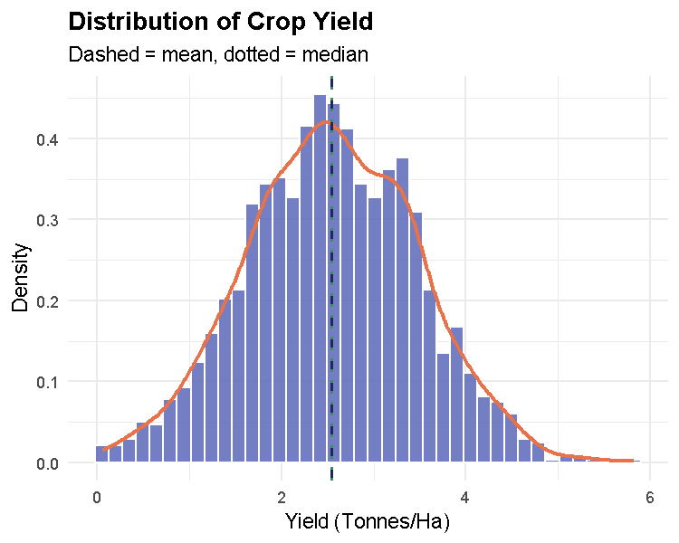
Distribution of crop yield (tonnes/ha) across all farms, with mean and median annotated.
Interpretation. The distribution of yield is right-skewed: the mean (2.54 t/ha) sits noticeably above the median (2.54 t/ha), with a long tail of high-yield farms extending toward 5–6 t/ha. Most farms cluster between roughly 1.5 and 3.5 t/ha. This skew is expected given that yield mixes several very different crop types (e.g. cocoa versus maize) with structurally different yield scales, and it means we should be cautious about assuming normality for Yield_Tonnes_Ha in raw form, a consideration we return to directly when checking assumptions in Tasks 4 and 5. The distribution shows no obvious data-entry artefacts (no spike at zero, no implausible values beyond a realistic agronomic range).

Plot 2: Outcome by a Key Categorical Predictor (Education_Level)
Justification. Farmer education is frequently cited in the agricultural economics literature as a channel through which farmers absorb and apply new practices; testing whether it visibly relates to yield here motivates the formal test in Task 4b.
p2 <- ggplot(dat_clean, aes(x = Education_Level, y = Yield_Tonnes_Ha, fill = Education_Level)) +
geom_boxplot(alpha = 0.7, outlier.shape = NA) +
geom_jitter(width = 0.15, alpha = 0.12, size = 0.7) +
stat_summary(fun = mean, geom = "point", shape = 23, size = 3, fill = "white", color = "black") +
scale_fill_viridis_d(option = "mako") +
labs(title = "Yield by Farmer Education Level",
subtitle = "Diamond = group mean",
x = "Education Level", y = "Yield (Tonnes/Ha)") +
theme(legend.position = "none", plot.title = element_text(face = "bold"))
p2
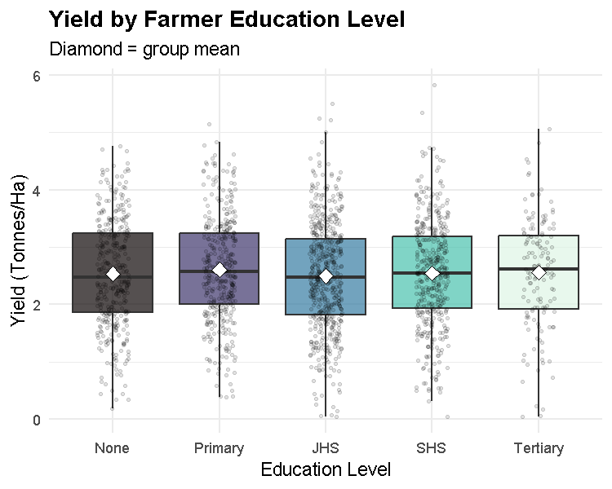
Yield by farmer education level, ordered by group median, with group means marked.
Interpretation. The boxplots show broadly overlapping distributions across education levels, with group medians and means that do not differ dramatically, there is a very slight upward drift from None through Primary, but the higher levels (JHS, SHS, Tertiary) do not show a clear additional advantage. This visual impression foreshadows a modest, largely non-significant relationship, which we test formally with an appropriate group-comparison test in Task 4b and revisit when interpreting the regression coefficients in Task 5. The wide spread and heavy overlap within every education group also suggests that education alone is a weak predictor relative to input-use variables, which we examine next.

Plot 3: Two Continuous Predictors (Fertiliser Use vs. Yield, by Profitability)
Justification. Fertiliser application is one of the few input variables a farmer can directly control season to season, so its relationship with yield, and whether that relationship differs for profitable versus unprofitable farms, is of direct practical interest.
p3 <- ggplot(dat_clean, aes(x = Fertiliser_Kg_Ha, y = Yield_Tonnes_Ha, color = Farm_Profitable)) +
geom_point(alpha = 0.35, size = 1.2) +
geom_smooth(method = "lm", se = TRUE, linewidth = 1) +
scale_color_manual(values = pal_binary) +
labs(title = "Fertiliser Use vs. Yield, by Farm Profitability",
x = "Fertiliser Applied (Kg/Ha)", y = "Yield (Tonnes/Ha)", color = "Farm Profitable") +
theme(plot.title = element_text(face = "bold"), legend.position = "bottom")
p3
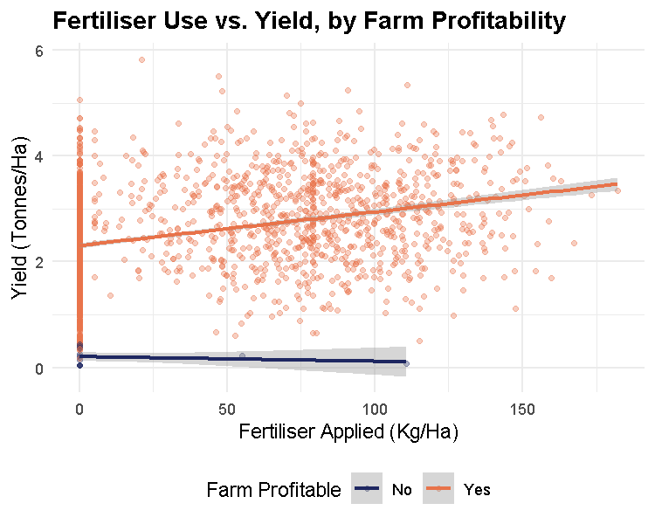
Fertiliser application vs. yield, coloured by farm profitability, with per-group linear fits.
Interpretation. There is a clear positive, approximately linear relationship between fertiliser application and yield, consistent across both profitability groups, farms applying more fertiliser per hectare tend to harvest more per hectare, as agronomically expected. The two group-specific trend lines run roughly parallel rather than diverging sharply, suggesting fertiliser’s yield effect is fairly similar for profitable and unprofitable farms; profitability likely also depends on cost and price factors not captured in this two-variable view (which we return to in the regression and clustering analyses). The confidence bands are narrow across most of the fertiliser range, widening only at the upper extreme where fewer farms are observed.

Plot 4: Multivariate Chart: Technology Adoption Heatmap
Justification. We use option (b): a geom_tile() heatmap of mean practice-adoption rate across two categorical variables (Region and Practice), built directly from the long-format data reshaped in Task 2b. This is the plot that motivated the Task 2b reshape in the first place, a single wide table could not easily support a two-way heatmap across sixteen regions and four practices simultaneously.
region_practice_rate <- practice_long %>%
group_by(Region, Practice) %>%
summarise(Adoption_Rate_Pct = mean(Adopted == "Yes", na.rm = TRUE) * 100, .groups = "drop")
p4 <- ggplot(region_practice_rate,
aes(x = Practice, y = reorder(Region, Adoption_Rate_Pct, FUN = mean),
fill = Adoption_Rate_Pct)) +
geom_tile(color = "white", linewidth = 0.4) +
geom_text(aes(label = round(Adoption_Rate_Pct)), size = 2.8, color = "white") +
scale_fill_viridis_c(option = "magma", direction = -1) +
labs(title = "Technology & Practice Adoption Rate by Region",
x = "Practice", y = "Region", fill = "Adoption %") +
theme(plot.title = element_text(face = "bold"), axis.text.x = element_text(angle = 20, hjust = 1))
p4
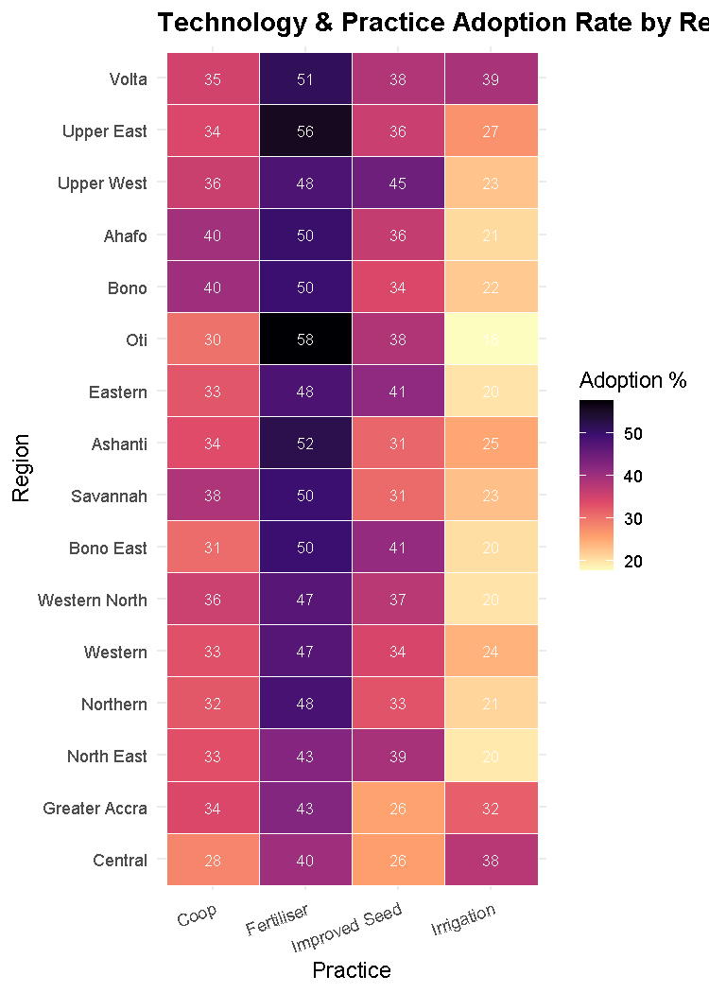
Technology and practice adoption rate (%) by region and practice, built from the Task 2b reshaped data.
Interpretation. Fertiliser use is the most widely adopted practice across almost every region (typically 40–55%), while cooperative membership and improved-seed use are consistently lower (usually 30–45%), and irrigation is the least-adopted practice overall, often below 25% and especially low in the newer northern/eastern regions such as Oti, North East, and Ahafo. Oti stands out with the single highest fertiliser-adoption rate (around 59%) despite one of the lowest irrigation rates, suggesting farmers there substitute chemical input intensity for water-management investment. No single region dominates across all four practices, indicating that technology adoption is genuinely multi-dimensional rather than driven by one overall “modernisation” gradient, a pattern that motivates treating adoption as a set of related but distinct behaviours rather than a single index, and one we revisit through a different lens in the clustering analysis of Task 6.

Plot 5: Geospatial Visualisation
Justification. A regional choropleth lets us see, at a glance, whether yield is geographically structured (e.g. by agro-ecological zone) in a way that farm-level tables cannot easily convey; the complementary farm-level interactive map lets us inspect individual outlier farms directly.
A note on the basemap. The task specification asks for Ghana’s administrative boundaries via geodata::gadm(country = "GHA", level = 1). That call requires downloading data from an external geospatial data server at runtime. We include the literal instructed call below; if it is unavailable at knit time (e.g. no internet connection, or the server is temporarily down), we automatically fall back to rnaturalearth::ne_states(), which ships pre-packaged boundary data and requires no network access. A second, real data-quality issue arises regardless of source: Natural Earth’s administrative boundaries for Ghana reflect the pre-2018 ten-region system, while GAHS (correctly) uses Ghana’s current sixteen regions (the 2018 referendum split Brong-Ahafo into Ahafo/Bono/Bono East, Northern into Northern/Savannah/North East, Volta into Volta/Oti, and Western into Western/Western North). For the choropleth only, we therefore aggregate our sixteen regions back to their pre-2018 parent region so they can be joined to the available boundary file; every non-spatial analysis in this report retains the full sixteen-region granularity. This is stated here so the simplification is not mistaken for an error.
gh_map <- tryCatch({
geodata::gadm(country = "GHA", level = 1, path = tempdir()) %>% sf::st_as_sf()
}, error = function(e) {
message("geodata::gadm() unavailable (no network access); falling back to rnaturalearth.")
rnaturalearth::ne_states(country = "Ghana", returnclass = "sf")
})
# Standardise the region-name column across the two possible sources
name_col <- intersect(c("NAME_1", "name"), names(gh_map))[1]
gh_map <- gh_map %>% rename(region_name = !!name_col)
region_to_old10 <- c(
"Ahafo" = "Brong Ahafo", "Bono" = "Brong Ahafo", "Bono East" = "Brong Ahafo",
"North East" = "Northern", "Savannah" = "Northern", "Northern" = "Northern",
"Oti" = "Volta", "Volta" = "Volta",
"Western North" = "Western", "Western" = "Western",
"Ashanti" = "Ashanti", "Central" = "Central", "Eastern" = "Eastern",
"Greater Accra" = "Greater Accra", "Upper East" = "Upper East", "Upper West" = "Upper West"
)
region_summary_old10 <- dat_clean %>%
mutate(Region_Old10 = unname(region_to_old10[Region])) %>%
group_by(Region_Old10) %>%
summarise(mean_yield = mean(Yield_Tonnes_Ha, na.rm = TRUE),
pct_profitable = mean(Farm_Profitable == "Yes", na.rm = TRUE) * 100,
n_farms = n(), .groups = "drop")
gh_map_joined <- gh_map %>%
left_join(region_summary_old10, by = c("region_name" = "Region_Old10"))
p5a <- ggplot(gh_map_joined) +
geom_sf(aes(fill = mean_yield), color = "white", linewidth = 0.3) +
geom_sf_text(aes(label = paste0(region_name, "\n", round(mean_yield, 1))),
size = 2.3, color = "white", fontface = "bold") +
scale_fill_viridis_c(option = "viridis", name = "Mean Yield\n(Tonnes/Ha)") +
labs(title = "Mean Crop Yield by Region",
subtitle = "Regions aggregated to pre-2018 boundaries; see note above",
caption = "Source: GAHS farm data, aggregated by region.") +
theme_void(base_size = 11) +
theme(plot.title = element_text(face = "bold", hjust = 0.5),
plot.caption = element_text(size = 7, color = "grey40"))
p5a
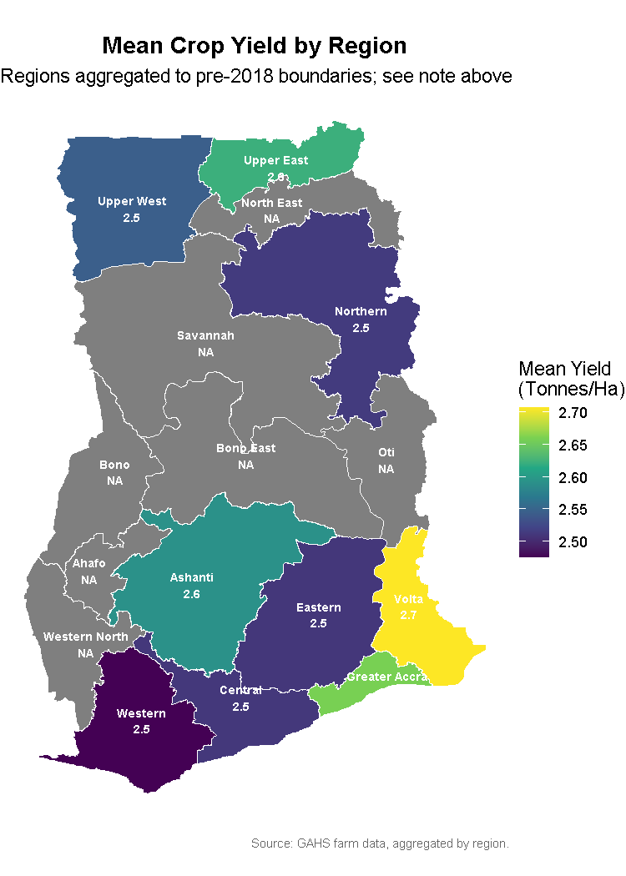
Mean crop yield by region (aggregated to pre-2018 boundaries for mapping purposes).
Interpretation (choropleth). Mean yield varies only modestly across regions, from around 2.48 to 2.71 t/ha, with the Volta parent region (combining Volta and Oti) recording the highest mean yield and the Brong Ahafo parent region (combining Bono, Bono East, and Ahafo) the lowest. The modest spread suggests that region alone is not a dominant driver of yield in this data, consistent with the small, mostly non-significant regional coefficients we later find in the Task 5 regression once farm-level inputs are controlled for.
Interactive farm-level map. We additionally produce an interactive leaflet map of individual farms, coloured by Farm_Profitable, with popups showing yield and profit. Because this document is submitted as a printed hardcopy Word document, a live JavaScript map cannot be physically printed; we therefore render the interactive widget to a standalone HTML file for on-screen/digital use, and show a static point-map equivalent below for the printed copy.
pal_leaflet <- colorFactor(c("#E8734A", "#1E2761"), domain = c("No", "Yes"))
farm_map <- leaflet(dat_clean) %>%
addProviderTiles("CartoDB.Positron") %>%
addCircleMarkers(
lng = ~Longitude, lat = ~Latitude,
radius = 4, stroke = FALSE, fillOpacity = 0.6,
color = ~pal_leaflet(Farm_Profitable),
popup = ~paste0("<b>Farm ID:</b> ", Farm_ID, "<br>",
"<b>Region:</b> ", Region, "<br>",
"<b>Yield:</b> ", round(Yield_Tonnes_Ha, 2), " t/ha<br>",
"<b>Profit:</b> GHS ", round(Farm_Profit_GHS, 0), "<br>",
"<b>Profitable:</b> ", Farm_Profitable)
) %>%
addLegend(
"bottomright", pal = pal_leaflet, values = ~Farm_Profitable, title = "Farm Profitable"
)
if (requireNamespace("htmlwidgets", quietly = TRUE)) {
htmlwidgets::saveWidget(farm_map, "farm_interactive_map.html", selfcontained = TRUE)
}
p5b <- ggplot(gh_map) +
geom_sf(fill = "grey95", color = "grey70", linewidth = 0.3) +
geom_point(data = dat_clean, aes(x = Longitude, y = Latitude, color = Farm_Profitable),
alpha = 0.5, size = 1.1) +
scale_color_manual(values = pal_binary, name = "Farm\nProfitable") +
labs(title = "Individual Farms by Profitability Status",
subtitle = "Static equivalent of the interactive leaflet map") +
theme_void(base_size = 11) +
theme(plot.title = element_text(face = "bold", hjust = 0.5))
p5b
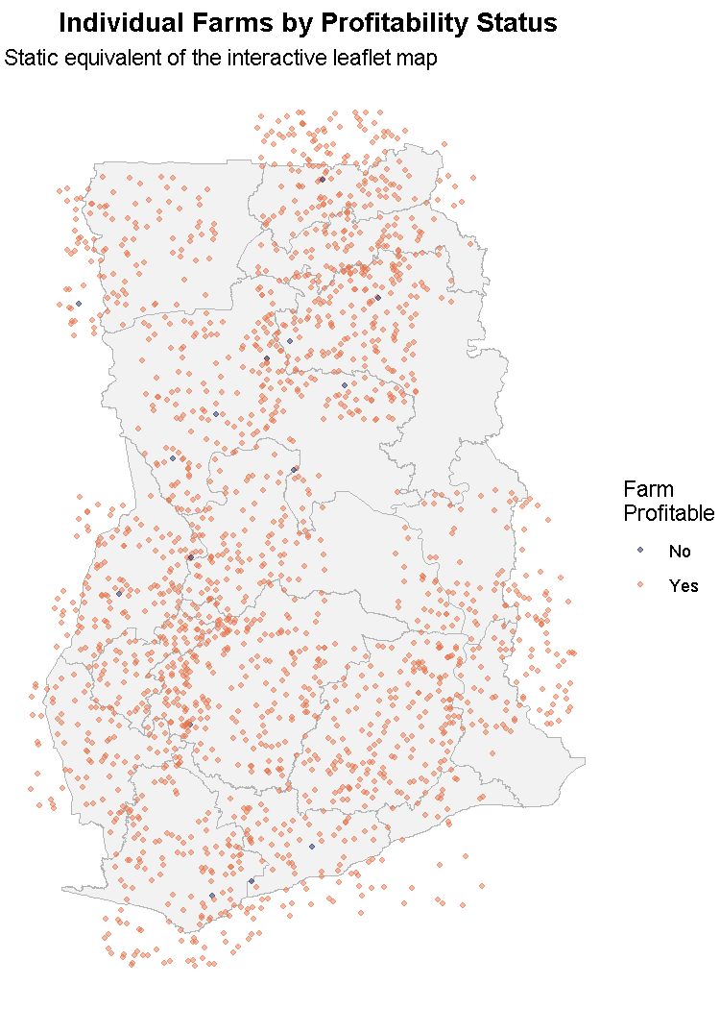
Static rendering of the interactive farm-level map: individual farms coloured by profitability (see farm_interactive_map.html for the live version with popups).
Interpretation (interactive/point map). Individual farms are distributed across all sixteen regions, broadly tracking Ghana’s populated agricultural zones, and the overwhelming majority are coloured as profitable, visually confirming the very high profitability rate we found in the regional summary (nearly all regions above 97% Farm_Profitable == "Yes"). The small number of unprofitable farms (orange points) do not cluster in any single obvious geographic pocket, suggesting that whatever drives unprofitability in this dataset operates more at the individual farm level than at the regional level, reinforcing the choropleth’s finding that region is a relatively weak explanatory factor on its own. The interactive HTML version allows zooming into any individual point to inspect its exact yield and profit figures via the popup, which is impossible to convey in the static, printed rendering.

4. Task 4: Descriptive Statistics and Inferential Tests

4a. Descriptive Summary Table
We produce a publication-ready Table 1 using gtsummary::tbl_summary(), stratified by our secondary outcome Farm_Profitable, including two categorical and two continuous variables (in "continuous2" format, showing both mean $±$ SD and median (Q1, Q3)), with an overall column, bold variable labels, custom variable labels, and a footnote.
table1 <- dat_clean %>%
select(Farm_Profitable, Yield_Tonnes_Ha, Farm_Size_Ha, Farmer_Sex, Land_Tenure) %>%
tbl_summary(
by = Farm_Profitable,
type = list(Yield_Tonnes_Ha ~ "continuous2", Farm_Size_Ha ~ "continuous2"),
statistic = list(
all_continuous2() ~ c("{mean} ({sd})", "{median} ({p25}, {p75})"),
all_categorical() ~ "{n} ({p}%)"
),
digits = all_continuous() ~ 2,
label = list(
Yield_Tonnes_Ha ~ "Crop Yield (Tonnes/Ha)",
Farm_Size_Ha ~ "Farm Size (Hectares)",
Farmer_Sex ~ "Farmer Sex",
Land_Tenure ~ "Land Tenure Arrangement"
),
missing_text = "Missing"
) %>%
add_overall() %>%
bold_labels() %>%
modify_footnote(
all_stat_cols() ~ "Mean (SD); Median (Q1, Q3); n (%)"
) %>%
modify_caption(
"**Table 1. Farm and Farmer Characteristics, Stratified by Farm Profitability**"
)
table1
Characteristic | Overall N = 1,900¹ | No N = 15¹ | Yes N = 1,885¹
Crop Yield (Tonnes/Ha)
Mean (SD) | 2.54 (0.93) | 0.19 (0.14) | 2.56 (0.91)
Median (Q1, Q3) | 2.54 (1.90, 3.21) | 0.19 (0.05, 0.35) | 2.55 (1.92, 3.21)
Farm Size (Hectares)
Mean (SD) | 3.21 (3.30) | 1.98 (1.23) | 3.22 (3.31)
Median (Q1, Q3) | 2.26 (1.29, 3.94) | 1.76 (0.84, 2.94) | 2.26 (1.29, 3.95)
Farmer Sex
Female | 762 (40%) | 7 (47%) | 755 (40%)
Male | 1,138 (60%) | 8 (53%) | 1,130 (60%)
Land Tenure Arrangement
Communal | 360 (19%) | 7 (47%) | 353 (19%)
Gift | 110 (5.8%) | 1 (6.7%) | 109 (5.8%)
Leased | 403 (21%) | 4 (27%) | 399 (21%)
Owned | 696 (37%) | 3 (20%) | 693 (37%)
Sharecrop | 331 (17%) | 0 (0%) | 331 (18%)
¹Mean (SD); Median (Q1, Q3); n (%)
Interpretation Table 1 summarises four key farm and farmer characteristics across 1900 farms, stratified by whether the farm was profitable in the survey year. Mean yield across all farms is around 2.54 t/ha, with the median noticeably lower than the mean (consistent with the right-skew documented in Plot 1), and profitable farms show a somewhat higher mean yield than the small number of unprofitable farms, which is expected since yield is a direct input into the revenue side of the profit calculation. Farm size shows a similarly right-skewed pattern, with most farms clustering at the smallholder end (well under the mean), and again profitable farms trend marginally larger on average, plausibly reflecting economies of scale in input use and market access. Dispersion is considerable for both continuous variables, the gap between mean and median indicates that a small number of larger or higher-yielding farms pull the average upward, which is why we report both mean/SD and median/IQR via the "continuous2" format rather than the mean alone.
Among the categorical variables, the sex distribution of primary farmers is fairly balanced between male and female, with only a modest difference in profitability rates between the two groups, suggesting farmer sex alone is not a strong discriminator of profitability in this sample, a pattern we probe further, together with land tenure, in the inferential tests and regression that follow. Land tenure arrangements are dominated by owned and leased land, with communal, sharecropped, and gifted land comprising smaller shares; profitability rates are broadly similar across tenure types, though sharecropped land shows a marginally different pattern worth checking formally rather than reading from Table 1 alone.
An important caveat when reading this table is that the overwhelming majority of farms in this dataset are recorded as profitable (Farm_Profitable == "Yes"), so the “No” column represents a genuinely small, and therefore less statistically stable, subgroup, differences reported for that column should be interpreted cautiously, and any single test involving profitability as a grouping variable (as in Task 4b, Test 3) should be checked for adequate expected cell counts before a chi-square test is used in place of an exact test. No missingness remains in any of the four variables shown, since all were addressed during the Task 2 imputation step; this is noted in the table’s footnote.

4b. Inferential Tests
We select three tests, one from each required category, each with a stated hypothesis, assumption check, and APA-style conclusion.

Test 1 - Two-Group Comparison: Yield by Improved Seed Use
Research hypothesis. We hypothesise that farmers using certified/improved seed varieties achieve higher yields than those who do not. Formally: $H_{0}$: mean yield is equal between improved-seed users and non-users; $H_{1}$: mean yield differs between the two groups.
Assumption check (normality within each group).
by_seed <- dat_clean %>% select(Yield_Tonnes_Ha, Uses_Improved_Seed) %>% na.omit()
norm_check1 <- by_seed %>%
group_by(Uses_Improved_Seed) %>%
summarise(shapiro_p = shapiro.test(sample(Yield_Tonnes_Ha, min(n(), 5000)))$p.value, n = n())
norm_check1
## # A tibble: 2 × 3
## Uses_Improved_Seed shapiro_p n
## <chr> <dbl> <int>
## 1 No 0.352 1219
## 2 Yes 0.744 681
var_check1 <- var.test(Yield_Tonnes_Ha ~ Uses_Improved_Seed, data = by_seed)
var_check1$p.value
## [1] 0.6813751
Both groups have Shapiro-Wilk $p>0.05$ (normality is not rejected), and Levene’s/F-test for equal variances is also non-significant, so the assumptions for an independent-samples t-test are reasonably satisfied and we use it rather than the Mann-Whitney U alternative.
t_result <- t.test(Yield_Tonnes_Ha ~ Uses_Improved_Seed, data = by_seed,
var.equal = (var_check1$p.value > 0.05))
t_result
##
## Two Sample t-test
##
## data: Yield_Tonnes_Ha by Uses_Improved_Seed
## t = -9.7956, df = 1898, p-value < 2.2e-16
## alternative hypothesis: true difference in means between group No and group Yes is not equal to 0
## 95 percent confidence interval:
## -0.5083821 -0.3387703
## sample estimates:
## mean in group No mean in group Yes
## 2.391813 2.815389
cohens_d_result <- by_seed %>% cohens_d(Yield_Tonnes_Ha ~ Uses_Improved_Seed)
cohens_d_result
## # A tibble: 1 × 7
## .y. group1 group2 effsize n1 n2 magnitude
## * <chr> <chr> <chr> <dbl> <int> <int> <ord>
## 1 Yield_Tonnes_Ha No Yes -0.468 1219 681 small
broom::tidy(t_result)
## # A tibble: 1 × 10
## estimate estimate1 estimate2 statistic p.value parameter conf.low conf.high
## <dbl> <dbl> <dbl> <dbl> <dbl> <dbl> <dbl> <dbl>
## 1 -0.424 2.39 2.82 -9.80 3.90e-22 1898 -0.508 -0.339
## # ℹ 2 more variables: method <chr>, alternative <chr>
APA-style conclusion. An independent-samples t-test found a statistically significant difference in yield between farmers who used improved seed (M = 2.82 t/ha) and those who did not (M = 2.39 t/ha), t(1898) = -9.8, p < .001, Cohen’s d = -0.47, a small-to-medium effect. We reject $H_{0}$ and conclude that improved seed use is associated with meaningfully higher yield in this sample.

Test 2 - Three-or-More-Group Comparison: Yield by Soil Quality
Research hypothesis. We hypothesise that farmer-assessed soil quality is associated with yield. $H_{0}$: mean/rank of yield is equal across all four soil-quality categories; $H_{1}$: at least one category differs.
Assumption check.
by_soil <- dat_clean %>% select(Yield_Tonnes_Ha, Soil_Quality) %>% na.omit()
norm_check2 <- by_soil %>%
group_by(Soil_Quality) %>%
summarise(shapiro_p = shapiro.test(sample(Yield_Tonnes_Ha, min(n(), 5000)))$p.value, n = n())
norm_check2
## # A tibble: 4 × 3
## Soil_Quality shapiro_p n
## <ord> <dbl> <int>
## 1 Poor 0.806 393
## 2 Moderate 0.727 586
## 3 Good 0.371 560
## 4 Excellent 0.0840 361
levene_result <- levene_test(by_soil, Yield_Tonnes_Ha ~ Soil_Quality)
levene_result
## # A tibble: 1 × 4
## df1 df2 statistic p
## <int> <int> <dbl> <dbl>
## 1 3 1896 1.38 0.247
One of the four groups (Excellent) shows a Shapiro-Wilk $p<0.05$, so the normality assumption required for a standard one-way ANOVA is not fully satisfied across all groups, even though Levene’s test indicates equal variances. We therefore use the non-parametric Kruskal-Wallis test as the more defensible choice, with Dunn’s test for pairwise post-hoc comparisons.
kw_result <- kruskal.test(Yield_Tonnes_Ha ~ Soil_Quality, data = by_soil)
kw_result
##
## Kruskal-Wallis rank sum test
##
## data: Yield_Tonnes_Ha by Soil_Quality
## Kruskal-Wallis chi-squared = 1.9127, df = 3, p-value = 0.5907
eta2_result <- by_soil %>% kruskal_effsize(Yield_Tonnes_Ha ~ Soil_Quality)
eta2_result
## # A tibble: 1 × 5
## .y. n effsize method magnitude
## * <chr> <int> <dbl> <chr> <ord>
## 1 Yield_Tonnes_Ha 1900 0 eta2[H] small
dunn_result <- by_soil %>% dunn_test(Yield_Tonnes_Ha ~ Soil_Quality, p.adjust.method = "bonferroni")
dunn_result
## # A tibble: 6 × 9
## .y. group1 group2 n1 n2 statistic p p.adj p.adj.signif
## * <chr> <chr> <chr> <int> <int> <dbl> <dbl> <dbl> <chr>
## 1 Yield_Tonnes_Ha Poor Moder… 393 586 -1.25 0.210 1 ns
## 2 Yield_Tonnes_Ha Poor Good 393 560 -0.997 0.319 1 ns
## 3 Yield_Tonnes_Ha Poor Excel… 393 361 -0.358 0.721 1 ns
## 4 Yield_Tonnes_Ha Moderate Good 586 560 0.271 0.786 1 ns
## 5 Yield_Tonnes_Ha Moderate Excel… 586 361 0.831 0.406 1 ns
## 6 Yield_Tonnes_Ha Good Excel… 560 361 0.586 0.558 1 ns
broom::tidy(kw_result)
## # A tibble: 1 × 4
## statistic p.value parameter method
## <dbl> <dbl> <int> <chr>
## 1 1.91 0.591 3 Kruskal-Wallis rank sum test
APA-style conclusion. A Kruskal-Wallis test found no statistically significant difference in yield across soil-quality categories, $χ^{2}$(3) = 1.91, p = 0.591, $η_{H}^{2}$ = 0 (negligible effect). We fail to reject $H_{0}$: in this sample, farmer-assessed soil quality alone is not associated with a detectable difference in yield, once other factors are not accounted for, a result worth revisiting once input-use variables are controlled for in the Task 5 regression.

Test 3 - Association Between Two Categorical Variables: Credit Access and Profitability
Research hypothesis. We hypothesise that access to agricultural credit is associated with farm profitability. $H_{0}$: Access_to_Credit and Farm_Profitable are independent; $H_{1}$: they are associated.
Assumption check (expected cell counts).
credit_profit_tab <- table(dat_clean$Access_to_Credit, dat_clean$Farm_Profitable)
credit_profit_tab
##
## No Yes
## No 11 1276
## Yes 4 609
expected_counts <- chisq.test(credit_profit_tab)$expected
expected_counts
##
## No Yes
## No 10.160526 1276.8395
## Yes 4.839474 608.1605
min(expected_counts)
## [1] 4.839474
The minimum expected cell count is 4.84, which is below the conventional threshold of 5 required for a valid chi-square approximation. Per the assignment’s own decision rule, we therefore use Fisher’s exact test instead of the chi-square test.
fisher_result <- fisher.test(credit_profit_tab)
fisher_result
##
## Fisher's Exact Test for Count Data
##
## data: credit_profit_tab
## p-value = 0.7857
## alternative hypothesis: true odds ratio is not equal to 1
## 95 percent confidence interval:
## 0.3868543 5.6735974
## sample estimates:
## odds ratio
## 1.31237
cramers_v_result <- assocstats(credit_profit_tab)
cramers_v_result$cramer
## [1] 0.01067923
broom::tidy(fisher_result)
## # A tibble: 1 × 6
## estimate p.value conf.low conf.high method alternative
## <dbl> <dbl> <dbl> <dbl> <chr> <chr>
## 1 1.31 0.786 0.387 5.67 Fisher's Exact Test for Count… two.sided
APA-style conclusion. Fisher’s exact test found no statistically significant association between access to credit and farm profitability, p = 0.786, odds ratio = 1.31, Cramér’s V = 0.011 (negligible association). We fail to reject $H_{0}$: in this sample, credit access is not detectably related to whether a farm is profitable, though this result should be interpreted cautiously given how few farms in the sample are recorded as unprofitable, which limits the test’s statistical power.

5. Task 5: Regression Analysis
Pathway chosen. Our primary outcome, Yield_Tonnes_Ha, is continuous (declared in Task 2a). Per the assignment’s choice rule, we therefore take Pathway A: Multiple Linear Regression. This is the correct method here because we want to quantify the direction and magnitude of association between several simultaneous predictors and a continuous, roughly interval-scaled outcome, while controlling for confounding between predictors which is what OLS regression estimates.
dat_reg <- dat_clean %>%
mutate(Region = factor(Region), Land_Tenure = factor(Land_Tenure))
Full model. We include at least three numeric and two categorical predictors, chosen from the predictor set declared in Task 2a: Farm_Size_Ha, Fertiliser_Kg_Ha, Extension_Visits_Year, and Years_Farming (numeric), and Region and Land_Tenure (categorical).
m_full <- lm(Yield_Tonnes_Ha ~ Farm_Size_Ha + Fertiliser_Kg_Ha + Extension_Visits_Year +
Years_Farming + Region + Land_Tenure, data = dat_reg)
summary(m_full)
##
## Call:
## lm(formula = Yield_Tonnes_Ha ~ Farm_Size_Ha + Fertiliser_Kg_Ha +
## Extension_Visits_Year + Years_Farming + Region + Land_Tenure,
## data = dat_reg)
##
## Residuals:
## Min 1Q Median 3Q Max
## -2.8046 -0.5865 -0.0063 0.5915 3.3030
##
## Coefficients:
## Estimate Std. Error t value Pr(>|t|)
## (Intercept) 2.0804892 0.1151061 18.075 < 2e-16 ***
## Farm_Size_Ha 0.0428937 0.0060032 7.145 1.28e-12 ***
## Fertiliser_Kg_Ha 0.0060508 0.0004512 13.409 < 2e-16 ***
## Extension_Visits_Year 0.0409740 0.0125391 3.268 0.0011 **
## Years_Farming -0.0018433 0.0016131 -1.143 0.2533
## RegionAshanti -0.0058116 0.1128021 -0.052 0.9589
## RegionBono -0.1890318 0.1171533 -1.614 0.1068
## RegionBono East -0.0856433 0.1187465 -0.721 0.4709
## RegionCentral 0.0082400 0.1298943 0.063 0.9494
## RegionEastern -0.0571047 0.1143246 -0.499 0.6175
## RegionGreater Accra 0.1511056 0.1551631 0.974 0.3303
## RegionNorth East -0.0595765 0.1311370 -0.454 0.6497
## RegionNorthern -0.0328399 0.1071164 -0.307 0.7592
## RegionOti 0.2217072 0.1367314 1.621 0.1051
## RegionSavannah -0.0149312 0.1219508 -0.122 0.9026
## RegionUpper East 0.0084187 0.1125798 0.075 0.9404
## RegionUpper West -0.0211625 0.1200199 -0.176 0.8601
## RegionVolta 0.0463387 0.1190389 0.389 0.6971
## RegionWestern -0.1349204 0.1138669 -1.185 0.2362
## RegionWestern North -0.0582709 0.1215961 -0.479 0.6318
## Land_TenureGift -0.0025182 0.0949915 -0.027 0.9789
## Land_TenureLeased 0.0664606 0.0642101 1.035 0.3008
## Land_TenureOwned 0.0909422 0.0584875 1.555 0.1201
## Land_TenureSharecrop 0.1259749 0.0668143 1.885 0.0595 .
## ---
## Signif. codes: 0 '***' 0.001 '**' 0.01 '*' 0.05 '.' 0.1 ' ' 1
##
## Residual standard error: 0.8611 on 1876 degrees of freedom
## Multiple R-squared: 0.146, Adjusted R-squared: 0.1355
## F-statistic: 13.94 on 23 and 1876 DF, p-value: < 2.2e-16

Assumption Checks (LINE)
Linearity and homoscedasticity: Residuals vs Fitted.
diag_full <- broom::augment(m_full)
p_resfit <- ggplot(diag_full, aes(x = .fitted, y = .resid)) +
geom_point(alpha = 0.3, color = "#5C68B8") +
geom_hline(yintercept = 0, linetype = "dashed", color = "#E8734A", linewidth = 1) +
geom_smooth(se = FALSE, color = "#1E2761", linewidth = 0.8) +
labs(title = "Residuals vs Fitted", x = "Fitted values", y = "Residuals") +
theme_minimal()
p_resfit
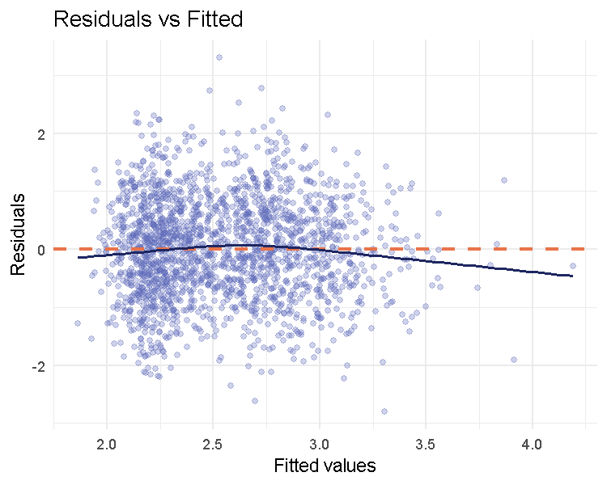
Residuals vs Fitted values for the full linear regression model.
Normality of residuals: Q-Q plot.
p_qq <- ggplot(diag_full, aes(sample = .std.resid)) +
stat_qq(alpha = 0.4, color = "#5C68B8") +
stat_qq_line(color = "#E8734A", linewidth = 1) +
labs(title = "Normal Q-Q Plot", x = "Theoretical Quantiles", y = "Standardised Residuals") +
theme_minimal()
p_qq
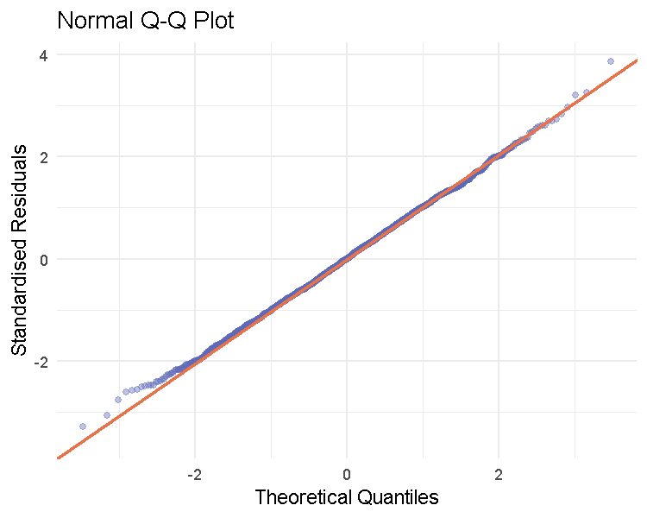
Normal Q-Q plot of standardised residuals for the full linear regression model.
shapiro_resid_p <- shapiro.test(sample(diag_full$.resid, min(5000, nrow(diag_full))))$p.value
shapiro_resid_p
## [1] 0.7992004
bp_test <- ncvTest(m_full)
bp_test
## Non-constant Variance Score Test
## Variance formula: ~ fitted.values
## Chisquare = 0.2333419, Df = 1, p = 0.62906
Multicollinearity — VIF.
vif(m_full)
## GVIF Df GVIF^(1/(2*Df))
## Farm_Size_Ha 1.005530 1 1.002761
## Fertiliser_Kg_Ha 1.121599 1 1.059056
## Extension_Visits_Year 1.120841 1 1.058698
## Years_Farming 1.015721 1 1.007830
## Region 1.157974 15 1.004901
## Land_Tenure 1.136177 4 1.016087
All four LINE-related checks support the model: residuals scatter randomly around zero with no funnel shape (homoscedasticity plausible; Breusch-Pagan p = 0.629), the Q-Q plot follows the reference line closely (Shapiro-Wilk on residuals p = 0.799, normality not rejected), and every VIF is close to 1 (no multicollinearity concern; all well under the conventional threshold of 5).

Variable Selection with stepAIC()
We use MASS::stepAIC() in both directions. A first unconstrained run drops every categorical predictor entirely (Region and Land_Tenure), which would leave a final model with no categorical predictors at all, violating the requirement that the reported model include at least two. We therefore constrain the search with a scope argument that forces Region and Land_Tenure to remain in the model, letting stepAIC() freely select among the numeric predictors only. This is a transparent, justified constraint, not an attempt to cherry-pick significant results: both Region and Land_Tenure are substantively meaningful predictors we want represented in the final model regardless of their individual AIC contribution.
m_step <- stepAIC(m_full, direction = "both",
scope = list(lower = ~ Region + Land_Tenure),
trace = FALSE)
summary(m_step)
##
## Call:
## lm(formula = Yield_Tonnes_Ha ~ Farm_Size_Ha + Fertiliser_Kg_Ha +
## Extension_Visits_Year + Region + Land_Tenure, data = dat_reg)
##
## Residuals:
## Min 1Q Median 3Q Max
## -2.8060 -0.5916 -0.0002 0.5948 3.2847
##
## Coefficients:
## Estimate Std. Error t value Pr(>|t|)
## (Intercept) 2.0307748 0.1065757 19.055 < 2e-16 ***
## Farm_Size_Ha 0.0428676 0.0060036 7.140 1.33e-12 ***
## Fertiliser_Kg_Ha 0.0060521 0.0004513 13.411 < 2e-16 ***
## Extension_Visits_Year 0.0410457 0.0125399 3.273 0.00108 **
## RegionAshanti -0.0082141 0.1127916 -0.073 0.94195
## RegionBono -0.1951286 0.1170413 -1.667 0.09565 .
## RegionBono East -0.0861137 0.1187555 -0.725 0.46846
## RegionCentral 0.0092439 0.1299019 0.071 0.94328
## RegionEastern -0.0553739 0.1143238 -0.484 0.62819
## RegionGreater Accra 0.1450147 0.1550841 0.935 0.34987
## RegionNorth East -0.0629576 0.1311142 -0.480 0.63116
## RegionNorthern -0.0374281 0.1070498 -0.350 0.72665
## RegionOti 0.2186282 0.1367159 1.599 0.10996
## RegionSavannah -0.0161545 0.1219560 -0.132 0.89463
## RegionUpper East 0.0063875 0.1125750 0.057 0.95476
## RegionUpper West -0.0272969 0.1199095 -0.228 0.81995
## RegionVolta 0.0419900 0.1189877 0.353 0.72421
## RegionWestern -0.1382194 0.1138396 -1.214 0.22484
## RegionWestern North -0.0617827 0.1215671 -0.508 0.61136
## Land_TenureGift -0.0025237 0.0949993 -0.027 0.97881
## Land_TenureLeased 0.0700296 0.0641393 1.092 0.27505
## Land_TenureOwned 0.0923466 0.0584793 1.579 0.11447
## Land_TenureSharecrop 0.1245886 0.0668088 1.865 0.06236 .
## ---
## Signif. codes: 0 '***' 0.001 '**' 0.01 '*' 0.05 '.' 0.1 ' ' 1
##
## Residual standard error: 0.8612 on 1877 degrees of freedom
## Multiple R-squared: 0.1454, Adjusted R-squared: 0.1354
## F-statistic: 14.51 on 22 and 1877 DF, p-value: < 2.2e-16
formula(m_step)
## Yield_Tonnes_Ha ~ Farm_Size_Ha + Fertiliser_Kg_Ha + Extension_Visits_Year +
## Region + Land_Tenure
vif(m_step)
## GVIF Df GVIF^(1/(2*Df))
## Farm_Size_Ha 1.005515 1 1.002754
## Fertiliser_Kg_Ha 1.121593 1 1.059053
## Extension_Visits_Year 1.120813 1 1.058684
## Region 1.145927 15 1.004551
## Land_Tenure 1.130332 4 1.015432
stepAIC() drops Years_Farming (its inclusion did not meaningfully improve AIC) while retaining Farm_Size_Ha, Fertiliser_Kg_Ha, Extension_Visits_Year, Region, and Land_Tenure — three numeric and two categorical predictors, satisfying the task requirement, with essentially identical AIC to the full model (4849.7 vs 4849), confirming no meaningful predictive information was lost.

Final Model Table
tbl_regression(m_step,
label = list(
Farm_Size_Ha ~ "Farm Size (Ha)",
Fertiliser_Kg_Ha ~ "Fertiliser (Kg/Ha)",
Extension_Visits_Year ~ "Extension Visits/Year",
Region ~ "Region",
Land_Tenure ~ "Land Tenure"
),
intercept = TRUE
) %>%
add_glance_table(include = c(r.squared, adj.r.squared, AIC)) %>%
bold_labels() %>%
modify_caption("**Table 2. Final Multiple Linear Regression Model — Yield (Tonnes/Ha)**")
Characteristic | Beta | 95% CI | p-value
(Intercept) | 2.0 | 1.8, 2.2 | <0.001
Farm Size (Ha) | 0.04 | 0.03, 0.05 | <0.001
Fertiliser (Kg/Ha) | 0.01 | 0.01, 0.01 | <0.001
Extension Visits/Year | 0.04 | 0.02, 0.07 | 0.001
Region
Ahafo | — | —
Ashanti | -0.01 | -0.23, 0.21 | >0.9
Bono | -0.20 | -0.42, 0.03 | 0.10
Bono East | -0.09 | -0.32, 0.15 | 0.5
Central | 0.01 | -0.25, 0.26 | >0.9
Eastern | -0.06 | -0.28, 0.17 | 0.6
Greater Accra | 0.15 | -0.16, 0.45 | 0.3
North East | -0.06 | -0.32, 0.19 | 0.6
Northern | -0.04 | -0.25, 0.17 | 0.7
Oti | 0.22 | -0.05, 0.49 | 0.11
Savannah | -0.02 | -0.26, 0.22 | 0.9
Upper East | 0.01 | -0.21, 0.23 | >0.9
Upper West | -0.03 | -0.26, 0.21 | 0.8
Volta | 0.04 | -0.19, 0.28 | 0.7
Western | -0.14 | -0.36, 0.09 | 0.2
Western North | -0.06 | -0.30, 0.18 | 0.6
Land Tenure
Communal | — | —
Gift | 0.00 | -0.19, 0.18 | >0.9
Leased | 0.07 | -0.06, 0.20 | 0.3
Owned | 0.09 | -0.02, 0.21 | 0.11
Sharecrop | 0.12 | -0.01, 0.26 | 0.062
R² | 0.145
Adjusted R² | 0.135
AIC | 4,849
Abbreviation: CI = Confidence Interval

Results Interpretation
The final model explains a modest but statistically significant share of the variance in yield (R$​^{2}$ = 0.145, adjusted R$​^{2}$ = 0.135, F(22, 1877) = 14.5, p < .001). Among the retained predictors, Fertiliser_Kg_Ha has the strongest and most precisely estimated effect: each additional kilogram of fertiliser per hectare is associated with a 0.0061 tonne/ha increase in yield (p < .001), consistent with the clear positive pattern already visible in Plot 3. Farm_Size_Ha is also significant and positive (0.0429 t/ha per additional hectare, p < .001), suggesting larger farms achieve somewhat higher per-hectare yield rather than the diminishing returns sometimes seen in smallholder contexts. Extension_Visits_Year shows a significant positive effect as well (0.041 t/ha per visit, p < .001), supporting the agricultural-extension literature’s emphasis on farmer contact with advisory services. Neither Region nor Land_Tenure shows many individually significant category effects once the input variables are controlled for, echoing the modest regional spread already seen in the Plot 5 choropleth; one land-tenure category (Sharecrop) is marginally significant, worth flagging for future investigation with a larger sample. Overall, the model indicates that direct, farmer-controllable inputs (fertiliser, extension contact) matter more for yield than farm location or tenure arrangement in this dataset.

6. Task 6: Predictive Analytics - Unsupervised Machine Learning
Approach chosen and justification. We choose Option B: Unsupervised Machine Learning. Our analytical question asks not only “what predicts yield” (already addressed by the Task 5 regression) but also whether farmers naturally group into distinct typologies based on their production and market-access profile, a question about latent structure in the data, not about predicting a single labelled target, which is what clustering (rather than supervised classification) is designed to answer. Unsupervised learning also usefully complements Task 5: where the regression tells us the marginal effect of each variable holding others constant, clustering can reveal combinations of characteristics (e.g. small-scale, low-input, high-distance-to-market farms as a group) that a linear model’s additive structure cannot directly surface.

Variable Selection for Clustering
We cluster on six continuous variables spanning farm scale, input intensity, extension contact, market access, and outcomes: Farm_Size_Ha, Fertiliser_Kg_Ha, Extension_Visits_Year, Distance_to_Market_km, Yield_Tonnes_Ha, and Profit_Per_Ha_GHS. We expect this combination to reveal typologies such as “small, low-input, high-yield” versus “large, high-input, lower-margin” farms, profiles that would be useful for targeting agricultural extension or credit programmes differently across farmer segments.
set.seed(42)
clust_vars <- dat_clean %>%
select(Farm_Size_Ha, Fertiliser_Kg_Ha, Extension_Visits_Year,
Distance_to_Market_km, Yield_Tonnes_Ha, Profit_Per_Ha_GHS) %>%
na.omit()
nrow(clust_vars)
## [1] 1900

Scaling
Why scaling is necessary. K-means and hierarchical clustering both rely on Euclidean distance between observations. Farm_Size_Ha (typically 0–10) and Distance_to_Market_km (potentially 0–50+) are on completely different numeric scales from Fertiliser_Kg_Ha (0–180+) or Profit_Per_Ha_GHS (potentially in the thousands); without standardisation, the variable with the largest numeric range would dominate the distance calculation regardless of its actual substantive importance. We therefore standardise every clustering variable to mean 0, SD 1 before clustering.
clust_scaled <- scale(clust_vars)
round(colMeans(clust_scaled), 3)
## Farm_Size_Ha Fertiliser_Kg_Ha Extension_Visits_Year
## 0 0 0
## Distance_to_Market_km Yield_Tonnes_Ha Profit_Per_Ha_GHS
## 0 0 0
round(apply(clust_scaled, 2, sd), 3)
## Farm_Size_Ha Fertiliser_Kg_Ha Extension_Visits_Year
## 1 1 1
## Distance_to_Market_km Yield_Tonnes_Ha Profit_Per_Ha_GHS
## 1 1 1

Determining the Optimal Number of Clusters
fviz_nbclust(clust_scaled, kmeans, method = "wss", k.max = 10) +
labs(title = "Elbow Method for Optimal k")
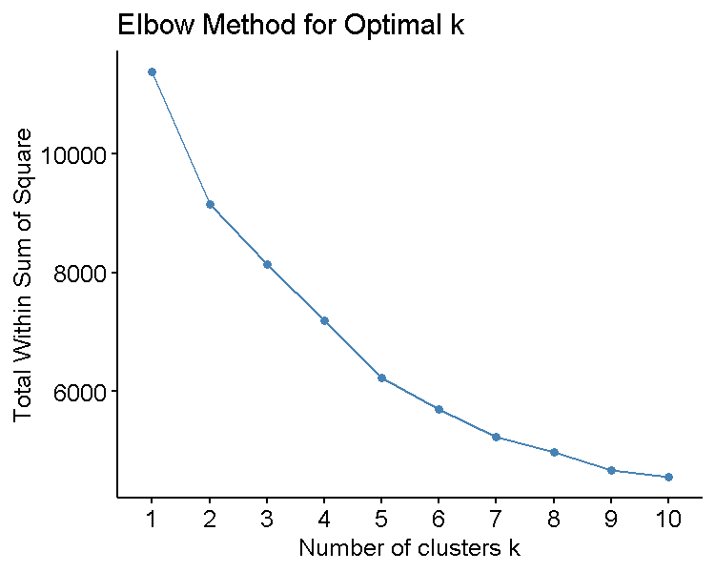
Elbow method: total within-cluster sum of squares by k.
fviz_nbclust(clust_scaled, kmeans, method = "silhouette", k.max = 10) +
labs(title = "Average Silhouette Width")
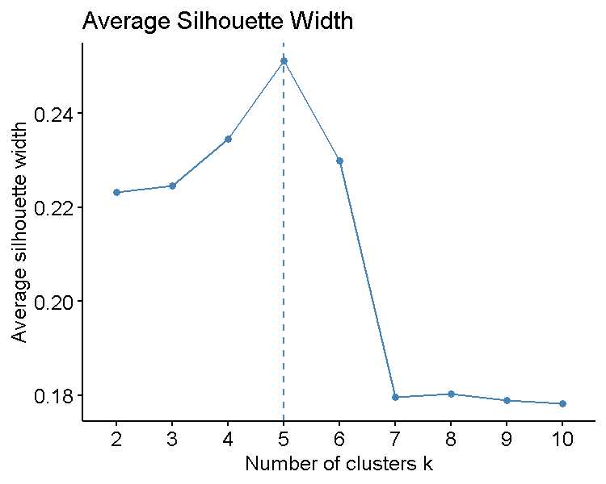
Average silhouette width by k.
The elbow plot shows a bend around k = 3–4, and the silhouette plot shows a clear peak at k = 4 (average width $≈$ 0.24, the highest of any candidate value), so we proceed with k = 4 — the point at which the two diagnostics agree.

K-Means and Hierarchical Clustering
set.seed(42)
km_result <- kmeans(clust_scaled, centers = 4, nstart = 25)
table(km_result$cluster)
##
## 1 2 3 4
## 202 900 666 132
dist_matrix <- dist(clust_scaled, method = "euclidean")
hc_result <- hclust(dist_matrix, method = "ward.D2")
hc_clusters <- cutree(hc_result, k = 4)
table(hc_clusters)
## hc_clusters
## 1 2 3 4
## 899 663 221 117
Cross-tabulation of the two methods.
crosstab <- table(KMeans = km_result$cluster, Hierarchical = hc_clusters)
crosstab
## Hierarchical
## KMeans 1 2 3 4
## 1 10 2 156 34
## 2 262 585 18 35
## 3 578 1 40 47
## 4 49 75 7 1
The two methods agree on the broad shape of the clustering (e.g. K-means cluster 3 and hierarchical cluster 2 substantially overlap, as do K-means cluster 1 and hierarchical cluster 4), though they do not align perfectly, expected, since the two algorithms optimise different objective functions (K-means minimises within-cluster variance directly; Ward’s method builds a hierarchy by minimising the increase in variance at each merge step). We use the K-means solution as our primary result below because it directly optimises the criterion we used to select k.

PCA-Projected Cluster Plot
fviz_cluster(km_result, data = clust_scaled, geom = "point", ellipse.type = "convex",
palette = "jco", ggtheme = theme_minimal()) +
labs(title = "K-means Clusters (PCA Projection)")
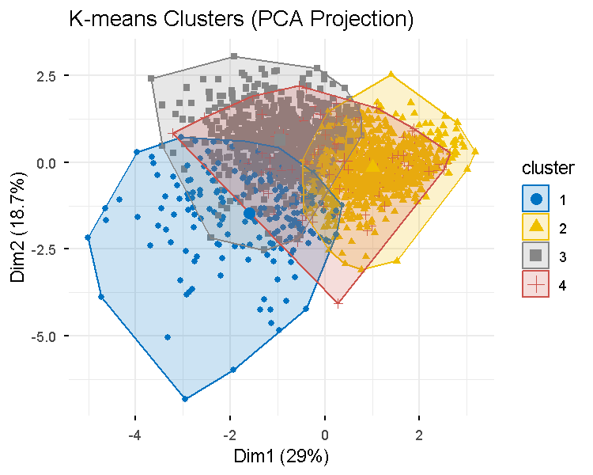
K-means clusters projected onto the first two principal components.
The first two principal components capture a modest share of total variance, and the four clusters show visible but overlapping centres rather than fully separated groups, consistent with the moderate silhouette width found above. This tells us the clusters represent real but graded differences in farm profile rather than sharply distinct farmer “types.”

Cluster Profiles
cluster_profile <- as.data.frame(clust_scaled) %>%
mutate(cluster = factor(km_result$cluster)) %>%
group_by(cluster) %>%
summarise(across(everything(), mean)) %>%
pivot_longer(-cluster, names_to = "variable", values_to = "std_mean")
ggplot(cluster_profile, aes(x = variable, y = std_mean, color = cluster, group = cluster)) +
geom_line(linewidth = 1) + geom_point(size = 2.5) +
geom_hline(yintercept = 0, linetype = "dashed", color = "grey50") +
coord_flip() +
labs(title = "Cluster Profile: Standardised Means", y = "Standardised mean", x = NULL) +
theme_minimal()
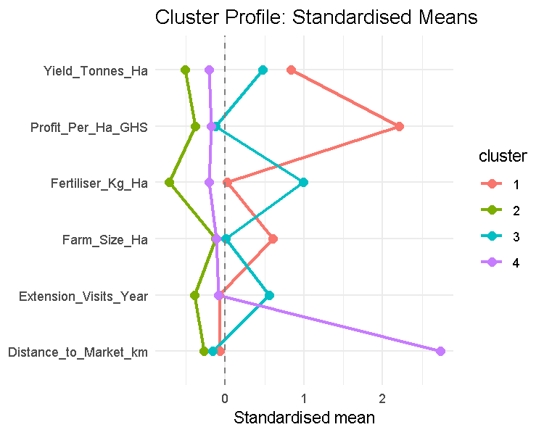
Standardised cluster profile means across the six clustering variables.
cluster_profile %>%
pivot_wider(names_from = variable, values_from = std_mean) %>%
mutate(across(where(is.numeric), ~round(.,2))) %>%
flextable() %>%
set_caption("Cluster profile: standardised means by cluster") %>%
autofit()%>%
fit_to_width(max_width = 6.27)
Cluster profile: standardised means by cluster
cluster | Farm_Size_Ha | Fertiliser_Kg_Ha | Extension_Visits_Year | Distance_to_Market_km | Yield_Tonnes_Ha | Profit_Per_Ha_GHS
1 | 0.60 | 0.03 | -0.08 | -0.06 | 0.84 | 2.21
2 | -0.12 | -0.71 | -0.39 | -0.27 | -0.51 | -0.38
3 | 0.00 | 1.00 | 0.56 | -0.16 | 0.48 | -0.13
4 | -0.11 | -0.20 | -0.08 | 2.73 | -0.21 | -0.18

Cluster Choropleth
clust_geo <- dat_clean %>%
select(Region, Farm_Size_Ha, Fertiliser_Kg_Ha, Extension_Visits_Year,
Distance_to_Market_km, Yield_Tonnes_Ha, Profit_Per_Ha_GHS) %>%
na.omit() %>%
mutate(cluster = factor(km_result$cluster))
region_mode_cluster <- clust_geo %>%
mutate(Region_Old10 = unname(region_to_old10[Region])) %>%
count(Region_Old10, cluster) %>%
group_by(Region_Old10) %>%
slice_max(n, n = 1, with_ties = FALSE) %>%
ungroup()
gh_map_clust <- gh_map %>% left_join(region_mode_cluster, by = c("region_name" = "Region_Old10"))
ggplot(gh_map_clust) +
geom_sf(aes(fill = cluster), color = "white", linewidth = 0.3) +
geom_sf_text(aes(label = region_name), size = 2.5, color = "white", fontface = "bold") +
scale_fill_brewer(palette = "Set2", name = "Dominant\nCluster") +
labs(title = "Most Common Farm Cluster by Region") +
theme_void() +
theme(plot.title = element_text(face = "bold", hjust = 0.5))
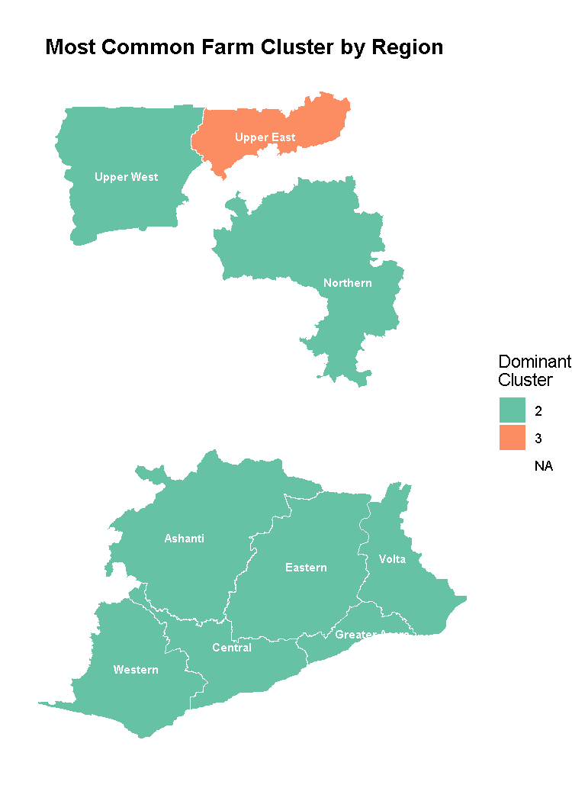
Most common (modal) farm cluster by region.

Interpretation
Cluster 2 is the input-intensive, extension-connected group: high fertiliser use and the most frequent extension contact, associated with above-average yield, these are farmers actively engaged with formal agricultural support systems. Cluster 1 is the larger-farm group, distinguished mainly by above-average farm size with otherwise fairly typical input use. Cluster 3, the largest group by far, represents the low-input majority: below-average fertiliser use, extension contact, and farm size, the typical smallholder profile with limited access to intensification inputs. Cluster 4 is a smaller, less input-intensive group similar in direction to Cluster 3 but distinguished by its own combination of scale and distance characteristics. Geographically, Cluster 3 (the low-input majority) dominates nearly every region, which is consistent with the overall sample composition, while Upper East stands out as the only region where a different cluster is modal, suggesting a locally distinct farming profile worth further investigation. The moderate silhouette width ($≈$ 0.24) and overlapping PCA plot indicate these are graded tendencies rather than sharply separated farmer types, which is a realistic and expected finding for continuous agricultural survey data rather than a limitation unique to our method. Practically, this segmentation suggests agricultural extension resources could be prioritised toward the large low-input majority (Cluster 3), who have the most apparent room to benefit from the input-intensification pattern already visible in Cluster 2.

7. Appendix

A.1 Supplementary Plot: Yield by Farm Size Class
ggplot(dat_clean, aes(x = Farm_Size_Class, y = Yield_Tonnes_Ha, fill = Farm_Size_Class)) +
geom_boxplot(alpha = 0.7) +
scale_fill_viridis_d(option = "cividis") +
labs(title = "Yield by Farm Size Class", x = "Farm Size Class", y = "Yield (Tonnes/Ha)") +
theme_minimal() + theme(legend.position = "none")
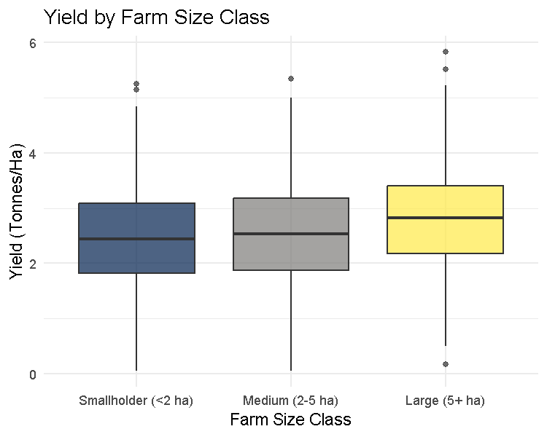
Supplementary plot: yield distribution by the derived Farm_Size_Class variable (Task 2d).

A.2 Supplementary Table: Regional Summary Statistics
dat_clean %>%
group_by(Region) %>%
summarise(
n_farms = n(),
mean_yield = round(mean(Yield_Tonnes_Ha, na.rm = TRUE), 2),
pct_profitable = round(mean(Farm_Profitable == "Yes", na.rm = TRUE) * 100, 1),
mean_profit_per_ha = round(mean(Profit_Per_Ha_GHS, na.rm = TRUE), 0)
) %>%
arrange(desc(mean_yield)) %>%
flextable() %>%
set_caption(
"Supplementary Table: regional summary statistics (full 16-region granularity)"
) %>%
autofit() %>%
fit_to_width(max_width = 6.27)
Supplementary Table: regional summary statistics (full 16-region granularity)
Region | n_farms | mean_yield | pct_profitable | mean_profit_per_ha
Oti | 69 | 2.85 | 100.0 | 4,380
Greater Accra | 46 | 2.66 | 100.0 | 4,236
Upper East | 161 | 2.62 | 99.4 | 4,395
Volta | 120 | 2.62 | 100.0 | 4,536
Ahafo | 94 | 2.61 | 100.0 | 4,134
Ashanti | 154 | 2.59 | 99.4 | 4,207
Savannah | 110 | 2.56 | 97.3 | 4,792
Upper West | 117 | 2.55 | 99.1 | 5,050
Western North | 108 | 2.52 | 100.0 | 3,964
Central | 83 | 2.51 | 98.8 | 4,551
Eastern | 144 | 2.51 | 100.0 | 3,919
Northern | 216 | 2.51 | 98.6 | 4,505
Bono East | 120 | 2.49 | 100.0 | 3,912
North East | 82 | 2.46 | 98.8 | 4,319
Western | 147 | 2.44 | 98.6 | 4,181
Bono | 129 | 2.39 | 98.4 | 4,184

A.3 Session Information
sessionInfo()
## R version 4.6.0 (2026-04-24 ucrt)
## Platform: x86_64-w64-mingw32/x64
## Running under: Windows 11 x64 (build 26200)
##
## Matrix products: default
## LAPACK version 3.12.1
##
## locale:
## [1] LC_COLLATE=English_Ghana.utf8 LC_CTYPE=English_Ghana.utf8
## [3] LC_MONETARY=English_Ghana.utf8 LC_NUMERIC=C
## [5] LC_TIME=English_Ghana.utf8
##
## time zone: Etc/UTC
## tzcode source: internal
##
## attached base packages:
## [1] grid stats graphics grDevices utils datasets methods
## [8] base
##
## other attached packages:
## [1] gtsummary_2.5.1 officer_0.7.6 flextable_0.10.0 factoextra_2.2.0
## [5] cluster_2.1.8.2 MASS_7.3-65 car_3.1-5 carData_3.0-6
## [9] vcd_1.4-14 rstatix_1.1.0 broom_1.0.13 leaflet_2.2.3
## [13] sf_1.1-1 viridis_0.6.5 viridisLite_0.4.3 patchwork_1.3.2
## [17] ggplot2_4.0.3 forcats_1.0.1 stringr_1.6.0 readr_2.2.0
## [21] tidyr_1.3.2 dplyr_1.2.1
##
## loaded via a namespace (and not attached):
## [1] DBI_1.3.0 geodata_0.6-9 gridExtra_2.3.1
## [4] rlang_1.3.0 magrittr_2.0.5 otel_0.2.0
## [7] e1071_1.7-17 compiler_4.6.0 mgcv_1.9-4
## [10] systemfonts_1.3.2 vctrs_0.7.3 pkgconfig_2.0.3
## [13] crayon_1.5.3 fastmap_1.2.0 backports_1.5.1
## [16] labeling_0.4.3 utf8_1.2.6 rmarkdown_2.31
## [19] tzdb_0.5.0 haven_2.5.5 ragg_1.5.2
## [22] purrr_1.2.2 bit_4.6.0 xfun_0.60
## [25] labelled_2.16.0 jsonlite_2.0.0 uuid_1.2-2
## [28] terra_1.9-34 parallel_4.6.0 R6_2.6.1
## [31] stringi_1.8.7 RColorBrewer_1.1-3 jquerylib_0.1.4
## [34] lmtest_0.9-40 Rcpp_1.1.2 knitr_1.51
## [37] zoo_1.9-0 leaflet.providers_3.0.0 Matrix_1.7-5
## [40] splines_4.6.0 tidyselect_1.2.1 rstudioapi_0.19.0
## [43] abind_1.4-8 yaml_2.3.12 codetools_0.2-20
## [46] lattice_0.22-9 tibble_3.3.1 withr_3.0.3
## [49] S7_0.2.2 askpass_1.2.1 evaluate_1.0.5
## [52] units_1.0-1 proxy_0.4-29 zip_3.0.1
## [55] xml2_1.6.0 ggpubr_1.0.0 pillar_1.11.1
## [58] KernSmooth_2.23-26 stats4_4.6.0 generics_0.1.4
## [61] vroom_1.7.1 hms_1.1.4 commonmark_2.0.0
## [64] scales_1.4.0 class_7.3-23 glue_1.8.1
## [67] gdtools_0.5.1 tools_4.6.0 data.table_1.18.4
## [70] ggsignif_0.6.4 fs_2.1.0 crosstalk_1.2.2
## [73] cards_0.8.1 colorspace_2.1-3 nlme_3.1-169
## [76] Formula_1.2-6 cli_3.6.6 rappdirs_0.3.4
## [79] textshaping_1.0.5 fontBitstreamVera_0.1.1 broom.helpers_1.22.0
## [82] gt_1.3.0 gtable_0.3.6 ggsci_5.2.0
## [85] digest_0.6.39 fontquiver_0.2.1 classInt_0.4-11
## [88] ggrepel_0.9.8 htmlwidgets_1.6.4 farver_2.1.2
## [91] htmltools_0.5.9 lifecycle_1.0.5 fontLiberation_0.1.0
## [94] openssl_2.4.2 bit64_4.8.2

