Project: | Todo Web Application
Course: | CSD-380 DevOps
Description: | This test plan verifies that the core functionalities of the Todo app (available at https://buwebdev.github.io/todo/) meet the stated business requirements.
Date: | 06/21/2025
To complete the test case plan, fill out the information for Project, Course, Description and Date in the header below.
.
TABLE OF CONTENTS
<DESCRIPTION> 2
1. Website Loads Successfully – Page 2
2. Add New Todo Item – Page 2
3. Mark Item as Completed – Page 3
4. Delete Todo Item – Page 3
5. Todo List Persistence – Page 4

For each test, the developer should: provide a test description, a test objective, the developer name and date tested. For each step, fill out the actions to be taken and describe the expected results, and indicate yes or no for each step depending upon the result. The peer tester should provide their name, date tested, indicate yes or no for each step depending upon the result, and a screenshot (thumbnail) of the result.

Test 1 | Website Loads Successfully
 | Test Objective: Verifies that the web application is accessible and reloads correctly. | Developer:  Date tested: 2025/06/22 | Peer tester: Kyle Marlia-Conner  Date tested: 2025/06/21
Step | Action | Expected results: | Developer pass/fail | Tester pass/fail  + Screenshot
1 | Open browser and go to https://buwebdev.github.io/todo/ | Page loads without error | Yes | Yes  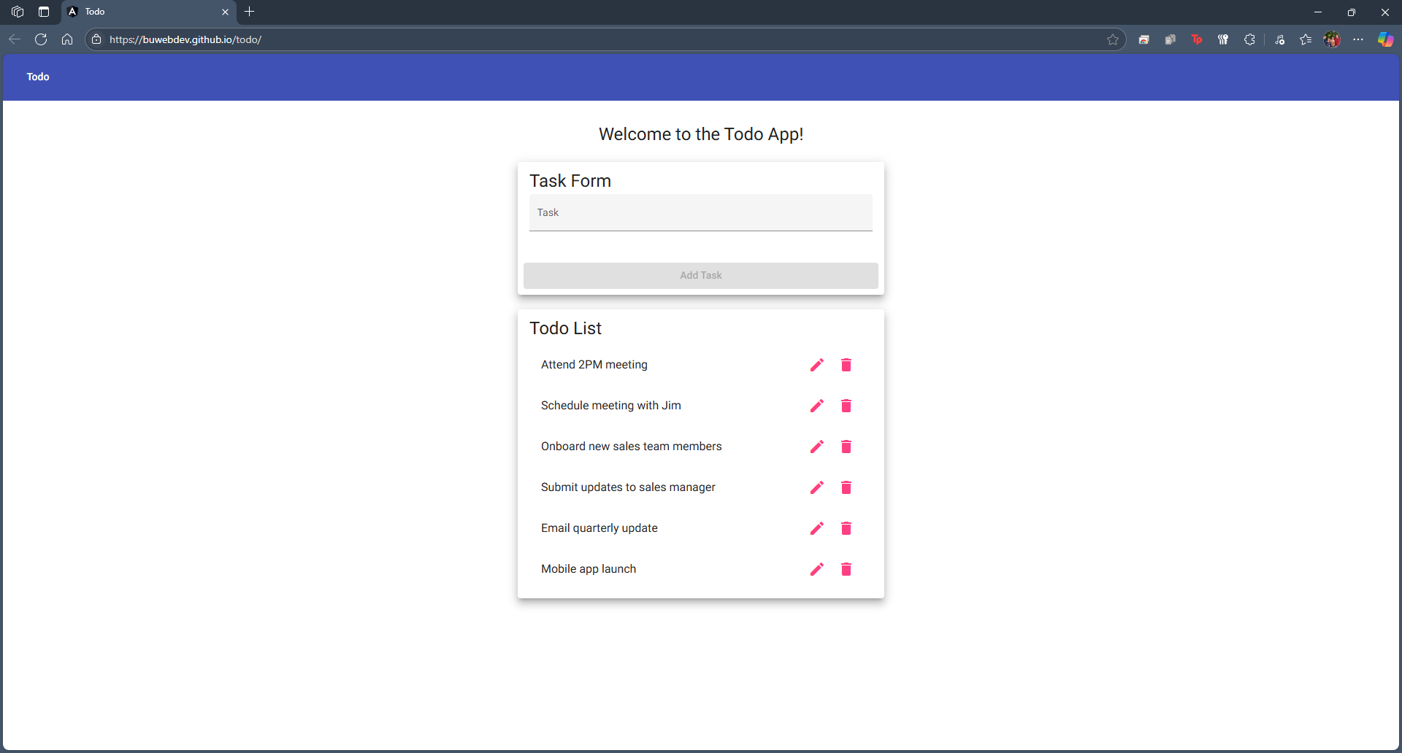
2 | Observe the landing page | Page displays input field and todo list UI | Yes | Yes  
3 | Refresh browser window | Page reloads successfully without any errors | Yes | Yes  
4 | Click F12 and inspect for console errors | No critical errors in console log | Yes | Yes  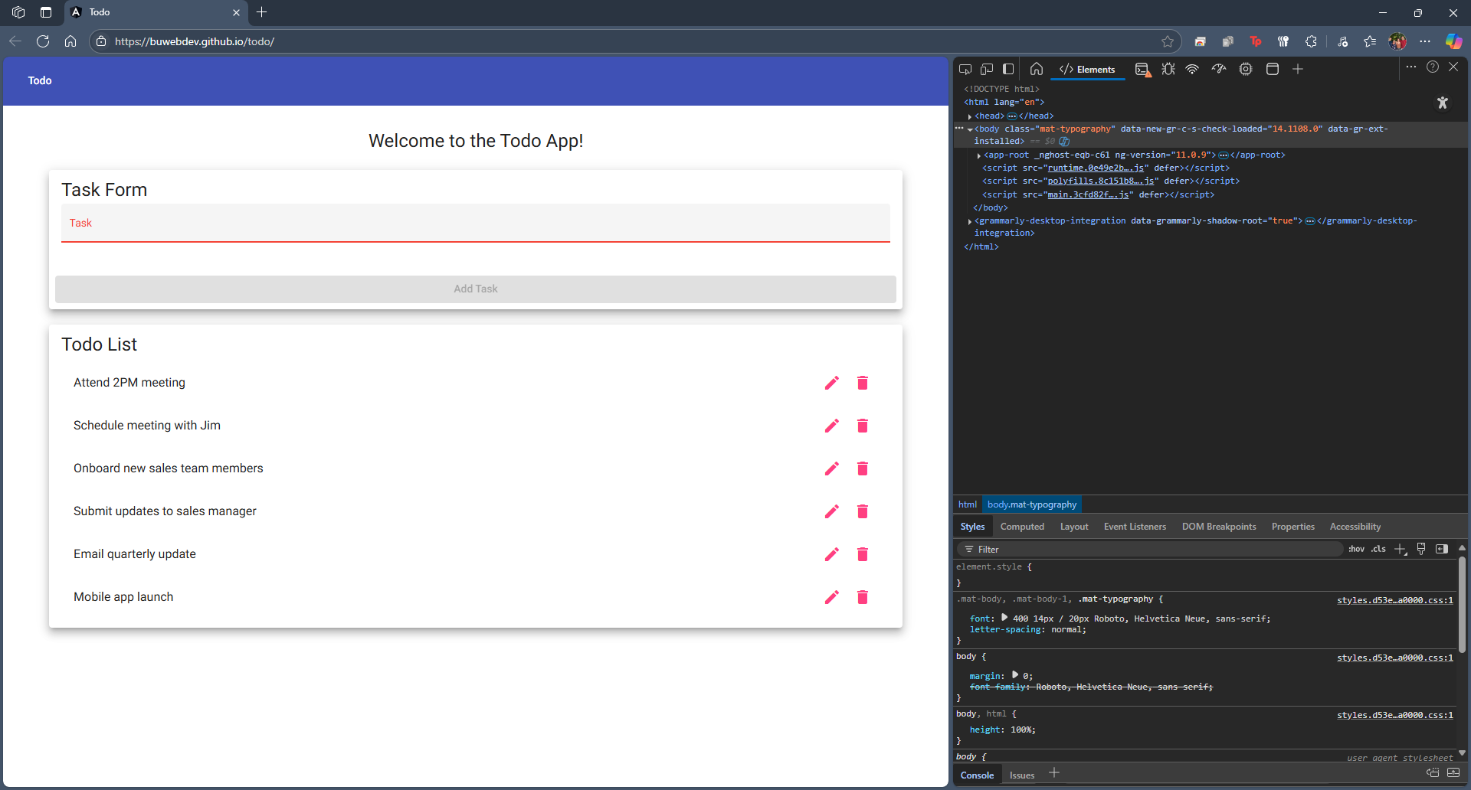
5 | Try URL on mobile and desktop browsers | Page renders responsively and correctly | Yes | Yes  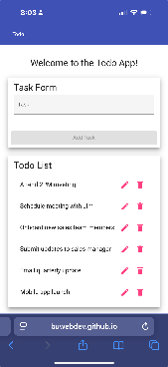
Comments | The page loaded correctly without any errors across different browsers. The UI appeared consistent and fully functional upon refresh. The site also worked on mobile without rendering issues.  Kyle: The page loaded completely fine, reloaded correctly, and opened on mobile the way it is expected to do so. Instructions were elementary, and able to be followed very clearly.
Test 2 | Add New Todo Item (Adding a task to the Todo is the assumption)
 | Test Objective: Verifies that a user can add a new task to the todo list. | Developer: Amit Rizal  Date tested: 2025/06/22 | Peer tester: Kyle Marlia-Conner  Date tested: 2025/06/21
Step | Action | Expected results: | Developer pass/fail | Tester pass/fail
1 | Visit the website | Page loads with input box | Yes | Yes  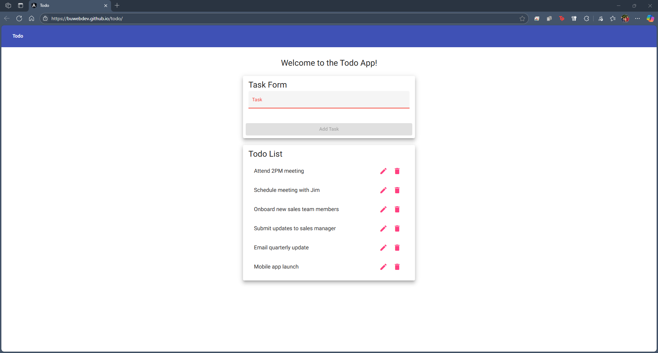
2 | Enter 'Call mom' in the input field | Text appears in input field | Yes | Yes  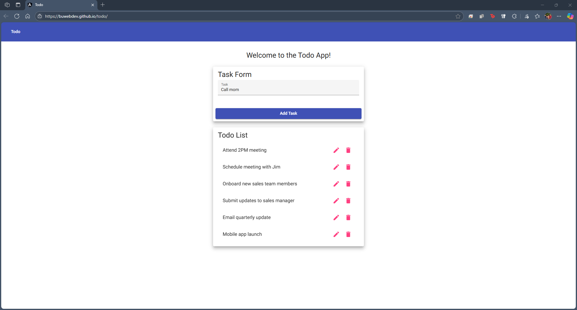
3 | Click the '+' button | 'Call mom' is added to the list | Yes | Yes (though there is no “+” button, assuming “Add Task”)  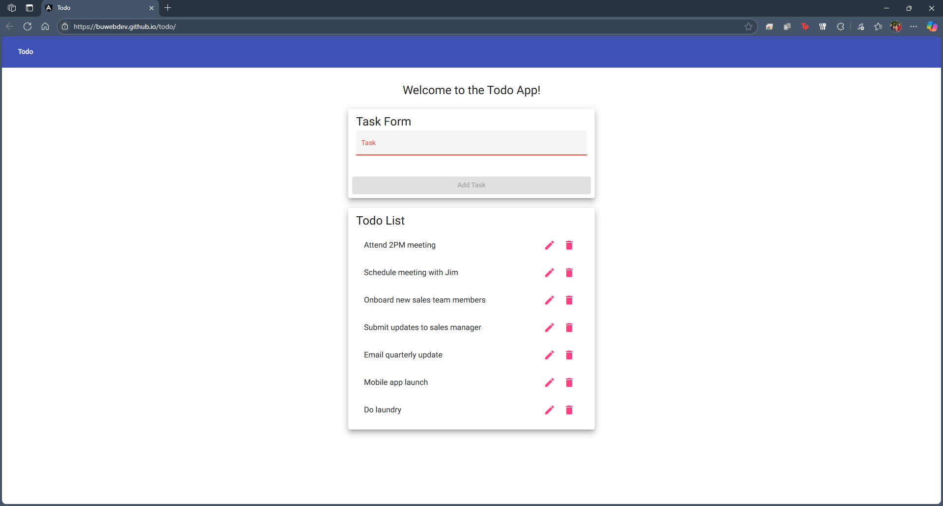
4 | Add another item ('Pay bills') | 'Pay bills' is added below previous item | Yes | Yes  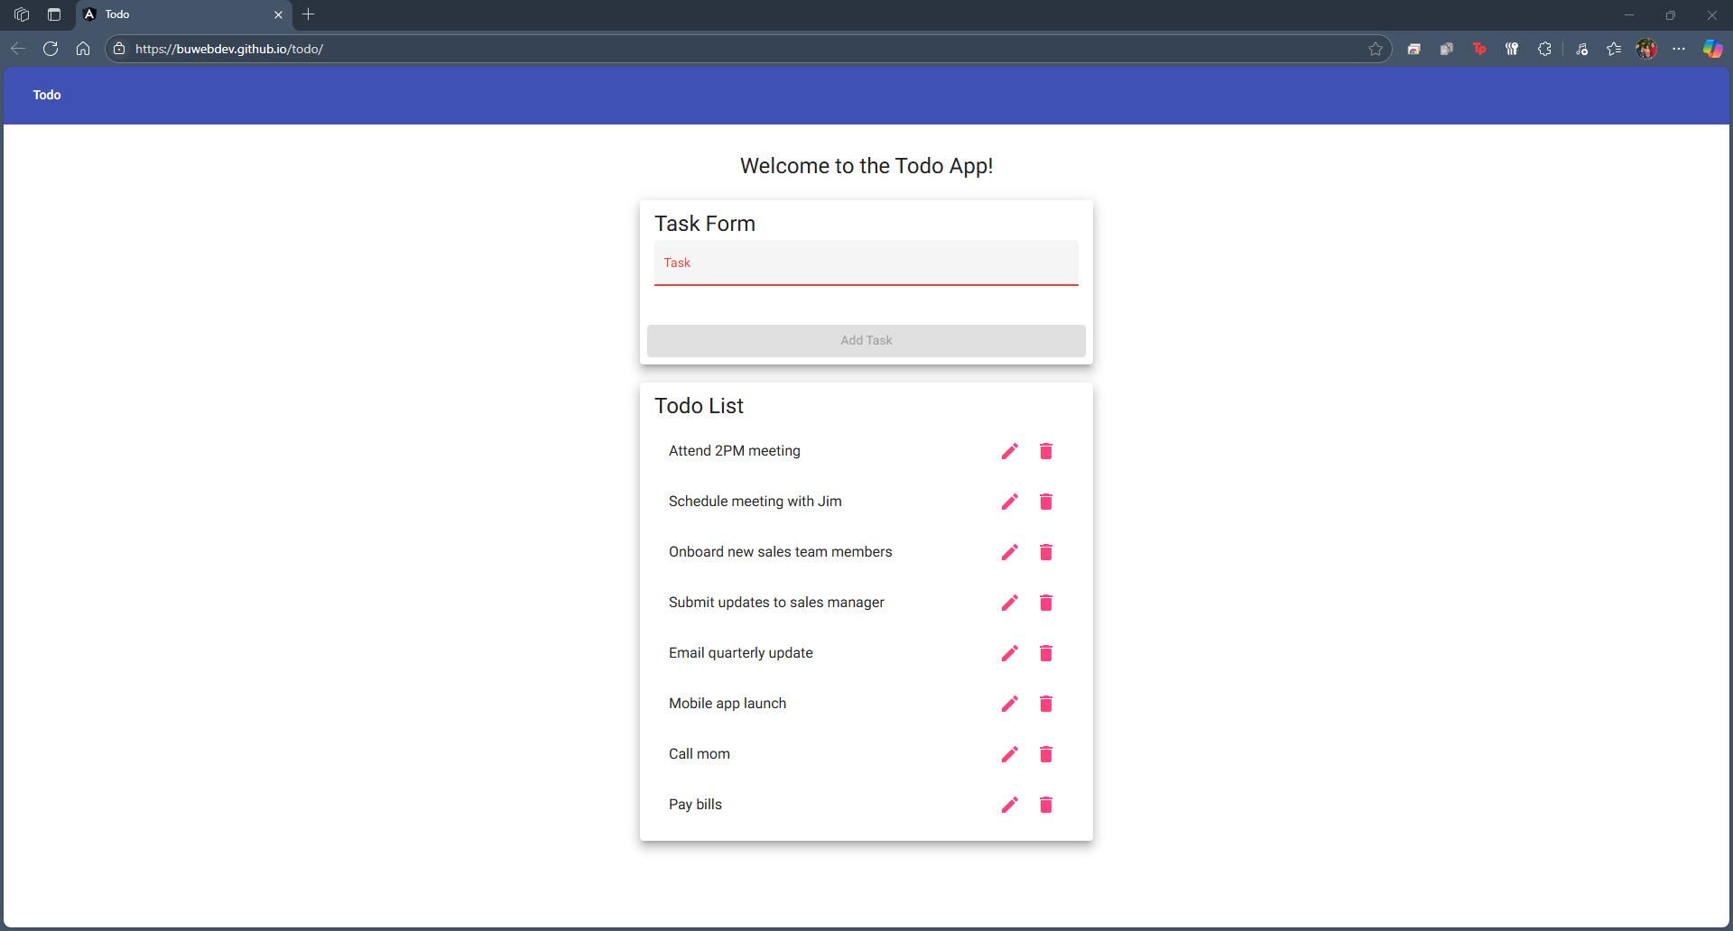
5 | Observe item alignment and format | Both items are properly aligned and formatted | Yes | Yes  
Comments | The item addition process is intuitive and seamless. There was no delay or glitch while adding tasks, and the interface updated dynamically. A confirmation animation or message might enhance user feedback.  Kyle- Besides the “+” not existing, everything worked exactly as expected from Amits steps. The page allowed for a new entry to be added, and proceeded to add the new item to the bottom of the list. The same with the second item being added.

Test 3 | Mark Item as Completed
 | Test Objective: Verifies that users can mark todo items as completed using checkboxes. | Developer: Amit Rizal  Date tested: 2025/06/22 | Peer tester: Kyle Marlia-Conner  Date tested: 2025/06/21
Step | Action | Expected results: | Developer pass/fail | Tester pass/fail
1 | Add 'Do laundry' to the list | 'Do laundry' is added | Yes | Yes  
2 | Click the checkbox next to the item | Item is visually marked as complete | Yes | No (what check box?)  
3 | Observe style change | Text is struck-through or faded | Yes | No  
4 | Refresh page | Item is still shown as completed (if persistent) | No | No  
5 | Try on a mobile device | Checkbox interaction works correctly | Yes | No  
Comments | The item was marked complete successfully. However, the state was lost on refresh, which could be improved using local storage or session handling. Visually, the UI clearly differentiates completed items.  Kyle- There is no checkbox to cross out a completed item. Not on browser, not on mobile. When taking the assumption that the instructions of the symbol were wrong, the edit or delete buttons available do not give the ability to “check the item as completed”.

Test 4 | Delete Todo Item
 | Test Objective: Verifies that users can delete a todo item from the list. | Developer: Amit Rizal  Date tested: 2025/06/22 | Peer tester: Kyle Marlia-Conner  Date tested: 2025/06/21
Step | Action | Expected results: | Developer pass/fail | Tester pass/fail
1 | Add 'Buy milk' to the list | 'Buy milk' appears in the list | Yes | Yes  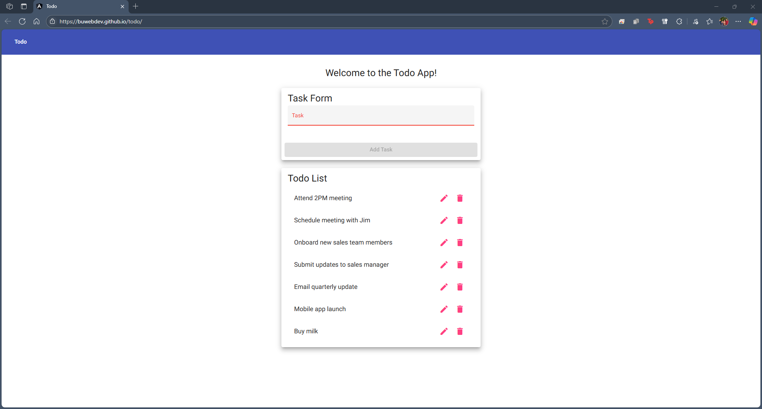
2 | Click the delete icon next to 'Buy milk' | 'Buy milk' is removed from the list | Yes | Yes  
3 | Verify remaining list items | Other items remain intact | Yes | Yes  
4 | Try deleting multiple items | Each item is deleted individually | Yes | Yes  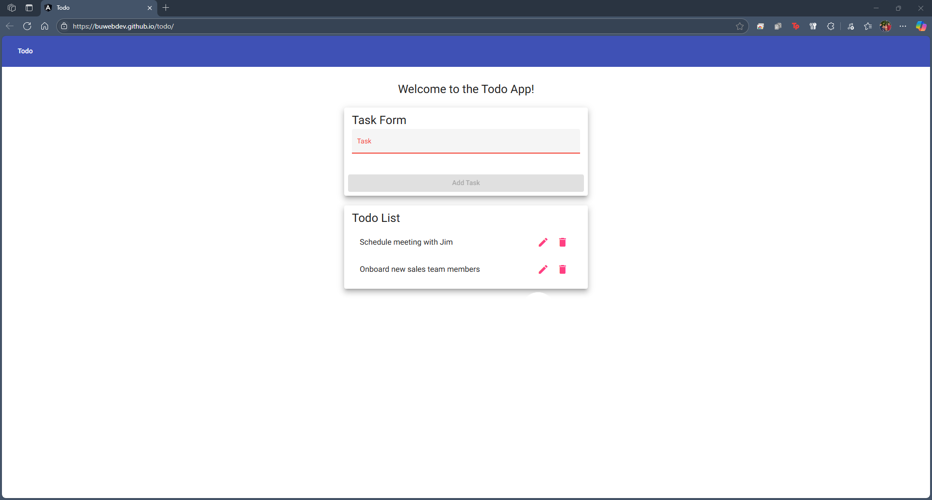
5 | Attempt to delete a non-existent item | No crash or error occurs | Yes | Yes  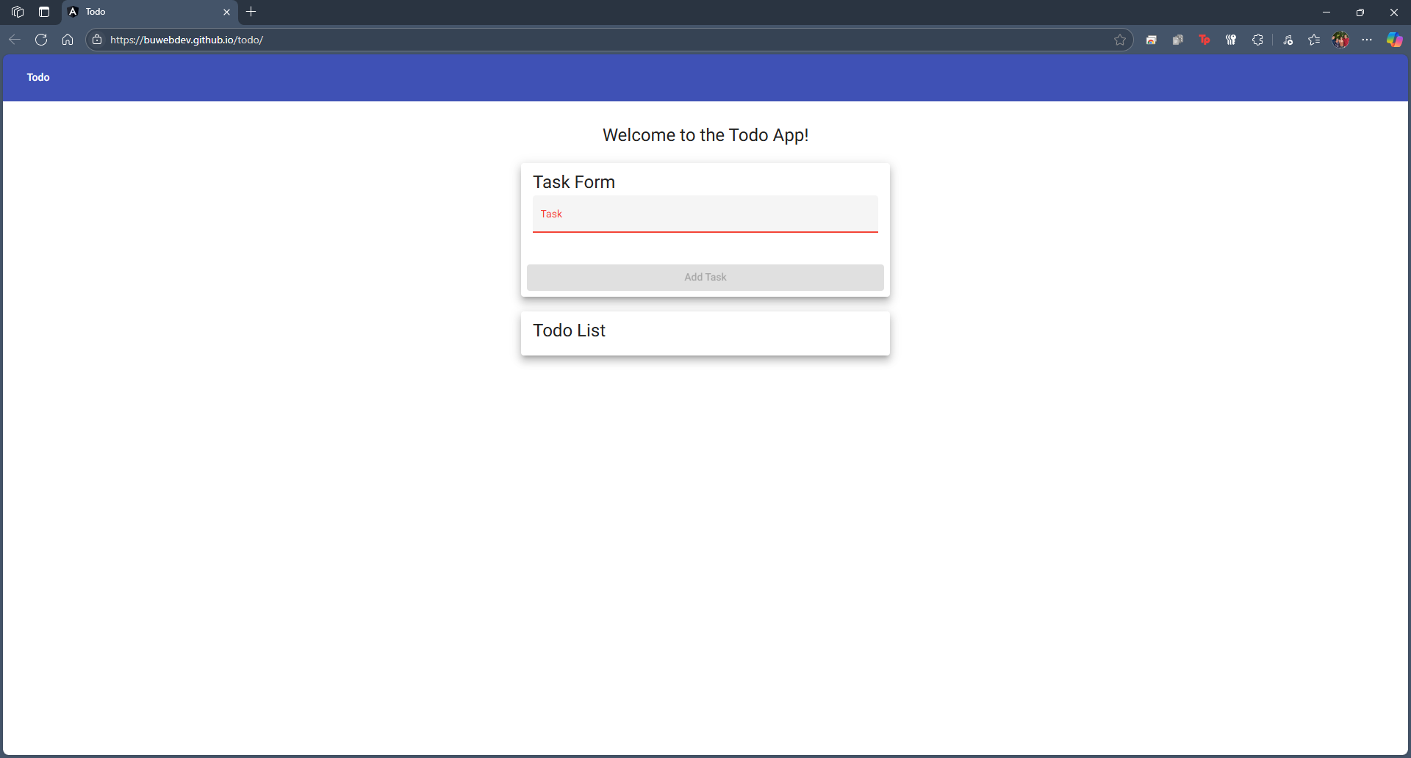
Comments | The delete function worked reliably. No errors were encountered even when deleting multiple items. Consider adding a confirmation prompt to prevent accidental deletions.  Kyle- The items are removed from the list and ability to view once the delete button is clicked. Do to this, there is not a way to delete an item that is not populating the list, so everything checks out.

Test 5 | Todo List Persistence
 | Test Objective: Verifies that items persist after a page reload or session refresh. | Developer: Amit Rizal  Date tested: 2025/06/22 | Peer tester: Kyle Marlia-Conner  Date tested: 2025/06/21
Step | Action | Expected results: | Developer pass/fail | Tester pass/fail
1 | Add 'Finish homework' to the list | 'Finish homework' appears | Yes | Yes  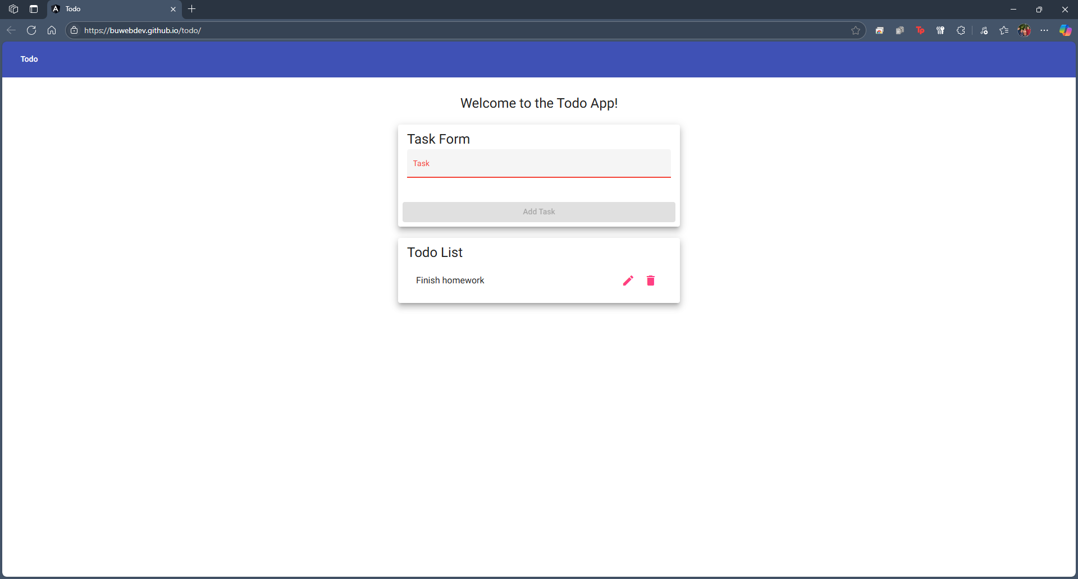
2 | Close and reopen the browser tab | 'Finish homework' still appears | No | No  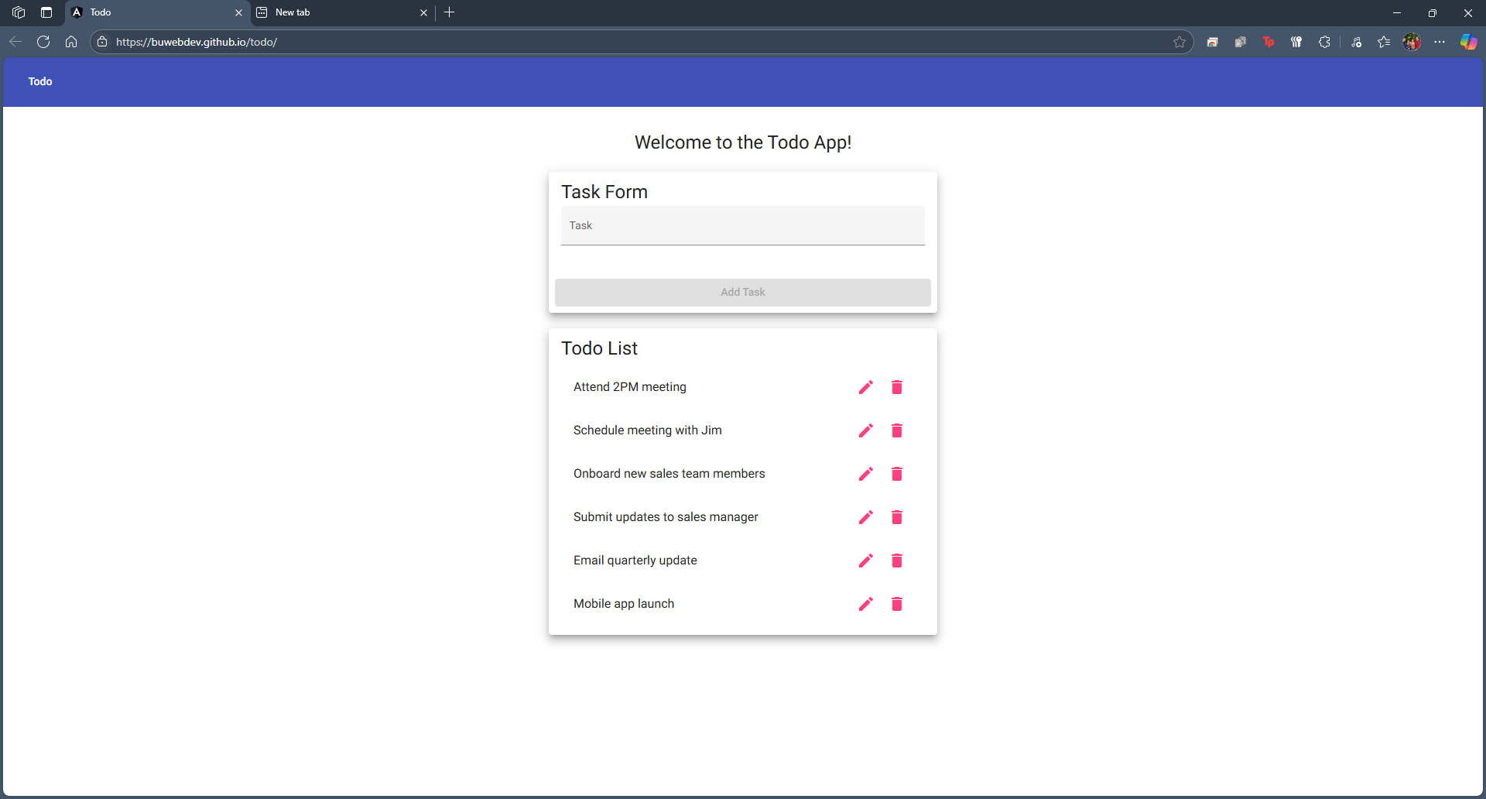
3 | Add a new item and refresh page | New item is retained (if persistent) | No | No  
4 | Check browser storage | No local/session storage observed | No | N/A
5 | Try using a different device | Todo list does not persist across devices | No | Yes?  
Comments | Persistence did not work across refreshes or devices. Implementing local or session storage would help retain data between sessions and improve usability for users returning to the app.  Kyle- Besides not knowing how it was wanted to observe the session data potentially being saved, the instructions were clear for the most part. The last expected outcome was something of a double negative, so it was correct that data does not persist across devices or upon a refresh/reload of the browser.

