Test 1 | Viewing To-Do list items.
 | Test Objective:  Ensure that all created tasks are displayed clearly for the user to see. | Developer: Rachel Shaw  Date tested: 6/19/2025 | Peer tester: Kyle Marlia-Conner  Date tested: 2025/06/22
Step | Action | Expected results: | Developer pass/fail | Tester pass/fail  + Screenshot
1 | Visit https://buwebdev.github.io/todo/ | Page should load without issue | yes | Yes  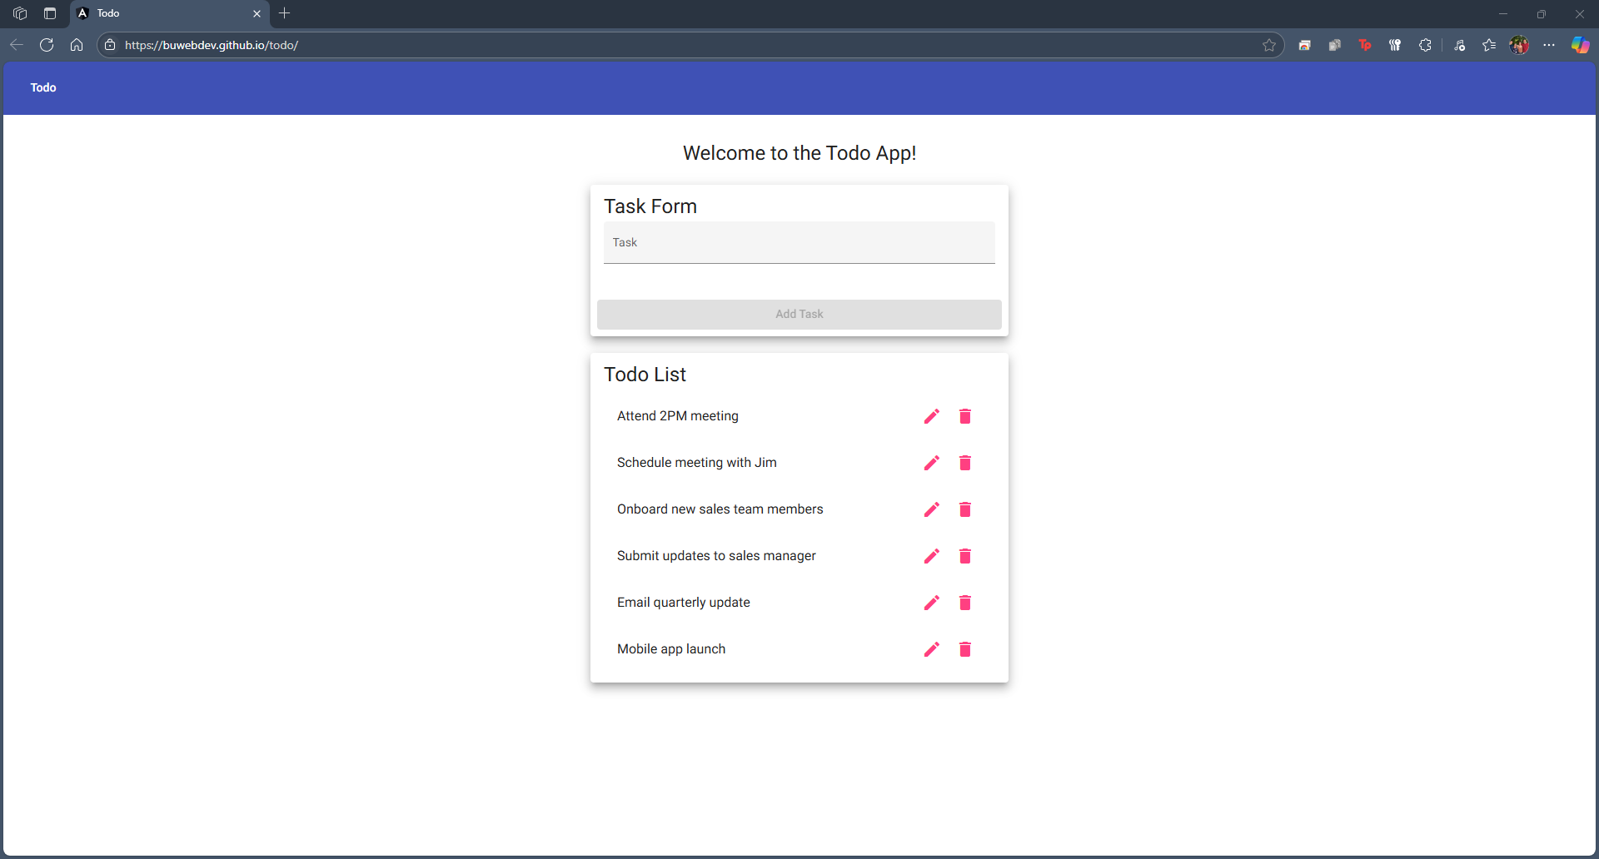
2 | Confirm that all 6 preset example items are present | Page should display 6 example task below the task form | yes | Yes  
3 | Create an additional task “Board meeting at 5PM” | Once task is submitted, the input field should clear automatically, ready for the next input. | yes | Yes  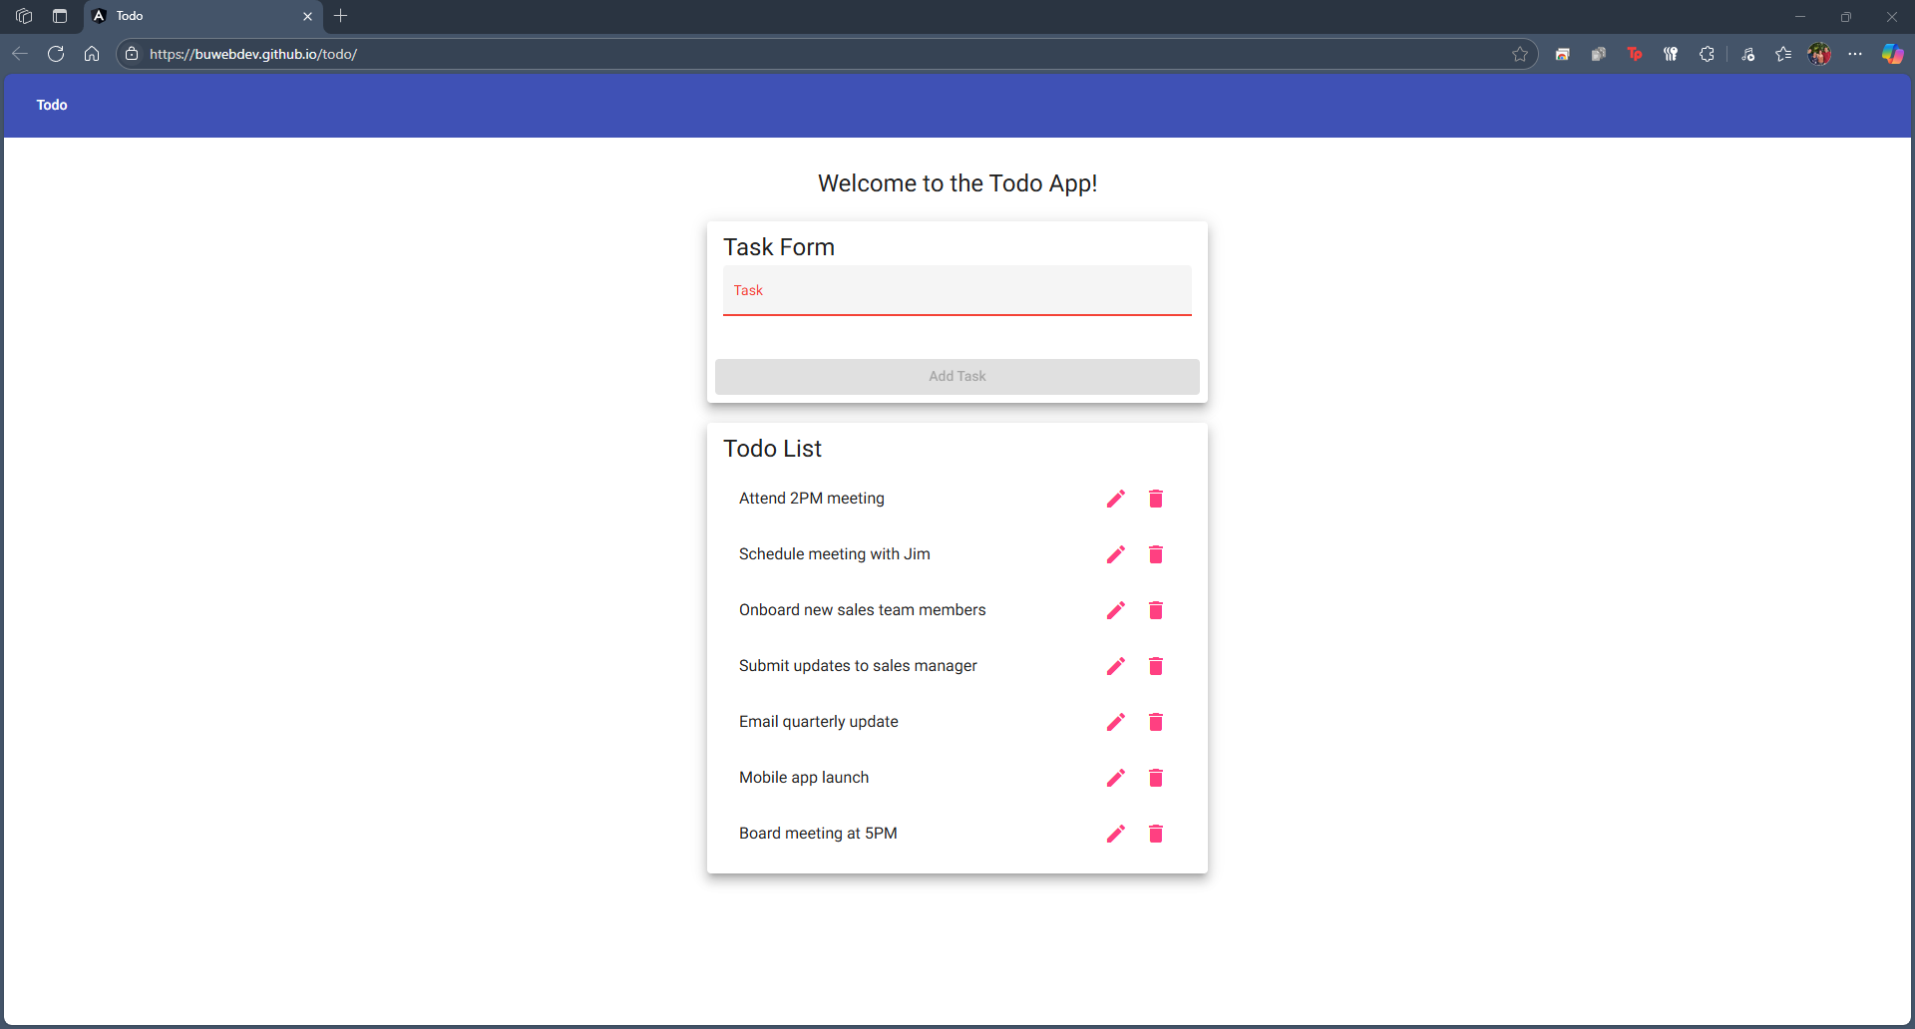
4 | Ensure additional task, “Board meeting at 5PM” is added to the displayed list | “Board meeting at 5PM” appears at the bottom of the task list below the task form exactly as typed in the task form. | yes | Yes  
5 | Create another additional task: “Organize file cabinet” | Once task is submitted, the input field should clear automatically, ready for the next input. | yes | Yes  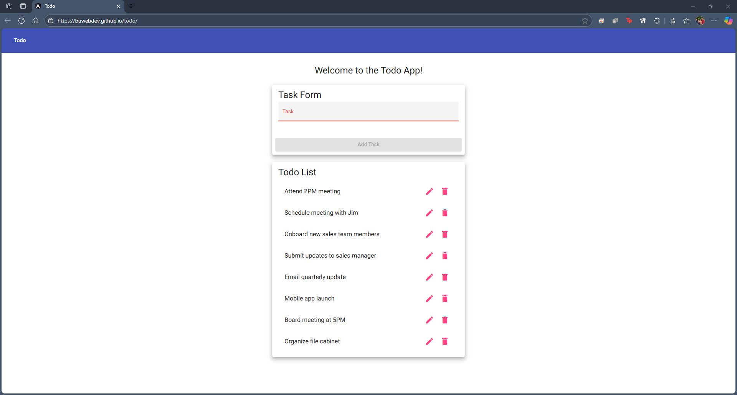
6 | Ensure additional task, “Organize file cabinet” is added to the displayed list | “Organize file cabinet” appears at the bottom of the task list below the task form exactly as typed in the task form. | yes | Yes  
Comments | Kyle- The instructions and expected results were correct. I ran into no issues adding new items to the list, and then viewing said items. They populated the list at the very bottom, with the newest entered item being at the bottom.

Test 2 | Blank task forms are not accepted
 | Test Objective:  Ensure that a blank task cannot be added to the list. | Developer: Rachel Shaw  Date tested: 6/19/2025 | Peer tester: Kyle Marlia-Conner  Date tested: 2025/06/22
Step | Action | Expected results: | Developer pass/fail | Tester pass/fail + Screenshot
1 | Visit https://buwebdev.github.io/todo/ | Page should load without issue | yes | Yes  
2 | Ensure “Add task” button is grey and unclickable by default upon loading | “Add task” button is grey and unclickable upon loading the page. | yes | Yes  
3 | Begin typing: “Board meeting” into the task form without submitting | “Add task” button should turn blue and allow tester to click once the input reaches four characters. | yes | Yes  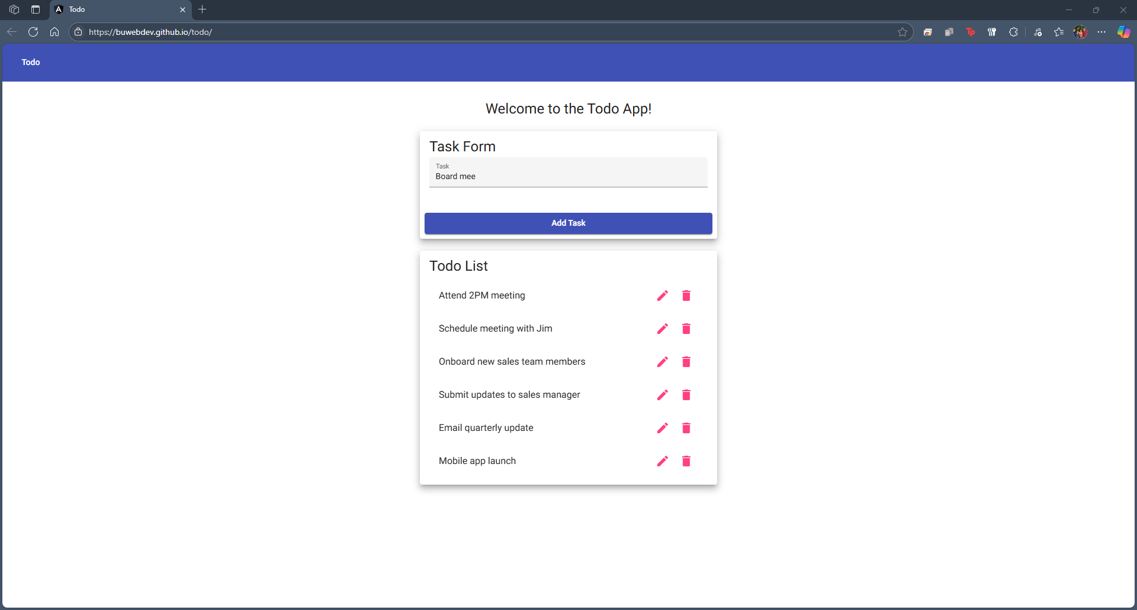
4 | Click “Add task” button. | Test task should appear at the bottom of the list | yes | Yes  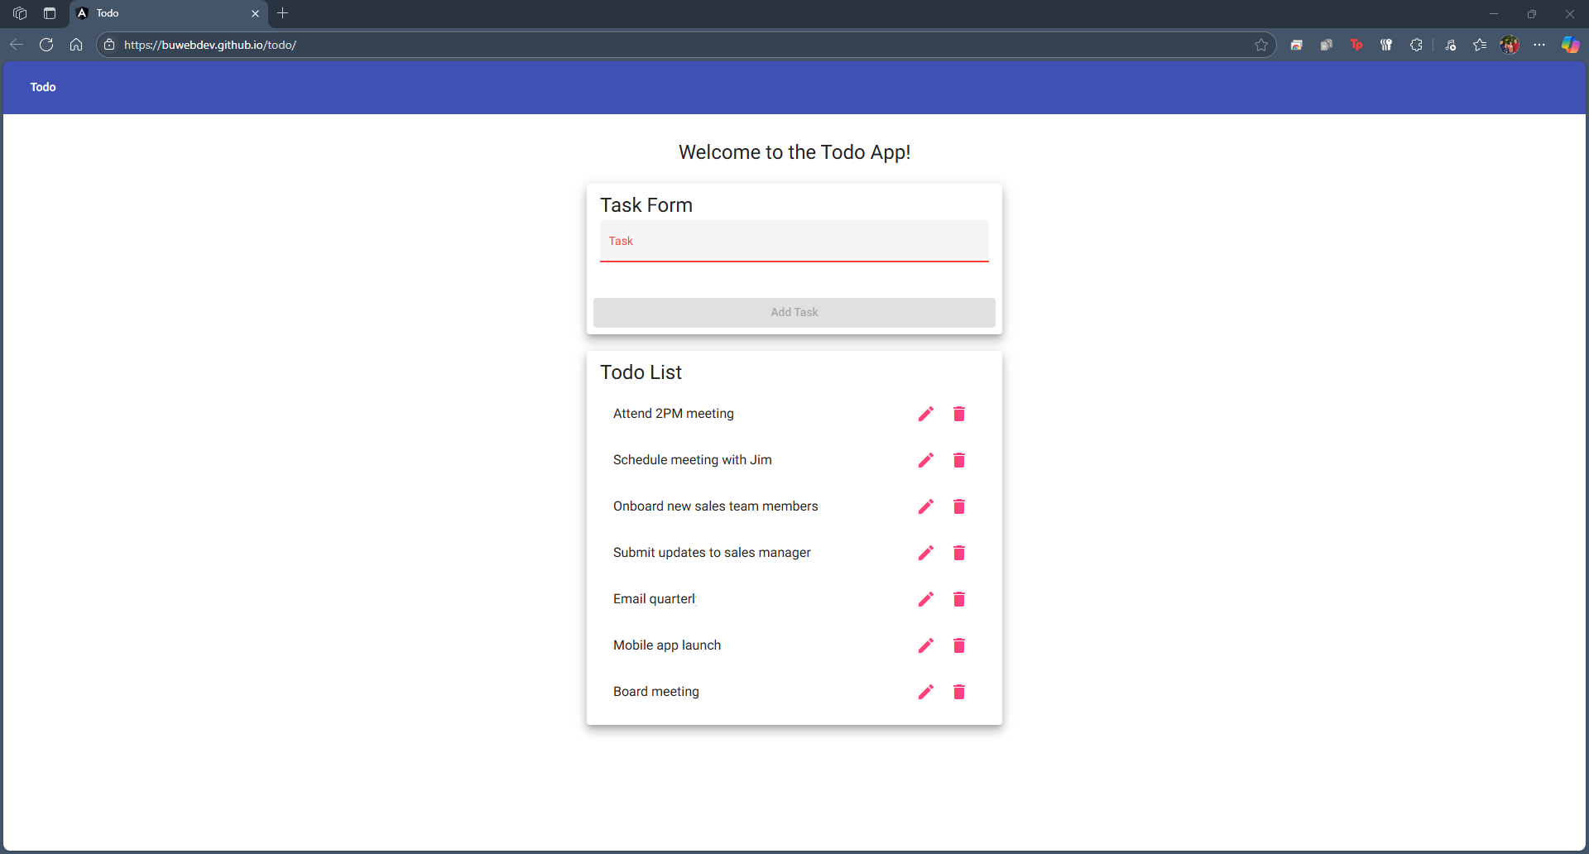
5 | Ensure the “Add task” button returns to an unclickable state once the task form clears. | Once input field clears automatically, “Add task” button should become grey and unclickable again. | yes | Yes  
Comments | Kyle- All steps and expected outcomes were correct. The website does not allow a user to be able to insert an empty task to the list. Only once something has been added to the Task Form input field, will the Add Task button activate.

Test 3 | Mobile view is functioning correctly.
 | Test Objective:  Ensure users can view their tasks from their mobile devices. | Developer: Rachel Shaw  Date tested: 6/19/2025 | Peer tester: Kyle Marlia-Conner  Date tested: 2025/06/22
Step | Action | Expected results: | Developer pass/fail | Tester pass/fail
1 | On a mobile device, visit https://buwebdev.github.io/todo/ | Page should load without issue. | yes | Yes  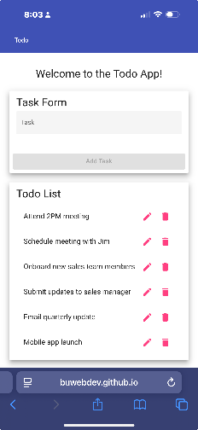
2 | Confirm both task form and preset Todo list are visible | Both task list and task form are included in the mobile view. | yes | Yes  
3 | Ensure the view and items fit within the device’s screen. | Page should automatically resize to fit the device’s screen size. | yes | Yes  
Comments | This test must be done on a mobile device such a smartphone.  Kyle- The page and elements not only opened and functioned correctly on a smartphone, but it also resized to fit the aspect ratio of the device correctly. No issues, clear instructions, just worked across the board.

Test 4 | Custom error 404 page
 | Test Objective:  Confirm that that invalid URLs prompt the custom 404 page | Developer: Rachel Shaw  Date tested: 6/19/2025 | Peer tester: Kyle Marlia-Conner  Date tested: 2025/06/22
Step | Action | Expected results: | Developer pass/fail | Tester pass/fail + Screenshot
1 | Visit https://buwebdev.github.io/toodoo/ | GitHub error 404 page should appear | yes | Yes  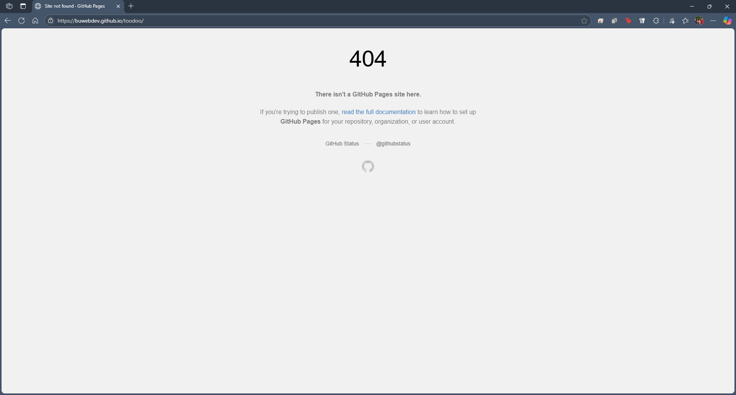
Comments | Please make sure the typo in the provided URL is present before attempting to load the page.  Kyle- The page loaded into a GitHub 404 error page. It states that “There isn’t a GitHub Pages site here.”

Test 5 | Delete ToDo task item
 | Test Objective:  Ensure that the delete task button functions as it should | Developer: Rachel Shaw  Date tested: 6/19/2025 | Peer tester: Kyle Marlia-Conner  Date tested: 2025/06/22
Step | Action | Expected results: | Developer pass/fail | Tester pass/fail + Screenshot
1 | Visit https://buwebdev.github.io/todo/ | Page should load without issue | yes | Yes  
2 | Delete one of the preset example tasks in the to do list area by clicking the trashcan item to the right of the task. | Tasks should disappear from the Todo list. | yes | Yes  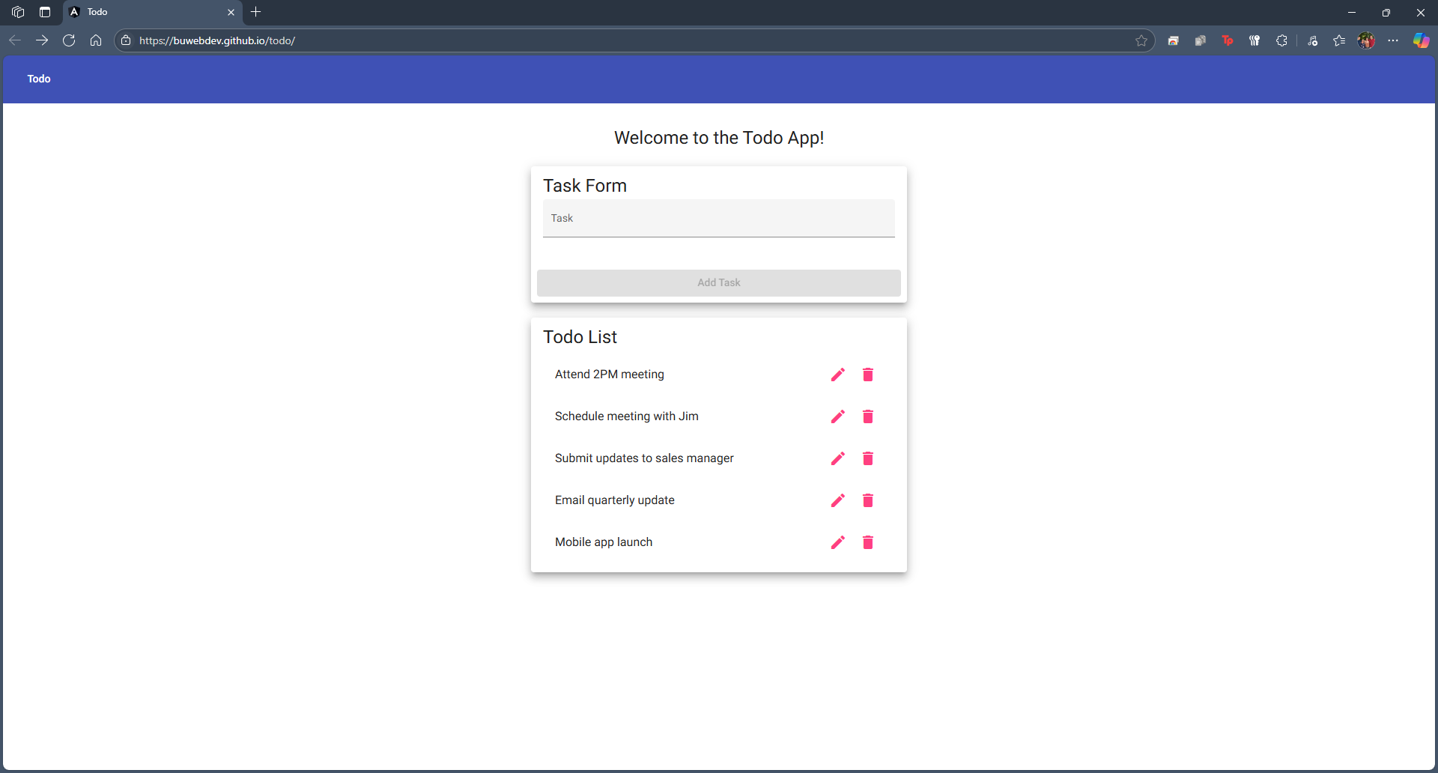
Comments | Kyle- After loading the site and clicking on the Trashcan/Delete option, a task is then removed from the list completely.

