Kyle Marlia-Conner
5/31/2025
Assignment 1

Java Screenshot:
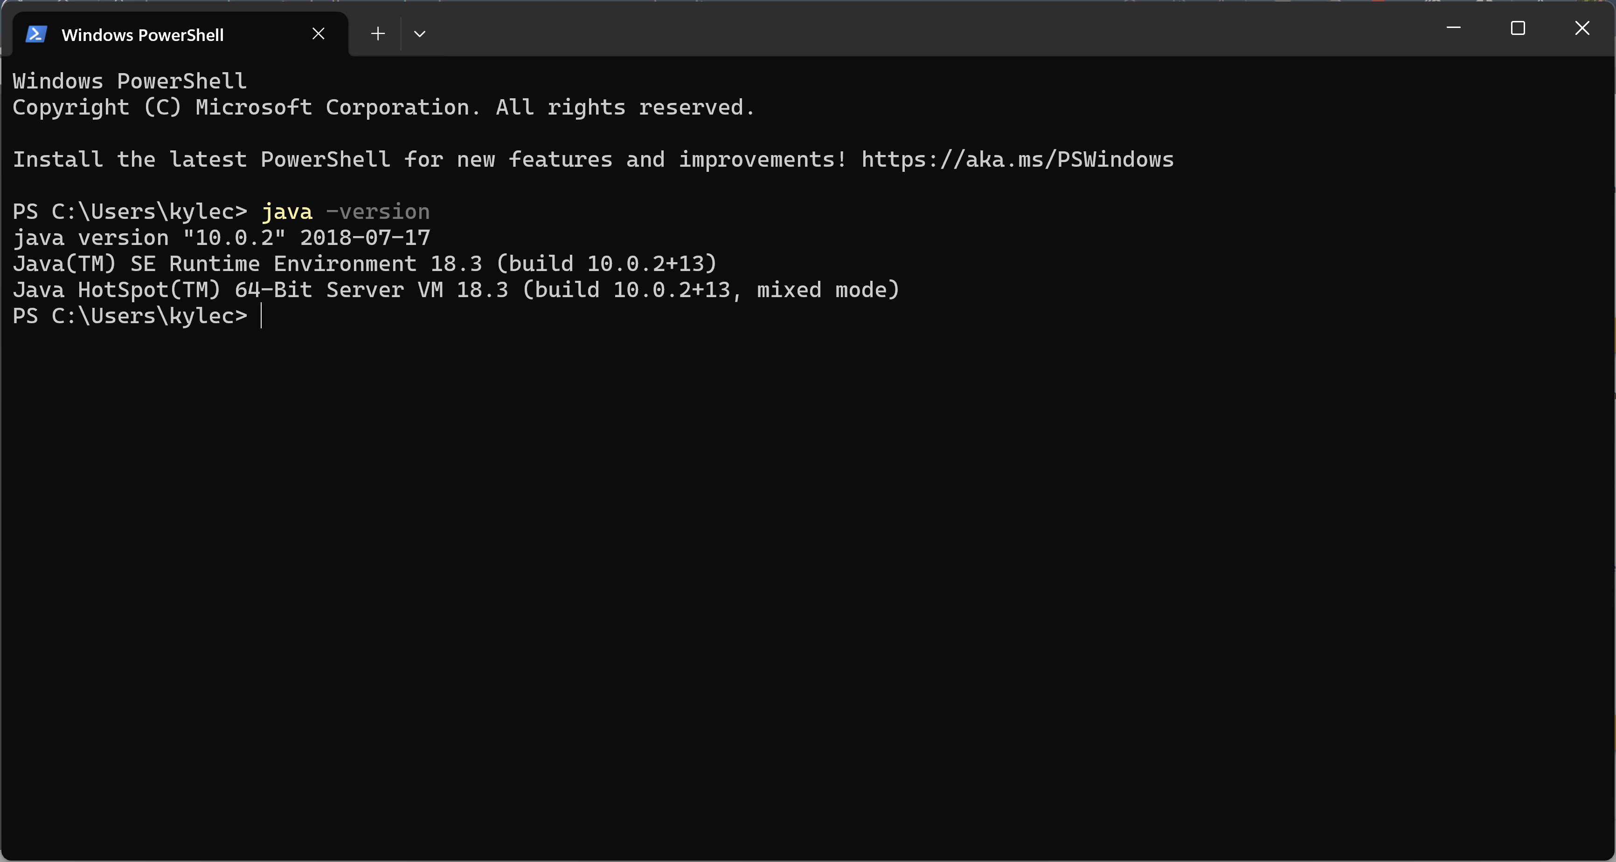
Tomcat Connection to Eclipse:
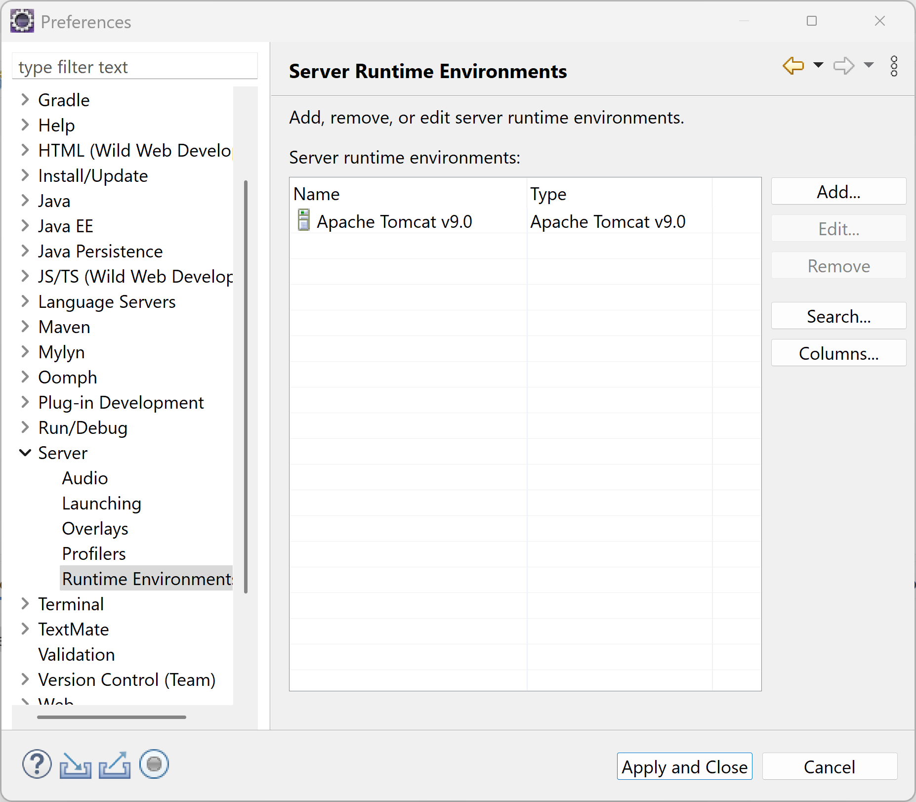
Eclipse IDE:
