Kyle Marlia-Conner
05/31/2025
Module 2

Code Screenshot (HTML/Java):
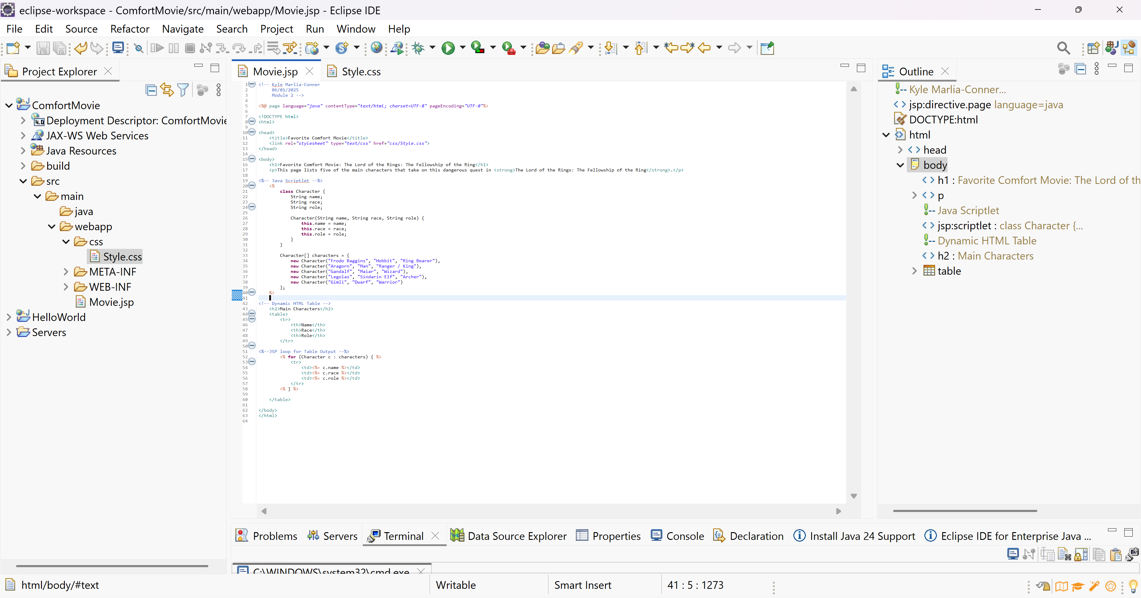
Code Screenshot (CSS):
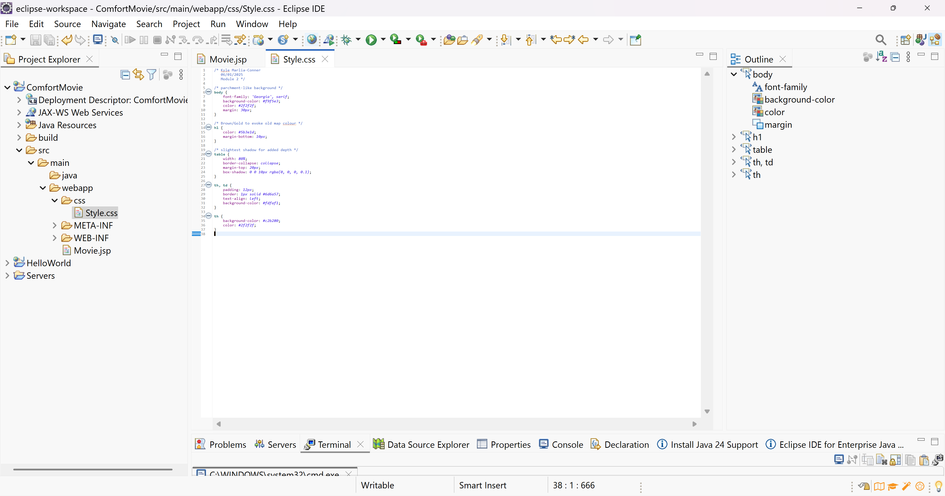
Output Screenshot:
