CS323 Documentation
About 2 pages

- Problem Statement
This assignment’s task is to create a lexical analyzer or lexer. Tokens and their lexemes are returned for an inputted file. An FSM is used to determine what characters are IDs, real numbers, and integers.

- How to use your program
- Open assignment1.exe
- Type in file name, then press enter. Or type “quit” to exit.
- Design of your program
Identifiers:
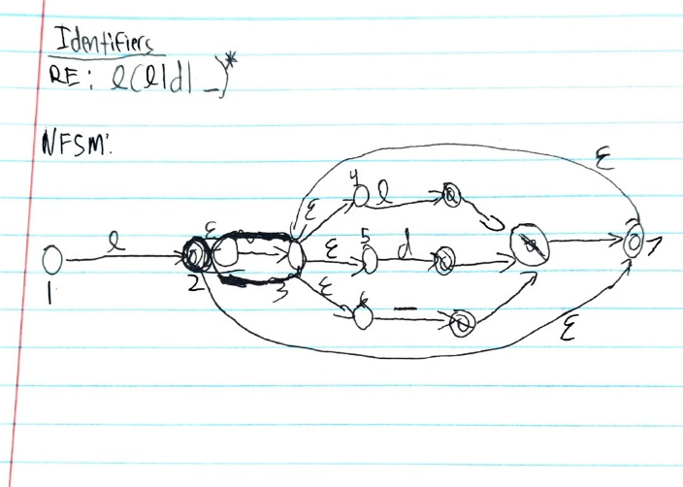
 | L | D | _
q₀ {1} 1 | {2,3,4,5,6,7} [2] | {} | {}
{2,3,4,5,6,7} | {3,4,5,6,7} | {3,4,5,6,7} | {3,4,5,6,7}
{3,4,5,6,7} | {3,4,5,6,7} | {3,4,5,6,7} | {3,4,5,6,7}
{} | {} | {} | {}
ε‑closures:
q₀ (1) = {1}
(2) = {2,3,4,5,6,7}
(3) = {3,4,5,6}
(4) = {4}
(5) = {5)
(6) = {6}
(7) = {3,4,5,6,7}
DFSM table: Accepting states 2 and 3 are identical. Remove state 3 and make 3 the empty state.

 | L | D | _
1 | 2 | 2 | 3
2 | 2 | 2 | 2
3 | 3 | 3 | 3
Final DFSM table:
2 is accepting state.
Integers:
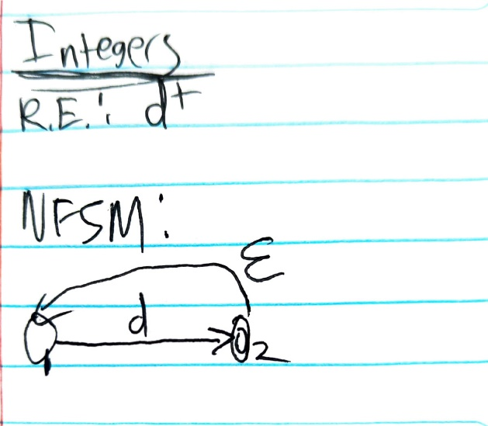
ε‑closures:
q₀ (1) = {1}
(2) = {1,2}
DFSM table: make set 3 the empty set
 | Dight | Non-Digit
q₀ {1} 1 | {1,2} [2] | []
{1,2} | {1,2} | []
[] | [] | []
Final DFSM table
 | Digit | Non-Digit
1 | 2 | 3
2 | 2 | 3
3 | 3 | 3
Real Numbers:
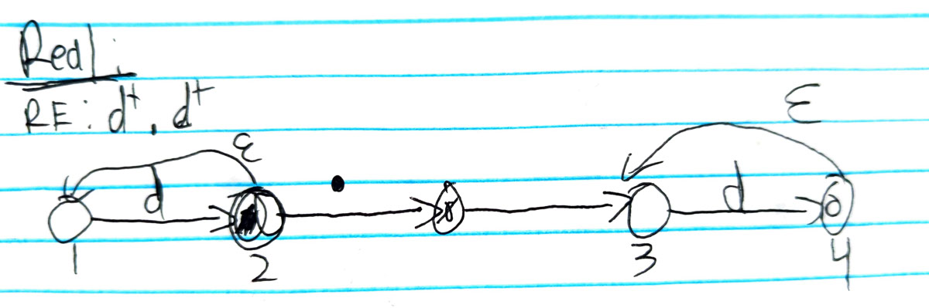
ε‑closures:
q₀ (1) = {1}
(2) = {1,2}
(3) = {3}
(4) = {3,4}
DFSM table: make set 5 an empty set
 | Digit | . | Neither
q₀ {1} 1 | {1,2} [2] | [] | []
{1,2} | {1,2} | {3} | []
{3} | {3,4} | [] | []
{3,4} | {3,4} | [] | []
[] | [] | [] | []
Final DFSM table:
 | Digit | . | Neither
1 | 2 | 5 | 5
2 | 2 | 3 | 5
3 | 4 | 5 | 5
4 | 4 | 5 | 5
5 | 5 | 5 | 5

- Any Limitation
<All features are running according to the assignment but you limit your program due to resource limitations, such as
Maximum number of lines in the source code, size of the identifier, integer etc. Say ‘None’ if there is no limitation>
None

- Any shortcomings
<Anything you could NOT implement although that is required by the
Assignment. Say ‘None’ if there is no shortcoming>
None

