Predicting Housing Prices in Greater Boston

Application of Statistics and Econometrics in Finance and Accounting
Date: June 15, 2026

1. Introduction
This report analyses the Boston housing market using the Boston dataset from the MASS package. The goal is to identify which socio-economic and structural factors best explain median home values across Boston census tracts.

Research question: What factors best predict housing prices in Boston?
Dependent variable: medv (median value of owner-occupied homes in $1,000s).
Main predictors: rm (rooms), lstat (% lower-status population), nox (air pollution), ptratio (pupil-teacher ratio), dis (distance to employment centres), and other neighbourhood variables.

2. Data Exploration
The dataset contains 506 observations and 14 variables. The data come from the 1970s and should be interpreted in that historical context.

Table 1. Summary statistics
variable | mean | sd | min | max
crim | 3.614 | 8.602 | 0.006 | 88.976
zn | 11.364 | 23.322 | 0.000 | 100.000
indus | 11.137 | 6.860 | 0.460 | 27.740
chas | 0.069 | 0.254 | 0.000 | 1.000
nox | 0.555 | 0.116 | 0.385 | 0.871
rm | 6.285 | 0.703 | 3.561 | 8.780
age | 68.575 | 28.149 | 2.900 | 100.000
dis | 3.795 | 2.106 | 1.130 | 12.126
rad | 9.549 | 8.707 | 1.000 | 24.000
tax | 408.237 | 168.537 | 187.000 | 711.000
ptratio | 18.456 | 2.165 | 12.600 | 22.000
black | 356.674 | 91.295 | 0.320 | 396.900
lstat | 12.653 | 7.141 | 1.730 | 37.970
medv | 22.533 | 9.197 | 5.000 | 50.000

Data issues:
- medv is censored at 50 ($50,000) for 16 tracts.
- crim is highly right-skewed.
- Strong correlations among predictors suggest multicollinearity.
- Cross-sectional data limits causal interpretation.

Table 2. High correlations among predictors (|r| > 0.7)
var1 | var2 | r
indus | nox | 0.764
nox | age | 0.731
indus | dis | -0.708
nox | dis | -0.769
age | dis | -0.748
indus | tax | 0.721
rad | tax | 0.910

Figure 1. Distribution of medv
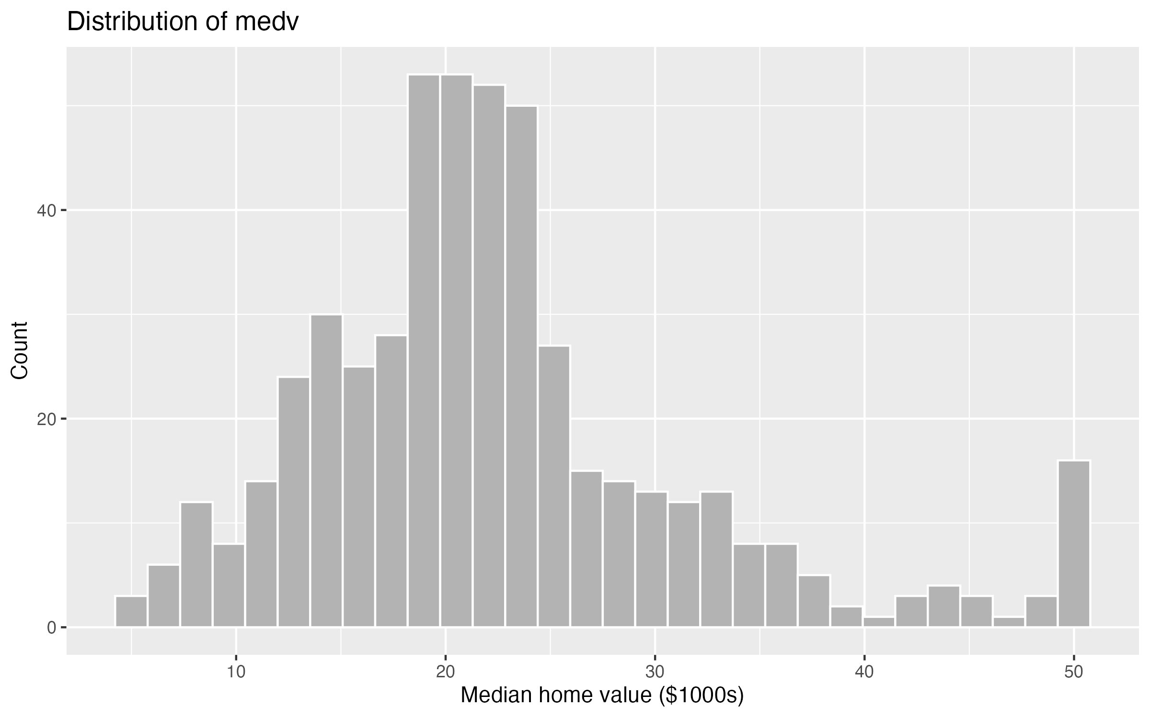

Figure 2. Correlation matrix
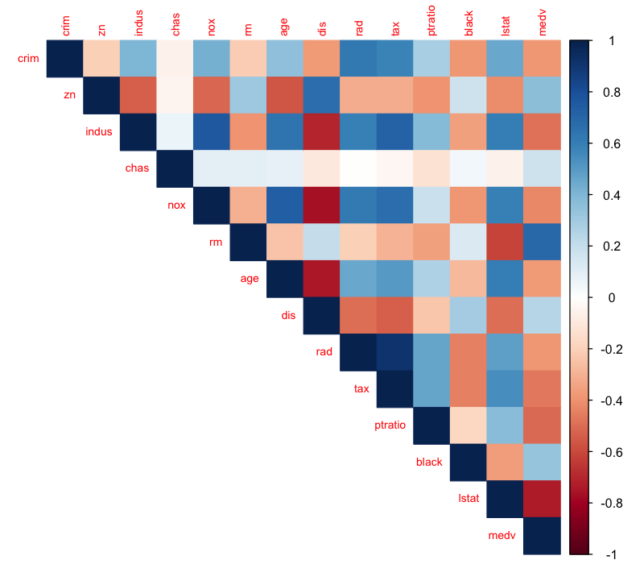

Figure 3. medv vs lstat
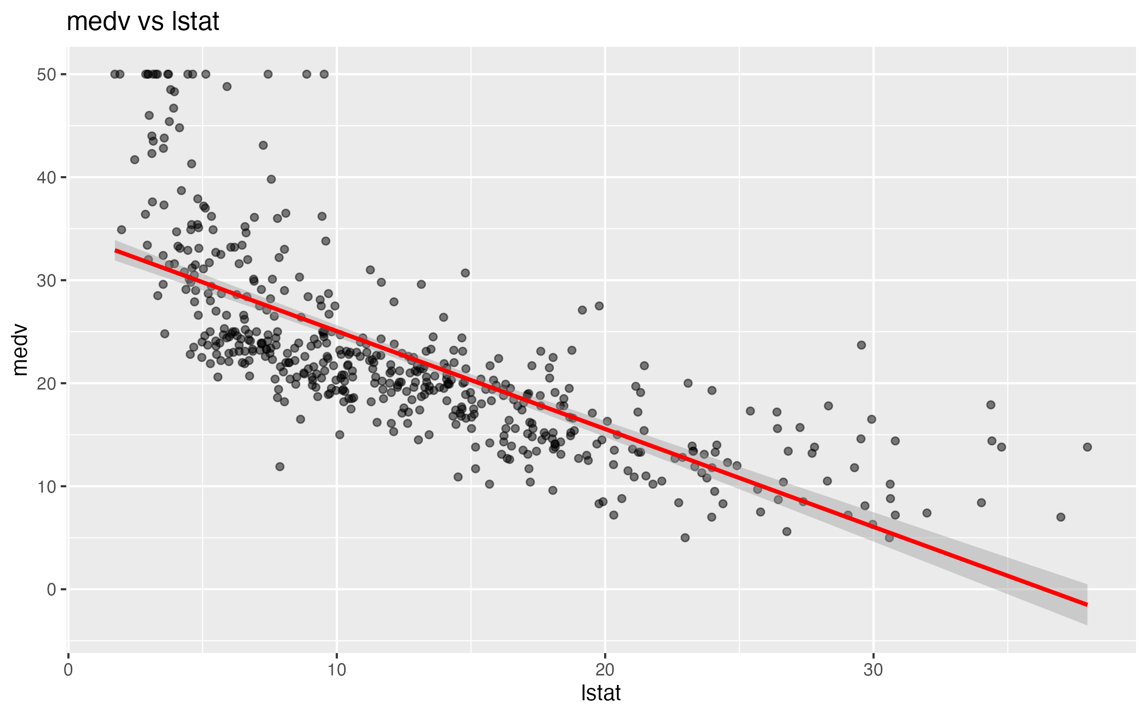

Figure 4. medv vs rm
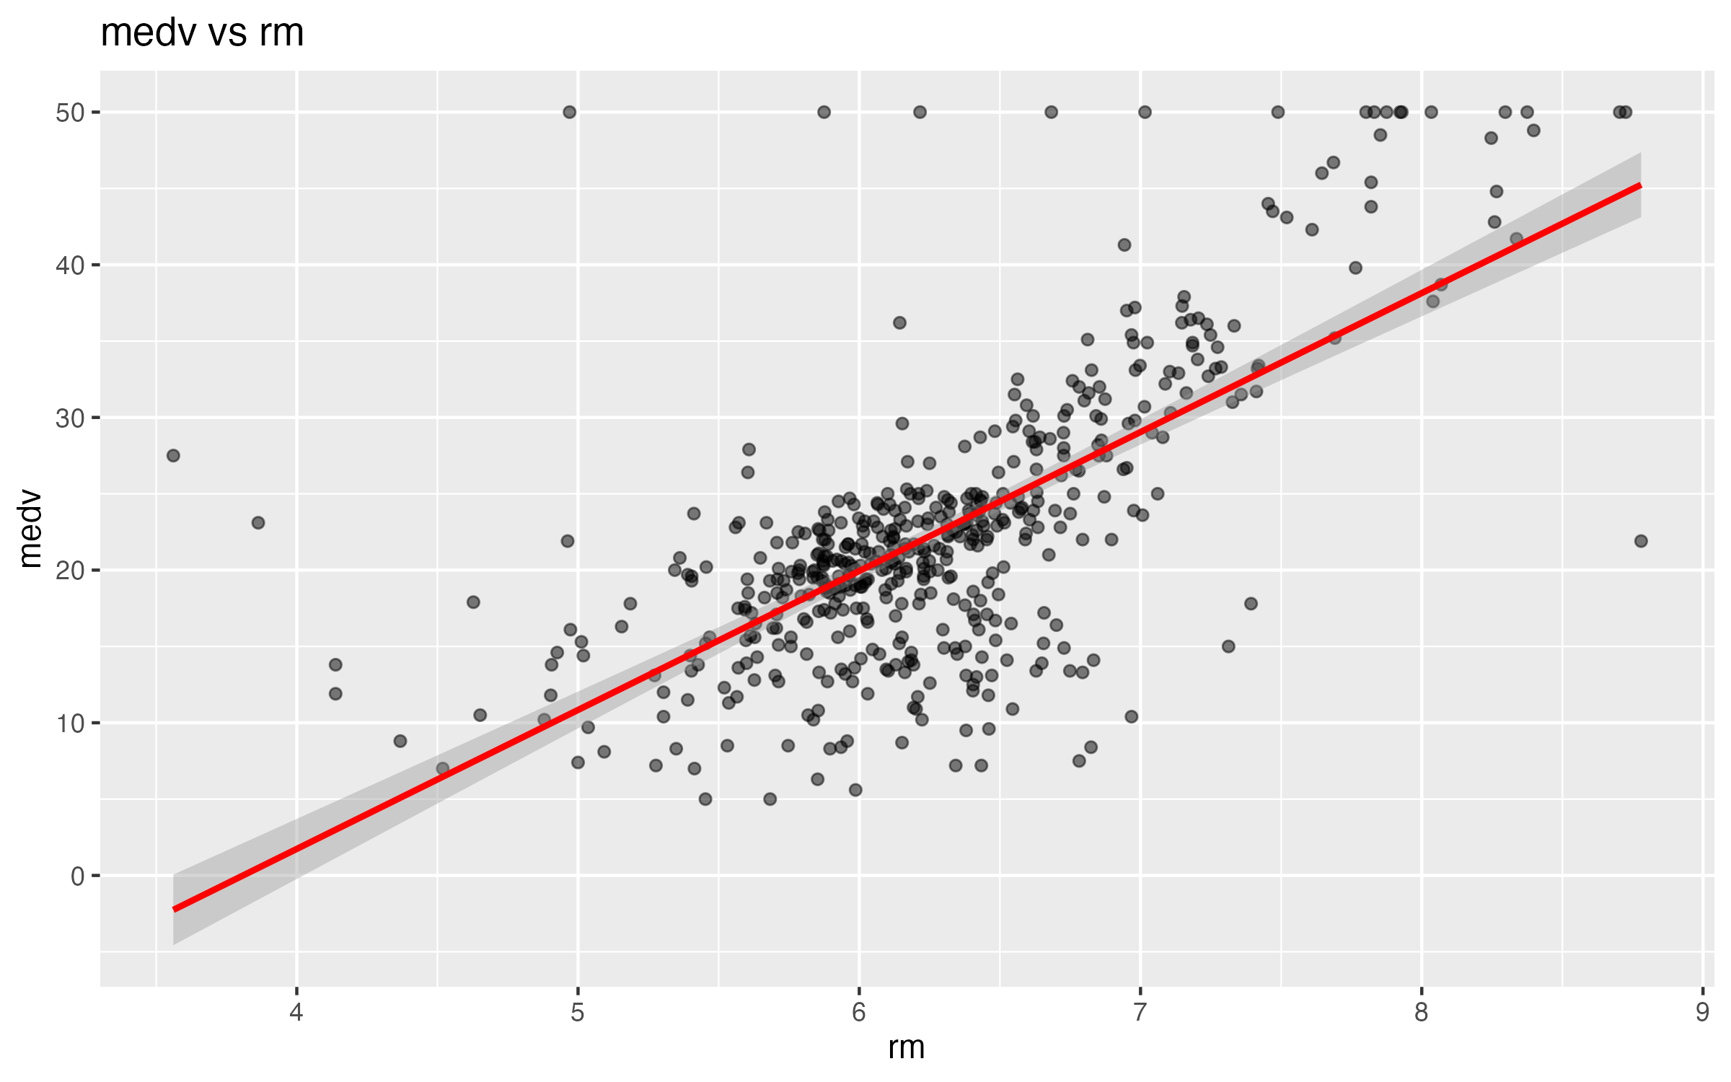

3. Regression Analysis

3.1 Simple linear regression
Four simple models were estimated: medv ~ rm, medv ~ lstat, medv ~ nox, and medv ~ ptratio.

Table 3. Simple regression models
model | r_squared | adj_r_sq | AIC | BIC
rm | 0.484 | 0.483 | 3,352.151 | 3,364.831
lstat | 0.544 | 0.543 | 3,288.975 | 3,301.655
nox | 0.183 | 0.181 | 3,584.455 | 3,597.135
ptratio | 0.258 | 0.256 | 3,535.591 | 3,548.270

The best simple model is lstat with adjusted R-squared = 0.543.
A higher lstat is associated with lower median home values. More rooms (rm) are associated with higher values.

Figure 5. Simple regression: medv ~ lstat
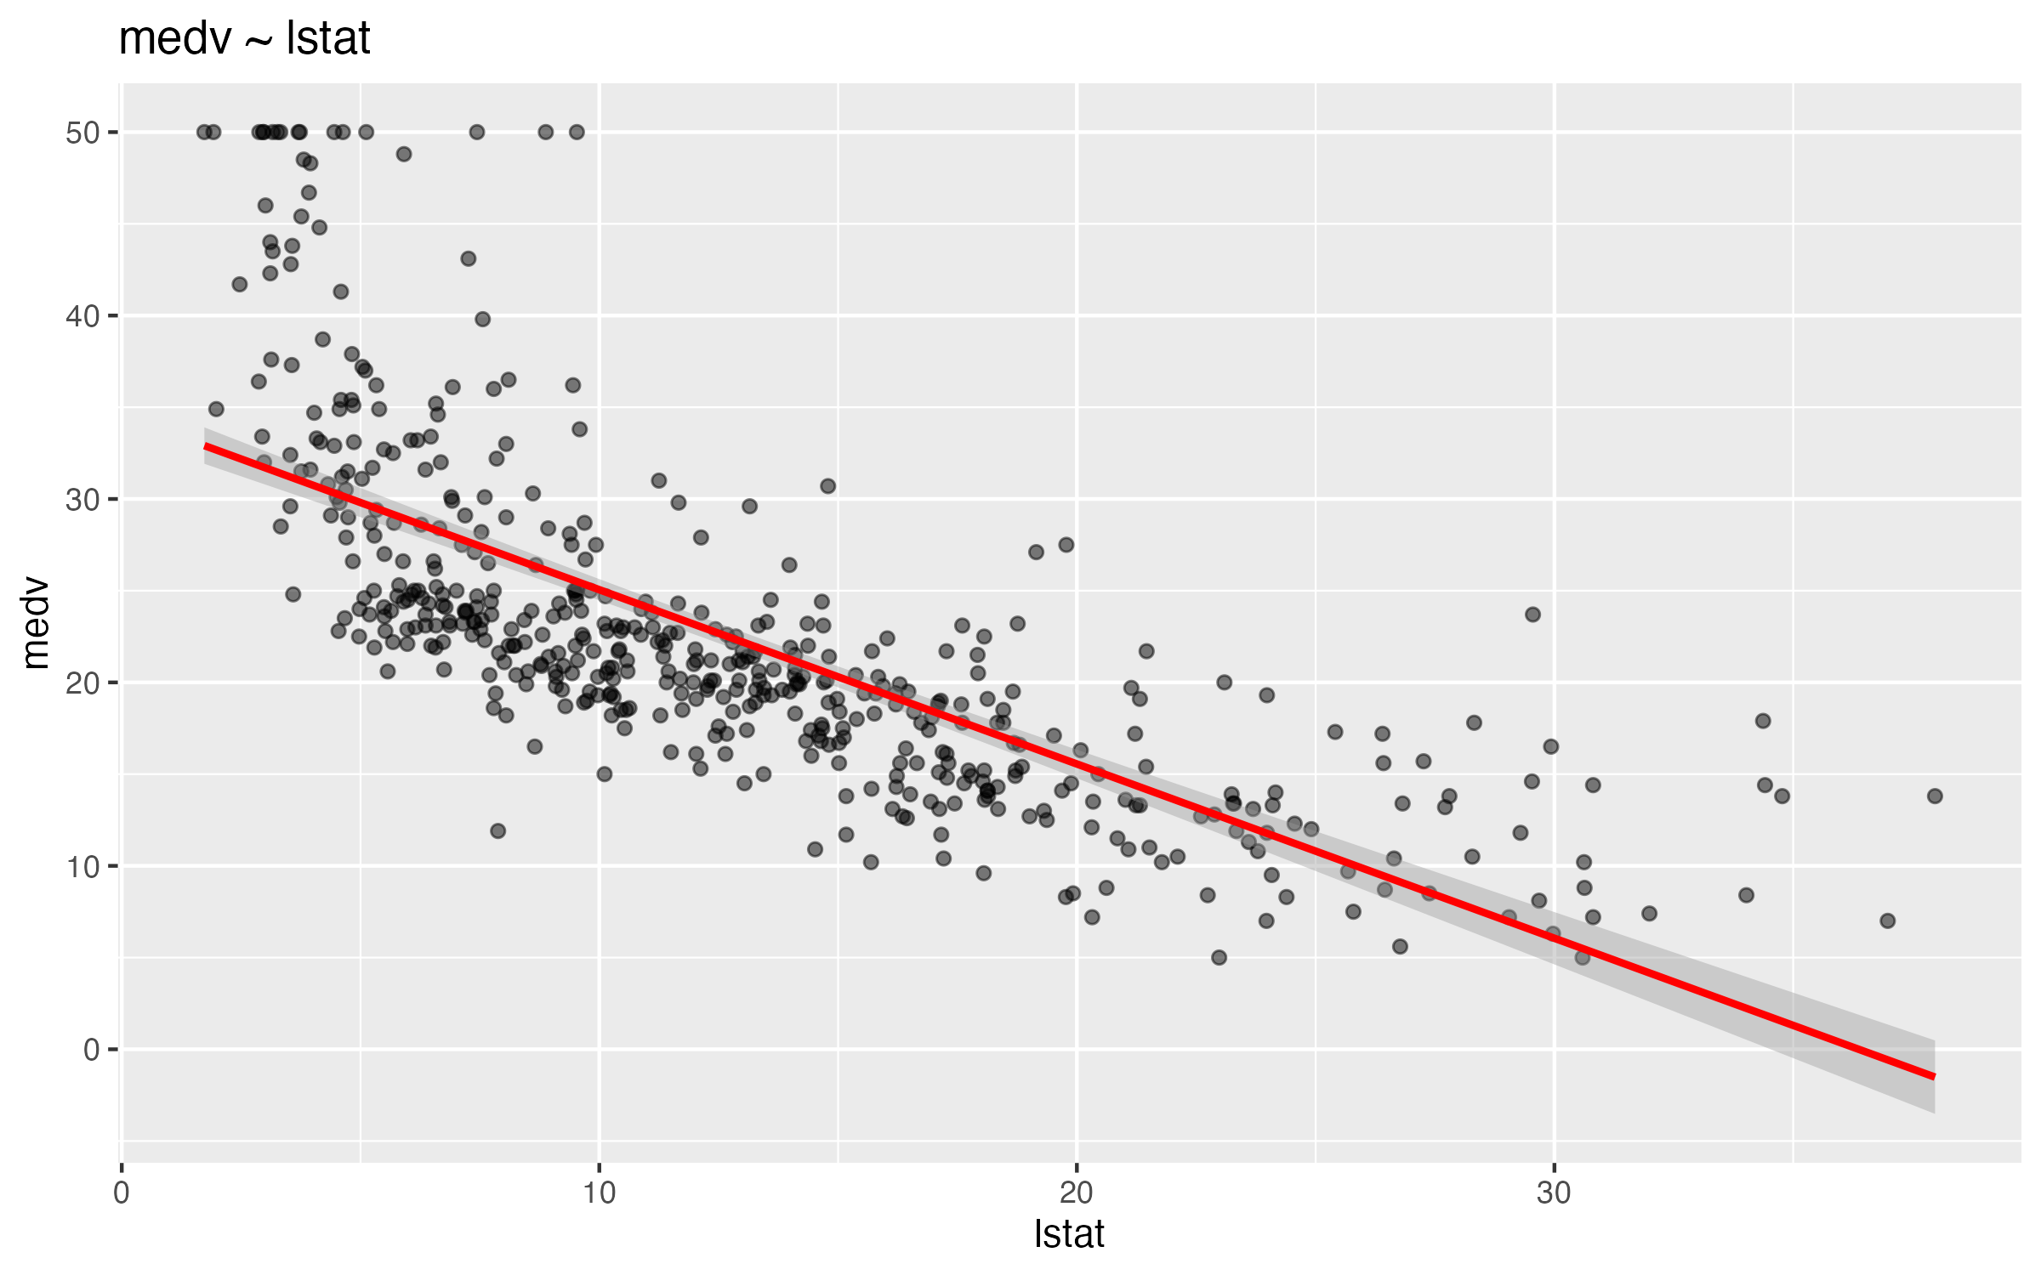

Figure 6. Simple regression: medv ~ rm
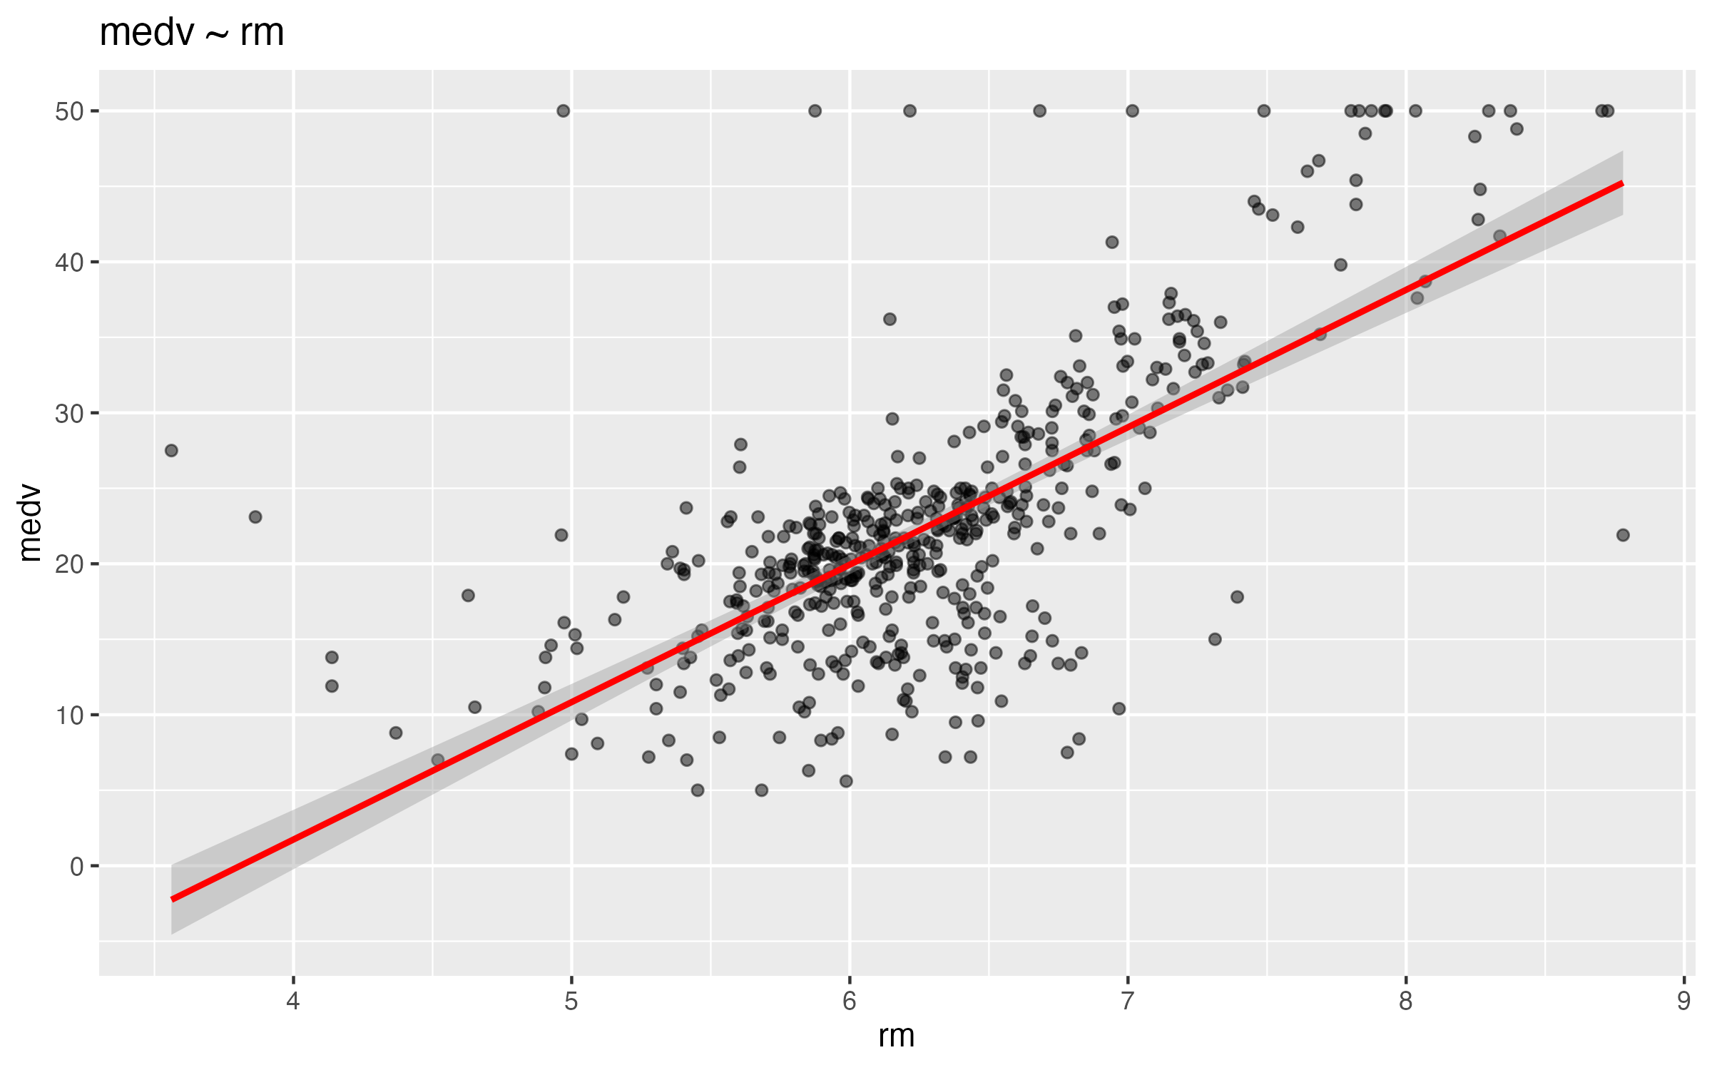

3.2 Multiple regression
Three manual multiple regression models were estimated:
MR1: medv ~ rm + lstat + nox + dis
MR2: medv ~ rm + age + tax + ptratio
MR3: medv ~ rm + lstat + ptratio + dis + nox + chas

Table 4. Multiple regression models
model | r_squared | adj_r_sq | AIC | BIC
mr1 | 0.659 | 0.656 | 3,148.768 | 3,174.127
mr2 | 0.603 | 0.600 | 3,224.662 | 3,250.021
mr3 | 0.716 | 0.712 | 3,059.939 | 3,093.751

3.3 Model selection
stepAIC() and regsubsets() were used for automated model selection. Both methods selected the same final model:
medv ~ crim + zn + chas + nox + rm + dis + rad + tax + ptratio + black + lstat

Table 5. Comparison of all models
model | r_squared | adj_r_sq | AIC | BIC
rm | 0.484 | 0.483 | 3,352.151 | 3,364.831
lstat | 0.544 | 0.543 | 3,288.975 | 3,301.655
nox | 0.183 | 0.181 | 3,584.455 | 3,597.135
ptratio | 0.258 | 0.256 | 3,535.591 | 3,548.270
mr1 | 0.659 | 0.656 | 3,148.768 | 3,174.127
mr2 | 0.603 | 0.600 | 3,224.662 | 3,250.021
mr3 | 0.716 | 0.712 | 3,059.939 | 3,093.751
stepAIC | 0.741 | 0.735 | 3,023.726 | 3,078.671
regsubsets | 0.741 | 0.735 | 3,023.726 | 3,078.671

The final model explains about 73.5% of the variation in medv (adjusted R-squared = 0.735).

3.4 Linear vs nonlinear models (diminishing returns)
To test whether house size and neighbourhood status show diminishing returns, quadratic terms were added to the simple models:
- medv ~ rm + rm^2
- medv ~ lstat + lstat^2

Table 6. Linear vs nonlinear model comparison
model | r_squared | adj_r_sq | AIC | BIC
rm linear | 0.484 | 0.483 | 3,352.151 | 3,364.831
rm + rm^2 | 0.548 | 0.547 | 3,286.202 | 3,303.109
lstat linear | 0.544 | 0.543 | 3,288.975 | 3,301.655
lstat + lstat^2 | 0.641 | 0.639 | 3,170.516 | 3,187.422
mr1 linear | 0.659 | 0.656 | 3,148.768 | 3,174.127
mr1 + rm^2 + lstat^2 | 0.766 | 0.763 | 2,961.897 | 2,995.709

Table 7. Quadratic term estimates
model | term | estimate | std.error | p.value
rm + rm^2 | I(rm^2) | 2.470 | 0.291 | 0
lstat + lstat^2 | I(lstat^2) | 0.044 | 0.004 | 0

Table 8. ANOVA tests: linear vs quadratic models
comparison | p_value
rm linear vs rm + rm^2 | 0
lstat linear vs lstat + lstat^2 | 0

For rm, the quadratic term is significant (p = 0) and positive. This suggests increasing returns to additional rooms.
For lstat, the quadratic term is significant (p = 0) and positive. The negative effect of socioeconomic status weakens at higher levels of lstat.

Figure 10. medv vs rm: linear vs quadratic fit
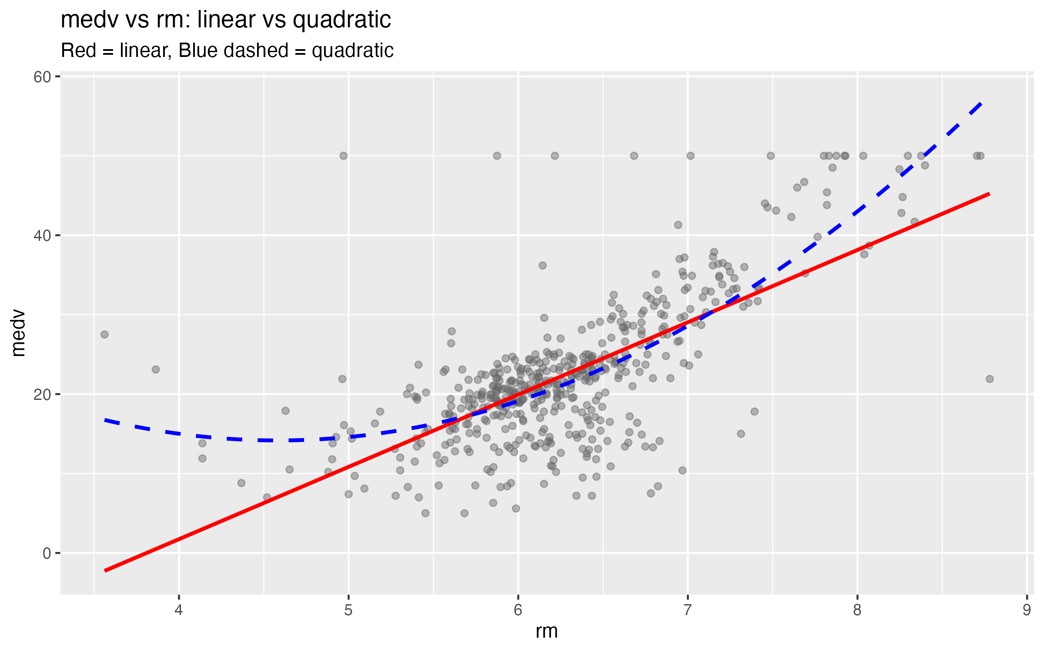

Figure 11. medv vs lstat: linear vs quadratic fit
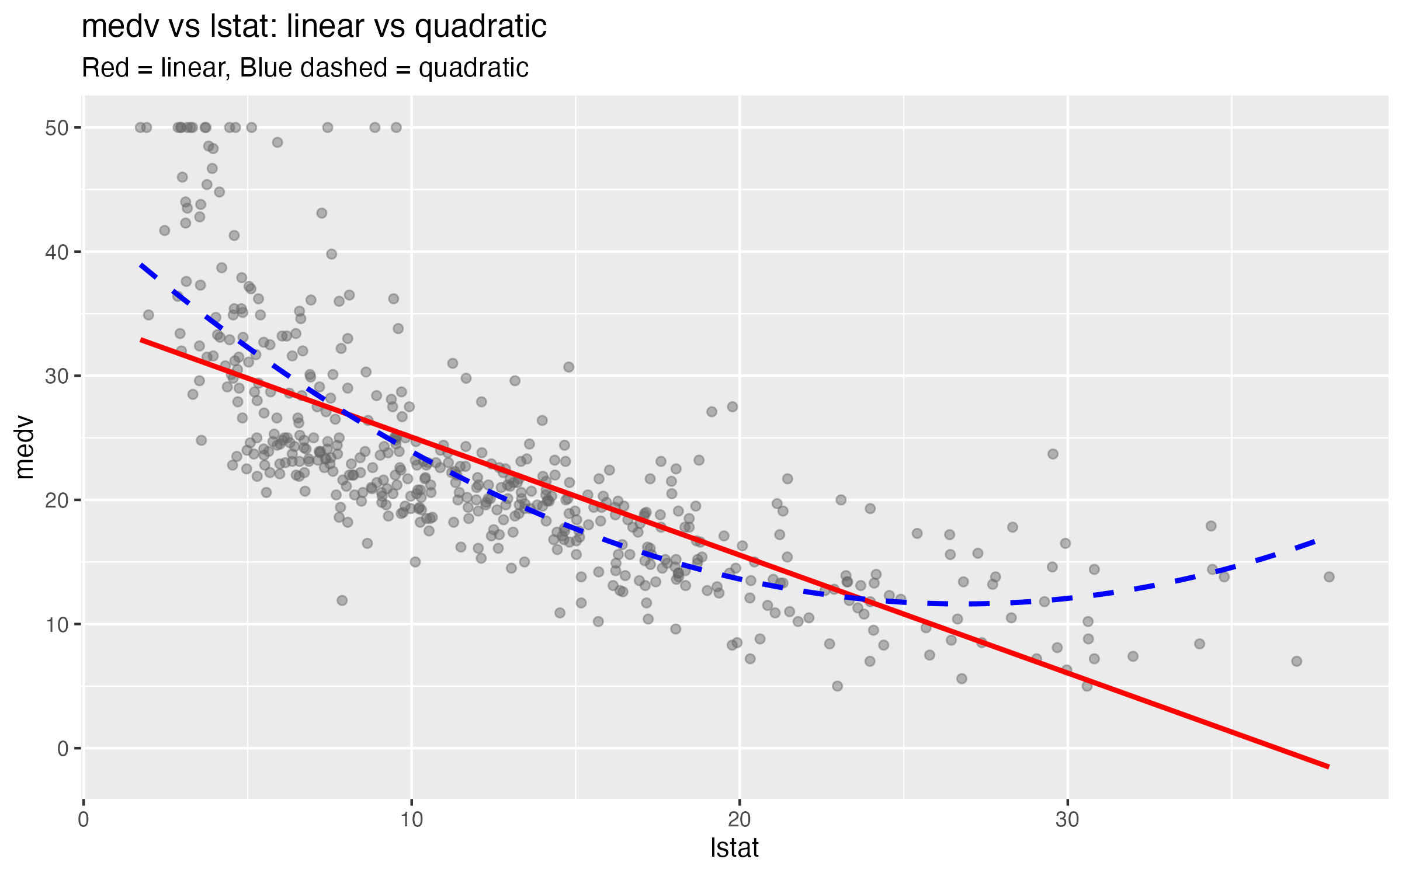

4. Model Diagnostics

Table 9. Variance Inflation Factors
variable | VIF
crim | 1.790
zn | 2.239
chas | 1.060
nox | 3.778
rm | 1.835
dis | 3.443
rad | 6.861
tax | 7.272
ptratio | 1.758
black | 1.342
lstat | 2.582
rad and tax have VIF above 5, indicating moderate multicollinearity.

Figure 7. Residuals vs fitted values
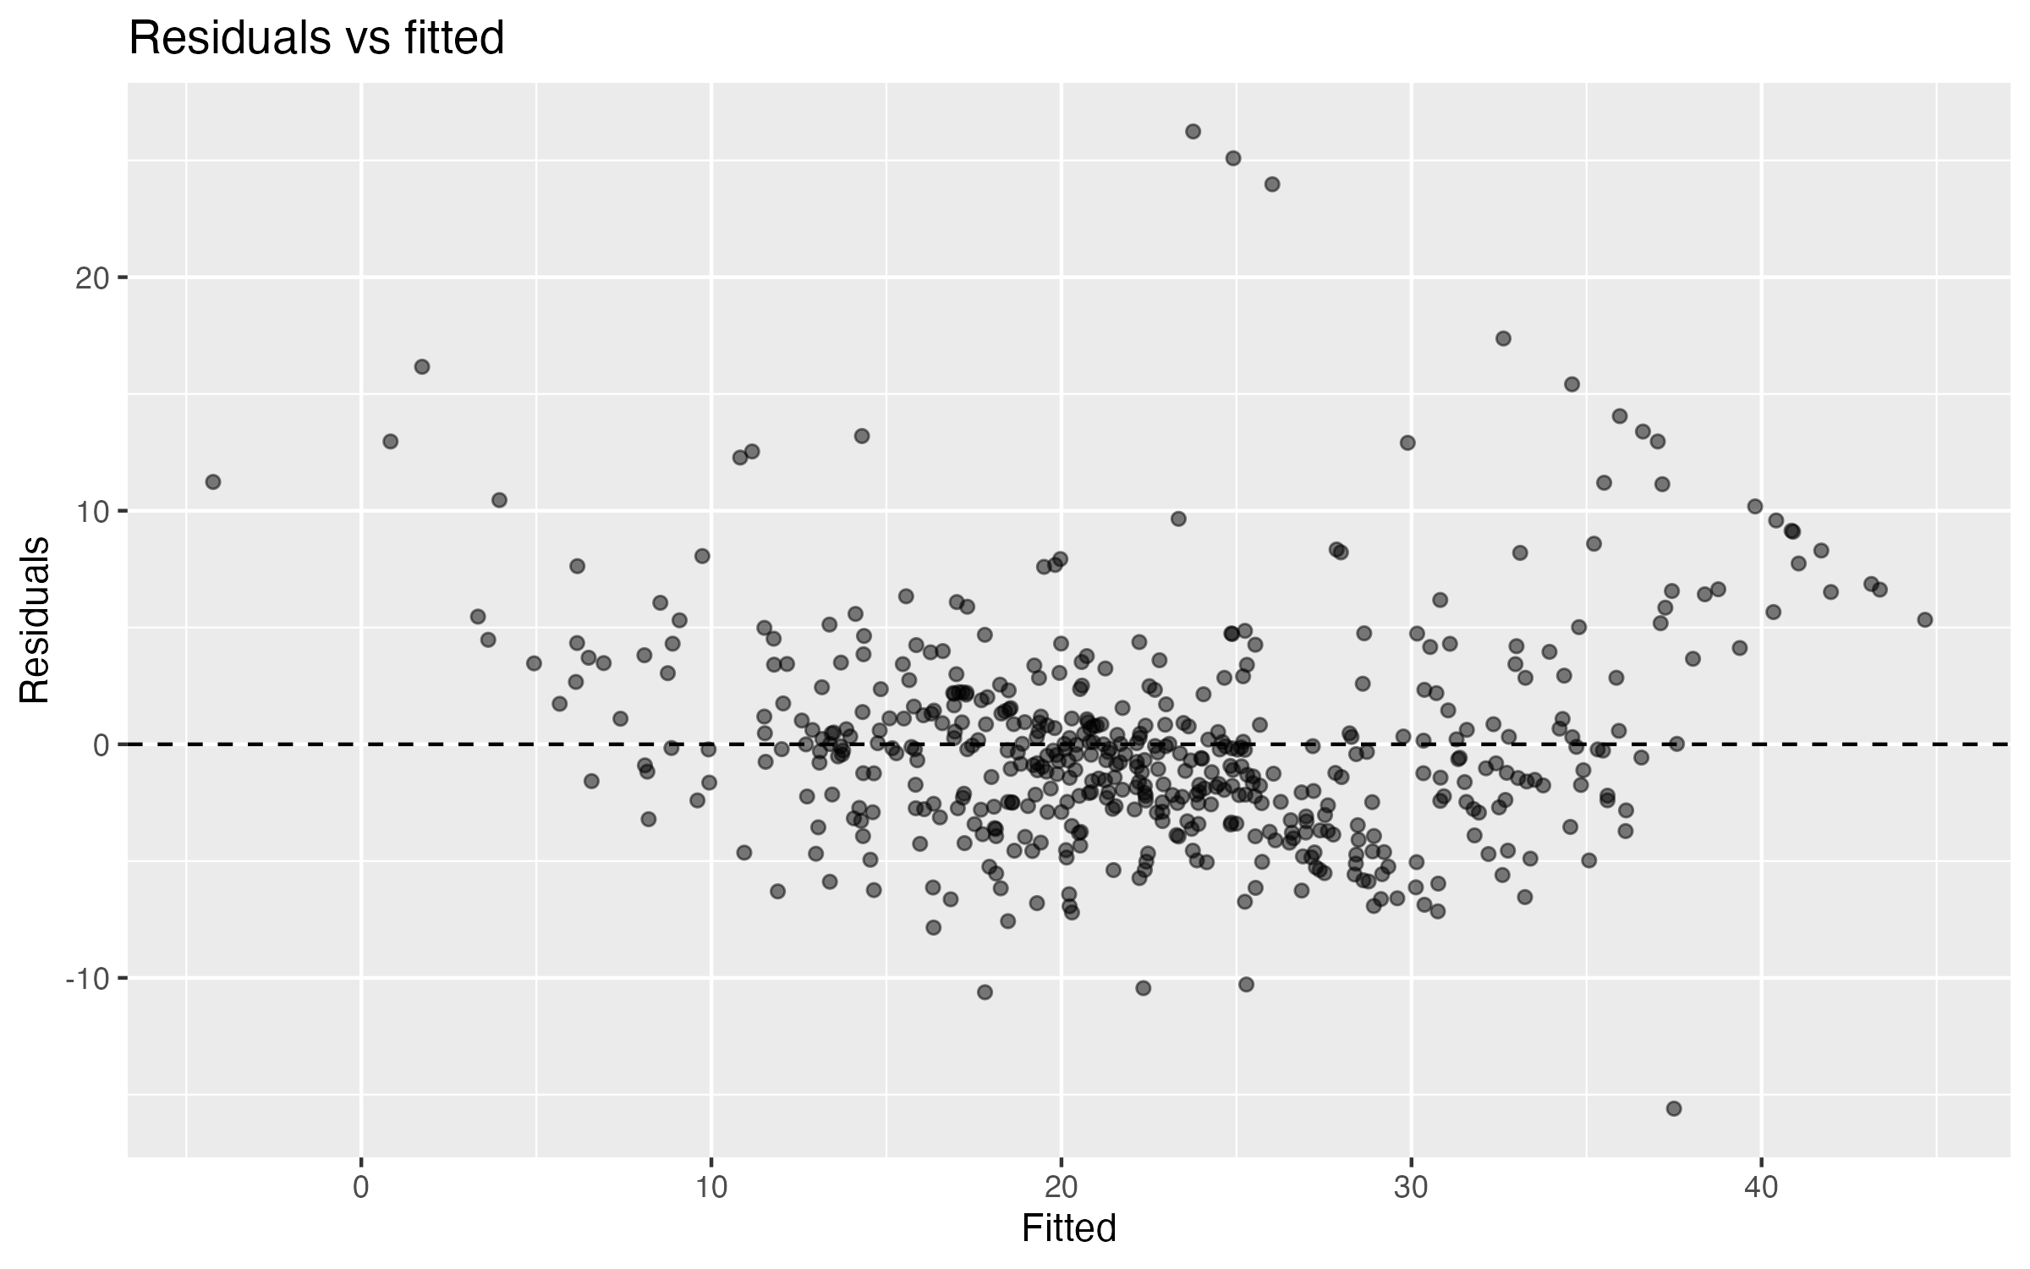

Figure 8. Q-Q plot of residuals
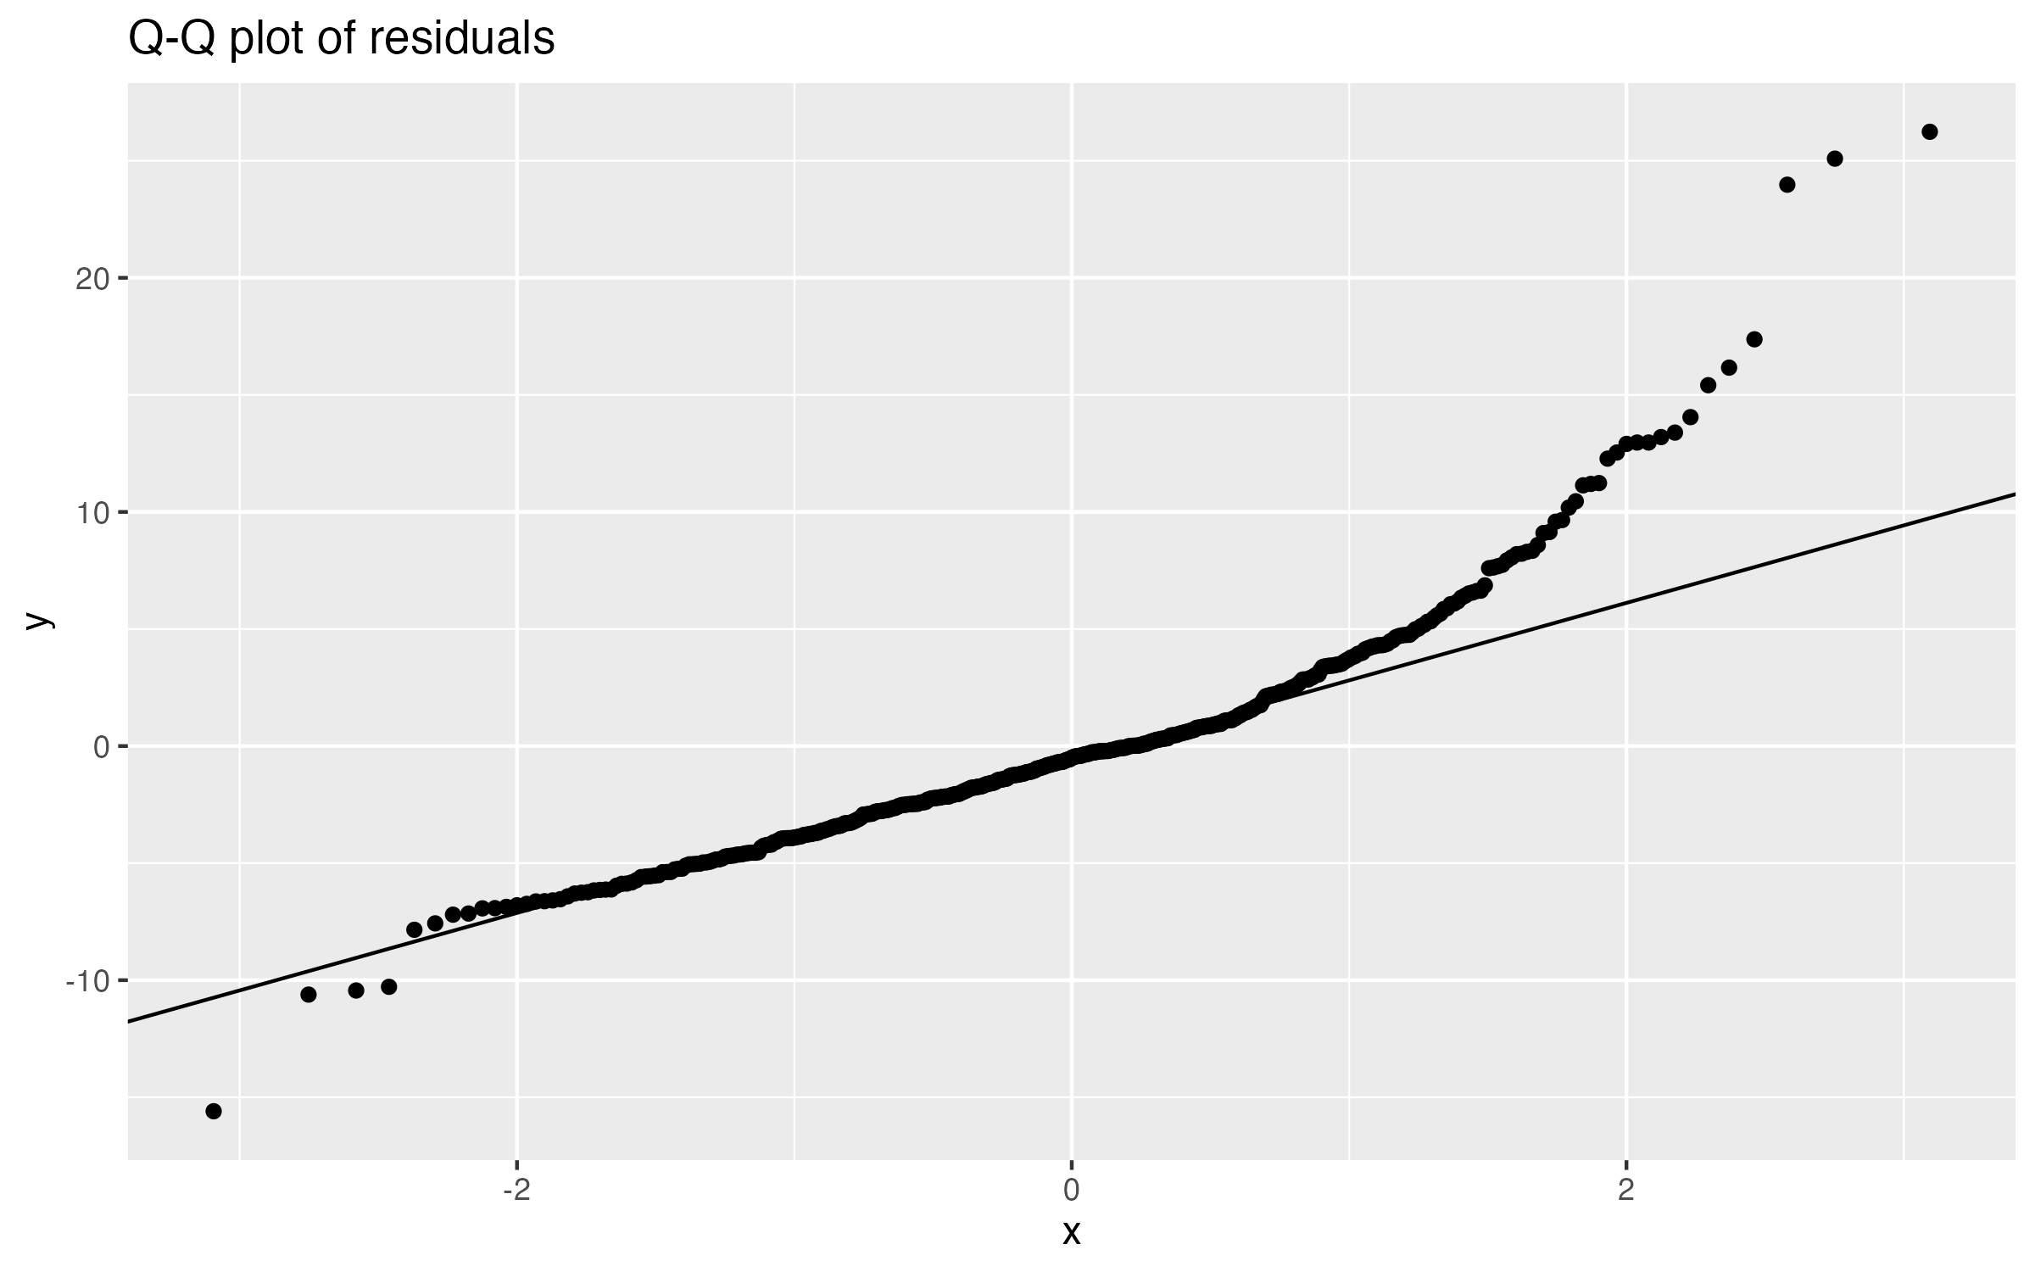

Figure 9. Regression diagnostics
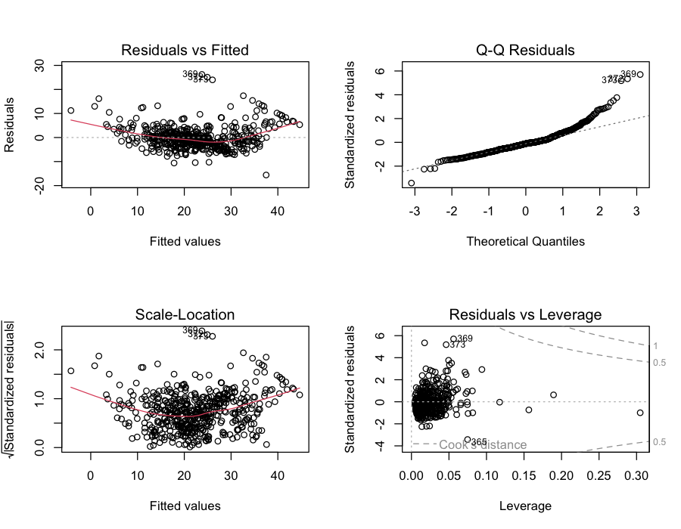

5. Interpretation
In the final model, the strongest effects come from lstat, rm, nox, and dis. Each additional room increases median home value by about $3,800. A 10-point increase in lstat reduces median value by about $5,200.
Multiple regression clearly outperforms simple regression (adjusted R-squared increases from about 0.54 to 0.73).

6. Limitations
- Cross-sectional data; causal claims are not possible.
- Omitted variables such as renovation quality or local amenities.
- medv is censored at $50,000.
- Data reflect 1970s conditions.
- Multicollinearity affects precision of individual coefficients.

7. Conclusion
Median housing prices in Boston are best explained by a combination of housing size, socioeconomic composition, environmental quality, accessibility, and school quality. For real estate analysis, a multivariate model is preferable to single-predictor models.

Appendix
All results can be reproduced with:
source('install_packages.R'); source('run_all.R')

