## **LAB 2 Coding on data center design**

In my program, it is possible to compute numbers of needed cables, TORs and Spine switches for a given server’s number. The computation runs for 2 layer Data Center with a particular Ratio. The Ratio is used to calculate the constraints in Top of the rack server, then connect TORs to a suitable amount of Spine Switches.

Dialog box:

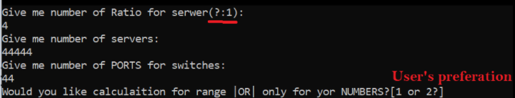

User’s preferation:

* 1

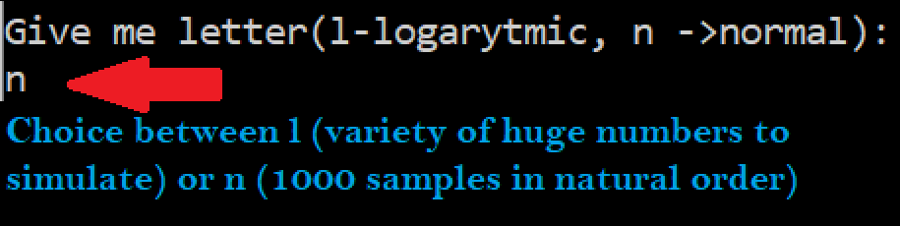

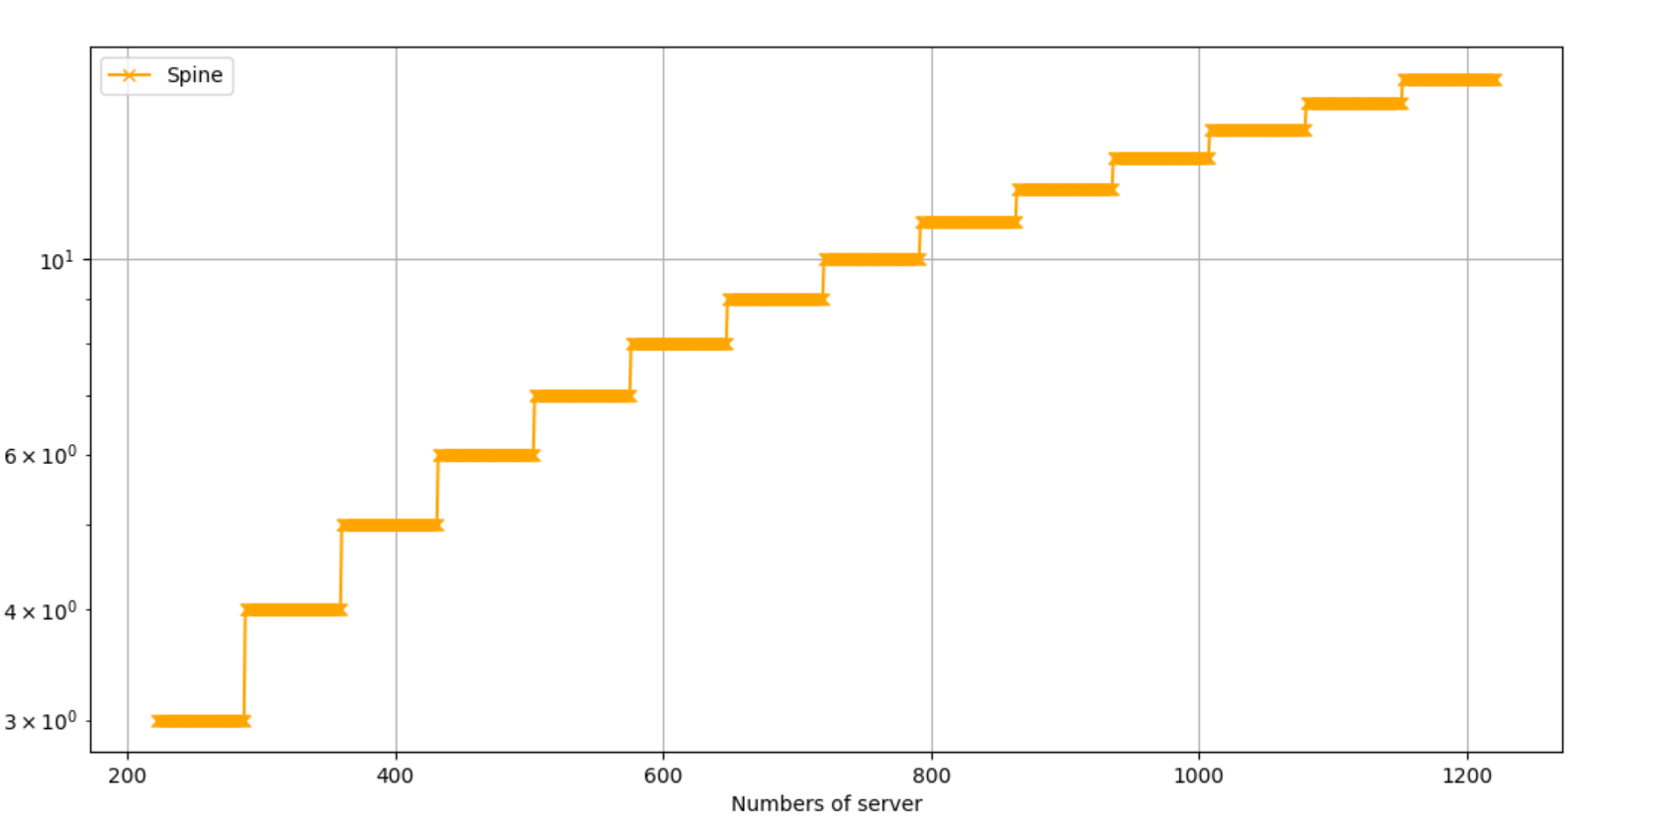

*y - Spine switches

If you want to plot cables or TORs you ought to uncomment a line in the plot function.

* 2

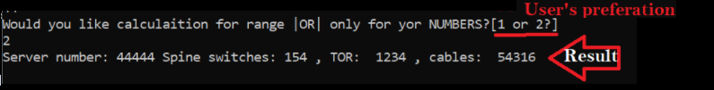

*Cables includes connection of servers to TOR

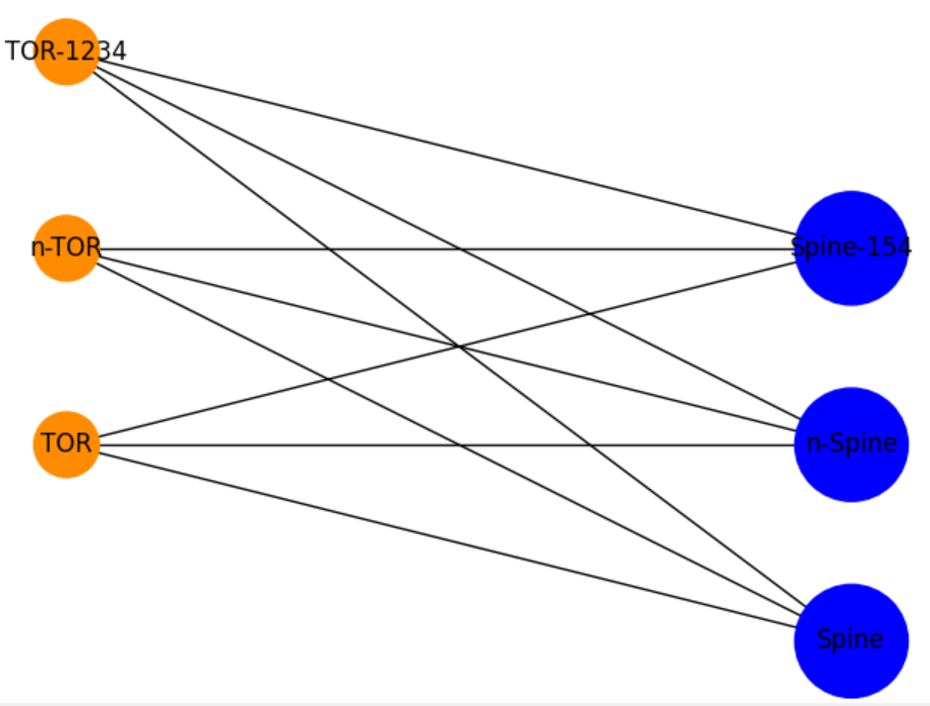

Illustative graph shows that every Tor links to each spine’s switch.