Silego Light

The project presents the rich possibilities of the Silego SLG46620 chip. It deploys its digital and analogue resources.

Initially a stepper motor driver was created. See Video1.mp4. But it didn't reveal the whole beauty of the chip.

Could it handle more complex application?

By adding only two resistors, two fotoresistors and two diodes (see the schematics below) it turned into quite a functional application.

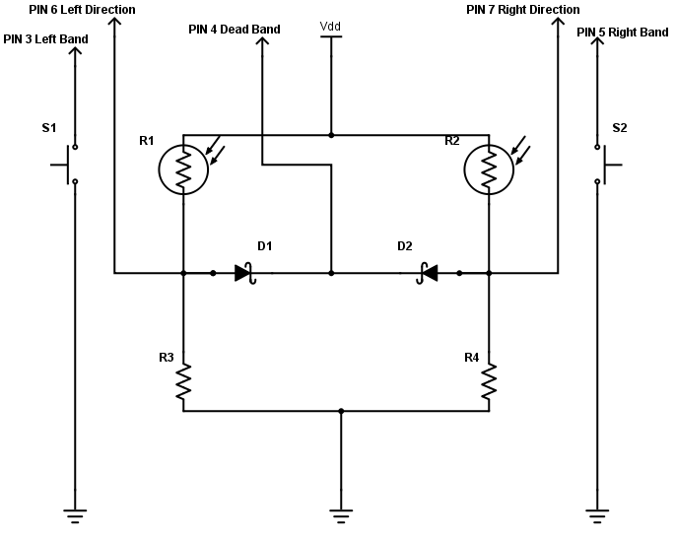
This is a light following device. When properly mounted it could follow the source of light by being turned left or right by the stepper motor.

Just watch Video2.mp4.

At the very beginning it demonstrates the dead band. The amount of light on two of the fotoresistors is more less the same. The drive remains steady. Then a beam of light is directed at one of the fotoresistors. It turns in one direction. Then the beam passes to the other one. The motor changes its direction. Finally after a while it hits one of the limits (when I make the short) and the motor stops. But it is OK when it turns in the other direction until it hits the other limit... . It is shown there just watch the video carefully.

All of this in a single chip, the tiny one.

The Silego schematics is provided below.

Matrix 0:
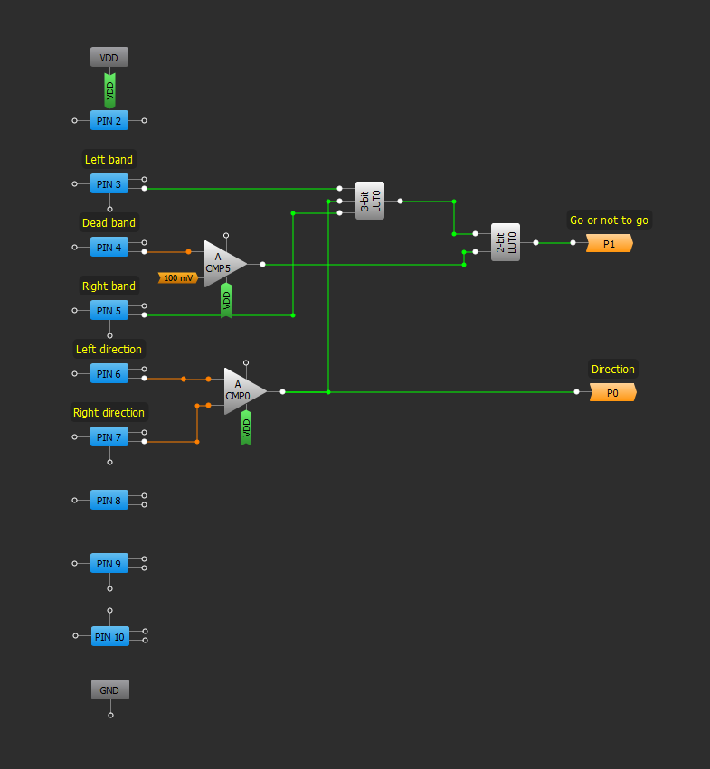

Matrix 1:

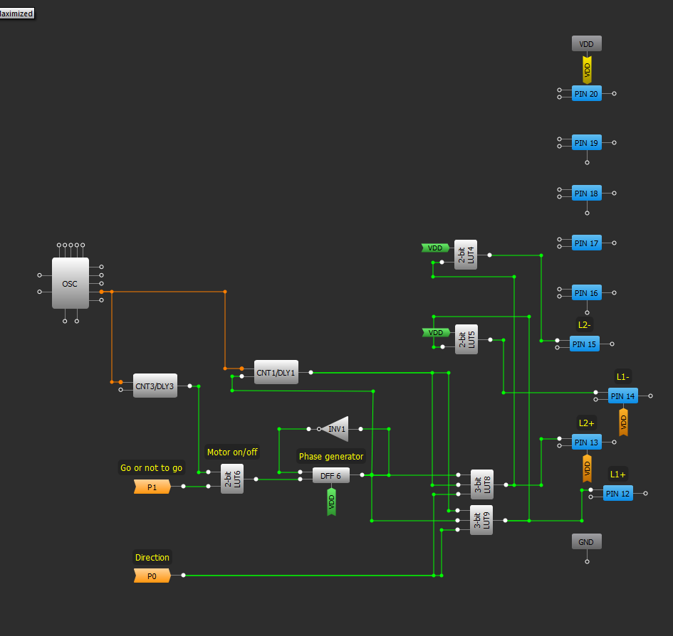

Would it be possible to squeeze more from it?

Sure it would!

In Matrix 0 there a free ADC, SPI, and PGA. That would allow for mounting a photovoltaic panel and reading its voltage with the external microcontroller. Really impressive.

