vcdMaker

A User's Guide for vcdMaker
Edition 2
April, 2016

Copyright (c) 2016 Wojciech Rynczuk
Table of Contents
1 Licensing 1
2 Introduction 2
3 Installation 3
3.1 Installing 3
3.2 Uninstalling 3
4 Getting Started with vcdMaker 4
5 Creating log files 4
6 Creating VCD files 5
7 Merging VCD files 6
8 Viewing VCD files 6
8.1 GtkWave 6
8.1.1 Downloading 6
8.1.2 First steps 7

Licensing
The MIT License (MIT)
Copyright (c) 2015 Wojciech Rynczuk
Permission is hereby granted, free of charge, to any person obtaining a copy of this software and associated documentation files (the "Software"), to deal in the Software without restriction, including without limitation the rights to use, copy, modify, merge, publish, distribute, sublicense, and/or sell copies of the Software, and to permit persons to whom the Software is furnished to do so, subject to the following conditions:
The above copyright notice and this permission notice shall be included in all
copies or substantial portions of the Software.
THE SOFTWARE IS PROVIDED "AS IS", WITHOUT WARRANTY OF ANY KIND, EXPRESS OR IMPLIED, INCLUDING BUT NOT LIMITED TO THE WARRANTIES OF MERCHANTABILITY, FITNESS FOR A PARTICULAR PURPOSE AND NONINFRINGEMENT. IN NO EVENT SHALL THE AUTHORS OR COPYRIGHT HOLDERS BE LIABLE FOR ANY CLAIM, DAMAGES OR OTHER LIABILITY, WHETHER IN AN ACTION OF CONTRACT, TORT OR OTHERWISE, ARISING FROM, OUT OF OR IN CONNECTION WITH THE SOFTWARE OR THE USE OR OTHER DEALINGS IN THE SOFTWARE.

Introduction
Quite often while debugging a computer system there are created huge log files which need to be analyzed afterwards. That could be achieved by parsing the trace and extracting the relevant information but initially one needs to know what the information is. The vcdMaker tool has been created to serve this purpose and help software and firmware engineers to analyze their applications and systems. Not only does it translate a human readable log files into the Variable Change Dump format files but also allows for their further manipulation. Finally, the end result might be easily visualized using any of the VCD viewers. As a single picture is said to be worth thousand words the approach makes the debugging process easier and more efficient.

The tool is provided as a freeware. There are no charges for using it but the development team would appreciate some feedback. All of the comments, requests or screen captures presenting the way you benefited from using it are appreciated. Contact us via vcdmaker@mail.com.

Installation

Installing
Start the installation by executing the vcdMakerInstaller.msi. Then just follow the installer. During the process you will be able to adjust the installation path. The installer will copy all the necessary files, create the shortcut to the vcdMaker manual in your Programs Menu and update the user's environmental variable PATH. Therefore once installed a user will be able to invoke the application from any location.
The setup log could be created by invoking the installer in the following way:
msiexec /i vcdMakerInstaller.msi /l*v vcdMakerInstallation.log

Uninstalling
The vcdMaker package can be easily and entirely removed by the Programs and Features Control Panel tool. Alternatively one could use the following command:
msiexec /x vcdMakerInstaller.msi

Getting Started with vcdMaker
Running vcdMaker is easy but to make the learning curve really steep there have been provided sample files one could use to get the knack of the tool.
In the target installation folder there is a sample sub-folder containing the example.txt file. It composes of an arbitrary set of signals and their values changing over time. The format of the input file has been described in 5. Copy the file to any folder you wish to experiment in.
Then, use the following command to create the output VCD file:
vcdMaker -f example.txt -o output.vcd -t us
The vcdMaker will parse the example.txt file and create the output.vcd file. That's it!
So as to get the feeling of how you could use the VCD file it is recommended to read the Chapter 8 first.

Creating log files
Let's present the format of the log file by an example below.
...
#77655698 FRDM.Sensors.Magnetometer.MagY 873 32
#77655817 FRDM.Sensors.Magnetometer.MagZ 3126 32
#77756251 FRDM.Buttons.SW1 1 1 Key pressed
#77805674 FRDM.Sensors.Magnetometer.MagX 64955 32
#77805797 FRDM.Sensors.Magnetometer.MagY 853 32
#77805916 FRDM.Sensors.Magnetometer.MagZ 3191 32
#77806061 FRDM.Sensors.Slider 99 7
#77808473 FRDM.Sensors.Accelerometer.AccX 0.538574 f
#77808473 FRDM.Sensors.Accelerometer.AccY 0.172852 f
#77808473 FRDM.Sensors.Accelerometer.AccZ 0.706543 f
...
The structure of the log line is:
TS – Time stamp. The time unit is provided later during the creation of the VCD file. The entries in the log file do not have to be ordered. In other words, the entries with lower time stamp values might follow the entries with higher time stamp values. It might be that there are a few loggers in your system accessing the same logging device (e.g. UART). They all might log at their own pace and flush the buffers randomly. The events will be reordered properly during the VCD file creation.
#TS Level1...LevelX.SignalName SignalValue [size | f] Comment

Level and SignalName – The structure describing the hierarchy for accessing the signal or the variable. The hierarchy can be illustrated by the tree. For instance:
Top_Module
|
---------------------------
| |
Module_1 Module_2
| |
-------- --------
| | | |
Var_1 Var_2 Var_1 Var_2

In total there are four variables in the system above. They could be described as follows:
Top_Module.Module_1.Var_1
Top_Module.Module_1.Var_2
Top_Module.Module_2.Var_1
Top_Module.Module_2.Var_2

SignalValue – The signal value can be an integer value or a real value (represented by the %f printf() format).
[size | f] – The signal hierarchy is followed by the size parameter or f. The size parameter shall follow integer signals and represent the number of bits needed to represent the value. Currently the maximum size shall not exceed 64. The f character shall follow a real value.
Comment – The comment is optional. It might be any user defined string.

Creating VCD files
Producing the VCD file from the log file saved in the format presented in 5 is not difficult. The syntax of the command is:
vcdMaker -f logFilename -o filename.vcd -t timeUnit [-lc lcSignalName] [-v]
logFilename – The name of the log file created in the format presented in 5.
filename – The target VCD file name.
timeUnit – The time unit in which the samples have been recorded. Available time units are: s, ms, us, ns, ps, fs.
-lc lcSignalName – the switch is optional and it allows for adding a signal containing the log line number referencing to any signal change occurring at a given time. Buy following the line number one can easily identify the interesting place in the log. The lcSignalName name shall follow the standard signal format.
-v – the switch is optional while it enables the verbose mode in which the application will print out all of the log lines not matching the expected format. It is recommended to use this mode after the initial vcdMaker execution returns a positive number of invalid lines.

Merging VCD files
In the case there was a need to analyze a distributed system in which each of the nodes produced its own log there is a possibility to merge two VCD files.
vcdMaker -f1 filename1.vcd -f2 filename2.vcd -o filename.vcd
[-m1 marker1 -m2 marker2] [-p1 prefix1] [-p2 prefix2]
filename1 – The name of the first VCD file.
filename2 – The name of the second VCD file.
filename – The target VCD file name.
marker1 – The synchronization time in the first VCD file. No time unit must be provided. The marker must follow the unit used in the first VCD file.
marker2 - The synchronization time in the second VCD file. No time unit must be provided. The marker must follow the unit used in the second VCD file.
prefix1 – A prefix to be added to all of the signals in the filename1.vcd. E.g. for '-p1 System1' the TopModule.App.Sum signal would be changed to System1.TopModule.App.Sum.
prefix2 - A prefix to be added to all of the signals in the filename2.vcd.
It is perfectly fine to provide one of the prefixes, two of them or none of them. If there are twin signals in the input files and the prefixes are not provided the conflicting situation is reported and the merging process is broken.
Merging rules
There must be two markers provided or none of them.
If no markers are provided it is assumed that the logs have been captured in the same time domain.
If two VCD files are using two different time units the finer one will be used.

Viewing VCD files
There are many applications on the market allowing for viewing Variable Change Dumb format files and they are especially popular among RTL designers. Although very often such tools are quite expensive there exist a few free alternatives and one of them has been presented later in this manual.

GtkWave
GtkWave has been chosen for various reasons. It's free, light, easy to use and it has got rich features.

Downloading
The tool can be downloaded from:
http://gtkwave.sourceforge.net/

First steps
For the users convenience there has been provided the introduction to the GtkWave on the following pages. The further details related to the tool can be found in the GtkWave documentation itself.

Step 1
Run the tool. Drag and drop the examples.vcd file to the GtkWave.
In the top SST pane expand the FRDM and select Buttons. Keep 'Ctrl' pressed and in the bottom SST pane select SW1 and SW3. Click the Append button.
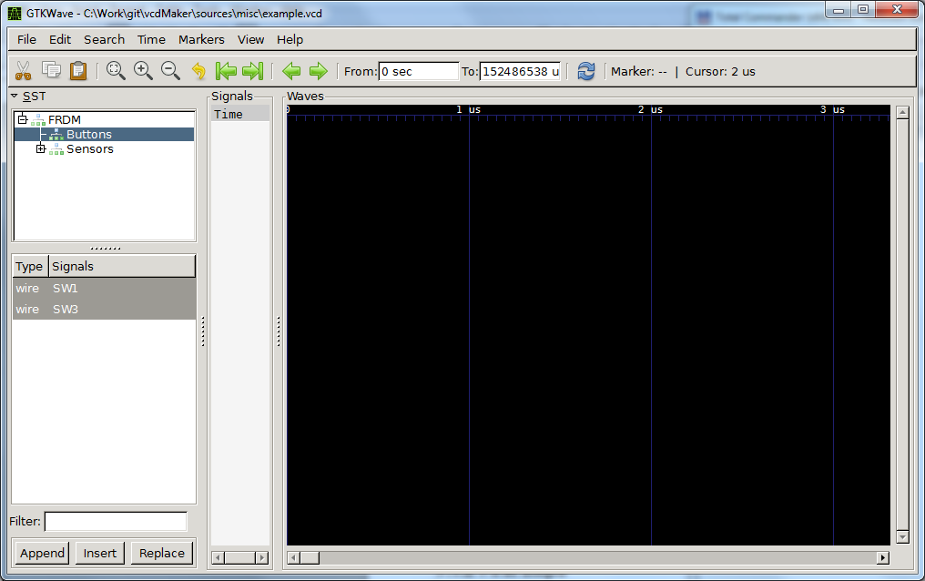

Step 2
In the top SST pane set the focus on Sensors. Keeping 'Ctrl' pressed select Light and Slider from the bottom SST pane. Click the Append button.
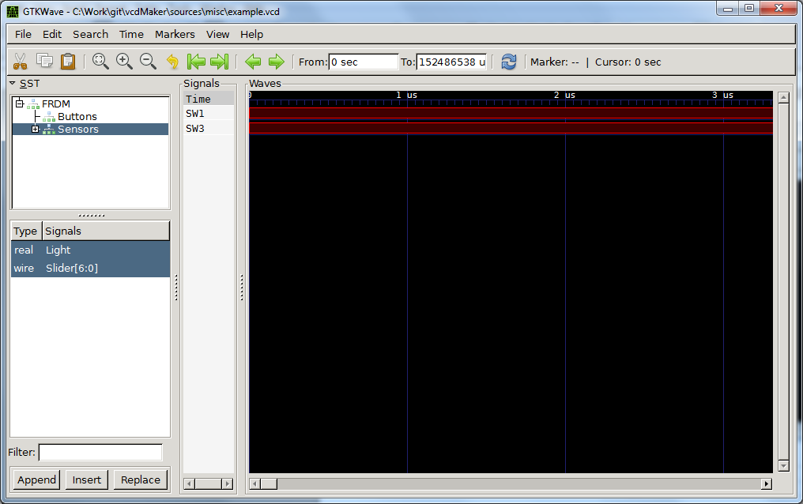

Step 3
In the top SST pane expand Sensors and select Accelerometer. In the bottom SST pane select AccX. Click Append again.
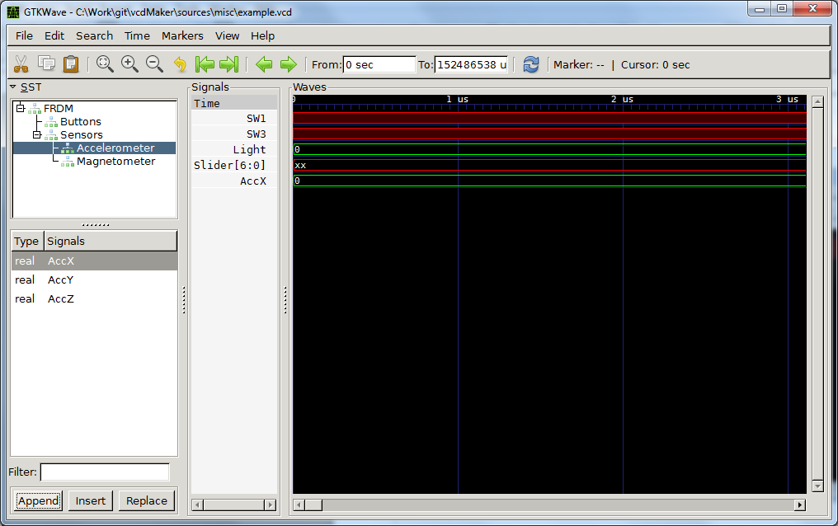

Step 4
In the Signals pane select SW3. Press Find Next Edge button (green right arrow) three times. Then, press Zoom Out button (zoom minus) several times so as you get a similar view scale as below.
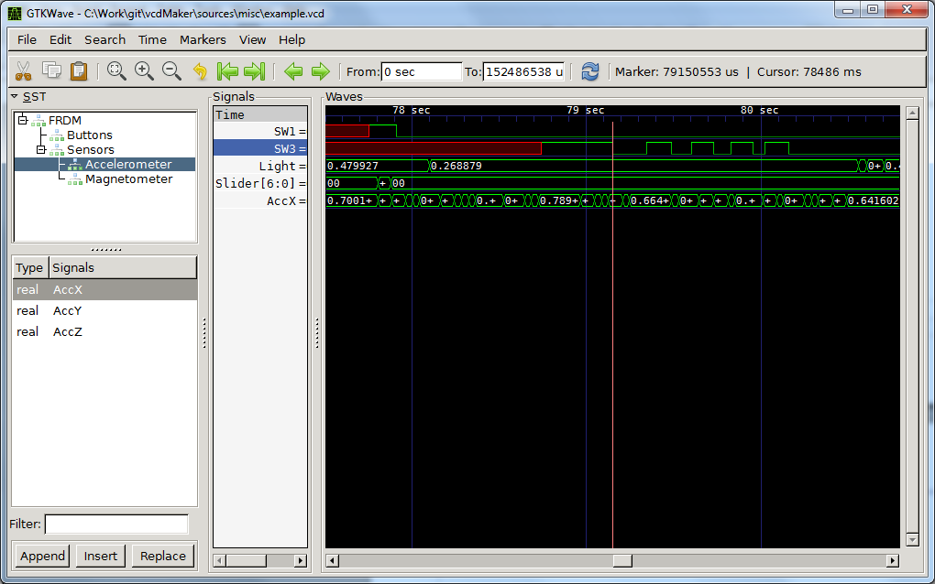

Step 5
Now, click close to the next rising edge of the SW3. Press 'b' key. Then click on the nearest falling SW3 edge. As measured by GtkWave the pulse is 142.712 [ms] width. Congratulations! You just learned how to measure time between two registered events.
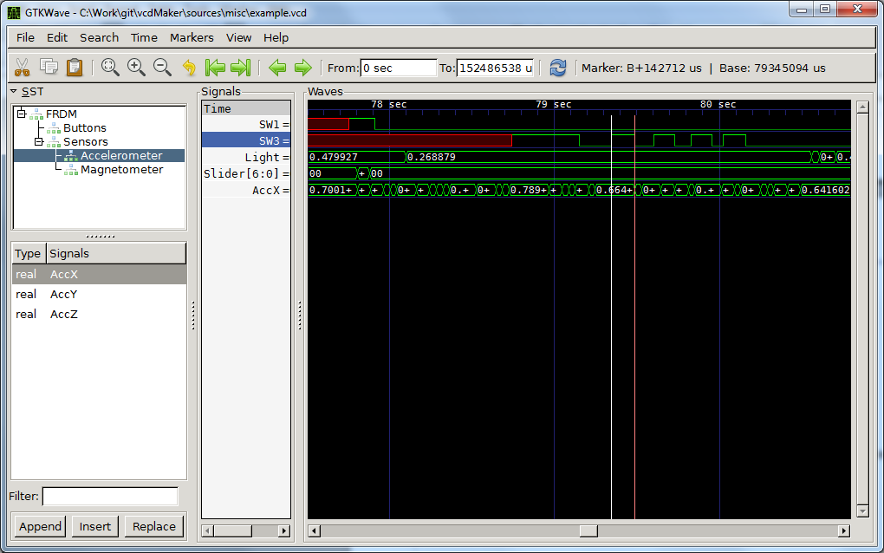

Step 6
In the Signals pane select Slider. Right click on Slider. Select Data Format -> Analog -> Interpolated. Now, you can scroll left and right the Waves window to see the changes of the signal over time. Of course, you can zoom it in or out to get the better results.
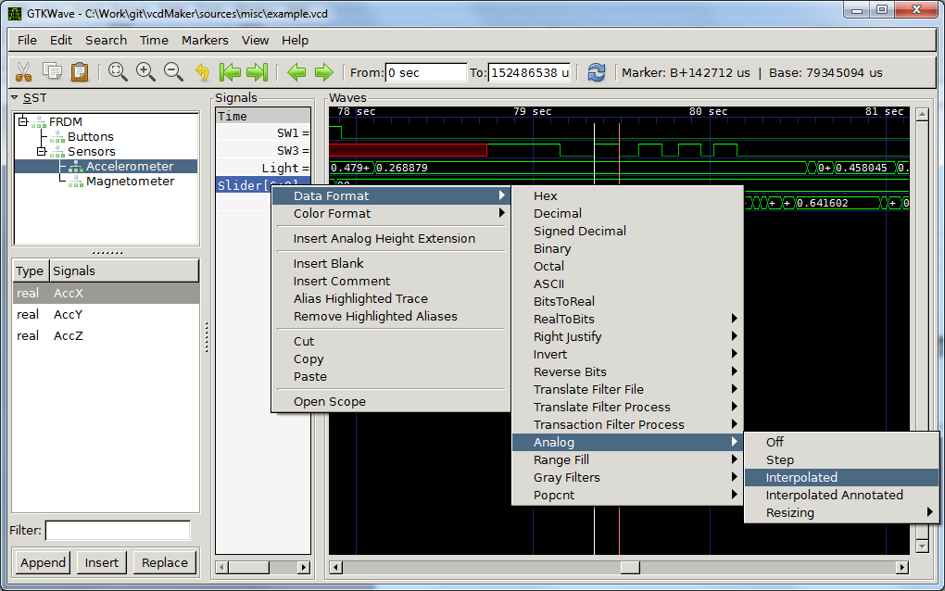

Step 7
In the Signals pane select Slider and right click on it. Select Insert Analog Height Extension. It will make the row higher and scaled better for the analog view. You can repeat steps 6 and 7 for AccX as well.
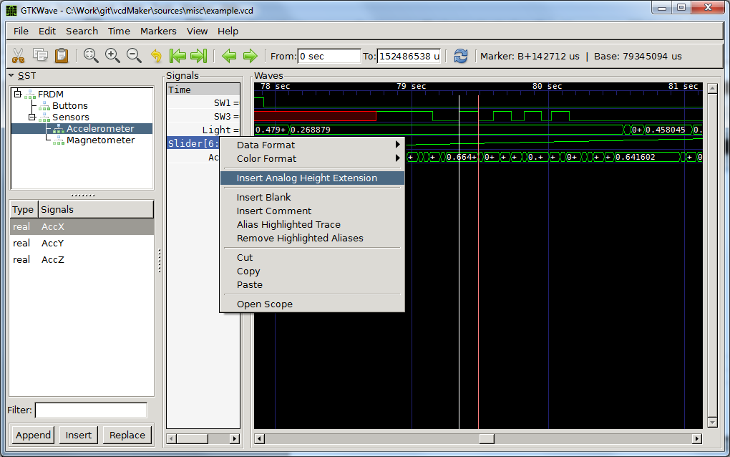

Step 8
Well done! Hopefully, these simple steps let you know the most basic operations of the GtkWave. There are also the most commonly used ones as well. For further information about the tool please refer to its documentation.
