vcdMaker

A User's Guide to vcdMaker
Edition 3
August, 2018

Copyright (c) 2018 vcdMaker team
Table of Contents
1 Licensing 1
2 Introduction 2
3 Installation 3
3.1 Windows 3
3.1.1 Installing 3
3.1.2 Uninstalling 3
3.2 Linux 4
3.2.1 Installing 4
RPM 4
DPKG 4
3.2.2 Uninstalling 4
RPM 4
DPKG 4
4 Getting Started with vcdMaker 5
5 Input log files 6
5.1 Specifying the user log format 6
5.2 The inherent vcdMaker log format 7
6 Creating VCD files 10
7 Merging log files 11
8 Viewing VCD files 13
8.1 GtkWave 13
8.1.1 Downloading 13
8.1.2 First steps 13
9 Warnings and errors 22
10 Reference projects 24
11 Release notes 25
11.1 Version 1.0.1 25
11.2 Version 2.0.1 25
11.3 Version 3.0.1 25

Licensing
The MIT License (MIT)
Copyright (c) 2017 vcdMaker team
Permission is hereby granted, free of charge, to any person obtaining a copy of this software and associated documentation files (the "Software"), to deal in the Software without restriction, including without limitation the rights to use, copy, modify, merge, publish, distribute, sublicense, and/or sell copies of the Software, and to permit persons to whom the Software is furnished to do so, subject to the following conditions:
The above copyright notice and this permission notice shall be included in all
copies or substantial portions of the Software.
THE SOFTWARE IS PROVIDED "AS IS", WITHOUT WARRANTY OF ANY KIND, EXPRESS OR IMPLIED, INCLUDING BUT NOT LIMITED TO THE WARRANTIES OF MERCHANTABILITY, FITNESS FOR A PARTICULAR PURPOSE AND NONINFRINGEMENT. IN NO EVENT SHALL THE AUTHORS OR COPYRIGHT HOLDERS BE LIABLE FOR ANY CLAIM, DAMAGES OR OTHER LIABILITY, WHETHER IN AN ACTION OF CONTRACT, TORT OR OTHERWISE, ARISING FROM, OUT OF OR IN CONNECTION WITH THE SOFTWARE OR THE USE OR OTHER DEALINGS IN THE SOFTWARE.

Introduction
Quite often while debugging a computer system huge log files are created and they need to be analyzed afterwards. That could be achieved by parsing the trace and extracting the relevant information but initially one needs to know what the information is. The vcdMaker tool set has been created to serve this purpose and help software and firmware engineers to analyze their applications and systems. It translates a human readable log files into the Variable Change Dump format files allowing for their further visualization which can be done using any of the VCD viewers. As a single picture is said to be worth thousand words the approach makes the debugging process easier and more efficient.

The tool set is provided as a freeware. There are no charges for using it but the development team would appreciate your feedback. All of the comments, requests or screen captures presenting the way you benefited from using it are appreciated. Contact us via vcdmaker@mail.com.

Installation

Windows

Installing
Start the installation by executing the vcdMakerSetup.exe. Then just follow the installer. During the process you will be able to adjust the installation path. The installer will copy all the necessary files, create the shortcut to the vcdMaker manual in your Programs Menu and update the user's environmental variable PATH. Therefore once installed a user will be able to invoke the application from any location.
The setup log could be created by invoking the installer in the following way:
vcdMakerSetup.exe /install /log vcdMakerInstallation.log

Uninstalling
The vcdMaker package can be easily and entirely removed by the Programs and Features Control Panel tool. Alternatively one could use the following command:
vcdMakerSetup.exe /uninstall

Linux
There are binary packages available for the Linux distributions using the RPM and the DPKG package managers. The packages contain the applications themselves, the manual pages, the user documentation as well as sample files. By default, they will be installed in the '/usr/share/doc/vcdMaker' folder.

Installing

RPM
rpm -i package_name.rpm

DPKG
dpkg -i package_name.deb

Uninstalling

RPM
rpm -e vcdmaker

DPKG
dpkg -r vcdmaker

Getting Started with vcdMaker
Running vcdMaker is easy but to make the learning curve really steep there have been provided sample files one could use to get the knack of the tool.
In the target installation folder there is a sample sub-folder containing the example.txt file (for Windows, for Linux see 3.2). It composes of an arbitrary set of signals and their values changing over time. The format of the input file has been described in 5. Copy the file to any folder you wish to experiment in.
Then, use the following command to create the output VCD file:
vcdMaker -o output.vcd -t us example.txt
The vcdMaker will parse the example.txt file and create the output.vcd file. That's it!
So as to get the feeling of how you could use the VCD file it is recommended to read the Chapter 8 first.

Using vcdMerge is equally easy! There are sample files provided as well. Let's merge system1_time1.txt and system2_time2.txt. The logs represent systems working in different time domains (they are not synchronized).
The synchronization points in both logs have been marked with the 'Sync' events. Browse the logs and search for them. Their time stamps are the parameters of the signals sources.
The syntax is:
vcdMerge.exe -o merge_t1_t2.vcd T,71050601,us,System1,Counter,system1_time1.txt T,234256037,us,System2,Counter,system2_time2.txt
For the synchronized sources (system1_time1.txt and system2_time1.txt) the time stamps shall be set to 0:
vcdMerge.exe -o merge_t1_t1.vcd T,0,us,System1,Counter,system1_time1.txt T,0,us,System2,Counter,system2_time1.txt

Input log files
vcdMaker tools can parse any user provided log. The syntax of the log can be specified by the XML file which has been described in 5.1. Alternatively the logs to be processed might be created in the inherent vcdMaker format presented in 5.2.

Specifying the user log format

The XML structure
The user log format can be specified by the XML file with the following structure:
<?xml version="1.0" encoding="UTF-8" standalone="no" ?>
<!DOCTYPE signals SYSTEM "vcdMaker.dtd">
<signals>

<vector>
<line> Regular expression describing the line including group matching </line>
<timestamp> Timestamp expression </timestamp>
<name> Name expression </name>
<value> Integer value expression </value>
<size> Size expression </size>
</vector>

<real>
<line> Regular expression describing the line including group matching </line>
<timestamp> Timestamp expression </timestamp>
<name> Name expression </name>
<value> Float value expression </value>
</real>

<event>
<line> Regular expression describing the line including group matching </line>
<timestamp> Timestamp expression </timestamp>
<name> Name expression </name>
</event>

…
</signals>

</log_configuration >

There might exist several vector, real or event nodes. According to the user needs. The syntax of the XML file can be verified with the provided DTD file (samples/vcdMaker.dtd in the target installation directory):
<?xml version="1.0" encoding="UTF-8"?>
<!ELEMENT signals (vector | real | event)*>

<!ELEMENT vector ( line,
timestamp,
name,
value,
size)
>
<!ELEMENT real ( line,
timestamp,
name,
value)
>
<!ELEMENT event ( line,
timestamp,
name)
>
<!ELEMENT line (#PCDATA)>
<!ELEMENT timestamp (#PCDATA)>
<!ELEMENT name (#PCDATA)>
<!ELEMENT value (#PCDATA)>
<!ELEMENT size (#PCDATA)>

For example, to parse the inherent vcdMaker format one could use the configuration file below:
<?xml version="1.0" encoding="UTF-8" standalone="no" ?>
<!DOCTYPE signals SYSTEM "vcdMaker.dtd">
<signals>

<vector>
<line>#([[:d:]]+) ([[:graph:]]+) ([[:d:]]+) ([[:d:]]+)( +.*)?</line>
<timestamp>dec(1)</timestamp>
<name>txt(2)</name>
<value>dec(3)</value>
<size>dec(4)</size>
</vector>

<real>
<line>#([[:d:]]+) ([[:graph:]]+) ([[:d:][:punct:]]+) f( +.*)?</line>
<timestamp>dec(1)</timestamp>
<name>txt(2)</name>
<value>flt(3)</value>
</real>

<event>
<line>#([[:d:]]+) ([[:graph:]]+) e( +.*)?</line>
<timestamp>dec(1)</timestamp>
<name>txt(2)</name>
</event>

</signals >

Signal line specification
To construct the signal correctly one needs some information describing it. The <line> element of the XML helps defining the data useful to create it from the parsed log line. It is a regular expression containing groups which can be referred to later. See the example above.

Info! At least, a log line shall contain its name and value.

Expression functions
There are several functions which can be used to construct signal properties and they have been listed below:
- dec(group_number)
It returns the integer representation of the string provided by the regex capture group. It must be a valid decimal string, e.g. '153'.
- hex(group_number)
It returns the integer representation of the string provided by the regex capture group. It must be a valid hexadecimal string, e.g. 'A78'.
- line()
It returns the number of the parsed log line. Hint: it allows for parsing logs not containing timestamps at all. It could be useful in some circumstances.
- flt(group_number)
It returns the float representation of the string provided by the regex capture group. It must be a valid float string, e.g. '3.14159'.
- txt(group_number)
It returns the string captured by the regex group. It must be a valid string, e.g. 'Sensor_1'.

group_number – decimal integer in the range from 1 to the last index of the given regex group

Integer expressions
The integer expression is a combination of arithmetic operators and expression functions. The precedence of operators is traditional. Available operands: '*', '/', '+', '-', '()'.

Example
10 * (dec(1) + dec(3)) + hex(2)
The value of the expression can be easily calculated applying simple arithmetics.
If dec(1) equals 2, hex(2) equals 0xB and dec(3) equals 5 then the calculated output value is 81.

Float expressions
The float expression is a combination of arithmetic operators and the flt() expression function which is the only accepted function in this case. The precedence of operators is traditional. Available operands: '*', '/', '+', '-', '()'.

Example
2.5 * (flt(1) + flt(2)) – 0.9
Again, the value of the expression is based on a simple arithmetic evaluation.
If flt(1) equals 2.5, flt(2) equals 1.1 then the calculated output value is 8.1.

String expressions
It is a combination of strings (in double quotation marks) and regex groups. Available operands: '+'.

Example
"SomeName." + txt(1) + "OtherName" + txt(2) + "1"
So, in the final string 'txt(1)' will be replaced by the first regex capture group while 'txt(2)' will be replaced by the second regex capture group.
If txt(1) is "XYZ" while txt(2) is ".ABC" the output string will be:
"SomeName.XYZOtherName.ABC1"

Timestamp expression
This must be a valid integer expression. The timestamps do not have appear in the ascending order. Signals will be properly sorted by a tool. The line() function returns the processed log line number.

Name expression
This must be a valid string expression. The name of the signal shall follow the guideline presented in the chapter 5.1.11.

Value expression
For a vector signal this must be a valid integer expression. The line() function returns always 0.
For a real signal this must be a valid float expression.

Size expression
This must be a valid integer expression. The line() function returns always 0.

Signal naming
This is a structure describing the hierarchy for accessing the signal or the variable. Each level of the structure must be separated by the '.' character. The hierarchy could be illustrated by the tree. For instance:

Top_Module
|
---------------------------
| |
Module_1 Module_2
| |
-------- --------
| | | |
Var_1 Var_2 Var_1 Var_2

In this example there are four variables in the system above and they shall be defined as follows:
Top_Module.Module_1.Var_1
Top_Module.Module_1.Var_2
Top_Module.Module_2.Var_1
Top_Module.Module_2.Var_2

The nesting of the signal name is not limited to three levels. A user can use whatever nesting level is required.

Example
The provided sample files (user1.xml and user2.xml) can be used as a reference.
vcdMaker -o output.vcd -t us -u user1.xml example_user.txt
vcdMerge.exe -o merge_t1_t2.vcd U{user2.xml},71050601,us,System1,Counter,system1_time1_user.txt T,234256037,us,System2,Counter,system2_time2.txt

The inherent vcdMaker log format
Let's present the inherent format of the input log file by an example below.
...
#77655698 FRDM.Sensors.Magnetometer.MagY 873 32
#77655817 FRDM.Sensors.Magnetometer.MagZ 3126 32
#77756251 FRDM.Buttons.SW1 1 1 Key pressed
#77805674 FRDM.Sensors.Magnetometer.MagX 64955 32
#77805797 FRDM.Sensors.Magnetometer.MagY 853 32
#77805916 FRDM.Sensors.Magnetometer.MagZ 3191 32
#77806061 FRDM.Sensors.Slider 99 7
#77806070 FRDM.Sync e
#77808473 FRDM.Sensors.Accelerometer.AccX 0.538574 f
#77808473 FRDM.Sensors.Accelerometer.AccY 0.172852 f
#77808473 FRDM.Sensors.Accelerometer.AccZ 0.706543 f
...
In general a log signal syntax is defined as follows:
#Timestamp Signal_name Value <Size | f | e> Optional_comment
There are common properties of the log signals:
- Timestamp – The system time stamp. The time unit is provided later during the creation of the VCD file. The entries in the log file do not have to be ordered. In other words, the entries with lower time stamp values might follow the entries with higher time stamp values. The events will be reordered properly during the VCD file creation. This might be useful when there are a few loggers in your system accessing the same logging device (e.g. UART). They all might log at their own pace and flush their buffers randomly.
- Signal name
The naming convention has been described in the chapter 5.1.11.

There are also properties specific to different signal types:
- integer values
Value – The value of the variable.
#Timestamp TopModule...SubModule.VarName Value Size Comment
E.g.
#77655698 FRDM.Sensors.Magnetometer.MagY 873 32
Size - The size parameter represents the number of bits needed to represent the value. Currently the maximum size shall not exceed 64 (any integer between larger than 0 and lesser than 65).
- real values
Value - Real values shall be expressed in the '%f printf()' format.
#Timestamp TopModule...SubModule.VarName Value f Comment
E.g.
#77808473 FRDM.Sensors.Accelerometer.AccZ 0.706543 f

- events
#Timestamp TopModule...SubModule.EventName e Comment
E.g.
#77806070 FRDM.Sync e

Creating VCD files
To produce the VCD file from a log file use the following command:
vcdMaker -t timeUnit [-c LineCounterName] [-u UserLogFormat] [-v] -o filename.vcd logFilename
filename – The target VCD file name.
timeUnit – The time unit in which the samples have been recorded. Available time units are: s, ms, us, ns, ps, fs.
-c LineCounterName – the switch is optional and it allows for adding a signal containing the log line number referencing to any signal change occurring at a given time. By following the line number one can easily identify the interesting place in the log. The LineCounterName name shall follow the standard signal format. If no top module name is provided Top will be assumed. For example, if you name it just 'Counter' it will appear in the output VCD file as 'Top.Counter' as every variable needs its rooting.
-u UserLogFormat – the switch is optional and it allows for providing the XML file describing the format of the log provided. See details in 5.1. If not provided, the syntax presented in 5.2 is expected.
v – the switch is optional while it enables the verbose mode in which the application will print out all of the log lines not matching the expected format. It is recommended to use this mode after the initial vcdMaker execution returns a positive number of invalid lines.
logFilename – The name of the log file to be processed.

Examples:
Basic syntax:
vcdMaker -o out.vcd -t us example.txt

User defined log format:
vcdMaker -o out.vcd -u vcdMaker.xml -t us example.txt

Adding the line counter:
vcdMaker -o out.vcd -t us -c Counter example.txt

Merging log files
There is also a possibility to create a single output VCD file out of several input log files. The feature might be useful while analyzing behaviors within distributed systems. The syntax of the vcdMerge command is as follows:
vcdMerge [-t timeUnit] [-v] -o filename sources
filename – The target VCD file name.
timeUnit – The time unit in which the output VCD file will be produced. Available time units are: s, ms, us, ns, ps, fs. If the parameter is not provided then the finest time base among the sources is selected. E.g. if one of the sources provides a log in 'ms' while another one provides a log in 'us' the output file will be in 'us'.
Warning! When the time unit is forced and it is less accurate that the finest unit within the provided sources the time stamps of some signals in the output VCD file might contain a rounding error (+/- 1 [time unit]). Usually, it is better to use the automatically chosen time unit.
-v – the switch is optional. It enables the verbose mode in which the application will print out all of the log lines not matching the expected format.
sources – The descriptions of the signals sources.
A user might merge as many sources as needed.
Each source is characterized be a set of parameters separated with ',':

format,timestamp,unit,prefix,counter,filename

format The format of the input file. Use 'T' for the inherent vcdMaker log format described in 5.2. Use 'U{log_format.xml}' to specify the user log format. See details in 5.1.
timestamp The synchronization time for the input log. Set to 0 for synchronized logs.
unit The unit of the time stamp.
prefix The prefix to be added to all the signals within the unit. It can be left empty. Then, no prefix is added.
counter The line counter signal name to be added to the output file. It can be left empty. Then, no line counter signal is added.
filename The name of the file to be merged.

Examples:
All source options used:
vcdMerge -o out.vcd -v T,71050601,us,Prefix1,Counter1,log1.txt U{vcdMaker.xml},234256037,us,Prefix2,Counter2,log2.txt
No signal counters:
vcdMerge -o out.vcd -v T,71050601,us,Prefix1,,log1.txt T,234256037,us,Prefix2,,log2.txt

No prefixes nor signal counters:
vcdMerge -o out.vcd -v T,71050601,us,,,log1.txt T,234256037,us,,,log2.txt

Those two logs contain data from two different targets fitted with accelerometers. The boards were bundled together. When the logs are properly aligned and displayed in the analog form it can be easily spotted that the signals registered are correlated. One can also notice that the Z-axes were flipped.

Viewing VCD files
There are many applications on the market allowing for viewing Variable Change Dumb format files and they are especially popular among RTL designers. Although very often such tools are quite expensive there exist a few free alternatives and one of them has been presented later in this manual.

GtkWave
GtkWave has been chosen for various reasons. It's free, light, easy to use and it has got rich features.

Downloading
The tool can be downloaded from:
http://gtkwave.sourceforge.net/

First steps
For the users convenience there has been provided the introduction to the GtkWave on the following pages. The further details related to the tool can be found in the GtkWave documentation itself.

Step 1
Run the tool. Drag and drop the examples.vcd file to the GtkWave.
In the top SST pane expand the FRDM and select Buttons. Keep 'Ctrl' pressed and in the bottom SST pane select SW1 and SW3. Click the Append button.
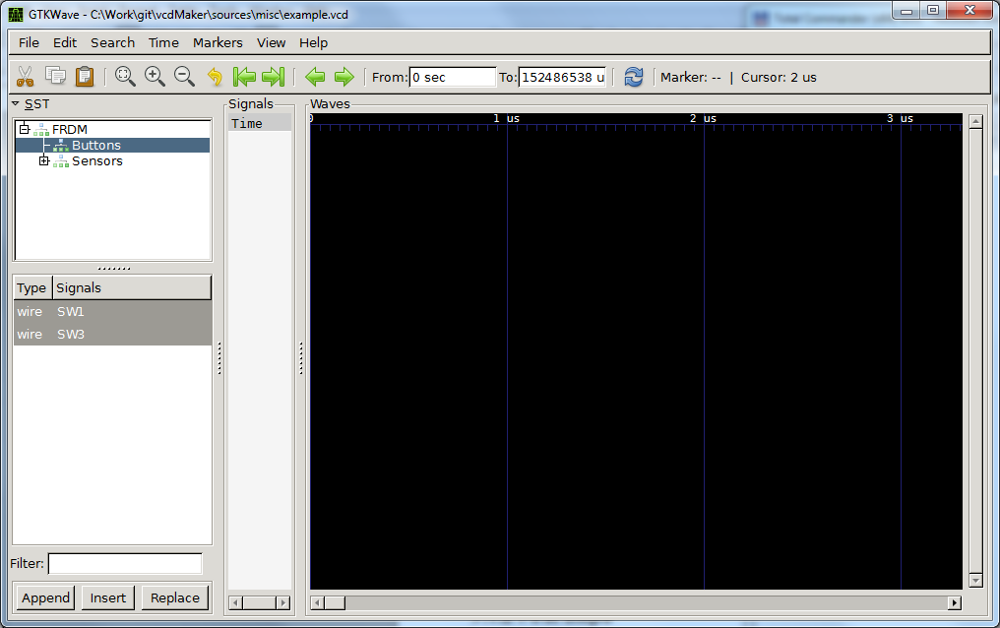

Step 2
In the top SST pane set the focus on Sensors. Keeping 'Ctrl' pressed select Light and Slider from the bottom SST pane. Click the Append button.
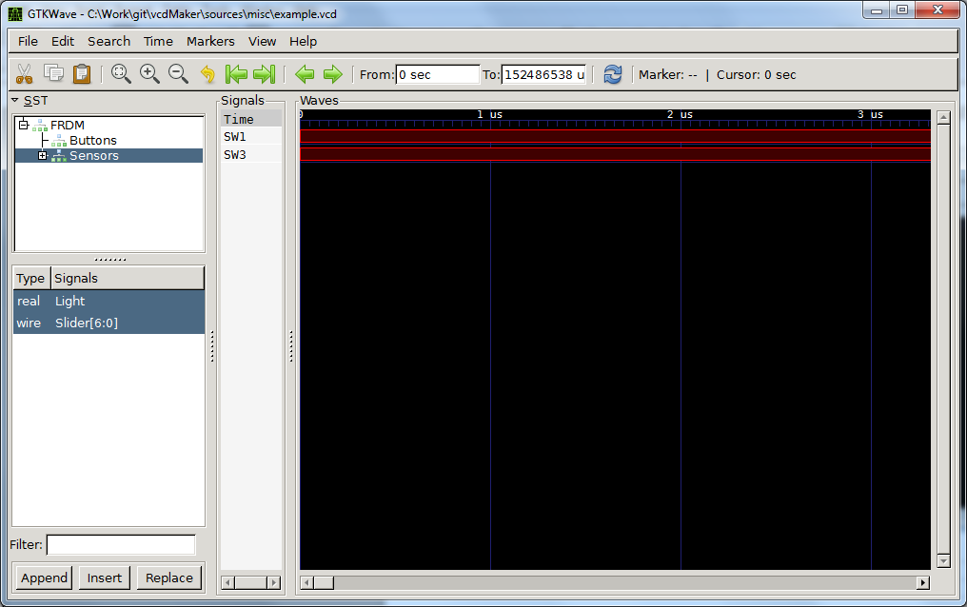

Step 3
In the top SST pane expand Sensors and select Accelerometer. In the bottom SST pane select AccX. Click Append again.
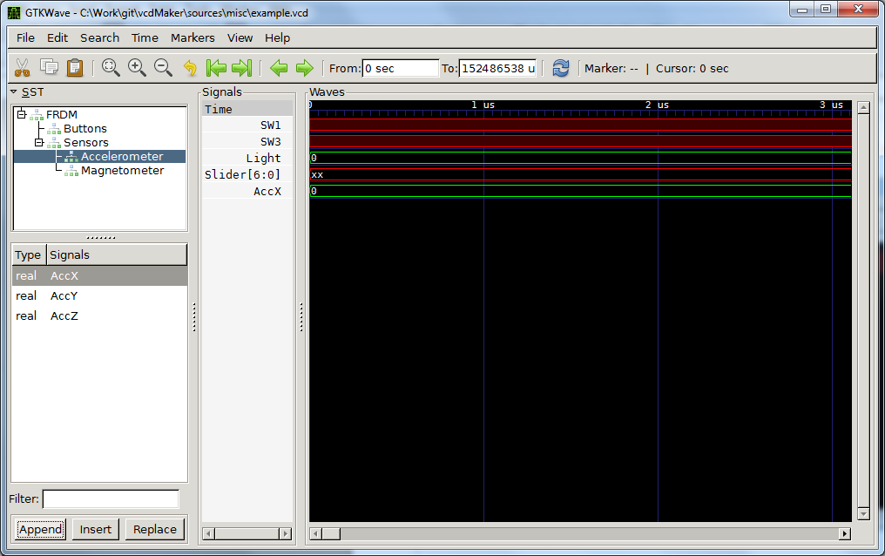

Step 4
In the Signals pane select SW3. Press Find Next Edge button (green right arrow) three times. Then, press Zoom Out button (zoom minus) several times so as you get a similar view scale as below.
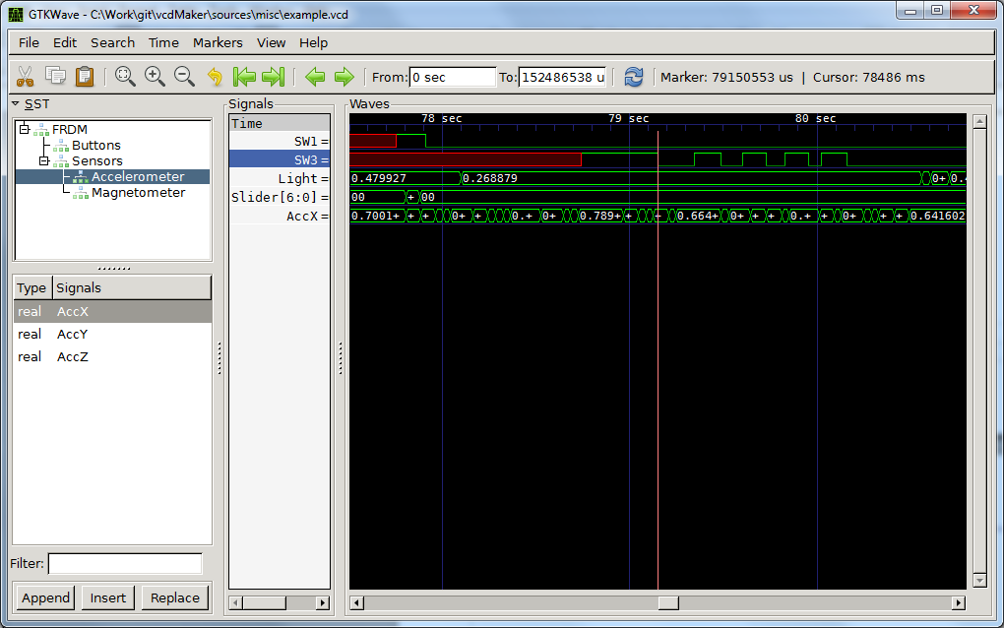

Step 5
Now, click close to the next rising edge of the SW3. Press 'b' key. Then click on the nearest falling SW3 edge. As measured by GtkWave the pulse is 142.712 [ms] width. Congratulations! You just learned how to measure time between two registered events.
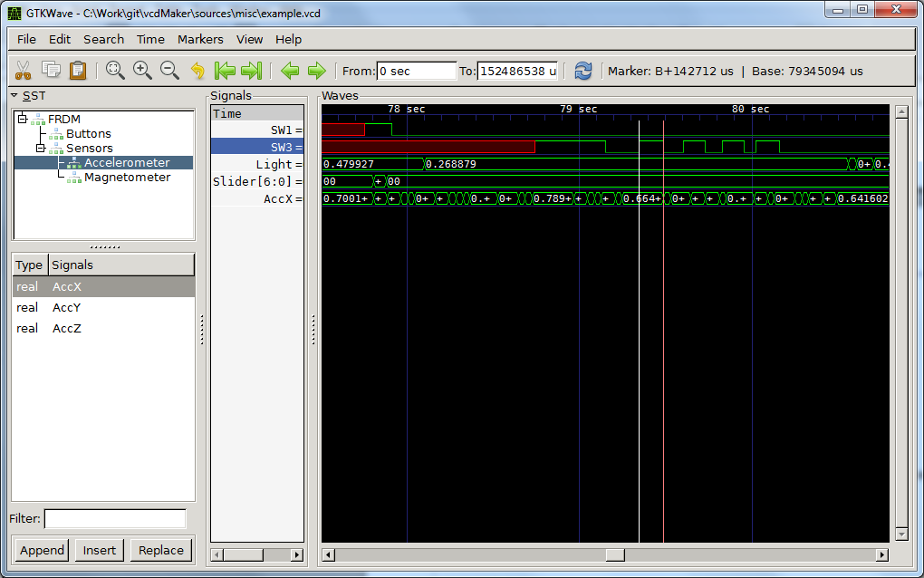

Step 6
In the Signals pane select Slider. Right click on Slider. Select Data Format -> Analog -> Interpolated. Now, you can scroll left and right the Waves window to see the changes of the signal over time. Of course, you can zoom it in or out to get the better results.
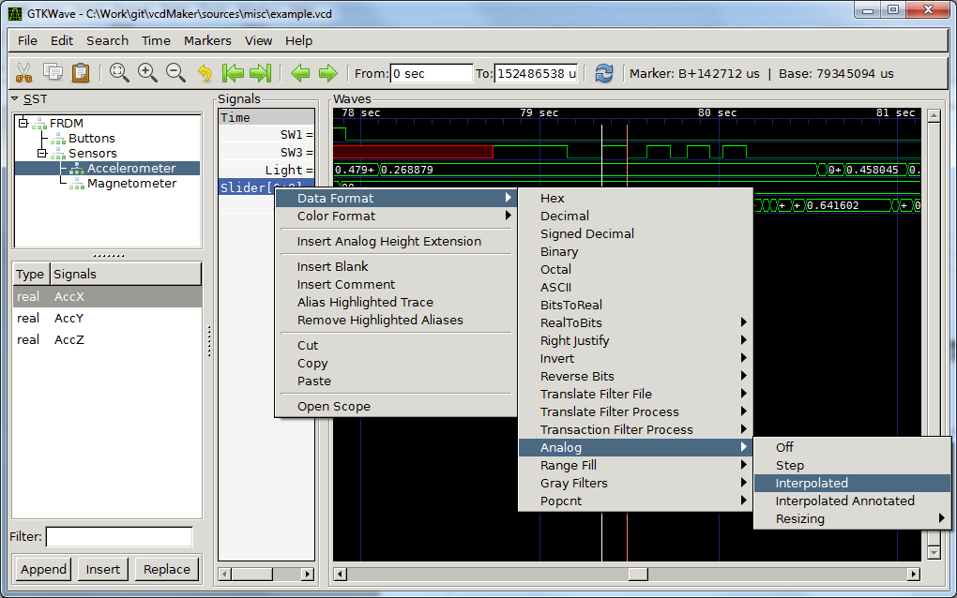

Step 7
In the Signals pane select Slider and right click on it. Select Insert Analog Height Extension. It will make the row higher and scaled better for the analog view. You can repeat steps 6 and 7 for AccX as well.
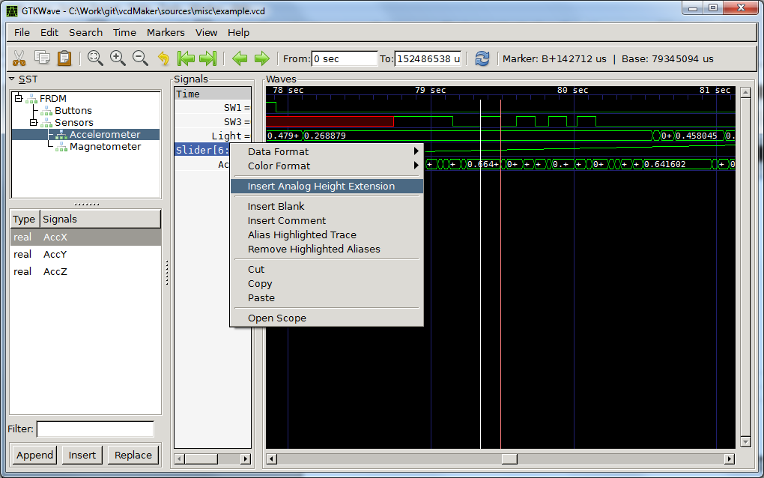

Step 8
Well done! Hopefully, these simple steps let you know the most basic operations of the GtkWave. There are also the most commonly used ones as well. For further information about the tool please refer to its documentation.
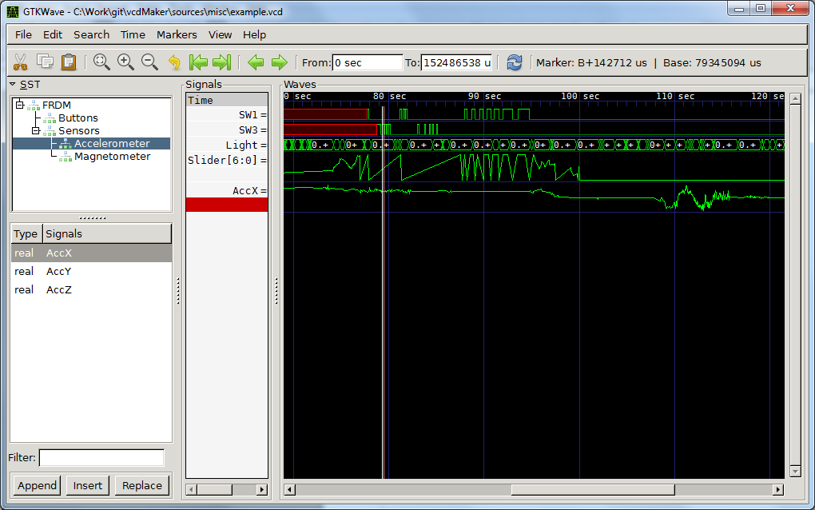

Warnings and errors
Legend:
Common
vcdMaker
vcdMerge

The following table presents a list of possible warnings.
Warning | String | Description
0001 | Synchronization time out of bounds. Cannot merge {source}. | The entire signal source cannot be merged as its new synchronization point timestamp falls out of 64-bit value.  Consider changing the output time unit.
0002 | Timestamp out of bounds. Cannot merge {signalName} at {timestamp} {timeUnit}. | The signal cannot be merged as its new timestamp falls out of 64-bit value.  Consider shortening the log or changing the output time unit.
0003 | Evaluating {file_name}.  Line {line_number}: {log_line}  Expression: {problematic expression}  Value {value} exceeds the {size}-bit size of the vector. Dropping the signal. | The log line matching the vector signal type has been encountered but the value of the signal to be created exceeds its declared size. The signal won't be created. The size of the vector shall be increased.

The errors likely to occur has been listed below.
Error | String | Description
0001 | Opening file {fileName} failed, it either doesn't exist or is inaccessible. | Missing file. Check if the path and the file name are correct.
0002 | Inconsistent signal: {signalName}. Types: {signal1Type} / {signal2Type}. Sizes: {signal1Size} / {signal2Size}. Sources: {signal1Source} and {signal2Source}. | There are inconsistent signals (from the same or different sources).  vcdMaker provides also the log line numer at which the inconsistent signal appeared.  Make sure you have no two similar signals differing only by their types or sizes.  For vcdMerge, consider adding or changing the source specific prefix.
0003 | Invalid time unit: {timeUnit}. | The time unit out of spec.  Make sure the provided time unit is valid:  [s, ms, us, ns, ps, fs].
0004 | Synchronization point value out of bounds: {timeStamp}. | The synchronization point falls out of the 64-bit value.  Consider changing the output time unit.
0005 | Invalid log file format: {format}. | The file format out of spec.  Currently only 'T' format is suppoerted.
0006 | Invalid synchronization point value: {synchronizationPoint}. | The synchronization point value wasn't provided in the valid decimal format.  Correct the value of the synchronization point.
0007 | Invalid number of source parameters: {sourceDescription}. | Wrong number of source parameters, separated by ','.  Correct the source description.
0008 | Leading time out of bounds. | Leading source time out of bounds.  Consider changing the output time unit.
0009 | There are at least two signal sources required. | Too few signal sources.  At least two signal sources are required.
0010 | XML - No parsing regular expression. | The regular expression describing the user log syntax is missing.
0011 | XML - No timestamp expression. | The expression used to create the signal timestamp is missing.
0012 | XML - No name expression. | The expression used to create the signal name is missing.
0013 | XML - No value expression. | The expression used to create the signal value is missing.
0014 | XML - No size expression. | The expression used to create the signal size is missing.
0015 | XML - Unexpected tag: {tag_name} | Unexpected tag in the user provided XML file.
0016 | Opening XML file {file_name} failed. The XML file might be incorrect. | The XML file could not be read. Its syntax might be wrong.
0017 | No signals creators. Hint: Verify the correctness of the XML file specifying the user log format. | Log files could not be parsed as there is no valid signal creatos registered. Most likely the syntax of the provided XML specifying the user log format is wrong.
0018 | Parsing error in {file_name}:  {Erroenous expression} | User expression parsing error. It might be a wrong expression syntax, an invalid function name or an erroenous function parameter.
0019 | Evaluation error in {file_name}.  Line {line_number}: {log_line}  Expression: {problematic expression}  {Error reason} | The error occured while evaluating one of the user expressions.  The possible error reasons are:  - Division by zero  The evaluation of the expression leads to the division by zero.  - Cannot convert to decimal  The argument of the dec() function is incorrect.  - Cannot convert to hex  The argument of the hex() function is incorrect.  - Cannot convert to double  The argument of the flt() function is incorrect.  - Out of range decimal value  The value captured by regex is too big to be converted successfully.  - Regex group index out of range  The referenced group index does not exist.  - Overflow while adding  The addition operation resulted in the value above the upper limit of the type.  - Overflow while multiplying  The multiplication operation resulted in the value above the upper limit of the type.  - Underflow while substracting  The substraction operation resulted in the value below the lower limit.

Reference projects
There are a few projects which have been created using popular development platforms and which demonstrate the way vcdMaker tools could be used.

The demo for the Freescale FRDM-KL46Z kit:
https://developer.mbed.org/users/ketjow/code/vcdMaker_Demo/

The demo for the STM Discovery L476 kit:
https://developer.mbed.org/users/ketjow/code/vcdMaker_Demo_DISCO_L476/

The demo for the Microchip Xpress kit:
https://mplabxpress.microchip.com/mplabcloud/example/details/261

Release notes

Version 1.0.1
- vcdMaker
  - The initial version of the application
  - Supported platforms:
    - Win32

Version 2.0.1
- vcdMaker
  - New features:
    - Updated command line interface – removed ' -f ' option
    - Line counter
    - Events logging
  - Supported platforms:
    - Win32
    - Linux
  - Resolved issues:
    - #1 - Floats in vcd not rounded.
- vcdMerge
  - The initial version of the application
  - Supported platforms:
    - Win32
    - Linux

Version 3.0.1
- vcdMaker/ vcdMerge
  - New features:
    - Parsing user logs
    - Error/Warning reporting
  - Resolved issues:
    - #22 – Linux target shall be able to cope with logs containing Windows EOLs

  - Supported platforms:
    - Win32
    - Linux

