**DEPARTMENT OF ELECTRICAL / ELECTRONIC**

**ENGINEERING**

**FACULTY OF ENGINEERING**

**NIGER DELTA UNIVERSITY**

**WILBERFORCE ISLAND**

**BAYELSA STATE**

**CONTRO II ASSIGNEMENT:**

**SIMULATION OF A SYSTEM WITH AND WITHOUT PID**

**NAME: WOKORO DOUYE SAMUEL**

**MAT NO: UG/12/1463**

**LEVEL : 500 LEVEL**

**COURSE : CONTROL SYSTEMS II**

**1ST AUGUST, 2017**

**QUESTION**

$$G(s)=\frac{100}{s(s^{2}+ 13s+30)}$$

Obtain using simulink, a simulation of the above system and device a PID controller to obtain props behavior for the system

**SIMULATION WITHOU PID CONTROLLER**

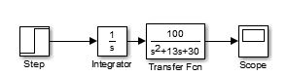

Fig.1 showing simulation diagram without **PID** controller

SIMULATION OUTPUT

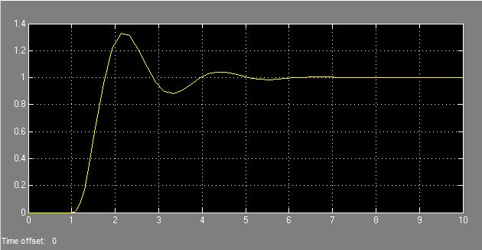

Fig 2. Simulation output without **PID**

**SIMULATION WITH PID**

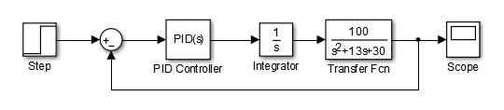

Fig 3. Block diagram of model with **PID**

Simulation output

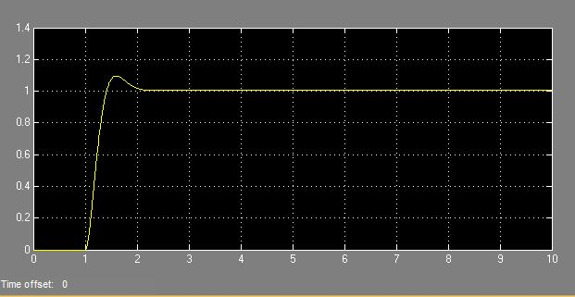

Fig 4. Simulation output with **PID** compensator