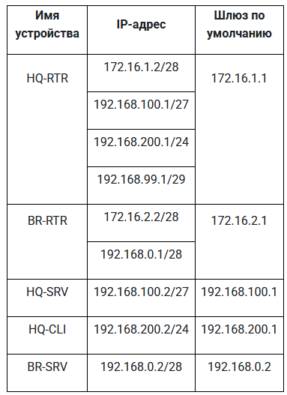

6. Настройка туннеля
int tunnel.1
ip addr 10.10.10.1/30
ip tunnel 172.16.1.2 172.16.2.2 mode gre

7. Настройка OSPF
router ospf 1
passive-interface default
no passive-interface tunnel.1
network 10.10.10.0/30 area 0
network 192.168.100.0/27 area 0
network 192.168.200.0/24 area 0
network 192.168.99.0/29 area 0
(network 10.10.10.0/30 area 0)
(network 192.168.0.0/28 area 0)
int tunnel.1
ip ospf authentication message-digest
ip ospf message-digest-key 1 md5 P@ssw0rd

8. Настройка NAT
int isp | int 100 | int 200 | int 999
ip nat outside | ip nat inside | ip nat inside | ip nat inside
ip nat pool VLAN100 192.168.100.1-192.168.100.30
ip nat pool VLAN200 192.168.200.1-192.168.200.254
ip nat pool VLAN999 192.168.99.1-192.168.99.6
ip nat source dynamic inside-to-outside pool VLAN100 overload interface isp
ip nat source dynamic inside-to-outside pool VLAN200 overload interface isp
ip nat source dynamic inside-to-outside pool VLAN999 overload interface isp

9. Настройка DHCP
ip pool VLAN200 192.168.200.2-192.168.200.254
dhcp-server 1
pool VLAN200 1
mask 24
gateway 192.168.200.1
dns 192.168.100.2
domain-name au-team.irpo
int 200
dhcp-server 1

10. Настройка DNS
systemctl enable --now dnsmasq
vim /etc/dnsmasq.conf

domain=au-team.irpo
expand-hosts
listen-address=192.168.100.2,127.0.0.1
server=77.88.8.7
address=/hq-rtr.au-team.irpo/172.16.1.2
address=/br-rtr.au-team.irpo/172.16.2.2
address=/hq-srv.au-team.irpo/192.168.100.2
address=/hq-cli.au-team.irpo/192.168.200.2
address=/br-srv.au-team.irpo/192.168.0.2
address=/docker.au-team.irpo/172.16.1.1
address=/web.au-team.irpo/172.16.2.1

systemctl restart dnsmasq

vim /etc/resolv.conf
nameserver 192.168.100.2
search au-team.irpo
ip domain-name au-team.irpo
ip name-server 192.168.100.2

