IS287: Java Programming II
Assessment Exercise: Number Conversion 2015
The task for this assessment is to re-structure the provided project (NumConv) to use an interface, inheritance, and polymorphism, as described below. You will also add a new conversion operation to the program.

The program provided is one you may have developed in the Java I programming course: Binary numbers to their Decimal equivalents and Decimal numbers to Binary, according to specific algorithms. Those specific algorithms are described in the original (Java I) program specification (attached at the end of this document). For Binary to Decimal the program calculates by adding up the positional values of all 1 bits; for decimal to binary it uses a recursive algorithm to divide the original number by 2 (down to zero) and collect the remainders. Only positive integers are allowed as input values.

The original solution provided has three general components: a windows style form interface and two business classes – one for Decimal-to-Binary conversions (Dec2Bin.java) and one for Binary-to-Decimal (Bin2Dec.java). Note that these two business class objects are designed to require instantiation (rather than using static methods) because they each produce a ‘process log’ which describes the individual steps of each conversion. That process log is made available by the business classes along with the result. The original program form is:
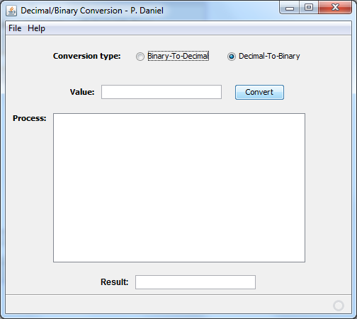

Your tasks, then, are as follows:

- Add an interface to the project which declares methods needed to satisfy the form requirements
- Re-write the Binary-to-Decimal class to implement the interface
- Add a superclass to the Decimal-to-Binary operation called Dec2Num which houses the conversion algorithm and implements the interface
- Re-Write the Decimal-to-Binary class to extend the new superclass
- Add a new business class Dec2Hex which provides Decimal-to-Hexadecimal conversion results

Development Details:
The new form will look like this:
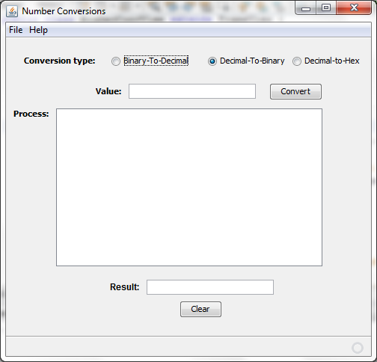

The interface should be called Conversion.java and it will have the following method declarations:
- String getValue(): a method to return the original input value
- String getResult(): a method to return the final result
- boolean isValid(): a method to indicate if the input value was valid for the desired operation
- ArrayList<String> getProcessLog(): a method to return the process log

The existing Bin2Dec.java class should be re-written to implement the interface, providing code for all the required interface methods.
- The class should also be given constants for VALUEDESC = “Binary’ and RESULTDESC = ‘Decimal’. These will be used to modify the form display labels for ‘value’ and ‘result’ fields (as described below)

Also note that by creating the interface you should re-cast the code behind the form to use polymorphism. In other words, a global object of ‘Conversion’ type should now be used, and should be instantiated with calls to the specific operational classes, as needed.

The Decimal-to-number conversions require a bit more than a simple re-write of the underlying sub-class. It should first be noted that the process of converting from a decimal to a number of another base is the same for each base, except that the division changes according to the base used. In other words, when converting from decimal to binary the original number is successively divided by 2, whereas when converting from decimal to hexadecimal (base 16) the original number is successively divided by 16.

So to provide an extensible structure, you will first create a new class Dec2Num.java which implements the interface and which contains the basic conversion algorithm. This class will, however, leave the actual creation of the result value to the specific subclasses. Thus, Dec2Num will have the following methods:
- A constructor which accepts a string as the input value and an integer to indicate the ‘base’ of the number to be generated (e.g., 2 or 16). The constructor will validate that the input string is a positive integer
- An isValid() method to indicate whether or not the input number could be converted
- A private method to perform the conversion and produce both an array list of the process steps (log) and an array list of the remainders generated during the algorithm. You may copy and modify the algorithm in the provided Dec2Bin.java class (which uses recursion), or you may write your own code for the algorithm.
- A method getValue() to return the original start value (a method as required by the interface)
- A method getProcessLog() to return the array list describing the algorithm steps (see example forms shown below)
- The method getResult() is part of the interface, but must be left to the sub-classes for implementation
- A method getRemainders() to return the array list of remainders generated. Note that this method should not be public, but should only be available to the sub-classes (that use it to build the final result)

The Dec2Bin class should be re-written as a sub-class of Dec2Num (i.e., it now extends Dec2Num). Its features are:
- A constructor that receives the string start value, calls the superclass to send it both the value and the base (2), and then uses the remainders array available from the superclass to build the final result string
- Class constants for VALUEDESC = “Decimal” and RESULTDESC = “Binary”
- A getResult() method to return the final result value (as a string)

A new Dec2Hex class should then be built for the decimal to hexadecimal operation. Its features are the same as Dec2Bin, with the following adjustments required:
- The VALUEDESC constant will still be “Decimal” but the RESULTDESC constant will now be “Hexadecimal”
- When creating the result string you must handle the fact that remainder values may be any number from zero to 15. The hexadecimal codes for the numbers 10-15 are: A B C D E and F (in that order). In other words, 10=A, 11=B, etc.

Finally, the class constants for VALUEDESC and RESULTDESC should be used to change the labels on the form after a radio button operation is selected, such that the text of the label on the input value changes to VALUEDESC and the text of the label on the result field changes to RESULTDESC. In other words, if Binary-to-Decimal is selected the label on the input line becomes ‘Binary Value’ and the label on the result field becomes ‘Decimal Result’. The form would look like this:

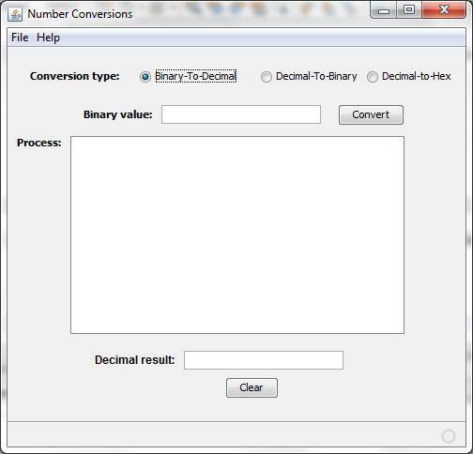

Sample runs of each operation follow. For Binary-to-Decimal:
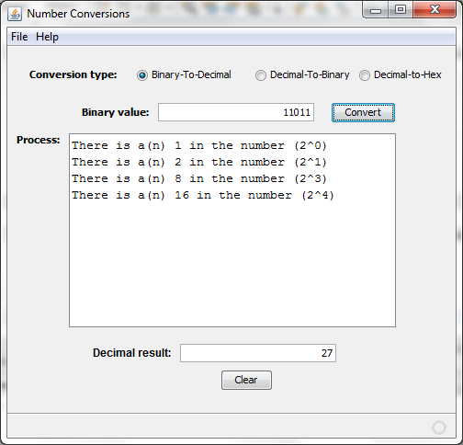

For Decimal-to-Binary:
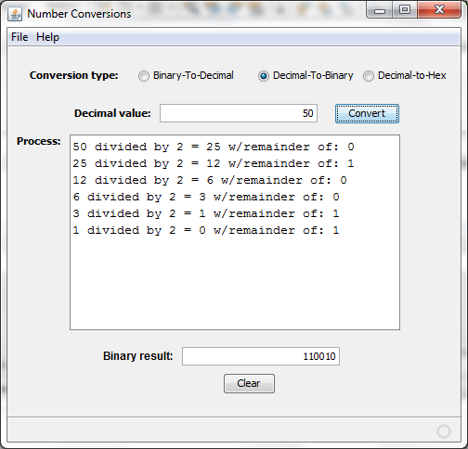

For Decimal-to-Hexadecimal:
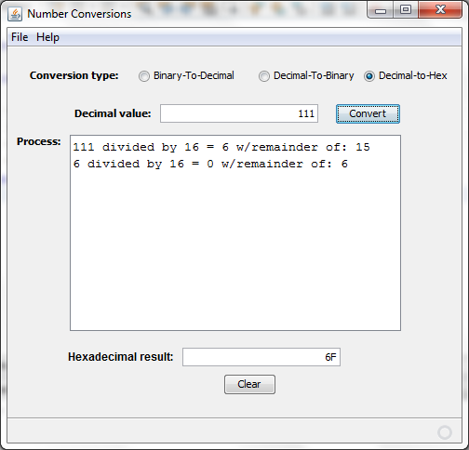

You should use the original project provided and make your changes directly inside that project. Zip and submit your finished program through blackboard (in the usual way).

