**PhantomJS**

1. Define

* A **headless browser** is a **web browser** without a graphical user interface
* PhantomJS is a headless browser

1. Resource

Declare Selenium in project

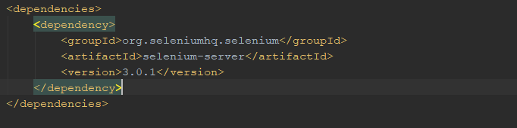

<http://phantomjs.org/download.html>

Declare webdriver with phantomjs in project



1. Demo

* Selenium : support to get link
* PhantomsJS : support to headless testing(not open browser)

Demo with javascript

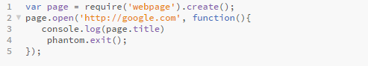

Demo with java

