**Assignment No: _3__**

**Date: 31/ 03 /2025**

**Title: Implementation and Performance Comparison of Tree Data Structures for Efficient File System Management**

(Title based on the application domain and the data structure you will be implementing)

|  |  |  |  |
| --- | --- | --- | --- |
| **Assignment Type of Submission:** |  |  |  |
| **Group** | Yes | Yuxuan Song  24207239  Yijun Liu  24202574  Deepak Shelke  24208478 | **33.33**  **33.33**  **33.33** |



1. **Problem Domain Description:**

This report addresses the problem of selecting the top 10 most viewed posts from a large dataset of posts on a website. The website hosts a large number of posts for users to browse, and to enhance the user experience, it recommends the 10 posts with the highest view counts on the homepage. Given the large dataset size of 10,000 posts, an efficient algorithm is required to identify and extract the top 10 posts without sorting the entire dataset, which would be computationally expensive.

To simulate a real-world scenario, a dataset containing 10,000 posts was generated. Each postId was assigned a unique integer between 1 and 10,000, and each view count was a randomly generated integer between 0 and 99,999. The dataset was stored in a CSV file named posts.csv, with each row containing a postId and a view count. A naive approach would be to sort all 10,000 posts by view count and pick the top 10. However, sorting has a time complexity of O(n log n), which is inefficient for large datasets. Instead, a minimum heap (priority queue) was used because it allows efficient selection of the top 10 elements while scanning through the dataset in a single pass. The heap maintains only 10 elements at a time, ensuring efficient memory usage and reducing the overall time complexity to approximately O(n).

The algorithm follows these steps. First, a minimum heap of size 10 was created to store posts with their postId and viewCount. Then, the CSV file was read line by line, extracting the postId and viewCount from each row. Each post was then inserted into the heap. If the heap contained fewer than 10 elements, the new post was added. If the heap already had 10 elements, the new post’s view count was compared with the smallest view count in the heap. If the new post had more views than the smallest element in the heap, the smallest element was removed, and the new post was inserted. After processing all posts, the heap contained the 10 most viewed posts. Finally, the posts in the heap were retrieved and displayed, representing the top 10 most popular posts on the website.

The algorithm successfully processed the entire dataset and extracted the top 10 posts with the highest view counts. The execution time for processing all 10,000 posts and retrieving the results was approximately 18 milliseconds, demonstrating the efficiency of this method.

1. **Theoretical Foundations of the Data Structure(s) utilised**

In Java, Heap is realized by PriorityQueue. A PriorityQueue is a specialized data structure that organizes elements based on priority rather than insertion order. It is commonly implemented using a binary heap, which allows efficient insertion and removal while maintaining the priority order.

There are two primary types of priority queues. A min-heap PriorityQueue ensures that the element with the lowest key is always dequeued first, while a max-heap PriorityQueue dequeues the element with the highest key first. In Java, the PriorityQueue<E> class implements a min-heap by default, meaning the smallest element is always at the front.

The core methods of PriorityQueue include add(E e) (or offer(E e)), which inserts an element while maintaining the heap structure with a time complexity of O(log n). The poll() method removes and returns the highest-priority element (the root of the heap) with a time complexity of O(log n). The peek() method retrieves the highest-priority element without removing it in O(1) time. The remove(Object o) method removes a specific element from the queue, requiring O(n) time since a linear search is needed. The size() method returns the number of elements in the queue with a time complexity of O(1).

A PriorityQueue is typically implemented using an array-based binary heap. The structure follows these indexing rules:

Parent Node: Located at (i - 1) / 2.

Left Child: Located at 2 * i + 1.

Right Child: Located at 2 * i + 2.

Insertion operations maintain heap order using heapify-up, ensuring that the newly added element is placed in the correct position. When a new element is inserted, it is initially placed at the last available position in the heap (the next open slot in the array). Then, it is compared with its parent node (located at (i - 1) / 2). If the element has a higher priority (i.e., it is smaller in a min-heap or larger in a max-heap), it is swapped with its parent. This process continues recursively until the heap property is restored or the element reaches the root.

Deletion operations use heapify-down to restore the heap structure after removing the root element. The root node (index 0) is removed and replaced with the last element in the heap. Then, the new root is compared with its left and right children (located at 2 * i + 1 and 2 * i + 2, respectively). If the new root violates the heap property, it is swapped with the child that has the higher priority (i.e., the smaller child in a min-heap or the larger child in a max-heap). This process repeats until the element is correctly positioned, ensuring that the highest-priority element is always efficiently accessible.

For our implementation, a min-heap was chosen to store the top 10 viewed posts, allowing us to efficiently remove the smallest element and maintain only the 10 highest view counts. This ensured an efficient O(n log k) time complexity, where n is the total number of posts and k is the number of elements maintained in the heap (10 in our case). The heap operations, such as insert and remove, run in O(log k) time, making it highly efficient compared to sorting the entire dataset (O(n log n) complexity).

1. **Analysis/Design (UML Diagram(s))**

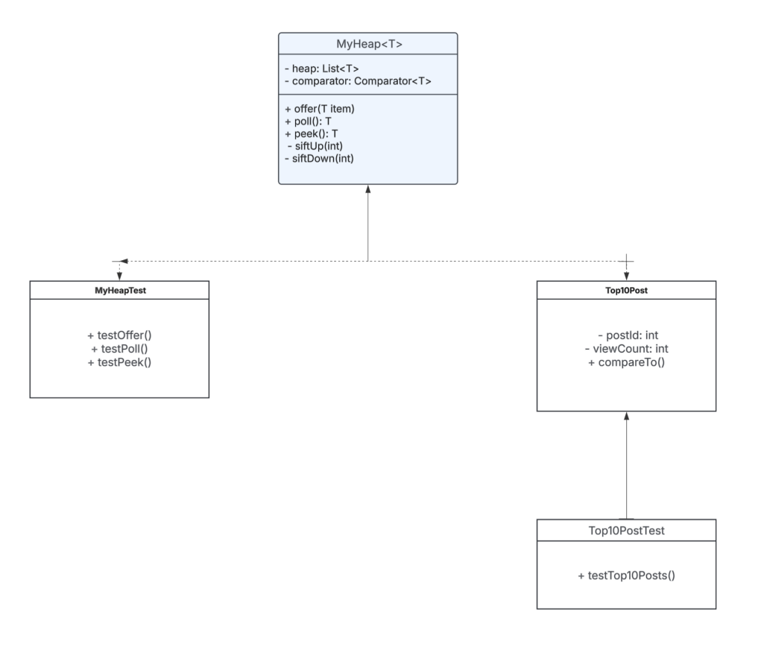

1. **Code Implementation (please add your TA -** [Furqan.rustam1@gmail.com](mailto:Furqan.rustam1@gmail.com) **– as a collaborator)**

GitHub (link):https://github.com/WolfClarence/Group9_Assignment3

This is a new repository, please join as the collaborator.

MyHeap Implementation:

MyHeap is a custom binary heap that functions similarly to Java’s PriorityQueue. It supports generic types and relies on a Comparator to determine ordering, allowing for both min-heaps and max-heaps. Internally, it uses an ArrayList for dynamic storage and implements heap operations like insertion (offer), removal (poll), and retrieval (peek).

To maintain the heap property, it employs heapify operations:

Sift-up restores order when adding elements.

Sift-down ensures order when removing elements.

This implementation provides an efficient O(log n) time complexity for insertions and deletions, making it suitable for priority-based applications.

The performance of both heaps was evaluated over 1,000,000 operations, and the execution times were logged into a CSV file. The test results show that the custom MyHeap implementation is slightly slower than Java's built-in PriorityQueue. For the Min-Heap, MyHeap took 746 ms, while PriorityQueue took 556 ms. For the Max-Heap, MyHeap took 629 ms, compared to PriorityQueue's 452 ms. This performance difference can be attributed to the fact that PriorityQueue is highly optimized with a well-structured internal implementation, ensuring efficient memory usage and optimized heap operations. Despite these differences in performance, the custom heap's execution time remains within acceptable bounds for most use cases, as both heaps maintain the expected O(log n) time complexity for insertion and deletion operations.

Sample output:

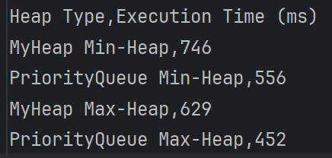

1. **Video of the Implementation running**

youtube link: https://youtu.be/Cy3iovg9wuo

Comments:

This is a brief overview of the code execution and result display. The results are shown in the console.

**Please save as pdf and submit on Brightspace**

**Students belonging to the same group** please **submit the same file .**