Isaac Wolf

Task 7 Report

------------------------------------------------------

Given:

* + Can only undercount by 1 if and only if not drunk
  + Can only overcount by 2 if and only if drunk
  + Drunks randomly count from N to N+2
  + Not Drunks undercount by 1, 5% of the time
  + Can only be N (0-4) stars

Therefore:

* + Can only possibly count 0-6 stars
  + Range of counted stars cannot exceed 3
  + If undercounting, not drunk
  + If overcounting, drunk
  + If counting correctly, 5% chance of being drunk
  + 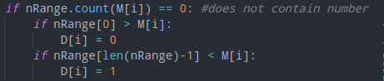
  + Sets drunk or not drunk if over or undercounting
  + N always less than or equal to lowest drunk count

and lowest+1 regardless, as drunks cannot undercount, non drunks can only undercount by 1

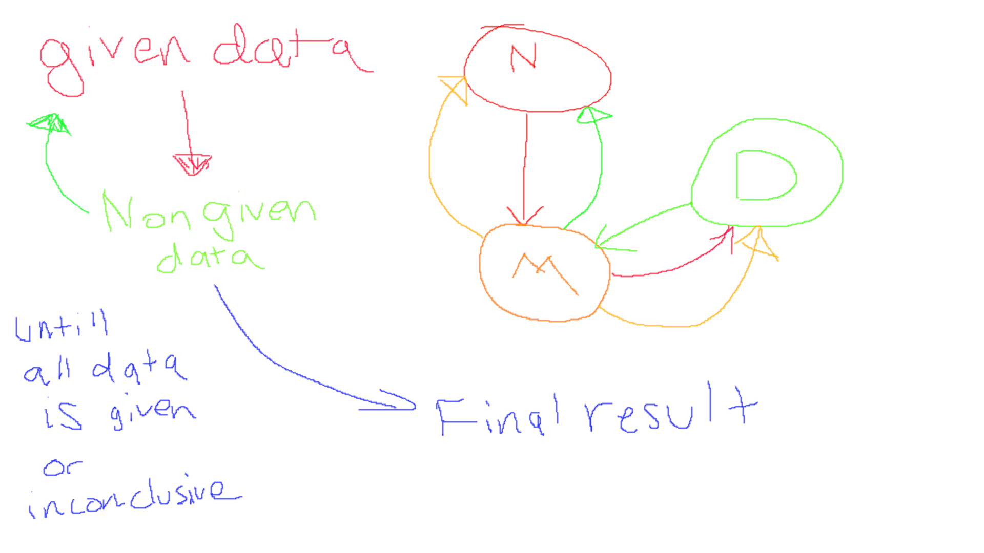

Pseudocode:

Check if Valid.

If N given:

For each astronomer

If M given but not D:

If overcount:

D = 1

If undercount:

D = 0

If neither:

5% chance of drunk

If D given but not M:

If drunk:

M = random between N and N+2

If sober:

If N > 0:

20% chance to count N-1

Else:

M = N

If Neither given:

5% chance to be drunk

Follow Previous guidelines

If both given:

Do nothing

If N not given:

N = [0-4] // process of elim

For each astronomer:

If M given:

N >= M-2

N <= M+1

If M lower than range:

M is sober

If M higher than range:

M is drunk

If M is Drunk:

N <= M

If M Sober:

N >= M

If length of range == 1:

we ‘re good

Else 20% chance to pick something random in the range

Otherwise pick lowest value

Run again for given N