CS132: Software Engineering

Specification
Banking System
Group 15
Author: 祝宇航 王芸飞 贾舜康
Catalogue
System Architecture 4
S1: Controller 4
● S1.1 Open APP 5
● S1.2 Close APP 5
● S1.3 Reset System Database 6
S2: ATM 7
● S2.1 Create Account 7
● S2.1.1 Input Account ID 8
● S2.1.2 Input Password ID 8
● S2.1.3 Confirm 8
● S2.2 Log In 8
● S2.2.1 Input Account ID 9
● S2.2.2 Input Password ID 9
● S2.2.3 Confirm 9
● S2.3 Query 10
● S2.4 Deposit Cash 11
● S2.4.1 Input amount 11
● S2.4.2 OK 11
● S2.5 Withdraw Cash 11
● S2.5.1 Input amount 11
● S2.5.2 OK 11
● S2.6 Transfer Money 11
● S2.6.1 Input receiver ID 11
● S2.6.2 Input amount 11
● S2.6.3 OK 11
● S2.7 Change Password 12
● S2.7.1 Input new password 12
● S2.7.2 OK 12
● S2.8 Cancel Account 12
● S2.9 Return Card 12
● S3.1 Log In 13
● S3.1.1 Input Account ID 14
● S3.1.2 Input Password ID 14
● S3.1.3 Confirm 14
● S3.2 Query 15
● S3.3 Transfer Money 15
● S3.3.1 Input receiver ID 15
● S3.3.2 Input amount 16
● S3.3.3 OK 16
● S3.4 Change Password 16
● S3.4.1 Input new password 16
● S3.4.2 OK 16
● S3.5 Log Out 16

System Architecture
The system architecture is shown below:

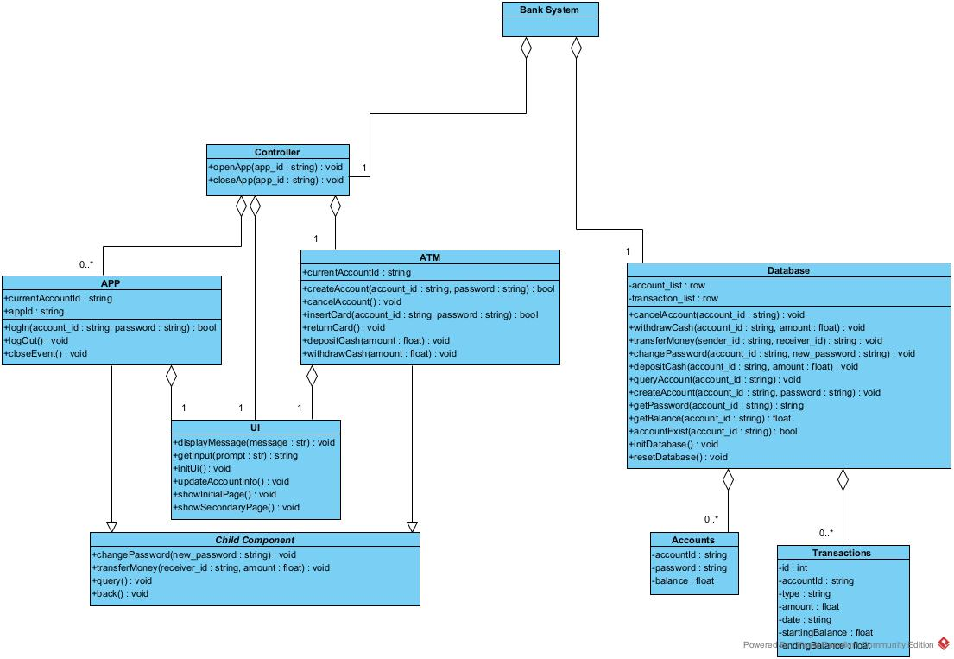

S1: Controller
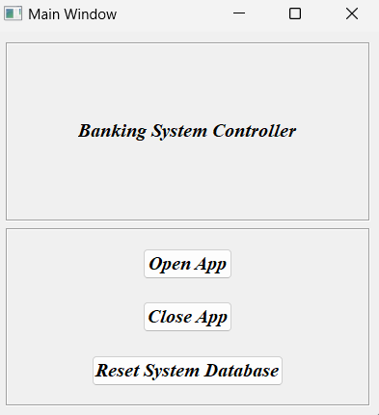
1
2
3
Controller Components
- S1.1 Open APP

Clicking this button will allow the user to enter an app ID to create a new app.
- Create an instance of an unopened app with an appId equal to the input app ID.
- Add the instance to the instance dictionary for easy subsequent lookups.
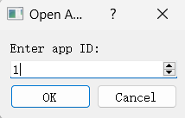
- S1.2 Close APP

Clicking this button will allow the user to enter an app ID to close a open app.
- Closes an instance of an app that is already open and has an appId equal to the entered app ID.
- Remove the instance from the instance dictionary.
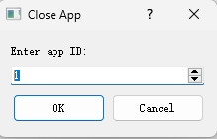
- S1.3 Reset System Database
Click on this button to reset the database in the banking system, removing all account and transaction information.
- Remove all data from the local database and reintialize.
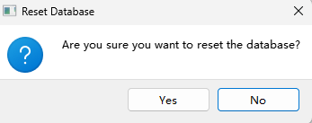

S2: ATM
Init Menu
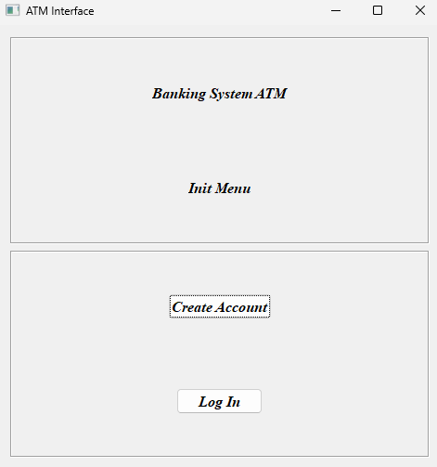
1
2
Init Menu Components
- S2.1 Create Account
Clicking on this button will redirect it to the Create Account Menu.
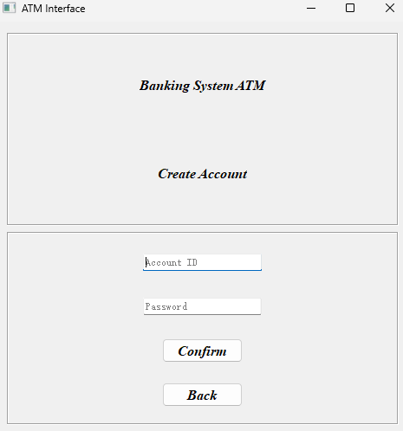
1
2
3
4
- S2.1.1 Input Account ID
- Determine if it is a 10-digit pure number.
- Determine if an account already exists
- S2.1.2 Input Password ID
- Determine whether the password meets the requirements of greater than or equal to 8 digits, and contains letters case and numbers.
- S2.1.3 Confirm
- Returns the creation results for display on the front end.
2. If created successfully the database will be updated.
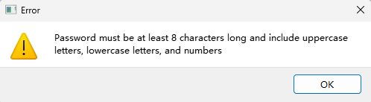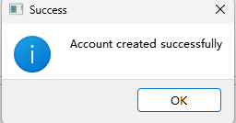
- S2.2 Log In
Clicking on this button will redirect it to the Log In Menu.
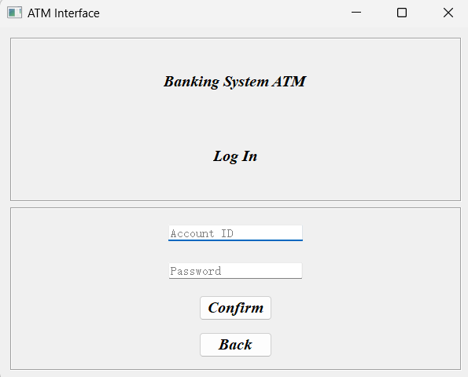
4
3
2
1
- S2.2.1 Input Account ID
- Determine if an account has been created.
- S2.2.2 Input Password ID
- Determine if the password is correct.
- S2.2.3 Confirm
- Returns login information to the front-end.
- If inserted card successfully, the ATM's currentAccountId will be set to this ID.
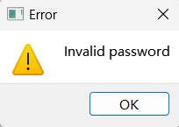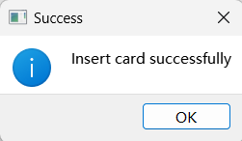

Main Menu
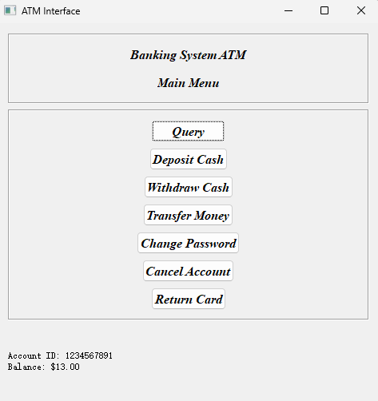
6
1
2
3
4
5
7
81
9
Main Menu Components
- S2.3 Query

Click this button and it will allow the user to perform the Query operation.
- Request data about currentAccountId from the database.
- Send the data to the front end to show the latest five.
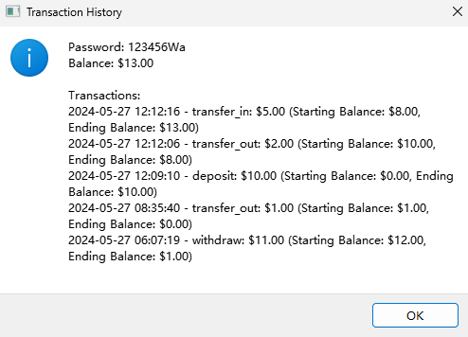
- S2.4 Deposit Cash

Click this button and it will allow the user to perform the Deposit operation.
- S2.4.1 Input amount
- Check if amount is in the correct interval.
- S2.4.2 OK
- Return Deposit result information to the front end.
- Updating relevant data in the database.
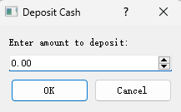
- S2.5 Withdraw Cash

Click this button and it will allow the user to perform the Withdraw operation.
- S2.5.1 Input amount
- Check if amount is in the correct interval.
- Check if the current account has enough amount.
- S2.5.2 OK
- Return Withdraw result information to the front end.
- Updating relevant data in the database.
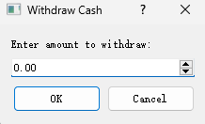
- S2.6 Transfer Money

Click this button and it will allow the user to perform the Transfer operation.
- S2.6.1 Input receiver ID
- Check if the current account is the same as the receiver ID.
- Check that the receiver ID conforms to the ID specification.
- Check if the receiver ID exists in the database.
- S2.6.2 Input amount
- Check if amount is in the correct interval.
- Check if the current account has enough amount.
- S2.6.3 OK
- Return Transfer result information to the front end.
- Updating relevant data in the database.
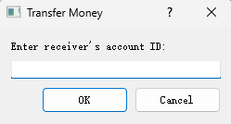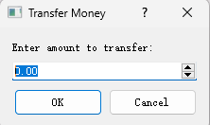
- S2.7 Change Password
Click on this button and it will allow the user to change Password.
- S2.7.1 Input new password
- Check that the new password is the same as the old password.
- Check that the new password is in specification.
- S2.7.2 OK
- Return Change Password result information to the front end.
- Updating relevant data in the database.
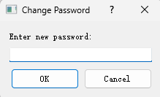
- S2.8 Cancel Account
Clicking on this button will allow the user to cancel the account.
- Check if the balance of the account is 0.
- Check the instance dictionary to see if an app is logged into the account.
- Remove relevant data from the database.
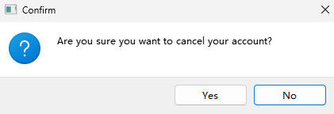
- S2.9 Return Card
Click on this button and it will automatically log out of the account. Then it will return to the Init Menu.
- Set currentAccountId to None and return to the Init Menu.
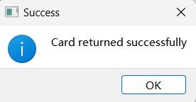
S3: APP
Init Menu
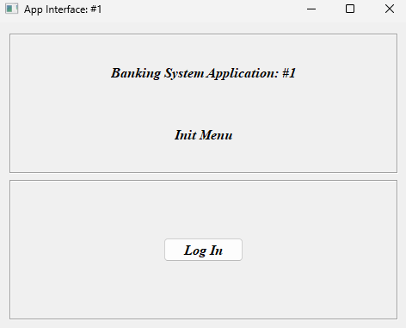
- S3.1 Log In
Clicking on this button will redirect it to the Log In Menu.
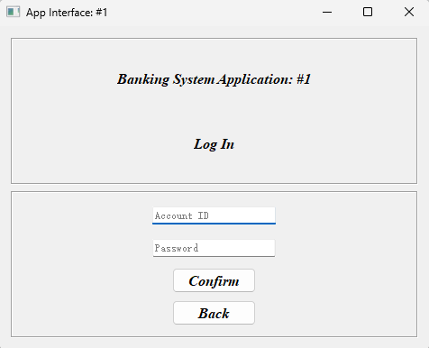
1
2
3
4
- S3.1.1 Input Account ID
- Determine if an account has been created.
- S3.1.2 Input Password ID
- Determine if the password is correct.
- S3.1.3 Confirm
- Returns login information to the front-end.
- If logged in successfully, the APP's currentAccountId will be set to this ID.
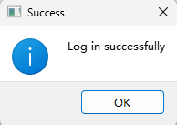

Main Menu
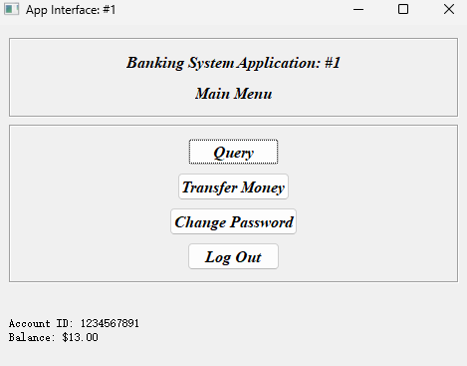
1
2
3
4
5
6
Main Menu Components
- S3.2 Query
Clicking on this button will return all the information about the account including the password, Balance and all the Transaction information
- Request data about currentAccountId from the database.
- Send the data to the front end to show the latest five.
.
- S3.3 Transfer Money

Click this button and it will allow the user to perform the Transfer operation.
- S3.3.1 Input receiver ID
- Check if the current account is the same as the receiver ID.
- Check that the receiver ID conforms to the ID specification.
- Check if the receiver ID exists in the database.
- S3.3.2 Input amount
- Check if amount is in the correct interval.
- Check if the current account has enough amount.
- S3.3.3 OK
- Return Transfer result information to the front end.
- Updating relevant data in the database.
- S3.4 Change Password
Click on this button and it will allow the user to change Password.
- S3.4.1 Input new password
- Check that the new password is the same as the old password.
- Check that the new password is in specification.
- S3.4.2 OK
- Return Change Password result information to the front end.
- Updating relevant data in the database.
- S3.5 Log Out
Click on this button and it will automatically log out of the account. Then it will return to the Init Menu.
- Set currentAccountId to None and return to the Init Menu.
