CS132: Software Engineering

Traceability
Banking System
Group 15
Author: 祝宇航 王芸飞 贾舜康

Catalogue
System Architecture 3
Software Traceability 4

System Architecture
The system architecture is shown below:

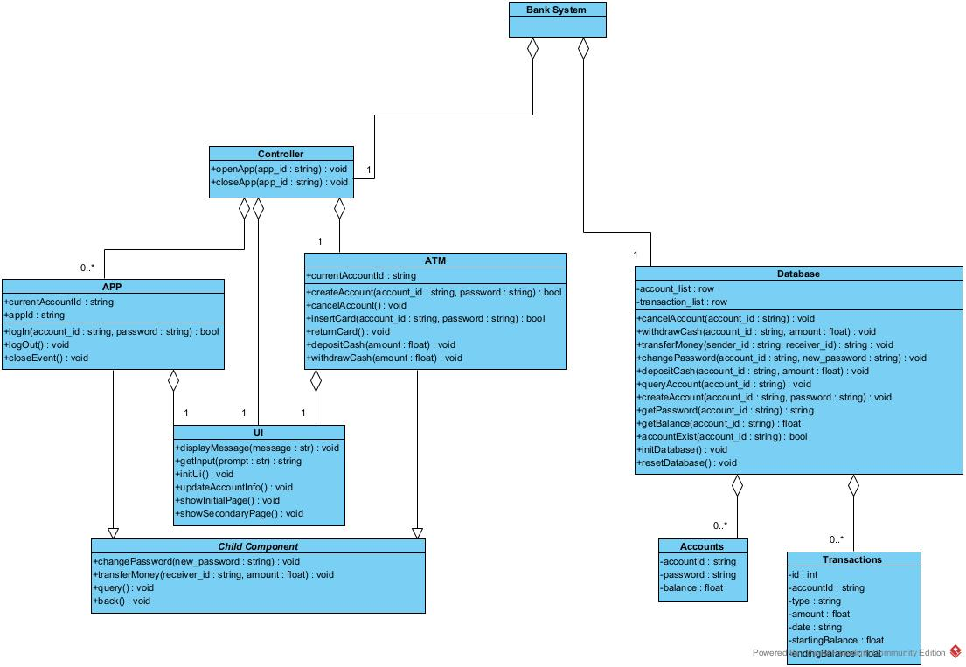

Software Traceability

Requirement | Is implemented by | Is validated by
R1 | S2.1, S2.8, S2.2, S2.9, S2.4, S2.5 | V1.1, V2.1,
R1.1 | S2.1 | V1.1.1, V1.1.13, V2.1, V4.1.1, V4.1.2
R1.1.1 | S2.1.1 | V1.1.1, V2.1, V4.1.1
R1.1.2 | S2.1.1 | V2.1, V1.1.13
R1.1.3 | S2.1.2 | V1.1.1
R1.1.4 | S2.1.3 | V4.1.3
R1.2 | S2.8 | V1.1.10, V2.1, V4.1.3
R1.2.1 | S2.8.1 | V1.1.10, V2.1
R1.2.2 | S2.8.2 | V1.1.10, V2.1
R1.2.3 | S2.8.3 | V4.1.3
R1.3 | S2.2 | V1.1.3, V4.1.3, V2.1
R1.3.1 | S2.2.1, S2.2.2 | V1.1.3, V2.1
R1.3.2 | S2.2.3 | V4.1.3, V2.1
R1.4 | S2.9 | V1.1.5, V4.1.3, V2.1
R1.5 | S2.4 | V1.1.4, V2.1
R1.5.1 | S2.4.1 | V1.1.4, V2.1
R1.5.2 | S2.4.1 | V1.1.4, V2.1
R1.5.3 | S2.4.1 | V1.1.4, V2.1
R1.5.4 | S2.4.2 | V1.1.4, V2.1
R1.5.5 | S2.4.2 | V4.1.3
R1.6 | S2.5 | V1.1.9, V2.1, V4.1.3
R1.6.1 | S2.5.1 | V1.1.9, V2.1
R1.6.2 | S2.5.1 | V1.1.9, V2.1
R1.6.3 | S2.5.1 | V1.1.9, V2.1
R1.6.4 | S2.5.1 | V1.1.9, V2.1
R1.6.5 | S2.5.2 | V1.1.9, V2.1
R1.6.6 | S2.5.2 | V4.1.3
R2 | S3.1, S3.5, S3.6 | V1.1, V2.2, V4.1.3
R2.1 | S3.1 | V1.1.2, V2.2, V4.1.3
R2.1.1 | S3.1.1, S3.1.2 | V1.1.2, V2.2
R2.1.2 | S3.1.1 | V1.1.2, V2.2
R2.1.3 | S3.1.3 | V1.1.2, V2.2
R2.1.4 | S3.1.3 | V4.1.3
R2.2 | S3.5 | V1.1.6, V4.1.2
R2.3 | S3.6 | V1.2.3, V2.2
R3 | S2.3, S2.6, S2.7, S3.2, S3.3, S3.4 | V1.1, V2
R3.1 | S3.4, S2.7 | V1.1.7, V2.1, V2.2
R3.1.1 | S2.7.1, S3.4.1 | V1.1.7,V2.1,V2.2
R3.1.2 | S2.7.1, S3.4.1 | V1.1.7,V2.1,V2.2
R3.1.3 | S2.7.1, S3.4.1 | V1.1.7,V2.1,V2.2
R3.1.4 | S2.7.2, S3.4.2 | V1.1.7,V2.1,V2.2
R3.1.5 | S2.7.2, S3.4.2 | V1.1.7,V2.1,V2.2
R3.1.6 | S2.7.2, S3.4.2 | V4.1.3
R3.2 | S3.3, S2.6 | V1.1.8,V2.3
R3.2.1 | S2.6.2, S3.3.2 | V1.1.8,V2.3
R3.2.2 | S2.6.1, S3.3.1 | V1.1.8,V2.3
R3.2.3 | S2.6.2, S3.3.2 | V1.1.8,V2.3
R3.2.4 | S2.6.3, S3.3.3 | V1.1.8,V2.3
R3.2.5 | S2.6.3, S3.3.3 | V1.1.8,V2.3
R3.2.6 | S2.6.3, S3.3.3 | V1.1.8,V2.3
R3.2.7 | S2.6.1, S3.3.1 | V4.1.3
R3.3 | S3.2, S2.3 | V1.1.12,V2
R3.3.1 | S3.2.1, S2.3.1 | V1.1.12,V2
R3.3.2 | S3.2.2, S2.3.2 | V1.1.12,V2
R3.3.3 | S3.2.1, S2.3.1 | V1.1.12,V2
R3.3.4 | S3.2.2, S2.3.2 | V1.1.12,V2
R4 | S1.1, S1.2, S1.3 | V1.2,V2
R4.1 | S1.1 | V1.2.2,V2.2,V2.3
R4.2.1 | S1.2 | V1.2.3,V2.2,V2.3
R4.2.2 | S1.2 | V1.2.3,V2.2,V2.3
R4.3 | S1.3 | V2

