CS132: Software Engineering

Validation
Banking System
Group 15
Author: 贾舜康 祝宇航 王芸飞
Catalogue
1. Unit Test 3
1.1 Server (Backend of the system) 3
1.1.1 Process request: create account 3
1.1.2 Process request: log in 4
1.1.3 Process request: Insert card 4
1.1.4 Process request: Deposit cash 5
1.1.5 Process request: Return card 6
1.1.6 Process request: Log out 6
1.1.7 Process request: Change password 6
1.1.8 Process request: Transfer Money 7
1.1.9 Process request: Withdraw cash 8
1.1.10 Process request: Cancel account 9
1.1.11 Process request: Get balance 10
1.1.12 Process request: Query 10
1.1.13 Account exist 10
1.1.14 Verify password 11
1.1.15 Get balance 11
1.1.16 Has sufficient balance 12
1.2 Controller (frontend) 12
1.2.1 Init 12
1.2.2 Open app 13
1.2.3 Close App 13
2. Integrated Functional Test 14
2.1 Integrated Functional tests on ATM 14
2.2 Integrated Functional tests on APP 18
2.3 Integrated Functional tests on APP and ATM(transfers between multiple users) 19
2.3 Test Results 21
3. Model Checking 21
3.1 Introduction 21
3.2 Assumption 22
3.3 Properties Validation 23
4. Risk Management 24
4.1.1 Risks related to invalid input: non-digit and invalid length 24
4.1.2 Risks related to invalid input: pressing the button that is not needed: e.g: when transferring, pressing the cancel account 24
4.1.3 Risks of transaction to be not atomic and problems cause by excessive amount of input at short time. 24

- Unit Test
This section provides information of unit tests we made for every main function with statement coverage, branch coverage and condition coverage criteria. Testing cases with runnable test functions are provided in every test, you can find in corresponding files.
  - Server (Backend of the system)
    - Process request: create account
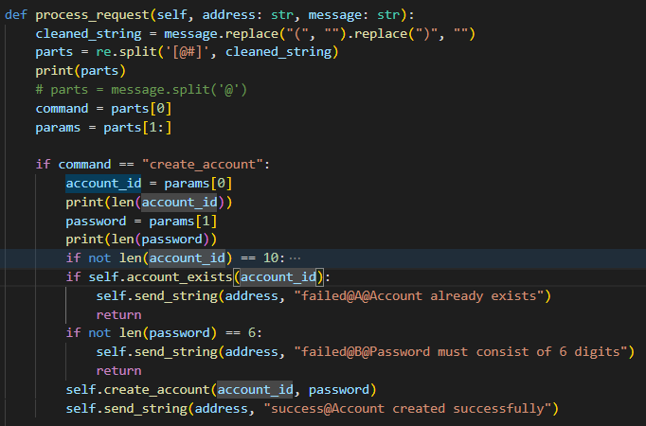
- Coverage Criteria: Branch Coverage
-TestFunction:src/test/unitttest_server.py/test_001,test_002,test_003,test_004
- Test Case
Test Case | T1.1.1.1 | T1.1.1.2 | T1.1.1.3 | T1.1.1.4
Input | "create_account@1234567890#000000" | “create_account@145670#000000” | “create_account@5876476543#00000” | “create_account@2024888888#000000”
Coverage Item | Tcover1.1.1.1 | Tcover1.1.1.2 | Tcover1.1.1.3 | Tcover1.1.1.4
State | This account does not exist | ----- | ----- | This account already exist
Expected Output | "success@Account created successfully" | "failed@A@Account ID must consist of 10 digits" | "failed@B@Password must consist of 6 digits" | “failed@A@Account already exists”
Test Result | Passed | Passed | Passed | Passed
- Test Coverage: 4/4 = 100%
    - Process request: log in
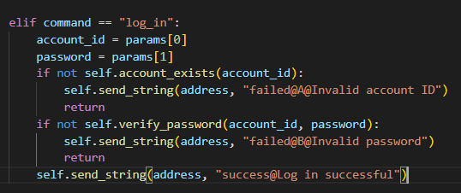
- Coverage Criteria: Branch Coverage
- TestFunction:src/test/unitttest_server.py/test_005,test_006,test_007
- Test Case
Test Case | T1.1.2.1 | T1.1.2.2 | T1.1.2.3
Input | log_in@2024888888#000000 | log_in@2024888889#000000 | log_in@2024888888#000001
Coverage Item | Tcover1.1.2.1 | Tcover1.1.2.2 | Tcover1.1.2.3
State | The account exist | The account does not exist | The account password is 000000
Expected Output | " success@Log in successful" | "failed@A@Invalid account ID" | "failed@B@Invalid password"
Test Result | Passed | Passed | Passed
- Test Coverage: 3/3 = 100%
    - Process request: Insert card
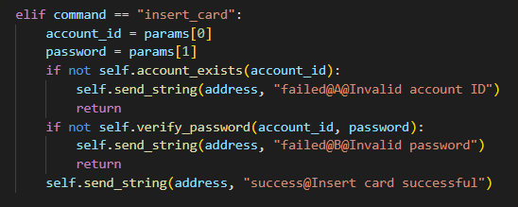
- Coverage Criteria: Branch Coverage
- TestFunction:src/test/unitttest_server.py/test_008,test_009,test_010
- Test Case
Test Case | T1.1.3.1 | T1.1.3.2 | T1.1.3.3
Input | insert_card@2024888888#000000 | insert_card@2024888889#000000 | insert_card@2024888888#000001
Coverage Item | Tcover1.1.3.1 | Tcover1.1.3.2 | Tcover1.1.3.3
State | The account exist | The account does not exist | The account password is 000000
Expected Output | "success@Insert card successful" | "failed@A@Invalid account ID" | "failed@B@Invalid password"
Test Result | Passed | Passed | Passed
- Test Coverage: 3/3 = 100%
    - Process request: Deposit cash
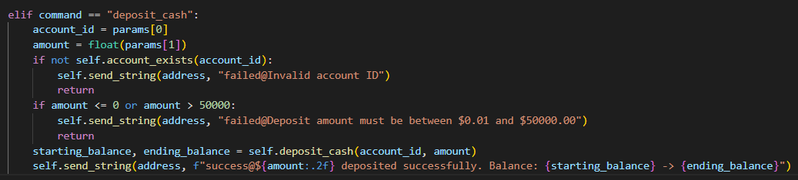
- Coverage Criteria: Branch Coverage
- TestFunction:src/test/unitttest_server.py/test_011,test_012,test_013,test_014
- Test Case
Test Case | T1.1.4.1 | T1.1.4.2 | T1.1.4.3 | T1.1.4.4
Input | deposit_cash@2024888888#200 | deposit_cash@2024888889#200 | deposit_cash@2024888888#50001 | deposit_cash@2024888888#-78.90
Coverage Item | Tcover1.1.4.1 | Tcover1.1.4.2 | Tcover1.1.4.3 | Tcover1.1.4.4
State | The account exist | The account does not exist | ----- | -----
Expected Output | "success@$200.00 deposited successfully. Balance: 10000.0 -> 10200.0" | "failed@Invalid account ID" | "failed@Deposit amount must be between $0.01 and $50000.00" | “failed@Deposit amount must be between $0.01 and $50000.00”
Test Result | Passed | Passed | Passed | Passed
- Test Coverage: 4/4 = 100%
    - Process request: Return card
- Coverage Criteria: Statement Coverage
- TestFunction:src/test/unitttest_server.py/test_015
- Test Case
Test Case | T1.1.5.1
Input | “return_card”
Coverage Item | Tcover1.1.5.1
State | -----
Expected Output | “success@Card returned successfully”
Test Result | Passed
- Test Coverage: 1/1 = 100%
    - Process request: Log out
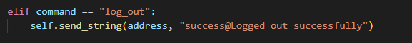
- Coverage Criteria: Statement Coverage
- TestFunction:src/test/unitttest_server.py/test_016
- Test Case
Test Case | T1.1.6.1
Input | “log_out”
Coverage Item | Tcover1.1.6.1
State | -----
Expected Output | “success@Logged out successfully”
Test Result | Passed
- Test Coverage: 1/1 = 100%
    - Process request: Change password
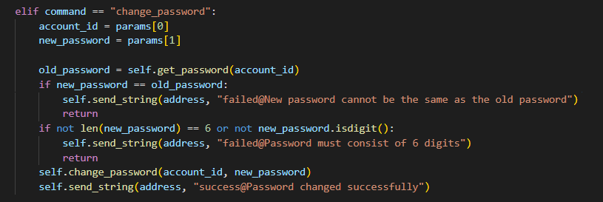
- Coverage Criteria: Branch Coverage
- TestFunction:src/test/unitttest_server.py/test_017,test_018,test_019,test_020
- Test Case
Test Case | T1.1.4.1 | T1.1.4.2 | T1.1.4.3 | T1.1.4.4
Input | change_password@2024888888#000000 | change_password@2024888888#abcefg | change_password@2024888888#12345 | change_password@2024888888#123456
Coverage Item | Tcover1.1.4.1 | Tcover1.1.4.2 | Tcover1.1.4.3 | Tcover1.1.4.4
State | ----- | ----- | ----- | -----
Expected Output | "failed@New password cannot be the same as the old password" | "failed@Password must consist of 6 digits" | "failed@Password must consist of 6 digits" | “success@Password changed successfully”
Test Result | Passed | Passed | Passed | Passed
- Test Coverage: 4/4 = 100%
    - Process request: Transfer Money
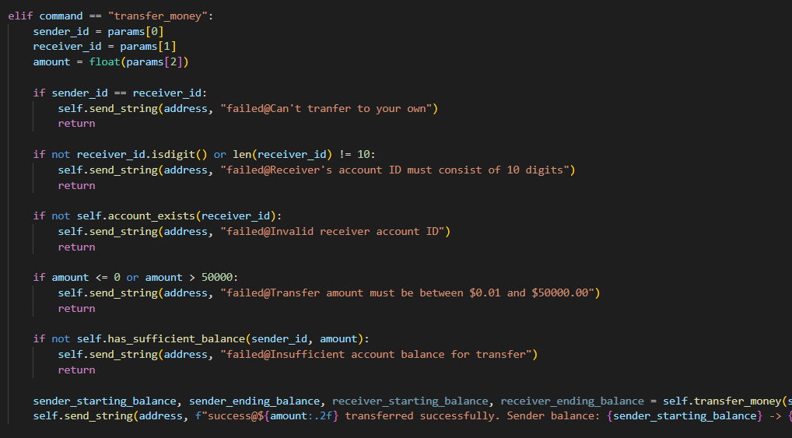
- Coverage Criteria: Branch Coverage
- TestFunction:src/test/unitttest_server.py/test_021,test_022,test_023_1,test_023_2,test024_1,test024_2,test_024_3
- Test Case
Test Case | T1.1.8.1 | T1.1.8.2 | T1.1.8.3
Input | transfer_money@2024888888#2024000000#5000 | transfer_money@2024888888#2024000001#5000 | transfer_money@2024888888#2024000000#50000.01 | transfer_money@2024888888#2024000000#40000.0
Coverage Item | Tcover1.1.8.1 | Tcover1.1.8.2 | Tcover1.1.8.3 | Tcover1.1.8.7
State | ----- | ----- | ----- | ----
Expected Output | "success@$5000.00 transferred successfully. Sender balance: 10200.0 -> 5200.0" | "failed@Invalid receiver account ID" | " failed@Transfer amount must be between $0.01 and $50000.00" | failed@Insufficient account balance for transfer
Test Result | Passed | Passed | Passed | Passed
Test Case | T1.1.8.4 | T1.1.8.5 | T1.1.8.6 | -----
Input | transfer_money@2024888888#2024000000#-78.90 | transfer_money@2024888888#2024888888#5000 | transfer_money@2024888888#2024#5000 | -----
Coverage Item | Tcover1.1.8.4 | Tcover1.1.8.5 | Tcover1.1.8.3 | ------
State | ----- | ----- | ----- | ----
Expected Output | "failed@Transfer amount must be between $0.01 and $50000.00" | "failed@Can't tranfer to your own" | "failed@Receiver's account ID must consist of 10 digits" | -----
Test Result | Passed | Passed | Passed

- Test Coverage: 7/7 = 100%
    - Process request: Withdraw cash
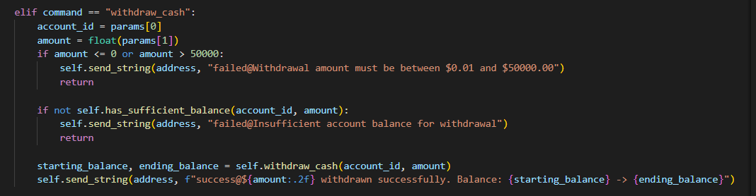
- Coverage Criteria: Branch Coverage
- TestFunction:src/test/unitttest_server.py/test_025,test_027,test_028
- Test Case
Test Case | T1.1.9.1 | T1.1.9.2 | T1.1.9.3
Input | withdraw_cash@2024888888#5200 | withdraw_cash@2024888888#50000 | withdraw_cash@2024888888#-78.90
Coverage Item | Tcover1.1.9.1 | Tcover1.1.9.2 | Tcover1.1.9.3
State | ----- | ----- | -----
Expected Output | "success@$5200.00 withdrawn successfully. Balance: 5200.0 -> 0.0" | "failed@Insufficient account balance for withdrawal" | "failed@Withdrawal amount must be between $0.01 and $50000.00"
Test Result | Passed | Passed | Passed
- Test Coverage: 3/3 = 100%
    - Process request: Cancel account
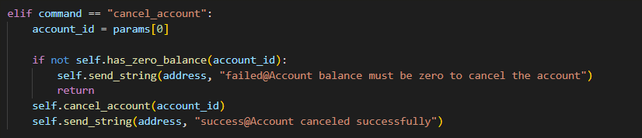
- Coverage Criteria: Branch Coverage
- TestFunction:src/test/unitttest_server.py/test_029,test_030
- Test Case
Test Case | T1.1.10.1 | T1.1.10.2
Input | cancel_account@2024888888 | cancel_account@2024000000
Coverage Item | Tcover1.1.10.1 | Tcover1.1.10.2
State | ----- | -----
Expected Output | "success@Account canceled successfully" | " failed@Account balance must be zero to cancel the account"
Test Result | Passed | Passed
- Test Coverage: 2/2 = 100%
    - Process request: Get balance
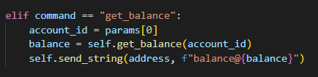
- Coverage Criteria: Statement Coverage
- TestFunction:src/test/unitttest_server.py/test_031
- Test Case
Test Case | T1.1.11.1
Input | “get_balance@2024000000”
Coverage Item | Tcover1.1.11.1
State | -----
Expected Output | “balance@15000.0”
Test Result | Passed
- Test Coverage: 1/1 = 100%
    - Process request: Query
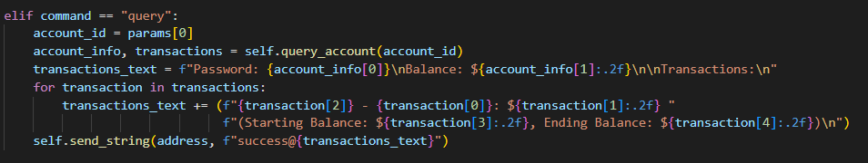
- Coverage Criteria: Statement Coverage
- TestFunction:src/test/unitttest_server.py/test_032
- Test Case
Test Case | T1.1.12.1
Input | “query@2024000000”
Coverage Item | Tcover1.1.12.1
State | -----
Expected Output | String
Test Result | Passed
- Test Coverage: 1/1 = 100%
    - Account exist
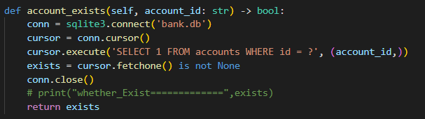
- Coverage Criteria: Statement Coverage
- TestFunction:src/test/unitttest_server.py/test_033
- Test Case
Test Case | T1.1.13.1
Input | “2024000000”
Coverage Item | Tcover1.1.13.1
State | -----
Expected Output | True
Test Result | Passed
- Test Coverage: 1/1 = 100%
    - Verify password
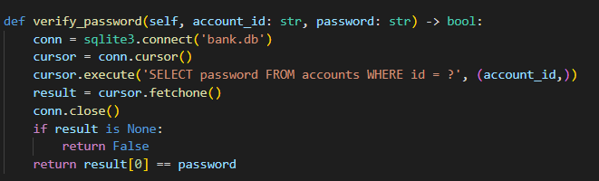
- Coverage Criteria: Statement Coverage
- TestFunction:src/test/unitttest_server.py/test_034
- Test Case
Test Case | T1.1.14.1
Input | "2024000000", "000000"
Coverage Item | Tcover1.1.14.1
State | -----
Expected Output | True
Test Result | Passed
- Test Coverage: 1/1 = 100%
    - Get balance
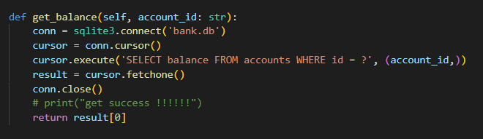
- Coverage Criteria: Statement Coverage
- TestFunction:src/test/unitttest_server.py/test_035
- Test Case
Test Case | T1.1.15.1
Input | "2024000000"
Coverage Item | Tcover1.1.15.1
State | -----
Expected Output | 15000
Test Result | Passed
- Test Coverage: 1/1 = 100%
    - Has sufficient balance
- Coverage Criteria: Statement Coverage
- TestFunction:src/test/unitttest_server.py/test_035
- Test Case
Test Case | T1.1.14.1
Input | "2024000000", 10000.0
Coverage Item | Tcover1.1.16.1
State | -----
Expected Output | 15000
Test Result | Passed
- Test Coverage: 1/1 = 100%
  - Controller (frontend)
    - Init
- Coverage Criteria: Statement Coverage
- TestFunction: src/test/unitttest_controller.py/test_001_initUI
- Test Case
Test Case | T1.2.1.1
Input | ---
Coverage Item | Tcover1.2.1.1
State | ---
Expected Output | Main window appears with label 'Banking System Controller'
Test Result | Passed
- Test Coverage: 1/1 = 100%
    - Open app
- Coverage Criteria: Statement Coverage
- TestFunction: src/test/unitttest_controller.py/ test_002_open_app
- Test Case
Test Case | T1.2.2.1
Input | ---
Coverage Item | Tcover1.2.2.1
State | ---
Expected Output | num_apps = 1
Test Result | Passed
- Test Coverage: 1/1 = 100%
    - Close App
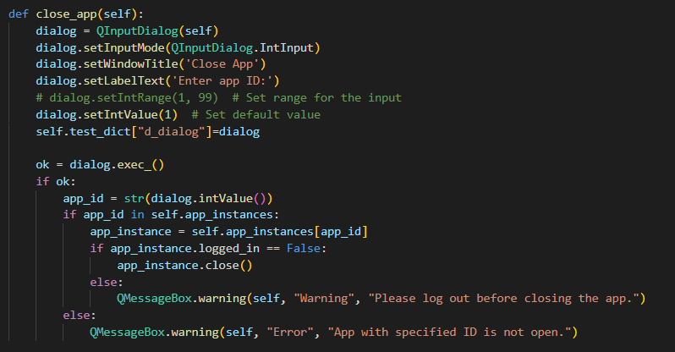
- Coverage Criteria: Branch Coverage
- TestFunction: src/test/unitttest_controller.py/ test_003_close_app, test_004_close_app_logged_in, test_005_close_app_notopen
- Test Case
Test Case | T1.2.3.1 | T1.2.3.1 | T1.2.3.1
Input | --- | --- | ---
Coverage Item | Tcover1.2.3.1 | Tcover1.2.3.2 | Tcover1.2.3.3
State | ---
Expected Output | --- | "Warning", "Please log out before closing the app." | "Error", "App with specified ID is not open."
Test Result | Passed | Passed | Passed
- Test Coverage: 3/3 = 100%

- Integrated Functional Test
This section provides information on the functional tests we have done for Banking system as well as common use cases. They are integrated into three groups: 1. Functional tests on ATM, including all functionalities concerning ATM with single user and multiple user. 2. Functional tests on APP with single user, with only single user and tests all functionalities except for transferring. 3 Functional tests on both ATM and APP, with multiple users transferring to each other.
  - Integrated Functional tests on ATM
- Test Function: src/test/functionalTestATM.py/test_001~031
- Test Case
Test Case | Operation | State | Expected Output | Test Result
T2.1.001 | Press create account button; Input 2024123456 as id; Input password 123456 | --- | MessageBoxText: Account created successfully and enter main page | Passed
T2.1.002 | Press deposit button; Input 10 as number of 100 cash and confirm | --- | MessageBoxText: $1000.00 deposited successfully | Passed
T2.1.003 | Press deposit button; Input 0 and cancel | --- | MessageBoxText: Deposit amount must be between $0.01 and $50000.00 | Skipped
T2.1.004 | Press deposit button; Input -1 and cancel | --- | MessageBoxText: Deposit amount must be between $0.01 and $50000.00 | Skipped
T2.1.005 | Press deposit button; Input 501 and cancel | --- | MessageBoxText: Deposit amount must be between $0.01 and $50000.00 | Skipped
T2.1.006 | Press withdraw button; Input 5 as number of 100 cash and confirm | --- | MessageBoxText: $500.00 withdrawn successfully | Passed
T2.1.007 | Press withdraw button; Input 0 and cancel | --- | MessageBoxText: Withdrawal amount must be between $0.01 and $50000.00 | Skipped
T2.1.008 | Press withdraw button; Input -1 and cancel | --- | MessageBoxText: Withdrawal amount must be between $0.01 and $50000.00 | Skipped
T2.1.009 | Press withdraw button; Input 501 and cancel | --- | MessageBoxText: Withdrawal amount must be between $0.01 and $50000.00 | Skipped
T2.1.010 | Press withdraw button; Input 20 and cancel | --- | MessageBoxText: Insufficient account balance for withdrawal | Passed
T2.1.011 | Press return card button | --- | MessageBoxText: Card returned successfully | Passed
T2.1.012 | Press log in button; Input 2024987654 as id; Input password 123456 | --- | MessageBoxText: Invalid account ID | Passed
T2.1.013 | Press log in button; Input 123451 as id; Input password 654321 | --- | MessageBoxText: Invalid account ID | Passed
T2.1.014 | Press log in button; Input 2024123456 as id; Input password 654321 | --- | MessageBoxText: Invalid password | Passed
T2.1.015 | Press log in button; Input 2024123456 as id; Input password 123456 | --- | MessageBoxText: Insert card successfully | Passed
T2.1.016 | Press change password button; Input j12re7 as password and cancel | --- | MessageBoxText: Password must consist of 6 digits | Skipped
T2.1.017 | Press change password button; Input 123456 as password and cancel | --- | MessageBoxText: New password cannot be the same as the old password | Passed
T2.1.018 | Press change password button; Input 654321 as password and confirm | --- | MessageBoxText: Password changed successfully; Card returned successfully | Passed
T2.1.019 | Press create account button; Input 1234O6789 as id; Input password 654321 | --- | MessageBoxText: Account ID must consist of 10 digits | Passed
T2.1.020 | Press create account button; Input 2024654321 as id; Input password jsk1!-=234 | --- | MessageBoxText: Password must consist of 6 digits; Back to previous page | Passed
T2.1.021 | Press create account button; Input 2024123456 as id; Input password 654321 | --- | MessageBoxText: Account already exists | Passed
T2.1.022 | Press create account button; Input 2024654321 as id; Input password 654321; Press deposit button; Input 10 as number of 100 cash and confirm | --- | MessageBoxText: Account created successfully; $1000.00 deposited successfully | Passed
T2.1.023 | Press transfer button; Input 123456789 as id and confirm | --- | MessageBoxText: Receiver's account ID must consist of 10 digits | Passed
T2.1.024 | Press transfer button; Input 2024123456 as id; Input jqk0 as money and confirm | --- | MessageBoxText: Transfer amount must be between $0.01 and $50000.00 | Passed
T2.1.025 | Press transfer button; Input 2024123456 as id; Input 9000 as money and confirm | --- | MessageBoxText: Insufficient account balance for transfer | Passed
T2.1.026 | Press transfer button; Input 2024654321 as id; Input 10 as money and confirm | --- | MessageBoxText:Can't tranfer to your own | Passed
T2.1.027 | Press transfer button; Input 2024987654 as id; Input 10 as money and confirm | --- | MessageBoxText: Invalid receiver account ID | Passed
T2.1.028 | Press transfer button; Input 2024123456 as id; Input 100 as money and confirm | --- | MessageBoxText: $100.00 transferred successfully | Passed
T2.1.029 | Press cancel account button | --- | MessageBoxText: Account balance must be zero to cancel the account | Passed
T2.1.030 | Press transfer button; Input 2024123456 as id; Input all the balance as money and confirm | --- | MessageBoxText: ${balance:.2f} transferred successfully | Passed
T2.1.031 | Press cancel account button | --- | Account canceled successfully | Passed
  - Integrated Functional tests on APP
- Test Function: src/test/functionalTestApp.py/test_001~009
- Test Case
Test Case | Operation | State | Expected Output | Test Result
T2.2.001 | Create account with ID 2024123456 and password 123456; Deposit $1000 | --- | MessageBoxText: Account created successfully; $1000.00 deposited successfully | Passed
T2.2.002 | Open the app with ID 1 | --- | App opened successfully | Passed
T2.2.003 | Skipped as appid is automatically assigned | --- | --- | Skipped
T2.2.004 | Open the app with ID 2 and then close it | --- | App opened successfully; App closed successfully | Passed
T2.2.005 | Log in to app 1 with ID 2024123456 and password 123456 | --- | MessageBoxText: Log in successfully | Passed
T2.2.006 | Open app with ID 3; Log in to app 3 with same account ID 2024123456 and password 123456 | --- | MessageBoxText: Log in successfully, the former app is forced to log out | Passed
T2.2.007 | Change password on app 3 to 000666 | --- | MessageBoxText: Password changed successfully; Card returned successfully; Logged out successfully | Passed
T2.2.008 | Log in to app 3 using new password 000666 | --- | MessageBoxText: Log in successfully | Passed
T2.2.009 | Query account balance on app 3 | --- | Account balance displayed successfully | Passed

  - Integrated Functional tests on APP and ATM(transfers between multiple users)
- Test Function: src/test/functionalTestApp.py/test_001~009
- Test Case
Test Case | Operation | State | Expected Output | Test Result
T3.2.001 | Create accounts with IDs 2024111111; 2024222222; 2024333333 and deposit $1000 each | --- | MessageBoxText: Account created successfully; $1000.00 deposited successfully; Card returned successfully | Passed
T3.2.002 | Open 3 apps with IDs 1; 2; 3 | --- | Apps opened and positioned successfully | Passed
T3.2.003 | Log in to apps 1; 2; 3 with respective accounts and check balance | --- | MessageBoxText: Log in successfully; Balance: $1000.00 for each account | Passed
T3.2.004 | Transfer $100 from account 2024111111 to 2024222222 | --- | MessageBoxText: $100.00 transferred successfully; Balance for 2024111111: $900.00; Balance for 2024222222: $1100.00 | Passed
T3.2.005 | Transfer $200 from account 2024222222 to 2024333333 | --- | MessageBoxText: $200.00 transferred successfully; Balance for 2024222222: $900.00; Balance for 2024333333: $1200.00 | Passed
T3.2.006 | Transfer $300 from account 2024333333 to 2024111111 | --- | MessageBoxText: $300.00 transferred successfully; Balance for 2024333333: $900.00; Balance for 2024111111: $1200.00 | Passed
T3.2.007 | Transfer $100.5 from account 2024111111 to 2024222222 | --- | MessageBoxText: $100.50 transferred successfully; Balance for 2024111111: $1099.50; Balance for 2024222222: $1000.50 | Passed
T3.2.008 | Transfer $200.99 from account 2024222222 to 2024333333 | --- | MessageBoxText: $200.99 transferred successfully; Balance for 2024222222: $799.51; Balance for 2024333333: $1100.99 | Passed
T3.2.009 | Transfer $1100.99 from account 2024333333 to 2024111111 | --- | MessageBoxText: $1100.99 transferred successfully; Balance for 2024333333: $0.00; Balance for 2024111111: $2200.49 | Passed
T3.2.010 | Query on all three apps | --- | Transactions and balance are displayed correctly | Passed

2.3 Test Results
You can run `python -m src.test.run_functionalTest` to test functional tests with UI about buttons’ click conditions and corresponding constrains during the process.
The result of functional tests on ATM.
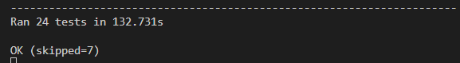
The result of function tests on App.
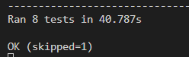
The result of function tests on multiple user transfer
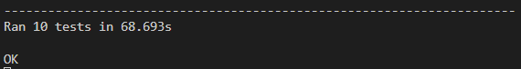

- Model Checking
This section provides an abstract model built in UPPAAL for model checking purposes. You can find the source files in model checking/painkiller.xml and run it locally using an UPPAAL application .
  - Introduction
The Painkiller Injection System is divided into three main modules, a User with app and can use ATM as well, an ATM machine, and a Server.
  - Assumption
There are totally three user, with each carrying 10 cash initially. There is no balance at their account.
There is only one instance of ATM and one instance of Server.

Fig.1 : UserWithAPP
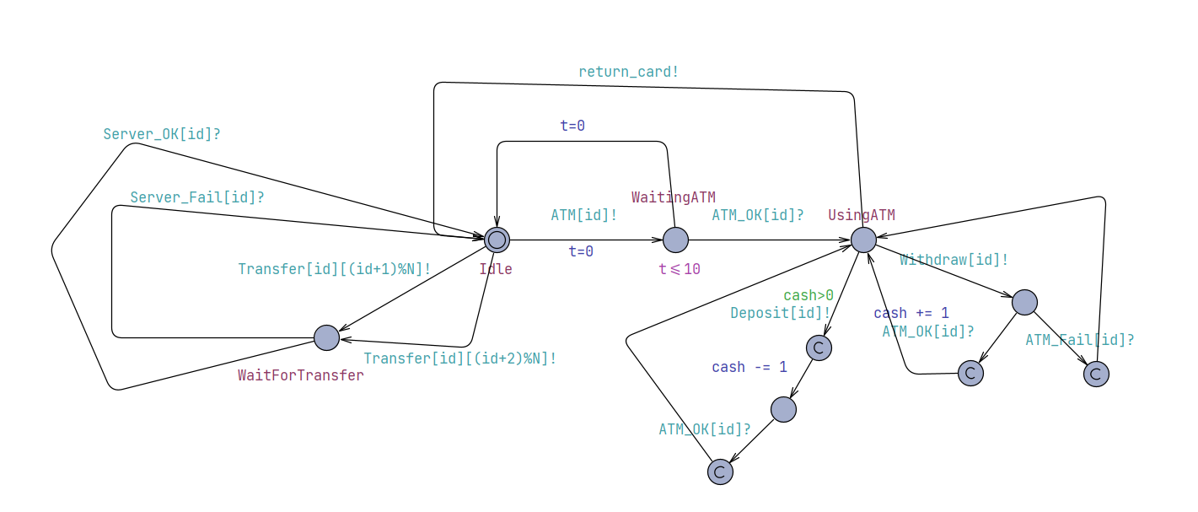

Fig.2: ATM machine
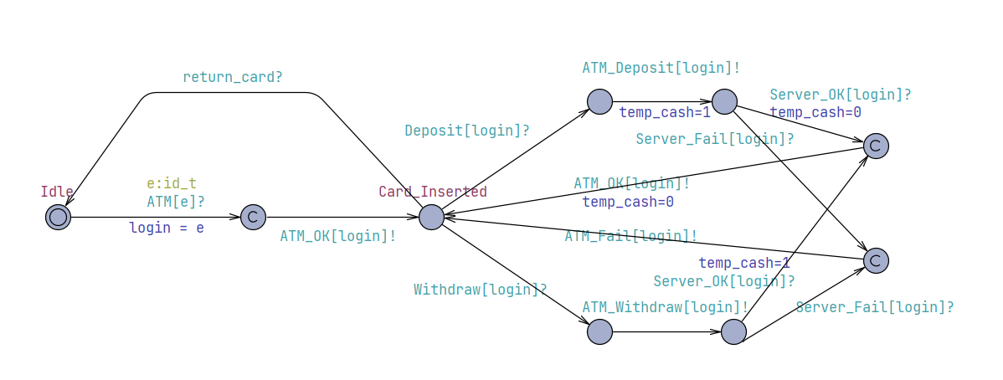
Fig.3: Server
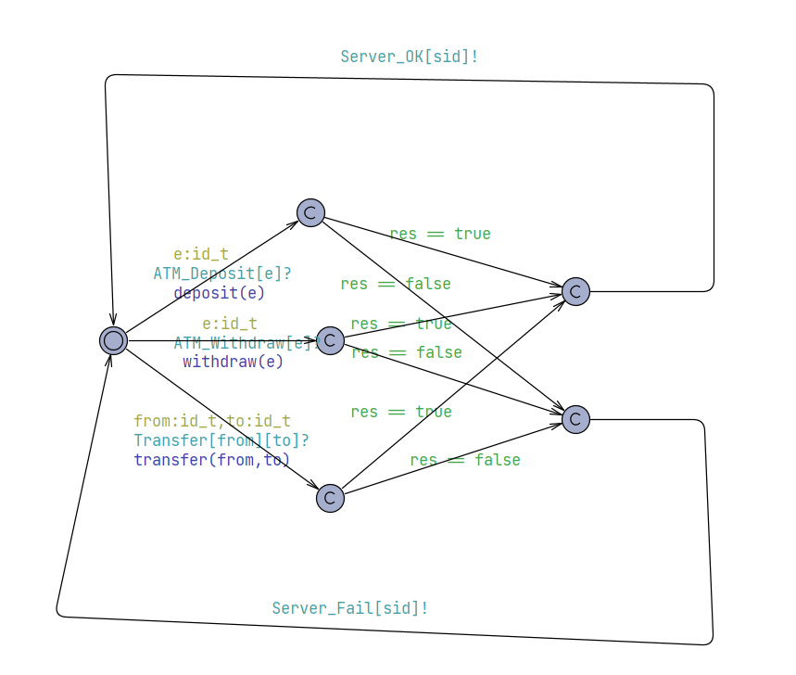

3.3 Properties Validation

3.3.1 No deadlock
Property | A[] not deadlock
Description | The whole system has no deadlock.
Result | Passed

3.3.2 Balance in server will always greater equal 0
Property | A[] Server.balance[0] >= 0 and Server.balance[1] >= 0 and Server.balance[2] >= 0
Description | Balance of every user in the server will always greater equal 0
Result | Passed

3.3.3 User who wants to transfer, always finishes the transfer process.
Property | A<> (UserWithApp(0).WaitForTransfer imply UserWithApp(0).Idle)
Description | User in the process of waiting for transfer always eventually ends up return to idle state
Result | Passed

3.3.4 The cash held by user and their balance at bank server always add up to a constant.
Property | A[] ((UserWithApp(0).Idle and UserWithApp(1).Idle and UserWithApp(2).Idle) imply (Server.balance[0]+Server.balance[1]+Server.balance[2]+UserWithApp(0).cash+UserWithApp(1).cash+UserWithApp(2).cash+ATMachine.temp_cash == 30))
Description | When user are not in intermediate state, the cash they have plus their balance in bank server always add up to the same constant.
Result | Passed

- Risk Management
    - Risks related to invalid input: non-digit and invalid length
In terms of the account input and password input, although a input line is used instead of specially made keyboard, but a regular expression of digit is enforced on the edit line, so user can only input digits within range to it.

    - Risks related to invalid input: pressing the button that is not needed.
There is a button hierarchy so that user will not press the button or input that are not related to the event they are doing. For example, user is not able to click on the cancel account button before they insert card into atm, because cancel account button only appears after log in.

    - Risks of transaction to be not atomic and problems cause by excessive amount of input at short time.
A sqlite database is used in this project to ensure ACID. Also, there is only one server thread dealing with all the requests from the clients, and there is a message queue to receive input so that no request will be omitted. The client will wait for the return message from server to continue. As a result, if massive input comes at same time, they may wait for a long time. However, in our implementation of frontend(app and atm interface), a pop-out window blocks other input, so exactly one user will be able to input at one time, so there not be such problem exists.

