CS132: Software Engineering

USER MANUAL
Banking System
Group 15
Author: 祝宇航 王芸飞 贾舜康
Catalogue
System Architecture 3
Controller Manual 3
Controller Manual Components 4
ATM Manual 6
Init Menu 6
Init Manual Components 6
Main Menu 9
Main Menu Components 9
APP Manual 12
Init Menu 12
Main Menu 14
Main Menu Components 14

System Architecture
The system architecture is shown below:

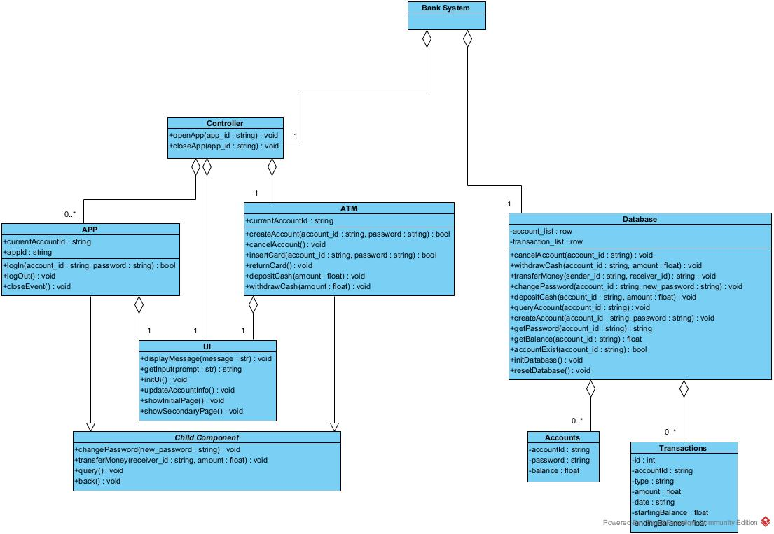

Controller Manual
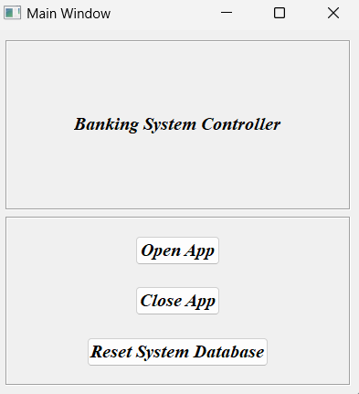
1
2
3

Controller Manual Components

- ”Open APP”
Clicking this button will allow the user to enter an app ID to create a new app, note that you need to enter an integer number within [1,99], and cannot create an existing app.
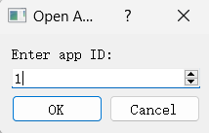

- ”Close APP”
Clicking this button will allow the user to enter an app ID to close a open app, note that you need to enter an integer number within [1,99], and can only close existing open apps.
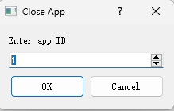

- “Reset System Database”
Click on this button to reset the database in the banking system, removing all account and transaction information.
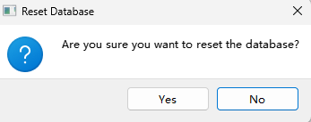
- The controller will automatically start a unique ATM interface.

ATM Manual

Init Menu
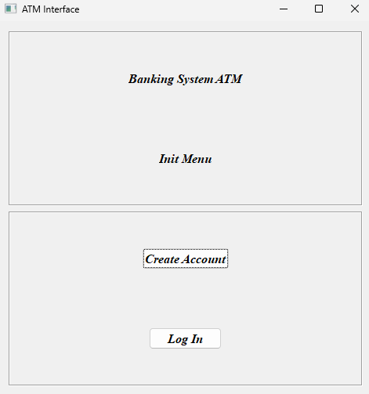
1
2

Init Manual Components
- “Create Account”
Clicking on this button will redirect it to the Create Account Menu.
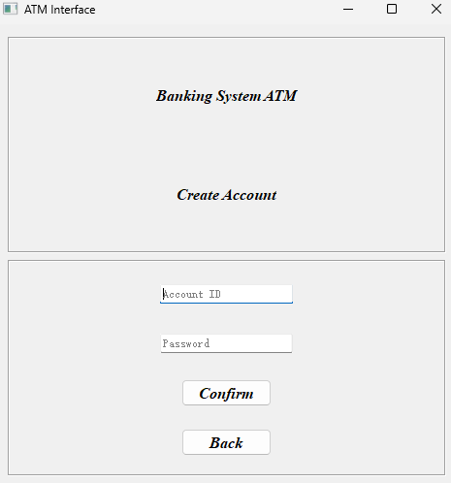
1
2
3
4

- ”Account ID Input”
In this text box, you can enter the account number, which needs to be 10 digits and has been created.

- ”Password ID Input”
In this text box, you can enter a password, which needs to be greater than or equal to 8 digits and contain both numeric and alphabetic case.

- “Confirm”
Clicking on this button will return information about the creation result. If it succeeds, it goes to the Main Menu; if it fails, it clears the input corresponding to the error.
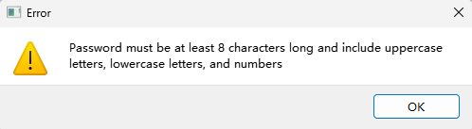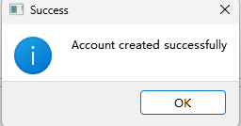
- ”Back”
Clicking on this button will redirect it to the Init Menu.
- “Log In”
Clicking on this button will redirect it to the Log In Menu.
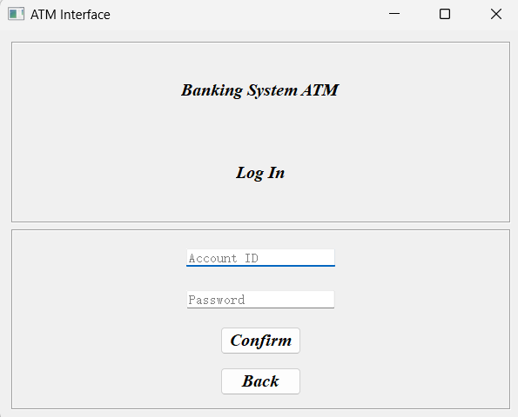
4
3
2
1

- ”Account ID Input”
In this text box, you can enter the account number, which needs to be 10 digits and has been created.

- ”Password ID Input”
In this text box, you can enter the password, the password needs to be greater than or equal to 8 digits, and contains numbers and letters case, and needs to be the account corresponding to the password.

- “Confirm”
Clicking on this button will return information about the creation result. If it succeeds, it goes to the Main Menu; if it fails, it clears the input corresponding to the error.
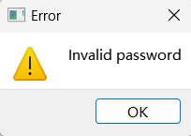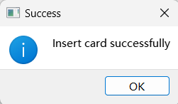
- ”Back”
Clicking on this button will redirect it to the Init Menu.

Main Menu
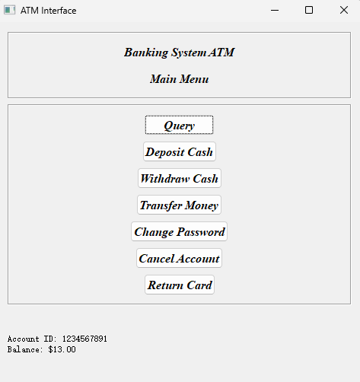
6
1
2
3
4
5
7
81
9

Main Menu Components
- “Query”
Clicking on this button will return all the information about the account including the password, Balance and all the Transaction information
.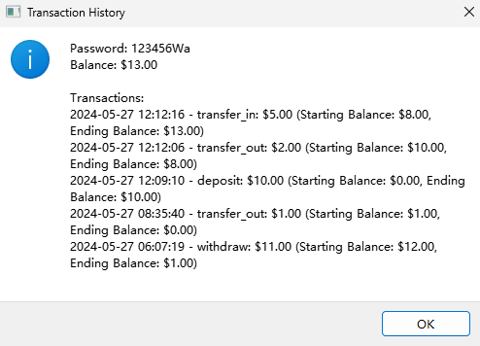

- “Deposit Cash”
Click this button and it will allow the user to perform the Deposit operation. The user will then need to enter the desired amount, note that the amount can be a float and needs to be within [0.01,50000.00].
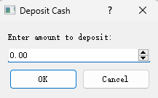

- “Withdraw Cash”
Click this button, it will allow the user to do Withdraw operation. User next need to enter the desired amount, note that the amount can be a float and need to be within [0.01,50000.00], and the amount needs to be less than or equal to the account's Balance number.
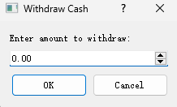

- “Transfer Money”
Click on this button and it will allow the user to perform the Transfer operation. The user will then need to enter the desired amount and receiver id, note that the amount can be a float and needs to be within [0.01,50000.00]. The amount needs to be less than or equal to the Balance of the account, and the receiver id needs to be an account that exists in the bank system.
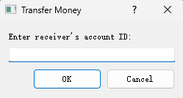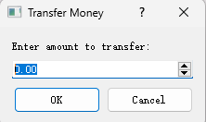

- “Change Password”
Click on this button and it will allow the user to change Password. The user will then need to enter the desired new password, which must conform to the password specification and cannot be the same as the old password. If success, it'll automatically return card.
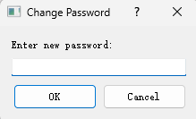

- “Cancel Account”
Clicking on this button will allow the user to cancel the account. The user then needs to confirm that they want to do this. If yes, it'll automatically return to the Init Menu.
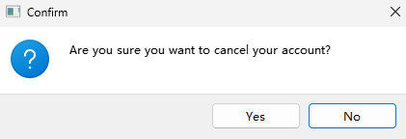

- “Return Card”
Click on this button and it will automatically log out of the account. Then it will return to the Init Menu.
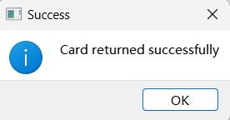

- “Account ID Display”
This is the ID of the account that is currently in ATM.
- “Balance Display”
This is the Balance of the account that is currently in ATM.

APP Manual

Init Menu
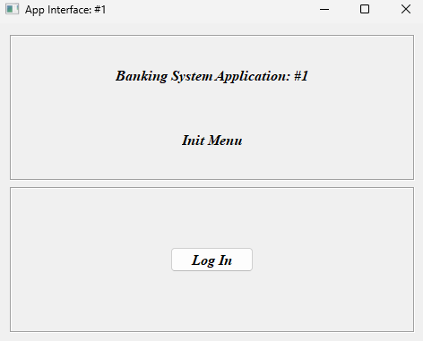
- “Log In” Clicking on this button will redirect it to the Log In Menu.
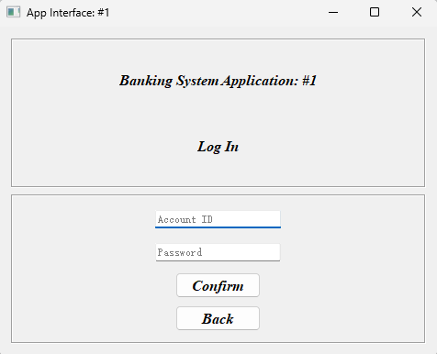
1
2
3
4

- ”Account ID Input”
In this text box, you can enter the account number, which needs to be 10 digits and has been created.

- ”Password ID Input”
In this text box, you can enter the password, the password needs to be greater than or equal to 8 digits, and contains numbers and letters case, and needs to be the account corresponding to the password.

- “Confirm”
Clicking on this button will return information about the creation result. If it succeeds, it goes to the Main Menu; if it fails, it clears the input corresponding to the error.
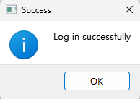
- ”Back”
Clicking on this button will redirect it to the Init Menu.

Main Menu
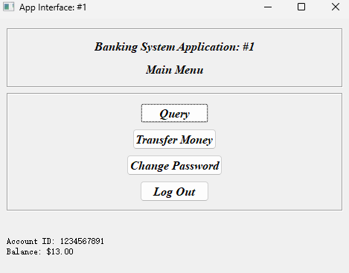
1
2
3
4
5
6

Main Menu Components
- “Query”
Clicking on this button will return all the information about the account including the password, Balance and all the Transaction information
.

- “Transfer Money”
Click on this button and it will allow the user to perform the Transfer operation. The user will then need to enter the desired amount and receiver id, note that the amount can be a float and needs to be within [0.01,50000.00]. The amount needs to be less than or equal to the Balance of the account, and the receiver id needs to be an account that exists in the bank system.

- “Change Password”
Click on this button and it will allow the user to change Password. The user will then need to enter the desired new password, which must conform to the password specification and cannot be the same as the old password. If success, then it'll automatically log out.
- “Log Out”
Click on this button and it will automatically log out of the account. Then it will return to the Init Menu.
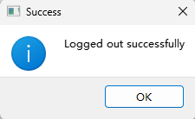

- “Account ID Display”
This is the ID of the account that is currently in ATM.

- “Balance Display”
This is the Balance of the account that is currently in ATM.

