CS132: Software Engineering

USER MANUAL
Elevator
Group 15
Author: 祝宇航 王芸飞 贾舜康
Catalogue
System Architecture 3
1. Inside Elevator UI 3
1.1 Overview 3
1.2 Select Floor 3
1.3 Open door & close door 4
2.Outside FloorUI 4
2.1 Overview 4
2.2 Direction Button 5
3.Simulation Window 5

System Architecture
The system architecture is shown below:
- Inside Elevator UI

Overview
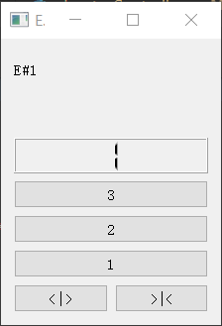
Label to display elevator number
LCD screen to display which floor the elevator at.
Open Door Button
Close Door Button
Floor button 3
Floor button 2
Floor button 1

Select Floor
User can press any floor button at any time. However, only when the floor button is lit up is the task confirmed by the elevator. The lit case is shown below.
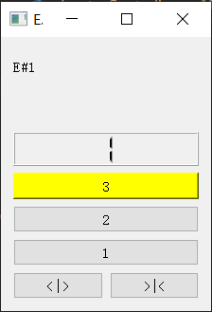
The resons for the cases where user presses the floor button but the floor button is not lit up is listed below:
1. The floor button pressed is the same as the floor where the elevator stops. Eg. When elevator stop at 1st floor and user presses floor 1 button
2. The elevator is moving, but the floor button pressed is a floor in the opposite direction. Eg. When the elevator is moving down from 2nd floor to 1st floor, user press the third floor.
3. The elevator is moving, user pressed 2nd floor but button is not lit up because the elevator is too close to the 2nd floor and it is not able to slow down to stop.

1.3 Open door & close door
These two button only functions when the elevator is stop.
For open door button:
- Pressed when door is closed: door starts to open
- Pressed when door is opening: no reaction
- Pressed when door is opened: keep it opened
- Pressed when door is closing: door will stop closing and start opening
For close door buttons:
- Pressed when door is closed: no reaction
- Pressed when door is opening: no reaction
- Pressed when door is opened: door starts to close
- Pressed when door is closing: no reaction

2.Outside FloorUI
LCD screen (left) displays the position of elevator 1
LCD screen (right) displays the position of elevator 2

2.1 Overview
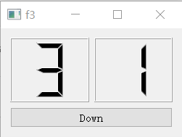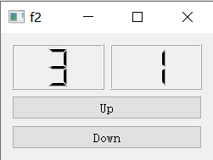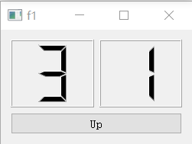
Direction button to call an elevator

2.2 Direction Button
User can press the direction button to call the elevator according to the direction he wants to go. The button will be lit up after pressing. When the elevator arrives, the light will be off.
When elevator has already arrived, user can press the direction button again to hold the door.

3.Simulation Window
A simulation window is provided to monitor the movement of elevator.
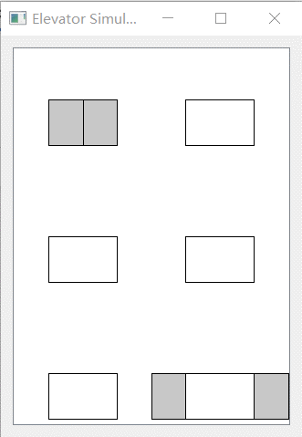
Grey rectangle represents the elevator.
Blank rectangle represent the floor position
When two rectangles separate, the door is opened

