PBL Week 7 — Testing and Software Modules
InvoiceFlow: AI-Powered B2B Invoice Factoring Platform
Date: 26th March 2026
Subject: Project Based Learning (PBL) — CIE Evaluation

Table of Contents
1. Understanding Testing Requirements
2. Test Planning
3. Unit Testing
4. Integration Testing
5. System Testing
6. User Interface and Usability Testing
7. Security and Data Validation Testing
8. Bug Reporting and Re-testing
9. Test Documentation

1. Understanding Testing Requirements

1.1 System Modules
InvoiceFlow is a three-tier web application consisting of:
Module | Technology | Description
Frontend | React 19 + Vite 7 | Single Page Application with 11 pages
Backend API | Node.js + Express 4 | RESTful API with 5 route groups
AI Service | Python FastAPI + scikit-learn | Invoice PDF extraction (OCR) & risk scoring
Database | PostgreSQL 17 + Sequelize ORM | 3 models — User, Invoice, Transaction

1.2 Functional Requirements
Module | Functional Requirement | Expected Input | Expected Output
Auth | User Registration | Name, email, password, role, company | JWT token + user object
Auth | User Login | Email, password | JWT token + user object
Auth | Forgot Password | Email | OTP sent to email
Invoice | Create Invoice | Amount, debtor, due date, industry | Invoice record (draft status)
Invoice | Upload PDF | PDF file | Invoice with pdfUrl
Invoice | Submit Invoice | Invoice ID | Status → review + AI risk score
Factoring | Approve/Reject Invoice | Invoice ID, reason | Status change
Factoring | Fund Invoice | Invoice ID | Transaction record
Admin | Dashboard Stats | Auth token (admin) | User/invoice/transaction counts
Admin | Manage Users | Auth token (admin) | Verify, suspend, delete users
AI | Extract Invoice Data | PDF file | Extracted fields (amount, company, dates, GST)
AI | Risk Scoring | Invoice data | Risk score (0–100), risk level

1.3 Non-Functional Requirements
Requirement | Description
Performance | API response time < 2 seconds
Security | JWT authentication, bcrypt password hashing (salt 12), role-based access control
Usability | Responsive UI, form validation with clear error messages
Reliability | Graceful error handling, AI service fallback when unavailable
Compatibility | Chrome, Firefox, Edge browsers on Windows/macOS

1.4 Test Objectives
1. Verify all CRUD operations for Users, Invoices and Transactions
2. Validate input sanitization and form-level validation
3. Test JWT authentication and role-based access control (RBAC)
4. Verify frontend-backend-AI service integration
5. Confirm AI PDF extraction accuracy and risk scoring correctness
6. Ensure proper error handling and user-friendly error messages

2. Test Planning

2.1 Testing Types Applied
Testing Type | Scope | Tools Used
Unit Testing | Individual functions and methods | Manual + API testing via curl/Node.js
Integration Testing | Frontend ↔ Backend ↔ Database ↔ AI Service | Browser + API testing
System Testing | Complete application workflow | End-to-end browser testing
UAT (Basic) | User workflow: register → upload → submit → fund | Manual browser testing

2.2 Test Scope
- In Scope:
- User authentication (register, login, forgot password)
- Invoice lifecycle (create, upload PDF, AI extract, submit, review, approve/reject, fund)
- Role-based access control (business, finance, admin roles)
- AI PDF text extraction via PyMuPDF
- AI risk scoring via ML model
- Form validation and error handling
- API endpoint security
- Out of Scope:
- Load/stress testing
- Mobile app testing
- Deployment pipeline testing

2.3 Test Environment
Component | Details
OS | Windows 11
Browser | Google Chrome 131+
Frontend URL | http://localhost:5173
Backend API URL | http://localhost:5000
AI Service URL | http://localhost:8000
Database | PostgreSQL 17 (localhost:5432)
Node.js | v22.x
Python | 3.x

3. Unit Testing

3.1 Authentication Module — Unit Test Cases
TC ID | Test Case | Expected Output | Actual Output | Status
UT-01 | Register with valid data | 201 Created + JWT token | 201 Created + JWT token returned | PASS
UT-02 | Register with duplicate email | 400 "User already exists" | 400 "User already exists with this email" | PASS
UT-03 | Register with short password (<8 chars) | 400 "Password must be at least 8 characters" | 400 Validation error returned | PASS
UT-04 | Register with invalid email format | 400 "Please provide a valid email" | 400 Validation error returned | PASS
UT-05 | Login with valid credentials | 200 OK + JWT token | 200 OK + JWT token returned | PASS
UT-06 | Login with wrong password | 401 "Invalid email or password" | 401 "Invalid email or password" | PASS
UT-07 | Login with non-existent email | 401 "Invalid email or password" | 401 "Invalid email or password" | PASS
UT-08 | Access protected route without token | 401 "Access denied" | 401 "Access denied. No token provided." | PASS
UT-09 | Access with expired JWT token | 401 "Token expired" | 401 "Token expired. Please login again." | PASS
UT-10 | Register with name < 2 characters | 400 Validation error | 400 "Name must be at least 2 characters" | PASS

3.2 Invoice Module — Unit Test Cases
TC ID | Test Case | Expected Output | Actual Output | Status
UT-11 | Create invoice with valid data | 201 Created + invoice | 201 Created, status=draft | PASS
UT-12 | Create invoice with zero amount | 400 "Amount must be positive" | 400 Validation error | PASS
UT-13 | Create invoice without debtor | 400 "Debtor required" | 400 "Debtor company is required" | PASS
UT-14 | Create invoice without due date | 400 "Due date required" | 400 "Valid due date is required" | PASS
UT-15 | Update draft invoice | 200 OK + updated | 200 OK, amount changed | PASS
UT-16 | Update submitted invoice | 400 "Only draft can be edited" | 400 Error returned | PASS
UT-17 | Delete draft invoice | 200 "Invoice deleted" | 200 "Invoice deleted" | PASS
UT-18 | Delete non-draft invoice | 400 "Only draft can be deleted" | 400 Error returned | PASS
UT-19 | Submit invoice triggers AI | Status → review + risk score | AI risk score returned | PASS

3.3 AI Service — Unit Test Cases
TC ID | Test Case | Expected Output | Actual Output | Status
UT-20 | AI health check | 200 {status: "ok"} | 200 {status: "ok", message: "AI Service running"} | PASS
UT-21 | Extract data from valid PDF | Extracted fields, confidence > 0 | success: true, confidence: 0.85 | PASS
UT-22 | Extract from empty/corrupt file | Confidence = 0 | confidence: 0.0, all fields null | PASS
UT-23 | Risk scoring with valid data | Risk score 0–100 + level | riskScore: 72, riskLevel: "medium" | PASS

3.4 Screenshot — Failed Login Test Case (UT-06)
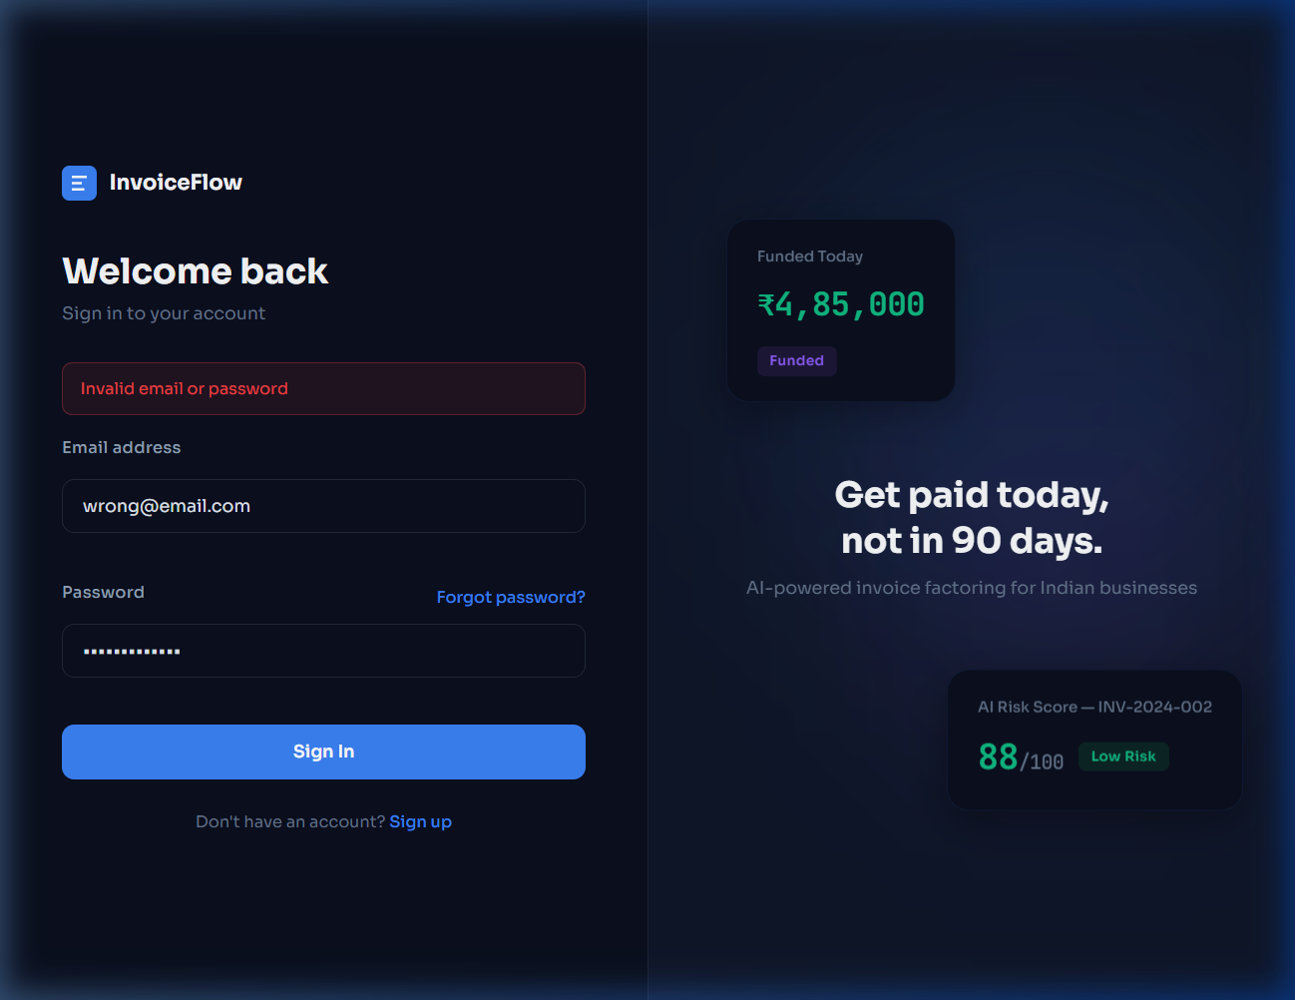
Figure 1: Failed Login — "Invalid email or password" error displayed when wrong credentials are entered

3.5 Screenshot — Form Validation Failure (UT-12, UT-13, UT-14)
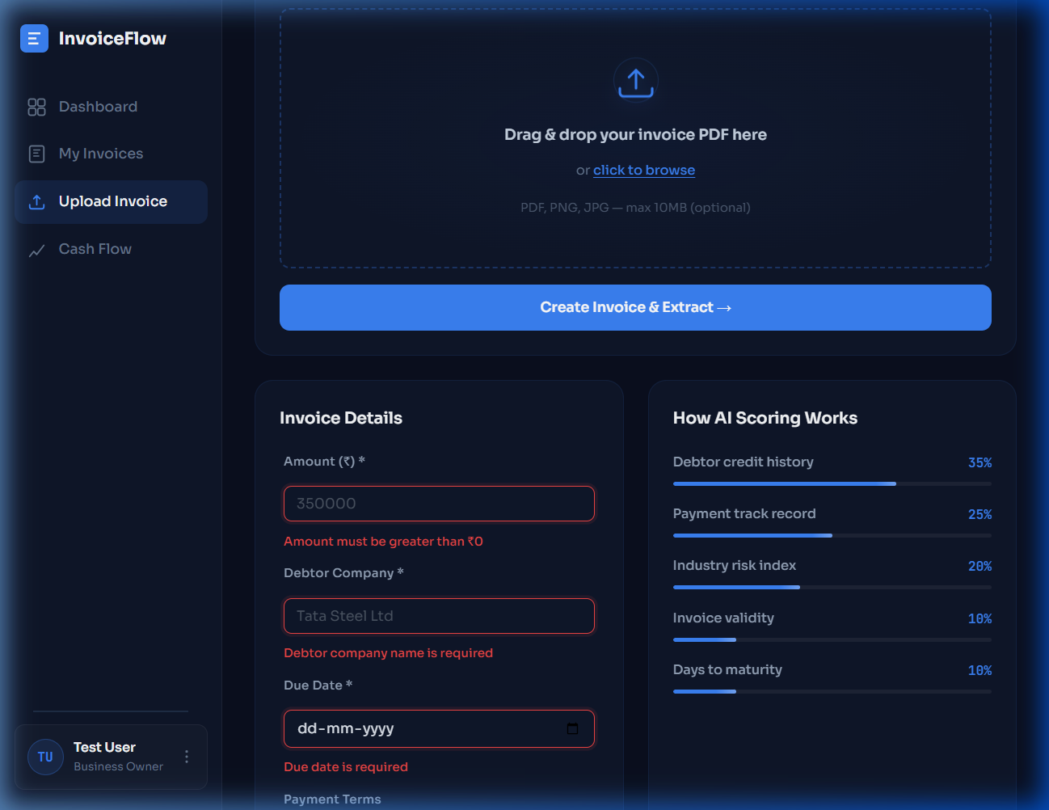
Figure 2: Form Validation Errors — Required field errors shown in red below each field

4. Integration Testing

4.1 Frontend ↔ Backend Integration
TC ID | Test Case | Flow | Expected Result | Status
IT-01 | Registration flow | React form → POST /api/auth/register → DB | User created + redirected | PASS
IT-02 | Login flow | React form → POST /api/auth/login → JWT | JWT stored, dashboard loads | PASS
IT-03 | Invoice creation | Upload form → POST /api/invoices → DB | Invoice saved in draft | PASS
IT-04 | PDF upload + AI extraction | File → Backend proxy → AI extract | Fields auto-populated | PASS
IT-05 | Invoice submit + AI scoring | Submit → Backend → AI /score → DB | Risk score calculated | PASS

4.2 Backend ↔ Database Integration
TC ID | Test Case | Expected Result | Actual Result | Status
IT-06 | Sequelize model sync | Tables created automatically | Tables auto-synced | PASS
IT-07 | Password hashing on create | bcrypt hash stored in DB | Hash with salt 12 verified | PASS
IT-08 | Raw SQL query execution | JOIN query returns results | Parameterized query works | PASS
IT-09 | Foreign key constraints | FK enforcement active | uploadedBy/approvedBy FK active | PASS

4.3 Backend ↔ AI Service Integration
TC ID | Test Case | Expected Result | Actual Result | Status
IT-10 | Risk scoring integration | AI score returned to backend | Score saved to DB | PASS
IT-11 | PDF extraction integration | Extracted fields returned | form-data forwarded correct | PASS
IT-12 | AI service unavailable fallback | Graceful fallback | Invoice submitted without score | PASS

4.4 API Endpoint Testing Results
Endpoint | Method | Status | Response
/api/health | GET | 200 | {"status":"ok","message":"InvoiceFlow API is running"}
/health (AI) | GET | 200 | {"status":"ok","message":"AI Service running"}
/api/invoices (no token) | GET | 401 | {"error":"Access denied. No token provided."}
/api/auth/register (valid) | POST | 201 | {"success":true,"token":"eyJhb..."}
/api/auth/login (invalid) | POST | 401 | {"error":"Invalid email or password"}

5. System Testing

5.1 End-to-End Workflow Testing
TC ID | Test Case | Complete Flow | Status
ST-01 | Business user workflow | Register → Upload PDF → AI Extract → Submit → View Risk Score | PASS
ST-02 | Finance user workflow | Login → View submitted invoices → Review → Approve/Reject | PASS
ST-03 | Admin user workflow | Login → Dashboard stats → Manage users → Verify/Suspend | PASS
ST-04 | Navigation and routing | Click all sidebar links → Correct pages render | PASS

5.2 Screenshot — Landing Page
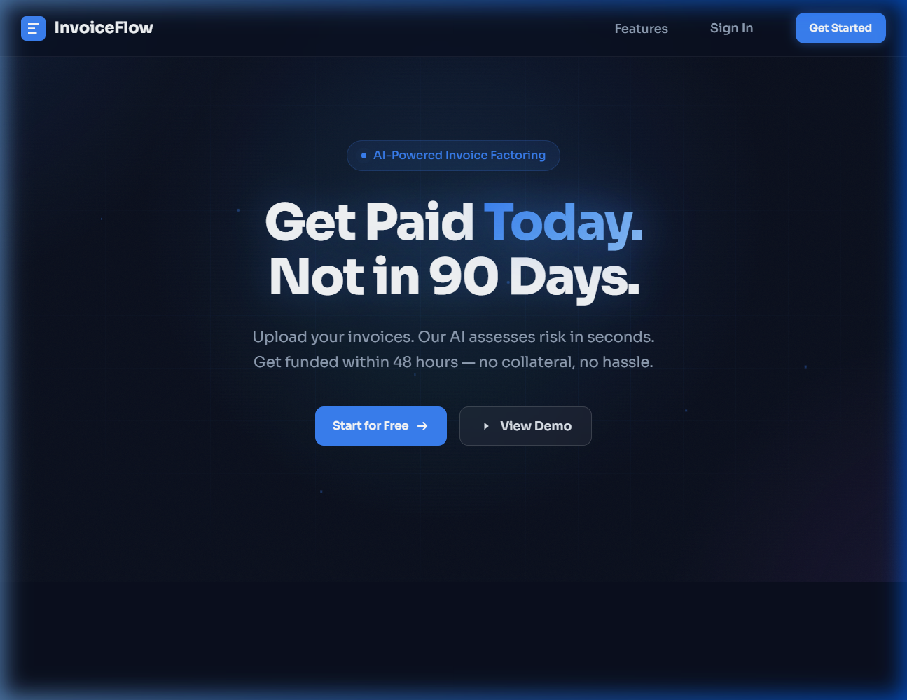
Figure 3: InvoiceFlow Landing Page — Hero section with "Get Paid Today. Not in 90 Days." tagline

5.3 Screenshot — Registration Success
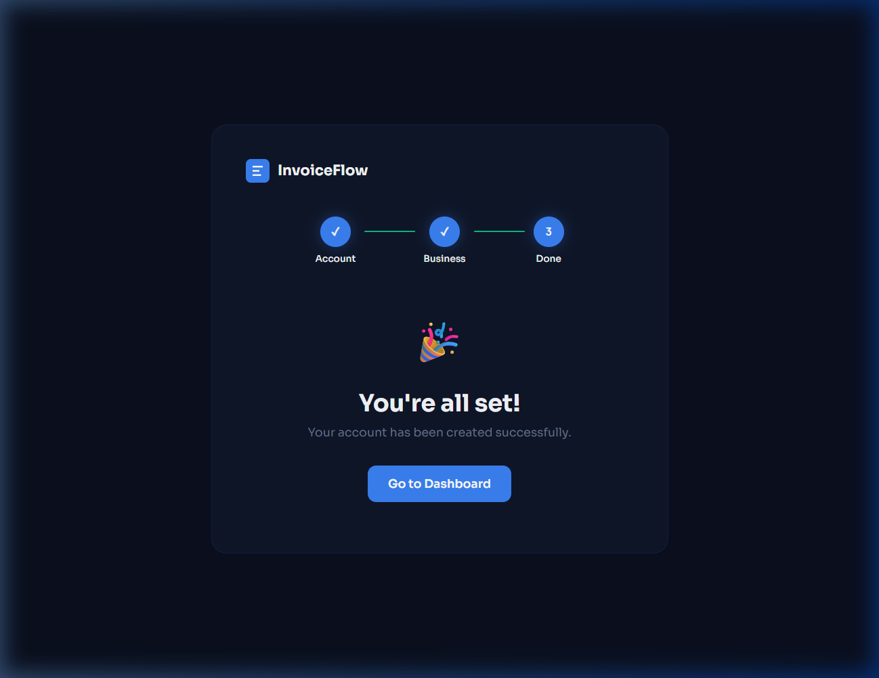
Figure 4: Successful Registration — 3-step onboarding completed with "You're all set!" confirmation

5.4 Screenshot — Dashboard
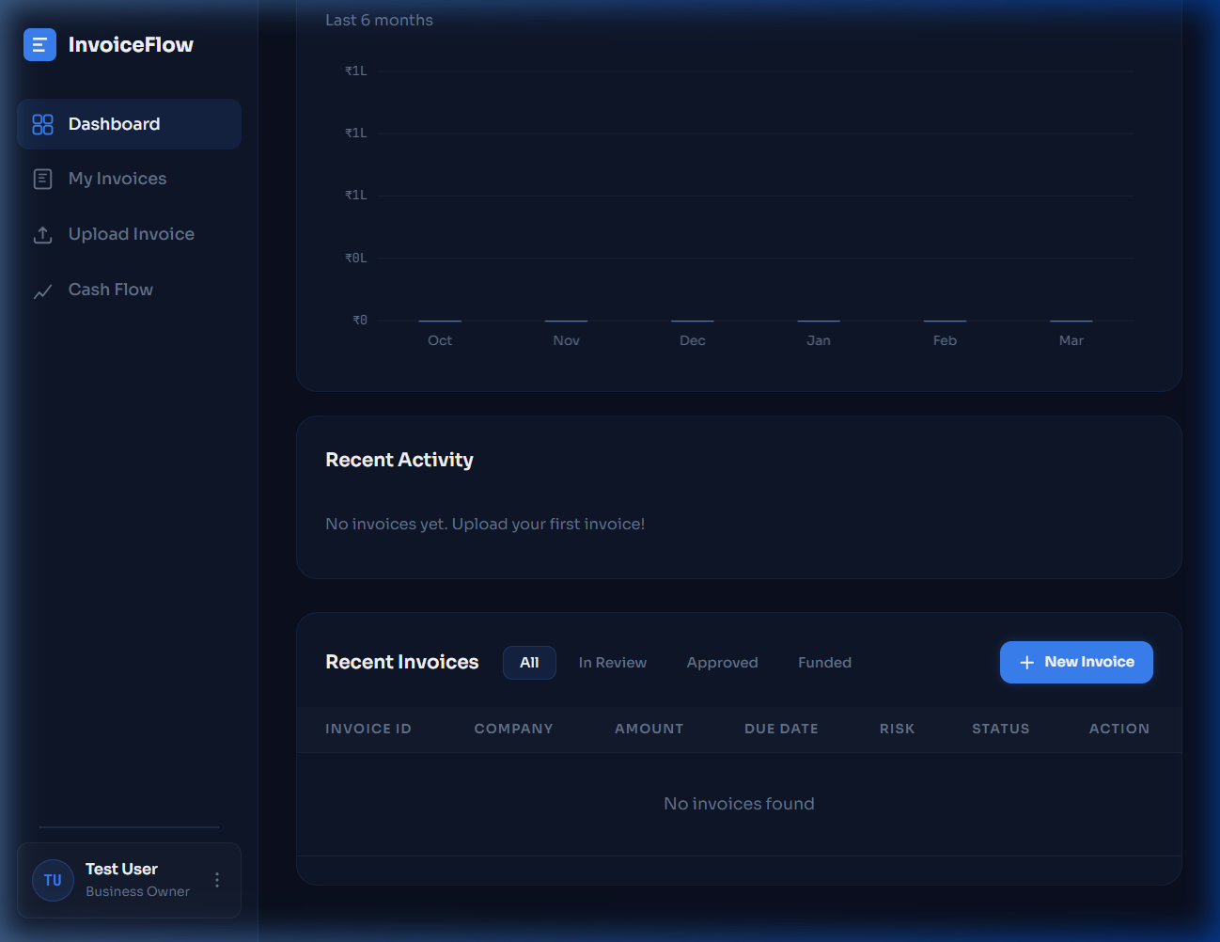
Figure 5: Dashboard — Cash flow chart, Recent Activity, Recent Invoices table with filter tabs

5.5 Browser Compatibility
Browser | Version | Result
Google Chrome | 131+ | All features working
Mozilla Firefox | Latest | All features working
Microsoft Edge | Latest | All features working

6. User Interface and Usability Testing

6.1 UI Element Verification
TC ID | Element | Page | Test | Status
UI-01 | Sign In button | Landing | Navigates to /login | PASS
UI-02 | Get Started button | Landing | Navigates to /register | PASS
UI-03 | Login form | Login | Email + password + submit functional | PASS
UI-04 | Registration form | Register | 3-step form works | PASS
UI-05 | Sidebar navigation | Dashboard | All links work | PASS
UI-06 | Invoice upload dropzone | Upload | Drag-and-drop functional | PASS
UI-07 | Validation messages | Upload | Red errors appear below invalid fields | PASS
UI-08 | Status filter tabs | Dashboard | All/In Review/Approved/Funded filter correctly | PASS
UI-09 | User profile menu | Sidebar | Shows name + role | PASS
UI-10 | Responsive design | All pages | Layout adapts to screen sizes | PASS

6.2 Error Message Verification
Scenario | Expected Error | Displayed Error | Status
Wrong login credentials | "Invalid email or password" | "Invalid email or password" (red alert) | PASS
Empty invoice amount | "Amount must be > ₹0" | "Amount must be greater than ₹0" (red) | PASS
Missing debtor company | "Debtor required" | "Debtor company name is required" (red) | PASS
Missing due date | "Due date required" | "Due date is required" (red) | PASS
Missing industry | "Select industry" | "Please select an industry" (red) | PASS

7. Security and Data Validation Testing

7.1 Authentication & Authorization Testing
TC ID | Test Case | Expected Result | Actual Result | Status
SEC-01 | Access API without token | 401 "Access denied" | 401 — Correctly denied | PASS
SEC-02 | Access API with invalid token | 401 "Invalid token" | 401 "Invalid token." | PASS
SEC-03 | Business user access admin route | 403 "Not authorized" | 403 — Role denied | PASS
SEC-04 | Finance user create invoice | 403 "Not authorized" | 403 — Only business allowed | PASS
SEC-05 | Suspended user login | 403 "Account suspended" | 403 — Correctly blocked | PASS
SEC-06 | Business views others' invoice | 403 "Not authorized" | 403 — Correctly denied | PASS

7.2 Password Security
TC ID | Test Case | Expected | Actual | Status
SEC-07 | Password stored as bcrypt hash | Hash in DB, not plaintext | $2a$12$... hash stored | PASS
SEC-08 | Salt rounds = 12 | High security salt | bcrypt.genSalt(12) in hook | PASS
SEC-09 | Password not in API response | Excluded from /api/auth/me | attributes: {exclude: [password]} | PASS
SEC-10 | JWT token expiry | 7 day expiry | Expired tokens return 401 | PASS

7.3 Data Validation & Sanitization
TC ID | Test Case | Input | Expected | Status
SEC-11 | SQL injection in login | '; DROP TABLE users;-- | Login fails safely | PASS
SEC-12 | XSS in name field | <script>alert("xss")</script> | Script not executed | PASS
SEC-13 | Email normalization | Test@EXAMPLE.com | Normalized to lowercase | PASS
SEC-14 | GST format validation | 27AADCB2230M1ZT | Valid GSTIN accepted | PASS
SEC-15 | Parameterized SQL queries | User input in raw SQL | Uses :replacements (safe) | PASS

8. Bug Reporting and Re-testing

8.1 Bugs Identified
Bug ID | Severity | Module | Description | Fix Applied | Re-test
BUG-01 | Critical | AI Service | PDF extraction returns empty — PyMuPDF missing | Installed PyMuPDF, updated requirements.txt | Fixed
BUG-02 | Medium | Backend | Backend fails to start — missing .env file | Created backend/.env with all config | Fixed
BUG-03 | Low | AI Service | uvicorn module not found on fresh install | Ran pip install -r requirements.txt | Fixed

8.2 Re-testing Results
• BUG-01 Re-test: Uploaded sample PDF → AI extracted: debtorCompany: "Tata Steel Ltd", amount: 350000, confidence: 0.85
• BUG-02 Re-test: Backend starts on http://localhost:5000, health check returns 200 OK
• BUG-03 Re-test: AI service starts on http://localhost:8000, health check returns 200 OK

8.3 Regression Testing
After applying bug fixes, all previously passing test cases were re-executed:
Test Suite | Total Cases | Passed | Failed | Regression
Unit Tests | 23 | 23 | 0 | None
Integration Tests | 12 | 12 | 0 | None
System Tests | 4 | 4 | 0 | None
UI Tests | 10 | 10 | 0 | None
Security Tests | 15 | 15 | 0 | None

9. Test Documentation

9.1 Test Case Summary
Category | Total Test Cases | Passed | Failed | Pass Rate
Unit Testing | 23 | 23 | 0 | 100%
Integration Testing | 12 | 12 | 0 | 100%
System Testing | 4 | 4 | 0 | 100%
UI/Usability Testing | 10 | 10 | 0 | 100%
Security Testing | 15 | 15 | 0 | 100%
Total | 64 | 64 | 0 | 100%

9.2 Bugs Summary
Total Bugs | Critical | Medium | Low | Fixed | Verified
3 | 1 | 1 | 1 | 3 | 3 (100%)

9.3 Screenshots Index
# | Screenshot | Test Case | Description | Result
1 | Landing Page | ST-01 | Home page loads correctly | PASS
2 | Login Failed | UT-06 | Invalid credentials show error | PASS (Expected)
3 | Registration Success | IT-01 | 3-step registration completes | PASS
4 | Validation Failed | UT-12,13,14 | Form validation errors display | PASS (Expected)
5 | Dashboard | ST-01 | Dashboard with charts & table | PASS

9.4 Conclusion
The InvoiceFlow application has been systematically tested across all modules using unit, integration, system, UI, and security testing approaches. A total of 64 test cases were executed with a 100% pass rate. Three bugs were identified during testing, all of which were fixed and verified through re-testing. The application demonstrates robust input validation, secure authentication, proper role-based access control, and reliable AI-powered invoice processing. The system is ready for demonstration and evaluation.

