Robot Worm ESP32 Parts List

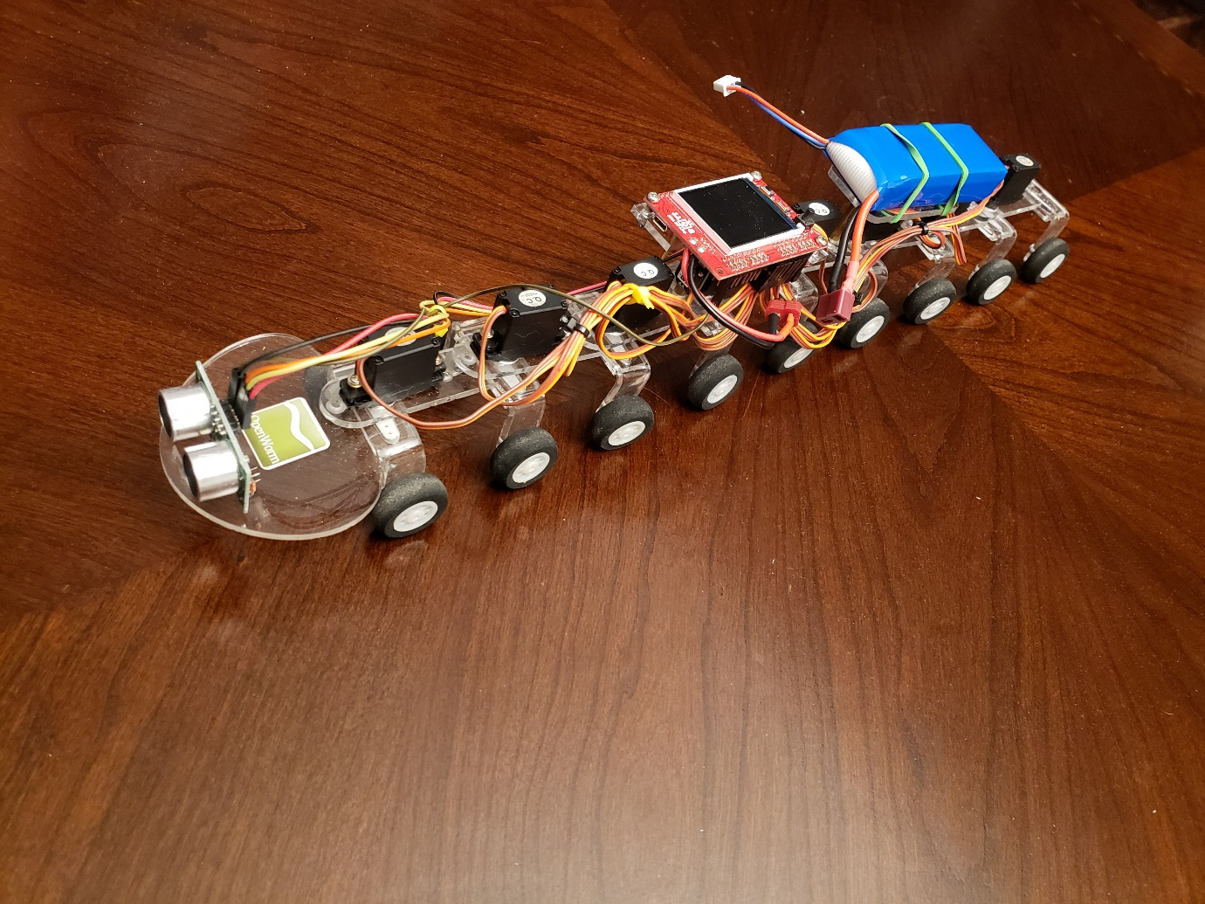

Use the Raspberry Pi assembly video for assembly of segments, wheels, and servos: <https://www.youtube.com/watch?v=6gbrbjGFhD4&feature=youtu.be>

**ESP32 board:**

Order from Out of the BOTS: <https://www.facebook.com/outofthebots/>

Laser-cut body parts also available in lieu of 3D printing them.

**3D printed body segments**: see .stl files.

**Wheels :** This part isn’t critical and easily exchanged for what is easily available locally. I used 25mm RC aircraft wheels then drilled out the axle holes to 3mm purchased from here from here <https://www.aliexpress.com/item/100pcs-Small-Light-Foam-Tail-Wheel-Diam-25mm-Thickness-11mm-Shaft-hole-2mm-For-RC-Remote/32705923540.html?spm=2114.01010208.3.10.b4OseI&ws_ab_test=searchweb0_0,searchweb201602_4_10152_10065_10151_10130_10068_5010017_10136_10157_10137_10060_10138_10131_10155_10062_10132_10156_10133_437_10154_10056_10055_10054_10059_303_100031_10099_10103_10102_10096_10147_10052_10053_10050_10107_10142_10051_5020019_10084_10083_10080_10082_10081_10110_519_10175_10111_10112_10113_10114_10037_10182_10185_10032_10078_10079_10077_10073_10123_142,searchweb201603_13,ppcSwitch_4&btsid=c1dbe6fc-0b51-4f03-8d57-6b99288429d4&algo_expid=840bed72-95b2-42cf-bef2-a14471322b64-1&algo_pvid=840bed72-95b2-42cf-bef2-a14471322b64>

**Battery:** 7.4V 2S 2000mAh 25C LiPolymer Battery T plug

<https://www.ebay.com/i/263959891231?chn=ps>

https://www.ebay.com/p/7-4-V-Battery-Charger-for-Double-Horse-RC-Helicopter-DH-9050-9053-9097-9100-9101/1948211389?iid=172007732203&chn=ps

**Servos:** Corona brand model CS-939MG I brought directly from factory here: <https://wxrgdz.en.alibaba.com/product/60608230195-804446832/Corona_CS939MG_Analog_Metal_Gear_Servo_2_5kg_0_14sec_12_5g_for_RC_toys.html>

Also: <https://hobbyking.com/en_us/corona-939mg-metal-gear-servo-2-5kg-0-14sec-12-5g.html?countrycode=US&gclid=Cj0KCQjwoZTNBRCWARIsAOMZHmGEeijs9xE-hcR2DAJ2OFpjulCqenN-gff_-upFRulK0nbGEl4q_wQaAmjZEALw_wcB&gclsrc=aw.ds>

You will also need some jumper wires and soldering iron.

F-F jumper wires: <https://www.adafruit.com/product/1949>

**Optional low battery alarm:**

[**http://www.ebay.com.au/itm/LED-RC-Lipo-Li-ion-Battery-Low-Voltage-Meters-Alarms-Test-Buzzer-Monitor-KB/232225019917?_trkparms=aid%3D555017%26algo%3DPL.CASSINI%26ao%3D1%26asc%3D20160706105120%26meid%3D94998925138d4c3380cf4f04fcb59951%26pid%3D100508%26rk%3D1%26rkt%3D1%26&_trksid=p2045573.c100508.m3226**](http://www.ebay.com.au/itm/LED-RC-Lipo-Li-ion-Battery-Low-Voltage-Meters-Alarms-Test-Buzzer-Monitor-KB/232225019917?_trkparms=aid%3D555017%26algo%3DPL.CASSINI%26ao%3D1%26asc%3D20160706105120%26meid%3D94998925138d4c3380cf4f04fcb59951%26pid%3D100508%26rk%3D1%26rkt%3D1%26&_trksid=p2045573.c100508.m3226)

Also: <https://www.amazon.com/dp/B00SCJOITA/ref=asc_df_B00SCJOITA5145422/?tag=hyprod-20&creative=395033&creativeASIN=B00SCJOITA&linkCode=df0&hvadid=198096709148&hvpos=1o1&hvnetw=g&hvrand=9385563450414889614&hvpone=&hvptwo=&hvqmt=&hvdev=c&hvdvcmdl=&hvlocint=&hvlocphy=9033288&hvtargid=pla-349312979893>

**Food distance sensors**:

1. Laser distance sensor VL53L0X:

https://www.aliexpress.com/item/GY-530-VL53L0X-Laser-Ranging-Sensor-Time-of-Flight-ToF-Distance-Measurement-Module-2-8-5V/32858618341.html

https://learn.adafruit.com/adafruit-vl53l0x-micro-lidar-distance-sensor-breakout

repository: https://bitbucket.org/thesheep/micropython-vl53l0x/src/9077f84e25409532b7ef220fa068605c971ba967/vl53l0x.py?at=default&fileviewer=file-view-default

code: vl53l0x.py and worm_run_segment_angles_laser.py

pin connections: vin -> 3v3, gnd -> gnd, sda -> 32, scl -> 33

1. US-100 Ultrasonic Distance Sensor (HCSR04 low voltage clone):

https://www.bananarobotics.com/shop/US-100-Ultrasonic-Distance-Sensor-Module

code: hcsr04.py and worm_run_segment_angles_sonic.py

pins: servo 0-7 -> pins 7-0