Robot Worm RPi Parts List

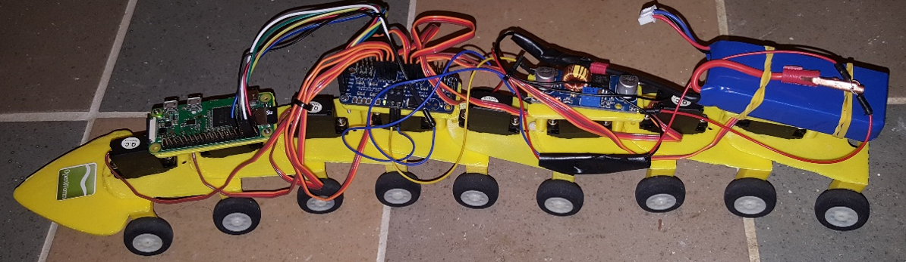

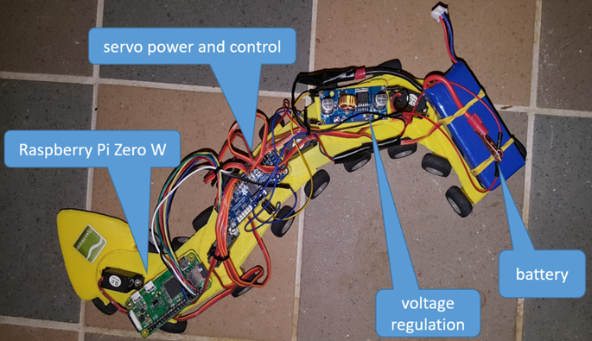

Raspberry Pi assembly video: <https://www.youtube.com/watch?v=6gbrbjGFhD4&feature=youtu.be>

Video topics:

Time:

0:0

Discussion of body parts; attaching wheels.

3:03

Attaching servos to segments.

4:58

Attaching boards, e.g. Raspberry Pi, and other components to segments.

8:16

Connecting power and adjusting voltages.

13:15

Connecting boards using RPi pinout diagram.

17:12

Logging on the the RPi; calibrating the servos; connecting segments.

19:10

Ordering segments with various component platforms.

22:03

Finishing discussion.

**3D printed body segments**: see .stl files.

**Wheels :** This part isn’t critical and easily exchanged for what is easily available locally. I used 25mm RC aircraft wheels then drilled out the axle holes to 3mm purchased from here from here <https://www.aliexpress.com/item/100pcs-Small-Light-Foam-Tail-Wheel-Diam-25mm-Thickness-11mm-Shaft-hole-2mm-For-RC-Remote/32705923540.html?spm=2114.01010208.3.10.b4OseI&ws_ab_test=searchweb0_0,searchweb201602_4_10152_10065_10151_10130_10068_5010017_10136_10157_10137_10060_10138_10131_10155_10062_10132_10156_10133_437_10154_10056_10055_10054_10059_303_100031_10099_10103_10102_10096_10147_10052_10053_10050_10107_10142_10051_5020019_10084_10083_10080_10082_10081_10110_519_10175_10111_10112_10113_10114_10037_10182_10185_10032_10078_10079_10077_10073_10123_142,searchweb201603_13,ppcSwitch_4&btsid=c1dbe6fc-0b51-4f03-8d57-6b99288429d4&algo_expid=840bed72-95b2-42cf-bef2-a14471322b64-1&algo_pvid=840bed72-95b2-42cf-bef2-a14471322b64>

**Nuts and bolts:** I used 3mm x 20mm bolts with nyloc nuts. It is critical that nyloc nuts r used

**PMW board:** This drives all the servos this is one from Adafruit <https://www.adafruit.com/product/815> but I used this 1 with same chip so same software to drive it but this 1 is better built and cheaper <http://www.ebay.com.au/itm/PCA9685-16-Channel-12-bit-PWM-Servo-motor-Driver-I2C-Module-For-Arduino-Robot-P6/182391317074?_trkparms=aid%3D222007%26algo%3DSIM.MBE%26ao%3D2%26asc%3D20140106155344%26meid%3D55e89eed8cb54264bcdedb85b836058c%26pid%3D100005%26rk%3D6%26rkt%3D6%26sd%3D262714356063&_trksid=p2047675.c100005.m1851>

**Battery:** I used a RC 7.4v 2S battery (you will need a discharge rate of min 3c but most RC batteries are like 25c so generally lots more than needed) the capacity doesn’t matter so much but I used 2000mah as it seemed to be a nice balance between size and lasting long enough before going flat. This is 1 I picked out for you guys just because it comes with a charger <http://www.ebay.com.au/itm/1x-2x-2000mAh-7-4V-25C-LiPo-Battery-2S-Balance-Charger-for-Syma-X8HG-Drone-/332136206449?var=&hash=item4d54dc5071:m:mdi5sJNL8wo9I-nlZyge7tg>

Also: <http://www.ebay.com/itm/like/191931347026?chn=ps&dispItem=1>

**Voltage step down converters:** I had to use 2 of them I used the an adjustable micro 360 for the RPi and adjusted it to 5v see <http://www.ebay.com.au/itm/5pcs-Mini-360-DC-DC-Buck-Converter-Step-Down-Module-4-75V-23V-to-1V-17V-/122098217064?hash=item1c6d9ef068:g:4vAAAOSwV0RXvWXl>

Also: <http://www.ebay.com/itm/like/351738012331?chn=ps&dispItem=1>

For the servos I used a larger amp adjustable conveter and adjusted it to 6v something like this <http://www.ebay.com.au/itm/XL4015-5A-DC-DC-Step-Down-Buck-Converter-Module-Power-Supply-LED-Lithium-Charger/192234308138?var=492161169440&_trkparms=aid%3D222007%26algo%3DSIM.MBE%26ao%3D2%26asc%3D20140106155344%26meid%3D538f67598ae24dbba1f6594d01d6020b%26pid%3D100005%26rk%3D6%26rkt%3D6%26sd%3D332197058401&_trksid=p2047675.c100005.m1851>

Also: <http://www.ebay.com/itm/like/112237134540?chn=ps&dispItem=1>

**Servos:** I used Corona brand model CS-939MG I brought directly from factory here <https://wxrgdz.en.alibaba.com/product/60608230195-804446832/Corona_CS939MG_Analog_Metal_Gear_Servo_2_5kg_0_14sec_12_5g_for_RC_toys.html>

Also: <https://hobbyking.com/en_us/corona-939mg-metal-gear-servo-2-5kg-0-14sec-12-5g.html?countrycode=US&gclid=Cj0KCQjwoZTNBRCWARIsAOMZHmGEeijs9xE-hcR2DAJ2OFpjulCqenN-gff_-upFRulK0nbGEl4q_wQaAmjZEALw_wcB&gclsrc=aw.ds>

**Optional low battery alarm**:

<http://www.ebay.com.au/itm/LED-RC-Lipo-Li-ion-Battery-Low-Voltage-Meters-Alarms-Test-Buzzer-Monitor-KB/232225019917?_trkparms=aid%3D555017%26algo%3DPL.CASSINI%26ao%3D1%26asc%3D20160706105120%26meid%3D94998925138d4c3380cf4f04fcb59951%26pid%3D100508%26rk%3D1%26rkt%3D1%26&_trksid=p2045573.c100508.m3226>

Also: <https://www.amazon.com/dp/B00SCJOITA/ref=asc_df_B00SCJOITA5145422/?tag=hyprod-20&creative=395033&creativeASIN=B00SCJOITA&linkCode=df0&hvadid=198096709148&hvpos=1o1&hvnetw=g&hvrand=9385563450414889614&hvpone=&hvptwo=&hvqmt=&hvdev=c&hvdvcmdl=&hvlocint=&hvlocphy=9033288&hvtargid=pla-349312979893>

You will also need some jumper wires from and some 3amp power wires and soldering iron and multimeter for adjusting the voltage on buck converters.

F-F jumper wires: <https://www.adafruit.com/product/1949>

**Optional food distance sensors**:

1. Microphone.

<https://www.adafruit.com/product/3421?gclid=CjwKCAiA24PVBRBvEiwAyBxf-Wls9y3wXzCSEnPIPcVHyg3uAx9FsF2ln5A3p_iyOcANLQTRcMAuoBoCo0AQAvD_BwE>

see: food_listener.py

1. Parallax PING))) ultrasonic distance sensor.

<https://www.parallax.com/sites/default/files/downloads/28015-PING-Sensor-Product-Guide-v2.0.pdf>

driver: sonar.py