KINDER FOOD FINDER

Final report



Information Technology Capstone Project

COMP5703/5707/5708

Group Members

1. Thien Long (Jordan) Ly (480450344)
2. Tung-Ching (Wolfe) Lee (312004761)
3. He Feng (Stacey) (460413541)
4. Mingyi Gao (Penny) (480087645)

Abstract

Public concerns over animal welfare have increased; Nowadays, people pay attention to the living condition of livestock and provide more support to brands which adopt moral husbandry practices. However, ambiguous branding and packaging could render all those supports irrelevant. As a result, this project is deployed as a solution to provide consumers a mean to access reliable information source regarding animal welfare and grant concerned researcher (The client in this case) a tool to analyze shoppers’ behavior in animal welfare context.

The project focuses on developing a mobile application which lets users search for animal welfare rating of different brands (Rated by professional organizations), report stores function which has a relevant brand and find stores function which is closed to their location. To accomplish all the fundamental functions mentioned above, the key deliverable of this project shall include (1) a mobile application, (2) server and database and (3) instruction on how to manage the app and server. Hence, due to the timeframe limitation of the project, the mobile app will be compatible with Android operating system only. Accordingly, as a significant number of users could access the mobile app, it is vital to ensure the quality of this project; As a result, the project team decided to adopt waterfall software development life cycle methodology since it provides a standard and reliable framework for the project. Finally, at the end of the project, source-codes of the application and server will be delivered to the client, and a training session will also be conducted to ensure the client is well equipped with the necessary knowledge of the products.

Table of Contents

Abstract 2

Table of Contents 3

1. Introduction 4

2. Related Literature 5

**2.1** **Literature Review** 5

3. Research/Project Problems 8

**3.1** **Research/Project Aims & Objectives** 8

**3.2** **Research/Project Questions** 8

**3.3** **Research/Project Scope** 8

4. Methodologies 10

**4.1** **Methods** 10

**4.2** **Data Collection** 11

**4.3** **Data Analysis** 12

**4.4** **Deployment** 12

**4.5** **Testing** 12

5. Resources 14

**5.1** **Hardware & Software** 14

**5.2** **Materials** 15

**5.3** **Roles & Responsibilities** 16

6. Expected Outcomes 18

**6.1** **Project Deliverables** 18

**6.2** **Implications** 18

7. MILESTONES/ SCHEDULE 20

References 21

# Introduction

Animal welfare refers to how animals and/ or livestock is treated within their living conditions (Agriculture Victoria Services, 2017). According to Agriculture Victoria, A farmstead is considered as animal-friendly only if it satisfies the minimum conditions as stated below:

* Physiological needs of animals like foods and water should be provided;
* Safety of the animals should be guaranteed;
* Pain, diseases or injuries to the animals should be identified and treated early, no animals should suffer from agony.
* Animals should be allowed to interact with members of their species socially.

Likewise, As the agriculture industry progresses, public concern for animal wellfare also becomes severe (Butterworth, 2018); People are no longer pursuit animal well-beings individually, but various organizations and group (Chen, 2016) have risen together with government to enforce animal welfare standards. Moreover, different standards regarding the well-being of livestock have been published and adopted to improve ethics in the livestock industry. For instance, RSPCA is an independent organization whose objective is promoting animal-welfare behaviour; The organization works with the government bodies and law enforcer to establish standards for animal well-beings. Hence, RSPCA have published various standards related to this topic; For example: Welfare standard for Meat chicken which identifies the minimum requirements when breeding chicken to collect meat, the standard discusses in detail about the required environment, healthcare, food and drinks that farmstead should follow. Brand that follows the standards can inform consumers through a RSPCA’s approved logo on the product package.

However, though public concerns for animal welfare in food product have increased significantly, end-users still encounter barriers when trying to align their shopping decisions with personal values; Those barriers are (1) ambiguous product labelling and (2) marketing claims from the food companies. Furthermore, in the absence of an accurate channel to provide animal well-being information, identifying an animal-friendly brand among different choices is a time-consuming process. Hence, though animal-welfare organizations (RSCPA, Australian Certified Organic - ACO, etc.) inform end-users about their standards through inserting logo on the product’s package, not every consumer understand the full meaning behind the standards. As a result, without the right tool to support the decision-making process, customer’s efforts would not impact the livestock industry or reach the farmsteads which adopt animal welfare behaviours.

Likewise, this project aims to remove any ambiguities related to the animal well-being by providing an accurate information channel to the customers; In specific, as smartphone has invaded more into our life, it also becomes a part of our world, the source of our entertainment and social connectivity (Shahzad & Alwagait, 2013). Hence, People could carry it around due to the compact size while having access to multiple channels (Social network, E-commerce, News, etc.). Taking into account the advantages of a smartphone, we want to develop a mobile application that enables customers to approach animal welfare information and help consumers to make the correct decisions regarding their beliefs. Furthermore, the app will also be used as a tool to help our client in her research in the animal-welfare topic; the research is expected to explore the factors that have impact on the shopping behaviour of consumers and use those factors to motivate consumers toward animal-friendly purchasing.

# Related Literature

## **Literature Review**

**The ethical consumption dilemma:**

* According to Futerra’s (2005) report, there is a difference between the consumer buying intention numbers and actual purchasing numbers of the consumers when it comes to ethical products. In other words, while most of the consumers are conscious in the moral side of their consumption, not many of them are acting upon it by buying ethical products like free-range poultry or organic food instead of regular industrial products.
* Moreover, Connolly & Shaw (2006) also discovered that while the consumer awareness on ethical issues is growing, the actual purchasing does not change proportionally. Therefore, it could be said that the consumer conscious of ethical consumption does not reflect the sale number of these products. So where does it go wrong? And what could be done to reduce the gap for the consumer?

**An intention-behavior gap explanation:**

* To explain this phenomenon, Carrington, Neville, & Whitwell (2010) have proposed to apply the purchase intention and consumer behavior gap theory into the situation. They explained that there are five main types of factor which influence the transmitting process which is: (1) physical surroundings (store location, product placement, etc.), (2) social surroundings (staff interaction, etc.), (3) temporal perspective (time of purchase, time constraint) , (4) task definition (buy for self or someone else, gifting, etc.) and (5) antecedent states (financial situation, product pricing, etc.) (Carrington, Neville, & Whitwell, 2010). Later, another research by Ghvanidze, Velikova, Dodd, & Oldewage-Theron (2016) also confirmed a similar framework for the explanation. The group discovered that a consumer intention would also be affected by personal needs and motivations when transmitting into purchasing action (Ghvanidze, Velikova, Dodd, & Oldewage-Theron, 2016). This is further explained in the research of Bray, Johns, & Kilburn (2011) where they used an online survey to look into what the consumers consider as a barrier for buying the ethical product. There are seven factors that prevent the consumer from purchasing ethical product which is: (1) price sensitivity, (2) personal experience, (3) ethical obligation, (4) lack of information, (5) quality, (6) inertia and (7) cynicism (Bray, Johns, & Kilburn, 2011). As a result, it could be said that the gap between consumer intention does not reflect his / her purchase, but it is a result of various environmental and situational factors.

**How to increase ethical consumption:**

* As it is shown that the consumer decision is affected by various factors, it is essential for the consumer to be well informed about ethical products. According to research using diary approach by Papaoikonomou, Valor, & Ginieis (2018) has also shown that most consumers rely heavily on the quality and quantity of the information about the product to make their purchases. However, when it comes to marketing purpose, not all messages affect consumer behavior the same. Andorfer & Liebe (2015) experiment on fair trade coffee sales in Germany has shown that within three main types of in-store incentives: (1) promotion, (2) additional information and (3) appealing to consumers’ moral obligation, only the monetary stimulus is sufficient for increasing the sale of the product. The finding has shown that most of the marketing efforts are less effective when it comes to consumer in-store purchasing behavior (Andorfer & Liebe, 2015). Therefore, it is vital for ethical product information to be easily accessed by the intended consumers.

**Mobile application and ethical products:**

* To provide more information to the consumers about ethical products, in recent years, there have been multiple mobile applications which dedicate for moral consumption purpose like Good on You, Shop Ethical!, Etc. These applications promote the use of an ethical product by informing the consumers on what product is moral as well as helping them to plan out their purchase. How practical are mobile applications in term of reducing the intention-behavior gap of the consumers? What makes mobile apps a new trend for ethical consumption?
* According to Fuentes & Sörum (2019), the main reason why mobile applications like Green Guide, Fair Trade app and Shopgun (which were analyzed by the researchers) are suitable for promoting ethical consumption is because of the how they could put pressure of moral obligation on the consumer on individual purchase level by allowing the users to search and note down their ethical product purchasing intention. In other words, mobile applications work as they affect the social obligation aspect of consumers. Besides, in their research on Buycott app, Eli, Dolan, Schneider & Ulijaszek (2016) has discovered that the application is practical because it provides the consumer with a peer to peer platform for conversation and review which create the community aspect for ethical consumption. This is appealing to the consumers as peer information is considered more trustworthy due to the abundance of marketing message nowadays. Moreover, with the collectivism creating by the community, the mobile application could also, in turn, create a collective bargaining power for the consumers when dealing with stores and manufacturers about ethical consumption. However, this would also become a problem of mobile applications for ethical consumption. In their analysis of thirty-two different ethical consumption applications, Nghiem & Carrasco (2016) have found that the best applications would require an official authoritativeness and a transparent and objective rating for the products. This fact is also supported by findings of Humphery & Jordan (2018) which showed that misleading rating would cause the ethical purpose of the application to go to the wrong directions. Therefore, while mobile apps are a powerful tool to promote ethical consumption, a cautious stance must be used to ensure the expected benefits for the consumers.

**Conclusion:**

* In conclusion, there is an intention-behavior gap of the consumers when it comes to purchasing ethical products as the consumers are affected by various factors when making their purchase (Carrington, Neville, & Whitwell, 2010). Therefore, to ensure consumer commitment, they should be given more incentive than just awareness of the ethical obligation. A very powerful tool for this cause is mobile applications as they could (1) help the consumers search and note down their planned purchase (Fuentes & Sörum, 2019) and (2) bolster a community for ethical consumption through peer to peer conversation and review (Eli, Dolan, Schneider, & Ulijaszek, 2016). Nevertheless, the mobile applications are to be used with care and require an official authoritativeness and a transparent and objective rating (Nghiem & Carrasco, 2016); otherwise, the collective purchasing power of the ethical consumers could be easily misguided (Humphery & Jordan, 2018).

# Research/Project Problems

## **Research/Project Aims & Objectives**

The objective of this project is the development of a user-friendly mobile application that would help the end-users (1) Access to animal well-being conditions of several livestock brands, (2) conveniently locate where to find these products through sourcing products’ selling points, (3) report where they see a particular product and let other users access that information. Hence

Furthermore, the system will also provide appropriate tool for the client (Of this project) to manage the information that the consumers can access. In summary, the objective is to provide consumers access to breeding conditions behind the specific product and to locate accredited products through a mobile application.

## **Research/Project Questions**

Firstly, this project was initiated due to the client’s demand to enrich her research with actual data from consumers of the livestock industry and evaluate those data against multiple hypotheses. In specific, the client wants to identify factors that have significant impact on the consumers toward animal-friendly purchasing. To collect such a huge amount of data from the end-users, the client chose mobile application due to its mobility, convenience and popularity attributes. Hence, a well-developed app shall enable users to check whether a brand is animal-friendly at anytime and anywhere, Furthermore, the software is also capable of collecting users’ usage pattern on behalf of the client. In short, the application will serve as a tool to help users access relevant information and conveniently record requested data for the client.

On the other hand, to assist the client in managing the information displayed by the mobile application, demand for a user-friendly server was also raised during at the beginning of the project. Furthermore, the project team was permitted to choose the implemented technology as convenient. As a result, we chose to develop a Web-page server/ Web services as most members have experienced related to Web development and the technology is easy to access by the client.

## **Research/Project Scope**

1. **The project scope of work includes:**

* Development of a mobile (Android) application and a server which could provide users with ratings of animal source food based on the living condition of the animal.
* The mobile application is expected to be user-friendly and cover the following features:
* Signup/ Login function: Users should be able to use their Facebook account to log in and use the service provided. Otherwise, users can choose to sign up for a new account;
* Search function: Enable users to search through products in the database and examine the rating of a product;
* Browse function: Allow users to browse by (1) Category, (2) Accreditation and (3) Rating to find welfare ratings for animal-source products;
* Search for a product in store: Enable users to scan through the stores available in the database and check which stores have a specific product;
* Recommend stores which have the product: Enable users to provide a recommendation on which stores have a particular product;
* Collect and display data: Data collected from users’ behaviors should be recorded in the database and can be extracted by the administrator (Admin);
* Input new product and rate product: Enable the administrators to enter new product and rate product in accordance with the animal living condition;
* The mobile application and website should be user-friendly. Hence the mobile application interface should be like “Good on you” mobile app.
* The server will have the following features:
* Brand Database for the application: The server will consist of a real-time database for the application. In specific, the application can access the real-time database and update (Adding, Updating, Deleting) welfare ratings for animal-sourced -products when the internet connection is available;
* Users’ behavior Database: Beside storing animal welfare rating information, the server will also store users’ behavior data. The mobile app will collect users’ behavior search history and store that in the local database; When the internet connection is available, the data will be transferred to the server;
* Administration: The server will have some built-in features to enable the administrator to manage both databases (Query, Insert, Update, Delete data in the database). Hence, the administrator will be able to access this function using an Admin account.
* Instruction on how to administer the mobile application and website must be documented to assist the client in managing the system.

1. **The project scope of work does not include:**

* Any adjustments related to the application after the project team finishes delivering the final products.
* Daily administrating of the mobile application server after the deployment phase.
* Any sales and marketing activities directed to end-customers.
* Further purchasing of software and hardware besides the software and hardware specified in this project.

# Methodologies

## **Methods**

* For the project, we have decided to use the waterfall methodology. This is the model where the software development process follows a linear pathway; The methodology breaks down the project into five different phases: (1) Requirement analysis, (2) Design, (3) Implementation, (4) Testing (5) Release/ Deployment and (6) Maintenance (Brindha & Vijayakumar, 2015). The standardized process of the waterfall model could be explained as followed:
* Requirement analysis: This is the first stage of the project where the team would engage the client and gather the project requirement or problem description as well as the project scope and constraints (i.e. timeline, project team, budget, etc.). This stage would include multiple meetings and contact between the team and the client side to ensure a thorough analysis of the requirement.
* Design: After the project team has fully understood the project scope and requirements, the team would move on to the next stage where the developer would transform the technical and function requirements of the product into designed programming feature. Besides, related resources such as server or platform would also be planned and purchased by the project team.
* Implementation: When the client approves the final design, the developers will start creating the new solution according to the design. At the end of this stage, a fully functional product would be created.
* Testing: Following the implementation stage, the project team would also need to conduct a series of test on the product. This stage is required to ensure product quality before being transfer over to the client.
* Release/Deployment (Bomarius & Komi-Sirviö, 2005): This stage is not usually presented in the traditional version of waterfall development life cycle model; However, per request by client, in this stage, the project team will work closely with cthe lient to transfer knowledge and resources related to the project to cthe lient. In specific, the project team will conduct training to cthe lient before passing on the products. In addition, instruction will be documented and delivered to cthe lient at this stage.
* Maintenance: Finally, during the life cycle of the product, regular maintenance would also be needed to guarantee the performance of the product as well as the implementation of further update or modification. However, due to the nature of the project, this stage would be handled by the client side.
* The following is the reason why we have decided to choose this method over other software development method like Agile:
* ***Clear definition of the problem and product requirement:*** With the project brief provided by the client, we believe that we have an apparent description of the problem as well as the client requirement on the final delivered product. Furthermore, there has been a similar project on ethical consumption rating app such as goodonyou.eco which have been successfully implemented. This would allow the waterfall methodology to be more efficient than another method.
* ***Project time constraint:*** As the project would need to be done within the thirteen weeks of the semester, the waterfall method would allow us to be more efficient with the time without the necessity of going through different iterations like other methods such as Agile. Also, with linear progression, the method would allow the group to have better control over the progress of the project.
* ***Less requirement for meeting schedule:*** While Agile and other iteration method require regular meeting within the team and the client, waterfall method allow the planning stage to be at the beginning of the project which also allows less requirement for meeting schedule. This would be more suitable for both the project team and the client of this project.

## **Data Collection**

* As defined above, the final deliverables of this project should contribute to helping the client collect data about users’ number of searches for each product categorized by gender and age. To capture all relevant data, the following approach is adopted in this project:
* Firstly, a Signup/ Login function is developed so each user can log in the application and website using their Facebook account/ or users could sign up for a new account. Hence, upon login using a Facebook account, users’ birthdate and gender will be captured. Otherwise, in case that users choose to sign up for a new account, the system will request them to enter data related to their gender and age.
* Secondly, every time a user search for a product (or click on that specific product to check the detailed information), the application and website will record their search history and send it to the database.
* Finally, to collect users’ behavior data, the client can access the database using the “collect and display data” function in the website to obtain the number of searches per product filtered by age and gender.

## **Data Analysis**

* At this state, the client only requests the project team to develop a mobile application, a server, database and document a manual on how to administer the system. Furthermore, the project team has to ensure that the system will help the client collect users’ behavior data upon implementing. This request may change in the next step.

## **Deployment**

* During the deployment phase of this project, firstly, the project team will demonstrate how the mobile application, server, and database work to the client. After that, the source codes of both mobile application and server will be transferred to the client. Furthermore, to ensure that the client could implement and administer the system effortlessly, the project team will also conduct training on how to manage the system to the client and deliver the training manual to the client before the project ends. In specific, the training manual will consist of information about (1) Features of the system, (2) Description of each feature and (3) How to use those features.

## **Testing**

* Software is now present in every aspect of our life and embedded in most devices that we use; It is difficult to find a device without a programmed software built inside these days. Hence, a single software written in one project could be installed by millions of users and help them either improve their living standards or just increase their work efficiency (Myers, Sandler & Badgett 2012). It is safe to say that technology impacts our daily routine and it is essential for developers to ensure the quality of a software.
* To deliver a reliable, usability and high-quality mobile application, it is essential to test the mobile application by implementing well-defined testing methods and tools. According to Gao et al. (2014), different testing methods will serve different purposes and help developers identify various issues with the application. Hence, due to the timeframe limitation of the project, the project team decided to implement the following testing activities: (1) Unit testing (2) functionality and behavior testing, (3) interoperability testing and (4) usability and internationalization testing.
* **Unit testing:** Unit testing could detect isolated feature bugs or defects immediately by programmers who can modify the code and test a function in a repeatable process. Unit testing needs to implementation during the whole programming code. For example, regarding the search function, tester generates inputs to a module and examines whether the output is accurate. Tester requires to compare the results between reality and expected to ensure the quality of each module.
* **Functionality and behavior testing:** Functionality and behavior testing method will help programmers identify whether the software operates according to the written requirements. Since it is essential to comply with the client’s requirements when developing software, the project has decided to adopt this project to ensure that all features of the app are taken into consideration in the developing process.
* **Interoperability testing:** It is expected that the app should target as many mobile devices as possible; For that reason, the interoperability testing method is adopted by the project team. This method enables programmers to test the compatibility of the software when it is installed in different devices. In specific, the mobile app will be installed into a virtual device and real-devices to test how it copes with these devices.
* **Usability and internationalization testing:** The testing method requires the team to mimic users and walk through every function of the app. Otherwise, the client could join the testing process and test how the application work; Besides, the project team will collect feedback from the client during that time and improve the application accordingly.

# Resources

## **Hardware & Software**

1. **Mobile application**

* The minimum version of Android SDK that this application supports is Android 4.1 – Jelly Bean since we want to ensure that the application could target most of our potential users. In specific, by supporting Android 4.1 version – Jelly Bean, the app is compatible with 99.6% of the devices (as of March 22, 2019) that run in the Android operating system.
* Furthermore, according to the project scope of work, the mobile application shall operate in Android operating system; For that reason, it will be developed in Java language and can be compiled using Android Studio (Provided by Google). Hence, the Integrated Development Environment (Android Studio) also provides Android Virtual Devices (AVD) function which allows programmers to launch and test the application on a virtual device.
* Facebook API: One of the external API which is employed for the application is Facebook API to comply with client’s requirements. One of the client requirements is creating a Login button which allows users to access the services of this app using their Facebook account. The approach was agreed between the client and the project team as Facebook API not only helps users Login quickly but also lets the mobile app capture user’s information (Gender and Age).

1. **Server and database**

* A Web application API will be developed as the server. In specific, the project team shall use JavaScript, NodeJS and ExpressJS as the programming language and libraries to develop the server; Hence, the mobile application will interact with the server by accessing Web URL and using Get, Post methods and query string. The server is expected to be able to run on any PC and server machine. NodeJS and JavaScript are adopted in this project due to their popularity in the programming community.
* Likewise, the project team uses MongoDB as a database of the system due to the compatibility between JSON data and mobile application.

## **Hardware**

* A real-time server and database are necessary for the operation of the mobile application. In specific, having a server permits the administrator:
* Control of data that the app will show to the users by adding, updating or deleting data in the database;
* Collect users’ behaviors of information by the client’s purpose.
* Enable users to report/ give feedback about stores which have a specific brand. The server will receive those reports directly and record them to the database; Furthermore, the data is then provided to all other users.
* Mobile devices which run in the Android operating system.

## **Materials**

* The dataset of the animal-sourced brand collected by the client; The dataset should consist of the following data columns:
* Brand categories;
* Brand title;
* Brand image;
* Accreditation;
* Rating (Avoid, Best, Good);
* Logo of the application developed by the client.
* Contents of multiple information activities in the mobile application (About Us, FAQs, Share, Glossary of terms, etc.) developed by the client.
* Furthermore, because this project aims to develop a mobile application, it is crucial that team members should possess or have access to computers with Android Studio application installed.
* Microsoft Office software which would enable team members to contribute their knowledge and effort in preparing a project proposal, progress report, and final report.

## **Roles & Responsibilities**

|  |  |  |
| --- | --- | --- |
| **Team member** | **ROLES** | **RESPONSIBILITIES** |
| **Jordan Ly** | **Team Leader**   * It is crucial having a team leader to allocate tasks, check up on members’ progress and review their work products for the success of the project and the quality of the project team’s final deliverables. | * Check up on members’ progress: To ensure that all members participate in the project and that their works should be finished on time, the team leader will check their deliverables every week. The adopted method for this task is the To-do list; In specific, all members must write down what they expect to do at the beginning of the week in the team To-do list. Hence, the team leader will use the listing to check the progress of the whole team every weekend. * Allocating works: After checking on members’ committed tasks, the Leader will advise all team members in case there are other tasks needed further attention, so they can focus on doing the right jobs and postpone the unimportant tasks. * Review members’ work products: To improve the quality of works delivered by all team members. Furthermore, it also helps ensure that the final deliverables comply with the scope of work and requirements defined by the client. |
| **Developer**   * Having expertise in mobile computing and web app development, Jordan will also act as a developer throughout the project period. In specific, he will conduct hands-on development on some of the important features of the mobile application and the server. | * Developing these following functions for the mobile application: * Search function and search UI for the application; * Browse function; * The local database which consists of the (1) Brand (Title and Image), (2) Accreditation (Rating, organizations and relevant Brand), (3) Users’ behaviors; * Find stores and report functions; * Developing the server and database for the system to ensure that the mobile application could connect to the server to retrieve and push relevant data. |
| **Business Analyst**   * It is crucial that the requirements of the final deliverables are correct and feasible. The Business Analyst will communicate directly with the client to gather and document the client’s expectations and requirements. | * Drafting the project proposal. * Liaising with the client to analyze and verify the requirements of the system. Ensuring that the requirements are completed, consistent, unambiguous and feasible for the project team; * Documenting the requirements of the mobile application and server; |
| **Wolfe Lee** | **Developer** | * Coding on the server side in this project, including set up the database on the server and connect it to Android application so the application can retrieve data from the server to display the information. * Coding the part of registration and login. * Managing the source code on GitHub to make sure the works from each member are working together and not conflict. * managing the wiki on GitHub to record the works which other members have done every week and ensure everything is in progress. |
| **Stacey** | **Developer** | * Developing the followings functions of the mobile application: * Home page; * Search and Search Results pages; * Browse and Browse Results pages; * Detail Information page; * Designing the UI prototype to ensure that the Android application is user-friendly. * Conducting training to the client * Implementing the unit testing to detect potential bugs in the individual module. * Implementing functionality and behavior testing to ensure that functions meet the requirements. * Implementing interoperability testing and usability and internationalization testing to deliver a reliable and usability application. |
| **Penny** | **Developer** | * Developing and Coding the followings functions of the mobile application: * Our Rating Page; * Locate / Report Function; * More Page * Designing the following functions for UI Prototype of the mobile application: * Browse Function, based on the initial Prototype. * Rating Function, Login/Register. * Coding and improving the actual User Interface of the mobile application to ensure that it is user-friendly, including: * More Page, including User Profile, Other Functions (Rating and Report) and More Information regarding this project. * Our Rating Function * Locate/Report Function * Documenting the manual and UI tests for the system to identify malfunctions. * Troubleshoot and debug to optimize performance. |

# MILESTONES/ SCHEDULE

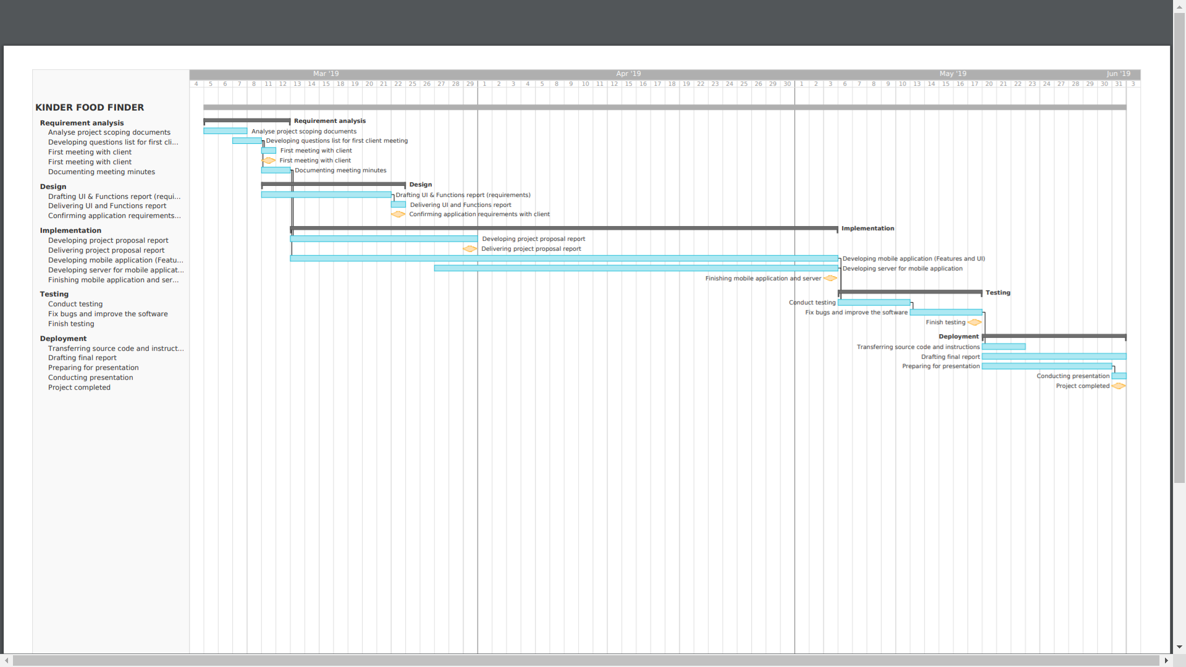

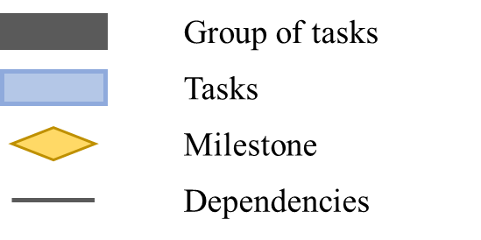

# RESULTS

## **Overview of the deliverable:**

* As indicated in the scope of work, the main deliverables of this project have two parts (1) an **Android mobile application** that enables people who uses it to access animal-welfare rating of different livestock brands and (2) a **Server** that helps the client and administrator manage the database and responses by sending data that the mobile app requests.
* Hence, figure xxx illustrates perfectly the architecture of the Kinder Food Finder system Firstly, consumers who goes shopping for animal-based products can access information about ethical brands, find location, and inform others where to find a particular good using the mobile application; In turn, depends on the commands given by the end-users, the mobile app will choose to display information or interact with the web server through HTTP connection (More information about the mobile app will be mentioned in part 7.2 Kinder Food Finder Mobile Application).
* Likewise, the server side of the Kinder Food Finder system was developed in the format of a Web application; In short, by accessing to the server using browser and HTTP URL, a web page will be displayed to the administrator and grants him/ or her full control over the data in the database (Which directly impacts the data that the server sends to the Kinder Food Finder app). Hence, most functions in the server web page are the four basics database methods: Query, Update, Delete and Insert; More information about the server-side will be discusses in part 7.3 Kinder Food Finder Server-Side

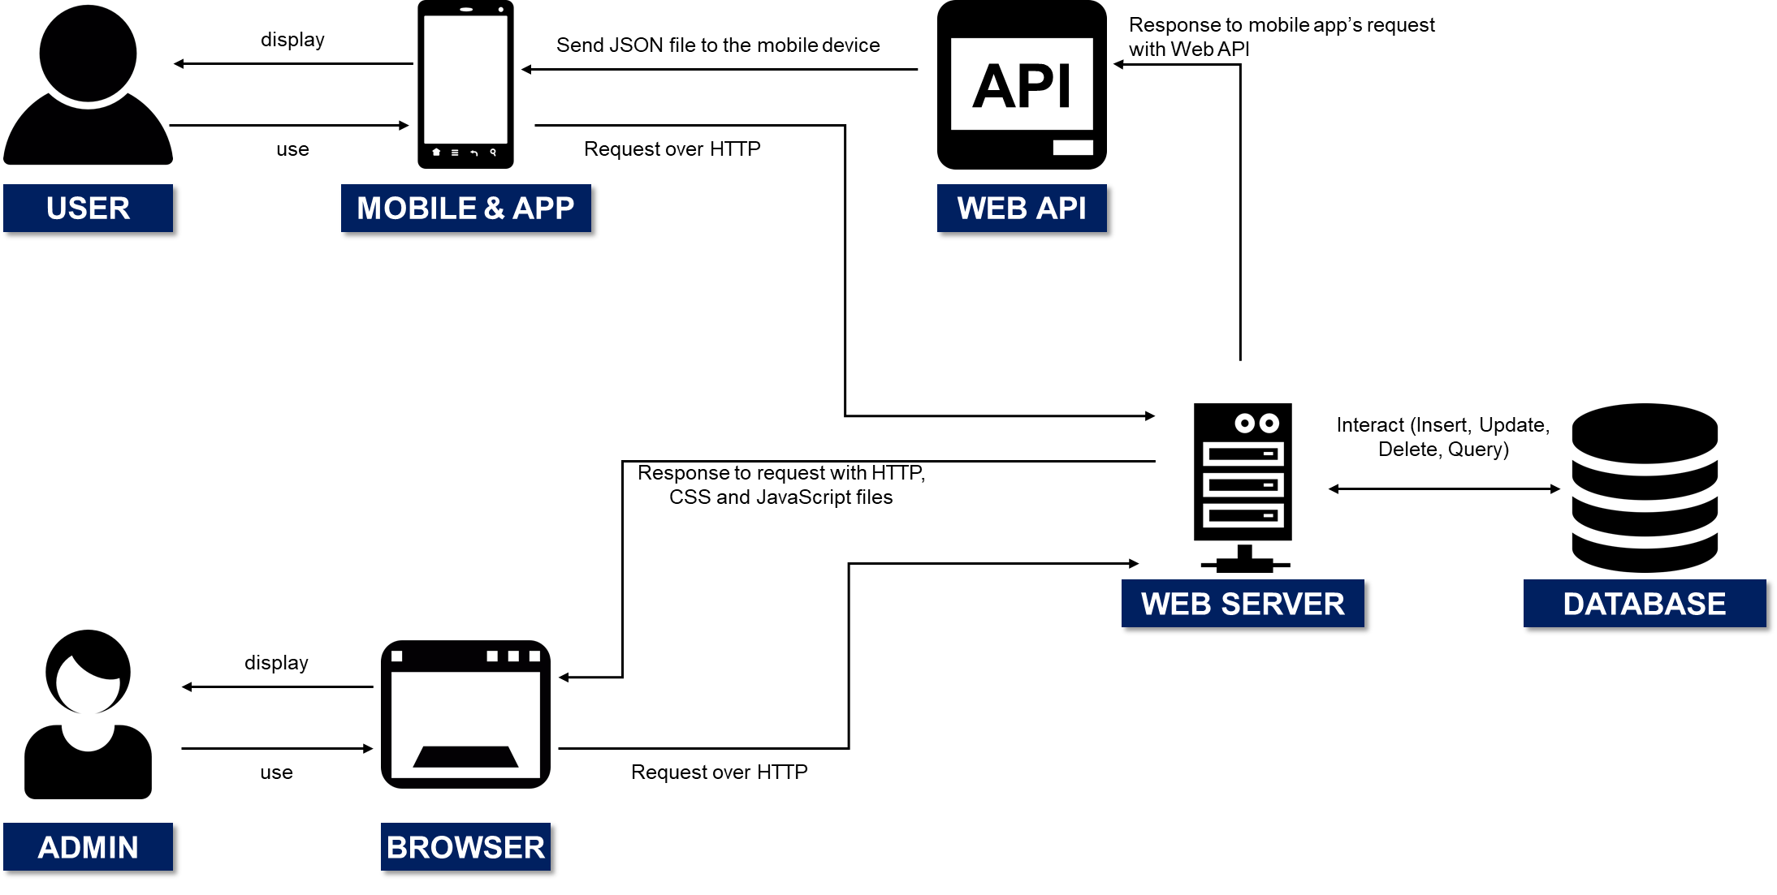

*Figure xxx. Architecture of the Kinder Food Finder system*

## **Kinder Food Finder Mobile Application**

## **Kinder Food Finder Server-Side**

1. **Structure of the server-side:**

* The Kinder Food Finder Web server is developed in accordance with the Model – View – Controller (MVC) framework, which is widely adopted in developing Web application (Model View Controller Pattern, 2015). In MVC, *model* indicates the data schemas that are used in later; For instance, we have mentioned a lot about **livestock brand** in this report; Hence, applying the same concept to the Web application, the model will help define the structure of the brand (Fields and attributes that a brand should have: Brand name, accreditation, rating, etc.). Furthermore, the *model* also provides the *controller* access to the database. Likewise, *controller* contains multiple **actions methods** that could handle incoming requests from the browser or the mobile application and interact with the *model* to manipulate the database. Hence, after finish processing requests, the *controller* will direct a corresponding response to the browser or mobile application; Furthermore, depends on the type of request, the response might be a rendered *view* to display a user interface for the Admin or data sent to the mobile application. Lastly, *view* is the user interface or complex visual representation of the data in the database that enables the Admin to interact with the web-page server (The server only sends data to the mobile application and does not display any *view*).

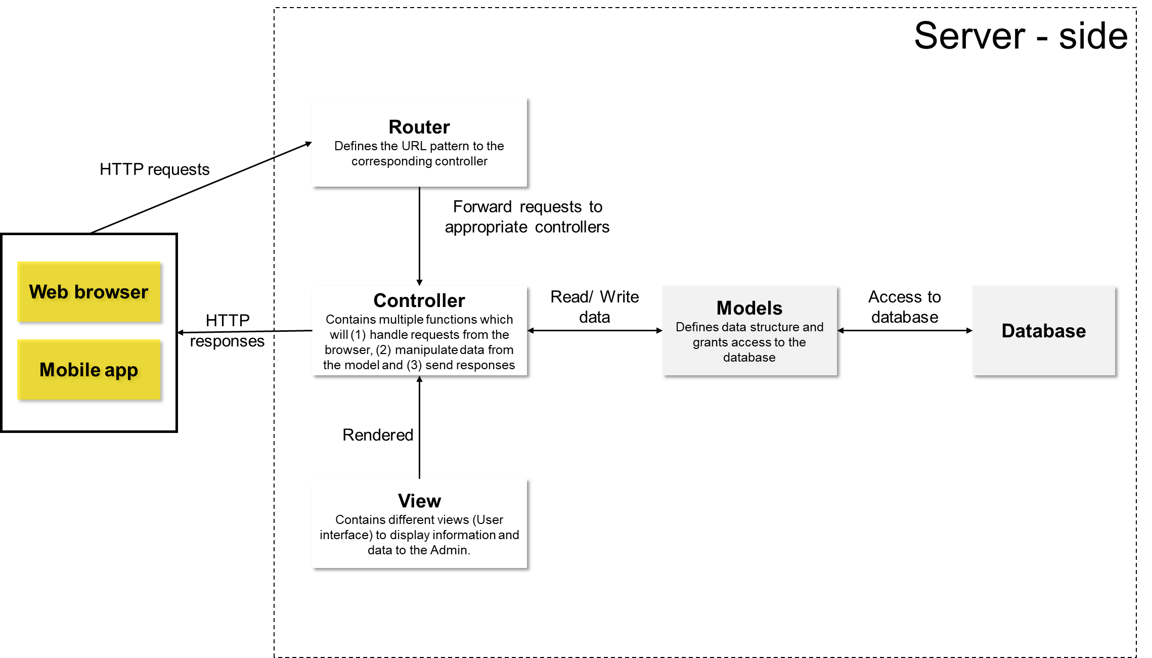

*Figure xxx. Structure of the Kinder Food Finder Server-side*

* Beside the main components of the MVC framework, router is an add-in item that links the HTTP URL connection with the relevant *controller.* For instance, when the Admin wants to go to the brand management page through the controller **databaseManagement**, he/ or she can access to it by typing the URL “<protocol + host name of the server>/dbmanagement” in the Web browser; In turn, the router will identify and call the controller that the Admin needs.
* Model-View-Controller framework is adopted due to its popularity and modularity. In specific, by separating components, MVC framework enables each project team member to work on different parts of the server-side and combine all individual part together upon completion.

1. **Technology**

|  |  |
| --- | --- |
| **Technology** | **Description** |
| **MongoDB** | * For the database, the project team uses MongoDB, which is a NoSQL database software that is highly compatible with JavaScript (Main programming language that is implemented for the server-side). There are various reasons as why we adopt this technology: * MongoDB is a Binary JSON data storage which illustrates the structure of single object unambiguously. * MongoDB also removes the need of complex join function from the development of the server. * **Location based data**. MongoDB natively supports geo-spatial coordinates and data indexing accordingly. * A strong, active community with many tutorials and examples available online. * Uses internal memory for storing the (windowed) working set, enabling faster access of data. |
| **JavaScript** | * On the other hand, as mentioned above, most features of the server-side are developed using JavaScript programming language; JavaScript (JS) is a dynamic and powerful programming language for web applications. According to Herron (2011), JS possesses multiple advantages which make it attractive to the Web development community: * JavaScript can be applied to develop both frontend and backend of the Web application. * Common testing and quality reporting tools for both backend and frontend. * Adopt common data format (JSON) for both server and the frontend. * Have several libraries that support the development of both backend and frontend. |
| **Node.js and Express.js** | * Though Node.js and Express.js are only platforms/ frameworks of JavaScript. It is worth noticing that Node.js and Express.js enable developers to build scalable web application faster; In specific, the web application developed by this technology has proved to be simpler, low memory consumption and high throughput. Furthermore, implementing Node.js, the server will use one single thread to handle several incoming requests and ensure that all operations are performed asynchronously and efficiently. |
| **Other programming languages/ technologies** | * Besides the key frameworks, platforms and technologies mentioned earlier, the project team also apply other programming languages; For instances: * Develop the front-end of the web-page server: Pug/ HTML, CSS, JQuery; * Integrated Development Environment: Intellij DEA. |

1. **Features of the server:**

* In this section of the report, we will talk more about the features and functions that the Kinder Food Finder server has. Likewise, as mentioned earlier, JavaScript is the main programming language that was used in the development process; Hence, though JS provides support to object-oriented programming (OOP), JavaScript is in fact, a multi-paradigm programming language that enables the developer to build software in using different styles (Visual programming, Object-oriented, Functional programming, Data flow programming, etc.). Furthermore, since the Kinder Food Finder server is developed in accordance with the MVC framework and not OOP, we will use this framework to illustrate the features on the server instead of the UML diagram. Due to the complexity and ad-hoc natures of the HTML and CSS languages, we will use pictures to display the interface instead diving into further details.
* On the other hand, the purpose of developing the Kinder Food Finder Server is to equip the administrator with a powerful tool to manage the system, decide which data will be sent to the mobile application and validate information received from the end-users; For instance, the Admin can decide to add or update brand and store in database (Add Real Free Range Eggs – Best rating to the database) and enable the app downloads new changes. As a result, most features and the user interface in the server-side are in form of basic database query, insert, delete and update functions:

|  |  |  |
| --- | --- | --- |
| **Name of the feature and view** | Import/ Insert Data | **No. WPS001** |
| **Description:** | * Firstly, this view enables the Admin to import new brand data to the database using a csv file; The Admin can simply click on the “*Choose File”* button and a window will pop-up allow him/ or her to browse through the computer’s folders and select the relevant file. Hence, the Admin shall click the “*Upload File”* button and data in the csv file will be processes and inserted to the database. * Likewise, to insert an individual brand data, the Admin can fill in the input boxes provided on the right side of this view. Upon clicking the *“Submit”* button, new brand data will be sent to the database. * The difference between import csv file and insert new brand is that Insert brand allows adding of only one brand data at a time while import csv allows the Admin to add multiple data. * Beside adding new brand data to the database, the Admin can also add new store (And later, add brands in a store) using the Insert new store feature (Which is identical to Insert new brand). | |

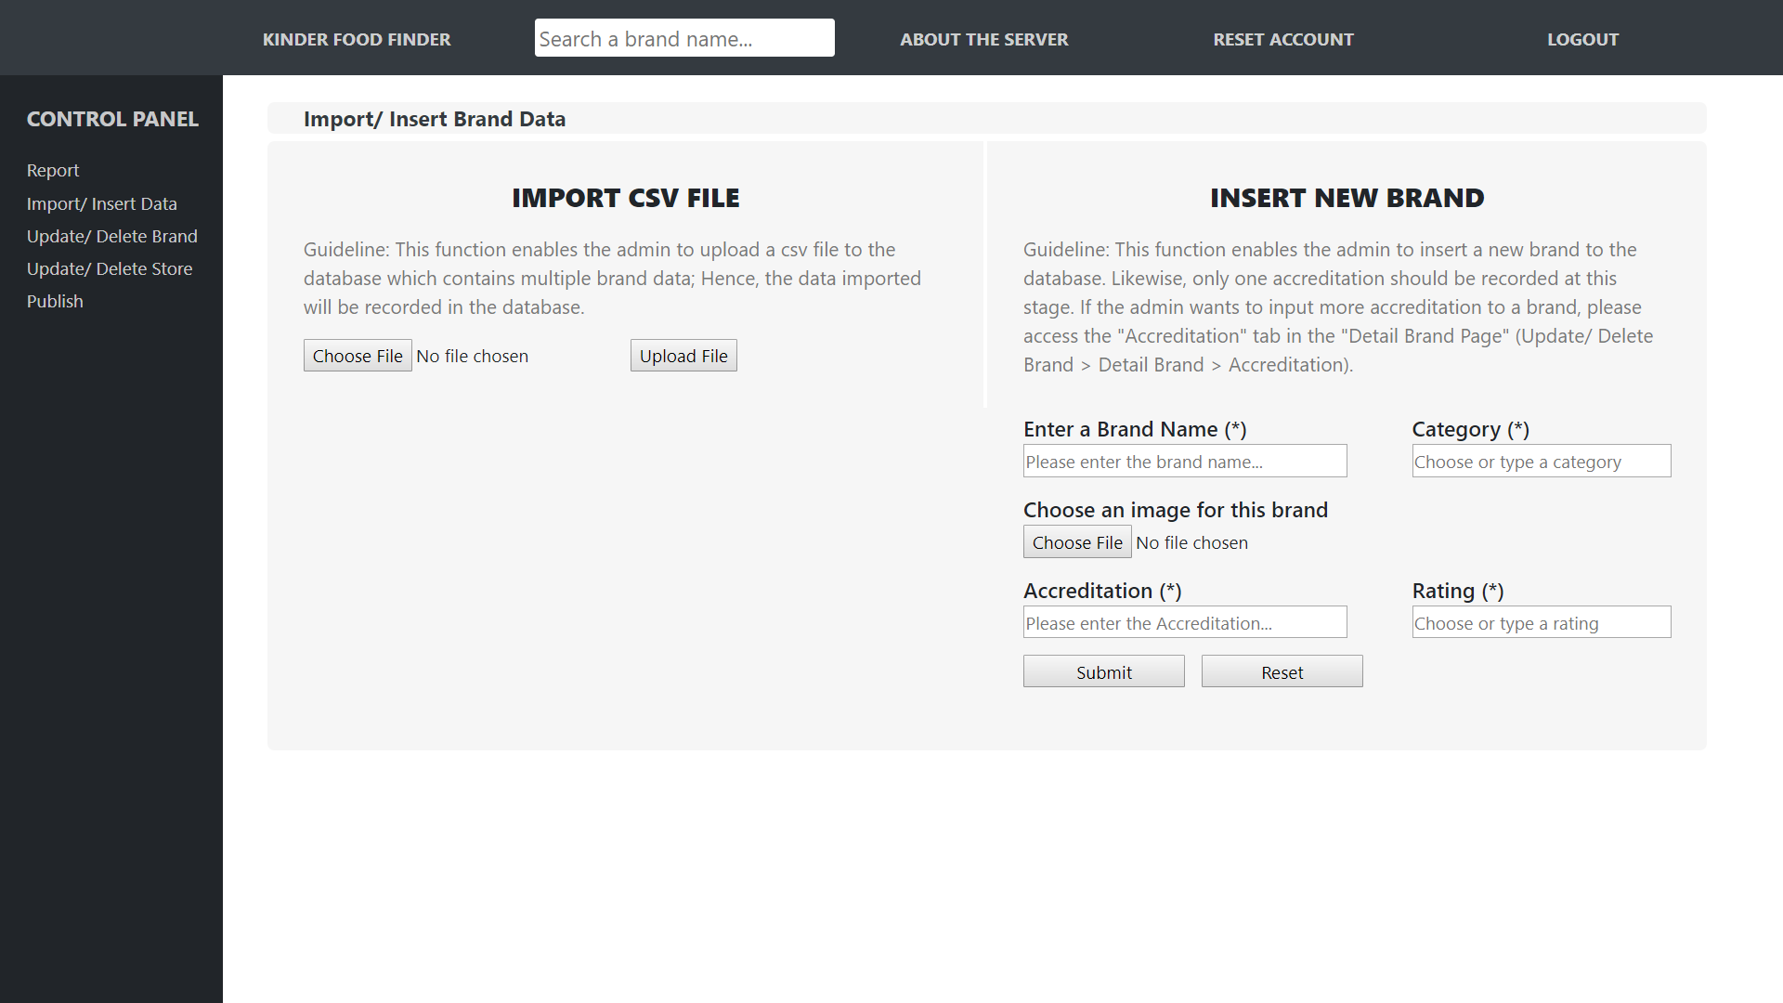

*Figure xxx. Import/ Insert Data (1)*

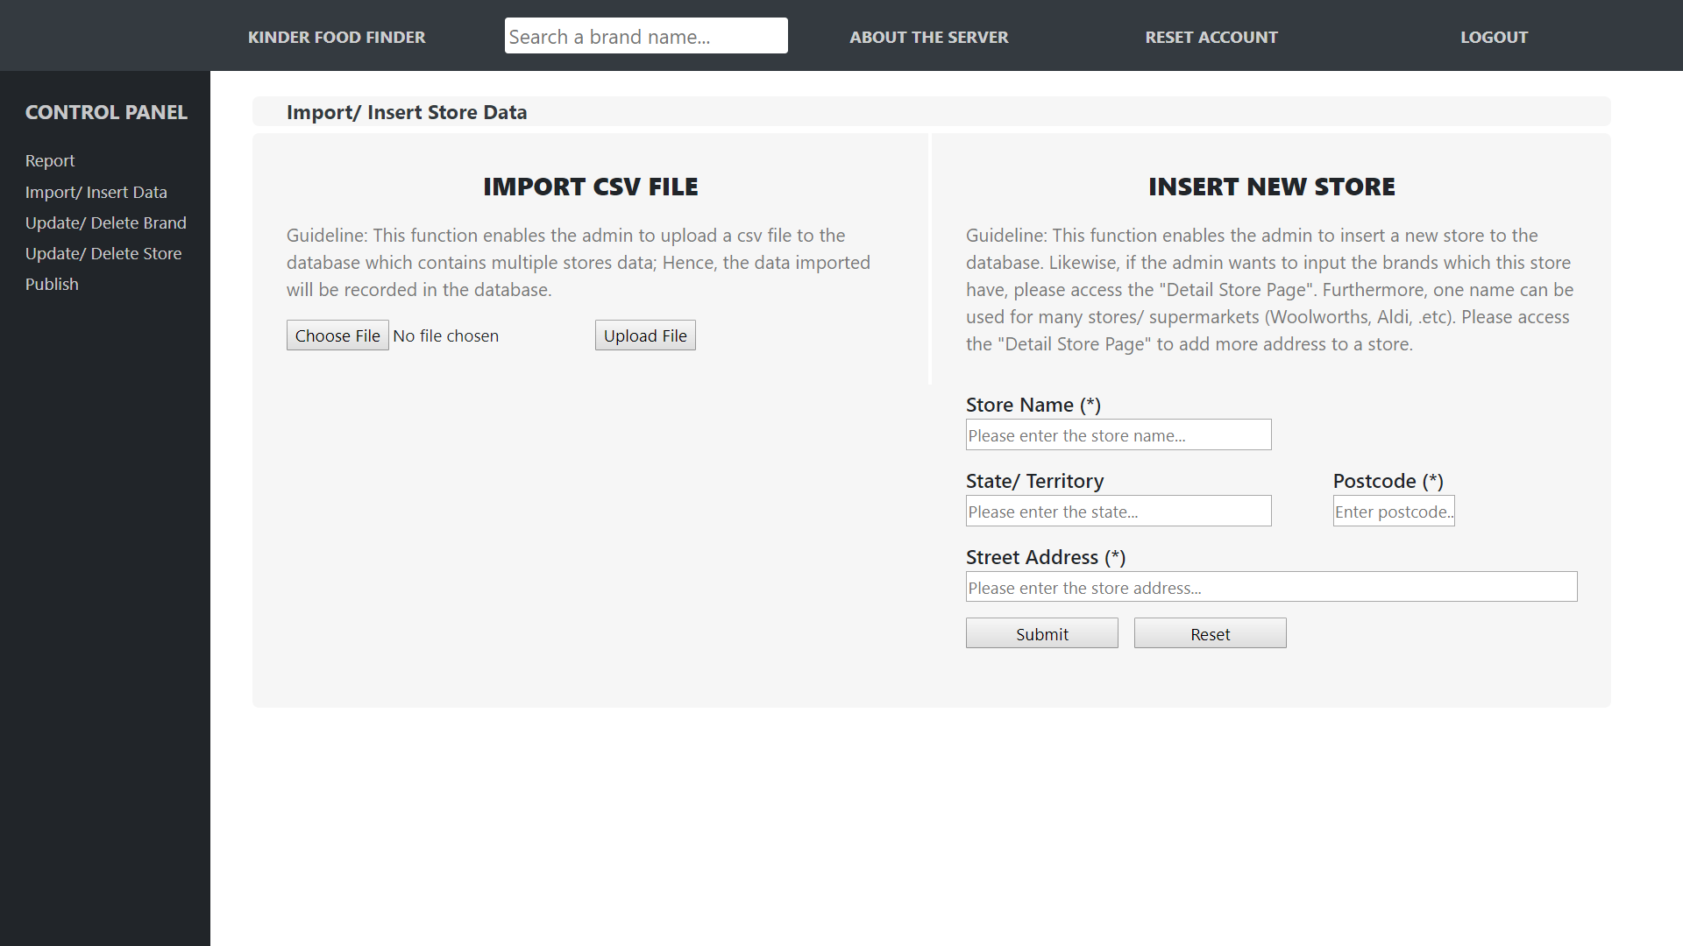

*Figure xxx. Import/ Insert Data (2)*

|  |  |  |
| --- | --- | --- |
| **Name of the feature and view** | Update/ Delete Brand | **No. WPS002** |
| **Description:** | * This feature displays all brands available in the database and allows the Admin to search through all data using the search box on the right corner of the view. * Likewise, as indicated in the name of this feature, the Admin can choose to delete brand(s) in the database by ticking on the *“Delete”* checkboxes on the right-hand side of; Furthermore, upon clicking the *“Delete”* button (The button with the trash can icon), the brand(s) that was(were) chosen would be removed completely from the database. * Furthermore, by clicking on the *“Name”* tag of each brand, the Admin will be able to access the **Detail Brand Page.** | |

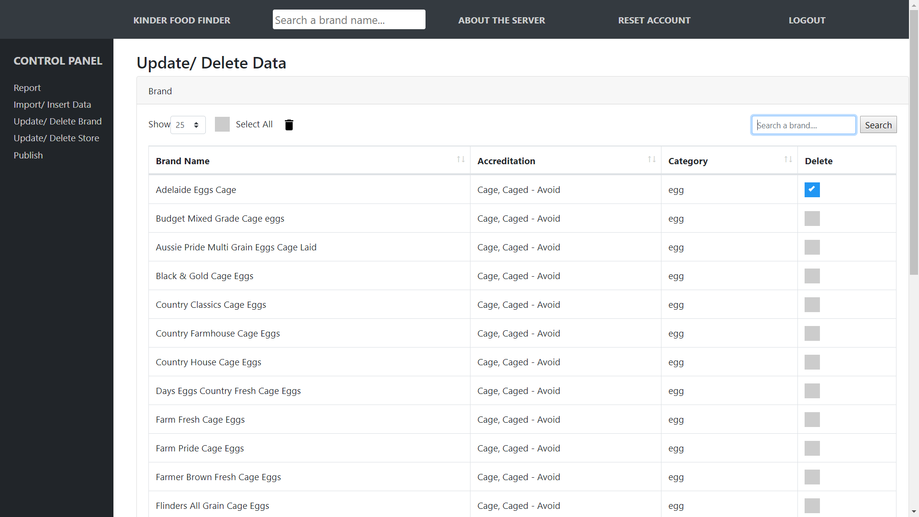

*Figure xxx. Delete/ Update Brand*

|  |  |  |
| --- | --- | --- |
| **Name of the feature and view** | **Detail Brand Page** | **No. WPS003** |
| **Description:** | * This feature does not only display detail information of a brand (Including brand name, category, picture, number of accreditation), but also allows the Admin to update change. For example, by simply clicking on the *“Edit”* button on the right side of each attribute, an input box will appear enables the he/ or she to make change to the product data. * Furthermore, the sub-panel (Below the name of the product) also allows the Admin to navigate and enter features related to Detail Brand Page: * **Accreditation** | |

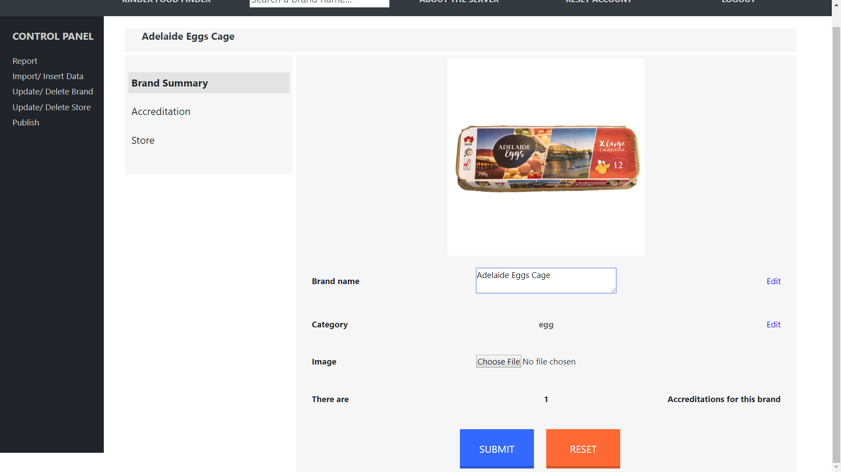

*Figure xxx. Detail Brand Page*

# DISCUSSION

## **Project Deliverables**

* Product-related deliverables:
* Source code in Java for the Kinder Food Finder mobile application;
* Source code in Javascript for the server and the MongoDB database to manage Brand data and Users’ behaviors;
* Instruction manual on how to operate the mobile application and server;
* Documentation of the system.

## **Implications**

* As mentioned earlier in Part 1(Introduction), as the agriculture industry evolves, more and more consumers want to buy, support and promote livestock products that are animal-friendly. On the other hand, the Government and Organizations have also imposed standards and regulations on this topic. However, though many parties have contributed in animal-welfare matter, we lack an information channel that connects those efforts together. In short, while people are shopping for goods that were produced more humanely, they usually struggle and waste a lot of time when it comes to finding the correct brand; False claiming, labelling and advertising are the factors that confuses the supporters of the animal-welfare movement.
* As a result, the Kinder Food Finder system, the output of this project, is expected to help solve this problem and act like as the channel that contains information about animal-welfare of different livestock products. In specific, mobile device users who download and run the app will be able to access the animal-welfare rating of several brands in the market. Likewise, the rating of those products is provided by recognized third party organizations in Australia; For example: Royal Society for the Prevention of Cruelty to Animals (RSPCA), National Association for Sustainable Agriculture Australia Limited (NASAA), Humane Choice, Australian Certified Organic, etc. Using the accreditations of those organizations provides the end-users of the Kinder Food Finder system with more independent and transparent information about animal living-condition.
* For the consumers, they could simply access the Search and Browse features of the app as mentioned above in part 7 (Results) and mobile device will display to them which brand has good and bad rating when it comes to treating livestock. Furthermore, the ratings are classified into three tiers **Best**, **Good** and **Avoid** respectively with accompanied explanations on the meaning of different ratings (Please have a look at figure xxx).
* In addition, the app also allows its users to access those features while being offline/ without the need of internet connection.
* is expected to enable our client to collect users’ behaviors data and use that information in researching the connection between animal welfare, consumers’ demographics, and shopping preferences. In specific, by the end of this project, the client shall implement the system (Including the application, server, and database) and enable real users to access the services provided by the system. Hence, when users interact with the mobile app and search for animal welfare rating of a brand, their behavior will be recorded by the application and sent to the server. The server will record those data in the database, and the client can access those data to enrich the research.
* Furthermore, the deliverables of this project also contribute in improving transparency regarding the living conditions of animals and help provide more information about their living situation to consumers; By granting access to this information, we expect that shoppers will make better choices for animal welfare when they go to the stores.

# LIMITATIONS AND FUTURE WORKS

Though the final products have been delivered to the client, due to the time constraint of this project, there are still limitations that the project team acknowledges. This part of the report documents these limitations and propose opportunities for further improvements:

* **The mobile application is for android operating system only:** The mobile app is only compatible with the Android operating system and built in accordance with the requirements of the project. However, iOS is still a major operating system that attracts plenty of mobile device owners. As a result, the Kinder Food Finder system could not reach and collect data from the the iOS users. This drawback might reduce the amount and accuracy of the statistical data collected from users. Hence, this matter should be handled with by implementing another Kinder Food Finder project for iOS that uses our final deliverables as foundations. In specific, in the new project, we should recruit developers that have competencies in iOS programming and build the iOS version of the app that have identical functions to the current Android version. Likewise, the server-side should be kept as-is and centralized; Hence, the iOS version of the app should be able to connect with the current server (Sending and receiving data).
* **Term & Conditions/ Privacy policy of the mobile application:** The purpose of Kinder Food Finder system is not only to provide an information channel about animal-welfare to the consumers, but also serves as a tool for the client of this project to collect demographic data from the users (How many times a brand is searched, filtered by age, gender, timeline, etc.). Hence, we acknowledge that the users should be notified about this matter and help inform them using a text in the Signup function of the mobile application (Refer to figure xxx). However, to ensure compliance with certain standards about collecting users’ data, the app should be improved further by a more refined “Terms & Conditions“. In specific, more effort should be spent on reviewing the legislations and standards regarding this matter; Furthermore, a decent “Terms & Conditions” that notifies the end-users about the data that will be collected should be developed and integrated into the mobile application.
* **Update birthday and gender after Signup:** Upon signing up for a new account or login-in the mobile application using Facebook account for the first time, the users will be asked to provide personal information like their gender and the birthday. Hence, the users can also choose the option to not display this information in the Kinder Food Finder system; As a result, the age and gender of users who chose not to display personal information will be recorded as unidentified in the database. Likewise, the personal information of the user is collected only during the signup process; After that, the user could not modify it further. In short, the users might input incorrect personal information and want to change that later; However, the current system does not have the necessary feature for that. This limitation can be improved by adding the feature that enables user to modify his/ or her personal profile in the “My account” view of the mobile application (Refer to figure xxx.). Furthermore, restrictions should be added to prevent users from editing the personal profile too many times, which might impact negatively on the statistical data collected.
* **Import csv file for store data:** To help the client input data related to animal-based brand/ product effectively, the project team has developed the feature to import csv file that consists of brand data; This feature enables the client/ the Admin to input multiple brand data at a time to the database. On the other hand, if the administrator wants to insert data of a store, he/ or she can only insert one at a time using the “Insert store data” feature; Though the project team has considered developing an “Import csv file for store data” feature, the complexity and ad-hoc nature of the feature discourages that team from completing it. However, this is also a limitation that can be improved; Because the client of this project has limited knowledge regarding Information Technology field, the initial requirements for the server-side were vague, most of the features are developed using the project team’s judgements. Hence, once this system is deployed, the client can get more familiar on how to manage and operate it and obtain more insights. At that stage, she might have a better idea on whether the “Import csv file for store data” is necessary and how it should be developed.
* **The system can only store and display one image per animal-based brand/ product:** At the current stage,the Admin can input one image per brand in the server (Refer to figure xxx); In turn, this image will be downloaded into the **local database** of the mobile device and displayed in the mobile application to the end-users and help them identify the brand/ product visually. Likewise, the number of images that can be stored and displayed to the end-users is limited to one per brand/ product; This feature is designed this way to cope with the limitation in the mobile device’s **storage capacity**. Likewise, in case there is intention to improve this feature by allowing the mobile application to display more than one pictures per brand, further performance evaluation testing should be conducted to ensure appropriate data size is used for the app. In specific, a sufficient amount of data (data of 1000 to 10,000 products and images) should be added to the system; Hence, once app downloads that data, examination should be carried out to check how much space is used by the Kinder Food Finder app. Hence, if the size of the Kinder Food Finder local database is excessive, the developer should reduce the number of images allowed on the server until achieving a reasonable amount.
* **One administrator account on the server-side:** To ensure that only the administrator appointed by the client can have access to the web-page server, the project has developed the login and account management function (On the server-side). However, there is a limitation of one administrator account only for the entire server-side which has access to every feature. In short, if the client decides to allocate the administrator’s responsibilities to multiple people, they can only access the system using one account; This could result in security issue. Likewise, this limitation can be improved by introducing a new hierarchical administrator account system. In specific, there should be one high-level administrative account on the server-side which is entitled directly to the client. This account enables the client to access all features available in the server-side; Furthermore, this account can create sub/ low-level administrative account and assign them access to different functions. The low-level account, though does not have access to every functions, should be able to perform certain actions that are allowed by the high-level account; Hence, sub account could not create more administrative account on the server-side.

References

1. Agriculture Victoria Services. (2017, October 24). *What is animal welfare?* Retrieved from <http://agriculture.vic.gov.au/pets/care-and-welfare/animal-welfare/what-is-animal-welfare>
2. Shahzad, B., & Alwagait, E. (2013). *Smartphone’s Popularity Measurement by Investigating Twitter Profiles*. Proceedings of 10th CONTECSI International Conference on Information Systems and Technology Management. doi:10.5748/9788599693094-10contecsi/rf-505
3. Butterworth, A. (Ed.). (2018). *Animal welfare in a changing world*. Retrieved from <https://ebookcentral-proquest-com.ezproxy1.library.usyd.edu.au>
4. Chen, P. (2016). *Animal welfare in Australia : politics and policy*. The University Of Sydney, N.S.W: Sydney University Press.
5. Alqudah, M., & Razali, R. (2017). Key factors for selecting an Agile method: A systematic literature review. International Journal on Advanced Science, Engineering and Information Technology, 7(2), 526-537.
6. Brindha, J., & Vijayakumar, V. (2015). Analytical comparison of waterfall model and object-oriented methodology in software engineering. Advances in Natural and Applied Sciences, 7-11.
7. Measey, P. (2014). What is Agile? In P. Measey (Ed.), Agile Foundations: Principles, practices and frameworks (pp. 2-10). Swindon: BCS Learning & Development Limited.
8. Bomarius, F., & Komi-Sirviö, S. (2005). Product focused software process improvement 6th international conference, PROFES 2005, Oulu, Finland, June 13-15, 2005 ; proceedings.
9. Andorfer, V. A., & Liebe, U. (2015). Do information, price, or morals influence ethical consumption? A natural field experiment and customer survey on the purchase of Fair Trade coffee. Social science research(52), 330-350.
10. Bray, J., Johns, N., & Kilburn, D. (2011). An exploratory study into the factors impeding ethical consumption. Journal of business ethics, 98(5), 597–608.
11. Carrington, M. J., Neville, B. A., & Whitwell, G. J. (2010). Why ethical consumers don’t walk their talk: Towards a framework for understanding the gap between the ethical purchase intentions and actual buying behaviour of ethically minded consumers. Journal of business ethics, 97(1), 139-158.
12. Connolly, J., & Shaw, D. (2006). Identifying fair trade in consumption choice. Journal of strategic marketing, 353–368.
13. Eli, K., Dolan, C., Schneider, T., & Ulijaszek, S. (2016). Mobile activism, material imaginings, and the ethics of the edible: Framing political engagement through the Buycott app. Geoforum, 63-73.
14. Fuentes, C., & Sörum, N. (2019). Agencing ethical consumers: smartphone apps and the sociomaterial reconfiguration of everyday life. Consumption Markets & Culture, 131-156.
15. Futerra, S. C. (2005). The rules of the game: The principals of climate change communication. London: Department for Environment, Food and Rural Affairs.
16. Ghvanidze, S., Velikova, N., Dodd, T. H., & Oldewage-Theron, W. (2016). Consumers' environmental and ethical consciousness and the use of the related food products information: The role of perceived consumer effectiveness. Appetite(107), 311-322.
17. Humphery, K., & Jordan, T. (2018). Mobile moralities: Ethical consumption in the digital realm. Journal of Consumer Culture, 520-538.
18. Nghiem, T. P., & Carrasco, L. R. (2016). Mobile applications to link sustainable consumption with impacts on the environment and biodiversity. BioScience, 384-392.
19. Papaoikonomou, E., Valor, C., & Ginieis, M. (2018). Looking for info? Understanding ethical consumer information management using a diary approach. Management Decision, 56(3), 645-662.
20. Gao, J., Bai, X., Tsai, W., & Uehara, T. (2014). Mobile Application Testing: A Tutorial. Computer,47(2), 46-55. doi:10.1109/mc.2013.445
21. Myers, G. J., Sandler, C., & Badgett, T. (2012). The art of software testing. Hoboken, NJ: John Wiley & Sons.
22. Model View Controller Pattern. (2015). In Professional Java® EE Design Patterns (pp. 183–193). Hoboken, NJ, USA: John Wiley & Sons, Inc. <https://doi.org/10.1002/9781119209393.ch14>
23. Herron, D. (2011). Node web development. Retrieved from https://ebookcentral-proquest-com.ezproxy1.library.usyd.edu.au