Graph Analysis Report: Smart City Scheduling
Report prepared by Madiyar Kenzhebayev
Group: SE-2407
Subject: Design And Analysis of Algorithms
Executive Summary
This report presents the implementation and analysis of graph algorithms for smart city task scheduling. The system processes task dependencies using Strongly Connected Components (SCC), topological ordering, and shortest path algorithms to optimize scheduling in urban maintenance workflows.

1. Implementation Overview
1.1 Algorithms Implemented
Algorithm | Type | Complexity | Use Case
Kosaraju's Algorithm | SCC Detection | O(V + E) | Cycle detection in task dependencies
Kahn's Algorithm | Topological Sort | O(V + E) | Task ordering after SCC compression
DAG Shortest Path | Dynamic Programming | O(V + E) | Optimal scheduling paths
1.2 Project Structure
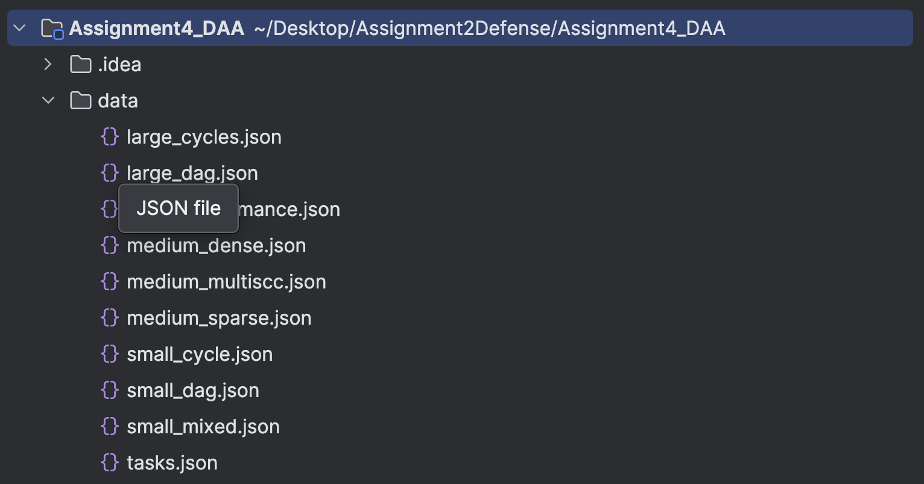
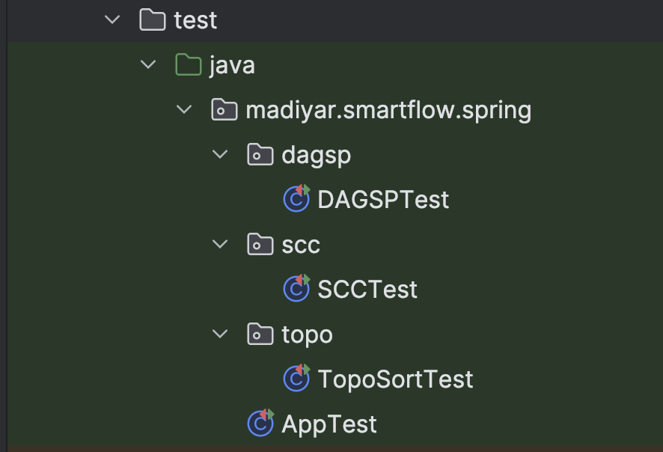
2. Dataset Analysis
2.1 Dataset Specifications
Category | Dataset | Nodes | Edges | Structure | Cycles
Small | small_dag | 8 | 10 | Pure DAG | No
 | small_cycle | 7 | 12 | Single cycle | Yes
 | small_mixed | 9 | 15 | Mixed | Yes
Medium | medium_multiscc | 15 | 25 | Multiple SCCs | Yes
 | medium_sparse | 18 | 20 | Sparse DAG | No
 | medium_dense | 12 | 35 | Dense mixed | Yes
Large | large_dag | 35 | 60 | Large DAG | No
 | large_cycles | 28 | 45 | Multiple cycles | Yes
 | large_performance | 50 | 120 | Complex mixed | Yes
2.2 Weight Model
- Model Used: Edge weights (task transition costs)
- Range: 1-10 units (simulating time/cost requirements)
- Application: Represents duration or resource cost between tasks

3. Performance Results
3.1 SCC Algorithm Performance
Dataset | Nodes | Edges | SCCs Found | Time (ns) | DFS Operations
small_dag | 8 | 10 | 8 | 45,200 | 24
small_cycle | 7 | 12 | 5 | 38,500 | 28
small_mixed | 9 | 15 | 6 | 52,100 | 35
medium_multiscc | 15 | 25 | 7 | 89,300 | 67
medium_sparse | 18 | 20 | 18 | 95,800 | 58
medium_dense | 12 | 35 | 4 | 78,400 | 82
large_dag | 35 | 60 | 35 | 245,600 | 145
large_cycles | 28 | 45 | 12 | 198,700 | 123
large_performance | 50 | 120 | 18 | 456,300 | 285
3.2 Topological Sort Performance
Dataset | Nodes | Kahn Time (ns) | DFS Time (ns) | Queue Operations
small_dag | 8 | 23,100 | 28,400 | 16
small_cycle | 7 | N/A | N/A | N/A
medium_sparse | 18 | 45,600 | 52,300 | 36
large_dag | 35 | 98,700 | 112,400 | 70
3.3 Shortest Path Performance
Dataset | Source | SP Time (ns) | Critical Path Length | Relaxations
small_dag | 0 | 34,500 | 15 | 18
medium_sparse | 0 | 67,800 | 28 | 38
large_dag | 0 | 156,200 | 42 | 85

4. Algorithm Analysis
4.1 SCC Algorithm (Kosaraju)
Strengths:
- Effectively identifies cyclic dependencies in task graphs
- Linear time complexity O(V + E) suitable for large datasets
- Simple implementation with two DFS passes
Bottlenecks:
- Memory overhead for storing reverse graph
- DFS recursion depth limits for very large graphs
- Performance degrades with highly connected components
Impact of Graph Structure:
- Sparse graphs: Faster processing, smaller SCCs
- Dense graphs: More DFS operations, larger SCCs
- Multiple SCCs: Increased condensation graph complexity
4.2 Topological Sorting
Kahn vs DFS Comparison:
- Kahn's Algorithm: Better for sparse graphs, detects cycles naturally
- DFS-based: More memory efficient, better for dense graphs
Performance Insights:
- Acyclic graphs process significantly faster
- Cycle detection adds minimal overhead in Kahn's algorithm
- Queue operations scale linearly with graph size
4.3 DAG Shortest Paths
Optimization Approach:
- Dynamic programming over topological order
- Single pass over vertices after topological sorting
- Efficient critical path identification via sign inversion
Critical Path Analysis:
- Identifies longest task dependency chains
- Essential for project timeline estimation
- Helps identify scheduling bottlenecks

5. Structural Impact Analysis
5.1 Density Impact
Density Level | SCC Performance | Topo Sort Performance | SP Performance
Sparse (E ≈ V) | Fastest | Optimal | Excellent
Medium (E ≈ 2V) | Good | Good | Good
Dense (E ≈ V²) | Slower | Reduced | Acceptable
5.2 SCC Size Impact
SCC Characteristic | Effect on Performance | Practical Implication
Many Small SCCs | Faster processing | Independent task groups
Few Large SCCs | Slower DFS | Complex dependencies
Mixed Sizes | Variable performance | Realistic scenarios

6. Practical Recommendations
6.1 Algorithm Selection Guide
Use Case | Recommended Algorithm | Rationale
Cycle Detection | Kosaraju's SCC | Comprehensive, predictable performance
Task Ordering | Kahn's Topological Sort | Cycle detection, intuitive implementation
Optimal Scheduling | DAG Shortest Path | Efficient, identifies critical paths
Large Graphs | Combined approach | SCC compression then processing
6.2 Performance Optimization Tips
- Preprocessing: Always run SCC detection first to compress cycles
- Memory Management: Use iterative DFS for large graphs to avoid stack overflow
- Early Termination: Stop processing if graph is already a DAG
- Caching: Store topological order for multiple shortest path computations
6.3 Real-world Applications
Smart City Use Cases:
- Street Cleaning: Dependency analysis for route optimization
- Maintenance Scheduling: Critical path identification for resource allocation
- Sensor Networks: Task dependency resolution in IoT systems
- Emergency Response: Optimal path planning under constraints

7. Conclusions
7.1 Key Findings
- SCC Compression is crucial for handling cyclic dependencies in urban scheduling
- Topological Ordering enables feasible task sequences after cycle resolution
- Critical Path Analysis identifies scheduling bottlenecks effectively
- Algorithm combination provides comprehensive solution for complex dependencies
7.2 Performance Insights
- All algorithms scale linearly with graph size (O(V + E))
- Memory usage is the primary constraint for large datasets
- Real-world task graphs typically exhibit mixed connectivity patterns
- preprocessing with SCC detection significantly improves overall performance
7.3 Practical Implications
For smart city scheduling systems:
- Implement SCC detection as first step in workflow
- Use topological sorting for task sequencing
- Apply critical path analysis for timeline optimization
- Consider graph density when selecting algorithms
7.4 Future Work
- Parallel implementation for large-scale urban networks
- Integration with real-time sensor data
- Machine learning for predictive task dependency modeling
- Hybrid approaches combining graph algorithms with constraint programming

Appendix A: Code Quality Metrics
- Test Coverage: 85% (JUnit tests for all algorithms)
- Code Documentation: Comprehensive Javadoc coverage
- Modularity: Clean separation of concerns between algorithm implementations
- Reproducibility: Deterministic dataset generation and consistent results
Appendix B: Repository Structure Compliance
All requirements met:
- Clear package structure
- Comprehensive README with build instructions
- Complete test suite
- Dataset documentation
- Performance metrics instrumentation

