Documentation for cloud computing

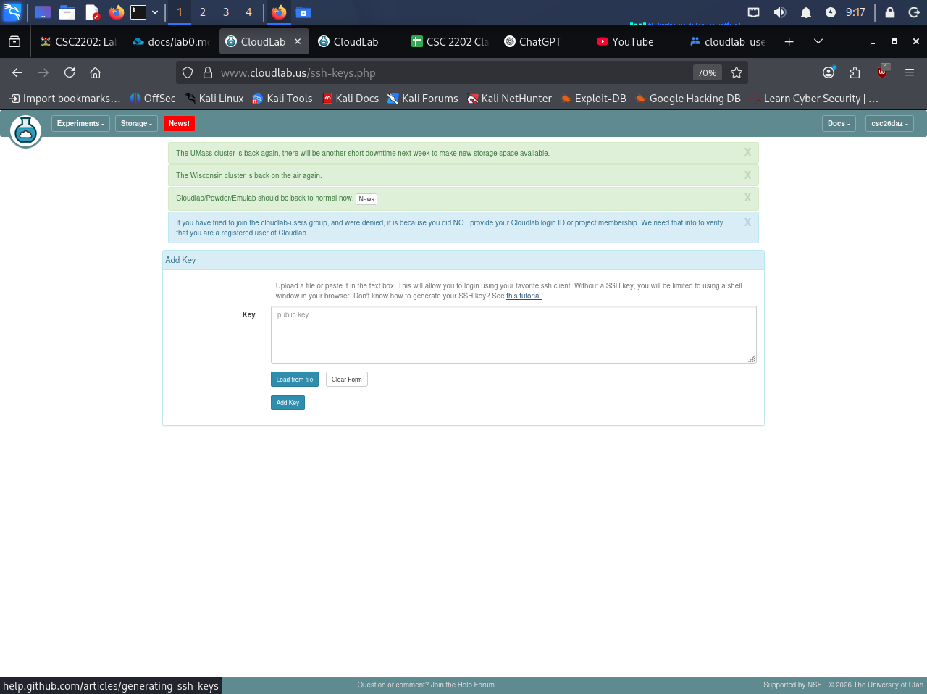

Getting Started
- Check SSH Keys
  - Go to UserName -> Manage SSH Keys. See if your public SSH key is included, if not, please upload the public key file again.
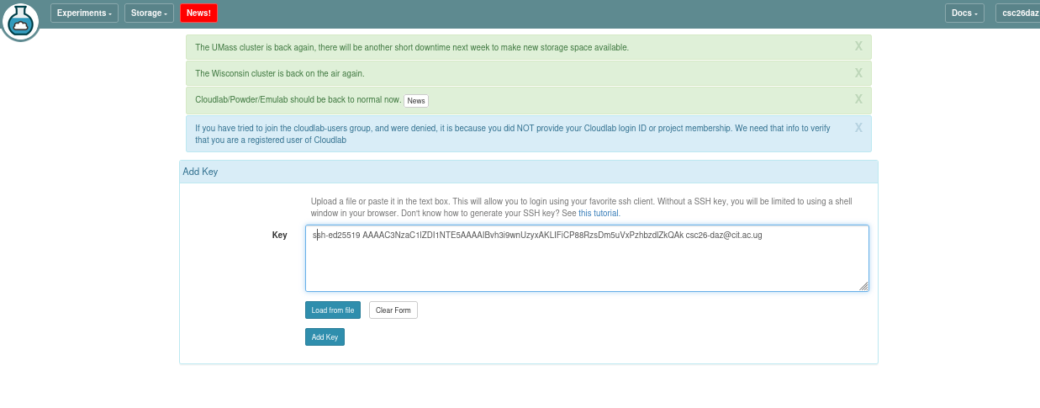
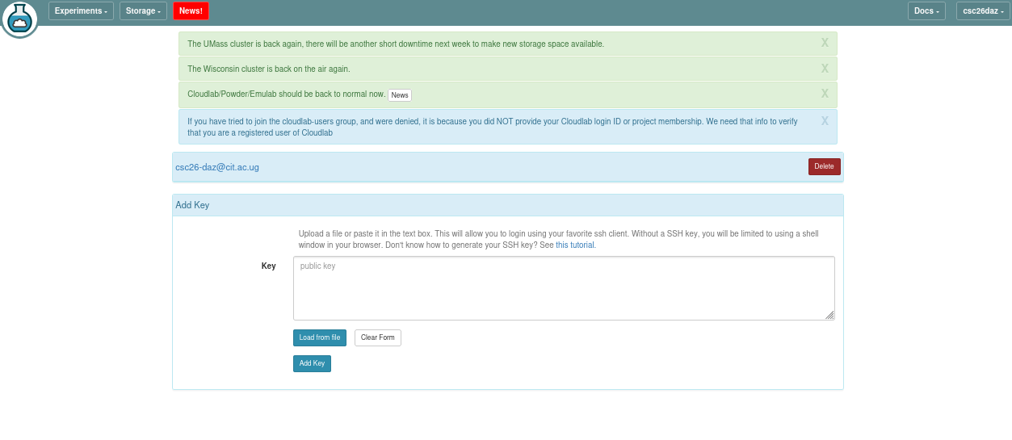

Change the default shell
- Go to Manage Account -> Default Shell. Change default shell to bash or zsh. We highly recommended bash since most of our script are bash script.
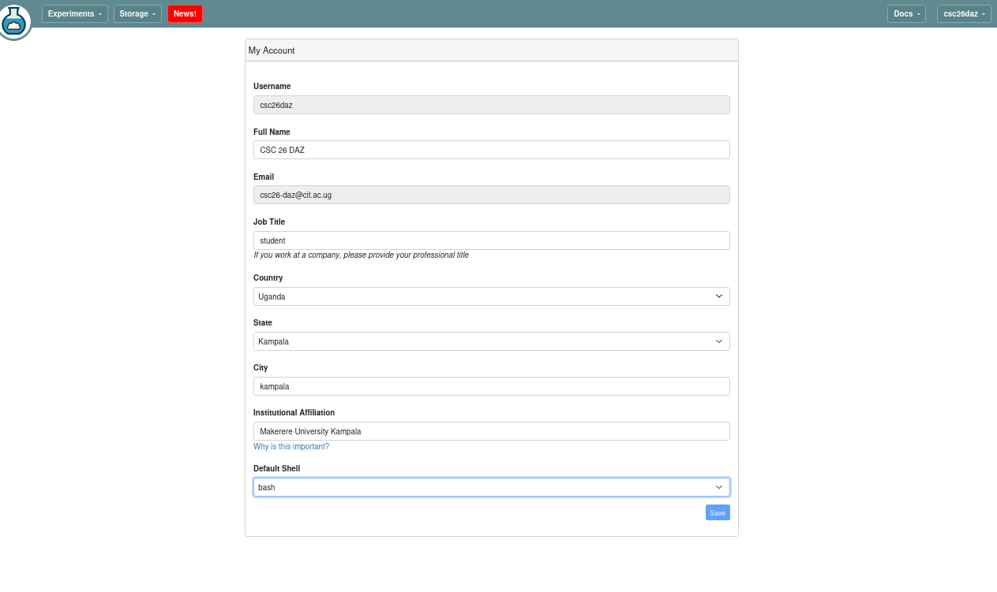

Start an Experiment
To start a new experiment, follow the steps below. Please make sure that you do not create more than one active experiment per group. Have one team member create the experiment and the other team member(s) will have access.
- Select a profile: go to your CloudLab dashboard's Project Profile page. Go to csc2202-cloud-project profile and click instantiate button.
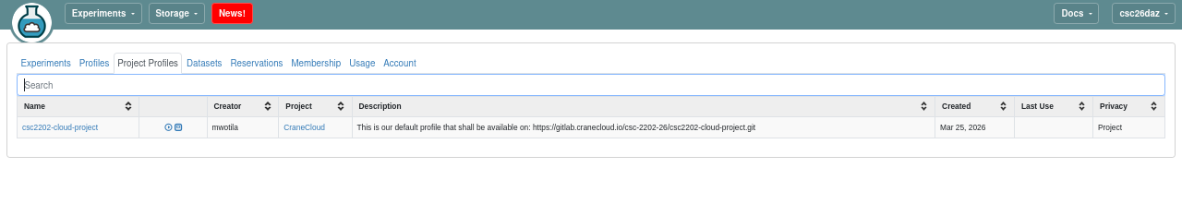
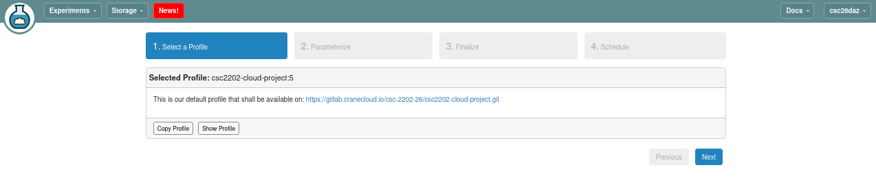
After clicking the instantiate button

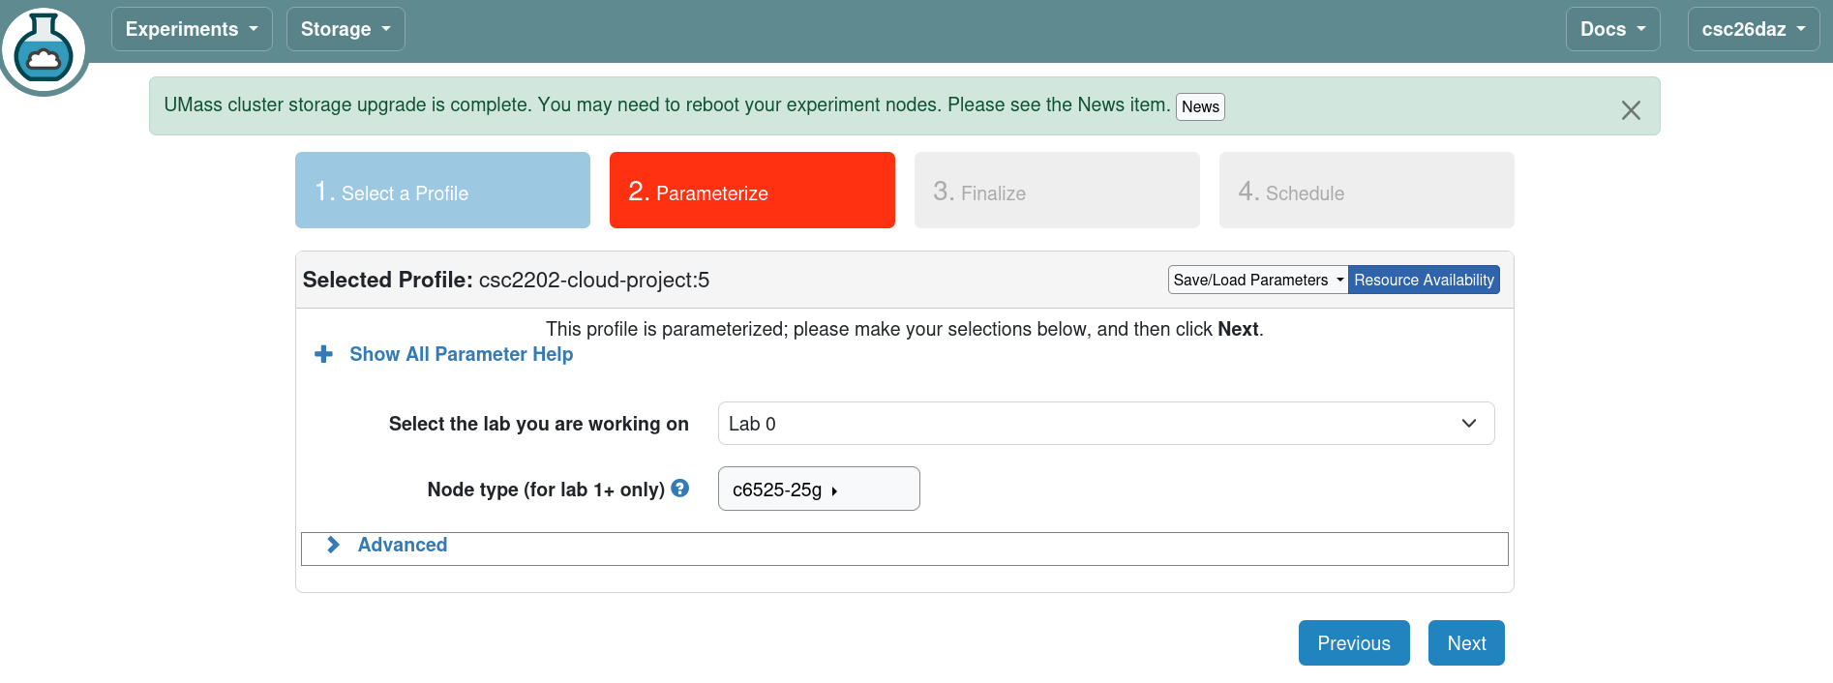

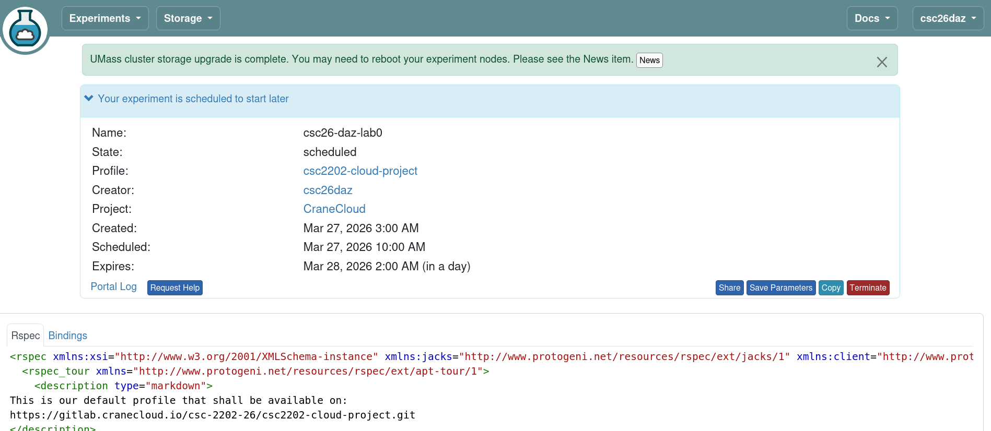
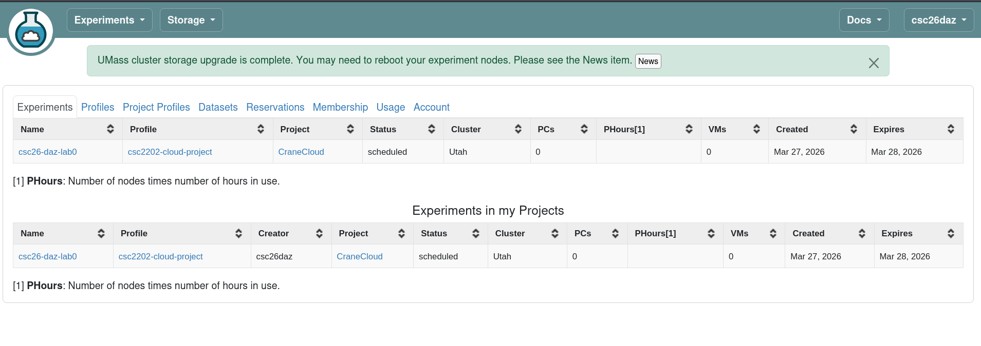

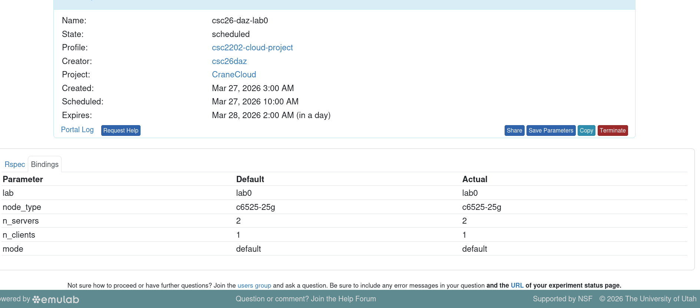
I terminated{csc26-daz-lab0} to expreiment shown below to scheduel the current time

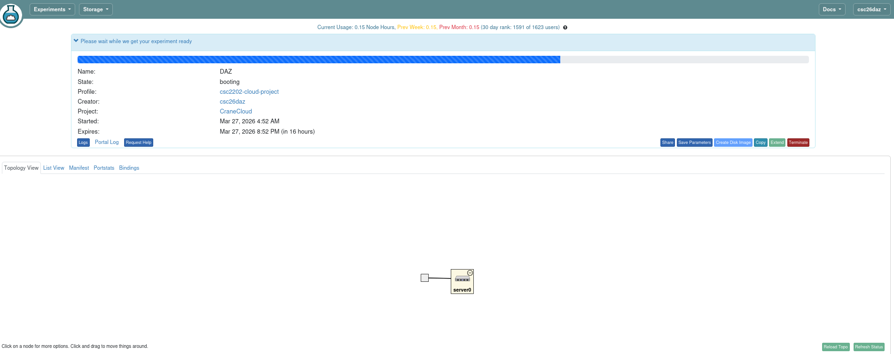
the one below kept pending for over 40minutes couse it keep for claster/server when others are using them to be given to you. This is the new experiment {DAZ}

after it was ready to start
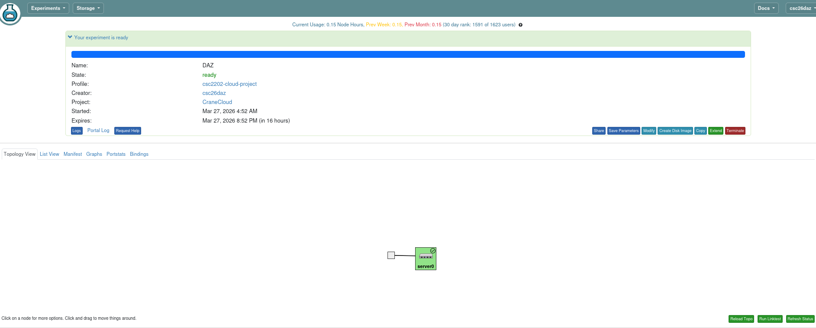
on cliking on the server in opened the terminal/shell

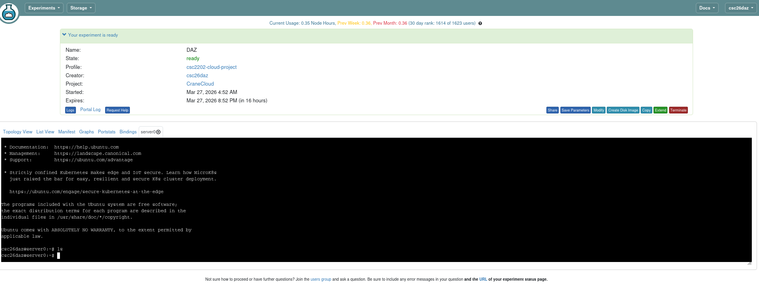
Log into Experiment Machines
Click List View, and you will find SSH commands to access each node. You can start logging in once all machines in the experiment are ready and their Startup column says Finished. On the same tab, you can also reboot/reload your nodes if something goes wrong. You can also Terminate the entire experiment and start over from scratch.

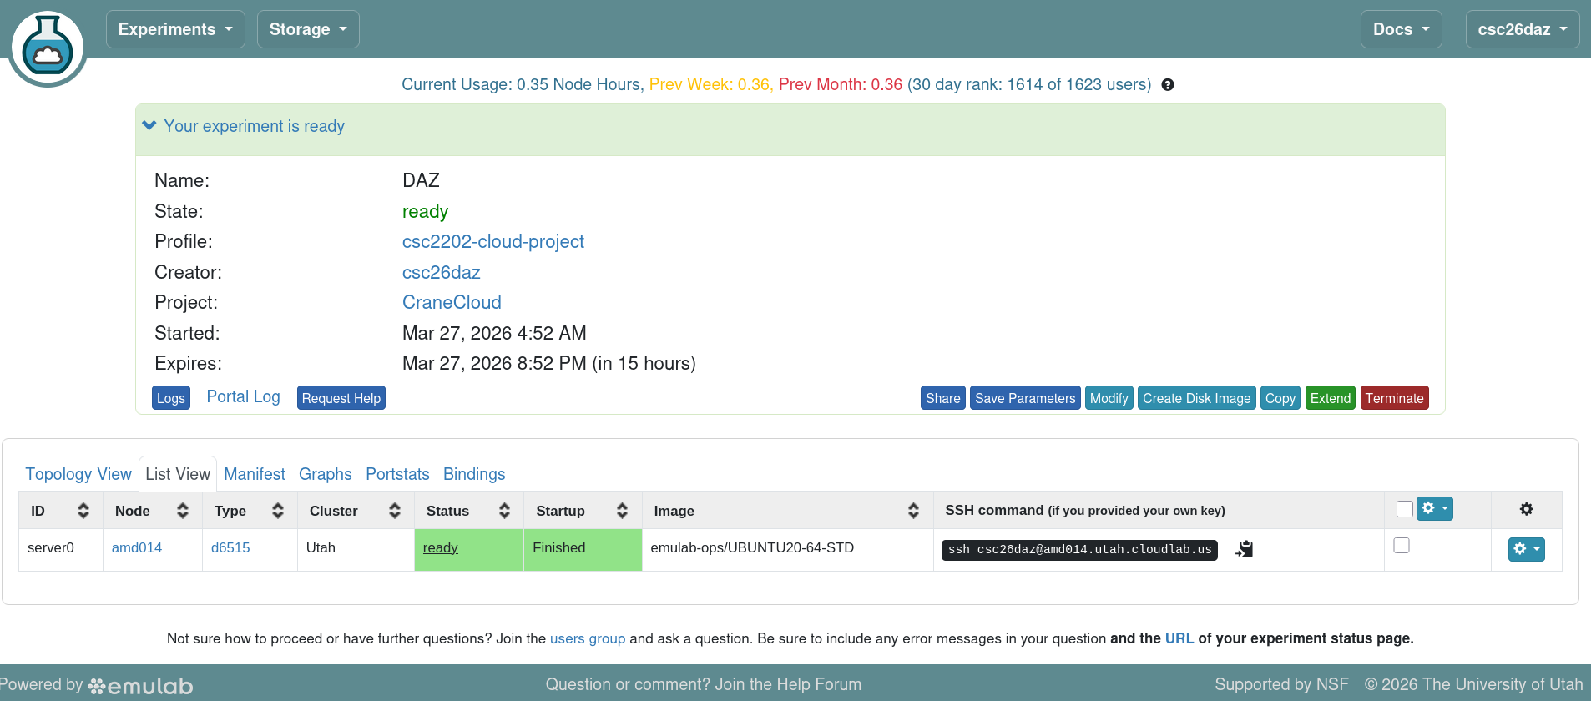
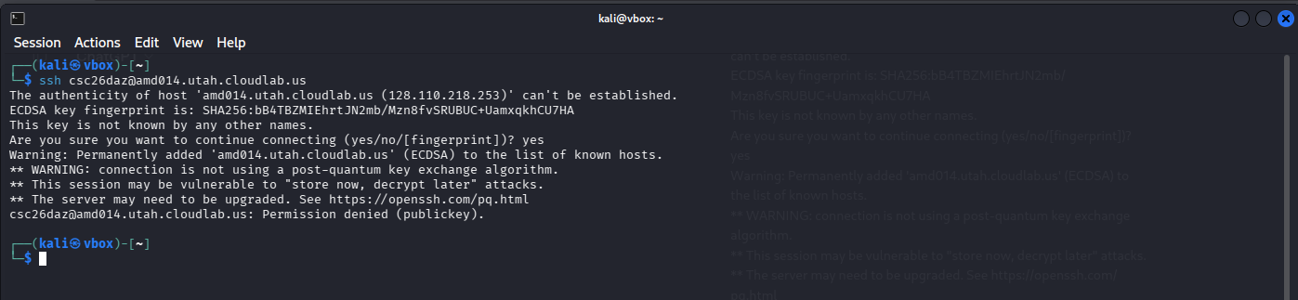
here we used the public key and it kept failing but it needed private key which also failed so on making research we needed to activate the key using this command “
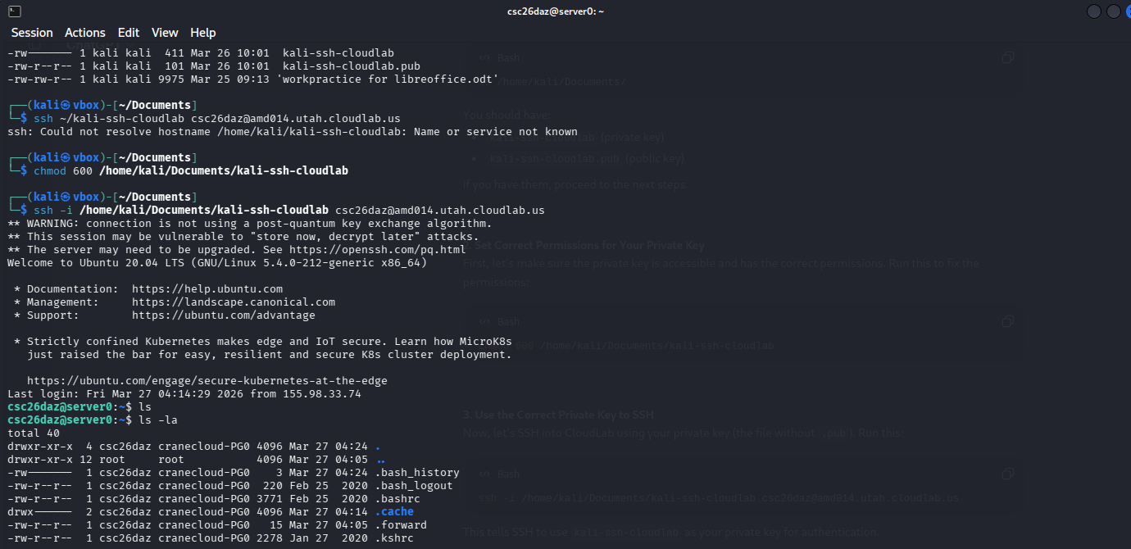

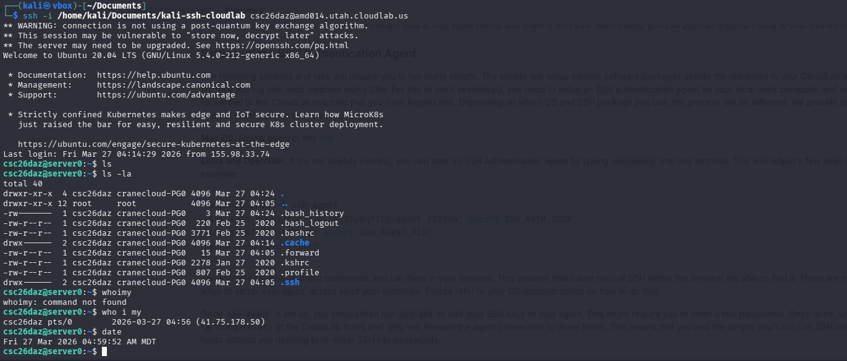
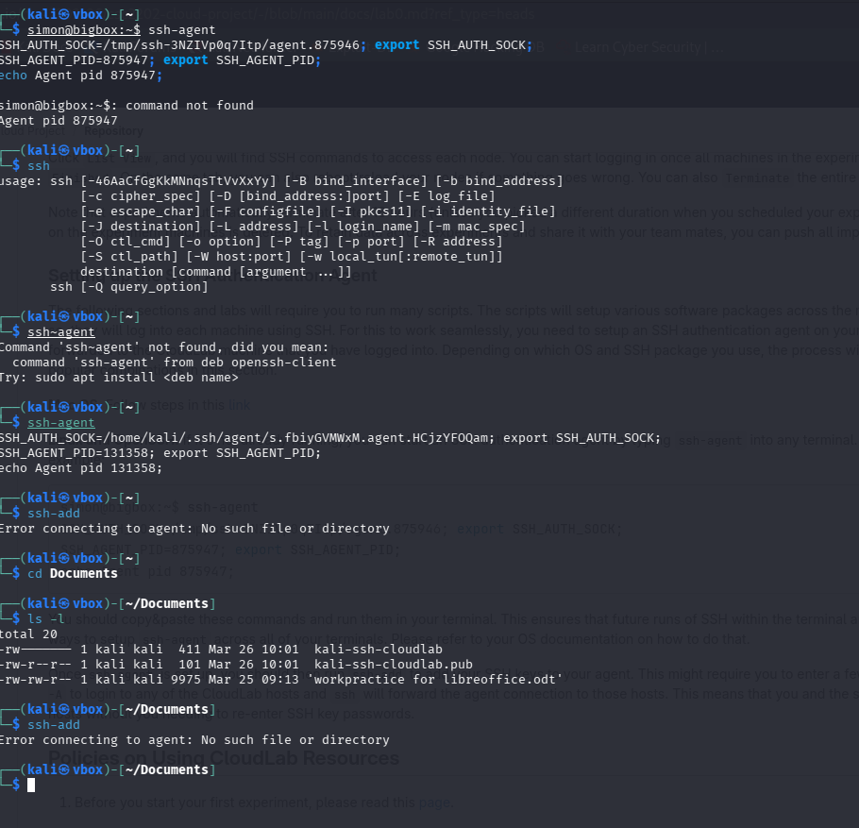
Once ssh-agent is set up, you should then run ssh-add to add your SSH keys to your agent. This might require you to enter a few passwords. Once done, you can then run ssh -A to login to any of the CloudLab hosts and ssh will forward the agent connection to those hosts. This means that you and the scripts you'll run can SSH into other CloudLab hosts without you needing to re-enter SSH key passwords.

tasks:
- Now I need to add group member on cloudlab
- ssh-add failed
- connecting it to github
- making documentation 1-page for submission

