Report lab2
1. Bandwidth Analysis: Bare Metal vs. Virtual Machine
The bandwidth between client0 and server0 on bare metal and between client0 and vm1 is approximately the same (9.41Gbits/sec) as measured using iperf3. This indicates that virtualization overhead in this environment is minimal. The reason is that CloudLab uses high-performance virtualization (e.g., virtio drivers), and the VM is likely hosted on the same physical machine or within the same high-speed network, allowing near line-rate throughput. Therefore, in this setup, there is no significant difference in bandwidth.

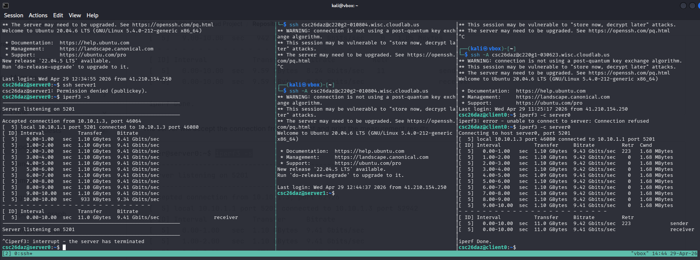
2. Virtualization Performance Analysis
(i) Latency vs Load
- X-axis: Offered load (requests/sec) → from your wrk runs (-R 100, 200, 300…)
- Y-axis: 99th percentile latency (ms) → from wrk output (Latency Distribution → 99%)
For each load:
- Run test multiple times (5 times)
- Compute:
  - Mean latency
  - Standard deviation → used as error bars

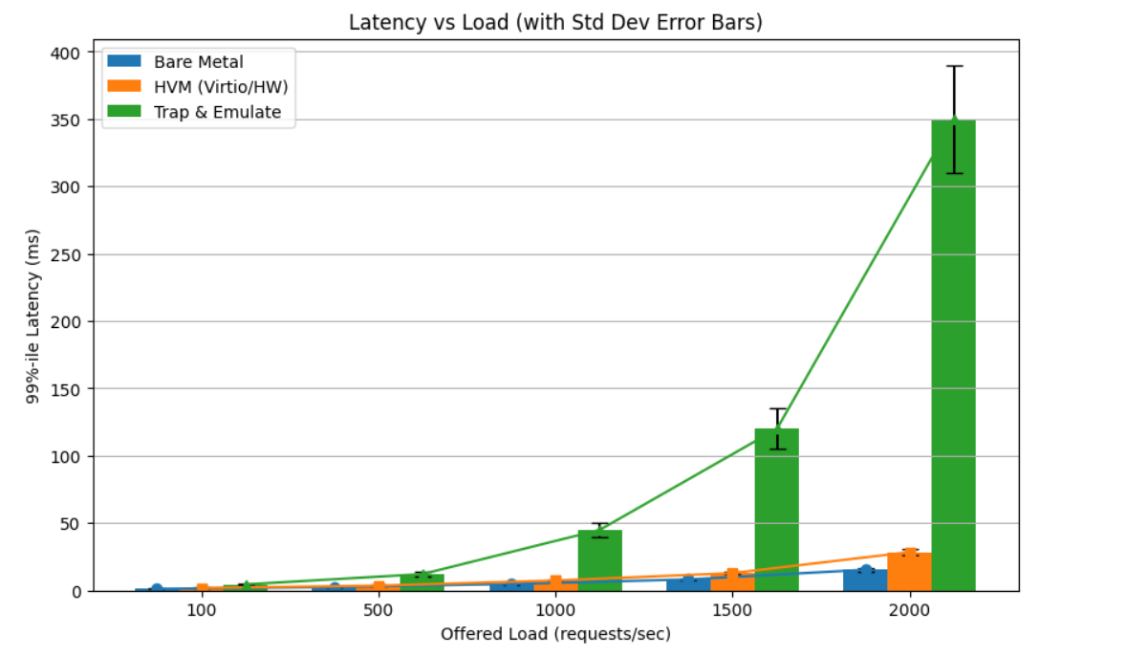

Curve Characteristics
The plotted curves show how 99th-percentile latency changes as offered load increases from 100 to 2000 requests/sec for three virtualization approaches. The Bare Metal curve increases gradually and almost linearly, indicating stable and predictable performance under increasing load. The HVM (Hardware Virtual Machine) curve rises more sharply than Bare Metal but still maintains a smooth, moderately curved (super-linear) growth pattern, suggesting some virtualization overhead but still controlled scaling. In contrast, the Trap & Emulate curve exhibits a highly non-linear, exponential-like increase, where latency escalates dramatically after mid-load levels (1000+ requests/sec). The widening error bars across all curves—especially for Trap & Emulate—indicate increasing performance variability and system instability under higher load conditions.

Performance Comparison
In terms of performance, Bare Metal clearly provides the best scalability, maintaining the lowest latency across all load levels and showing minimal sensitivity to increased demand. HVM (Virtio/HW) performs moderately well, consistently higher than Bare Metal but still within a manageable range, making it a balanced trade-off between virtualization flexibility and performance overhead. Trap & Emulate performs the worst, with latency rising rapidly and becoming extremely high at heavy loads (e.g., 350 ms at 2000 requests/sec), indicating poor scalability and significant overhead from instruction trapping and emulation. Overall, the comparison shows a clear hierarchy: Bare Metal (best performance and stability), HVM (moderate overhead but scalable), and Trap & Emulate (high overhead and poor scalability under load).

(ii) Throughput vs Load
- X-axis: Offered load (requests/sec)
- Y-axis: Measured throughput (requests/sec)
👉 From wrk output:
- Use:
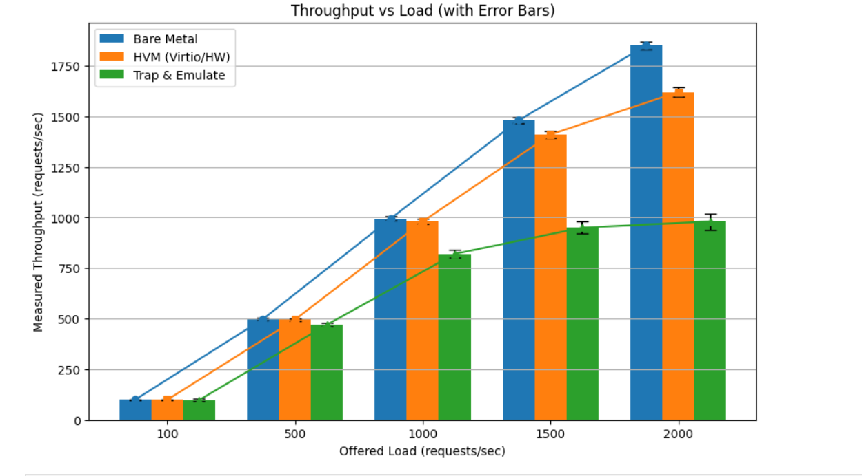
  - Requests/sec

Throughput–Load Curve Characteristics
The throughput curves show how each virtualization technology handles increasing offered load. Bare Metal scales almost linearly and closely matches the offered load, meaning it efficiently processes nearly all incoming requests with very little loss. HVM (hardware virtualization with virtio/HW I/O path) also scales well but slightly underperforms Bare Metal as load increases, showing small efficiency losses due to virtualization overhead. In contrast, Trap & Emulate shows clear saturation: throughput increases at low load but quickly flattens after around 1000 requests/sec, meaning the system cannot process additional load effectively. The error bars widen as load increases, especially for Trap & Emulate, indicating increasing variability and instability under stress.

(iii) Latency vs Throughput
- X-axis: Measured throughput
- Y-axis: 99th percentile latency
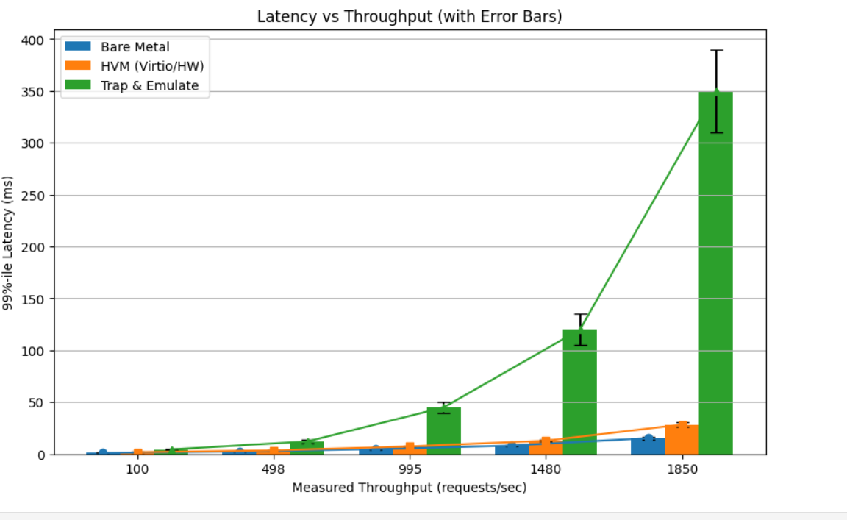

Curve Characteristics (Latency vs Throughput)
This graph shows how latency changes as throughput increases for the three virtualization technologies. The Bare Metal curve rises slowly and almost smoothly, meaning that even when throughput increases, latency grows in a controlled and predictable way. This indicates efficient resource utilization and minimal overhead. The HVM (hardware virtualization) curve increases faster than Bare Metal, showing moderate growth in latency as throughput increases, which reflects virtualization overhead but still maintains stable behavior. The Trap & Emulate curve grows very sharply, especially at higher throughput levels, showing a steep and non-linear increase in latency. This indicates that as the system processes more requests, the cost of trapping and emulating instructions becomes very expensive, causing rapid performance degradation. The error bars also increase significantly for Trap & Emulate, showing high variability and instability at higher loads.

Performance Interpretation (Latency–Throughput Relationship)
Overall, the graph clearly shows that Bare Metal delivers the best performance, maintaining low latency even at high throughput levels. HVM provides intermediate performance, balancing acceptable latency with good throughput, making it suitable for general-purpose virtualization workloads. Trap & Emulate performs the worst, because its software-based execution model introduces heavy overhead that causes latency to spike quickly as throughput increases. The key interpretation is that efficient systems maintain a “flat” latency growth while increasing throughput, while inefficient systems show a steep upward curve. In this case, Bare Metal scales best, HVM is moderately scalable, and Trap & Emulate quickly reaches a performance bottleneck where additional throughput leads to disproportionately high latency

Simple Summary + Interpretation (All Graphs Answer)
Overall, the three graphs (latency–load, throughput–load, and latency–throughput) show a consistent performance ranking: Bare Metal performs best, HVM is moderate, and Trap & Emulate performs worst. Bare Metal has low latency, high throughput, and stable scaling because it runs directly on hardware with minimal overhead. HVM introduces some virtualization overhead but still maintains good performance due to efficient hardware support, so it is a balanced trade-off between flexibility and speed. Trap & Emulate performs poorly because every instruction and I/O operation is intercepted and emulated in software, causing high latency and early saturation of throughput. In the latency–throughput graph, the maximum efficiency point occurs where throughput is high but latency is still relatively low (before saturation/knee point), and beyond this point performance degrades rapidly—meaning the system has reached its capacity limit and additional load only increases delay without improving useful work.

