
MAKERERE UNIVERSITY
COLLEGE OF COMPUTING AND INFORMATION SCIENCES
INTRODUCTION TO MACHINE LEARNING
PROJECT REPORT
By
GROUP Q
NAME | REGISTRATION NUMBER | STUDENT NUMBER
Mwizerwa Timothy | 24/U/24330/PS | 2400724330
Aroba Joseph | 24/U/03646/EVE | 2400703646
Kinda Kelsey Naluwafu | 24/U/05862/PS | 2400705862
Kato Adrian Mugerwa | 24/U/25909/PS | 2400725909
Naluyima Pauline Oliver | 24/U/08847/PS | 2400708847

MOBILE MONEY LOAN ELIGIBILITY AND LOAN AMOUNT PREDICTION
Hybrid Unsupervised and Supervised Machine Learning Project
Date: 28/50/ 2026

ABSTRACT
This project presents a hybrid machine learning system for mobile money loan decision support. The system uses customer transaction behaviour to group customers into risk segments, predict whether a customer is eligible for a loan, and estimate a safe loan amount for eligible customers. The project is inspired by digital credit services such as MoKash and Airtel Wewole, where many users may not have formal bank credit records.
The work combined unsupervised and supervised learning. In the unsupervised stage, K-Means, Gaussian Mixture Model, and Agglomerative Clustering were compared using a representative sample of 50,000 customer records. The comparison used Silhouette Score, Calinski-Harabasz Score, and Davies-Bouldin Score. K-Means gave the best clustering result on the sampled data and was also the most practical method because it supports GPU acceleration and scales better to large datasets.
In the supervised stage, classification models were trained to predict loan eligibility, while regression models were trained to estimate the loan amount. To improve the scientific quality of the project, possible data leakage was checked and direct leakage features such as cluster, risk group, and cash-flow proxy features were removed before classification. The report also explains that the loan eligibility and loan amount targets are academic rule-based targets because real repayment/default labels were not available. Therefore, the results should be understood as a proof-of-concept rather than a complete real-world credit scoring system.
The final results show that Random Forest performed best for loan eligibility classification and loan amount prediction. However, the very high performance is discussed carefully because the targets were generated from financial rules in the dataset. The project demonstrates how machine learning can support mobile money credit decisions, but future work should use real loan repayment history to improve real-world reliability.

Contents
CHAPTER ONE: INTRODUCTION 4
1.1 Background of the Study 4
1.2 Problem Statement 4
1.3 Aim and Objectives 4
1.4 Significance of the Study 5
1.5 Scope of the Project 5
CHAPTER TWO: LITERATURE REVIEW 6
2.1 Digital Credit Scoring 6
2.2 Unsupervised Learning in Customer Segmentation 6
2.3 Supervised Learning in Loan Prediction 6
2.4 Evaluation Metrics 6
CHAPTER THREE: METHODOLOGY 7
3.1 Research Design 7
3.2 Experimental Setup 7
3.3 Dataset Description 7
3.4 Data Preprocessing and Feature Engineering 8
3.5 Clustering Methodology 10
3.6 Supervised Learning Methodology 10
3.7 Data Leakage Control 10
CHAPTER FOUR: IMPLEMENTATION AND RESULTS 11
4.1 Exploratory Data Analysis 11
4.2 Clustering Results 11
4.3 Classification Results 13
4.4 Cross-Validation Results 15
4.5 Regression Results 15
4.6 Feature Importance 17
CHAPTER FIVE: DISCUSSION 17
5.1 Interpretation of Clusters 17
5.2 Interpretation of Classification Results 18
5.3 Interpretation of Regression Results 18
5.4 How the Project Was Improved 18
CHAPTER SIX: LIMITATIONS, CONCLUSION AND FUTURE WORK 18
6.1 Limitations 18
6.2 Ethical Considerations 19
6.3 Future Work 19
6.4 Conclusion 19

CHAPTER ONE: INTRODUCTION

1.1 Background of the Study
Mobile money has become one of the most used financial services in Uganda. Many people use mobile money to send, receive, save, withdraw, and pay money. These transactions can show useful patterns about how a customer handles money. For example, a customer who receives regular cash-in transactions and keeps a stable balance may be less risky than a customer with unstable balances and very few transactions.
Digital loan services need reliable ways to decide who should receive a loan and how much money should be given. Traditional banks normally use formal credit history, payslips, collateral, or bank statements. However, many mobile money users do not have these records. This creates a need for data-driven credit scoring methods that can use mobile money behaviour as an alternative source of information.
This project uses machine learning to support mobile money loan decisions. It first groups customers using unsupervised learning, then predicts loan eligibility using classification, and finally predicts the possible loan amount using regression.

1.2 Problem Statement
Mobile money loan providers face a challenge of approving loans without enough formal credit information. If a risky customer is approved, the provider may lose money because of default. If a good customer is rejected, the provider loses business and the customer is denied financial support. Manual or simple rule-based systems may not capture complex transaction patterns. Therefore, a machine learning approach can help to study customer behaviour, group risk levels, and support better loan decisions.

1.3 Aim and Objectives
The main aim of this project is to build a hybrid machine learning model that can support mobile money loan eligibility prediction and loan amount estimation.
The specific objectives are:
- To clean and prepare mobile money transaction data for machine learning.
- To aggregate transaction records into customer-level profiles.
- To engineer useful features such as transaction count, transaction amount, balance behaviour, and transaction type ratios.
- To apply unsupervised learning to segment customers into risk groups.
- To build supervised classification models for loan eligibility prediction.
- To build regression models for estimating eligible loan amount.
- To evaluate the models using suitable metrics and explain the limitations of the results.

1.4 Significance of the Study
This study is important because it shows how mobile money data can be used to support financial inclusion. Customers without formal credit history can still be assessed using their transaction behaviour. For providers, the system can reduce risky lending and support faster decision-making. For students and researchers, the project demonstrates a full machine learning workflow including preprocessing, clustering, classification, regression, evaluation, and interpretation.

1.5 Scope of the Project
The project focuses on an academic mobile money dataset and does not use real loan repayment outcomes. The supervised targets for eligibility and loan amount were generated using transparent financial rules. Because of this, the model results should be treated as a proof-of-concept and not as final production evidence. The project uses a 50,000-record sample for model comparison to reduce computation time while keeping the analysis meaningful.

CHAPTER TWO: LITERATURE REVIEW

2.1 Digital Credit Scoring
Digital credit scoring uses alternative data to estimate the creditworthiness of customers. In mobile money systems, transaction frequency, wallet balance, cash-in behaviour, cash-out behaviour, bill payments, and transfer patterns can provide useful signals. These signals can help lenders understand whether a customer has stable financial activity.

2.2 Unsupervised Learning in Customer Segmentation
Unsupervised learning is useful when there are no real labels such as default or non-default. Clustering algorithms group customers with similar behaviour. In this project, K-Means, Gaussian Mixture Model, and Agglomerative Clustering were compared. K-Means is fast and suitable for large datasets. Gaussian Mixture Model is probabilistic and can model softer cluster boundaries. Agglomerative Clustering is useful for hierarchical grouping but is slow and memory-heavy on large datasets.

2.3 Supervised Learning in Loan Prediction
Supervised learning uses labelled data to train models. In this project, classification was used to predict whether a customer is eligible for a loan, while regression was used to estimate the loan amount. The classification models included Logistic Regression, Decision Tree, Random Forest, Gradient Boosting, Support Vector Machine, and K-Nearest Neighbors. The regression models included Linear Regression, Ridge Regression, Decision Tree Regressor, Random Forest Regressor, Gradient Boosting Regressor, and KNN Regressor.

2.4 Evaluation Metrics
Different metrics were used because the project has different tasks. For clustering, Silhouette Score, Calinski-Harabasz Score, and Davies-Bouldin Score were used. For classification, Accuracy, Precision, Recall, F1 Score, ROC-AUC, and Confusion Matrix were used. For regression, Mean Absolute Error (MAE), Root Mean Squared Error (RMSE), and R-squared were used.
In loan eligibility prediction, precision is very important because approving a risky customer can lead to default. F1 Score is also useful because it balances precision and recall. In loan amount prediction, lower MAE and RMSE are better because they show that predicted loan amounts are close to the expected values.

CHAPTER THREE: METHODOLOGY

3.1 Research Design
The project followed a hybrid machine learning workflow. First, data was loaded and cleaned. Second, transaction data was aggregated into customer profiles. Third, features were engineered. Fourth, unsupervised clustering was used to group customers. Fifth, supervised models were trained for loan eligibility and loan amount prediction. Finally, the models were evaluated and interpreted.
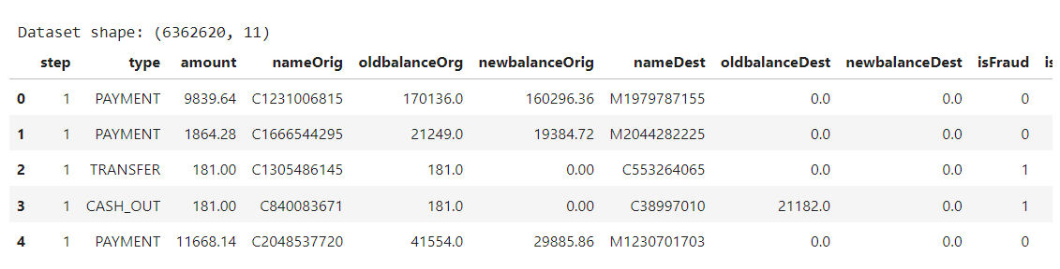
Figure 1: Dataset Loading and Customer Profile Shape

3.2 Experimental Setup
Table 1: Software and libraries used
Item | Description
Programming language | Python
Notebook environment | Jupyter Notebook / Kaggle or Colab environment
Data libraries | pandas, numpy, cuDF
Machine learning libraries | scikit-learn, cuML, XGBoost
Visualization libraries | matplotlib, seaborn
Hardware acceleration | GPU was used for cuML K-Means where available

3.3 Dataset Description
The dataset contains mobile money transaction information. The raw transaction data was transformed into customer-level data. The final customer dataset contained 6,353,307 customer records and 25 columns. Some important variables include transaction count, average transaction amount, total transaction amount, maximum transaction amount, balance values, balance changes, cash-flow ratios, and transaction type ratios.

3.4 Data Preprocessing and Feature Engineering
The preprocessing stage handled missing values, infinite values, outliers, and scaling. Missing and infinite values were replaced to prevent model errors. Extreme outliers were treated using clipping at the 1st and 99th percentiles. This method was used instead of deleting outlier customers because unusual transaction behaviour can still contain useful information for credit risk analysis.
The following customer-level features were engineered:
Table 2: Examples of engineered customer features
Feature group | Example features | Purpose
Transaction activity | transaction_count, type_ratio_PAYMENT, type_ratio_TRANSFER | Measures how active the customer is.
Transaction amount | avg_transaction_amount, total_transaction_amount, max_transaction_amount | Measures the size of customer transactions.
Balance behaviour | avg_oldbalance_org, avg_newbalance_orig, max_oldbalance_org | Measures wallet stability and financial capacity.
Cash-flow behaviour | avg_cash_flow_ratio, max_cash_flow_ratio | Measures pressure between transaction amounts and balances.
Log features | avg_log_amount, avg_log_cash_flow_ratio | Reduces the effect of highly skewed values.

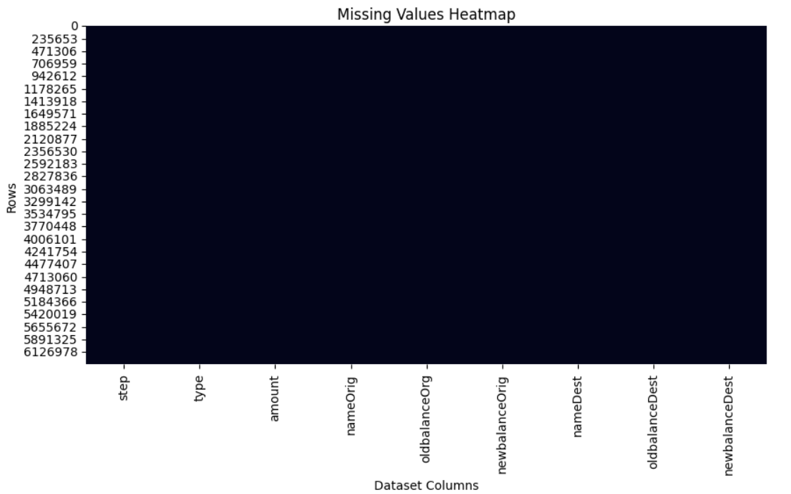
Figure 2: Missing Values Heatmap
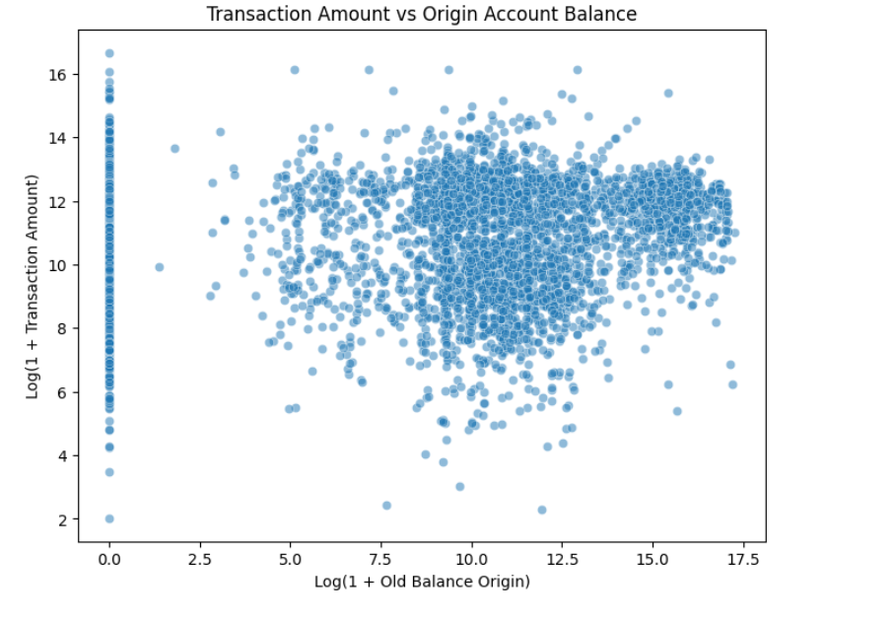
Figure 3: Transaction Amount Distribution or Boxplot

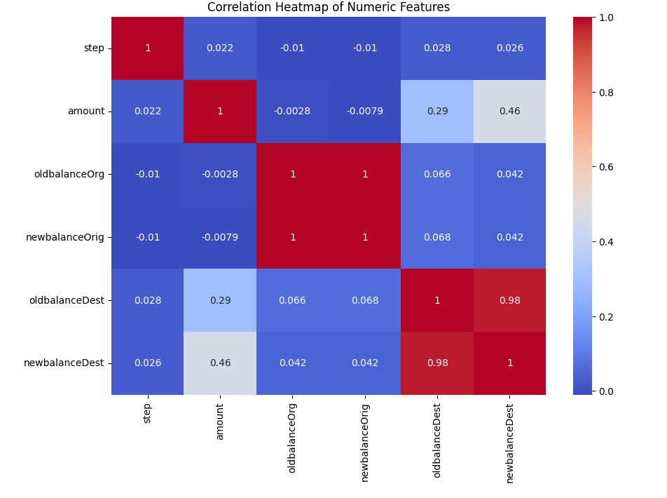
Figure 4: Correlation Heatmap

3.5 Clustering Methodology
The unsupervised learning section used a 50,000-record sample from the full dataset. This sample was used because the full dataset has more than 6.3 million records, and some algorithms such as Gaussian Mixture Model and Agglomerative Clustering are slow on very large data. Using the same sample for all clustering methods made the comparison fair.
The clustering methods were K-Means, Gaussian Mixture Model, and Agglomerative Clustering. K-Means was run using GPU support through cuML. Gaussian Mixture Model and Agglomerative Clustering were run using CPU-based scikit-learn. PCA was used only for visualization, not for training.
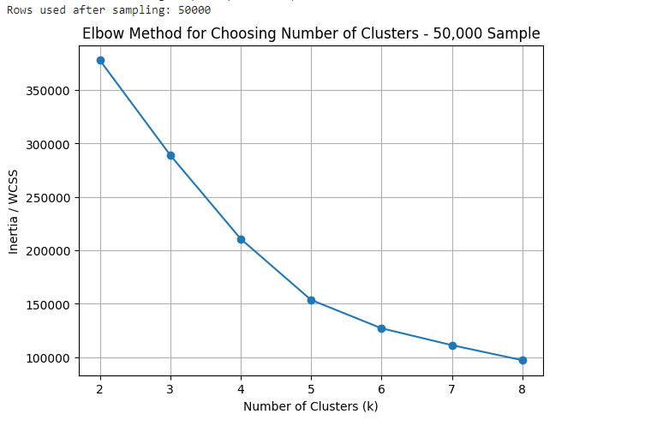
Figure 5: Elbow Method for Choosing Number of Clusters

3.6 Supervised Learning Methodology
For supervised learning, the target variable for classification was is_eligible. The target variable for regression was eligible_loan_amount. The data was split into 70% training and 30% testing. Several classification and regression models were trained and compared.
Because the original dataset did not contain real loan repayment or default labels, the targets were created using financial rules. This is important because the model may learn the same rules used to create the target. Therefore, the results were interpreted carefully.

3.7 Data Leakage Control
The first classification results were too high, which suggested possible data leakage. To reduce leakage, features directly related to the generated target were removed. These included cluster, risk_group_encoded, avg_log_cash_flow_ratio, avg_cash_flow_ratio, and max_cash_flow_ratio. Correlation analysis was also used to identify features that had a very strong relationship with the target.
This step improved the scientific quality of the project because it made the model less likely to cheat by using features that already contained the answer.

CHAPTER FOUR: IMPLEMENTATION AND RESULTS

4.1 Exploratory Data Analysis
EDA was used to understand the structure of the data before modelling. The missing value graphs helped to check data quality. The distribution and boxplot graphs showed that financial transaction values were skewed and contained outliers. The correlation heatmap showed relationships between transaction amount, balance behaviour, and cash-flow features.
These graphs supported the decision to clean missing values, clip extreme outliers, and scale the features before clustering and modelling.

4.2 Clustering Results
The clustering models were compared on the same 50,000-record sample. The results showed that K-Means had the highest Silhouette Score and the best overall clustering performance on this run. It also had the advantage of GPU support, making it more practical for large mobile money data.
Table 3: Clustering model results on 50,000 sample
Method | Silhouette Score | Calinski-Harabasz Score | Davies-Bouldin Score | Comment
K-Means (GPU) | 0.5625 | 18233.99 | 1.1162 | Best overall result and most scalable.
Agglomerative Clustering (CPU) | 0.4657 | 16232.29 | 1.2391 | Good result but slower and memory-heavy.
Gaussian Mixture Model (CPU) | 0.3511 | 10011.83 | 1.6639 | Weakest clustering result in this run.
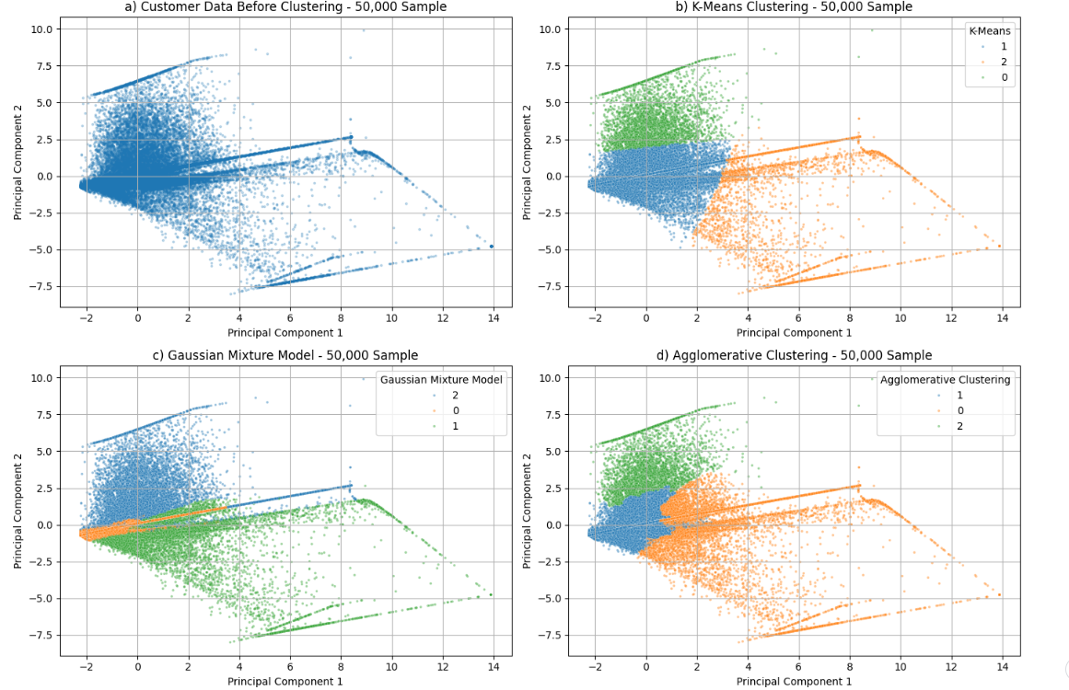
Figure 6: PCA-Based Visual Comparison of Clustering Methods
The PCA plots reduce the customer behaviour features into two dimensions so that the clusters can be viewed visually. Clearer separation means the method created more meaningful groups. The plots should be explained together with the metric table, because PCA is only a visualization tool.

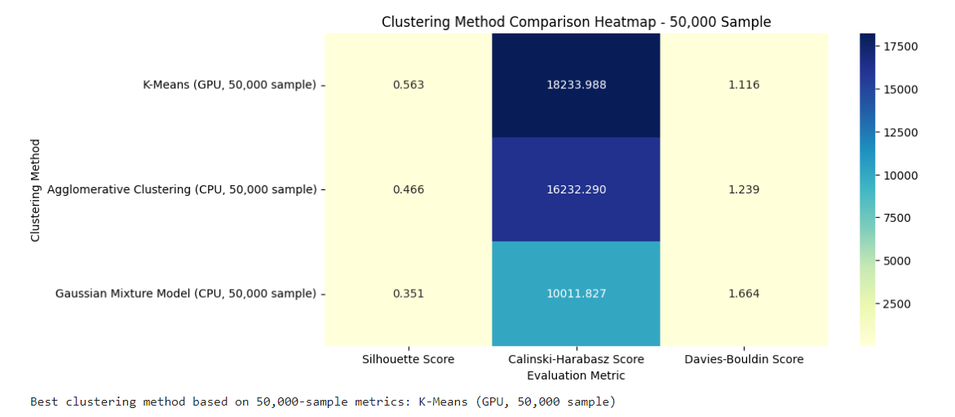
Figure 7: Clustering Method Comparison Heatmap
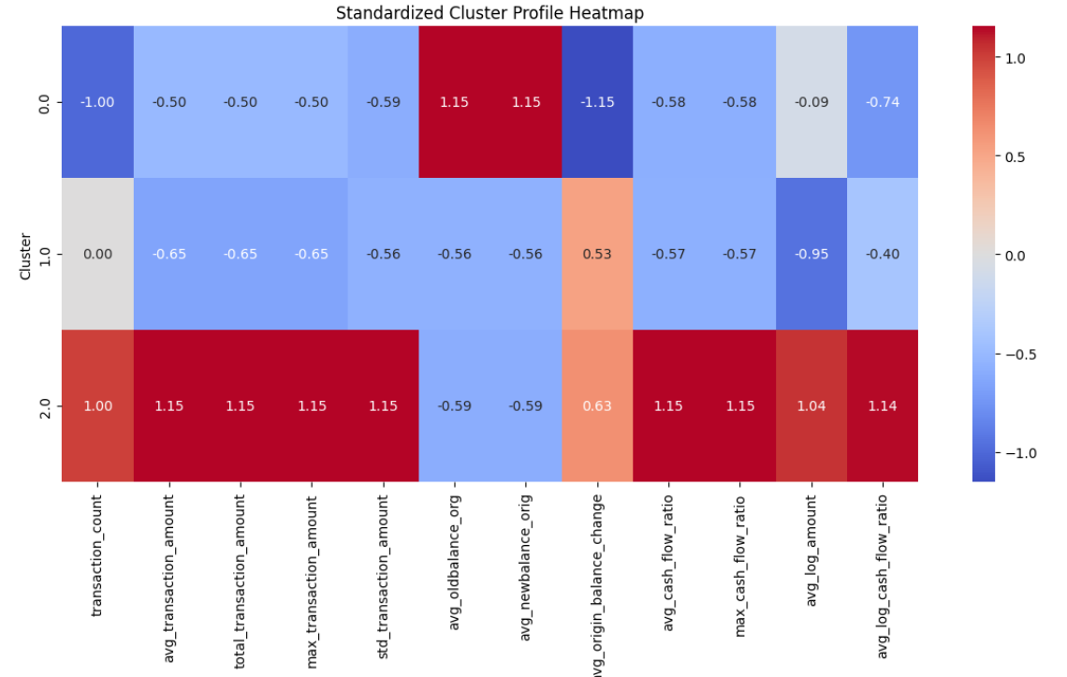
Figure 8: Standardized Cluster Profile Heatmap

4.3 Classification Results
Classification was used to predict loan eligibility. After removing leakage features, six models were compared. Random Forest performed best with the highest F1 Score and ROC-AUC. However, the high results must be interpreted carefully because the target was generated from rules instead of real loan repayment records.
Table 4: Classification model results
Model | Accuracy | Precision | Recall | F1 Score | ROC-AUC
Random Forest | 0.9960 | 0.9972 | 0.9974 | 0.9973 | 0.9999
Gradient Boosting | 0.9925 | 0.9953 | 0.9945 | 0.9949 | 0.9992
Decision Tree | 0.9619 | 0.9636 | 0.9852 | 0.9743 | 0.9912
K-Nearest Neighbors | 0.9385 | 0.9420 | 0.9761 | 0.9587 | 0.9526
Support Vector Machine | 0.8498 | 0.8495 | 0.9661 | 0.9041 | 0.8996
Logistic Regression | 0.8134 | 0.8449 | 0.9128 | 0.8776 | 0.8723

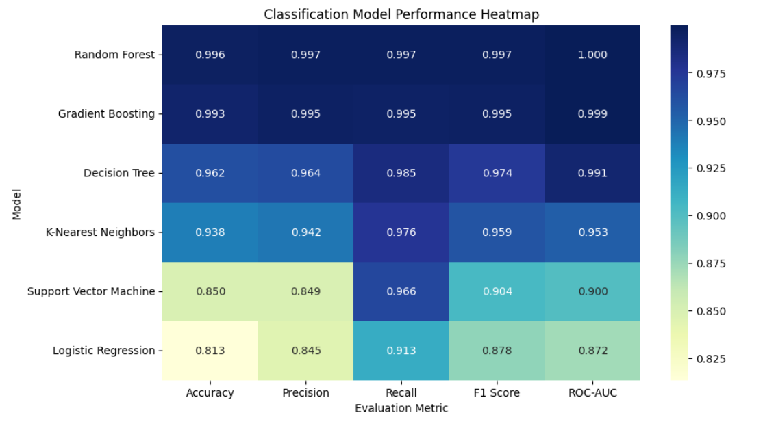
Figure 9: Classification Model Performance Heatmap
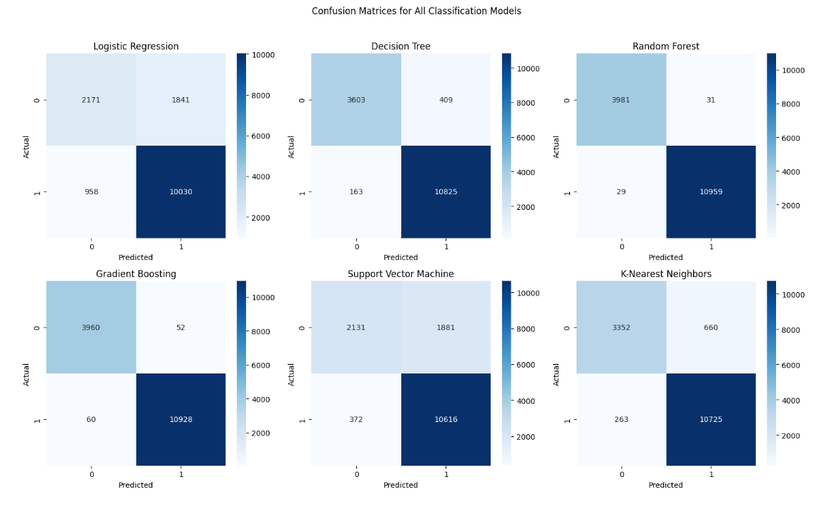
Figure 10: Confusion Matrix for Random Forest

4.4 Cross-Validation Results
Five-fold cross-validation was used on the 50,000-record sample to check whether the classification models were stable. Random Forest again gave the highest mean F1 Score. The small standard deviation shows that performance was stable across folds. Still, because the target was rule-generated, the result should be treated as internal validation and not as proof of real-world repayment prediction.
Table 5: Five-fold cross-validation F1 results
Model | Mean CV F1 | Std CV F1
Random Forest | 0.9978 | 0.0003
Gradient Boosting | 0.9951 | 0.0005
Decision Tree | 0.9700 | 0.0039
K-Nearest Neighbors | 0.9579 | 0.0013
Support Vector Machine | 0.9047 | 0.0027
Logistic Regression | 0.8736 | 0.0037

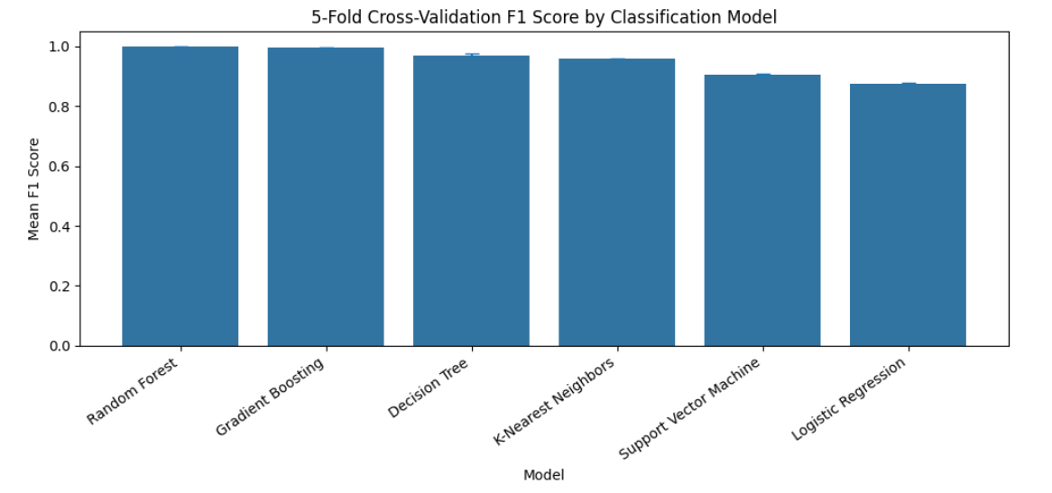
Figure 11: 5-Fold Cross-Validation F1 Score Bar Chart

4.5 Regression Results
Regression was used to estimate the eligible loan amount for customers predicted as eligible. Random Forest Regressor performed best with the lowest MAE and RMSE and the highest R-squared value. However, the high R-squared value is expected because the loan amount target was generated using financial rules from the same dataset. Therefore, this should be explained as a rule-learning result, not as real-world proof.
Table 6: Regression model results
Model | MAE | RMSE | R2 Score
Random Forest Regressor | 126.38 | 868.98 | 0.99997
Gradient Boosting Regressor | 568.41 | 1414.18 | 0.99993
Decision Tree Regressor | 2977.80 | 4777.80 | 0.99915
KNN Regressor | 2162.57 | 12918.95 | 0.99379
Ridge Regression | 34135.85 | 59437.79 | 0.86854
Linear Regression | 34165.81 | 59477.38 | 0.86836
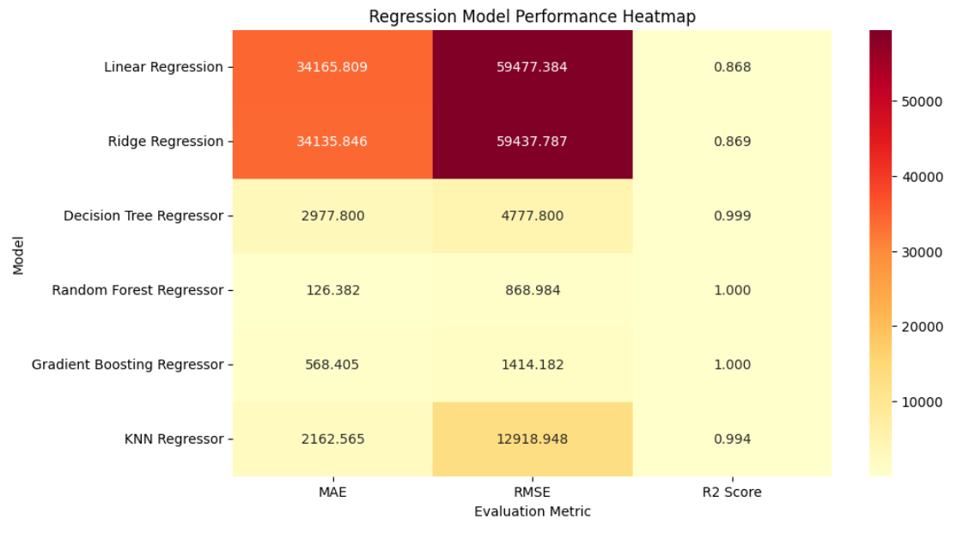
Figure 12: Regression Model Performance Heatmap
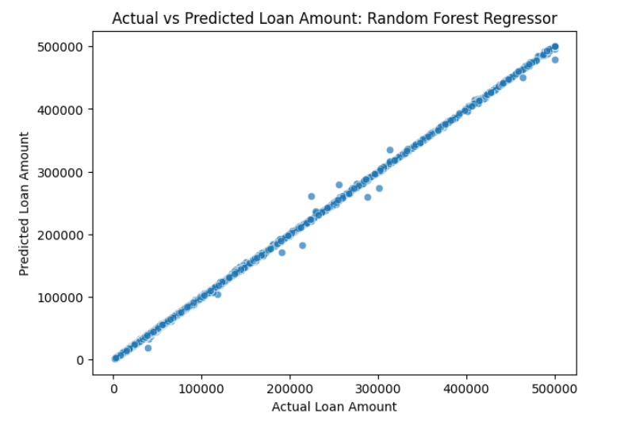
Figure 13: Actual vs Predicted Loan Amount

4.6 Feature Importance
Feature importance was used to understand which variables influenced the Random Forest classification model. The most important features included maximum old balance, average old balance, origin balance change, and total transaction amount. This means that wallet balance behaviour and transaction volume were important for predicting eligibility.
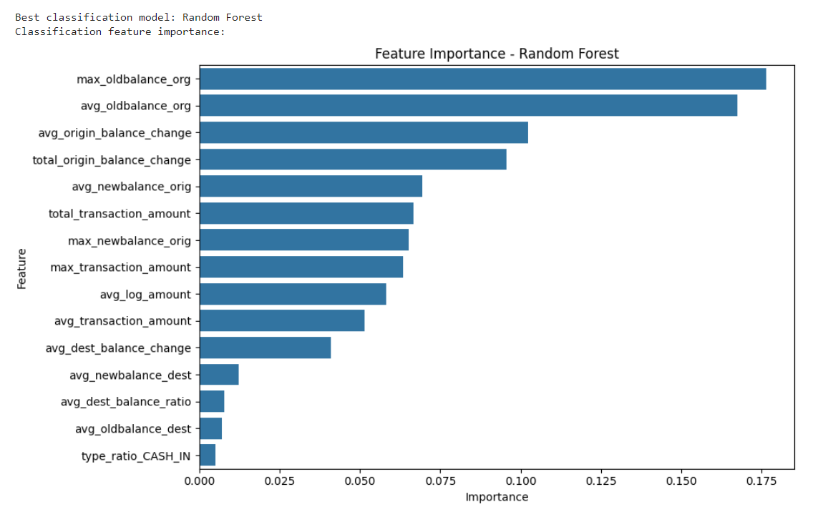
Figure 14: Feature Importance for Random Forest Classifier

CHAPTER FIVE: DISCUSSION

5.1 Interpretation of Clusters
The clustering stage grouped customers based on transaction behaviour. Customers with more stable balances and stronger transaction activity can be interpreted as lower risk, while customers with unstable cash-flow behaviour and weak transaction activity can be interpreted as higher risk. The exact names of the clusters depend on the profile heatmap, so the report should label each cluster after checking the mean values in the cluster profile.
K-Means was selected as the best practical clustering method because it gave the best metric result and can run faster on GPU. Although Agglomerative Clustering is useful, it is not suitable for the full 6.3 million-record dataset because it requires a lot of memory.

5.2 Interpretation of Classification Results
Random Forest was the best loan eligibility model. It performed better than Logistic Regression, SVM, KNN, Decision Tree, and Gradient Boosting in the test set and in cross-validation. This is because Random Forest can learn non-linear relationships and reduce overfitting by combining many decision trees.
However, the very high score should not be overclaimed. Since the eligibility target was generated from rules, the model learned patterns close to those rules. This is acceptable for an academic demonstration, but real loan repayment labels are needed before using the model in a real financial system.

5.3 Interpretation of Regression Results
Random Forest Regressor was the best model for loan amount prediction. It had the lowest error and the highest R-squared value. The result shows that tree-based ensemble models can model financial rules well. However, the loan amount was also generated using a formula, so the high R-squared value is expected. This should be explained clearly to avoid giving the impression that the model was tested on real loan outcomes.

5.4 How the Project Was Improved
The first version of the project had weaknesses such as possible data leakage, very high model scores without enough explanation, and limited discussion of the sampled clustering approach. The improved version addresses these weaknesses by explaining the 50,000 sample, removing leakage features from classification, adding cross-validation, describing every graph, and clearly stating that the supervised targets are academic rule-based targets.

CHAPTER SIX: LIMITATIONS, CONCLUSION AND FUTURE WORK

6.1 Limitations
- The dataset did not contain real loan repayment or default labels. Therefore, eligibility and loan amount were created using academic rules.
- The supervised model results are very high because the targets were generated from features in the dataset.
- The clustering comparison used a 50,000-record sample instead of the full 6.3 million records because some algorithms are computationally expensive.
- PCA plots show only two dimensions, so they cannot show all information in the original feature space.
- The model does not include important real-world credit variables such as income, employment status, age, savings history, previous loan repayment, or credit bureau data.
- The model was not tested on an external dataset, so generalization to real customers is unknown.

6.2 Ethical Considerations
Credit scoring systems can affect people financially. A wrong prediction can deny a good customer a loan or approve a risky customer. Therefore, such systems should be used carefully. In a real system, customer privacy, fairness, transparency, and human review should be considered. Customers should also be informed about how their data is used.

6.3 Future Work
- Use real loan repayment and default labels instead of rule-generated targets.
- Validate the model using an external dataset from a real mobile money provider.
- Apply fairness testing to check whether the model disadvantages some groups of customers.
- Use model explainability tools such as SHAP to explain individual predictions.
- Train K-Means on the full dataset for final customer segmentation while keeping sampling for comparison with slower algorithms.
- Add more customer information such as income, age, business type, repayment history, and savings behaviour.

6.4 Conclusion
This project developed a hybrid machine learning pipeline for mobile money loan eligibility and loan amount prediction. It used clustering to segment customers, classification to predict loan eligibility, and regression to estimate loan amounts. K-Means was the best clustering method on the 50,000 sample, Random Forest was the best classification model, and Random Forest Regressor was the best regression model.
The project shows that mobile money transaction behaviour can provide useful signals for digital credit analysis. However, because the supervised targets were rule-generated, the results should be interpreted as an academic proof-of-concept. To make the system stronger for real-world use, future work should use real loan repayment data and external validation.

REFERENCES
AIMind. (2023). Unlocking nonlinear data with polynomial kernels: The SVM secret. Retrieved from https://pub.aimind.so/unlocking-nonlinear-data-with-polynomial-kernels-the-svm-secret-61fac74074ae
Analytics Vidhya. (2021). Introduction to long short-term memory (LSTM). Retrieved from https://www.analyticsvidhya.com/blog/2021/03/introduction-to-long-short-term-memory-lstm/
Analytics Vidhya. (2024). Different types of attention mechanisms. Retrieved from https://www.analyticsvidhya.com/blog/2024/01/different-types-of-attention-mechanisms/
GeeksforGeeks. (2026). Machine learning tutorial. Retrieved from https://www.geeksforgeeks.org/machine-learning/machine-learning/
Group Q. (2026). Mobile money loan eligibility and loan amount prediction [Source code]. GitHub. Retrieved from https://github.com/TIMOTHY-ctrl/machine-earning--projects/
Machine Learning Mastery. (2022). Time series prediction with LSTM recurrent neural networks in Python with Keras. Retrieved from https://machinelearningmastery.com/time-series-prediction-lstm-recurrent-neural-networks-python-keras/
Machine Learning Mastery. (2023). An introduction to recurrent neural networks and the math that powers them. Retrieved from https://machinelearningmastery.com/an-introduction-to-recurrent-neural-networks-and-the-math-that-powers-them/

APPENDIX
