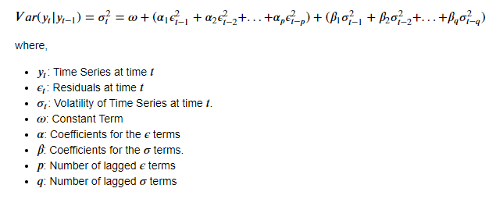

By *daily return,*we mean the relative change in the closing price of the stock from one day to the next. We define the daily return as the daily change in the *log* of the price, i.e.,



where *Pₜ*is the asset’s price on day*t.*Some might call this the daily *log return*, but we’ll refer to it just as the daily return.For small returns, this definition is approximately equal to the percent change in the price of the stock from one day to the next. The time-varying volatility of this daily return is the quantity we’d like to incorporate into our time-series forecasting models.

Mvarch modelise la volatilité du portefeuille