**Practical Activity 2**

**Based on Azure Cloud Disaster Recovery**



Name :Lamis Mohamed GabAllah

Email: [lamis.mohammed@womentechsters.org](mailto:lamis.mohammed@womentechsters.org)

Date: 29th May 2021

Assume that you are working as Azure cloud Information Security Officer in maintaining client’s data and servers running.

1. Deploy a windows server 2016 Gen 1 remotely on your machine from Azure cloud.

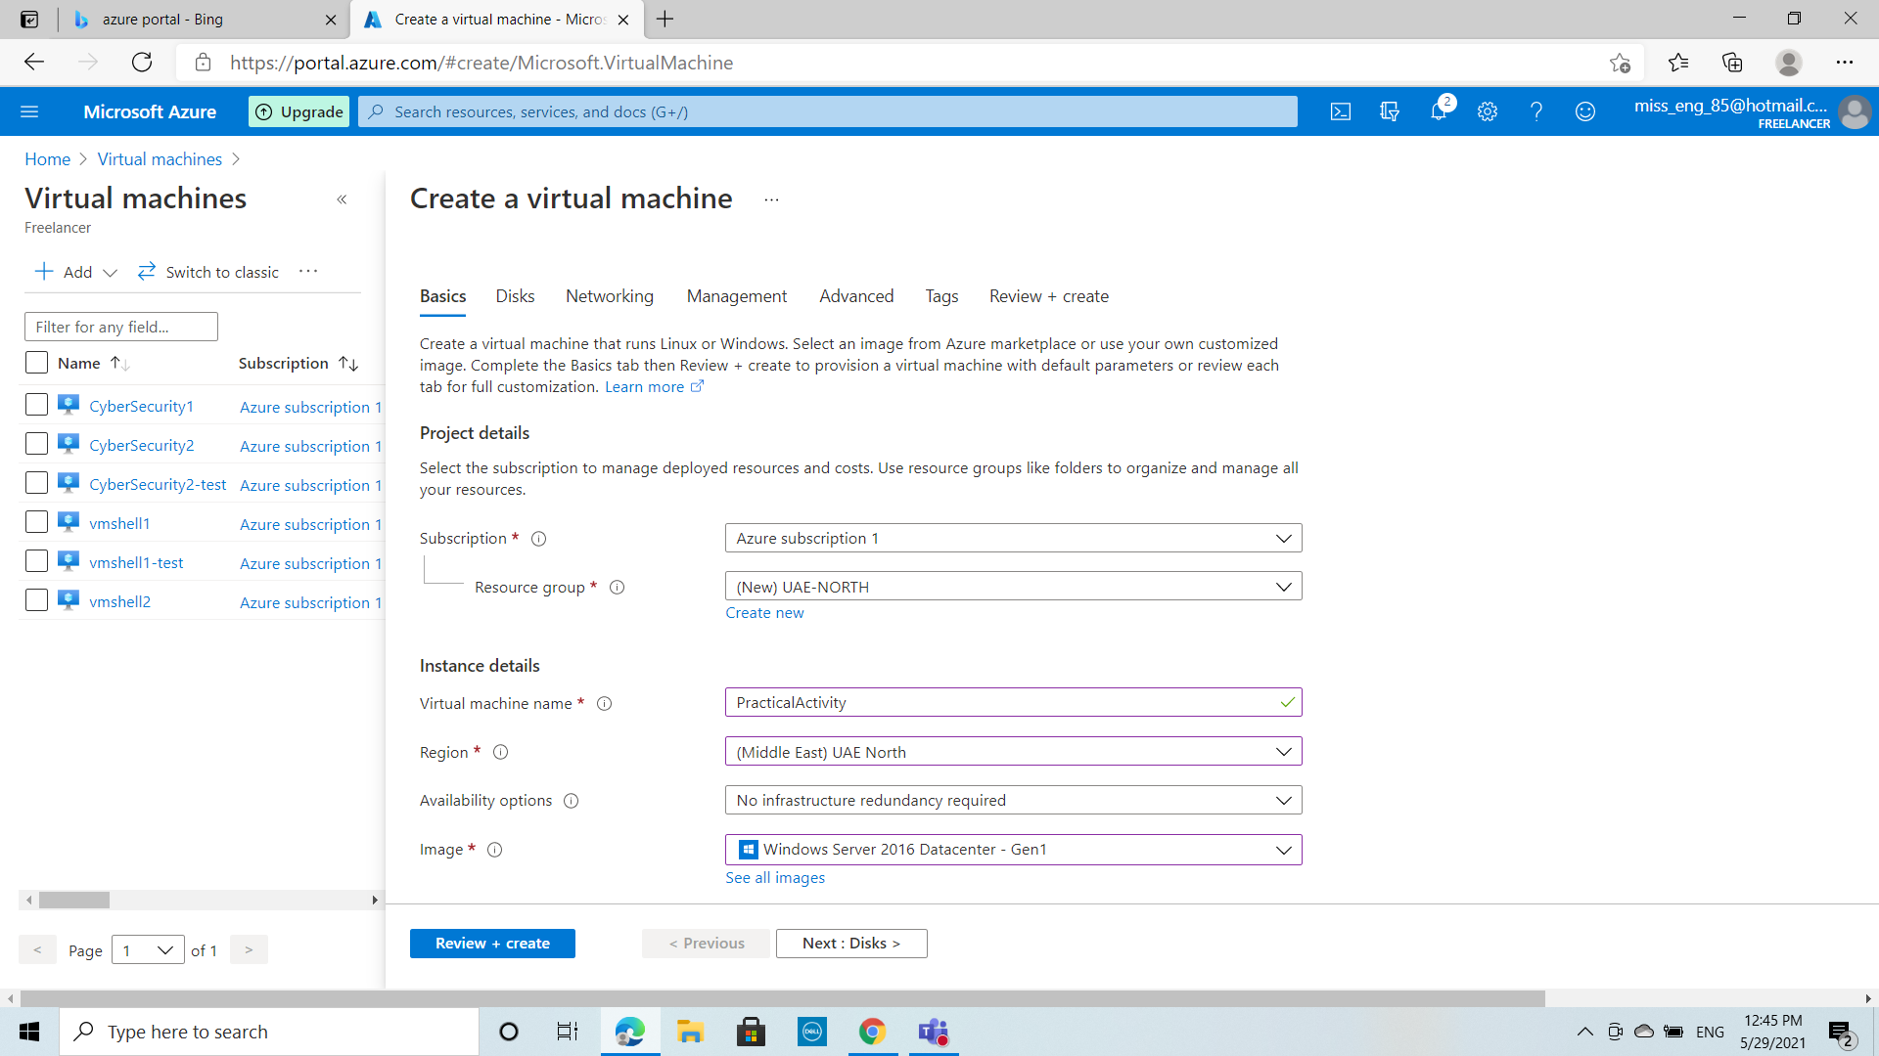

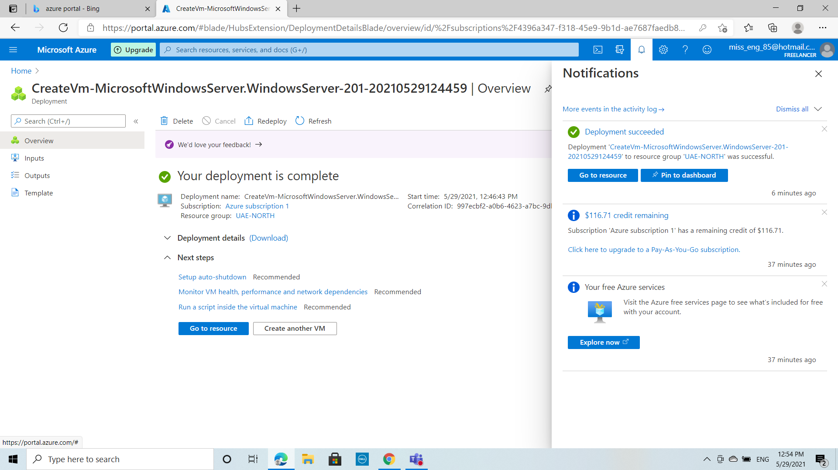

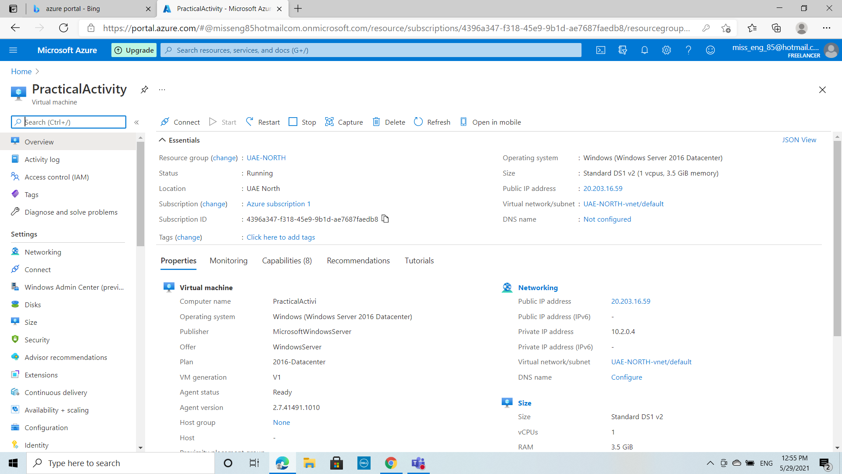

1. Install the windows feature- Web server management tools and confirm from your browser.

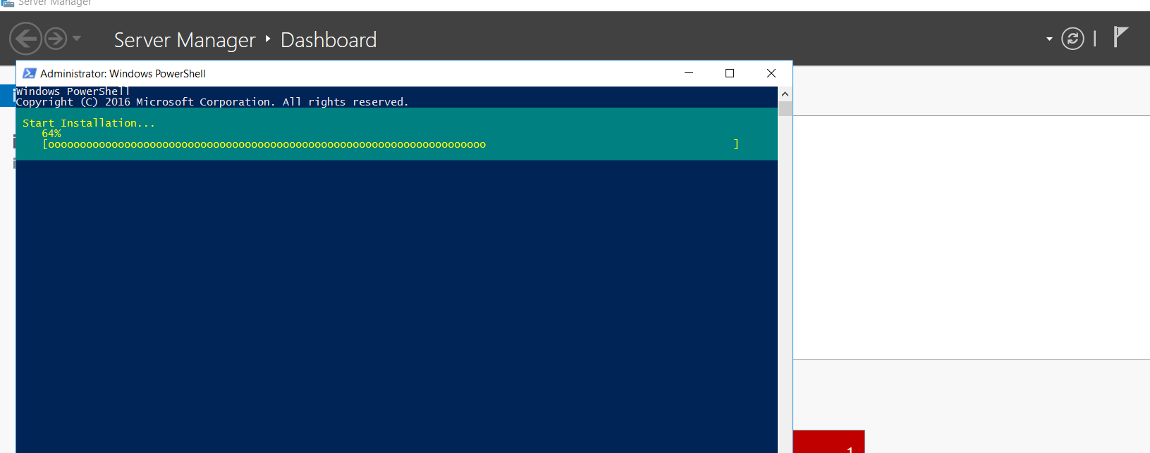

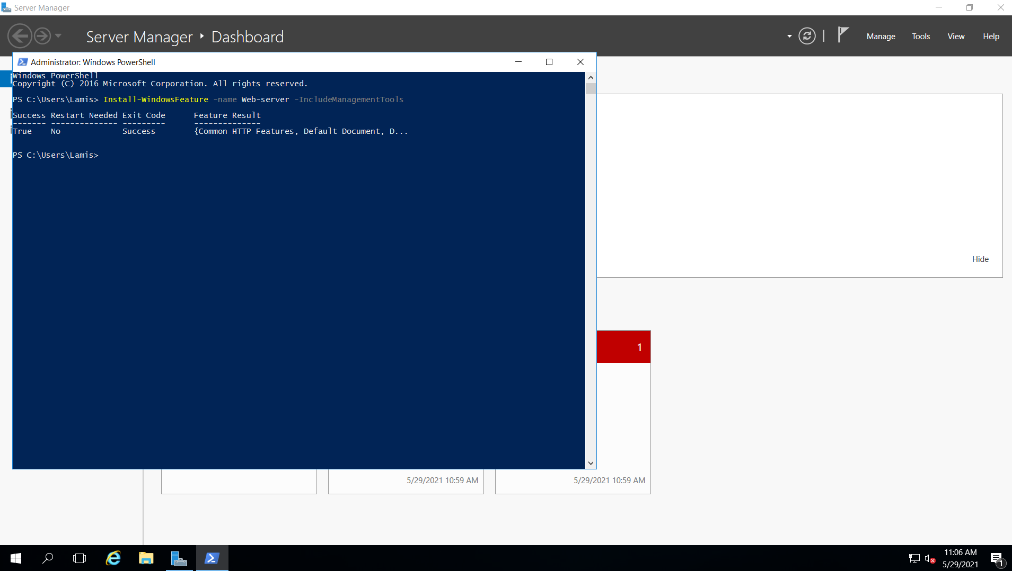

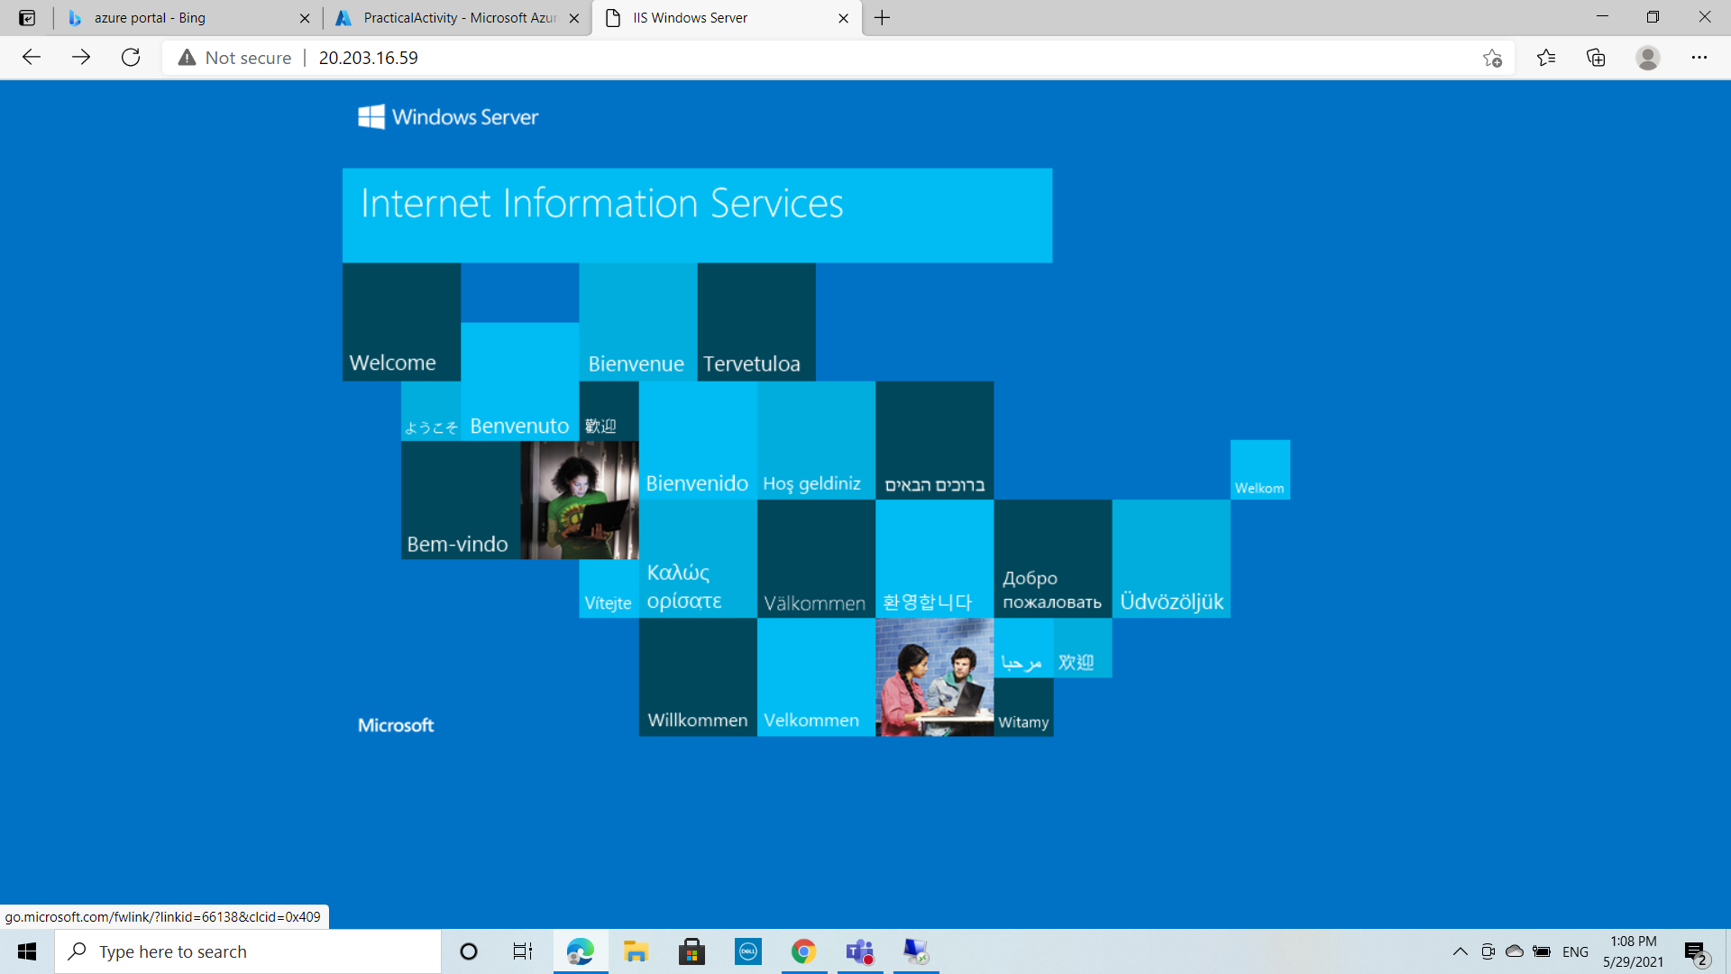

1. Create a Site Recovery Service Vault. Since your site will contain only one Windows Server just add the Windows server to Replicated Items in the Recovery Service Vault to be tracked.

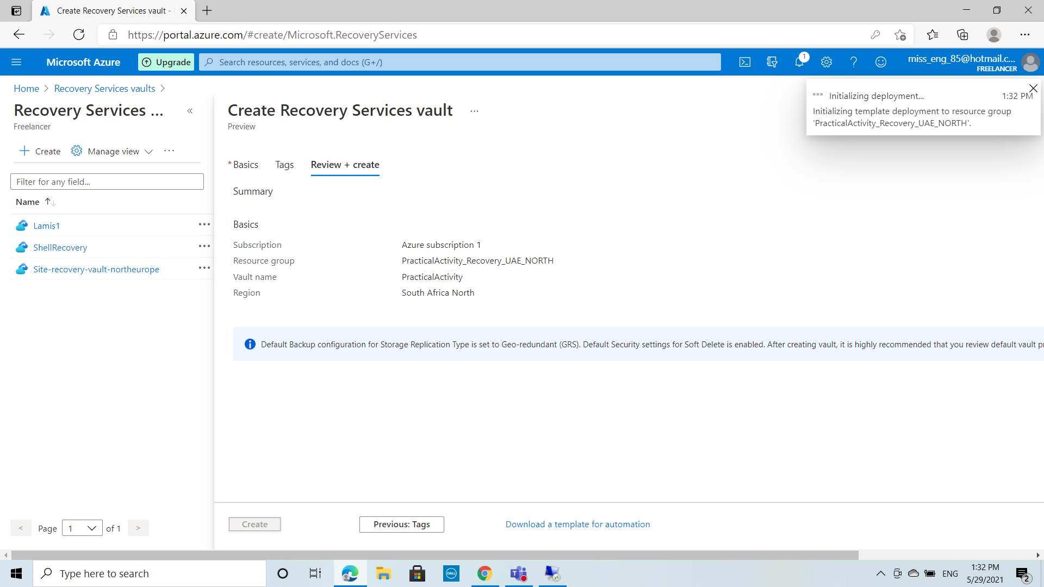

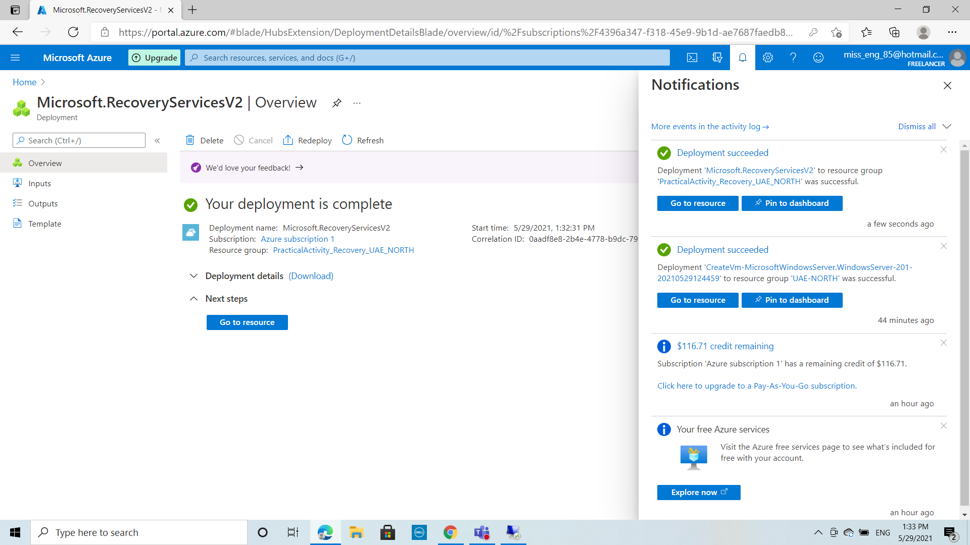

1. Stop the Windows server from Azure to Assume it’s ‘breakdown’

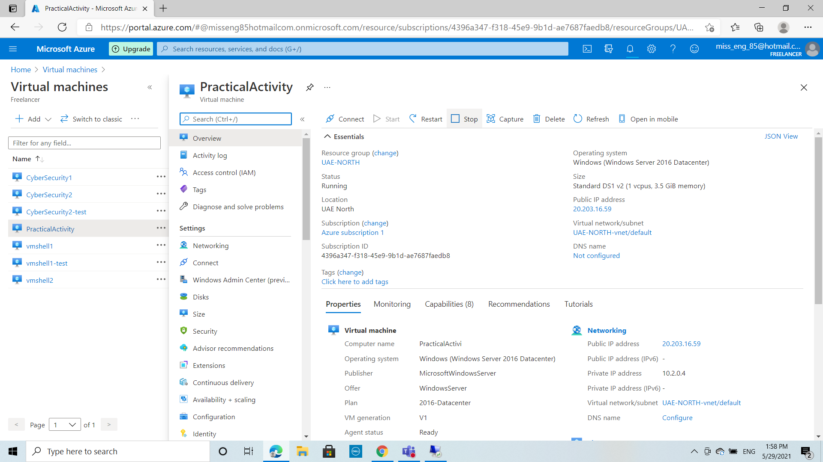

1. Then perform a Test Failover for the windows server.

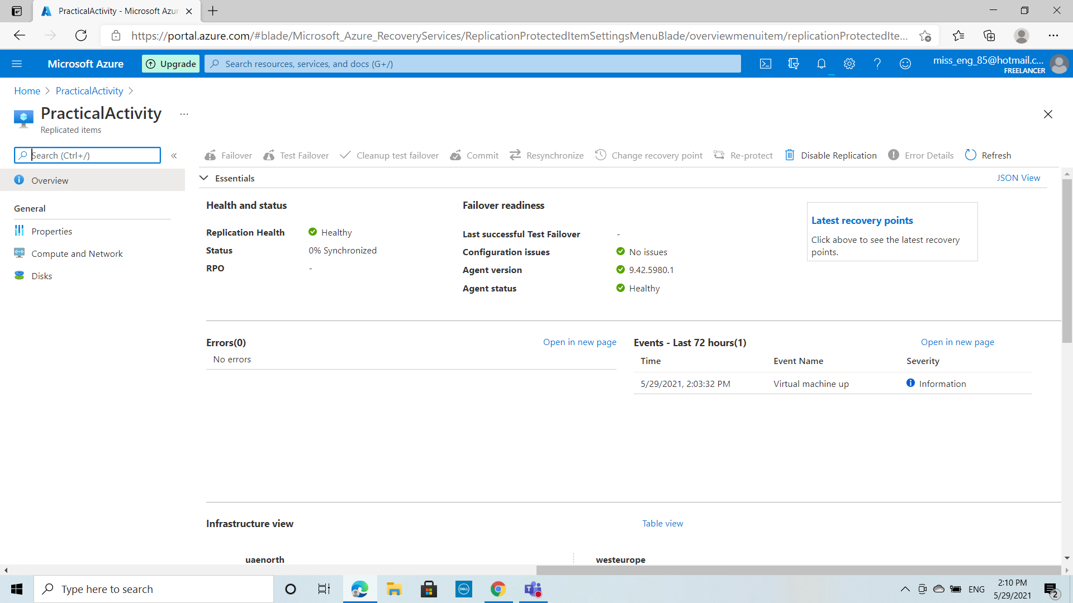

1. The test failover process should start.

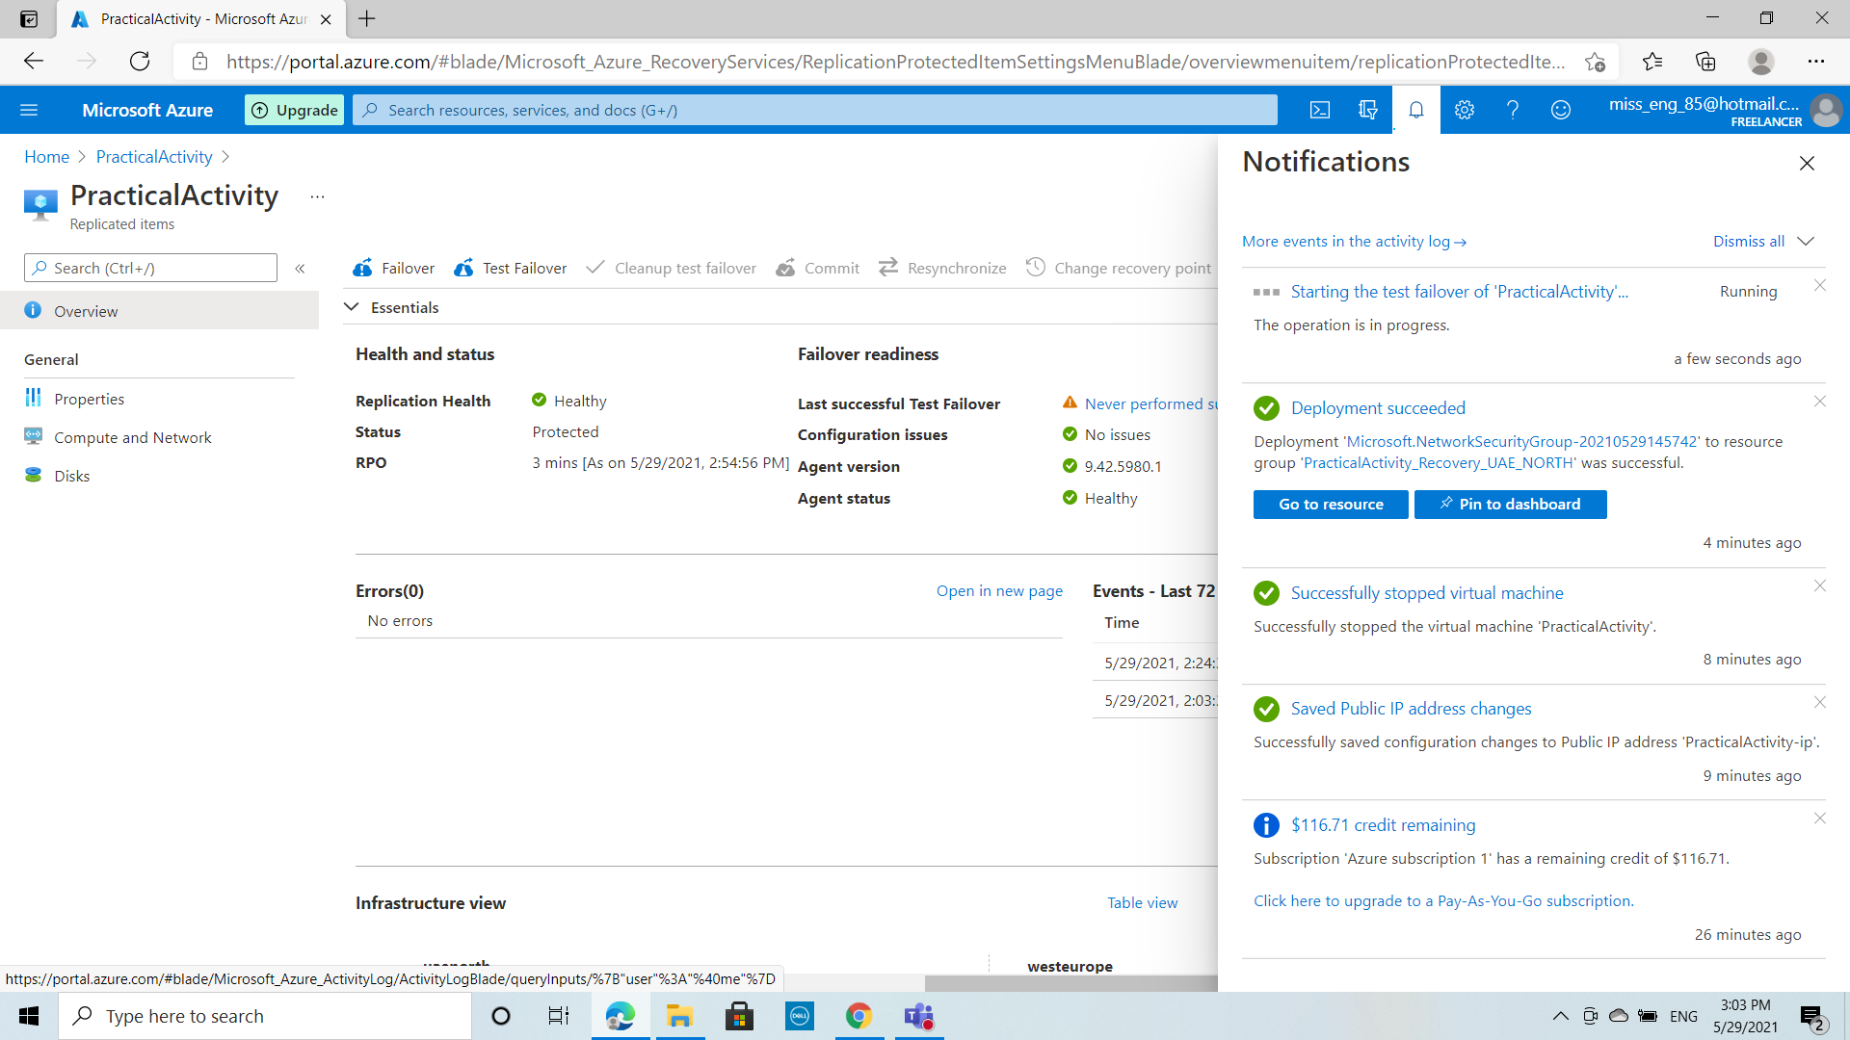

1. You should see a replicated copy of the windows server and run it, copy the public IP address and test it from your browser.

