[Sally.mukami@womentechsters.org](mailto:Sally.mukami@womentechsters.org)

1. Deploy a windows server 2016 Gen 1 remotely on your machine from Azure cloud.

Answer-I was able to successfully create a new virtual machine by going to the create resource group under virtual machines. The name of the Virtual machine is Server2016 and its under the Virtual_Practicals resource group.

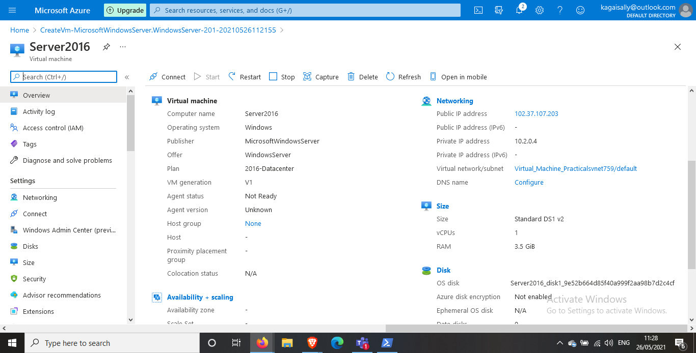

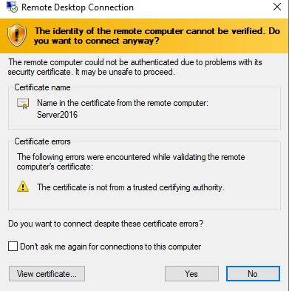

1. Install the Windows Feature – Web Server Management tools and confirm from your browser.

Answer- I have installed the Windows server management tools including the web server features and logged into te server from the web browser.

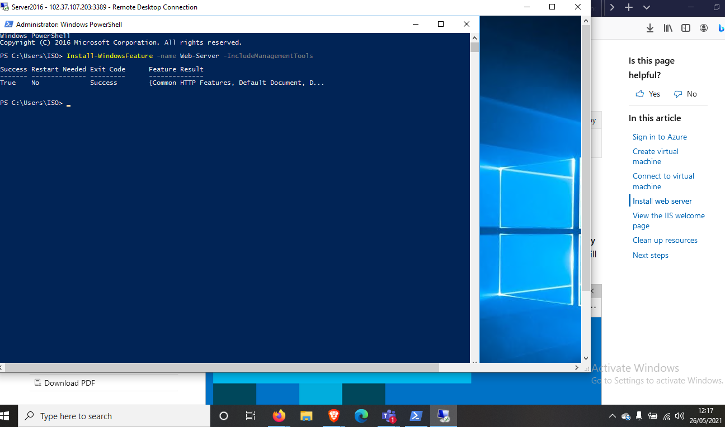

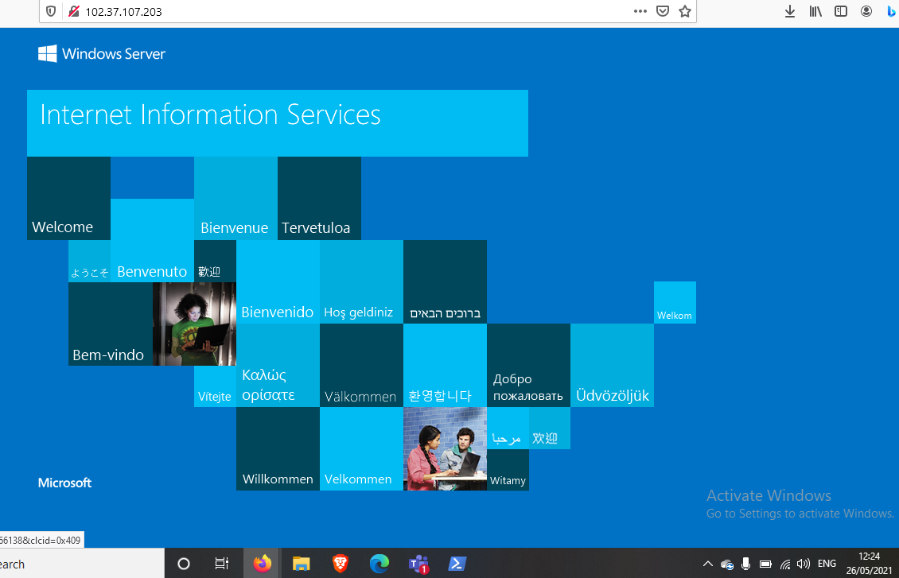

1. Create a Site Recovery Service Vault. Since your site will contain only one Windows Server just add the Windows server to Replicated Items in the Recovery Service Vault to be tracked.

Answer- The name of my service vault was demo-asr, I used the same vault as the one we used in class. The VM is located in South Africa and my target region for the replicated VM is North Europe.

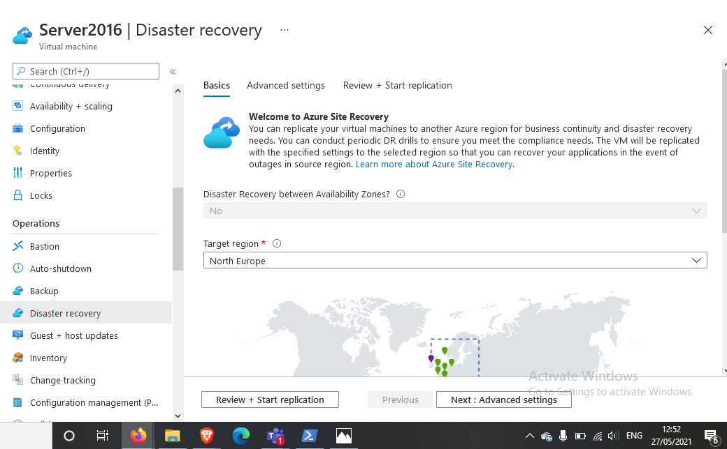

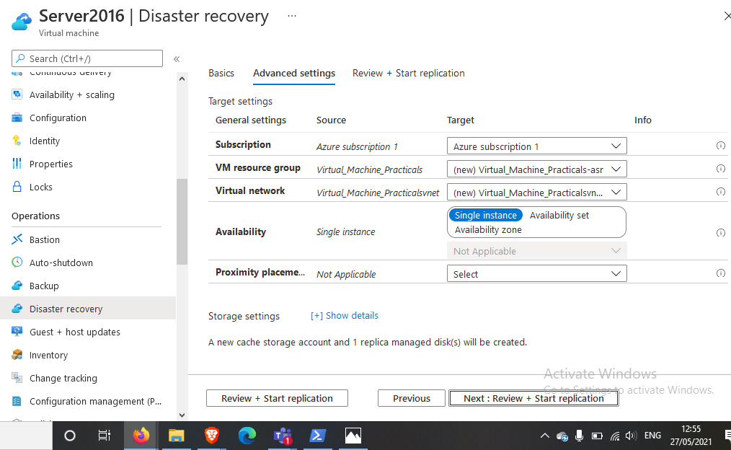

1. Stop the Windows server from Azure to Assume it’s ‘breakdown’

Answer- at the window server homepage I stopped the running VM and thus it gave me the warning sign as the platform assumed the VM is not configured properly.

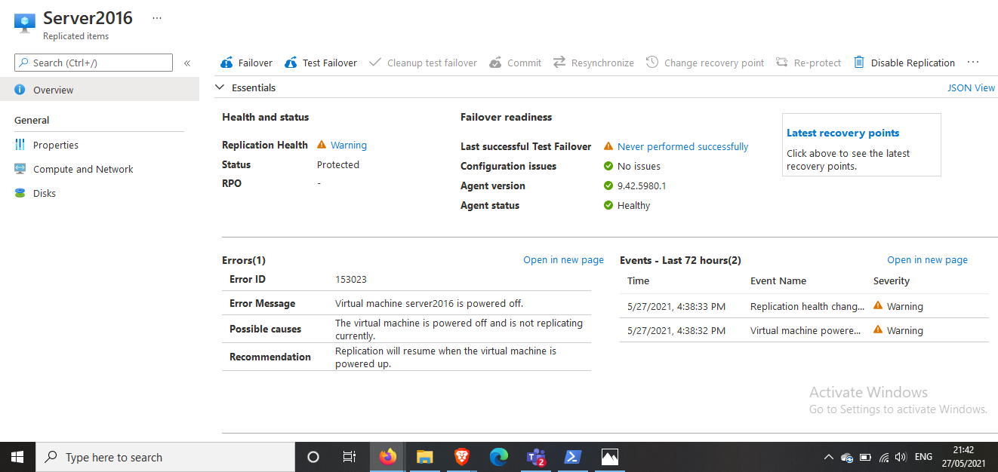

1. Then perform a Test Failover for the windows server.

Answer-I performed the test failover first before doing a full failover.

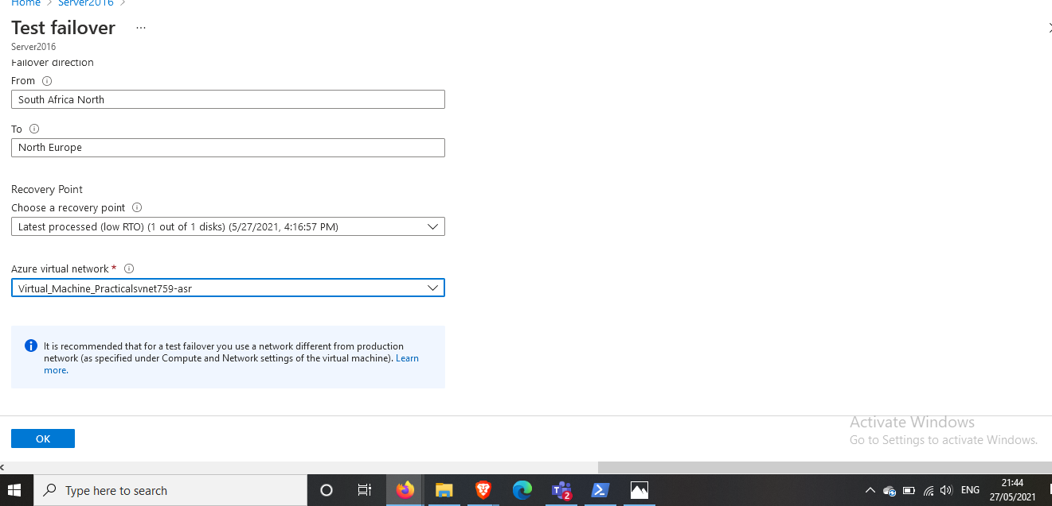

1. The test failover process should start.

Answer- The failover process started successfully and I was able to monitor the progress.

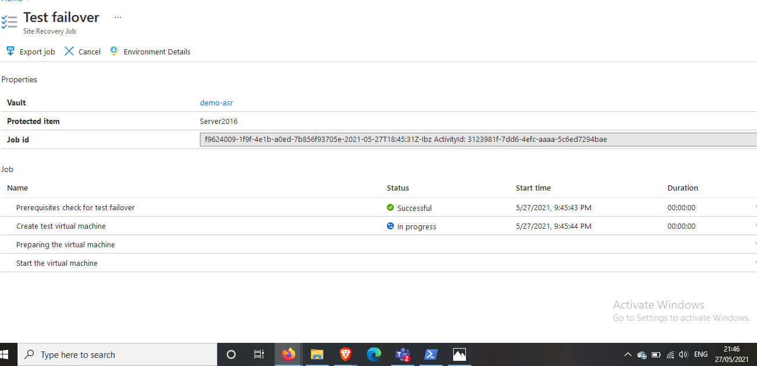

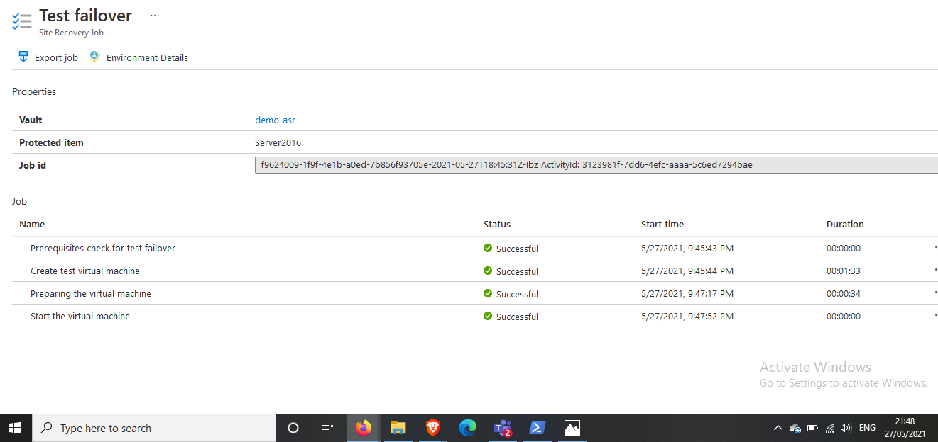

1. You should see a replicated copy of the windows server and run it, copy the public IP address and test it from your browser.

Answer- At the demo-asr vault I could access the replicated server, I further configured public ip address for the replicated VM and tried to log into it via my web browser. Each stage was a success.

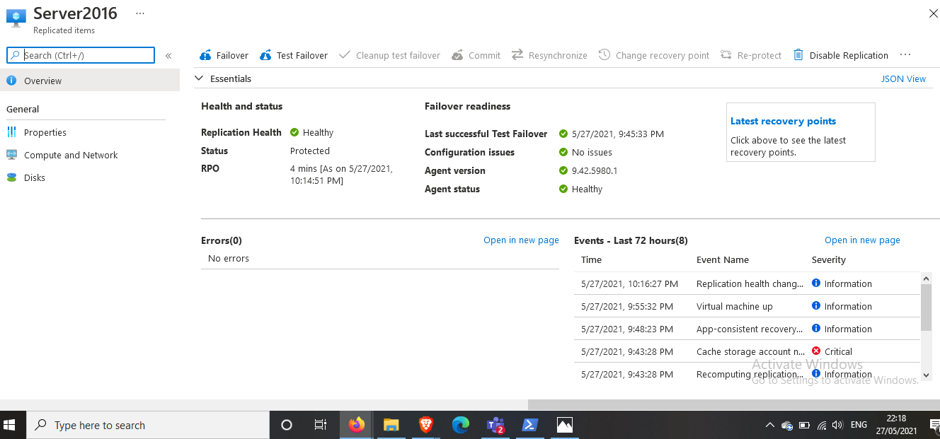

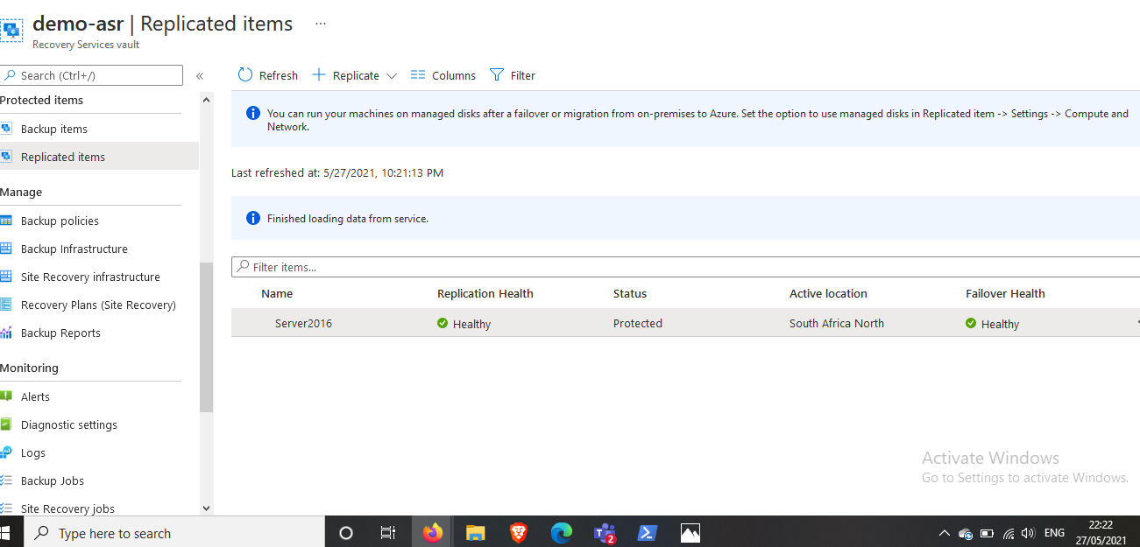

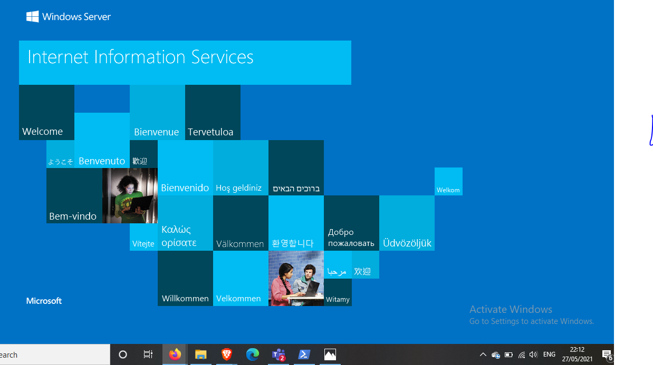

1. Make a clear documentation of this with clear explanations and attach screenshots of each step.