Practical Activity 2

Muniratu Linda Fianyeku

[Muniratu.linda@womentechsters.org](mailto:Muniratu.linda@womentechsters.org)

1. Deploy a windows server 2016 Gen 1 remotely on your machine from Azure cloud.

You first have to create a resource group if you don’t have one and then move on to create a virtual machine

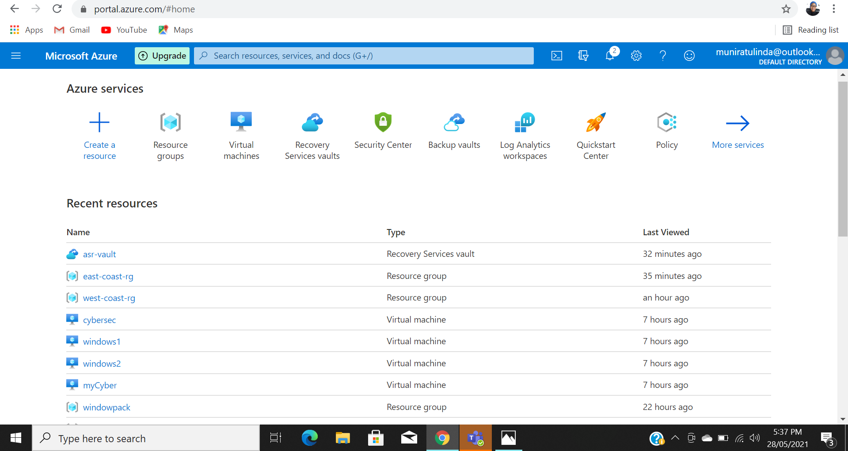

1. Select the virtual machine icon to navigate to the virtual machine creation page

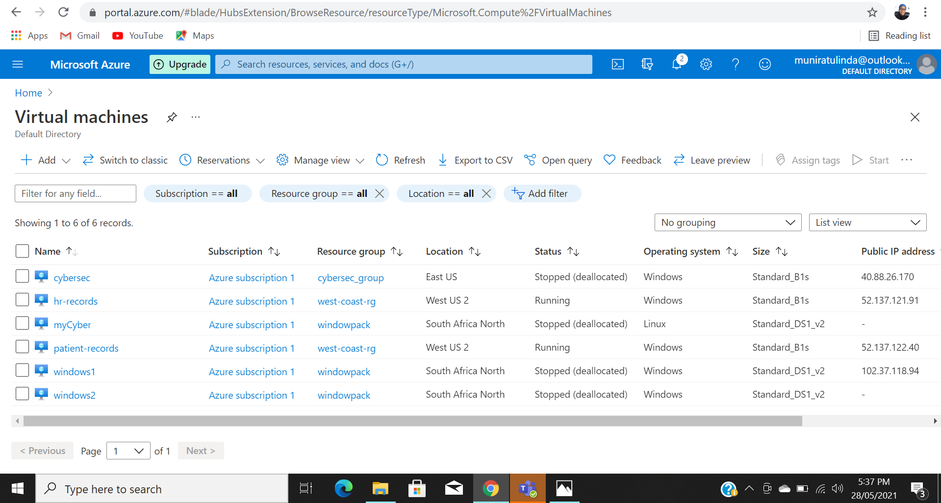

1. The add or create a new virtual machine using windows server 2016 Gen 1

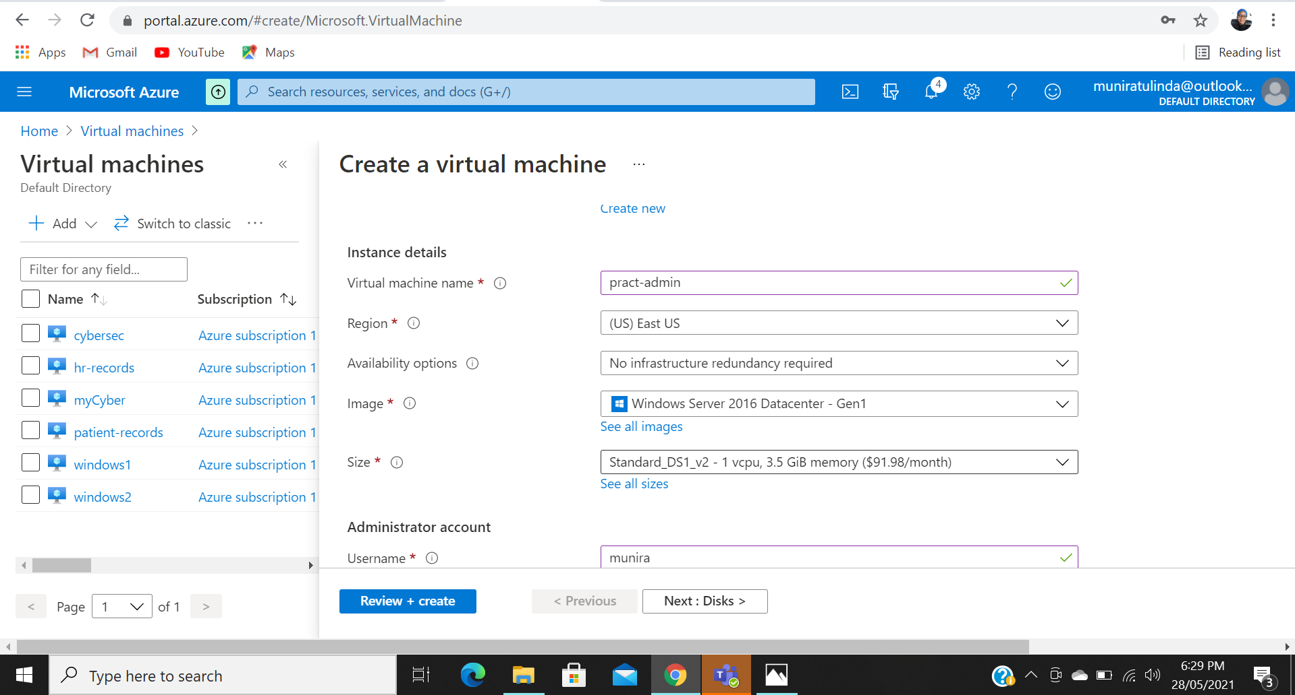

1. Set the following options and click on Review and create

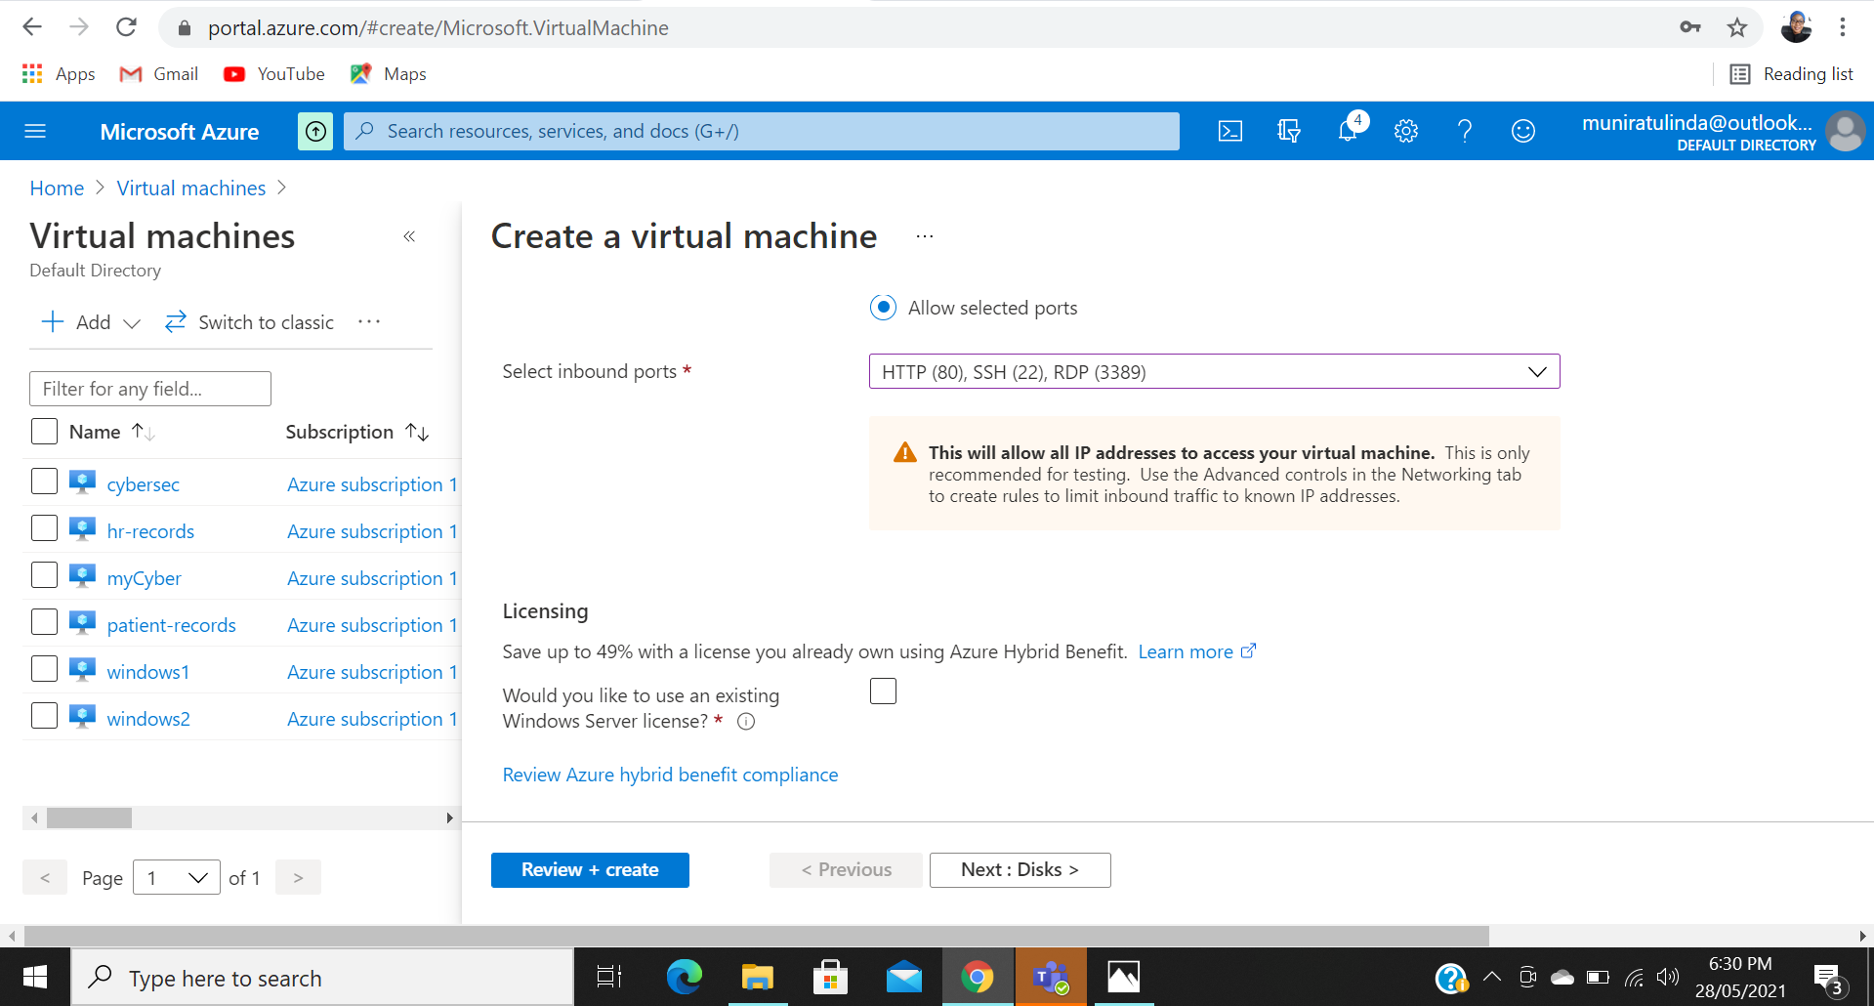

1. Wait for the Deployment notification to pop up

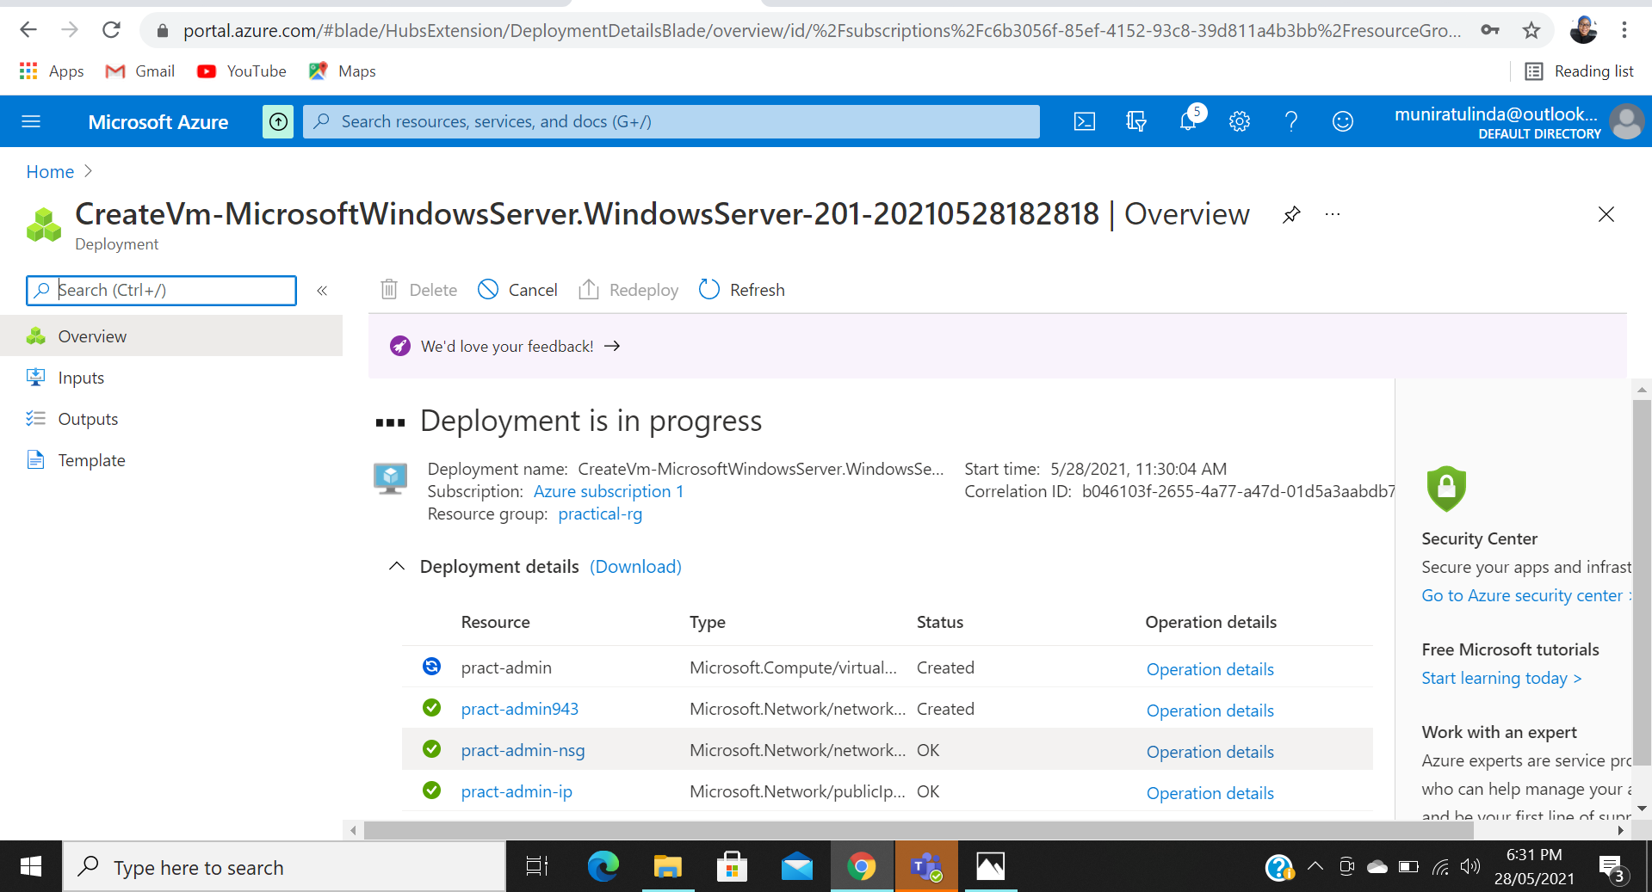

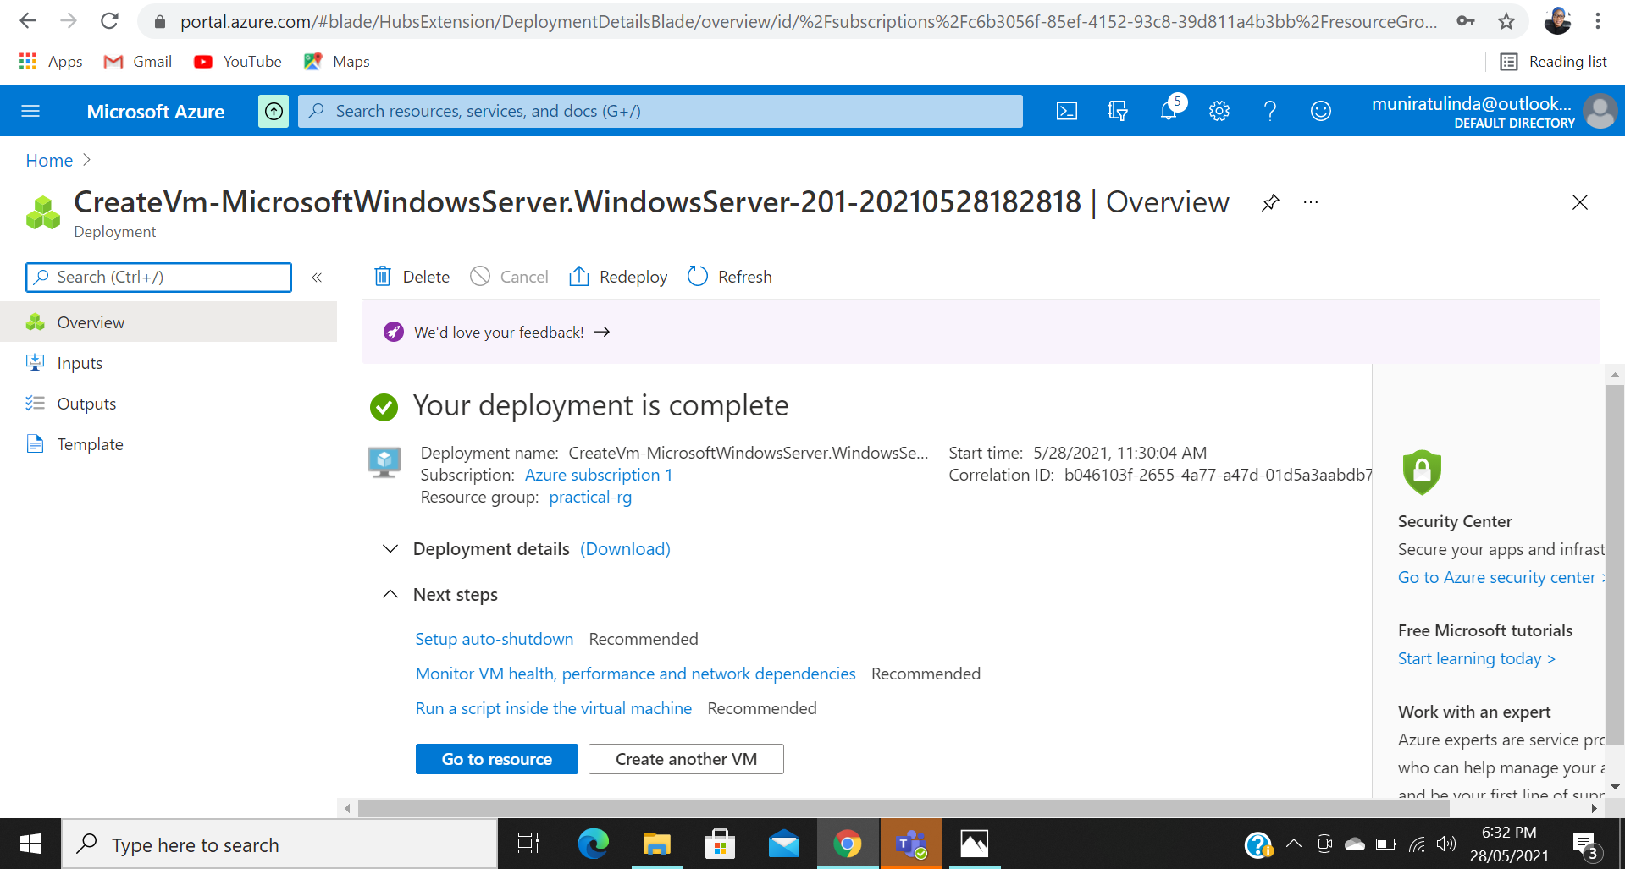

1. Virtual Machine has been created, so you click on Go to resource

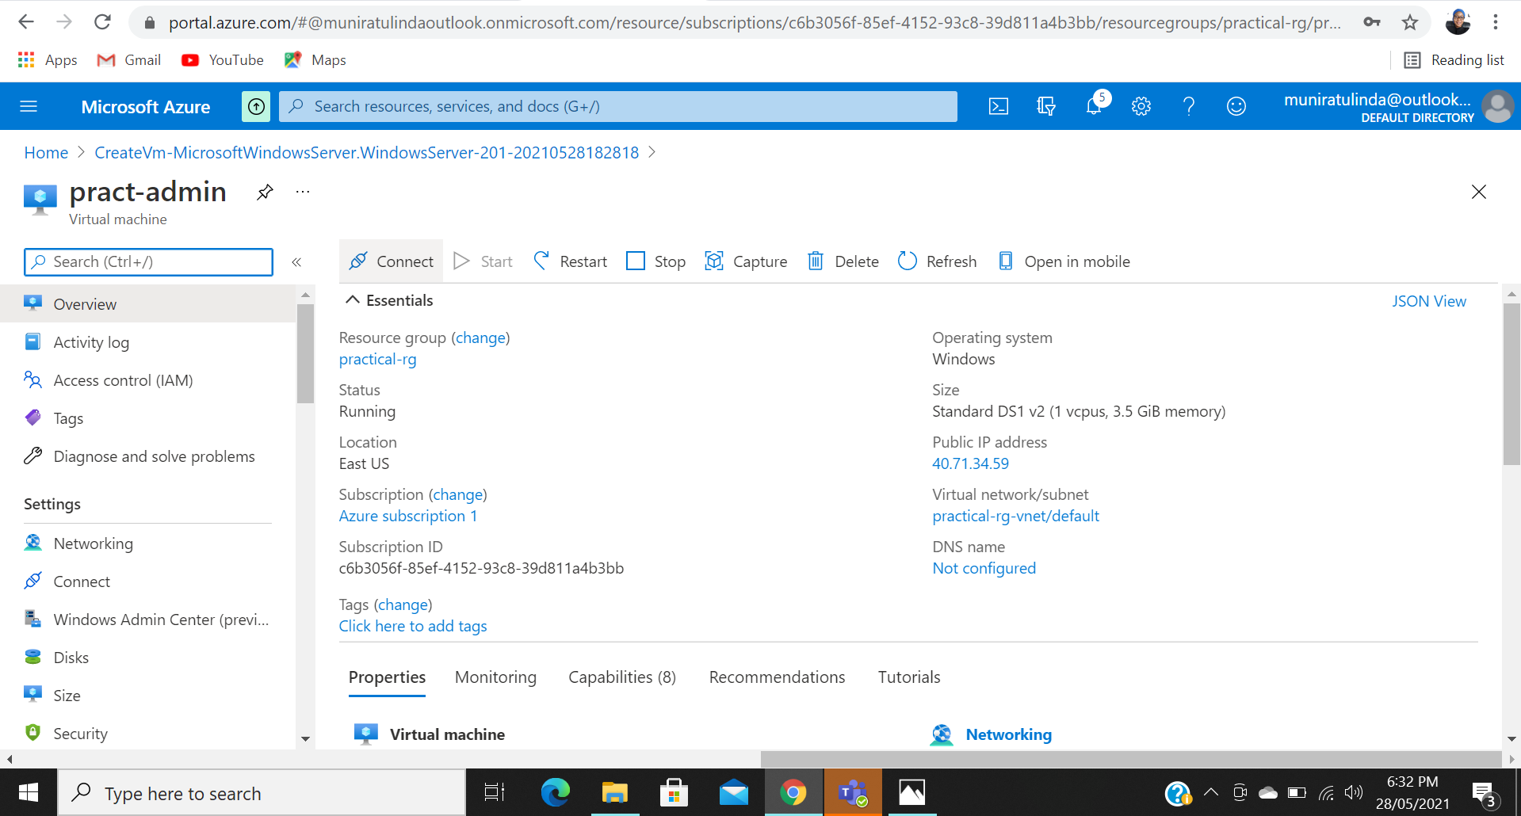

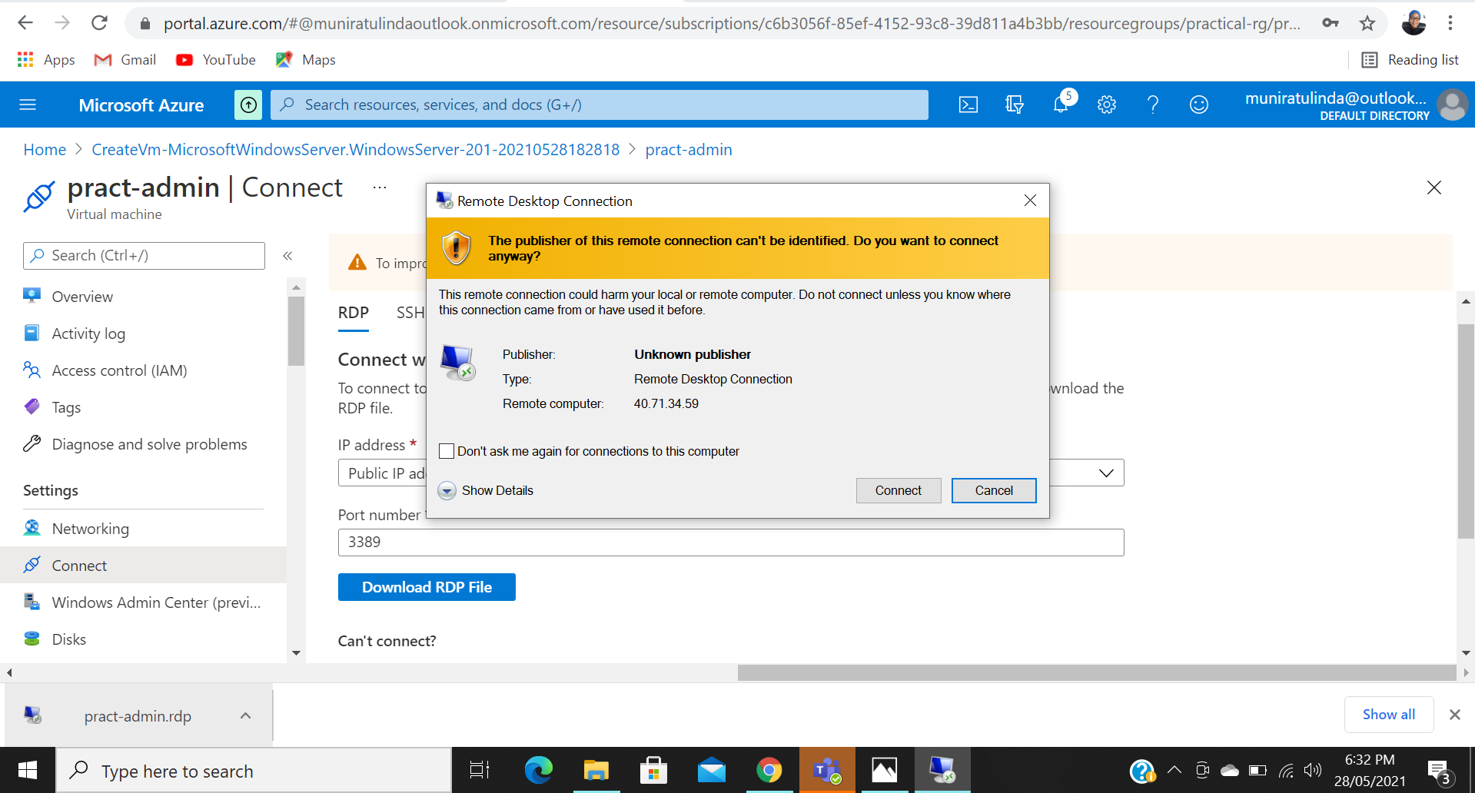

1. Create a Site Recovery Service Vault. Since your site will contain only one Windows Server just add the Windows server to Replicated Items in the Recovery Service Vault to be tracked.

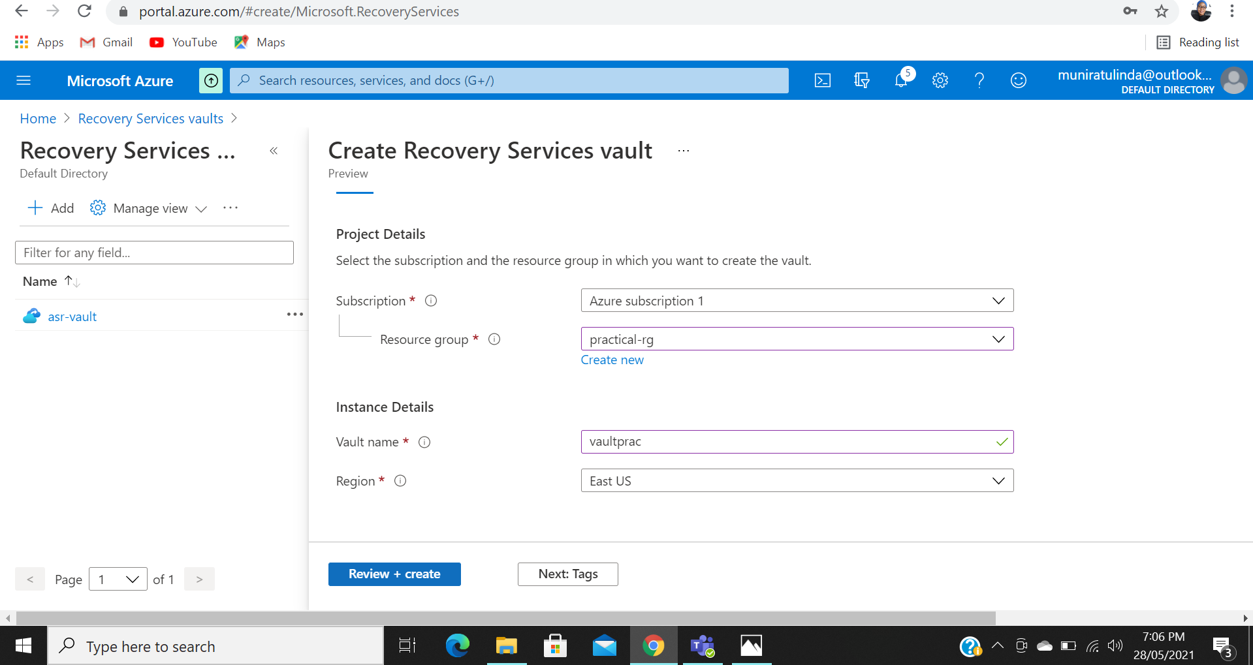

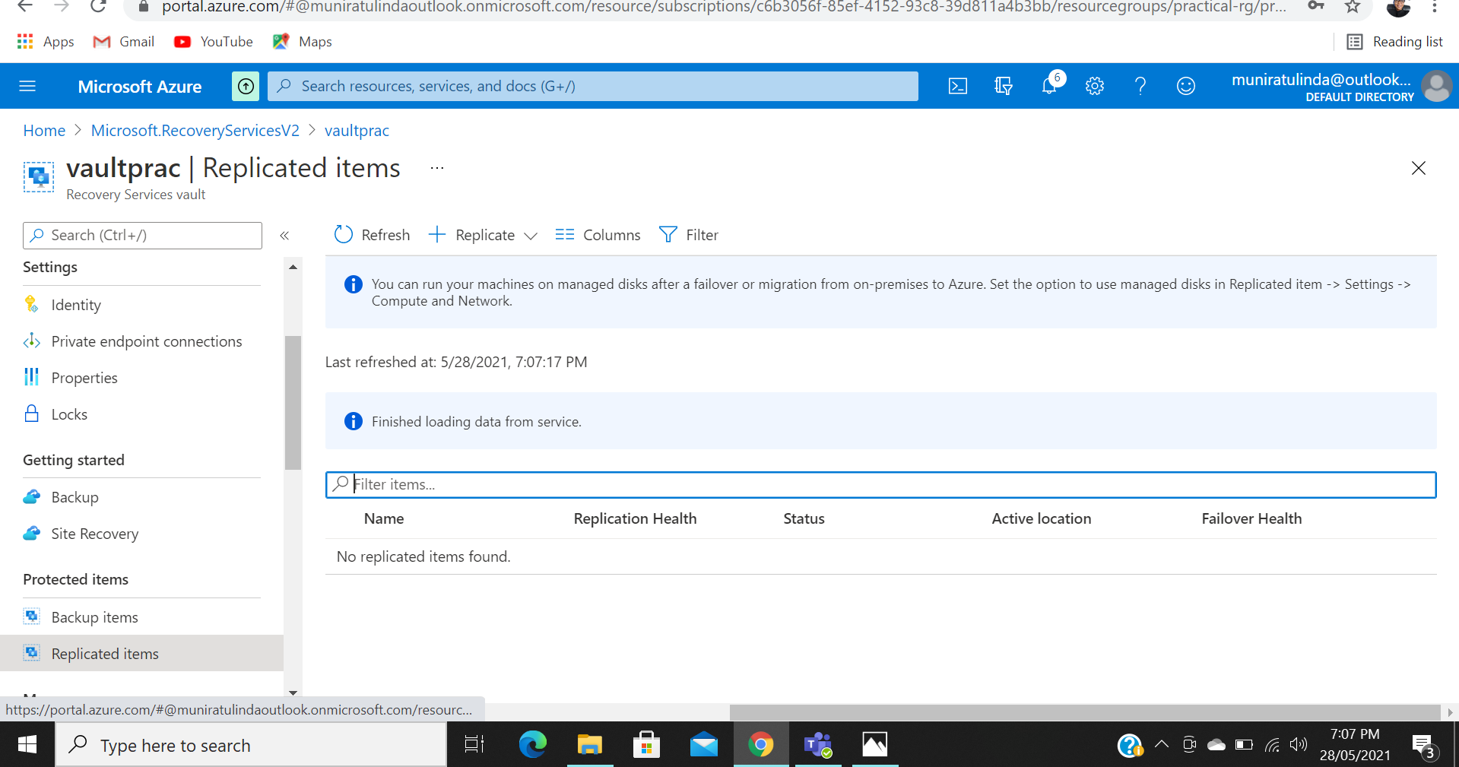

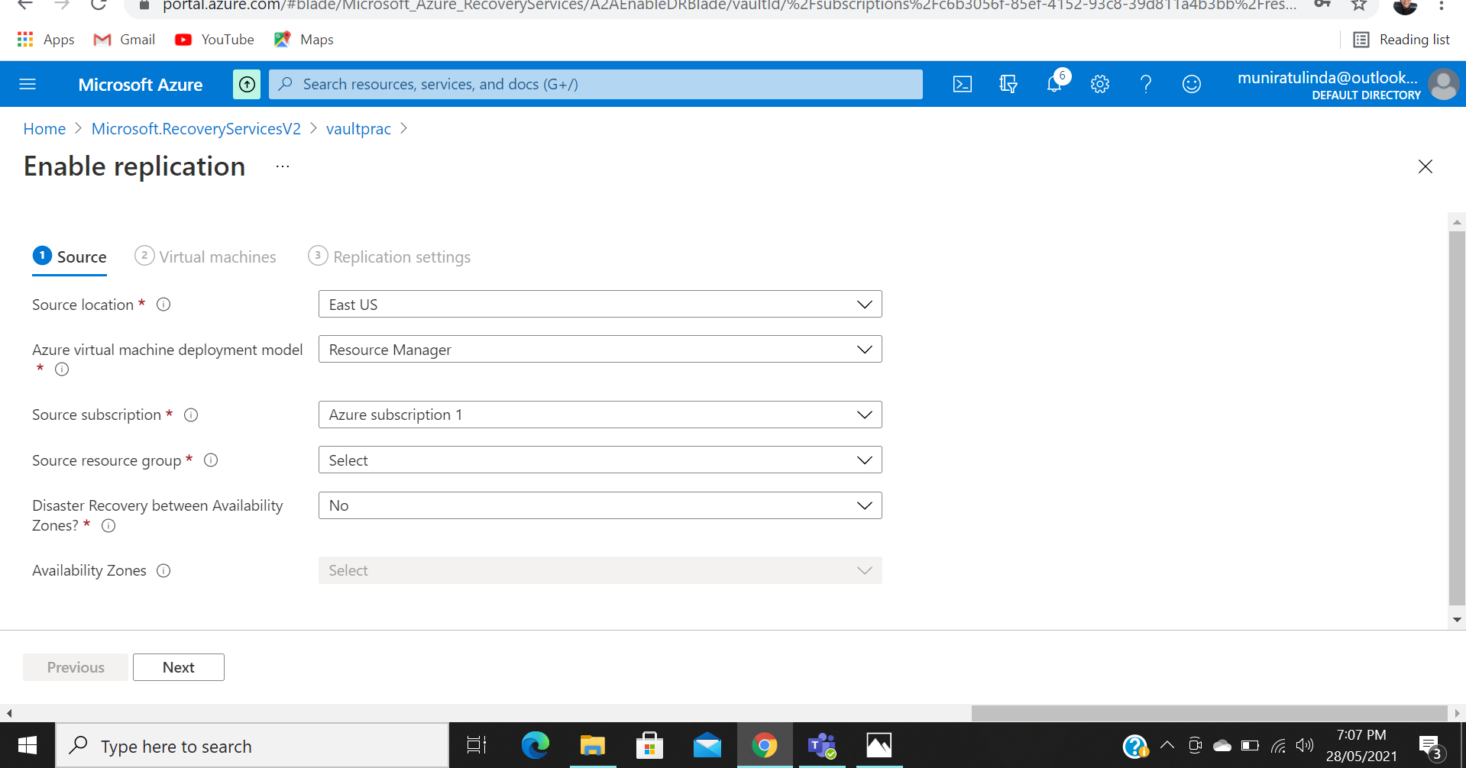

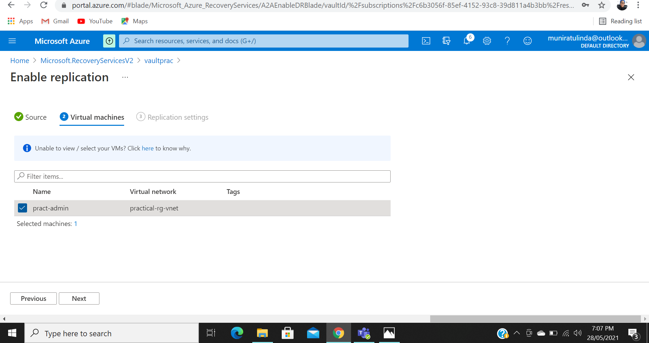

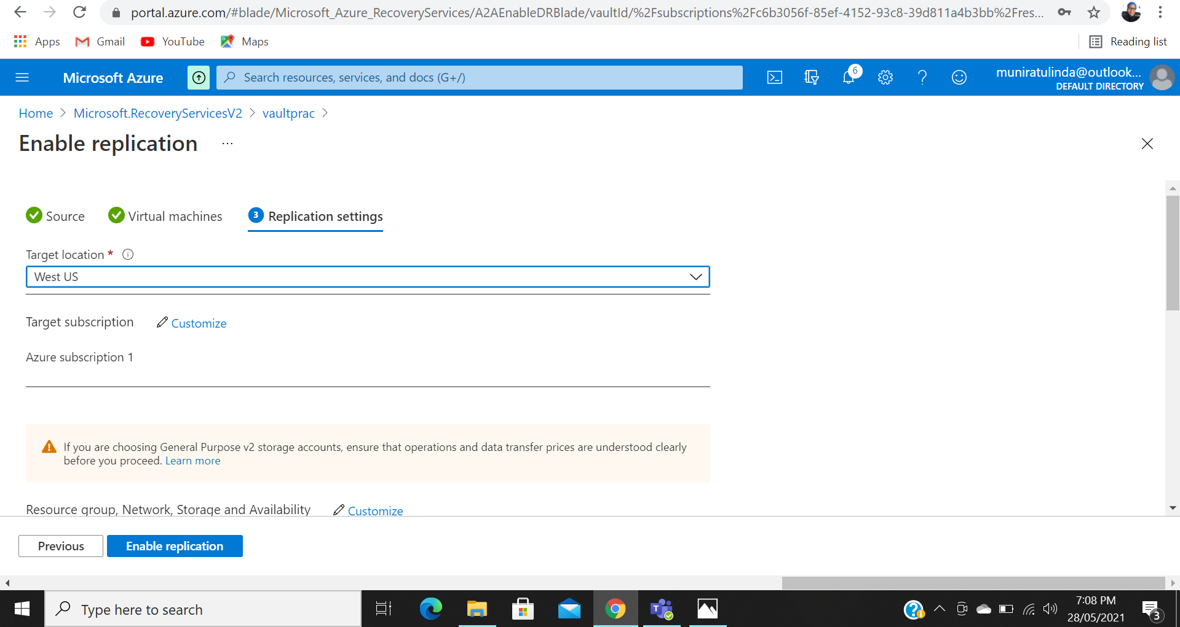

1. I then Stopped the Windows server from Azure to Assume the server’s ‘breakdown’ and then perform a Test Failover for the windows server.

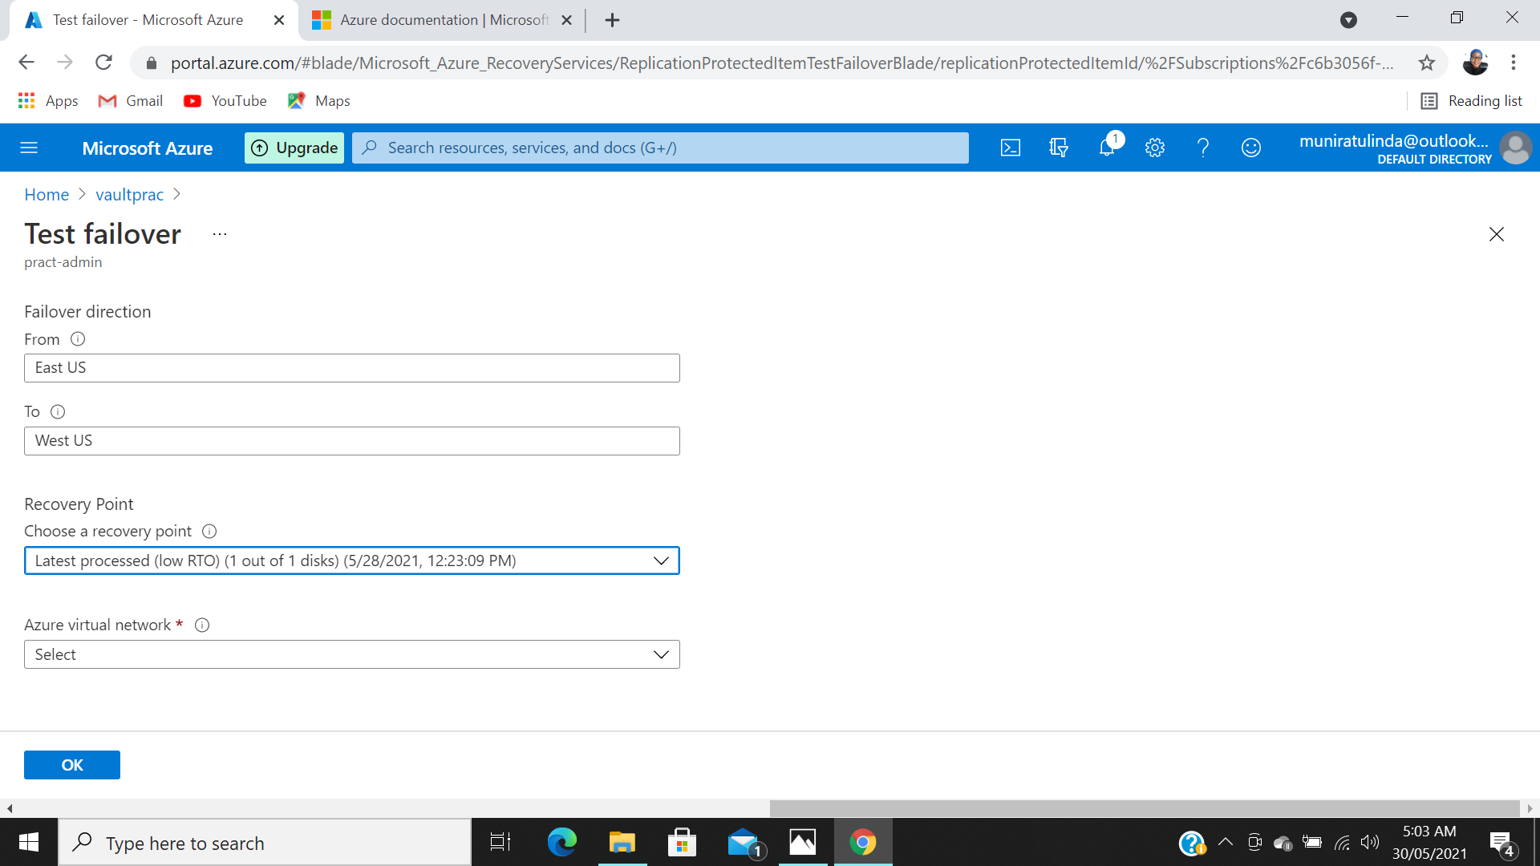

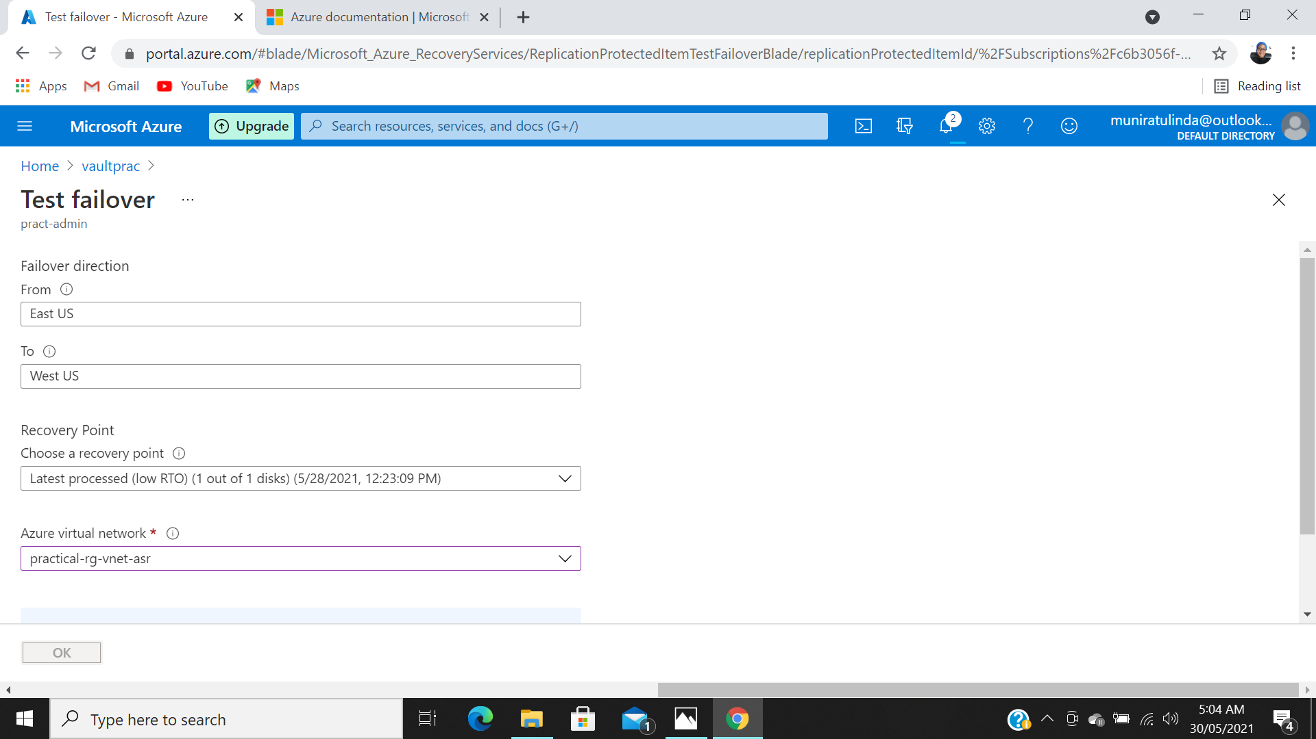

1. The test failover process notification should pop up should

