**Practical Activity 3**

**ON LINUX SYSTEM ADMINSTRATION**



Name :Lamis Mohamed GabAllah

Email: [lamis.mohammed@womentechsters.org](mailto:lamis.mohammed@womentechsters.org)

Date: 4th June 2021

**Part 1: of Practical Activity Week 3**

Perform the following activities and screenshot your output from Ubuntu- Terminal.

Do through research for the different commands you will utilize.

1. List the processes for the current shell.
2. Display information about processes.

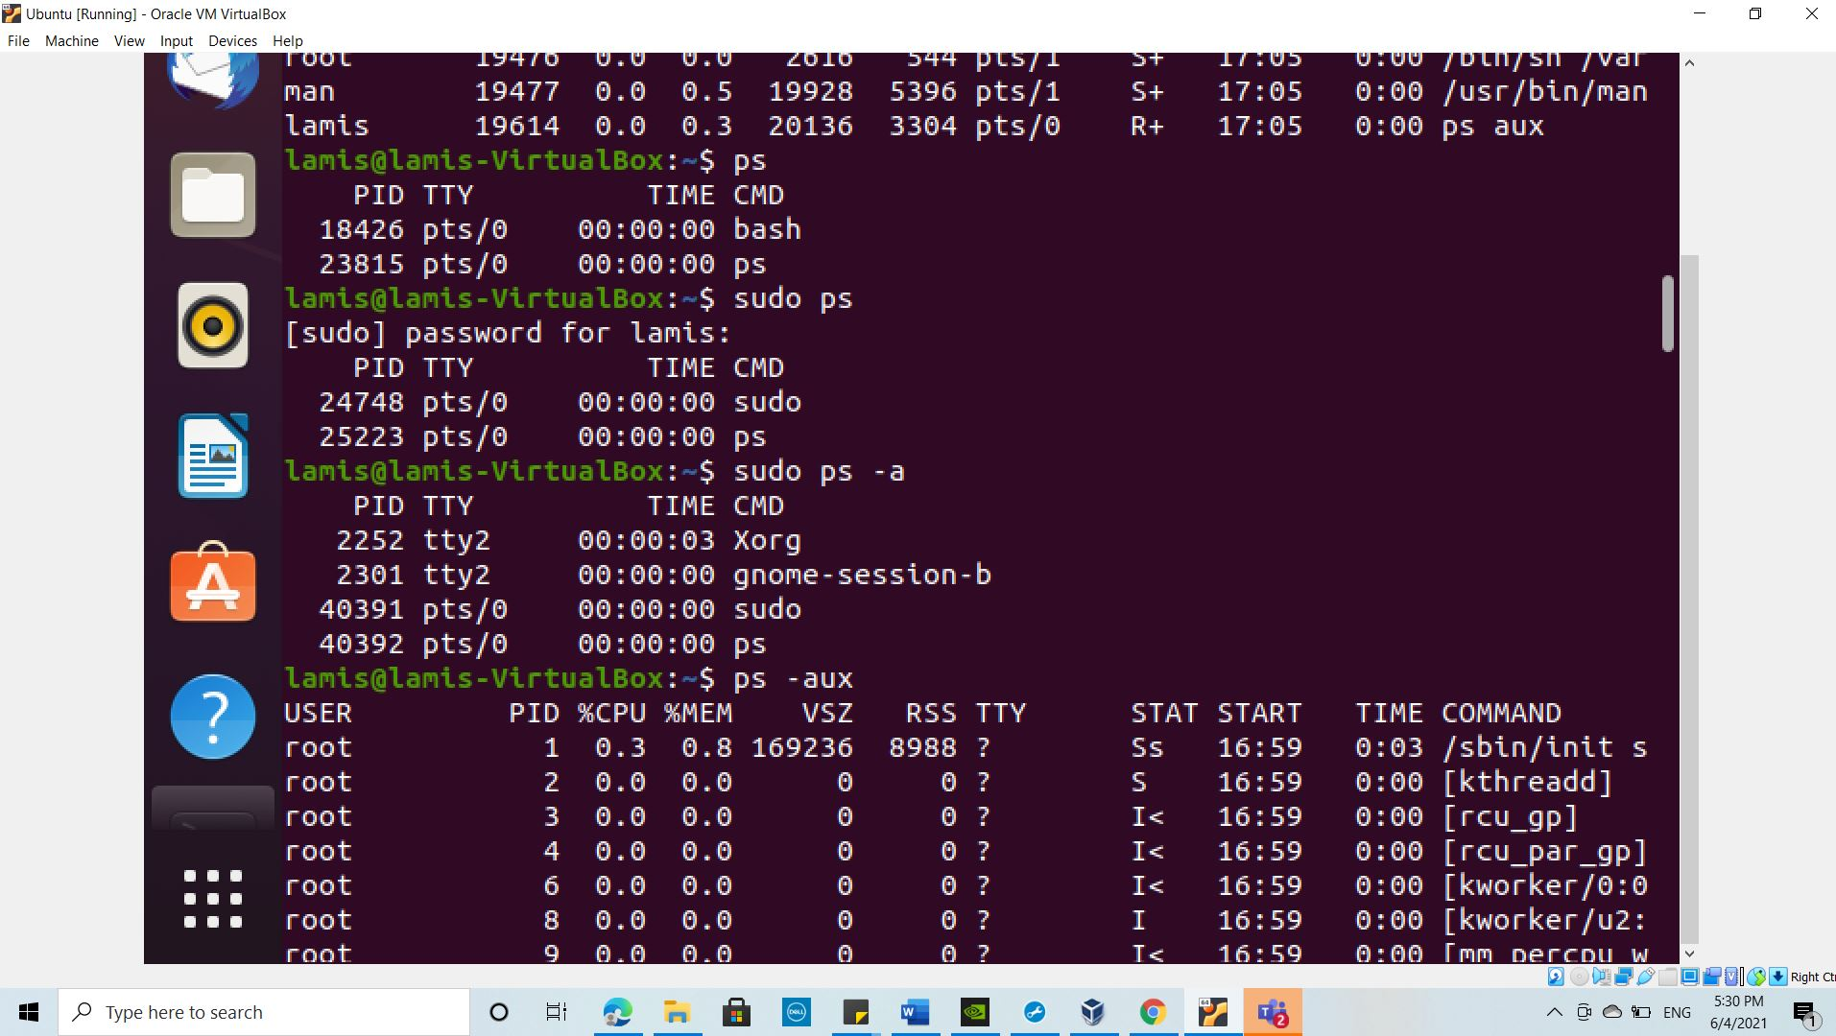

1. Display the global priority of a process and find out the column that provides.

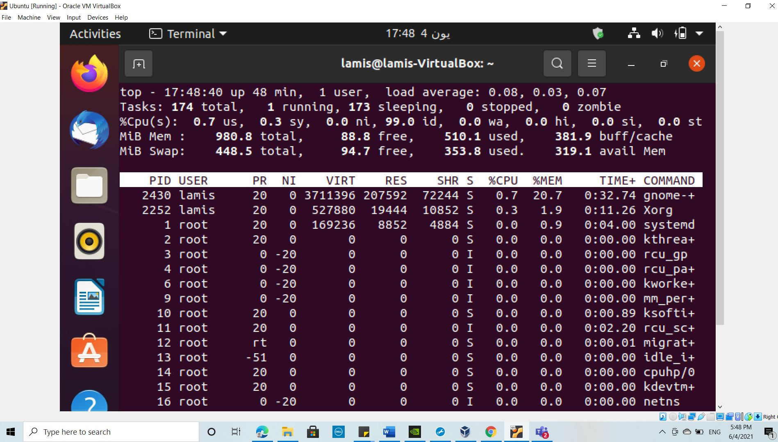

1. Change the priority of a process with default arguments.

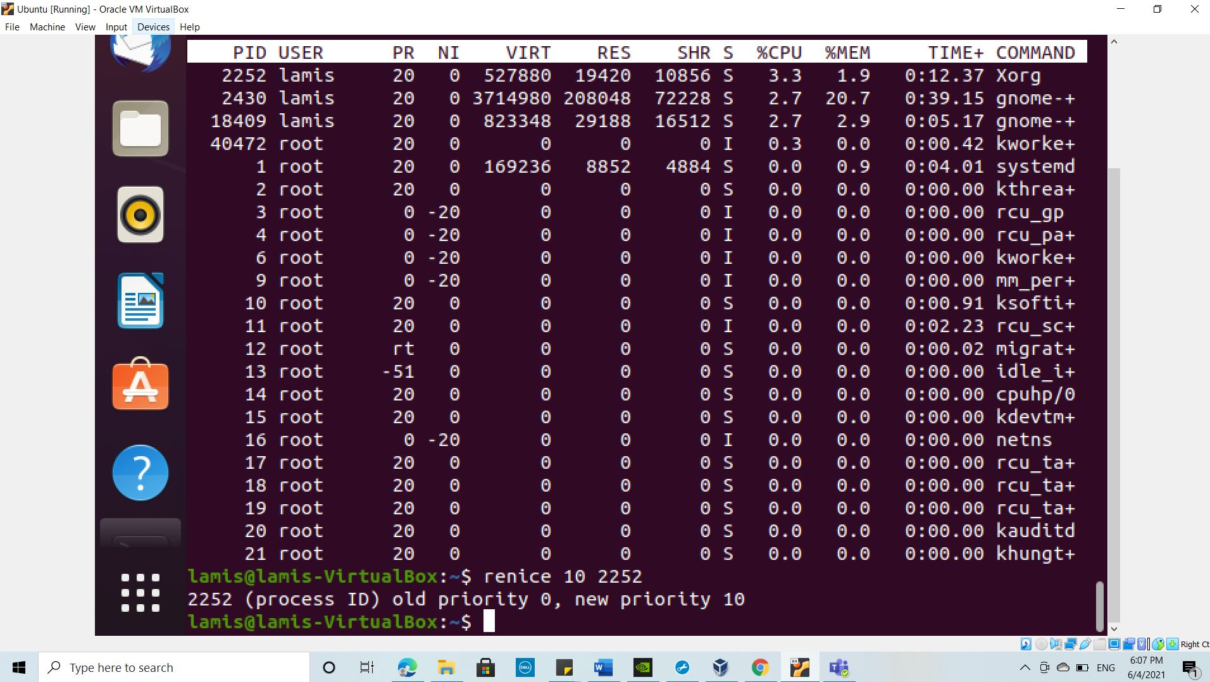

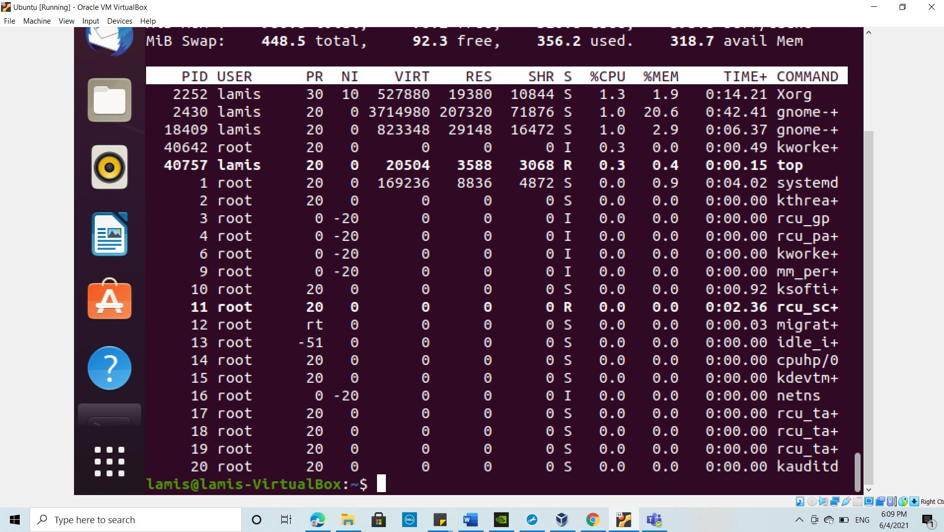

1. Display Virtual Memory Statistics.

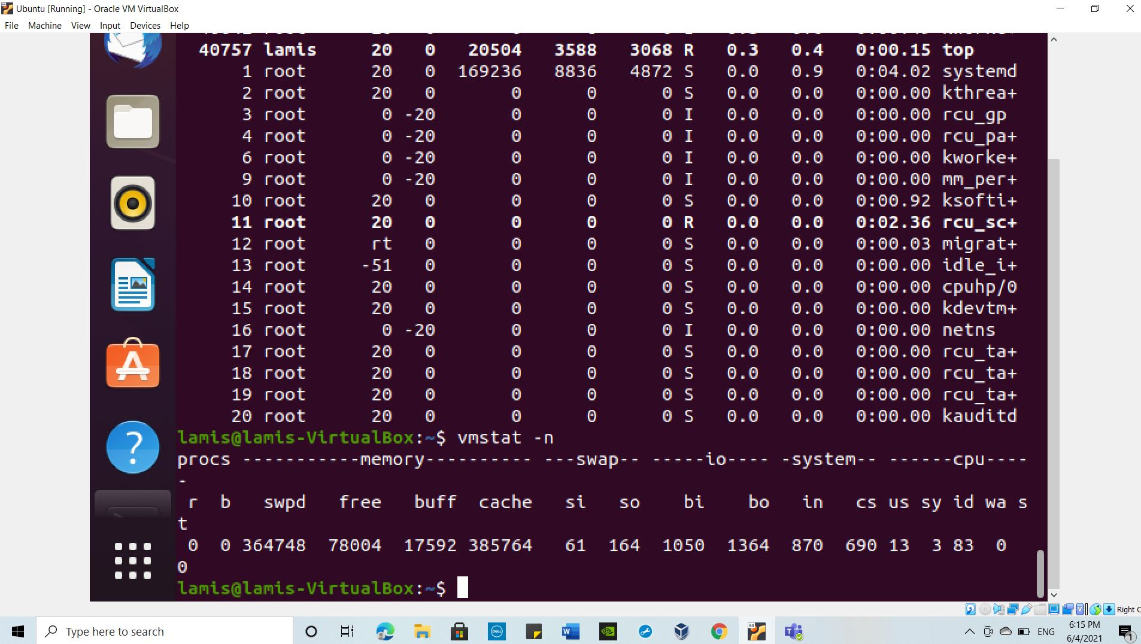

1. Display System Event Information.

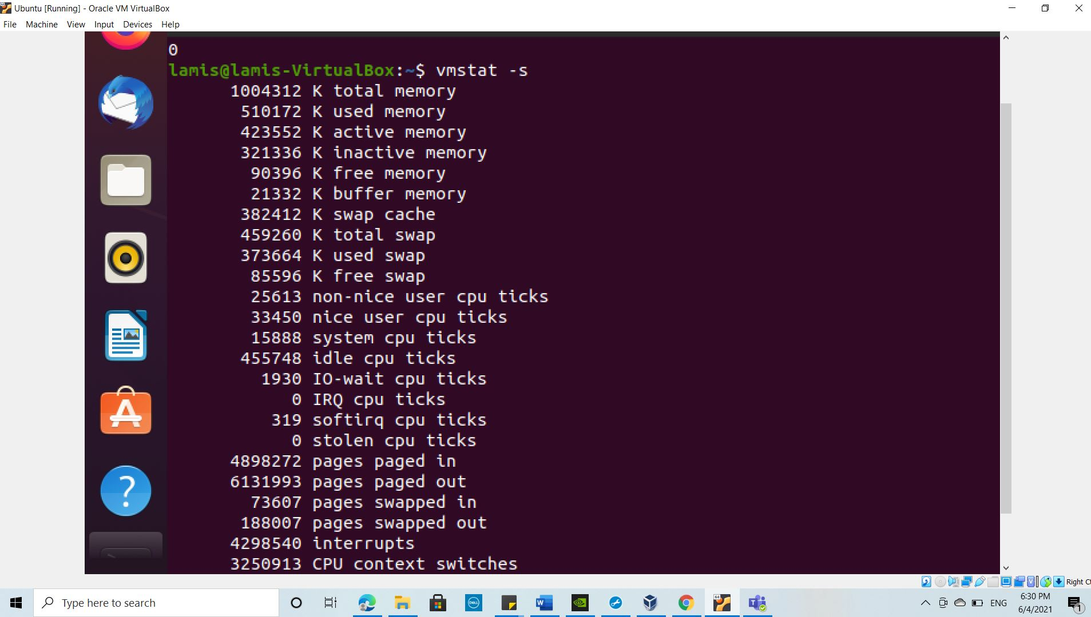

1. Display Swapping Statistics.

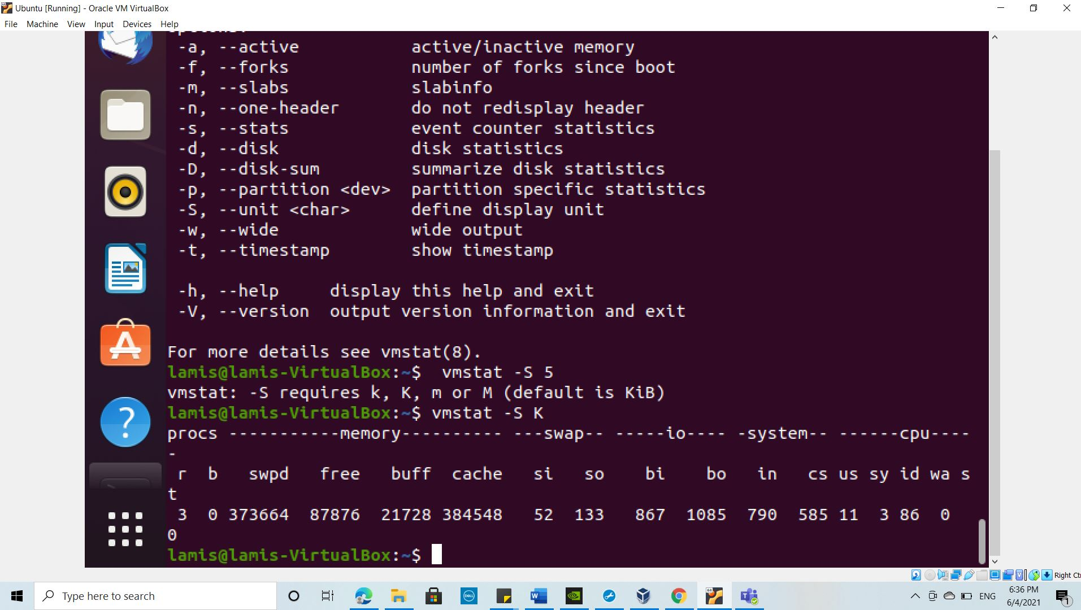

1. Check File Access statistics.

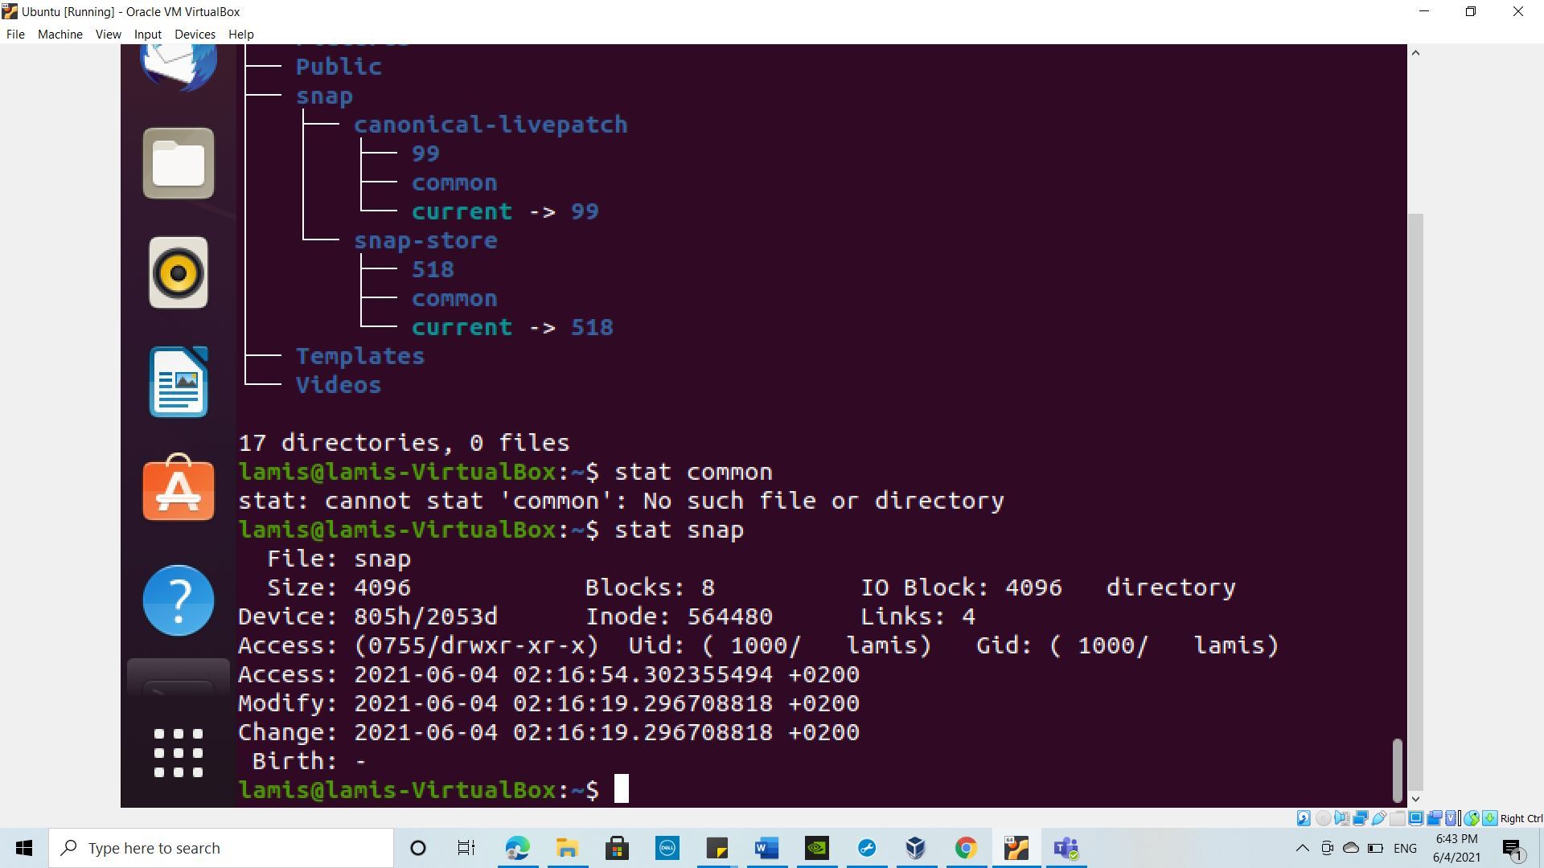

1. Check Buffer Activity statistics.

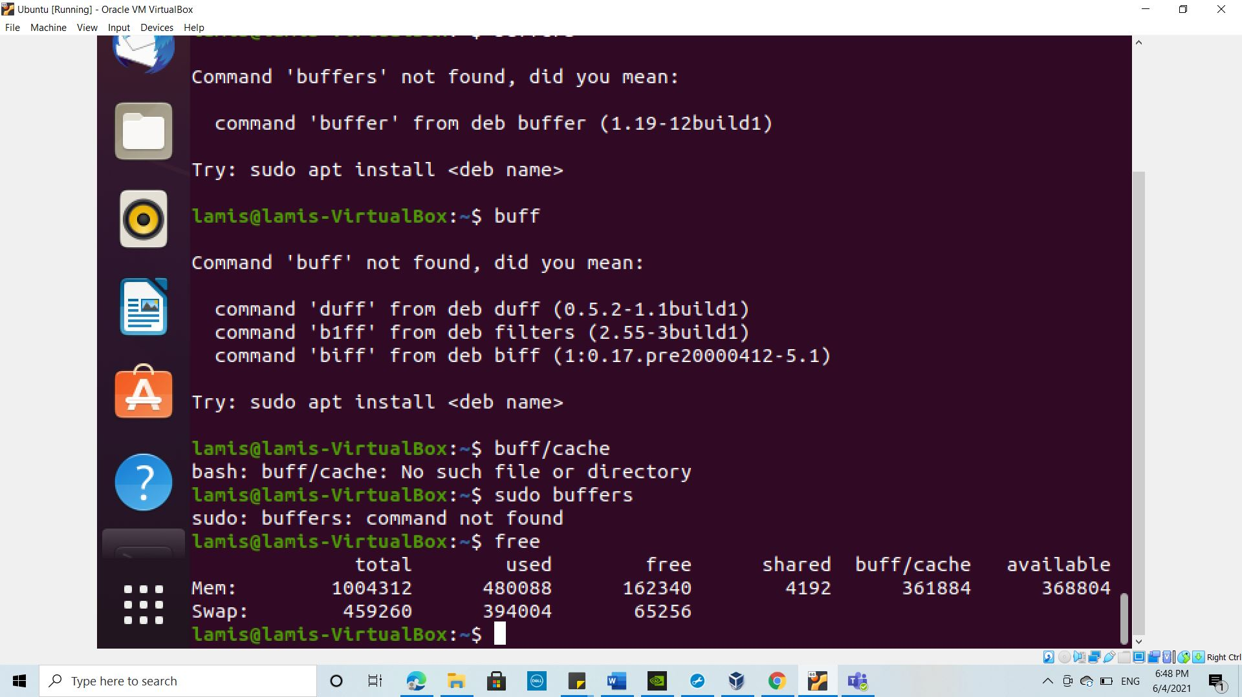

1. Check Disk Activity statistics.

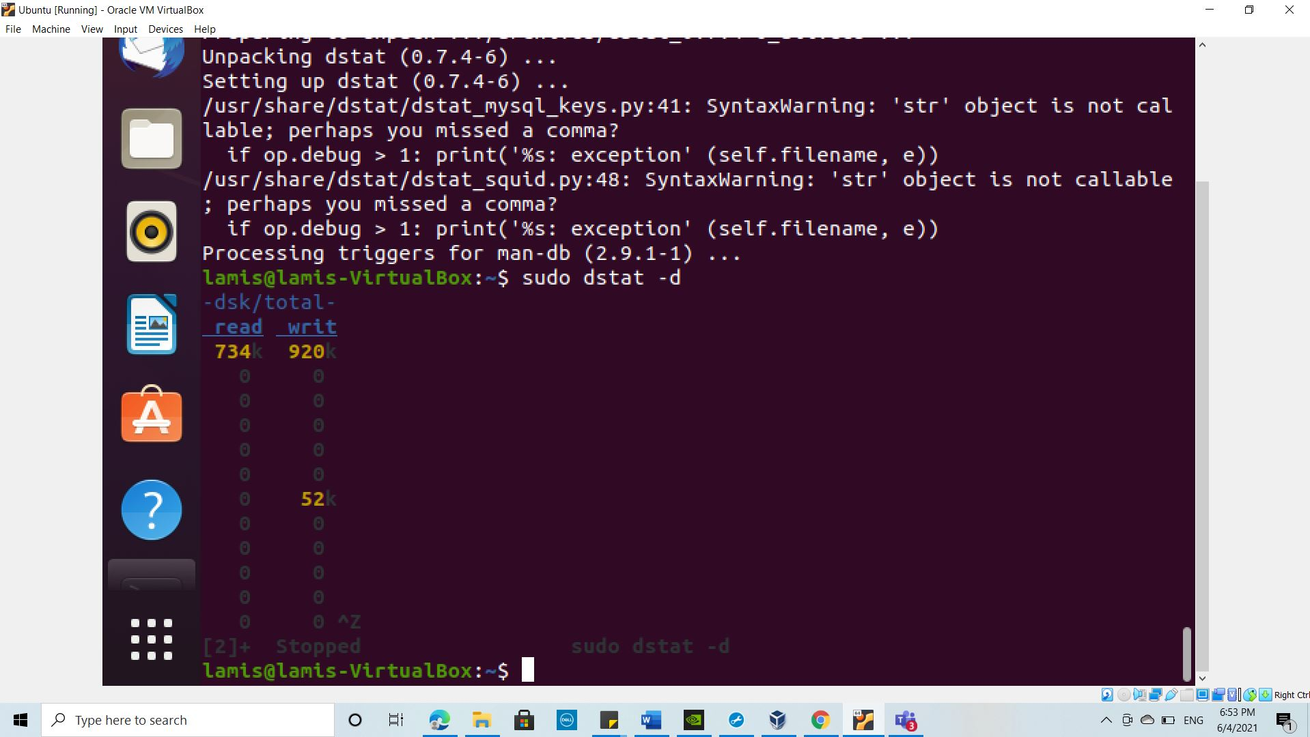

1. Check Inter process Communication statistics.

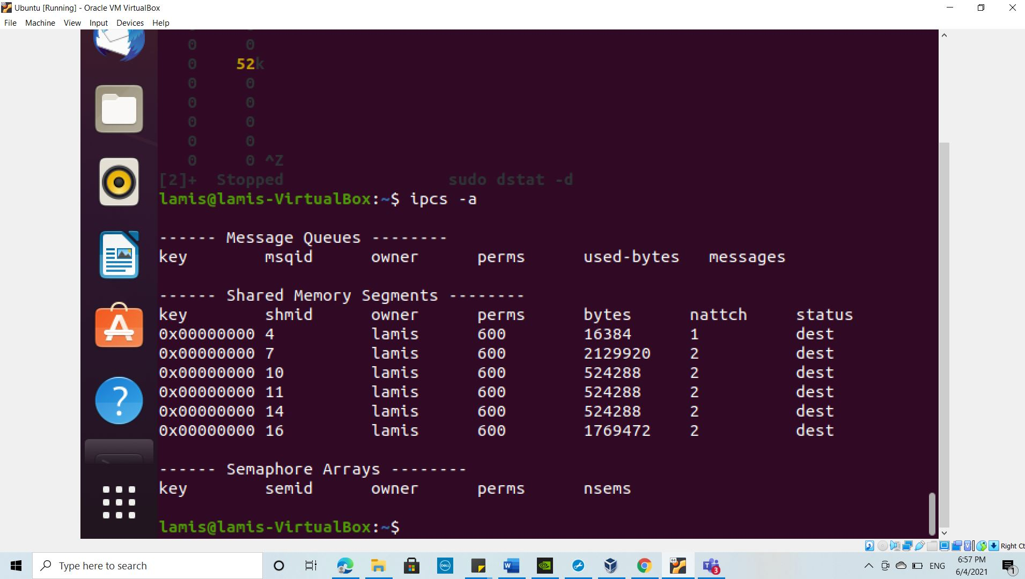

1. Check Unused Memory in the server.

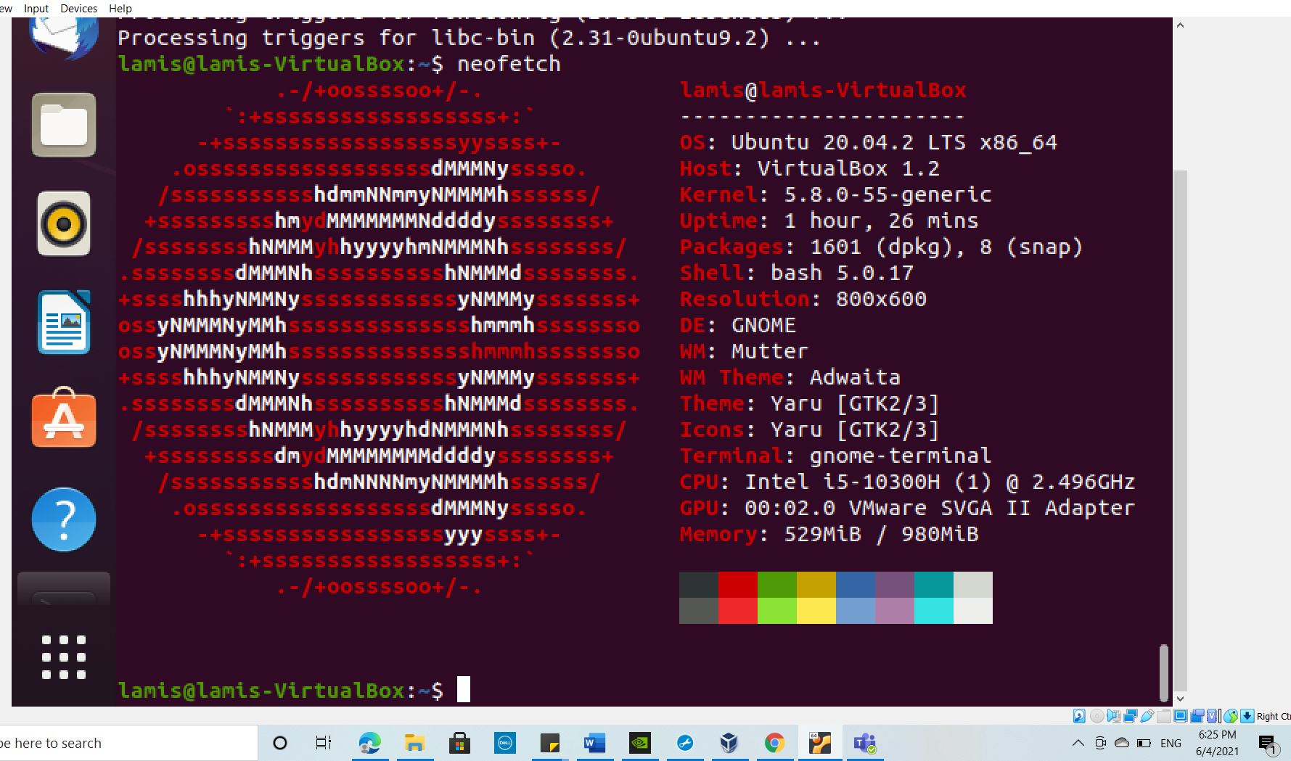

1. Check Swap Activities.

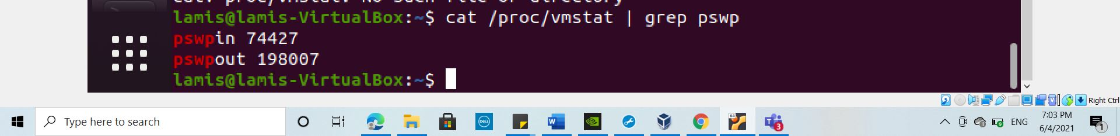

**Part 2 : Practical Activity Week 3**

This exercise is based on management of users accounts and creating of files. As linux security Administrator you should be able to assign different file permission and revoke permissions to unauthorized users. To improve your skills practice with this exercise.

**Entirely use the Terminal utilization of GUI will not be awarded any marks.**

Login to your terminal in Ubuntu.

1. Create a user account called user1 and another user2
2. Ensure user1 and user2 are password protected.
3. Logout and login as user1

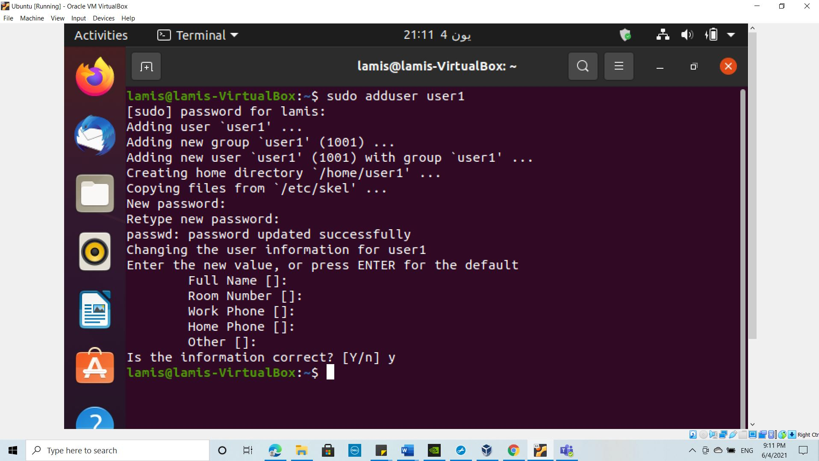

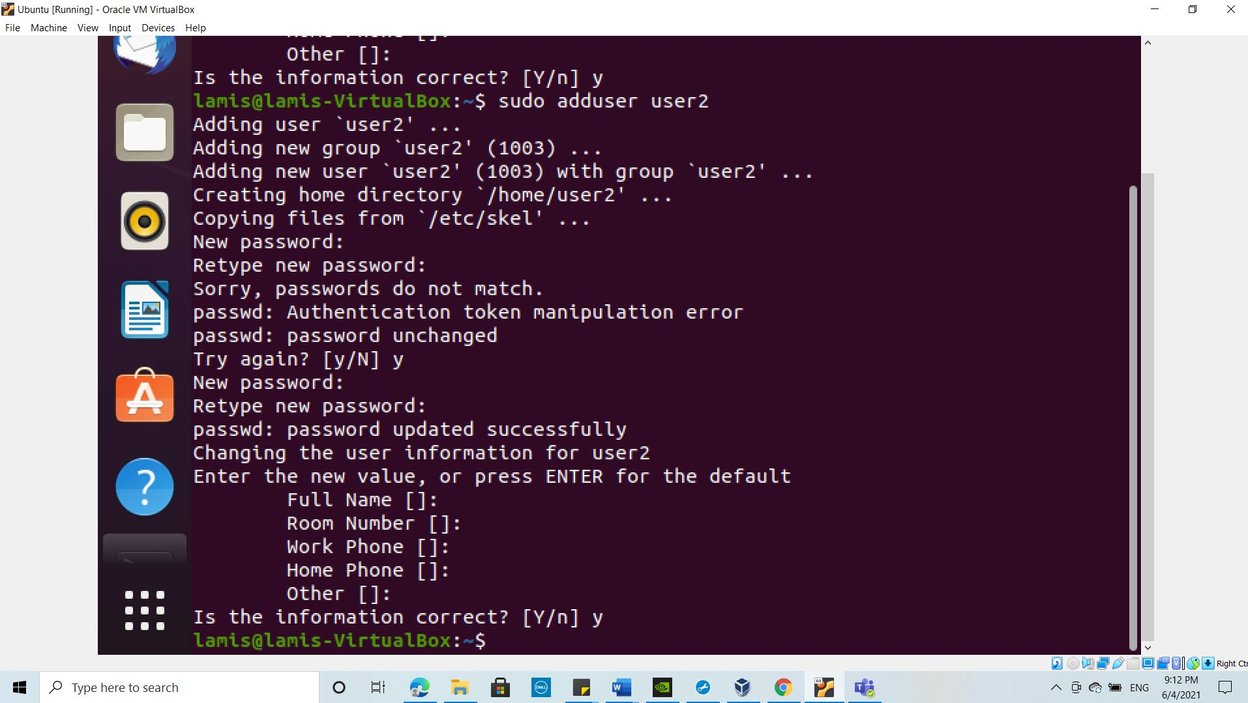

1. Create a testdir
2. Create a file testfile in testdir
3. Verify the ownership and the group of the testfile

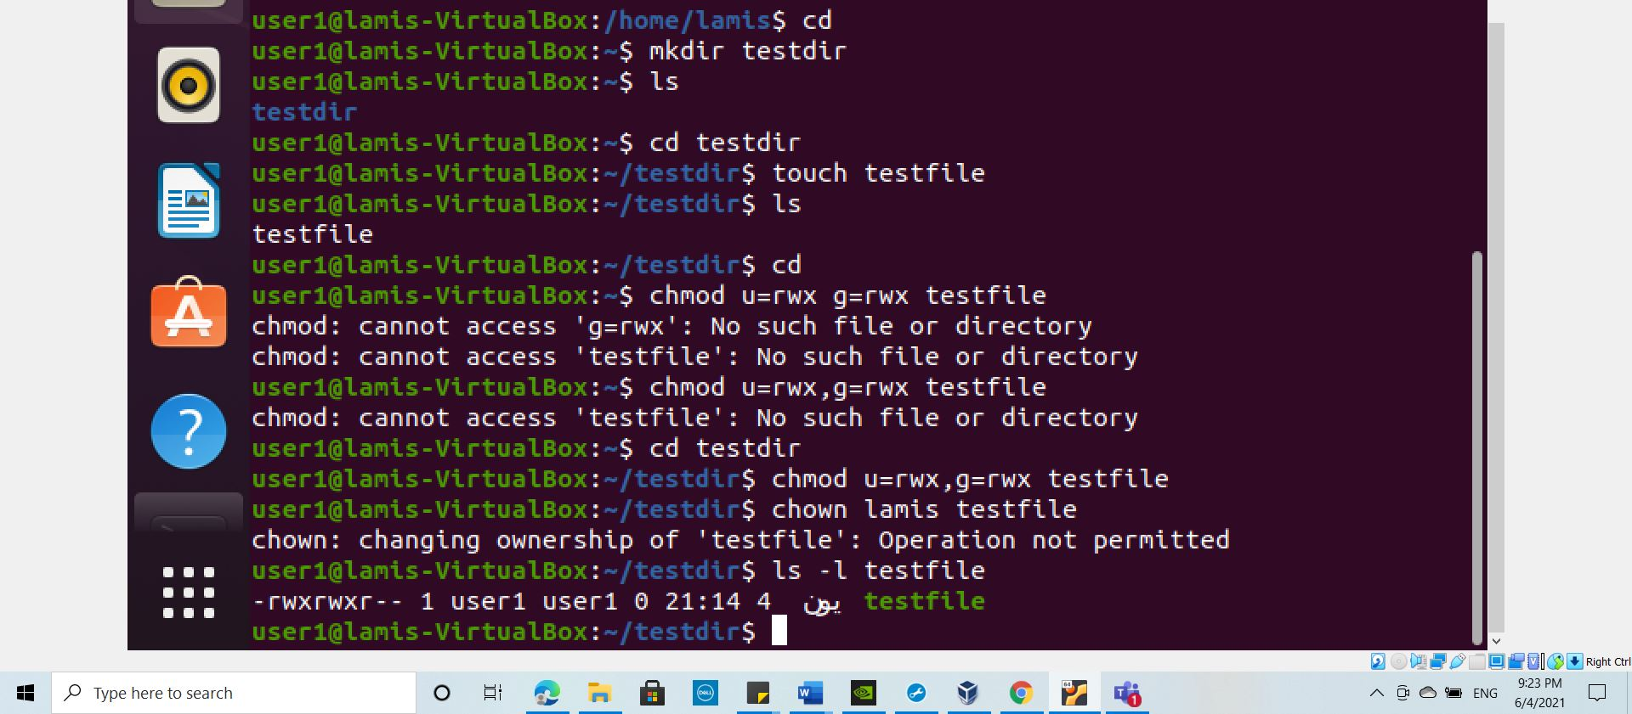

1. Switch to Superuser account
2. Create a public directory dir1
3. Set stickybit (save text attribute) on dir1

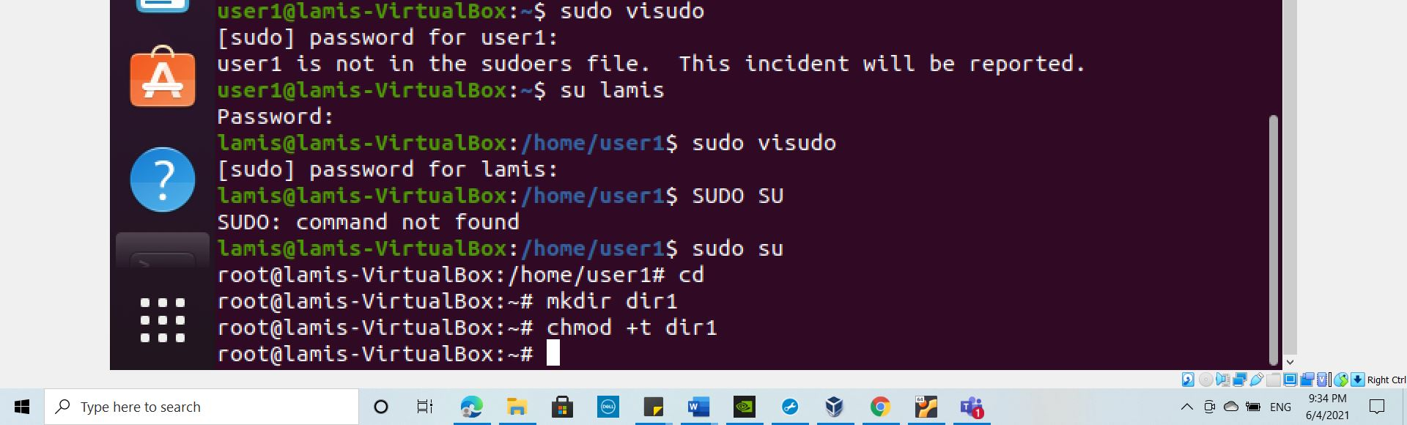

1. Logout and login as a normal user user1
2. Create a file userfile1 in dir1
3. Login as a different user user2
4. Try to edit or remove the file
5. Temporarily disable user logins

