**Practical Activity 4**

**ON BASH Programming Language**



**Name:** Lamis Mohamed GabAllah

**Email:** [lamis.mohammed@womentechsters.org](mailto:lamis.mohammed@womentechsters.org)

**Date:** 12th June 2021

**Question:**

**Write a shell script to validate password strength when a user enters. Here are a few assumptions for the password string.**

* Length – minimum of 8 characters.
* Contain both alphabet and number.
* Include both the small and capital case letters.

If the password doesn’t comply with any of the above conditions, then the script should report it as a <Weak Password> if the password complies with the conditions, it should echo <Strong Password Secure User>

**Instructions:**

1. Write the code in a file created in your home directory and call it **auntentic.sh**
2. Just the same way we have created scripts execute it and use **nano editor** to add your code.
3. After words Screenshot, your Code Paste it in a word Document as part one of your Report.
4. Also test your script by typing different passwords and screen shot the output from your terminal and add to your report document.

**NB: After successfully submitting this Practical Activity, you can push your code to git-hub and document it.**

**Answer:**

1. Write the code in a file created in your home directory and call it **auntentic.sh**

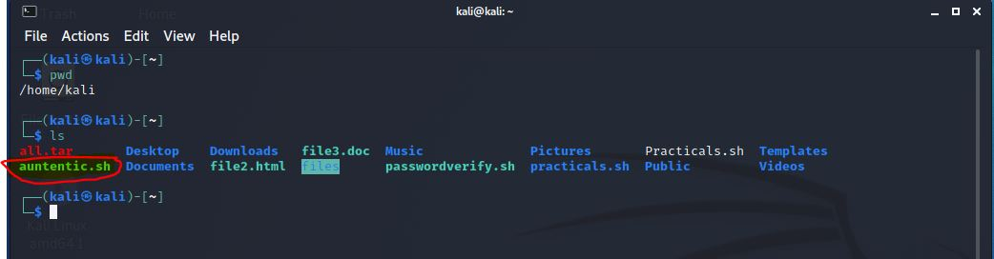

1. Just the same way we have created scripts execute it and use **nano editor** to add your code.

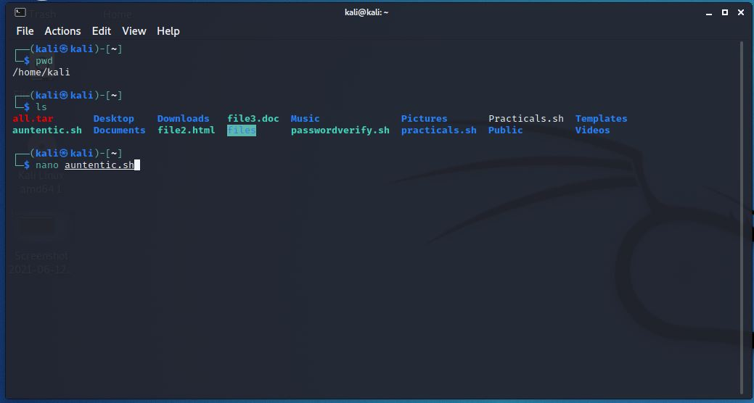

1. After words Screenshot, your Code Paste it in a word Document as part one of your Report.

#!/bin/bash

#This is a script for Password strength Validation

echo "Enter your Password"

#reading the user password

read password

#test the conditions to Validate the Password stregnth

until [[ $password = [^a-zA-Z0-9] || ${#password} -ge 8 ]]

do

#if the password not meet the strength coditions report its weak password for the user

echo "<Weak Password>"

#ask the user to Re-enter the password

echo "Enter your Password"

read password

done

#if the password meets the strength conditions accept it and report for the user its strong password

echo "<Strong Password Secure User>"

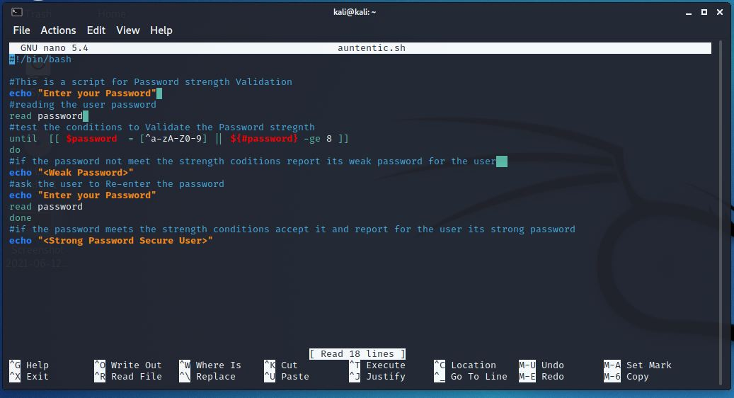

1. Also test your script by typing different passwords and screen shot the output from your terminal and add to your report document.

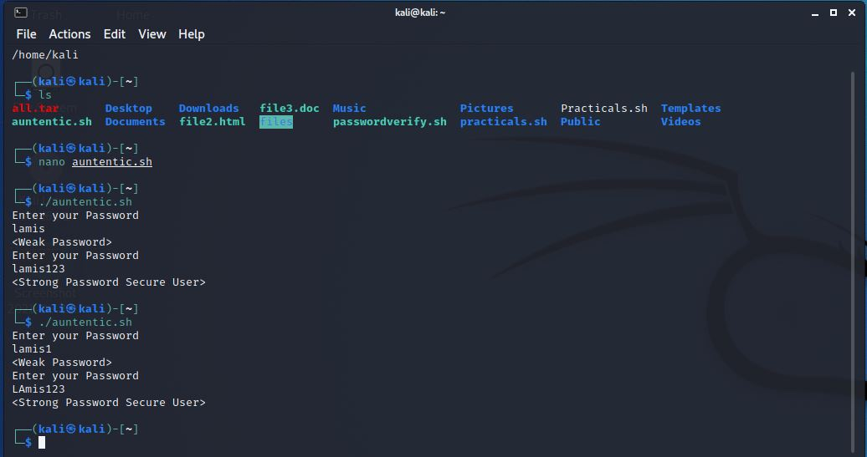

Github link :

https://github.com/Lamis-Mohamed/Cybersecurity1.git