**Solution to Practical Activity 5**

Assuming you are a system administrator in “CarMax” Car Dealership and you have been assigned with a task to add 1 Headquarters and 2 Sales Locations in a windows Server 2016 you configured.

* With the help of Active Directory, Add the Headquarters and 2 Sales Locations.

**Headquarters has:**

* Administrative Dept
* Accounting Dept
* Hr

**Each Sales Location has:**

* Sales Staff
* Mechanic Staff
* Management

**Solution steps**

* Creating organizational unit for headquaters and the two sales department under your domain. Right click on domain>click ‘New’>click ‘Organizational unit’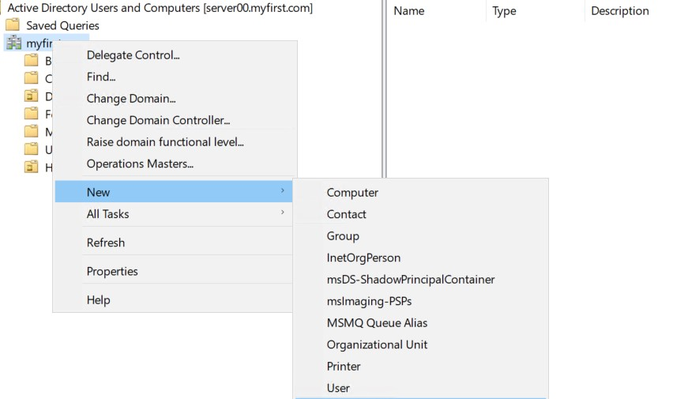
* On the pop up window write the name of the organizational unit as the case may be

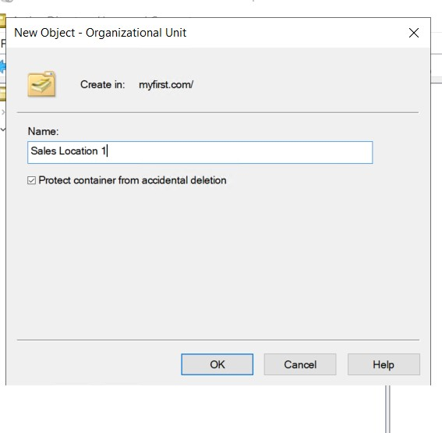

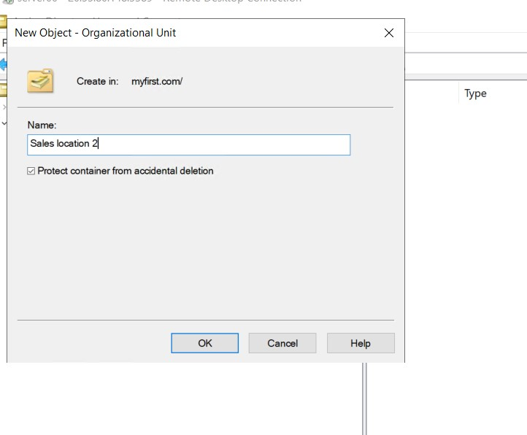

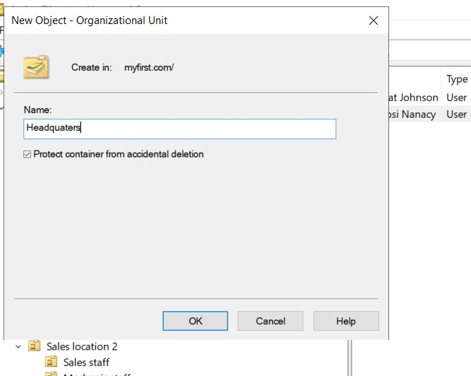

* Create organizational units under headquaters for administrative department, Hr and accounting department. Right click on headquaters>click ‘New’>click ‘Organizational unit’. On the pop up window, type in the name of department as the case may be.

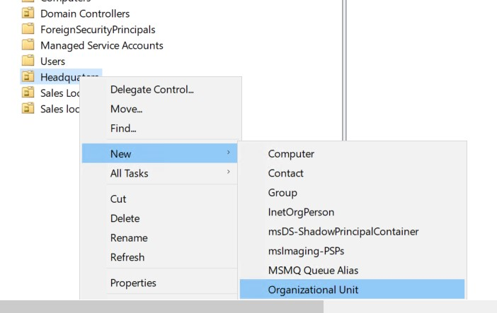

On the pop up window, type in the name of department as the case may be.

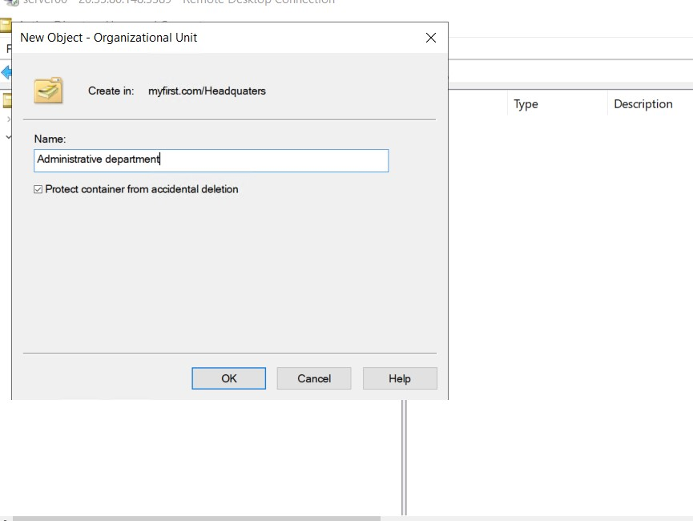

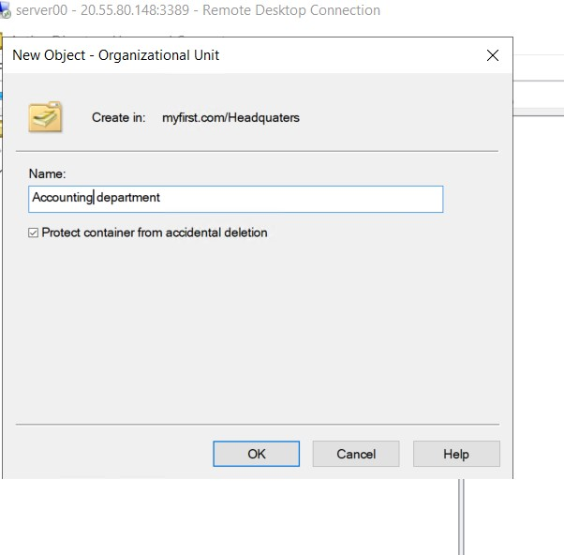

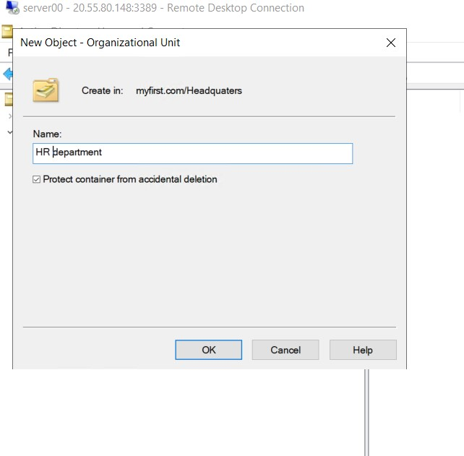

* Create organizational units under sales location 1 and 2 for sales staff, mechanic staff, management. Right click on sales location 1 (or sales location 2)>click ‘New’>click ‘Organizational unit’. On the pop up window, type in the name of department as the case may be.

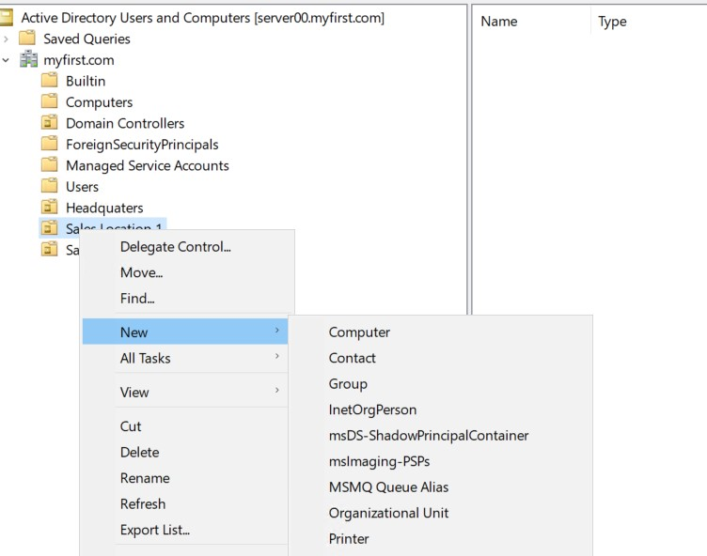

* On the pop up window, type in the name of department as the case may be.

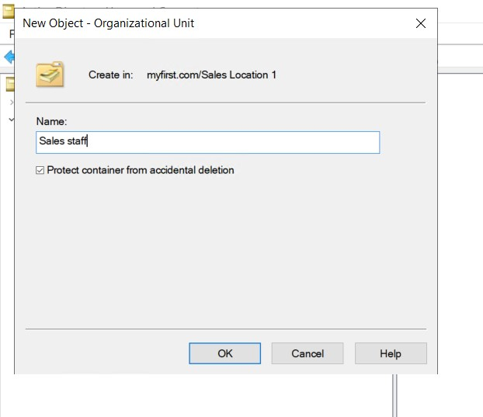

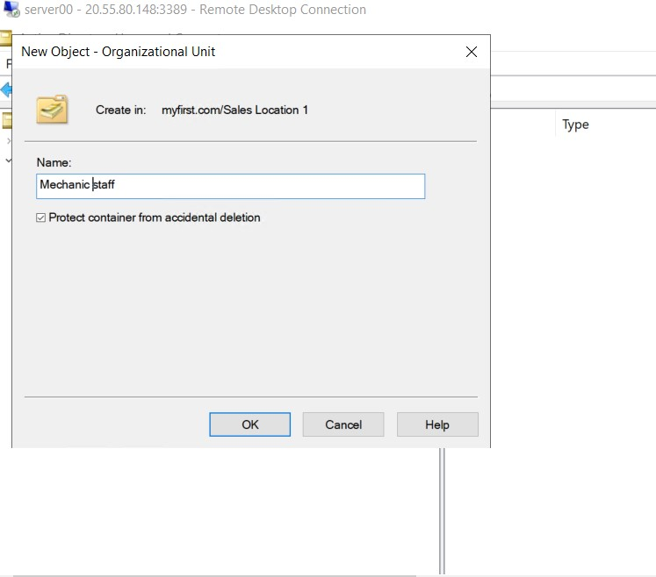

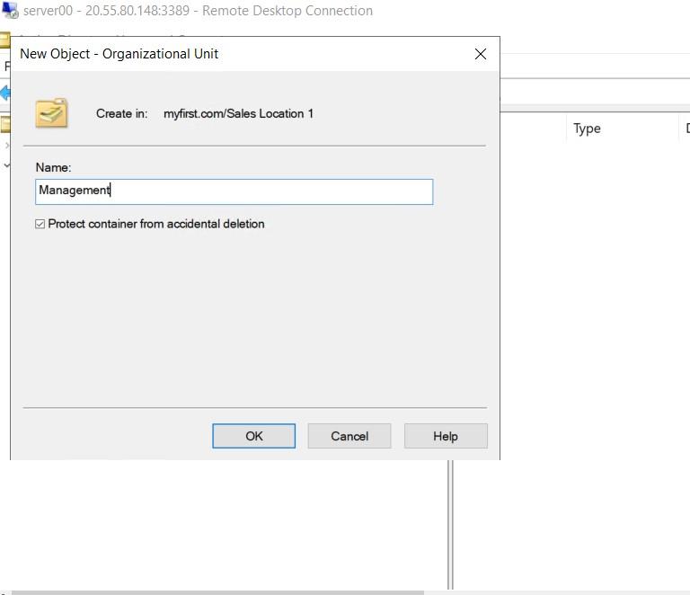

Resulting structure of organization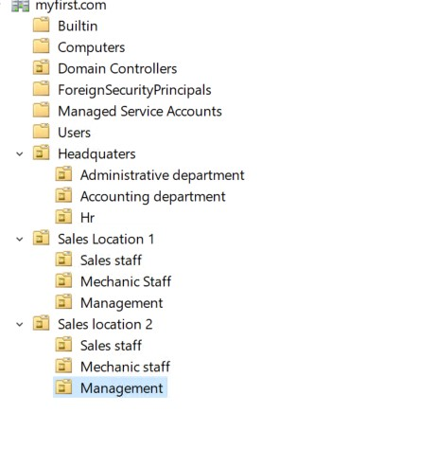

**Under each Unit add dummy users.**

* Assuming a user in Sales Staff is promoted to Administrative Dept, give a description on how you will handle this and make sure the **sales user is effectively transitioned to Administrative Unit**. Please give a detailed description with accompanied screenshots.

**Steps to solution:**

Jay Okocha is a member of sales staff that has been promoted to the administrative department.

Steps to ensure that he is effectively transitioned to administrative unit.

* Go to Sales Location 1>Sales staff. On the next panel, right click on the user Jay Okocha. Select ‘move’ from the drop down menu

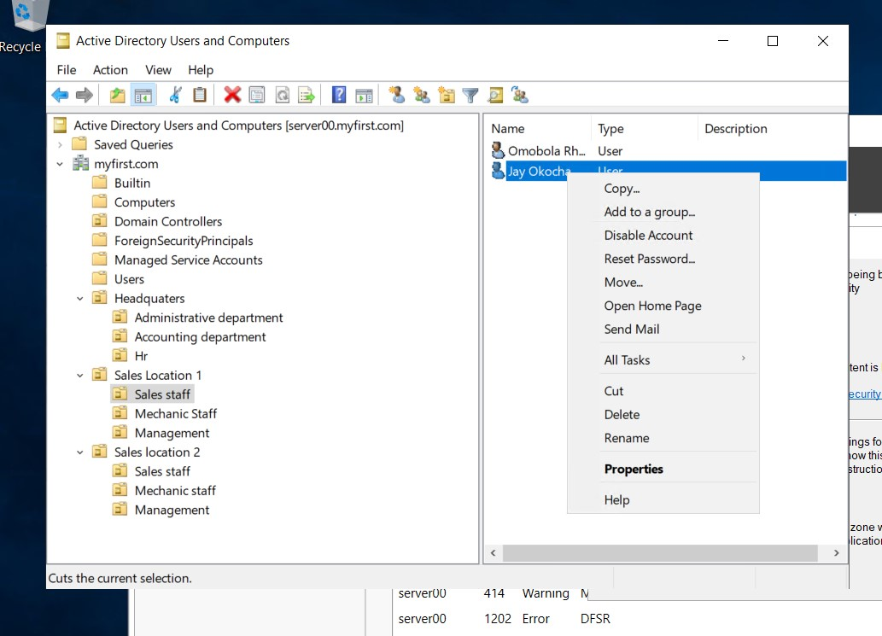

* On the pop up window, select administrative department
* 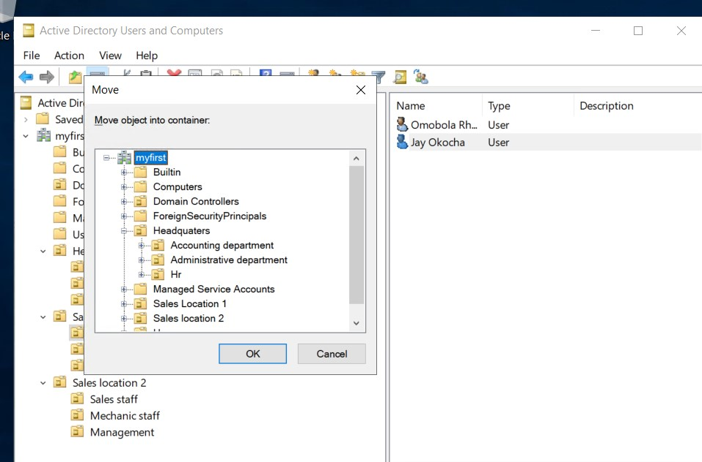
* Jay Okocha has been moved to Administrative department

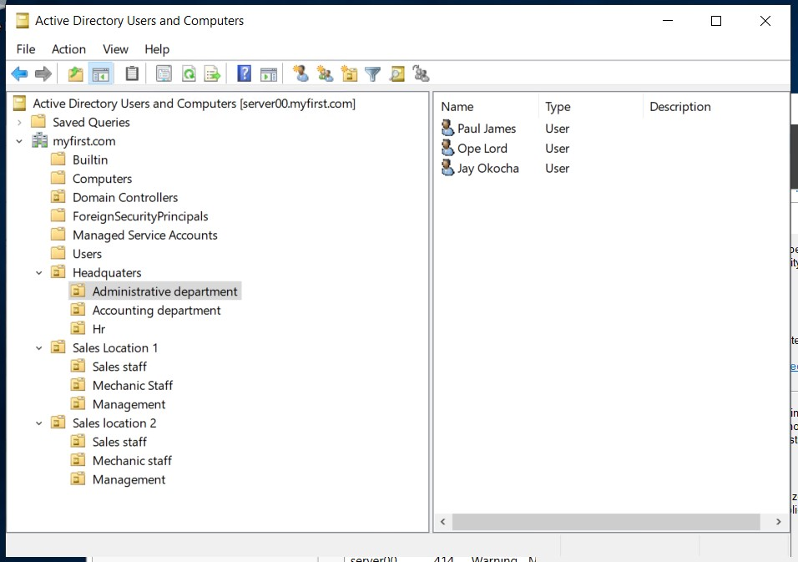

* Assuming “One dummy” user in Mechanic Staff has gone on leave for one month, give a detailed description of how you will ensure **their user account is inactive and cannot be accessed by any other person during this one-month leave.** This is to ensure unauthorized users to do not use that account to access the organization system.

**Steps to solution**

Nancy Pelosi, a member of the mechanic staff has gone on leave. My goal is to ensure her account is inactive and cannot be accessed by any other person during this one-month leave.

* Right click on Nancy Pelosi, in mechanic staff

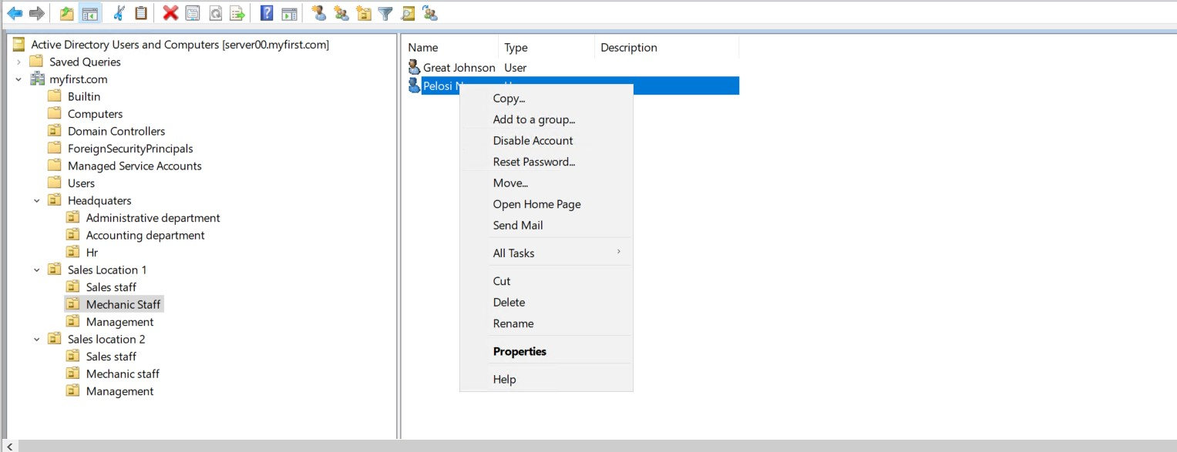

* Nancy Pelosi’s account has been disabled successfully

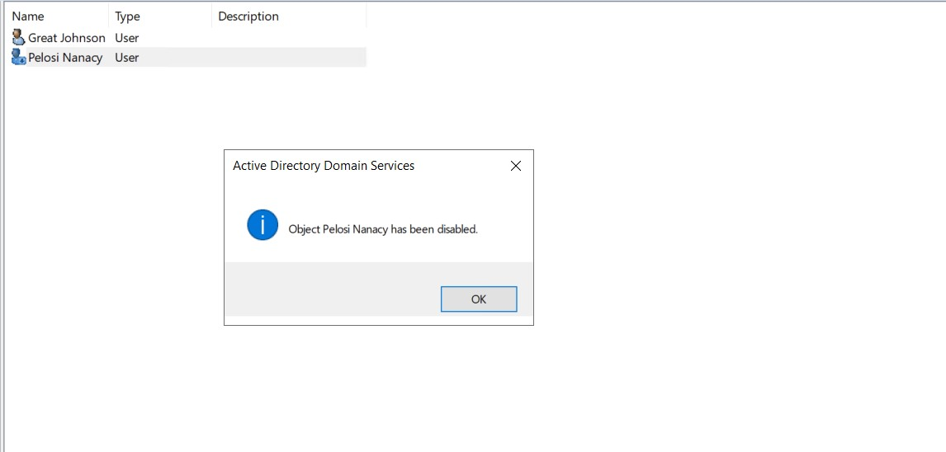

* In accounting Dept, we want to maintain high notes of security especially to the computers. **Add a computer policy under Accounting Dept** to ensure all computers are locked or disabled after 3 minutes of inactivity. The user has to login once again when back.

**Steps to solution:**

* On server manager, click on tool>On the drop-down menu, click on group policy manager.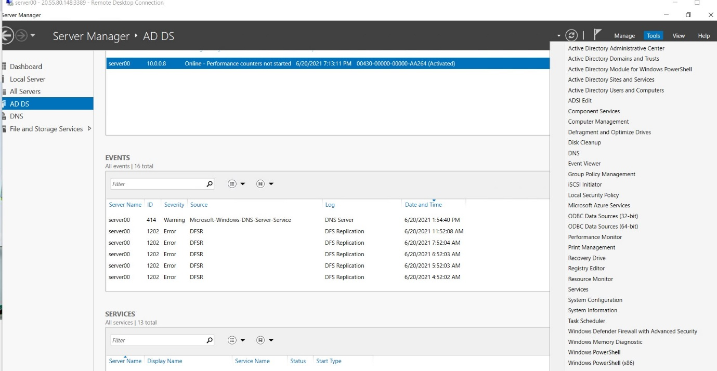
* On group policy management window> Expand ‘Domains’> Expand ‘myfirst.com’> Expand ‘Headquarters’> Right click ‘Accounting department’> Click on the first option, ‘Create GPO and link it here..’

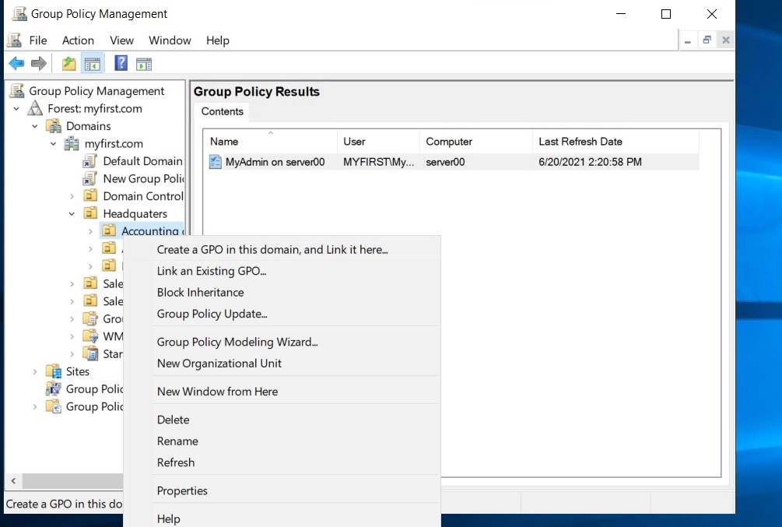

* Expand the accounting department and you will see a new icon under it. Right click on the GPO policy and select edit, to edit the policy

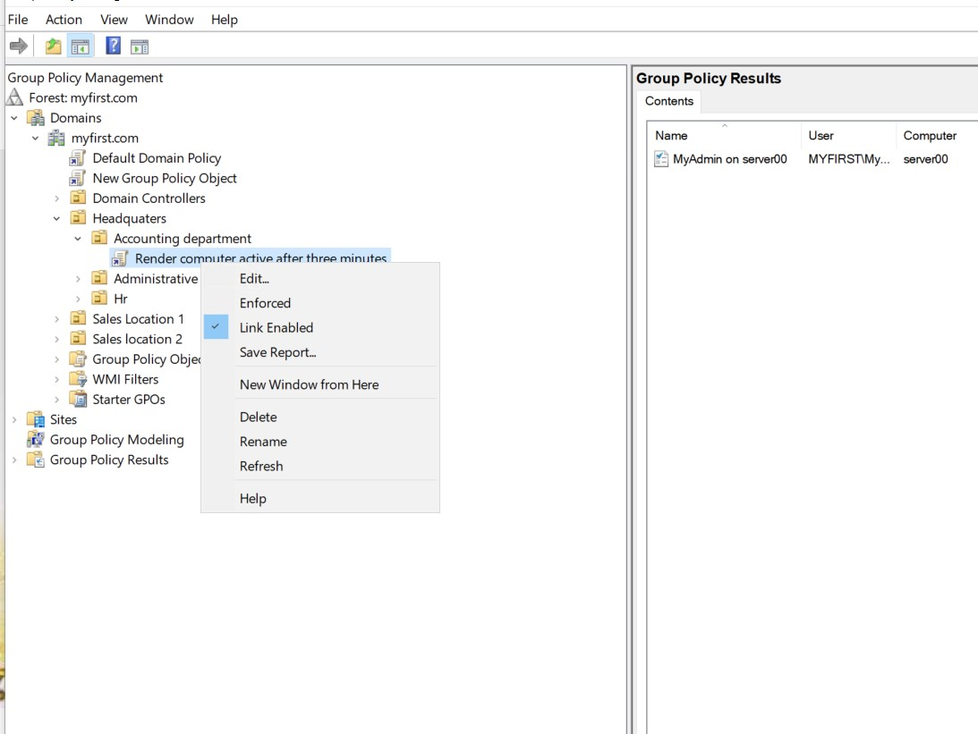

* Go to computer configuration>Policies>Windows settings>Security settings>SecurityOptions> Interactive logon: Machine inactivity limit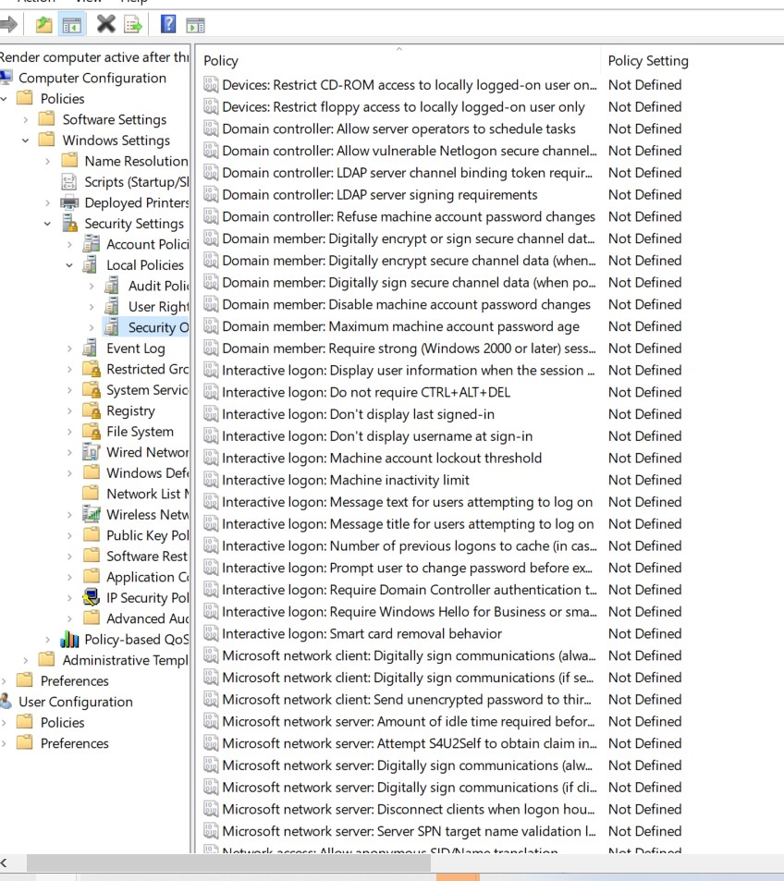
* On the pop up window, Check the define policy setting option. Then input 180 seconds (three minutes)

