Breaking down the each directory.

|  |  |  |
| --- | --- | --- |
| Directory | Contents | Examples |
| /bin | User bin files | ls |
| /boot | Boot images and kernel | config-3.10.0-229.14.1.el7.x86_64 |
| /dev | Devices such hard drives | /dev/sda |
| /etc | Configuration Files | ntp.conf |
| /home | Users home | treed |
| /lib | 32 bit libraries | sendmail |
| /lib64 | 64 bit libraries | php |
| /media | cdrom | Automounts cds |
| /mnt | Used to mount isos and cds | Show on screen |
| /opt | Location for third party rpms | Any application |
| /proc | Current Process (runtime) | cat /proc/version |

**Permissions**

**Users-Group-Others**

|  |  |  |
| --- | --- | --- |
| Read | Write | Execute |
| r | w | x |
| 4 | 2 | 1 |

d = directory l = link

These are the commands we covered

* **touch** command to make file
* **mkdir** to make directories
* **pwd** to make sure of what directory you are in
* **cd** to change directories
* **man** pages to find out about the command you are using plus options

Homework:

1. Log into your server cd /home ()
2. What are the permissions on the messages file
   1. Hint 1: use locate to find the file or find
   2. Hint 2: will be released on sunday (didn’t get released)
3. How do distinguish between a file, link, and directory?
   1. Link: Reference to another file, created by the **ln** command. Links give the same file multiple names, allowing it to live in two or more locations at once. 2 types
      1. **Symbolic Link** (symlink/softlink) - referes to another file by it’s path, like a Windows “shortcut” or a Mac “alias”. If you delete the orginal file, the now-dangling link will be invalid, pointing to a nonexistent file path: -s command
      2. **Hard Link** a second name for a physical file on disk (ti points to the same inode). If you delete the original file, the link still works: ln command
   2. File – files are collected in directories (both part of the Filesystem)
   3. Directory – (folders) form a hierarchy (tree)
4. Find the configuration in for httpd?
   1. /etc/httpd/conf (File not located – yum install httpd, updated, locate httpd | less)
5. Create a file called myfavorite.txt and place it in the /tmp directory (ls –l : for time stam)
   1. 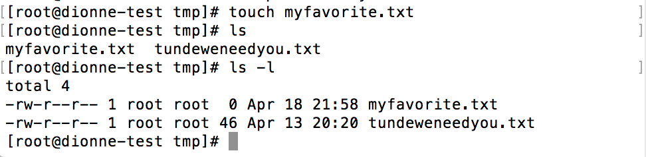
6. Create a directory under / called test
   1. 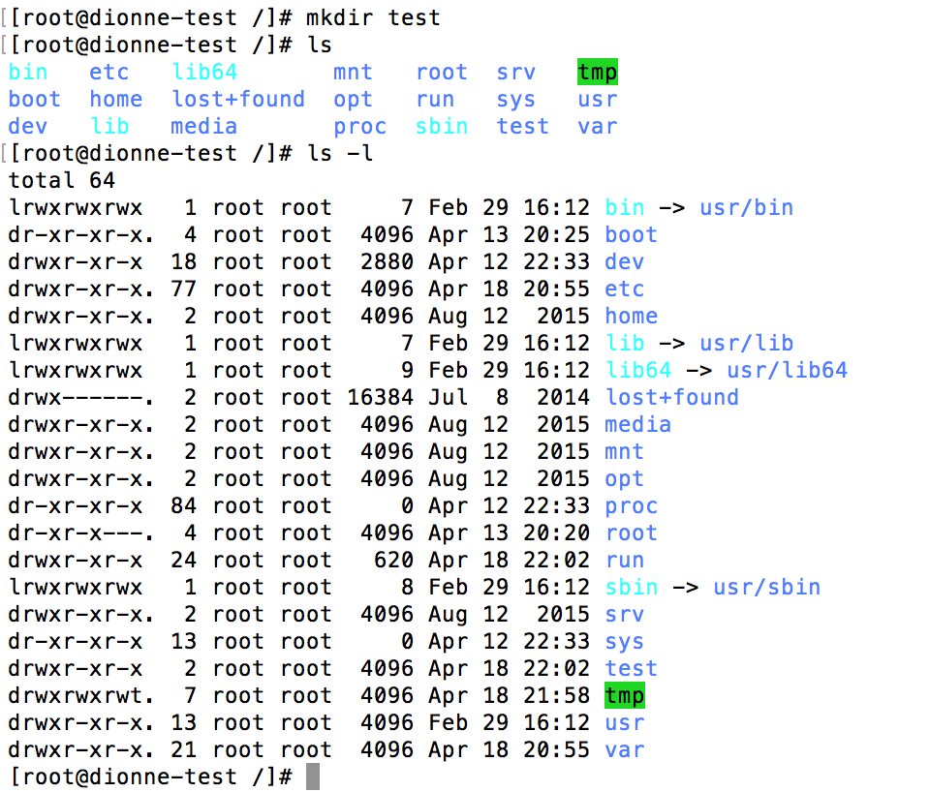
7. What does df –h tell me. Hint: man pages
   1. df – report file system disk space usage
   2. – h—human-readable: prints sizes in human readable format (e.g., 1k 234M 2G)
8. How do I find out who log onto the system? Hint: find the logs
   1. last
   2. 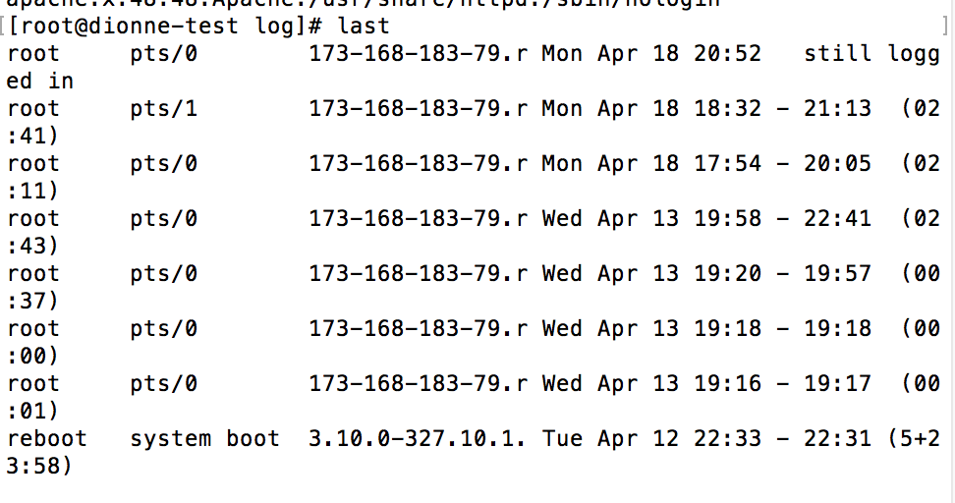
9. Find out how many users on the system?
   1. cat /etc/passwd
   2. 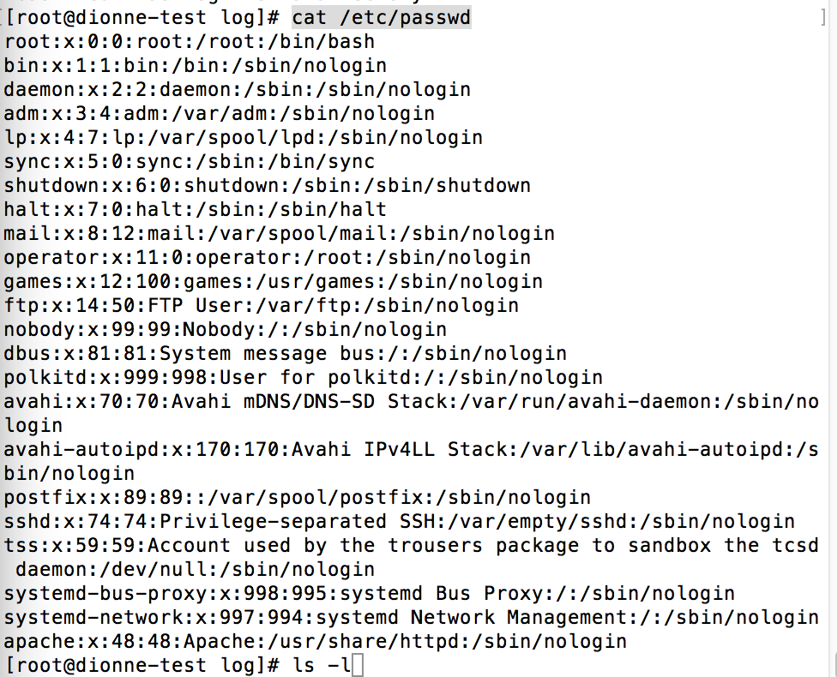
10. Can you tell me your hostname? Hint: Google!
    1. 
11. Use yum to install aide ?
    1. Set up aide:
       1. 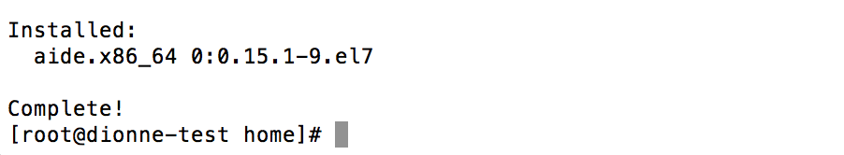
    2. What is aide – powerful system package for checking the integrity of files on a machine/system
    3. <http://linuxlov3r.blogspot.com/2012/09/configuration-and-setting-up-of-aide-on.html>
12. This is security database to let you know what vulnerabilities ae out there for all operating systems. Get yourselves familiar with that.
    1. CVE Database
       1. <https://cve.mitre.org/>
       2. <https://nvd.nist.gov/>