Residence Project on Data Minig
Dr. Satish Penmatsa
By Wondwosen Muhea
July 11, 2025

- Introduction

This report describes a comprehensive research process to develop and evaluate machine learning models, including regression, classification, and clustering algorithms, on data that relate to improving efficiency in robotics and characterizing the housing market. The complete analytical process is completed from the initial data preparation and exploratory analysis phase through model development, evaluation, and actionable insight articulation. The report will also consider the ethical implications of the analysis and make suggestions for future inquiry.

The report is decidedly focused on two distinct applications, UR3CobotOps, which uses data on the operational effectiveness of a UR3 collaborative robot, and AmesHousing, which is related to housing market changes over time. While both data types underwent the same comprehensive exploratory analysis, the report chose to focus on model development for AmesHousing data primarily due to the multi-collinearity and temporal nature of the UR3CobotOps data. Through this work, it is believed that the joint analysis of both domains and the model building of one domain illustrates the potential of both the methodological approach and the ability to demonstrate the methodological versatility and ability to generate useful and impactful inquiry (Tyrovolas, Aliev, Antonelli, & Stylios, 2024) (Ames Housing Dataset, n.d.).
- Data Preparation
This section will describe the methods that were implemented to solve quality issues in the data, which involve missing values, outliers, and errors in the datasets, and re-standardizing the data format for both datasets.
- UR3CobotOps Data Cleaning
The data cleaning for the UR3CobotOps dataset was twofold: addressing missing values and noisy data. The missing values for current, speed and temperature were obtained by using forward fill per cycle with a back-up of the median, this method was chosen to preserve continuity for real time state estimation and for anomaly detection. The missing values for tool current were dropped because a small fraction of the data was missing and we could limit artificial outcomes from the imputation. All columns associated with a joint were obtained by the conversion of the feature into a float for precision and model compatibility in ML libraries. Noisy data was addressed through the processes of clipping values for spikes outside of ±3 IQR, logical checks like checking for encoder slip and absolute temperature (if they were outside normal range), correctly merged duplicate timestamps and spurious flat line sensor data, to re-create and interpolate and/or drop missing bursts.
- AmesHousing Data Cleaning
The data cleaning operation on the AmesHousing dataset incorporated a combination of missing values handling, consideration for consistent data to avoid outliers in regression modeling.
Handling Missing Values Strategy (Categorical/Ordinal): NaNs in property quality categorical and ordinal features (pool., alley, basement, fireplace, garage, fence.) were given the string 'none'. In this instance 'none' is a valid category that provided useful information as a reconciliation for null values in these variables.
- Handling Missing Values Strategy (Numerical): NaNs in numerical features that had NaNs could be considered degree of quantity including garage area/capacity, total basement square footage, and area of finished/ unfinished basement and area of masonry veneer constructing. All missing values were given a value of 0, which signified no value, or zero quantity for these features.
- Contextual Imputation (Lot Frontage): Missing values imputing Lot Frontage in the neighborhood context allowed NaNs to be filled based on the median Lot Frontage value from like neighborhoods, as to limit arbitrary influences to local factors and neighborhood characteristics and maintaining spatial relationships. Global value median factors were considered for neighborhoods with minimal data space.
- Mode Imputation: Isolated missing values were filled with the mode for strata such as the type of electrical system, classification zoning, as these were not common occurrences and since the mode was the most abundant category of the fill in.
- Data Consistency: Garage year-built values where zero was present (an indication of a missing year) when it was demonstrated that a garage had existed (based on presence from other garage associated features) were corrected to have Year Built imputed. This indicates that the garage was built at the same time as the house unless it was indicated otherwise.
- Outlier Removal: Extreme outliers such as gross living area above grade were removed, this was done to prevent anomalous data points from having disproportionate skew to model training and help with a model in achieving robustness and an improved ability to generalize from a given model in regression outcomes.
- Modeling Details
This section describes the methods and approaches taken to model the prepared AmesHousing dataset. Due to the nature of the target variable (SalePrice), along with the findings from the EDA presented in the consolidated notebook, regression models will be the primary focus.
  - Feature Engineering
Feature engineering represented an important development step for improving the predictive power of the models for the AmesHousing dataset. Specific features were derived from existing features to ensure important complexities are captured and more information is accreted to the models.
- Combined Area Features: New features were combined, such as total sq. ft (combined floors and basement), total bathrooms, and total porch area that provided a comprehensive area metric while aggregating.
- Age Features: House age, remodel age, and garage age were calculated from several relevant year columns with the age features depicting the year the property was built (age < 0 was set to 0, as it did not make logical sense).
- Interaction Features: Interaction terms were created from multiplying overall quality with gross square footage and total square footage. Interaction features capture a synergistic effect when high quality with large size might be particularly relevant in determining sale price.
- Binary Existence Features: The binary feature flags (0 or 1) were created for the presence of the amenity (pool), amenity in secondary living quarters (second floor), secondary amenity area (garage), amenity in basement (basement), amenity fixture (fireplace). The flag features denote categorical presence in a single metric.
- Ratio Feature: Average sq. ft. per room was created as a metric depicting the spaciousness of the property. The metric is the normalized measure of room size across the floor plan.
- Type Coercion: Each newly engineered feature was ensured to be numeric; any NaNs because of calculations (e.g., zero rooms led to division by zero) were then filled with 0, maintaining the format for continuity.
  - Regression Models
For the regression task, Ordinary Least Squares (OLS) and Ridge regression models are developed. And results are shown in Fig 1.
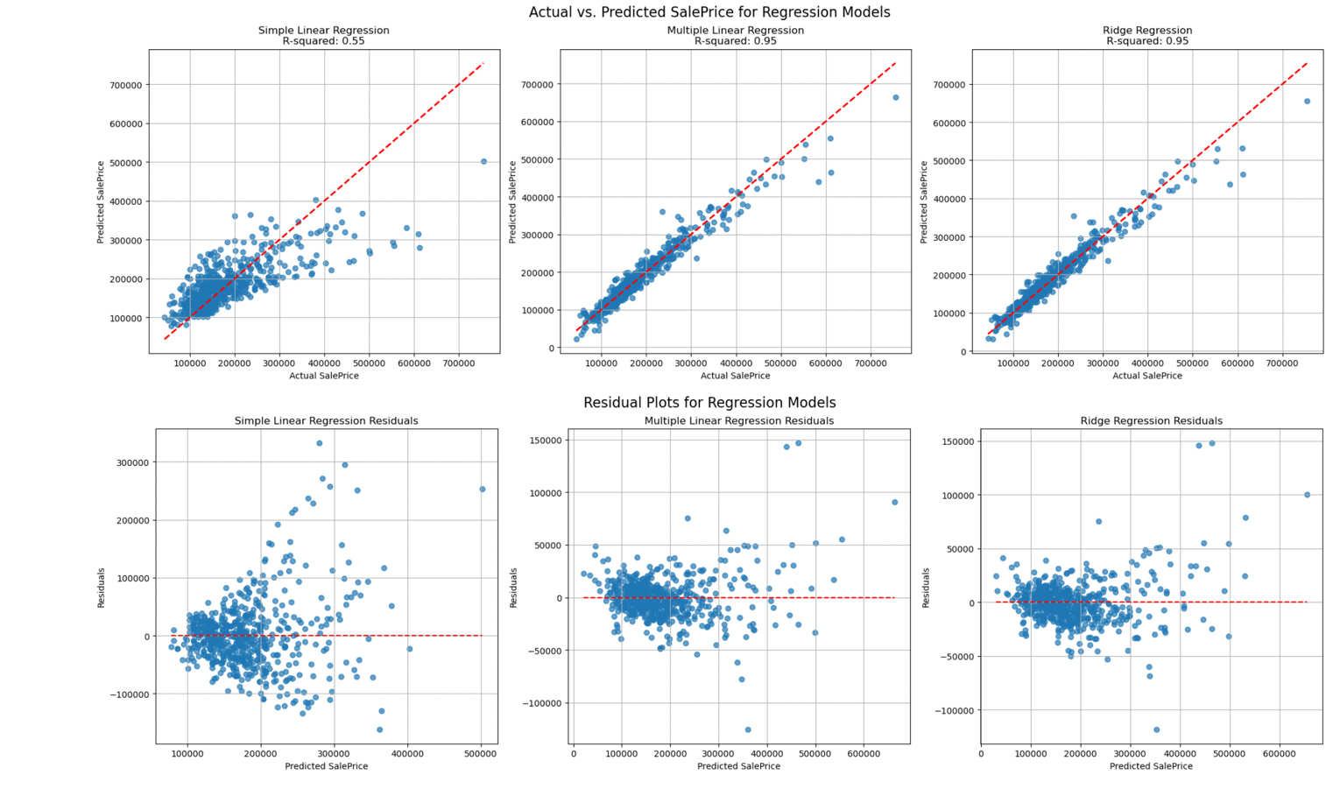
Fig 1. Regression Models
Visual Assessment of Actual vs. Predicted Plots (Top Row)
The top row is the Actual vs. Predicted SalePrice chart, the red dashed line is the perfect prediction.
- Simple Linear Regression: The points are spread apart around the red line far enough to have a reasonable fit. An R-squared of 0.55 also implies that, having all the features available, gross living area alone explains ~55% of the variance in SalePrice on what seems adequate to predict SalePrice with a reasonable degree of accuracy.
- Multiple Linear Regression: The points are a lot more bunched in around the red line specifically for the lower and medium-priced homes. With an R-squared value of 0.95, we have a clear improvement showing that the multiple features capture around 95% of the variance in SalePrice, and a much better representation of the relationships in the data.
- Ridge Regression: Like the Multiple Linear Regression, the points from Ridge Regression are very tightly clustered around the red line. The R-squared value of 0.95 is the same as in the other exploration. This is expected because Ridge is a linear regression, and its “use” is in a generalization sense, rather than being any different in-sample R-squared.
Visual Investigation of Residual Plots (Bottom Row):
The bottom row of plots shows the Residuals (Actual - Predicted) against the Predicted SalePrice. As a rule, the residuals should show a random scatter around zero with no apparent patterns.
- Residuals of the Simple Linear Regression: Simple Linear Regression Residuals have a clear pattern, because they look like a slight curve or are fanning out as the predicted prices increase. It suggests heteroscedasticity since one feature is clearly too limiting for the potential range of there to be systematic over- or under-predictions at some price ranges.
- Residuals of the Multiple Linear Regression Model: The Residuals for the Multiple Linear Regression model are much more evenly spread and randomly distributed around zero compared to the single-feature model. The issues of heteroscedasticity with a slight fanning out might still be present. This suggests that because it is a model with multiple features, it can more appropriately capture most of the linear relationships in the data well.
- Residuals of the Ridge Regression: The plot of residuals for Ridge Regression looks very similar to the Multiple Linear Regression, showing generally random scatter about zero. This indicates that regularization performs a good job of stabilizing coefficient estimates and not changing the basic linear relationship between SalePrice and the features (although the slight curve from the Multiple Linear Regression is still very visible, as expected with linear models).
Overall, it is clear from the progression from a simple linear model to multiple linear models, then to a regularized (Ridge Regression) model, that comprehensive feature engineering and regularization techniques can be advantageous for accurately predicting housing prices. In our case, Ridge regression was clearly the best candidate of all the models we explored, indicating it is more robust within the context of the characteristics of dataset and accuracy and generalizability on new datasets.
- Classification and Clustering
  - Classification Models
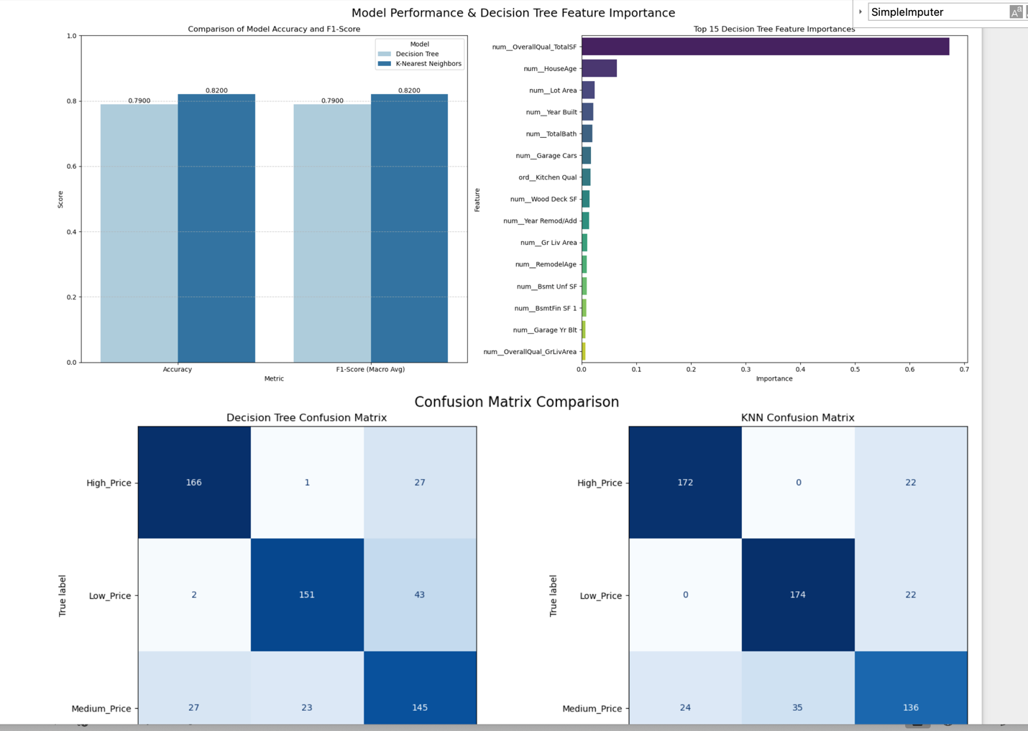
This section focuses on the construction and evaluation of classification models using the AmesHousing dataset, focusing on the classification of house prices into tiers.

Fig 2. Classification Models comparison

Model training and results
The results of the comparisons show the performance of the Decision Tree and K-nearest neighbours (KNN) models with respect to classification of the house prices into tiers (Fig 2).
- Model Overall Accuracy: KNN achieved an overall accuracy of 82.39%, slightly better than the Decision Tree the achieved an overall accuracy of 78.97% on the test set.
- Feature Importance (Decision Tree): On examining the Decision Tree feature importance, we found that the most useful feature was the engineered feature that took into consideration the overall quality and the overall square area, while house age and lot area followed, which suggests that these were the main differentiating features for classifying prices.
- Confusion Matrix Comparison: Both models performed very well and were able to classify "HighPrice" homes and "LowPrice" homes well. The "MediumPrice" classification was less accurate by the models in all the confusion matrices, and only the average misclassifications were more for the "MediumPrice" than for the other two categories of homes ("HighPrice" and "LowPrice"). For example, for Decision Tree, 27 homes were misclassified as "HighPrice" and 23 homes were misclassified as "LowPrice." For the KNN model, the results were similar, where homes were misclassified 24 as "HighPrice" and 35 homes were misclassified as "LowPrice." It appears the features for the "MediumPrice" homes had fewer distinguishing characteristics than the "HighPrice" homes and "LowPrice" homes.
Overall, the classification analysis of the AmesHousing dataset has shown that the K-nearest neighbors (KNN) model performed slightly better than the Decision Tree in overall test accuracy (82.39% vs. 78.97%), suggesting better generalization in classifying price tier. The KNN and Decision Tree models were both able to classify homes in the "HighPrice" and "LowPrice" tiers, however the results for the "MediumPrice" category showed significant misclassifications for both algorithms. These results suggest that the bounds for the medium price tier are not clearly defined - in other words, there are quite a few homes where their characteristics blend with the categories above and below the "MediumPrice" category. On the other hand, based on accuracy alone, the KNN and Decision Tree models achieved very similar macro-averaged F1-scores (0.82). This means that, per price category, both price classification models maintained very similar values of precision and recall.
  - Clustering Models
This section provides the results and critical insights obtained by applying clustering algorithms to the AmesHousing dataset, mainly focusing on how K-Means and Hierarchical Clustering cluster the data based upon "Overall Quality". Both clustering algorithms were configured to cluster the dataset into K=2 clusters as determined by Elbow method
Key Insights
Comparative results demonstrate how K-Means and Hierarchical Clustering clustered the data, primarily focusing on "Overall Quality", as well as how their clustered results are represented in a 2-dimensional space generated PCA.
Overall Quality by K-Means Cluster (K=2, Fig 3): Cluster 0 has a distribution of lower "Overall Quality" scores between 4 and 7 with a median of approximately 6. Cluster 1 has a distribution of much higher "Overall Quality" scores typically between 6 and 9 with some outliers for scores of 10. The algorithm successfully separated the dataset into two groups representing lower quality versus higher quality homes via "Overall Quality".
Overall Quality by Hierarchical Cluster (K=2, Fig 3): Similar to the K-Means results, Hierarchical Cluster 1 corresponds to lower "Overall Quality" scores, demonstrating a distribution very similar to K-Means Cluster 0. Hierarchical Cluster 2 corresponds to higher "Overall Quality" scores with a distribution that mirrors K-Means Cluster 1. This suggests that for K=2 both algorithms reveal very similar clusters based on the "Overall Quality" characteristic.
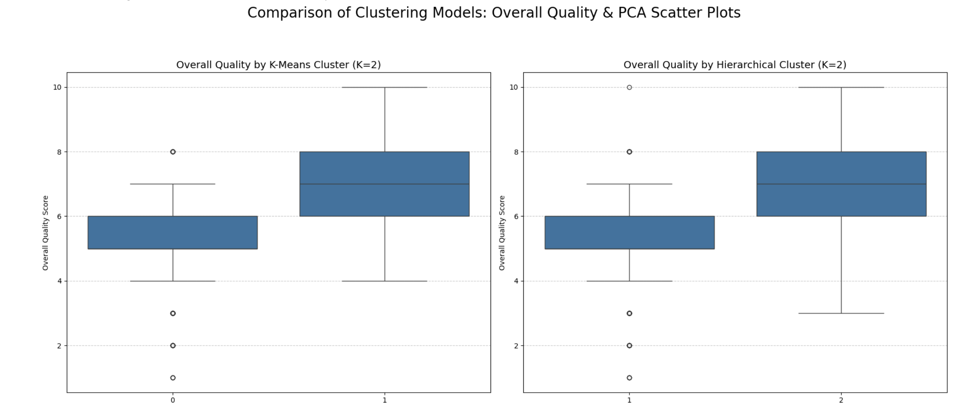
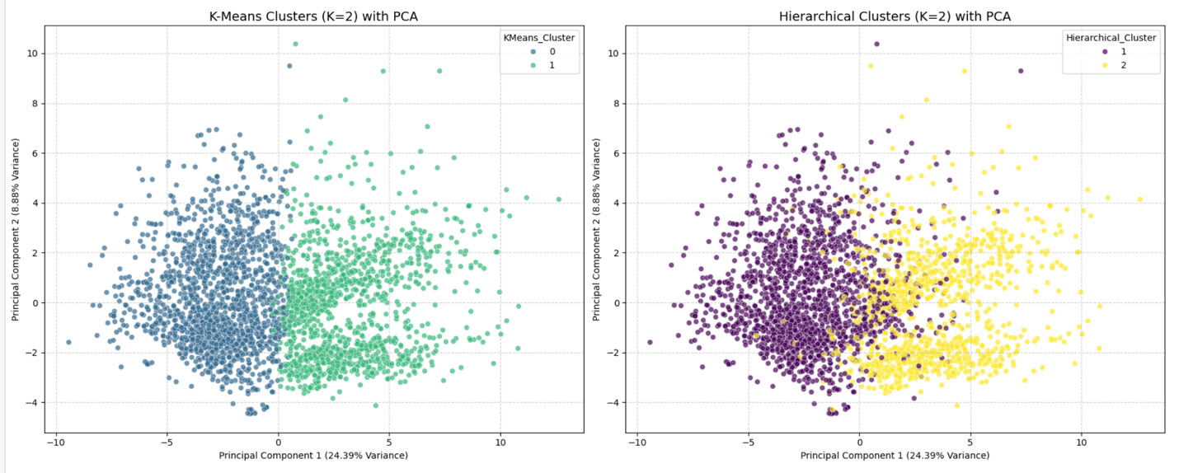
Fig 3. Clustering Box plot comparison
Fig 4. Clustering PCA scatter Plot
Furthermore, the scatter plots in Fig 4 depict the clustered data points in a 2-dimensional space, once again reduced from the original higher dimensional features via PCA.
K-Means Clusters (K=2) with PCA: The plot represented that data points were clustered into two distinct groups (blue and green) based on their K-Means cluster assignments. The clusters exist in a linearly separable representation space and appear to have well-defined boundaries of separation, suggesting that the K-Means algorithm neatly fit clusters in the data.
Hierarchical Clusters (K=2) with PCA: Similarly, the Hierarchical clustering also demonstrates how the clustered points have resulted in two clearly different groups (purple and yellow) in the same 2D PCA representation. The separation pattern demonstrated in the distribution of points and the point within clusters is nearly identical to that found in K-Means, further validating that the K-Means and Hierarchical algorithms are revealing similar properties of the underlying structure in the data, based on K=2 clusters.
Overall, since the target was K=2 and both clustering models (K-Means and Hierarchical Clustering) successfully partition the dataset into 2 clusters of meaning, and since one of these clusters defines properties of lower quality and the other of higher quality based on "Overall Quality", it follows that the separation in PCA indicates that these two partitions are distinct and identifiable clusters using either methodology.
- Ethical Issues
Machine learning models are increasingly being used to study sensitive datasets, such as housing prices. As with any use of sensitive data, we must consider the ethical implications. Predictive models are capable of encoding and amplifying biases already present in the provided training datasets, resulting in a potential discriminatory effect on people when the predictive model is used. For example, certain features may represent historical neighborhood conditions or sales prices that could reflect past redlining practices, or socio-economic imbalances that result in housing moment valuations that do not represent the true space's value. Also, complex models lack transparency. If we do not even understand how a model generates decisions, we could not identify and correct biases.
Models need to respect privacy and limit sensitive data sharing. One particularly concerning aspect of housing datasets is that they often contain personally identifiable information, which could place equity, safety, and security (e.g., how many things are there in this house that relates to my family) at risk. With that in mind, we need to monitor for fairness and be able to easily interpret model predictions and apply data governance.
- Recommendations
This study presented several considerations for future work. In the case of the AmesHousing dataset, we should investigate the "MediumPrice" classification problem more, such as through more advanced classification models, (e.g., Gradient Boosting, Support Vector Machines.) or develop more price tiers. In the case of regression, linear models performed well, especially when price average was 25k or more.
We can potentially develop non-linear regression models to understand complex variables that may reveal stronger predictive capability. For the UR3CobotOps dataset, the issues we identified, including multicollinearity and the time-series nature of the data, and more analysis and modeling algorithms best for timeseries data will be good. In the future, we could potentially integrate these models into a live monitoring system for UR3 Cobot operations. This could have numerous benefits for making instant decisions related to efficiency and safety.

References
Tyrovolas, M., Aliev, K., Antonelli, D., & Stylios, C. (2024). UR3 CobotOps [Dataset]. UCI Machine Learning Repository. https://doi.org/10.24432/C5J891.
Ames Housing Dataset. (n.d.). Kaggle. Retrieved from https://www.kaggle.com/datasets/shashanknecrothapa/ames-housing-dataset

