컴퓨터 네트워크(01) HW3

21300691 정원식

1. Client: HTTP version 1.1
2. 192.168.1.102
3. First: 200, Second: 404
4. Tue, 23 Sep 2003 05:29:50 GMT
5. 73 bytes
6. Date Information: Tue, 23 Sep 2003 05:35:00 GMT
7. 304 Not Modified

No, server didn’t return the contents of file explicitly. Because client had the file which client requested.

1. (1) nslookup

* nslookup www.mit.edu

return the name and IP address of the DNS server that provides the answer, and the IP address of requested domain name.

* nslookup -type=NS mit.edu

return authoritative DNS server’s domain name and IP address, and non-authoritative server’s(which has cache) domain name and IP address.

* nslookup www.aiit.or.kr bitsy.mit.edu
* send query to DNS server, get DNS server’s domain name and IP address, and the IP address of requested domain name(1st one).

(2) ipconfig

* ipconfig /all

Show my current TCP/IP information, including my address, and so on about my host.

* ipconfig /displaydns

Show cached records of DNS.

* ipconfig /flushdns

Flushing the DNS cache clears all entries and reloads the entries from the hosts file.

(3) Linux

nslookup -> dig

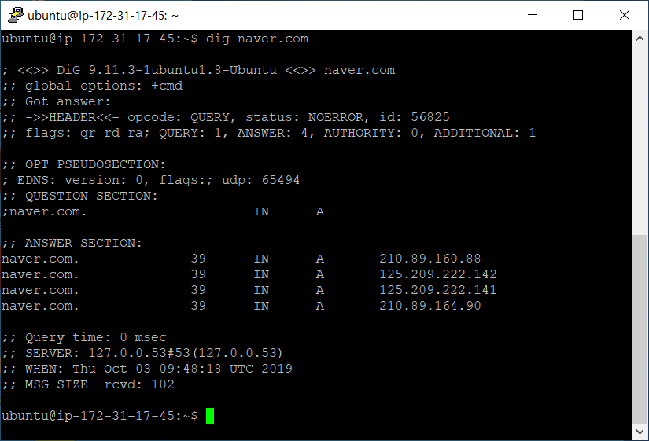

ipconfig -> ifconfig

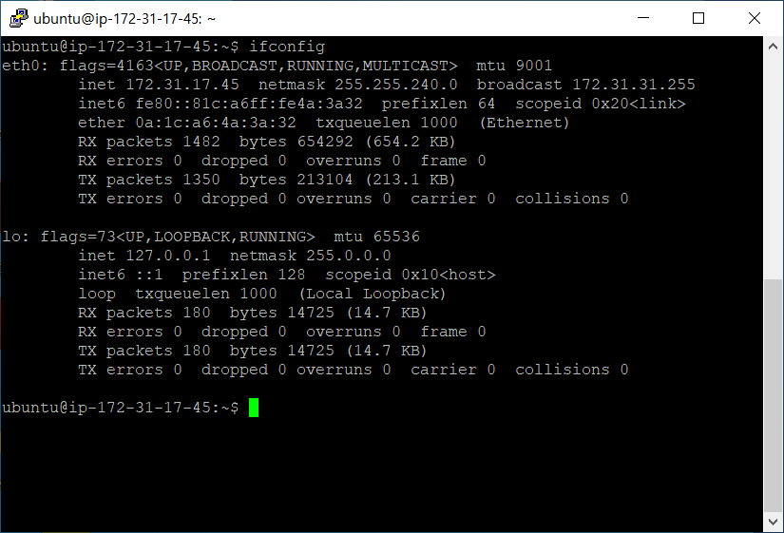

1. (1) use “ipconfig /flushdns”

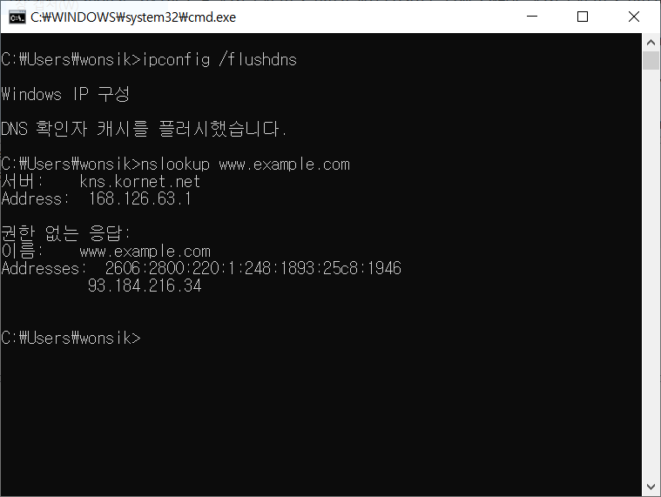

(2) filter: dns.qry.name == www.example.com

This filter catch packets which’s protocol is dns and query name is [www.example.com](http://www.example.com).

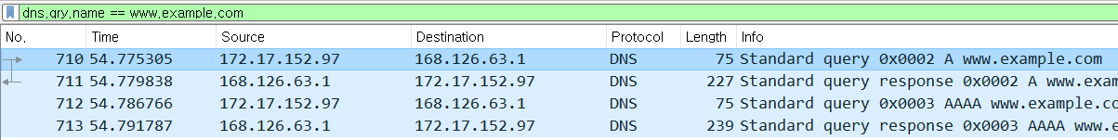

(3) packets

|  |  |  |  |  |  |
| --- | --- | --- | --- | --- | --- |
| No | Source | Destination | Protocol | Length | Info |
| 1 | 172.17.152.97 | 168.126.63.1 | DNS | 75 | standard query A www.example.com |
| 2 | 168.126.63.1 | 172.17.152.97 | DNS | 227 | standard query response A www.example.com |
| 3 | 172.17.152.97 | 168.126.63.1 | DNS | 75 | standard query AAAA www.example.com |
| 4 | 168.126.63.1 | 172.17.152.97 | DNS | 239 | standard query response A www.example.com |

No.1 packet is query about IPv4 of www.example.com from client to DNS server.

No.2 packet is response about IPv4 of www.example.com from DNS server to client.

No.3 packet is query about IPv6 of www.example.com from client to DNS server.

No.4 packet is response about IPv6 of www.example.com from DNS server to client.



(A) DNS query: No.1 and 3. DNS response: No.2 and 4. All of them uses UDP.

(B) Destination port for DNS query message and Source port for DNS response message: 53

(C) 168.126.63.1 which is DNS server.

(D) 2 types: A(IPv4), AAAA(IPv6). No answers are contained.

11. use “Upgrade” header like this. Upgrade: HTTP/2.0