|  |  |  |
| --- | --- | --- |
| **Web Service Development** | **Student**  **number** | **21300691** |
| **Homework 8** | **Name** | **Cheung, Won Sik** |

8_1

Code

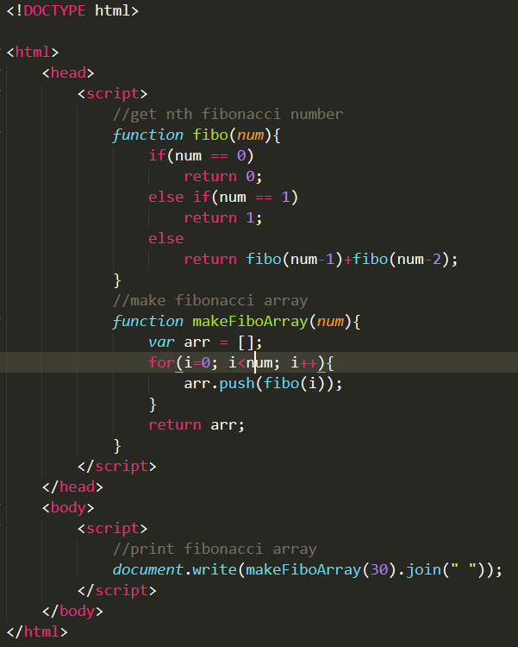

Result

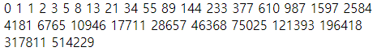

8_2

Code

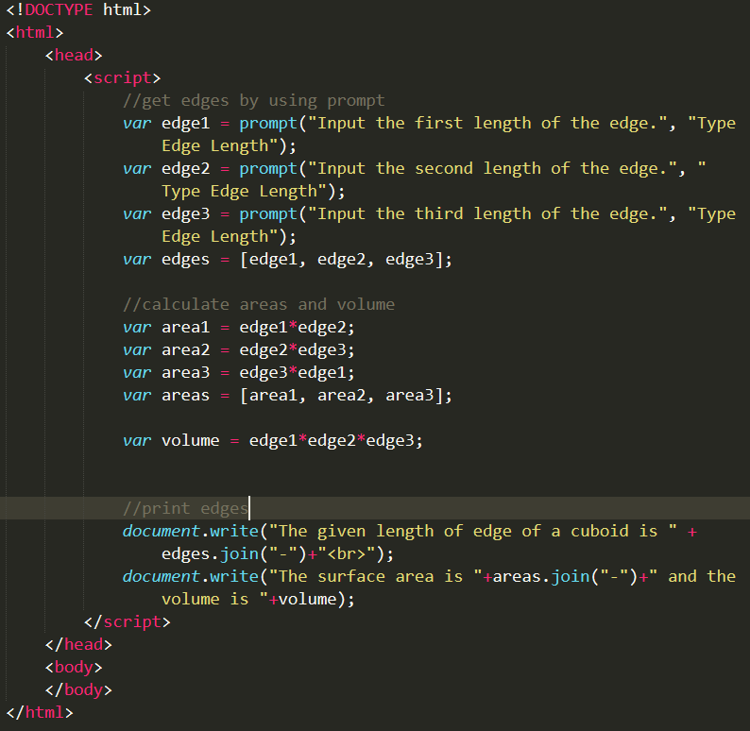

Result

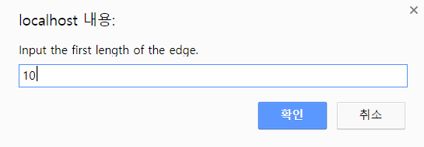

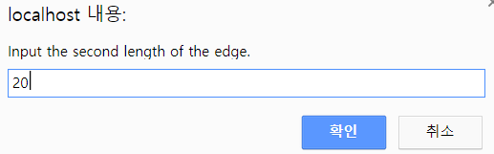

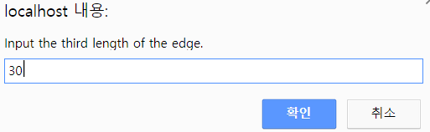

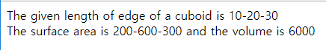

8_3

Code

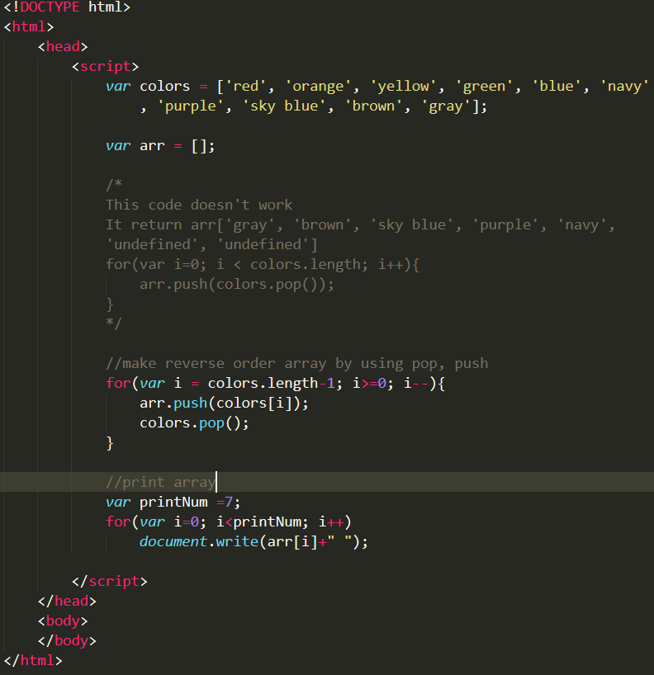

Result



8_4

Code

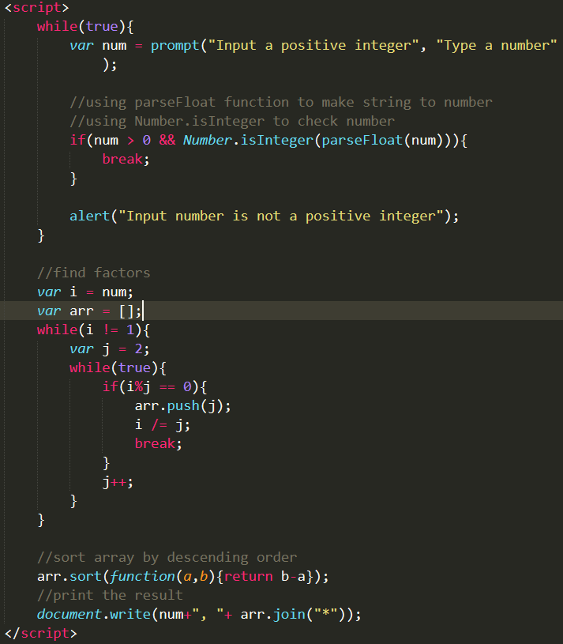

Result

