1. Use Case Diagram

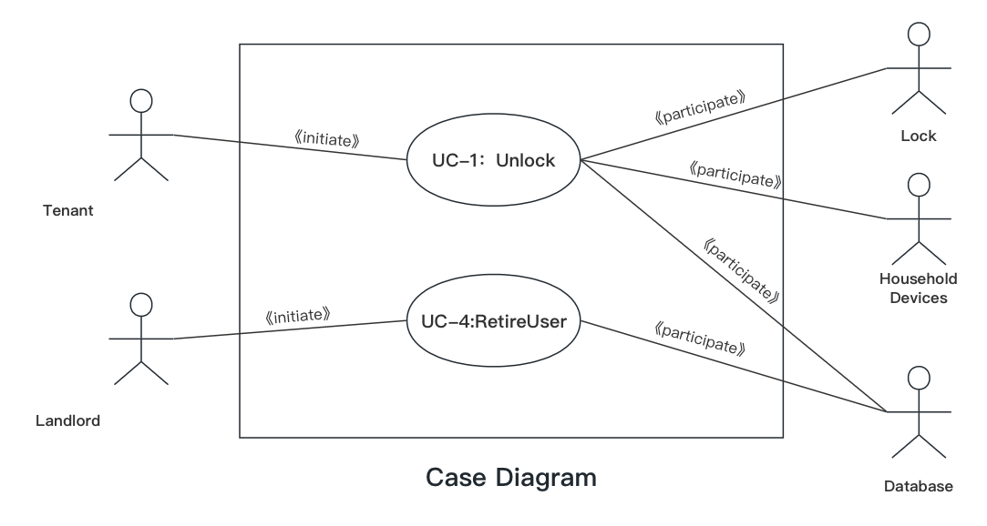

1. Use Case Schemas

|  |  |  |  |
| --- | --- | --- | --- |
| **Use Case UC-1:** | | | **Unlock** |
| **Related Requirements:** | | REQ-1, REQ-2, REQ-3, REQ-4, REQ-5 | |
| **Initiating Actor:** | | Tenant | |
| **Actor’s Goal:** | | To unlock the door and enter. | |
| **Participating Actors:** | | Lock, Household Devices, Database | |
| **Preconditions:** | | * The door is locked. * Some valid mobile devices identifier have been stored in the system database. * The door keypad is backlit if it’s dark for visibility. * The lock warns while trying too many times. | |
| **Postconditions:** | | * Start automatic lock timer. * The door is unlocked. | |
| **Flow of Events for Main Success Scenario:** | | | |
| →  ← | 1. **Tenant** arrives and chooses **Unlock** via mobile application. 2. **System** validates the request by checking the mobile device's authorization in the database. | | |
| ← | 1. **System** signals to the **Tenant** the lock status and logs the entry in the database. | | |
| → | 1. **Tenant** opens the door and enters. | | |

|  |  |  |  |
| --- | --- | --- | --- |
| **Use Case UC-4:** | | | **RetireUser** |
| **Related Requirements:** | | REQ-3, REQ-7 | |
| **Initiating Actor:** | | Landlord | |
| **Actor’s Goal:** | | To retire an existing user account and disable its access. | |
| **Participating Actors:** | | Database | |
| **Preconditions:** | | * The user required to be retired exists in the database. | |
| **Postconditions:** | | * The user’s account is removed from the database. * The devices associated with the users cannot unlock the door. | |
| **Flow of Events for Main Success Scenario:** | | | |
| →  ← | 1. **Landlord** started the **Database** management system and selects a user account to retire. 2. **System** validates the request and checks if the user account exists. | | |
| → | 1. **Landlord** deletes a user’s account and update the database. | | |

|  |  |  |  |
| --- | --- | --- | --- |
| **Use Case UC-4:** | | | **RetireUser** |
| **Related Requirements:** | | | REQ-3, REQ-7 |
| **Initiating Actor:** | | | Landlord |
| **Actor’s Goal:** | | | To retire an existing user account and disable its access. |
| **Participating Actors:** | | | Database |
| **Preconditions:** | | | * The user required to be retired exists in the database. |
| **Postconditions:** | | | * The user’s account is removed from the database. * The devices associated with the users cannot unlock the door. * The user’s account is removed from the database. * The devices associated with the users cannot unlock the door. |
| **Flow of Events for Main Success Scenario:** | | | |
| → | 1. | **Landlord** started the **Database** management system and selects a user account to retire. | |
| ← | 2. | **System** validates the request and checks if the user account exists. | |
| → | 3. | **Landlord** deletes a user’s account and update the database. | |
| **Flow of Events for Extensions (Alternate Scenarios):** | | | |
| → | 1a. | **Landlord** tries to retire a non-existent user account. | | 1a. Landlord tries to retire a non-existent user account. |
| ← | 2a. | **System** returns an error message stating that the user account doesn't exist. | |

1. Acceptance Tests

|  |  |  |
| --- | --- | --- |
| **Test-case Identifier:** | TC-1 | |
| **Use Case Tested:** | UC-1 | |
| **Pass/fail Criteria:** | The test passes if the Tenant successfully unlocks the door via the mobile application within the legal number of attempts | |
| **Input Data:** | Mobile devices identifier | |
| **Test Procedure:** | | **Expected Result:** |
| Step 1. Use an unauthorized mobile device to send command | | System warns to indicate failure;  records unsuccessful attempt in the database;  prompts the user to try again. |
| Step 2. Use an authorized mobile device to send command | | System plays a short piece of music to indicate success;  records successful access in the database;  unlock the door. |

|  |  |  |
| --- | --- | --- |
| **Test-case Identifier:** | TC-2 | |
| **Use Case Tested:** | UC-4 | |
| **Pass/fail Criteria:** | The test passes if the owner retires an existing user account and the devices associated with the user cannot unlock the door. | |
| **Input Data:** | Computer operation | |
| **Test Procedure:** | | **Expected Result:** |
| Step 1. Use an existing user account to retire | | The user account is removed from or disabled in the database. |
| Step 2. Use the retired account to open the door. | | System warns to indicate failure;  records unsuccessful attempt in the database;  prompts the user to try again. |
| Step 3. Use a non-existent user account to retire | | System returns an error message indicating the user account doesn't exist. |