**Sequence diagram for UC-1(Unlock)：**

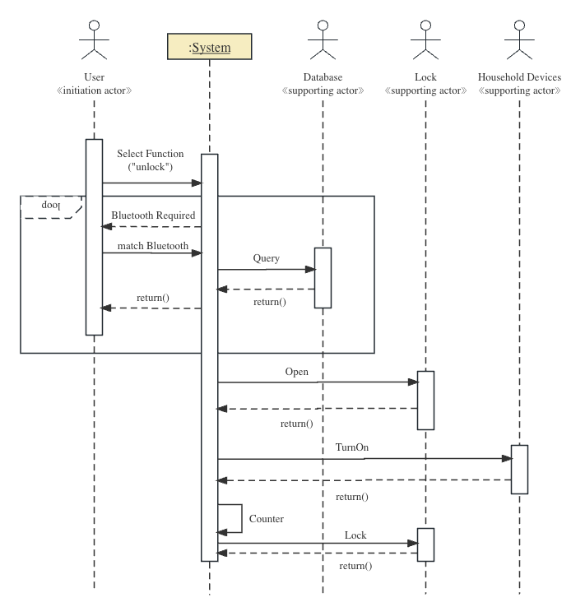

**Sequence diagram for UC-4(RetireUser)：**

**Activity diagram for UC-1(Unlock)：**

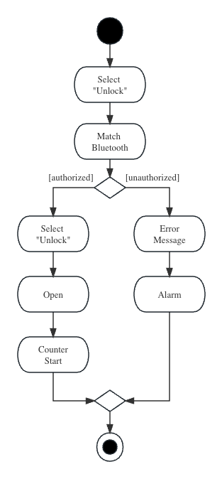

**Activity diagram for UC-4(RetireUser)：**

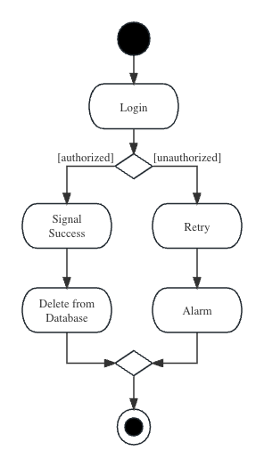

**Domain model for UC-4(RetireUser): CRC分析**

