XI’AN JIAOTONG-LIVERPOOL UNIVERSITY
西 交 利 物 浦 大 学
COURSEWORK SUBMISSION
COVER Page

Group Number | 39
Students' ID Number | 2360862 | 2360908
Module Code | CPT204
Assignment Title | CPT204 AY2526 Group Project
Submission Deadline | 2026/5/26
By uploading this coursework submission with this cover page, we certify the following:
 We have read and understood the definitions of collusion, copying, plagiarism, and dishonest use of data as outlined in the Academic Integrity Policy of Xi’an Jiaotong- Liverpool University.
 This work is entirely our own, original work produced specifically for this assignment. It does not misrepresent the work of another group or institution as our own.
 This work is not the product of unauthorized collaboration between ourselves and others.
 This work has not been shared wholly or in part outside of the group.
 It is a submission that has not been previously published, or submitted to any modules.
 Students who would like to submit the same or similar work from previous years to the current module or other modules must receive written permission from all instructors involved in advance of the assignment due date.
 All group members are equally and collectively responsible for the entire submission. Violations of academic integrity including failure to monitor group member contribution originality constitutes negligence.
 Unreported suspicious academic misconduct by one group member will be attributed to ALL members in terms of penalties. ALL members share the responsibilities.
 Use of generative AI is strictly prohibited for all assessments involved in this module.
We understand collusion, plagiarism, dishonest use of data, and submission of procured work are serious academic misconducts. All group members are held jointly accountable for the integrity
of the entire submission. By uploading or submitting this cover page, we acknowledge that we are jointly subject to penalties and disciplinary actions if we are found to have committed such acts.
~~~~~~~~~~~~~~~~~~~~~~~~~~~~~~~~~~~~~~~~~~~~~~~~~~~~~~~~~~~~~~~~~~~~~~~~~ We acknowledge that the university late submission policy will be applied if applicable.
~~~~~~~~~~~~~~~~~~~~~~~~~~~~~~~~~~~~~~~~~~~~~~~~~~~~~~~~~~~~~~~~~~~~~~~~~ Please list the ID number of any group member NOT contributing to the submission:

Please indicate whether based on your individual contributions you meet the learning outcomes covered by this coursework and confirm your submission meets with all above requirements by signing your name, handwritten in ink, in English (Foreign students) or PINYIN (local students):

Student ID | (tick) box to confirm you contributed to all cw tasks | (tick) box to confirm you meet all LOs covered by this cw | Signed
2360862 | ☑ | ☑
2360908 | ☑ | ☑ | 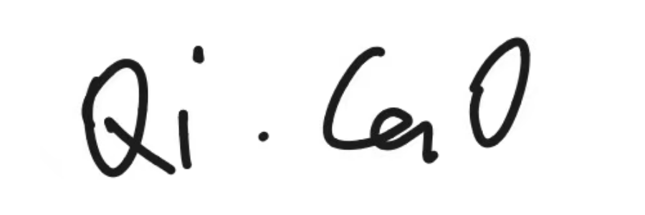

Date: 2026/05/26

Contents
Chapter 1 – Sorting Algorithm (Task A) 1
1.1 Implementation 1
1.1.1 Implementation of Sorting Algorithms 1
1.1.2 Task A Results 2
1.2 Analysis and Discussion 2
1.2.1 The Impact of Input Order on Sorting Performance 2
1.2.2 Three sorting algorithms’ performance and Dataset Characteristics 3
1.2.3 Which algorithm behaves most consistently across the three datasets? Why? 4
1.2.4 If only one algorithm could be used, which would you choose and why? 4
1.2.5 The most suitable for significantly larger dataset 5
1.2.6 Considering both runtime and memory usage, how does this affect your choice? 5
1.2.7 The selection of pivot in Quick Sort 6
Chapter 2 — Graph Algorithm (Task B) 7
2.1 Implementation 7
2.1.1 Graph Construction’s Implementation 7
2.1.2 Algorithm Implementation 7
2.1.3 Query I/O’s Implementation 8
2.2 Task B Query Results 9
2.3 Analysis and Discussion 9
2.3.1 Algorithm Choice and Rationale 9
2.3.2 Evaluating Time and Space Efficiency 10
2.3.3 Local vs Global Optimality 11
2.3.4 Alternative Algorithms under Varying Graph Conditions 11
(A). Unweighted Graph 12
(B). Large-Scale Graph Processing 12
(C). Node Coordinates Available 13
Chapter 3 — Design of the Overall Application (Task C) 13
3.1 Overall application design 13
3.2 Justification of Data Structure 13
3.1.1 Data structures for candidate location datasets 13
3.2 Classes and Functions 15
3.2.1 Classes collaborations in the workflow 16
3.3 Object-Oriented Design Principles and Importance 16
(1). Encapsulation 16
(2). Inheritance 17
(3). Polymorphism 17
(4). Abstraction 17
Chapter 4 Project Reflection (Task D) 18
4.1 AI-assisted planning and collaboration 18
4.2 Equality, Diversity, and Inclusion 19
4.2.1 Our understanding of EDI in the context of this project 19
4.2.2 EDI-based optimizations in the future 19
4.2.3 Challenges and Solutions 19
4.3 Life-long learning and future improvement 19
4.3.1 What this project taught about life-long learning 19
4.3.2 Our Contributions to Advanced Software Components in the Team Project 20
4.3.3 Next Steps for Future Development of This Application 20
Chapter 5 — Program Code 21
Chapter 6 — Appendix 70
Chapter 7 — Contribution Form 72

Chapter 1 – Sorting Algorithm (Task A)

1.1 Implementation

1.1.1 Implementation of Sorting Algorithms
In this task, we first created a class called Record to store the data. This class contains a private String variable locationId and a private int variable priorityScore, and public getter methods are provided to allow other classes to access their values safely. We also constructed a comparator to define the comparison logic between Record objects. The comparator first compares records by priorityScore in descending order. If two records have the same priorityScore, it then compares their locationId values in ascending order as a tiebreaker. This comparator is passed into each sorting algorithm so that Bubble Sort, Merge Sort, and Quick Sort all follow the same ranking rule. In this way, the comparison logic is separated from the sorting algorithms, making the implementation clearer and easier to maintain.
The pseudocode for the three sorting algorithms is shown below.
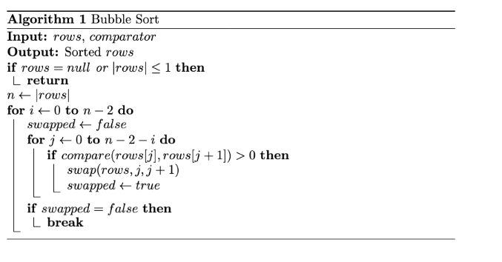  (a) Bubble Sort | 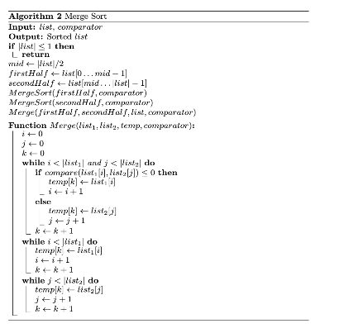  (b) Merge Sort | 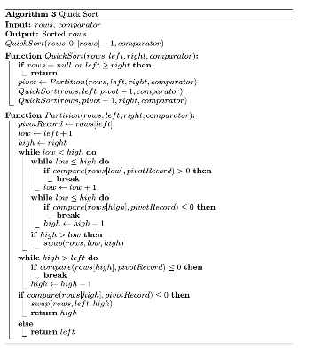  (c) Quick Sort
For Bubble Sort, we used a flag for optimization. The flag checks whether any swap occurs during a pass. If no swap occurs, the data is already sorted, so the algorithm can stop early. In the experiment, each algorithm was first run 50 times on each dataset as a warm-up. This was done to make the timing comparison fairer and more reliable. The warm-up process can reduce the influence of JVM start-up effects, class loading, bytecode interpretation, and just-in-time compilation. After the warm-up, each algorithm was executed 100 times on each dataset, and the average running time was calculated to reduce the effect of random fluctuations in a single run.

1.1.2 Task A Results
We evaluated the performance of three different sorting algorithms for the three datasets of candidate-location in the Urban Infrastructure Inspection System. The results are shown in Table 1 and Figure 1. The console output is shown in Appendix. In addition, the pivot for Quick Sort was simply selected as the first position in the array and the optimization of Quick Sort’s pivot selection will be analyzed in Section 1.3.7.
Dataset | Bubble (/ms) | Quick (/ms) | Merge(/ms) | Top 10 Selected Locations
Dataset A | 0.020 | 0.487 | 0.107 | L0001, L0002, L0003, L0004, L0005, L0006, L0007, L0008, L0009, L0010
Dataset B | 1.332 | 0.351 | 0.080 | L0101, L0102, L0103, L0104, L0105, L0106, L0107, L0108, L0109, L0110
Dataset C | 0.145 | 0.125 | 0.094 | L0201, L0202, L0203, L0204, L0205, L0206, L0207, L0208, L0209, L0210
Table 1. Sorting output and performance (in average speed) for the three required Sorter

1.2 Analysis and Discussion

1.2.1 The Impact of Input Order on Sorting Performance
The time complexity of Bubble Sort depends on whether the input data are already close to sorted. In the optimized version with a swapped flag, Bubble Sort can stop early if a full pass over the array produces no swaps. Therefore, its best-case time complexity is O(n), which occurs when the input data are already sorted or nearly sorted. However, in the average and worst cases, such as when the input data are randomly ordered or arranged in reverse order, Bubble Sort has a time complexity of O(n²), because it repeatedly traverses the array across multiple passes, compares adjacent elements, and performs many swaps.
The time complexity of Quick Sort is O(nlogn) on average, because the partitioning process usually divides the data into relatively balanced subarrays. However, Quick Sort is sensitive to input order. If the input data are nearly sorted and the pivot selection strategy is poor, the pivot may repeatedly divide the array into very unbalanced parts, causing the time complexity to degrade to O(n²).
The time complexity of Merge Sort is O(nlogn). The input order has little effect on its performance because Merge Sort always divides the array into two halves and then merges the elements back in order. Since there are about log n levels of recursion and each level requires O(n) time for merging, the overall time complexity remains O(nlogn) for nearly sorted, random, or duplicate-heavy data.

1.2.2 Three sorting algorithms’ performance and Dataset Characteristics
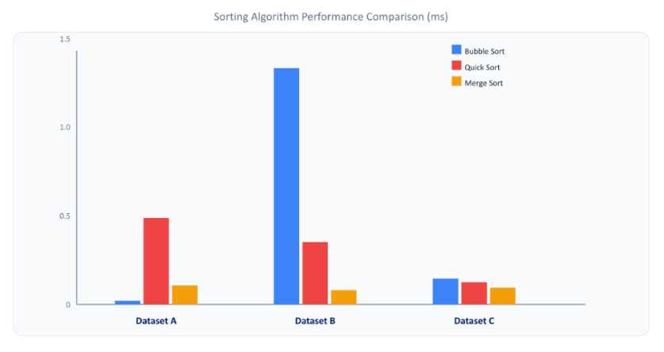
Fig.1. Result performances of three sorting algorithms on three candidate datasets
We check the ordering characteristics of the three datasets. Each dataset contains 1000 candidate records, but their ordering patterns are different:
- Dataset A is nearly sorted under the required ranking rule, with priority_score mostly in descending order and only a small number of records not following this order.
- Dataset B is largely randomly ordered. The data are not arranged according to the required ranking rule of descending priorityScore, with locationId used as the ascending tiebreaker.
- Dataset C is also partially ordered. The priorityScore values are generally arranged in descending order, but there are many duplicate values. For records with the same priorityScore, the locationId values are not consistently sorted in ascending order for tie-breaking.
For Dataset A, Bubble Sort is the fastest algorithm. Dataset A is nearly sorted and only a small number of elements are out of order, which is close to the best-case scenario for Bubble Sort. As a result, the optimized Bubble Sort with a swapped flag can stop early when no swaps occur in a full pass. In contrast, Merge Sort and Quick Sort still need to process the whole dataset, with an average time complexity of O(nlogn). Therefore, Bubble Sort performs best on Dataset A.
For Dataset B, Merge Sort is the fastest algorithm. Since Dataset B is randomly ordered, Bubble Sort needs to traverse the whole dataset across multiple passes, resulting in a time complexity of O(n²). Merge Sort and Quick Sort both have an average time complexity of O(nlogn), so they are generally more efficient than Bubble Sort on randomly ordered data. However, the speed of Quick Sort also depends on the choice of pivot. In our implementation, the first element is simply chosen as the pivot, which may negatively affect its runtime. Further analysis of this issue will be discussed in Section 1.2.7.
For Dataset C, Merge Sort is the fastest algorithm. The priorityScore values in Dataset C are already in descending order, but there are many duplicate values. So, the order of the data having same priorityScore needs to be sorted by random locationId. Merge Sort can handle this situation efficiently with a stable O(nlogn) time complexity. However, for Bubble Sort, the swaps operations are far less than Dataset B because only the data with same priorityScore need to be compared and sorted. As a result, the running time of Bubble Sort is close to the other two algorithms.

1.2.3 Which algorithm behaves most consistently across the three datasets? Why?
Merge Sort behaves the most consistently across the three datasets. It is based on the divide-and-conquer strategy, where the original array is repeatedly divided into two subarrays until smaller subproblems are formed. These subarrays are then sorted and merged back together. Since Merge Sort always performs about log₂n levels of division and processes all n elements during each merging level, its overall time complexity is O(nlogn). Therefore, its running time mainly depends on the input size rather than the initial order of the data.
In contrast, as discussed in Section 1.2.1, the input order has a greater influence on Bubble Sort and Quick Sort. Bubble Sort performs much better when the data are nearly sorted (Dataset A), but its running time increases significantly for randomly ordered data (Dataset B). Quick Sort is also affected by the choice of pivot. When the first element is used as the pivot, it may perform poorly on sorted or nearly sorted data, such as Dataset A and Dataset C, because the partitions can become unbalanced. However, for randomly ordered data (Dataset B), the partitions are usually more balanced, so its running time is generally more stable.
In conclusion, Merge Sort shows the most stable performance across the three datasets.

1.2.4 If only one algorithm could be used, which would you choose and why?
Among the three options, the best average runtime, the most stable behavior, and the simplest implementation, we would choose the algorithm with the most stable behavior. Stable behavior means that the algorithm is less affected by changes in input order or input characteristics, so its performance is more predictable and consistent.
When selecting an algorithm for a real system, we should not only focus on the best average runtime. In real applications, input conditions can vary, and not all datasets will satisfy the best-case scenario. Therefore, both average-case and worst-case performance should be considered.
Although the simplest implementation is easier to understand and implement, it does not always guarantee reliable performance. Since performance is essential in real-world systems, stable behavior is the most suitable choice.

1.2.5 The most suitable for significantly larger dataset
As the input size grows, Bubble Sort becomes less suitable because its time complexity is O(n²). This means that its running time increases quadratically as the dataset becomes larger. Merge Sort and Quick Sort are both more suitable for large datasets because their average time complexity is O(nlogn). Since n² grows much faster than nlogn, both algorithms are generally much more efficient than Bubble Sort when the dataset becomes significantly larger.
During the selection between Merge Sort and Quick Sort, Merge Sort is more suitable if runtime stability is the main concern. Merge Sort always has a time complexity of O(nlogn), and its performance is less affected by the initial order of the input data. In contrast, the performance of Quick Sort can be affected by the choice of pivot. However, Merge Sort requires additional memory space to store temporary subarrays during the merging process. This may become a challenge when the dataset is very large. Quick Sort usually requires less extra memory because it sorts the data mainly in place.
In conclusion, Merge Sort would be chosen when runtime stability is the main priority for a significantly larger dataset. However, if memory usage is also considered, Quick Sort may become a better choice because it is more space efficient. This problem will be analyzed in more detail in the next section.

1.2.6 Considering both runtime and memory usage, how does this affect your choice?
When both runtime and memory usage are considered, Bubble Sort is still not suitable for a significantly larger dataset. Although Bubble Sort has a space complexity of O(1), its time complexity is O(n²), so its runtime performance becomes poor when the input data are large, especially when they are randomly ordered.
Merge Sort has stable O(nlogn) runtime performance, but it requires additional memory space to store temporary subarrays during the merging process. Its space complexity is O(n), because extra arrays are needed to hold the divided subarrays and merged results. When the dataset is very large, this additional memory requirement may become a challenge, especially if the system has limited memory resources. In contrast, Quick Sort usually requires less extra memory because it sorts the data mainly in place.
As a result, Quick Sort would be the most suitable choice for a significantly larger dataset when both runtime efficiency and memory usage are considered, as long as a good pivot selection strategy is used.

1.2.7 The selection of pivot in Quick Sort
To optimize the runtime efficiency of Quick Sort, five pivot selection strategies are tested: left pivot, middle pivot, right pivot, middle of three and random pivot with seed = 42. The results are shown in Figure 2. The console output is shown in Appendix. It can be observed that different pivot selection strategies can lead to clear differences in runtime performance.
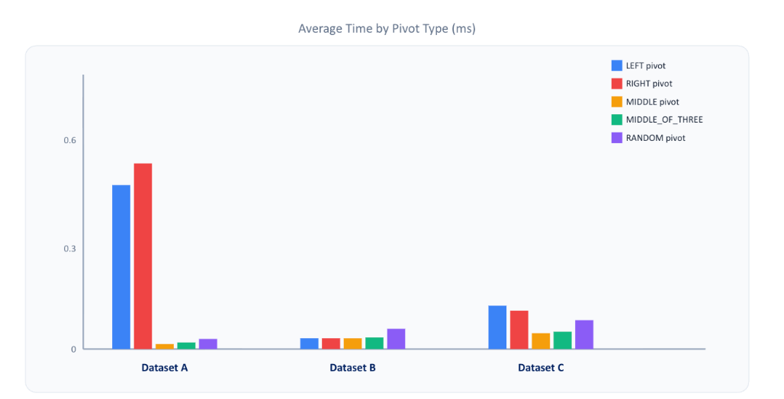
Fig.2. Performance of 5 Pivot selection strategy on three datasets
For Dataset A, which is nearly sorted, choosing the left or right element as the pivot performs poorly. This is because the pivot is likely to be close to the smallest or largest element, which can create highly unbalanced partitions. As a result, Quick Sort requires more recursive calls and the running time increases. In contrast, choosing the middle or random element as the pivot produces more balanced partitions, so the runtime is much lower.
For Dataset B, the data are largely randomly ordered. In this case, the choice of pivot has a smaller impact because the first, middle, right, or random element is less likely to consistently produce extremely unbalanced partitions. Therefore, the runtime differences between the pivot strategies are relatively small.
For Dataset C, the data are partially ordered, with priorityScore mostly in descending order and many duplicate values. In this situation, choosing the left or right element as the pivot can still lead to less balanced partitions, while the middle pivot performs better because it is more likely to divide the data into more balanced subarrays.
Overall, the results show that pivot selection is important for Quick Sort. A poor pivot choice can significantly reduce the efficiency of Quick Sort, especially when the input data are already sorted or partially ordered. Therefore, using the middle pivot or a middle of three pivot strategy is generally more reliable than always choosing the left or right element as the pivot.

Chapter 2 — Graph Algorithm (Task B)

2.1 Implementation

2.1.1 Graph Construction’s Implementation
The Graph Construction can be divided into two main stages: data reading and graph construction. For data reading, we use BufferedReader to read the paths.csv row by row and extracts from_location, to_location, and weight triplets of each entry. After obtaining this information, we use it to construct the graph. The graph is represented using an adjacency list data structure, which is implemented as HashMap<String, List<Edge>>. In this structure, each key represents a location, and its corresponding value stores a list of edges connected to that location. We use the addUndirectedEdge method to add each edge to both endpoints. This means that if there is an edge from location A to location B, the same connection is also added from location B to location A. This ensures that the graph can be traversed correctly from either direction.

2.1.2 Algorithm Implementation
We choose Dijkstra’s algorithm to handle single-source shortest path (SSSP) queries. The rationale for this choice will be explained in Section 2.3.1. The pseudocode for the algorithm is shown below.
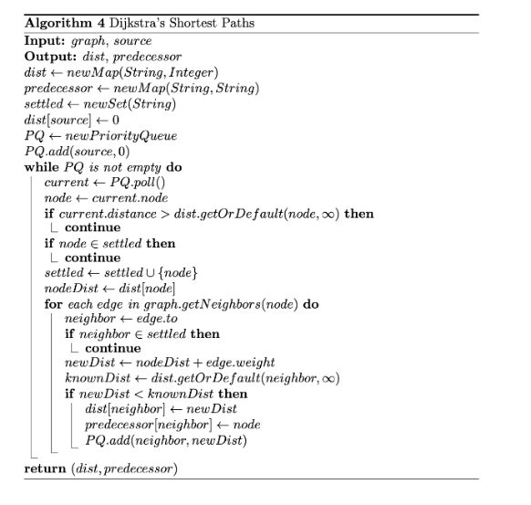
In this implementation of Dijkstra’s algorithm, we use a PriorityQueue to store candidate nodes that have not yet been processed, ordered by their current distance from the source. The queue ensures that the next node with the minimal distance can be extracted efficiently in O(log n) time, which is a core requirement of Dijkstra’s algorithm. To further optimize the algorithm, we use a lazy-deletion strategy: whenever a shorter path to a node is found, a new Entry is added to the priority queue, and old "stale" entries are skipped during the poll() phase. This ensures that Dijkstra only processes the most up-to-date minimum-cost entries, maintains O(ElogV) time complexity, and bypasses the lack of a decreaseKey operation in Java's PriorityQueue.

2.1.3 Query I/O’s Implementation
To handle all query cases consistently and to strictly satisfy the required output specification, we implemented a set of supporting classes: PathQuery, PathResult, QueryOutcome, and PathFormatter. Their logic can be explained through two main processes: query decomposition and result wrapping.
In the query decomposition stage, PathQuery stores the query name together with an ordered List<String> of waypoints, where the first element represents the start node, the last element represents the destination node, and any intermediate elements represent required waypoint. It interprets a multi-node request as a sequence of independent atomic shortest path subproblems between consecutive waypoints.
During each shortest-path computation, the algorithm returns a PathResult object. It stores the computed results using data structures such as Map<String, Integer> for shortest-path distances and Map<String, String> for predecessor relationships. As each segment is solved, PathQuery appends the resulting nodes into a List<String> representing the full route, while also accumulating the total path cost in an integer variable. When joining consecutive segments, duplicate junction nodes are removed to keep the final route continuous and correctly formatted.
After all segments have been processed, the complete path and the total path cost are wrapped into a QueryOutcome object. This class serves as a compact result container, holding the original query, the final List<String> path, and the total cost. Finally, PathFormatter converts the QueryOutcome into the required output format, presenting the query name, start node, destination node, any required waypoint(s), the final path in the form L0001 -> L0002 -> ..., and the total path cost.

2.2 Task B Query Results
The four required query cases were executed with the Dijkstra’s Algorithm. The console output is shown in Appendix, and the same results are summarized in Table 2.
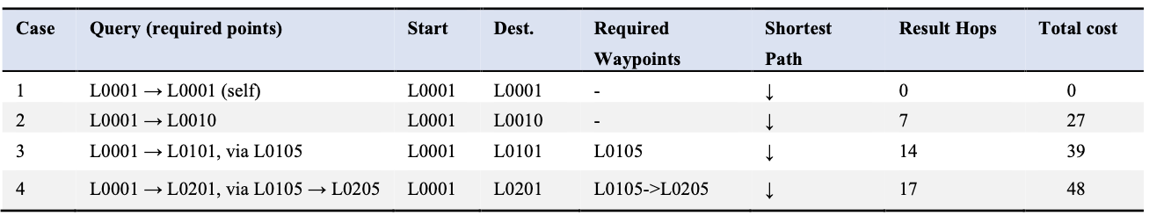
Table 2. Shortest-path results for the four required query cases (Cases 1–4)

2.3 Analysis and Discussion

2.3.1 Algorithm Choice and Rationale
We use Dijkstra’s algorithm in our program to solve a single-source shortest path (SSSP) problem. The graph defined by paths.csv is undirected, with edges weighted by non-negative road distances, and consists of 1000 nodes covering the entire infrastructure network.
BFS and DFS ignore edge weights and therefore cannot minimize path cost, so they are unsuitable. Prim's MST, Bellman–Ford, and Floyd–Warshall are correct algorithms, but unnecessary here since only single-pair queries are required and all edge weights are non-negative.
In contrast, Dijkstra's algorithm computes the minimum-cost path under these conditions. Its core edge relaxation operation—updating a node's distance when a shorter path is found—will fail if negative edge weights are present. Moreover, the graph contains 1000 nodes and 2600 edges, making it relatively sparse. Using Dijkstra’s algorithm with a priority queue (min-heap) is well-suited, as the min-heap efficiently extracts the next node with minimal distance, and the overall time complexity of O((V+E)logV) is appropriate for sparse graphs.

2.3.2 Evaluating Time and Space Efficiency
Our program implements Dijkstra’s algorithm, as detailed in Section 2.1.2. The pseudocode below is annotated with primitive operation counts - each line marked with its space cost (left) and time cost (right); then the efficiencies are concluded by summing these operations. V denotes the total number of vertices and E denotes the total number of edges.
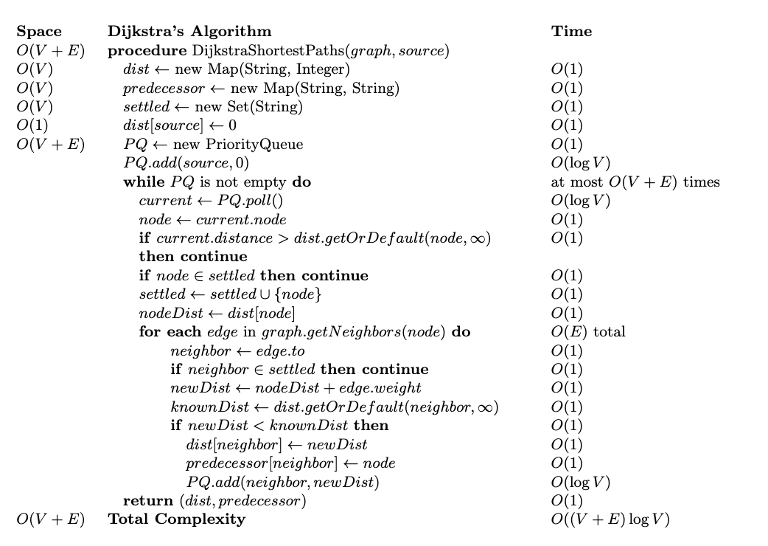
Time Complexity: O( (V+E) logV)
In this implementation, Dijkstra’s algorithm’s performance is primarily determined by two operations: polling the next node from the priority queue and performing edge relaxation. In each iteration, the algorithm polls the node with the smallest tentative distance from the min-heap, which costs O(logV) per poll. After retrieving the node, edge relaxation is applied to all its outgoing edges: for each neighbor, the algorithm checks if a shorter path exists, updates the distance if necessary, and inserts a new Entry into the priority queue, each insertion also costing O(logV). Together, these operations — polling the current minimal-distance node and relaxing edges — are repeated for all vertices and edges. With V vertices and at most E edges, the overall time complexity of Dijkstra’s algorithm is therefore O((V+E)logV).
Space Complexity: O( V+E )
The graph is represented using an adjacency list, which requires O(V+E) space. During our algorithm execution, we maintain a map for each vertex’s shortest known distance, a map for predecessor nodes, and a set of settled vertices. With V vertices, these structures use O(V) space. Additionally, a priority queue stores candidate edge entries, which in the worst case can contain O(E) entries. Therefore, the total space complexity of the implementation is bounded by O(V+E).

2.3.3 Local vs Global Optimality
No. Solving each shortest-path query optimally does not mean that the whole inspection-planning problem is solved optimally. In our problems, the start node, destination node, and required waypoint order are already fixed, so solving each segment optimally does give the optimal route for that specific query. For example, if a query must go from A1 to B1 via B5, then finding the shortest path for A1 -> B5 and the shortest path for B5 -> B1 gives the optimal route for that fixed ordered query, because the total cost is additive.
However, in the whole inspection-planning problem, the start node, destination node, and waypoint order are not fixed in advance. A set of locally optimal shortest-path results does not guarantee the best overall inspection plan, because the globally optimal solution may require a different selection of inspection targets or a different visiting order.
Therefore, shortest-path algorithms alone can only optimize fixed path segments, not the entire inspection plan. To solve the whole inspection-planning problem optimally, additional route-planning methods such as Travelling Salesman Problem-style optimization would be needed.

2.3.4 Alternative Algorithms under Varying Graph Conditions
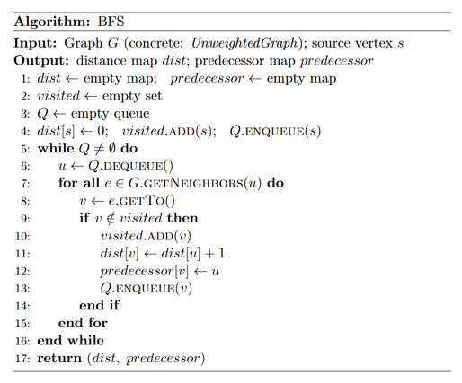 | 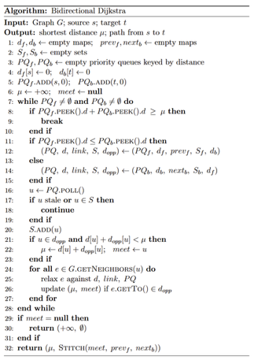 | 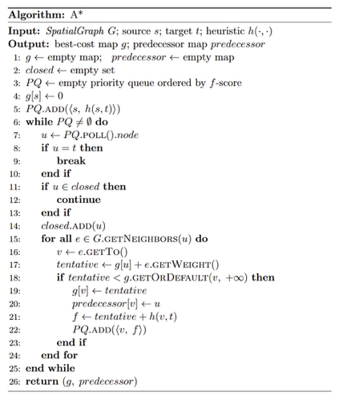

(A). Unweighted Graph
If the weighted graph is changed to an unweighted graph, the shortest paths are determined by the minimum number of edges. In this scenario, Breadth-First Search (BFS) and Depth-First Search (DFS) are considered as alternatives:
BFS: Breadth-First Search is the optimal choice for unweighted graphs. The pseudo code is shown above. It explores nodes level by level and guarantees the shortest path in terms of edge count. Starting from a given vertex, BFS explores all neighboring vertices first and adds them to a simple FIFO queue. Since all edges in an unweighted graph have the same cost, a PriorityQueue is not necessary. The FIFO queue used in BFS is sufficient to ensure that nodes closer to the source are processed before nodes that are farther away. Therefore, BFS has a time complexity of O(V+E). As a result, BFS is more suitable for this condition.
DFS: Depth-First Search explores nodes by following one path as deeply as possible before backtracking. This guarantees that every node is eventually visited, giving it linear time complexity O(V+E) and relatively low memory overhead. However, DFS does not guarantee minimal edge count paths, because it may first reach a node through a longer path before exploring shorter alternatives. To find the true shortest paths for all nodes from a source, DFS would need to explore all possible paths, which is computationally infeasible for large graphs. Therefore, DFS is unsuitable for this condition.

(B). Large-Scale Graph Processing
If the graph scale increases significantly, Dijkstra’s algorithm may perform numerous comparisons and heap operations on nodes that are not immediately relevant to the shortest path, which can reduce efficiency. Therefore, we consider using Bi-directional Dijkstra to improve performance. The pseudo code is shown above.
Bidirectional Dijkstra runs two simultaneous searches from the source and target and meet in the middle. This reduces the search space from a single large circle of radius d to two smaller circles of radius d/2 and can effectively downscale the number of settled nodes. However, one limitation is that this approach doubles the memory overhead for state tracking and is only applicable when the destination is known before the search begins.

(C). Node Coordinates Available
If the coordinates of nodes are available, the graph can be treated as a spatial network, enabling the use of heuristic- or geometry-informed algorithms. Having coordinates allows us to estimate the straight-line distance from any node to the goal, which can guide the search more efficiently than iterating over all edges blindly.
Under this condition, we consider using the A* algorithm. The pseudo code is shown above. The total cost function of A* is composed of two parts:
f(n)=g(n)+h(n)
where g(n) represents the actual cost from the start node to node n, like what Dijkstra computes, and h(n) is the heuristic estimate of the cost from node n to the goal, computed using the coordinates of the nodes.
One limitation of this algorithm is its reliance on the heuristic function h(n). If the heuristic provides an inaccurate estimate, it can significantly affect both the efficiency of the search and the optimality of the resulting path.

Chapter 3 — Design of the Overall Application (Task C)

3.1 Overall application design
In the overall application, Task A and Task B are connected through a CSV file. After Task A is completed, a CSV file called results.csv is generated to store the top 10 candidates selected from each of the three datasets. Then, Task B reads this CSV file to obtain the 30 selected inspection targets as its input. This made the connection between the two tasks clearer and helped ensure that the data transfer process was consistent and easy to check.

3.2 Justification of Data Structure

3.1.1 Data structures for candidate location datasets
Decisions for ADT and concrete class: For each candidate, we define a Record class to encapsulate its information. Each Record instance contains two variables: a String variable locationId and an int variable priorityScore. Both fields are private final and are exposed only through getters. After reading each CSV file, all its candidate records are stored in a list ADT, implemented by an ArrayList<Record>. For ranking, we have a RecordComparator which implements Comparator<Record>, and it encodes the required ranking rule by priority value.
Justification for selection: For efficiency aims, we chose ArrayList<Record> over LinkedList<Record> or Record[]. We rejected LinkedList<Record> because its getter and setter are both O(n); we rejected raw array Record[] because it performs poorly for both time and space complexity, and it doesn’t support dynamic resize. However, ArrayList can provides O(n) time for n-element construction, and O(1) time for access, which is key for supporting sorters’ efficiency. For clarity, by implementing RecordComparator, the three sorters only call comparator.compare(a, b). This is a strategic step to separate comparison rule from sorting execution. Also, the encapsulation of Record class can nicely define its responsibility. A Record is a container for each unbreakable pair, and it enhance readability and correctness.
3.1.2 Data Structures for Weighted Graph
Decisions for ADT and concrete class: for graph entity’s representation, we defined a WeightedGraph class implementing our Graph interface, and inside it we used a HashMap<String,List<Edge>> to implement Adjacency List ADT for storage. Meanwhile, we implemented a BufferedReader inside class GraphReader, to read the paths.csv row by row and extracts (from_location, to_location, weight) triplets of each Edge in Graph.
Justification for selection: For efficiency aims, we first identified that the graph is very sparse, average degree of node is very low. To implement the Adjacency List data structure, we considered several alternatives. Firstly, we rejected Adjacency Matrix (int[V][V]) because a sparse graph would waste memory space as most matrix cells will be empty. A flat List<Edge> is also not applicable, because every neighbor lookup would force an O(E) linear scan, so it is unusable in the inner search loop. Instead, we eventually used a HashMap<String,List<Edge>>. In the table below, we summarized efficiency of its related operations.
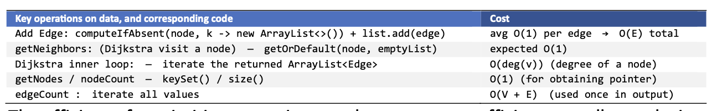
The efficiency for primitive operations is key support to efficient overall complexity. For clarity: as we code by following standards like comparator rules, or declaring as Map and then instantiate with HashMap, we ensured efficiency and maximized readability and facilitated future code reuse, if the system is further developed.

3.2 Classes and Functions
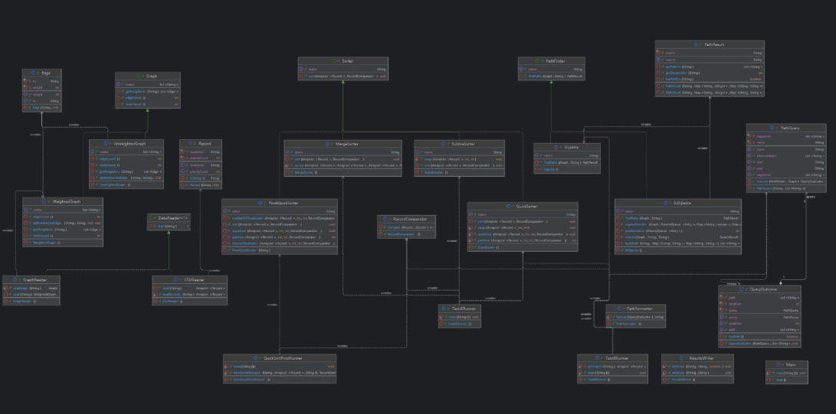
Fig.3. Classes Overview
Figure 3 shows an overview on classes. Figure 4 demonstrates two class diagrams which display the two tasks' major interfaces, classes and their key functions. In the diagram, associations between classes show their behavior and tasks, and thereby defines their responsibility scope. More details on each class's objectives are given in a summary table in Appendix.
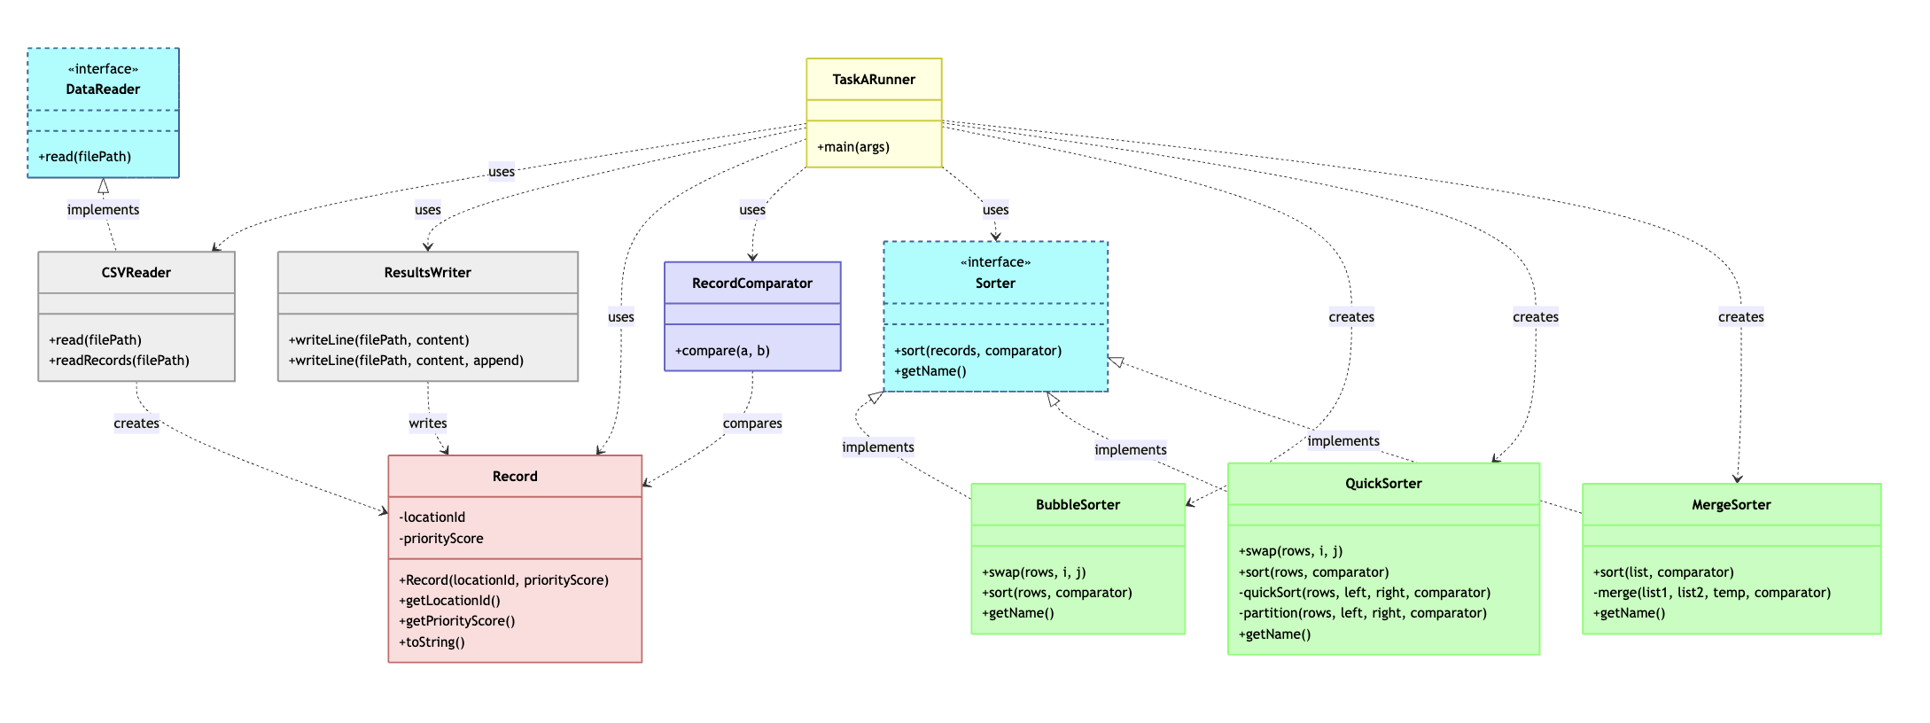
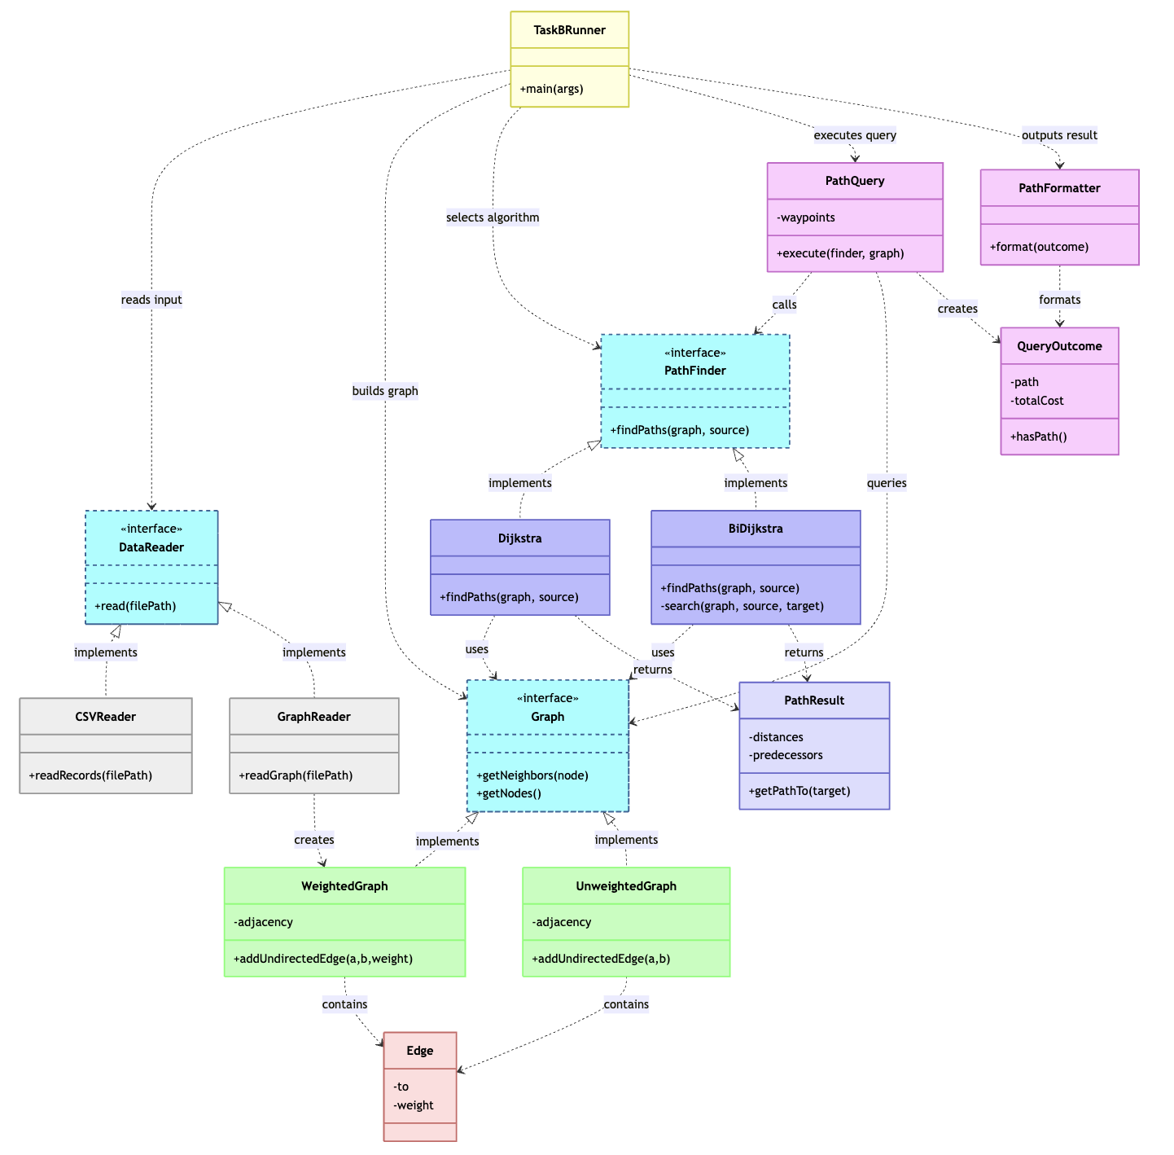
Fig.4. UML diagrams of important classes and interfaces of Task A and B

3.2.1 Classes collaborations in the workflow
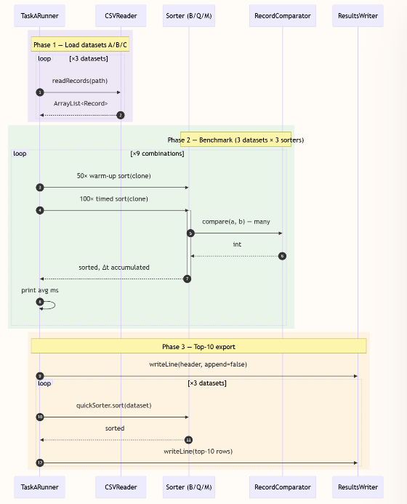  Fig.5(a). Workflow of Sorting subsystem and top 10 selection | 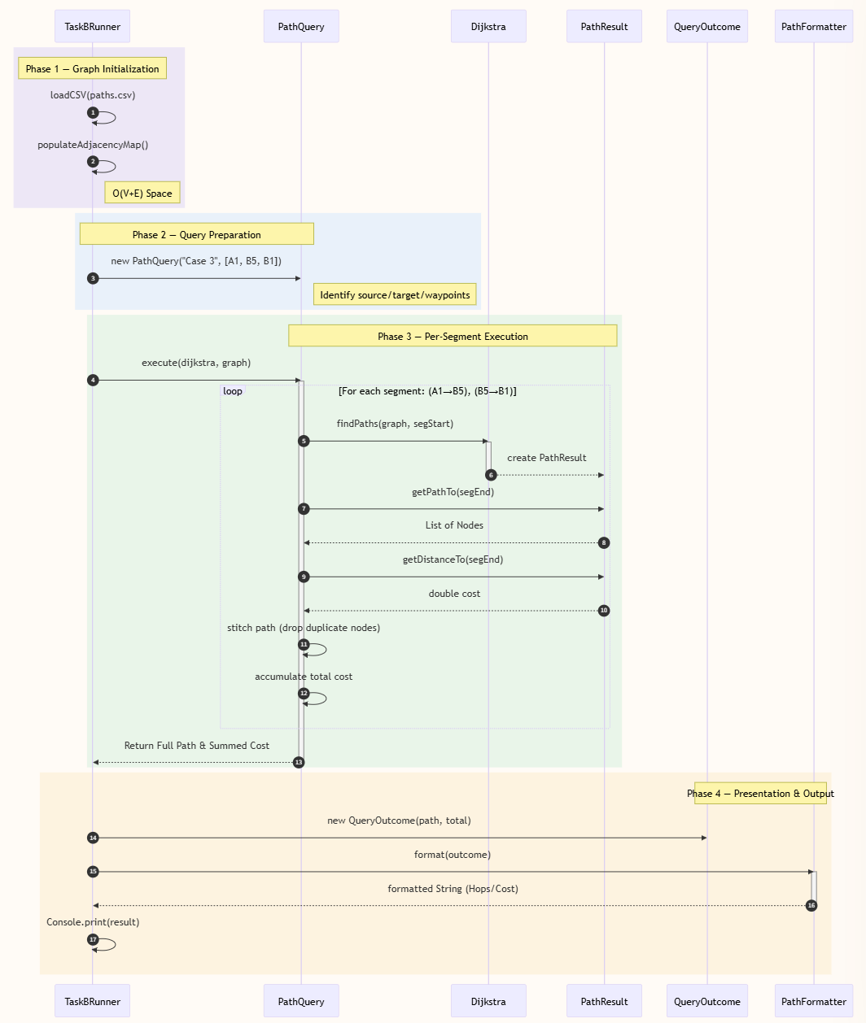  Fig.5(b). Workflow of Graph routing subsystem – handing typical query of a multi-node query Case 3 (A1 → via B5 → B1)
Sequence diagram can give a dynamic view on collaboration and interactions of major classes and functions. Figure 5(a) demonstrates one complete run of Task A’s sorting workflow, and it can be composed into three main phases: Load datasets, Benchmark looping, and Top 10 export. Figure 5(b) traces a typical compound case among the four required queries, with four major steps: graph setup; query handling; per-segment Dijkstra; formatting and output.

3.3 Object-Oriented Design Principles and Importance

(1). Encapsulation
Encapsulation is pivotal for information hiding and state protection. It is applied to protect the internal state of objects and hide complex data structures from external callers. In our program, classes such as Record, Edge, and QueryOutcome use private fields and public accessors (getters). The internal values of each object cannot be modified directly by external classes. Instead, other classes can only read the required information through public getter methods. For example, the Record class has two variables: locationId and priorityScore, which are stored as private fields. Once a Record object is instantiated, external classes cannot directly modify the values of these variables. Instead, other classes can only read the required information through public getter methods such as getLocationId() and getPriorityScore()
Encapsulation is important because it ensures data integrity by keeping the data immutable and consistent after the object is created. It also reduces unexpected changes to object states and makes the program easier to maintain and debug.

(2). Inheritance
Inheritance allows a class to reuse or follow the structure and behavior defined by another class or interface. In our program, all sorting classes implement the Sorter interface, which defines the sort and getName() methods. Each sorting class provides its own implementation of the sorting method to perform its specific sorting algorithm and overrides the getName() method to return the name of that algorithm.
Inheritance is important because it improves code reuse, consistency, and extensibility. By using inheritance or interface-based design, different classes can follow the same structure while providing their own specific implementations. This makes the program easier to maintain and extend.

(3). Polymorphism
Polymorphism allows different classes to be treated through the same interface or parent type, while each class executes its own specific method implementation at runtime. For example, in our program, the three sorting algorithms all implement the Sorter interface. They can be called using the same method, such as sort(), but each sorting class executes its own algorithm-specific implementation, such as Bubble Sort, Merge Sort, or Quick Sort.
Polymorphism allows different classes to be used through the same interface, which makes the program more flexible and easier to extend.

(4). Abstraction
Abstraction is an object-oriented programming principle that hides unnecessary implementation details and exposes only the essential functions or behaviors to the user. In our program, interfaces like Sorter, Graph and PathFinder define the essential operations that a class must provide, without exposing the internal implementation details. For example, Graph interface defines common graph operations, while WeightedGraph and UnweightedGraph provide their own internal representations.
Abstraction is important because it hides complex implementation details and exposes only the essential operations to other parts of the program. This makes the code easier to understand, use, and maintain. It also improves extensibility, because new implementations can be added without changing the code that depends on the abstract interface.

Chapter 4 Project Reflection (Task D)

4.1 AI-assisted planning and collaboration

Fig.5. Trello collaboration board
Trello assisted us in organizing, allocating, and planning our responsibility for this project. Initially, we divided the entire project into two primary sections: the Graph Part and the Sorting Part. Each of us was in charge of one part’s full work, such as drafting the report, preparing the presentation, and implementing the code. During using Trello, we further divided our responsibilities into a number of smaller tasks and entered them in the Trello collaboration board. We were then able to track each other's work throughout the project and have a clear understanding of our own duties.
Our productivity was boosted in several ways by AI-powered project management systems. We utilized the tool’s primary features, including the ability to prioritize tasks, notify us of approaching deadlines, and progress summaries. This usage improved both our individual time management skills and the efficiency of our teamwork collaboration.
However, there are also some disadvantages and risks. Over-reliance on AI-powered project management solutions is one possible issue. Over usage may reduce team members’ independent thinking, planning, and communication skills. Furthermore, AI may produce biased task designs or recommendations. If these generated contents are followed without rigorous verification, they may not always be acceptable or appropriate for the real project context, which could lead to issues.

4.2 Equality, Diversity, and Inclusion

4.2.1 Our understanding of EDI in the context of this project
EDI applies to both inside the development team and towards users. For development, equality means that every team member has a fair opportunity to contribute to the project, regardless of their gender. Diversity means that our team includes members with different backgrounds and expertise—for example, one member is good at writing while another is skilled in programming. Inclusion means that all members feel empowered and safe to share insights and raise their ideas and suggestions, ensuring that everyone’s perspective is considered. Externally, EDI focuses more on accessibility and user experience. EDI means to ensure that our software can serve a diverse audience.

4.2.2 EDI-based optimizations in the future
Based on the diversity principle, the project may provide more functions to satisfy different people’s need. For example, the system can more minor details of network information to the city planners. In addition, the system may add more languages for people in different countries to use.

4.2.3 Challenges and Solutions
A potential challenge is that different user groups may have different or even conflicting needs. To address this, the system could use role-based interface design, we can model each user group’s preference, and design customized features and information most relevant to their requirements.
Another challenge is that user requirements are difficult to collect accurately. To solve this, we could add a user survey functionality to the system, and prompt users to give feedback. This feedback collection can allow all users to submit their problems and suggestions during usage.

4.3 Life-long learning and future improvement

4.3.1 What this project taught about life-long learning
Our lesson from this project is that software development is a continuous, life-long learning process. Although we have learned theories about advanced OOP in course, we still encountered challenges during completing this project, like unclarity in planning and dilemmas in design decisions. Through the rich experience in this project, we realized the importance of staying curious and proactive, in both knowledge acquisition and skill development, to effectively enhance our problem-solving capability.

4.3.2 Our Contributions to Advanced Software Components in the Team Project
In this project, we initially split the whole task into two main parts: Sorting and Pathfinding. Then each team member is responsible for one part. Both team members contributed as developer, tester, deliverable-composer and coordinator. For developing and testing, we used GitHub to support collaboration and code integration. We each own module separately and then pushed the code to the shared repository. After individual development, we reviewed each other’s code, checked the correctness of the implementation, and provided suggestions for improvement. This process helped us improve code quality and ensure that different modules could work together correctly.

4.3.3 Next Steps for Future Development of This Application
In the future, we hope to develop an interactive user interface (UI) website to simplify visualization. City planners can view the connections between different locations and the current inspection routes. This increment will also clearly present the inspection data and provide intuitive insights into the network coverage of paths. We hope this development can facilitate planners to identify gaps or optimize future inspection routes.

Chapter 5 — Program Code
Entry point
Main.java

import service.TaskARunner;
import service.TaskBRunner;

public class Main {
public static void main(String[] args) {
System.out.println("========================================");
System.out.println(" CPT204 Group Coursework");
System.out.println(" Urban Infrastructure Inspection System");
System.out.println("========================================\n");

System.out.println(">>> PART 1: TASK A -- Sorting Algorithms & Top-10 Selection <<<\n");
TaskARunner.main(args);

System.out.println("\n>>> PART 2: TASK B -- Graph Algorithms & Shortest Paths <<<\n");
TaskBRunner.main(args);

System.out.println("\n========================================");
System.out.println(" All tasks completed.");
System.out.println("========================================");
}
}

Service layer — orchestration
service/TaskARunner.java

package service;

import java.util.ArrayList;

import comparator.RecordComparator;
import dataloader.CSVReader;
import dataloader.ResultsWriter;
import model.Record;
import sort.BubbleSorter;
import sort.MergeSorter;
import sort.QuickSorter;
import sort.Sorter;

public class TaskARunner {
public static void main(String[] args) {
int numberOfRuns = 100;
String datasetPathA = "Group Project Datasets/candidates_A.csv";
String datasetPathB = "Group Project Datasets/candidates_B.csv";
String datasetPathC = "Group Project Datasets/candidates_C.csv";
String resultsPath = "Group Project Datasets/results.csv";

ArrayList<Record> candidatesA = CSVReader.readRecords(datasetPathA);
ArrayList<Record> candidatesB = CSVReader.readRecords(datasetPathB);
ArrayList<Record> candidatesC = CSVReader.readRecords(datasetPathC);

Sorter bubbleSorter = new BubbleSorter();
Sorter quickSorter = new QuickSorter();
Sorter mergeSorter = new MergeSorter();
RecordComparator comparator = new RecordComparator();

//Test the sorting algorithms
//dataset A
System.out.println("--------------------------------");
System.out.println("Dataset A sorting time: ");
//Warm up the JVM
for (int i = 0; i < 50; i++) {
ArrayList<Record> candidatesAWarmup = new ArrayList<>(candidatesA);
bubbleSorter.sort(candidatesAWarmup, comparator);
}

long totalTime = 0;
for (int i = 0; i < numberOfRuns; i++) {
ArrayList<Record> candidatesAClone = new ArrayList<>(candidatesA);
long start = System.nanoTime();
bubbleSorter.sort(candidatesAClone, comparator);
long end = System.nanoTime();
totalTime += end - start;
}
System.out.println(bubbleSorter.getName() + " average time: " + totalTime / numberOfRuns / 1_000_000.0 + " ms");

//Warm up the JVM
for (int i = 0; i < 50; i++) {
ArrayList<Record> candidatesAWarmup = new ArrayList<>(candidatesA);
quickSorter.sort(candidatesAWarmup, comparator);
}
totalTime = 0;
for (int i = 0; i < numberOfRuns; i++) {
ArrayList<Record> candidatesAClone = new ArrayList<>(candidatesA);
long start = System.nanoTime();
quickSorter.sort(candidatesAClone, comparator);
long end = System.nanoTime();
totalTime += end - start;
}
System.out.println(quickSorter.getName() + " average time: " + totalTime / numberOfRuns / 1_000_000.0 + " ms");

//Warm up the JVM
for (int i = 0; i < 50; i++) {
ArrayList<Record> candidatesAWarmup = new ArrayList<>(candidatesA);
mergeSorter.sort(candidatesAWarmup, comparator);
}
totalTime = 0;
for (int i = 0; i < numberOfRuns; i++) {
ArrayList<Record> candidatesAClone = new ArrayList<>(candidatesA);
long start = System.nanoTime();
mergeSorter.sort(candidatesAClone, comparator);
long end = System.nanoTime();
totalTime += end - start;
}
System.out.println(mergeSorter.getName() + " average time: " + totalTime / numberOfRuns / 1_000_000.0 + " ms");

System.out.println("--------------------------------");

//dataset B
System.out.println("Dataset B sorting time: ");
//Warm up the JVM
for (int i = 0; i < 50; i++) {
ArrayList<Record> candidatesBWarmup = new ArrayList<>(candidatesB);
bubbleSorter.sort(candidatesBWarmup, comparator);
}
totalTime = 0;
for (int i = 0; i < numberOfRuns; i++) {
ArrayList<Record> candidatesBClone = new ArrayList<>(candidatesB);
long start = System.nanoTime();
bubbleSorter.sort(candidatesBClone, comparator);
long end = System.nanoTime();
totalTime += end - start;
}
System.out.println(bubbleSorter.getName() + " average time: " + totalTime / numberOfRuns / 1_000_000.0 + " ms");

//Warm up the JVM
for (int i = 0; i < 50; i++) {
ArrayList<Record> candidatesBWarmup = new ArrayList<>(candidatesB);
quickSorter.sort(candidatesBWarmup, comparator);
}
totalTime = 0;
for (int i = 0; i < numberOfRuns; i++) {
ArrayList<Record> candidatesBClone = new ArrayList<>(candidatesB);
long start = System.nanoTime();
quickSorter.sort(candidatesBClone, comparator);
long end = System.nanoTime();
totalTime += end - start;
}
System.out.println(quickSorter.getName() + " average time: " + totalTime / numberOfRuns / 1_000_000.0 + " ms");

//Warm up the JVM
for (int i = 0; i < 50; i++) {
ArrayList<Record> candidatesBWarmup = new ArrayList<>(candidatesB);
mergeSorter.sort(candidatesBWarmup, comparator);
}
totalTime = 0;
for (int i = 0; i < numberOfRuns; i++) {
ArrayList<Record> candidatesBClone = new ArrayList<>(candidatesB);
long start = System.nanoTime();
mergeSorter.sort(candidatesBClone, comparator);
long end = System.nanoTime();
totalTime += end - start;
}
System.out.println(mergeSorter.getName() + " average time: " + totalTime / numberOfRuns / 1_000_000.0 + " ms");

System.out.println("--------------------------------");

//dataset C
System.out.println("Dataset C sorting time: ");
//Warm up the JVM
for (int i = 0; i < 50; i++) {
ArrayList<Record> candidatesCWarmup = new ArrayList<>(candidatesC);
bubbleSorter.sort(candidatesCWarmup, comparator);
}
totalTime = 0;
for (int i = 0; i < numberOfRuns; i++) {
ArrayList<Record> candidatesCClone = new ArrayList<>(candidatesC);
long start = System.nanoTime();
bubbleSorter.sort(candidatesCClone, comparator);
long end = System.nanoTime();
totalTime += end - start;
}
System.out.println(bubbleSorter.getName() + " average time: " + totalTime / numberOfRuns / 1_000_000.0 + " ms");

//Warm up the JVM
for (int i = 0; i < 50; i++) {
ArrayList<Record> candidatesCWarmup = new ArrayList<>(candidatesC);
quickSorter.sort(candidatesCWarmup, comparator);
}
totalTime = 0;
for (int i = 0; i < numberOfRuns; i++) {
ArrayList<Record> candidatesCClone = new ArrayList<>(candidatesC);
long start = System.nanoTime();
quickSorter.sort(candidatesCClone, comparator);
long end = System.nanoTime();
totalTime += end - start;
}
System.out.println(quickSorter.getName() + " average time: " + totalTime / numberOfRuns / 1_000_000.0 + " ms");

//Warm up the JVM
for (int i = 0; i < 50; i++) {
ArrayList<Record> candidatesCWarmup = new ArrayList<>(candidatesC);
mergeSorter.sort(candidatesCWarmup, comparator);
}
totalTime = 0;
for (int i = 0; i < numberOfRuns; i++) {
ArrayList<Record> candidatesCClone = new ArrayList<>(candidatesC);
long start = System.nanoTime();
mergeSorter.sort(candidatesCClone, comparator);
long end = System.nanoTime();
totalTime += end - start;
}
System.out.println(mergeSorter.getName() + " average time: " + totalTime / numberOfRuns / 1_000_000.0 + " ms");

System.out.println("--------------------------------");

//Print the top 10 candidates for each dataset
ResultsWriter.writeLine(resultsPath, "location_id,priority_score", false);

System.out.println("Top 10 candidates for dataset A: ");
quickSorter.sort(candidatesA, comparator);
for (int i = 0; i < 10; i++) {
Record record = candidatesA.get(i);
System.out.println(record);
ResultsWriter.writeLine(resultsPath, record.getLocationId() + "," + record.getPriorityScore());
}

System.out.println("Top 10 candidates for dataset B: ");
quickSorter.sort(candidatesB, comparator);
for (int i = 0; i < 10; i++) {
Record record = candidatesB.get(i);
System.out.println(record);
ResultsWriter.writeLine(resultsPath, record.getLocationId() + "," + record.getPriorityScore());
}

System.out.println("Top 10 candidates for dataset C: ");
quickSorter.sort(candidatesC, comparator);
for (int i = 0; i < 10; i++) {
Record record = candidatesC.get(i);
System.out.println(record);
ResultsWriter.writeLine(resultsPath, record.getLocationId() + "," + record.getPriorityScore());
}
}

}

service/TaskBRunner.java

package service;

import java.util.ArrayList;
import java.util.Arrays;
import java.util.List;

import dataloader.CSVReader;
import dataloader.GraphReader;
import graph.Graph;
import model.Record;
import pathfinder.Dijkstra;
import pathfinder.PathFinder;
import routing.PathFormatter;
import routing.PathQuery;
import routing.QueryOutcome;

public class TaskBRunner {
public static void main(String[] args) {
String resultFile = "Group Project Datasets/results.csv";
String pathGraph = "Group Project Datasets/paths.csv";

// Task A handoff: top 10 per dataset becomes Task B input
ArrayList<Record> results = new ArrayList<>(CSVReader.readRecords(resultFile));
ArrayList<Record> topA = new ArrayList<>(results.subList(0, 10));
ArrayList<Record> topB = new ArrayList<>(results.subList(10, 20));
ArrayList<Record> topC = new ArrayList<>(results.subList(20, 30));

// Build the graph
Graph graph = GraphReader.readGraph(pathGraph);
System.out.println("Graph loaded: " + graph.nodeCount()
+ " nodes, " + graph.edgeCount() + " edges\n");

// Identify nodes for the 4 cases
String A1 = topA.get(0).getLocationId();
String A10 = topA.get(9).getLocationId();
String B1 = topB.get(0).getLocationId();
String B5 = topB.get(4).getLocationId();
String C1 = topC.get(0).getLocationId();
String C5 = topC.get(4).getLocationId();

// Define the 4 queries as ordered waypoint lists
PathQuery case1 = new PathQuery(
"Case 1: A1st -> A1st (self)",
Arrays.asList(A1));
PathQuery case2 = new PathQuery(
"Case 2: A1st -> A10th",
Arrays.asList(A1, A10));
PathQuery case3 = new PathQuery(
"Case 3: A1st -> B1st, via B5th",
Arrays.asList(A1, B5, B1));
PathQuery case4 = new PathQuery(
"Case 4: A1st -> C1st, via B5th then C5th",
Arrays.asList(A1, B5, C5, C1));

// Execute with Dijkstra
PathFinder finder = new Dijkstra();
List<PathQuery> queries = Arrays.asList(case1, case2, case3, case4);

for (PathQuery query : queries) {
QueryOutcome outcome = query.execute(finder, graph);
System.out.println(PathFormatter.format(outcome));
}
}

}

service/QuickSortPivotRunner.java

package service;

import java.util.ArrayList;

import comparator.RecordComparator;
import dataloader.CSVReader;
import model.Record;
import sort.PivotQuickSorter;
import sort.Sorter;

public class QuickSortPivotRunner {

public static void main(String[] args) {
int numberOfRuns = 100;

String datasetPathA = "Group Project Datasets/candidates_A.csv";
String datasetPathB = "Group Project Datasets/candidates_B.csv";
String datasetPathC = "Group Project Datasets/candidates_C.csv";

ArrayList<Record> candidatesA = CSVReader.readRecords(datasetPathA);
ArrayList<Record> candidatesB = CSVReader.readRecords(datasetPathB);
ArrayList<Record> candidatesC = CSVReader.readRecords(datasetPathC);

RecordComparator comparator = new RecordComparator();

String[] strategies = {"LEFT", "RIGHT", "MIDDLE", "MIDDLE_OF_THREE", "RANDOM"};

benchmarkDataset("A", candidatesA, strategies, comparator, numberOfRuns);
benchmarkDataset("B", candidatesB, strategies, comparator, numberOfRuns);
benchmarkDataset("C", candidatesC, strategies, comparator, numberOfRuns);
}

private static void benchmarkDataset(
String datasetLabel,
ArrayList<Record> candidates,
String[] strategies,
RecordComparator comparator,
int numberOfRuns) {
System.out.println("--------------------------------");
System.out.println("Dataset " + datasetLabel + " QuickSort pivot comparison:");

for (String strategy : strategies) {
Sorter quickSorter = new PivotQuickSorter(strategy);

// Warm up the JVM
for (int i = 0; i < 50; i++) {
ArrayList<Record> candidatesWarmup = new ArrayList<>(candidates);
quickSorter.sort(candidatesWarmup, comparator);
}

long totalTime = 0;
for (int i = 0; i < numberOfRuns; i++) {
ArrayList<Record> candidatesClone = new ArrayList<>(candidates);
long start = System.nanoTime();
quickSorter.sort(candidatesClone, comparator);
long end = System.nanoTime();
totalTime += end - start;
}

System.out.println(quickSorter.getName() + " average time: "
+ totalTime / numberOfRuns / 1_000_000.0 + " ms");
}
}
}

Algorithm layer — Sort
sort/Sorter.java

package sort;

import java.util.ArrayList;

import comparator.RecordComparator;
import model.Record;

public interface Sorter {
void sort(ArrayList<Record> records, RecordComparator comparator);
String getName();
}

sort/BubbleSorter.java

package sort;

import java.util.ArrayList;

import comparator.RecordComparator;
import model.Record;

public class BubbleSorter implements Sorter {
public static void swap(ArrayList<Record> rows, int i, int j) {
Record tmp = rows.get(i);
rows.set(i, rows.get(j));
rows.set(j, tmp);
}

@Override
public void sort(ArrayList<Record> rows, RecordComparator comparator) {
if (rows == null || rows.size() <= 1) {
return;
}
int n = rows.size();
for (int i = 0; i < n - 1; i++) {
boolean swapped = false;
for (int j = 0; j < n - 1 - i; j++) {
Record c0 = rows.get(j);
Record c1 = rows.get(j + 1);
if (comparator.compare(c0, c1) > 0) {
swap(rows, j, j + 1);
swapped = true;
}
}
if (!swapped) {
break;
}
}
}

@Override
public String getName() {
return "BubbleSort";
}
}

sort/MergeSorter.java

package sort;

import java.util.ArrayList;

import comparator.RecordComparator;
import model.Record;

public class MergeSorter implements Sorter {
@Override
public void sort(ArrayList<Record> list, RecordComparator comparator) {
if (list.size() > 1) {
ArrayList<Record> firstHalf = new ArrayList<>(list.subList(0, list.size() / 2));
sort(firstHalf, comparator);

ArrayList<Record> secondHalf = new ArrayList<>(list.subList(list.size() / 2, list.size()));
sort(secondHalf, comparator);

merge(firstHalf, secondHalf, list, comparator);
}
}

private static void merge(ArrayList<Record> list1, ArrayList<Record> list2, ArrayList<Record> temp,
RecordComparator comparator) {
int current1 = 0;
int current2 = 0;
int current3 = 0;

while (current1 < list1.size() && current2 < list2.size()) {
if (comparator.compare(list1.get(current1), list2.get(current2)) <= 0)
temp.set(current3++, list1.get(current1++));
else
temp.set(current3++, list2.get(current2++));
}

while (current1 < list1.size())
temp.set(current3++, list1.get(current1++));

while (current2 < list2.size())
temp.set(current3++, list2.get(current2++));
}

@Override
public String getName() {
return "MergeSort";
}
}

sort/QuickSorter.java

package sort;

import java.util.ArrayList;

import comparator.RecordComparator;
import model.Record;

public class QuickSorter implements Sorter {
public static void swap(ArrayList<Record> rows, int i, int j) {
Record tmp = rows.get(i);
rows.set(i, rows.get(j));
rows.set(j, tmp);
}

@Override
public void sort(ArrayList<Record> rows, RecordComparator comparator) {
quickSort(rows, 0, rows.size() - 1, comparator);
}

private static void quickSort(ArrayList<Record> rows, int left, int right, RecordComparator comparator) {
if (rows == null || left >= right) {
return;
}
int pivot = partition(rows, left, right, comparator);
quickSort(rows, left, pivot - 1, comparator);
quickSort(rows, pivot + 1, right, comparator);
}

private static int partition(ArrayList<Record> rows, int left, int right, RecordComparator comparator) {
Record pivotRecord = rows.get(left);
int low = left + 1;
int high = right;
while (low < high) {
while (low <= high && comparator.compare(rows.get(low), pivotRecord) <= 0) {
low++;
}
while (low <= high && comparator.compare(rows.get(high), pivotRecord) > 0) {
high--;
}
if (high > low) {
swap(rows, low, high);
}
}
while (high > left && comparator.compare(rows.get(high), pivotRecord) > 0) {
high--;
}
if (comparator.compare(rows.get(high), pivotRecord) <= 0) {
swap(rows, left, high);
return high;
} else {
return left;
}
}

@Override
public String getName() {
return "QuickSort";
}

}

sort/PivotQuickSorter.java

package sort;

import java.util.ArrayList;
import java.util.Random;

import comparator.RecordComparator;
import model.Record;

public class PivotQuickSorter implements Sorter {

private final String pivotStrategy;
private final Random random;

public PivotQuickSorter(String pivotStrategy) {
this.pivotStrategy = pivotStrategy;
this.random = new Random(42);
}

@Override
public void sort(ArrayList<Record> rows, RecordComparator comparator) {
quickSort(rows, 0, rows.size() - 1, comparator);
}

private void quickSort(ArrayList<Record> rows, int left, int right, RecordComparator comparator) {
if (rows == null || left >= right) {
return;
}
int pivot = partition(rows, left, right, comparator);
quickSort(rows, left, pivot - 1, comparator);
quickSort(rows, pivot + 1, right, comparator);
}

private int partition(ArrayList<Record> rows, int left, int right, RecordComparator comparator) {
int pivotIndex = choosePivotIndex(rows, left, right, comparator);
QuickSorter.swap(rows, left, pivotIndex);

Record pivotRecord = rows.get(left);
int low = left + 1;
int high = right;
while (low < high) {
while (low <= high && comparator.compare(rows.get(low), pivotRecord) <= 0) {
low++;
}
while (low <= high && comparator.compare(rows.get(high), pivotRecord) > 0) {
high--;
}
if (high > low) {
QuickSorter.swap(rows, low, high);
}
}
while (high > left && comparator.compare(rows.get(high), pivotRecord) > 0) {
high--;
}
if (comparator.compare(rows.get(high), pivotRecord) <= 0) {
QuickSorter.swap(rows, left, high);
return high;
}
return left;
}

private int choosePivotIndex(ArrayList<Record> rows, int left, int right, RecordComparator comparator) {
switch (pivotStrategy) {
case "LEFT":
return left;
case "RIGHT":
return right;
case "MIDDLE":
return left + (right - left) / 2;
case "MIDDLE_OF_THREE":
return medianOfThreeIndex(rows, left, right, comparator);
case "RANDOM":
return left + random.nextInt(right - left + 1);
default:
return left;
}
}

private int medianOfThreeIndex(ArrayList<Record> rows, int left, int right, RecordComparator comparator) {
int middle = left + (right - left) / 2;
Record leftRecord = rows.get(left);
Record middleRecord = rows.get(middle);
Record rightRecord = rows.get(right);

if (comparator.compare(leftRecord, middleRecord) <= 0) {
if (comparator.compare(middleRecord, rightRecord) <= 0) {
return middle;
}
if (comparator.compare(leftRecord, rightRecord) <= 0) {
return right;
}
return left;
}

if (comparator.compare(leftRecord, rightRecord) <= 0) {
return left;
}
if (comparator.compare(middleRecord, rightRecord) <= 0) {
return right;
}
return middle;
}

@Override
public String getName() {
return "QuickSort (" + pivotStrategy + " pivot)";
}
}

Algorithm layer — Path
pathfinder/PathFinder.java

package pathfinder;

import graph.Graph;

public interface PathFinder {
PathResult findPaths(Graph graph, String source);
String getName();
}

pathfinder/Dijkstra.java

package pathfinder;

import java.util.Comparator;
import java.util.HashMap;
import java.util.HashSet;
import java.util.Map;
import java.util.PriorityQueue;
import java.util.Set;

import graph.Edge;
import graph.Graph;

public class Dijkstra implements PathFinder {

@Override
public PathResult findPaths(Graph graph, String source) {
Map<String, Integer> dist = new HashMap<>();
Map<String, String> predecessor = new HashMap<>();
Set<String> settled = new HashSet<>();

dist.put(source, 0);

PriorityQueue<Entry> pq = new PriorityQueue<>(
Comparator.comparingInt(e -> e.distance));
pq.add(new Entry(source, 0));

while (!pq.isEmpty()) {
Entry current = pq.poll();
String node = current.node;

// Skip stale entry: a better distance was recorded after this one was inserted.
if (current.distance > dist.getOrDefault(node, Integer.MAX_VALUE)) {
continue;
}
if (settled.contains(node)) {
continue;
}
settled.add(node);

int nodeDist = dist.get(node);
for (Edge edge : graph.getNeighbors(node)) {
String neighbor = edge.getTo();
if (settled.contains(neighbor)) continue;
int newDist = nodeDist + edge.getWeight();
int knownDist = dist.getOrDefault(neighbor, Integer.MAX_VALUE);
if (newDist < knownDist) {
dist.put(neighbor, newDist);
predecessor.put(neighbor, node);
pq.add(new Entry(neighbor, newDist));
}
}
}

return new PathResult(source, dist, predecessor);
}

@Override
public String getName() {
return "Dijkstra";
}

private static class Entry {
final String node;
final int distance;

Entry(String node, int distance) {
this.node = node;
this.distance = distance;
}
}
}

pathfinder/BiDijkstra.java

package pathfinder;

import java.util.ArrayList;
import java.util.Collections;
import java.util.Comparator;
import java.util.HashMap;
import java.util.HashSet;
import java.util.List;
import java.util.Map;
import java.util.PriorityQueue;
import java.util.Set;

import graph.Edge;
import graph.Graph;

public class BiDijkstra implements PathFinder {

@Override
public PathResult findPaths(Graph graph, String source) {
Map<String, Integer> distances = new HashMap<>();
Map<String, String> predecessors = new HashMap<>();
Map<String, List<String>> paths = new HashMap<>();

distances.put(source, 0);
paths.put(source, Collections.singletonList(source));

for (String target : graph.getNodes()) {
if (target.equals(source)) {
continue;
}

SearchResult result = search(graph, source, target);
if (!result.hasPath()) {
continue;
}

distances.put(target, result.distance);
paths.put(target, result.path);
}

return new PathResult(source, distances, predecessors, paths);
}

@Override
public String getName() {
return "BiDijkstra";
}

private SearchResult search(Graph graph, String source, String target) {
if (source.equals(target)) {
return new SearchResult(0, Collections.singletonList(source));
}

Map<String, Integer> forwardDist = new HashMap<>();
Map<String, Integer> backwardDist = new HashMap<>();
Map<String, String> forwardPrev = new HashMap<>();
Map<String, String> backwardNext = new HashMap<>();
Set<String> forwardSettled = new HashSet<>();
Set<String> backwardSettled = new HashSet<>();

PriorityQueue<Entry> forwardQueue = new PriorityQueue<>(Comparator.comparingInt(e -> e.distance));
PriorityQueue<Entry> backwardQueue = new PriorityQueue<>(Comparator.comparingInt(e -> e.distance));

forwardDist.put(source, 0);
backwardDist.put(target, 0);
forwardQueue.add(new Entry(source, 0));
backwardQueue.add(new Entry(target, 0));

int bestDistance = Integer.MAX_VALUE;
String meetingNode = null;

while (!forwardQueue.isEmpty() && !backwardQueue.isEmpty()) {
int bestForward = peekDistance(forwardQueue);
int bestBackward = peekDistance(backwardQueue);
if (bestForward + bestBackward >= bestDistance) {
break;
}

if (bestForward <= bestBackward) {
SearchState state = expandFrontier(
graph, forwardQueue, forwardDist, forwardPrev, forwardSettled, backwardDist, bestDistance);
bestDistance = state.bestDistance;
if (state.meetingNode != null) {
meetingNode = state.meetingNode;
}
} else {
SearchState state = expandFrontier(
graph, backwardQueue, backwardDist, backwardNext, backwardSettled, forwardDist, bestDistance);
bestDistance = state.bestDistance;
if (state.meetingNode != null) {
meetingNode = state.meetingNode;
}
}
}

if (meetingNode == null) {
return SearchResult.noPath();
}

return new SearchResult(bestDistance, buildPath(meetingNode, forwardPrev, backwardNext));
}

private SearchState expandFrontier(
Graph graph,
PriorityQueue<Entry> queue,
Map<String, Integer> distances,
Map<String, String> links,
Set<String> settled,
Map<String, Integer> oppositeDistances,
int bestDistance) {
while (!queue.isEmpty()) {
Entry current = queue.poll();
if (current.distance > distances.getOrDefault(current.node, Integer.MAX_VALUE)) {
continue;
}
if (settled.contains(current.node)) {
continue;
}

settled.add(current.node);
String meetingNode = null;

if (oppositeDistances.containsKey(current.node)) {
int candidate = current.distance + oppositeDistances.get(current.node);
if (candidate < bestDistance) {
bestDistance = candidate;
meetingNode = current.node;
}
}

for (Edge edge : graph.getNeighbors(current.node)) {
String neighbor = edge.getTo();
int newDistance = current.distance + edge.getWeight();
if (newDistance < distances.getOrDefault(neighbor, Integer.MAX_VALUE)) {
distances.put(neighbor, newDistance);
links.put(neighbor, current.node);
queue.add(new Entry(neighbor, newDistance));
}

Integer oppositeDistance = oppositeDistances.get(neighbor);
if (oppositeDistance != null) {
int candidate = newDistance + oppositeDistance;
if (candidate < bestDistance) {
bestDistance = candidate;
meetingNode = neighbor;
}
}
}

return new SearchState(bestDistance, meetingNode);
}

return new SearchState(bestDistance, null);
}

private List<String> buildPath(String meetingNode, Map<String, String> forwardPrev,
Map<String, String> backwardNext) {
List<String> path = new ArrayList<>();

String current = meetingNode;
while (current != null) {
path.add(0, current);
current = forwardPrev.get(current);
}

current = backwardNext.get(meetingNode);
while (current != null) {
path.add(current);
current = backwardNext.get(current);
}

return path;
}

private int peekDistance(PriorityQueue<Entry> queue) {
Entry entry = queue.peek();
return entry == null ? Integer.MAX_VALUE : entry.distance;
}

private static class Entry {
final String node;
final int distance;

Entry(String node, int distance) {
this.node = node;
this.distance = distance;
}
}

private static class SearchState {
final int bestDistance;
final String meetingNode;

SearchState(int bestDistance, String meetingNode) {
this.bestDistance = bestDistance;
this.meetingNode = meetingNode;
}
}

private static class SearchResult {
final int distance;
final List<String> path;

SearchResult(int distance, List<String> path) {
this.distance = distance;
this.path = path;
}

static SearchResult noPath() {
return new SearchResult(Integer.MAX_VALUE, Collections.emptyList());
}

boolean hasPath() {
return !path.isEmpty();
}
}
}

pathfinder/PathResult.java

package pathfinder;

import java.util.ArrayList;
import java.util.Collections;
import java.util.List;
import java.util.Map;

public class PathResult {
private final String source;
private final Map<String, Integer> distances;
private final Map<String, String> predecessors;
private final Map<String, List<String>> paths;

public PathResult(String source, Map<String, Integer> distances, Map<String, String> predecessors) {
this(source, distances, predecessors, null);
}

public PathResult(String source, Map<String, Integer> distances, Map<String, String> predecessors,
Map<String, List<String>> paths) {
this.source = source;
this.distances = distances;
this.predecessors = predecessors;
this.paths = paths;
}

public String getSource() {
return source;
}

public int getDistanceTo(String target) {
return distances.getOrDefault(target, Integer.MAX_VALUE);
}

public boolean hasPathTo(String target) {
return distances.containsKey(target);
}

public List<String> getPathTo(String target) {
if (!hasPathTo(target)) {
return Collections.emptyList();
}
if (paths != null && paths.containsKey(target)) {
return new ArrayList<>(paths.get(target));
}
List<String> path = new ArrayList<>();
String current = target;
while (current != null) {
path.add(0, current);
current = predecessors.get(current);
}
return path;
}
}

Routing — path composition
routing/PathQuery.java

package routing;

import java.util.ArrayList;
import java.util.Collections;
import java.util.List;

import graph.Graph;
import pathfinder.PathFinder;
import pathfinder.PathResult;

public class PathQuery {
private final String name;
private final List<String> waypoints;

public PathQuery(String name, List<String> waypoints) {
if (waypoints == null || waypoints.isEmpty()) {
throw new IllegalArgumentException("waypoints must be non-empty");
}
this.name = name;
this.waypoints = waypoints;
}

public String getName() {
return name;
}

public List<String> getWaypoints() {
return waypoints;
}

public String getStart() {
return waypoints.get(0);
}

public String getEnd() {
return waypoints.get(waypoints.size() - 1);
}

public List<String> getIntermediates() {
if (waypoints.size() <= 2) return Collections.emptyList();
return waypoints.subList(1, waypoints.size() - 1);
}

public QueryOutcome execute(PathFinder finder, Graph graph) {
if (waypoints.size() == 1) {
String only = waypoints.get(0);
PathResult r = finder.findPaths(graph, only);
return new QueryOutcome(this, r.getPathTo(only), r.getDistanceTo(only));
}

List<String> fullPath = new ArrayList<>();
int totalCost = 0;

for (int i = 0; i < waypoints.size() - 1; i++) {
String segStart = waypoints.get(i);
String segEnd = waypoints.get(i + 1);

PathResult result = finder.findPaths(graph, segStart);
if (!result.hasPathTo(segEnd)) {
return new QueryOutcome(this, null, Integer.MAX_VALUE);
}

List<String> segmentPath = result.getPathTo(segEnd);
int segmentCost = result.getDistanceTo(segEnd);

if (i == 0) {
fullPath.addAll(segmentPath);
} else {
// Drop the duplicate junction node at the seam.
fullPath.addAll(segmentPath.subList(1, segmentPath.size()));
}
totalCost += segmentCost;
}

return new QueryOutcome(this, fullPath, totalCost);
}
}

routing/QueryOutcome.java

package routing;

import java.util.List;

public class QueryOutcome {
private final PathQuery query;
private final List<String> path;
private final int totalCost;

public QueryOutcome(PathQuery query, List<String> path, int totalCost) {
this.query = query;
this.path = path;
this.totalCost = totalCost;
}

public PathQuery getQuery() {
return query;
}

public List<String> getPath() {
return path;
}

public int getTotalCost() {
return totalCost;
}

public boolean hasPath() {
return path != null && !path.isEmpty();
}
}

routing/PathFormatter.java

package routing;

import java.util.List;

public class PathFormatter {
public static String format(QueryOutcome outcome) {
PathQuery query = outcome.getQuery();
StringBuilder sb = new StringBuilder();

sb.append("=== ").append(query.getName()).append(" ===\n");
sb.append("Start: ").append(query.getStart()).append("\n");
sb.append("Destination: ").append(query.getEnd()).append("\n");

List<String> intermediates = query.getIntermediates();
if (!intermediates.isEmpty()) {
sb.append("Waypoint(s): ").append(String.join(" -> ", intermediates))
.append(" (in order)\n");
}

if (!outcome.hasPath()) {
sb.append("Path: (no path found)\n");
sb.append("Total cost: N/A\n");
} else {
sb.append("Path: ").append(String.join(" -> ", outcome.getPath())).append("\n");
sb.append("Total cost: ").append(outcome.getTotalCost()).append("\n");
}

return sb.toString();
}
}

Graph model
graph/Graph.java

package graph;

import java.util.List;
import java.util.Set;

public interface Graph {
List<Edge> getNeighbors(String node);

Set<String> getNodes();

int nodeCount();

int edgeCount();
}

graph/WeightedGraph.java

package graph;

import java.util.ArrayList;
import java.util.Collections;
import java.util.HashMap;
import java.util.List;
import java.util.Map;
import java.util.Set;

public class WeightedGraph implements Graph {
private final Map<String, List<Edge>> adjacency = new HashMap<>();

public void addUndirectedEdge(String a, String b, int weight) {
adjacency.computeIfAbsent(a, k -> new ArrayList<>()).add(new Edge(b, weight));
adjacency.computeIfAbsent(b, k -> new ArrayList<>()).add(new Edge(a, weight));
}

@Override
public List<Edge> getNeighbors(String node) {
return adjacency.getOrDefault(node, Collections.emptyList());
}

@Override
public Set<String> getNodes() {
return adjacency.keySet();
}

@Override
public int nodeCount() {
return adjacency.size();
}

@Override
public int edgeCount() {
int total = 0;
for (List<Edge> edges : adjacency.values()) {
total += edges.size();
}
return total / 2;
}
}

graph/UnweightedGraph.java

package graph;

import java.util.ArrayList;
import java.util.Collections;
import java.util.HashMap;
import java.util.List;
import java.util.Map;
import java.util.Set;

public class UnweightedGraph implements Graph {
private static final int DEFAULT_WEIGHT = 1;

private final Map<String, List<Edge>> adjacency = new HashMap<>();

public void addUndirectedEdge(String a, String b) {
adjacency.computeIfAbsent(a, k -> new ArrayList<>()).add(new Edge(b, DEFAULT_WEIGHT));
adjacency.computeIfAbsent(b, k -> new ArrayList<>()).add(new Edge(a, DEFAULT_WEIGHT));
}

@Override
public List<Edge> getNeighbors(String node) {
return adjacency.getOrDefault(node, Collections.emptyList());
}

@Override
public Set<String> getNodes() {
return adjacency.keySet();
}

@Override
public int nodeCount() {
return adjacency.size();
}

@Override
public int edgeCount() {
int total = 0;
for (List<Edge> edges : adjacency.values()) {
total += edges.size();
}
return total / 2;
}
}

graph/Edge.java

package graph;

public class Edge {
private final String to;
private final int weight;

public Edge(String to, int weight) {
this.to = to;
this.weight = weight;
}

public String getTo() {
return to;
}

public int getWeight() {
return weight;
}
}

Domain model
model/Record.java

package model;

public class Record {
private final String locationId;
private final int priorityScore;

public Record(String locationId, int priorityScore) {
this.locationId = locationId;
this.priorityScore = priorityScore;
}

public String getLocationId() {
return locationId;
}

public int getPriorityScore() {
return priorityScore;
}

@Override
public String toString() {
return locationId + " " + priorityScore;
}
}

Data I/O
dataloader/DataReader.java

package dataloader;

public interface DataReader<T> {
T read(String filePath);
}

dataloader/CSVReader.java

package dataloader;

import java.io.*;
import java.util.ArrayList;

import model.Record;

public class CSVReader implements DataReader<ArrayList<Record>> {
@Override
public ArrayList<Record> read(String filePath) {
ArrayList<Record> records = new ArrayList<>();
try (BufferedReader reader = new BufferedReader(new FileReader(filePath))) {
String line;
reader.readLine();
while ((line = reader.readLine()) != null) {
String[] parts = line.split(",");
records.add(new Record(parts[0], Integer.parseInt(parts[1])));
}
}
catch (IOException e) {
e.printStackTrace();;
}
return records;
}

public static ArrayList<Record> readRecords(String filePath) {
return new CSVReader().read(filePath);
}
}

dataloader/GraphReader.java

package dataloader;

import java.io.BufferedReader;
import java.io.FileReader;
import java.io.IOException;

import graph.Graph;
import graph.WeightedGraph;

public class GraphReader implements DataReader<WeightedGraph> {
@Override
public WeightedGraph read(String filePath) {
WeightedGraph graph = new WeightedGraph();
try (BufferedReader reader = new BufferedReader(new FileReader(filePath))) {
String line;
reader.readLine();
while ((line = reader.readLine()) != null) {
if (line.trim().isEmpty()) continue;
String[] parts = line.split(",");
String from = parts[0].trim();
String to = parts[1].trim();
int weight = Integer.parseInt(parts[2].trim());
graph.addUndirectedEdge(from, to, weight);
}
} catch (IOException e) {
e.printStackTrace();
}
return graph;
}

public static Graph readGraph(String filePath) {
return new GraphReader().read(filePath);
}
}

dataloader/ResultsWriter.java

package dataloader;

import java.io.BufferedWriter;
import java.io.FileWriter;
import java.io.IOException;

public class ResultsWriter {
public static void writeLine(String filePath, String content) {
writeLine(filePath, content, true);
}

public static void writeLine(String filePath, String content, boolean append) {
try (BufferedWriter writer = new BufferedWriter(new FileWriter(filePath, append))) {
writer.write(content);
writer.newLine();
} catch (IOException e) {
e.printStackTrace();
}
}
}

Comparator
comparator/RecordComparator.java

package comparator;

import java.util.Comparator;

import model.Record;

public class RecordComparator implements Comparator<Record> {

@Override
public int compare(Record a, Record b) {
if (a.getPriorityScore() > b.getPriorityScore()) {
return -1;
}

if(a.getPriorityScore() == b.getPriorityScore()) {
return a.getLocationId().compareTo(b.getLocationId());

}
return 1;
}

}

Chapter 6 — Appendix
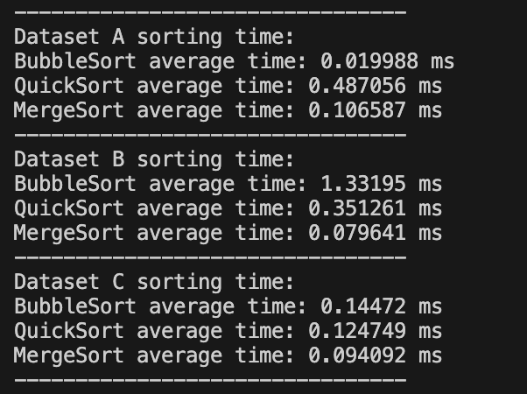

Fig.1. Console output of the three sorting algorithms on each dataset

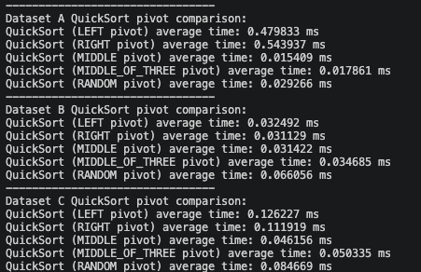
Fig.2. Console output of the five pivot selection strategries
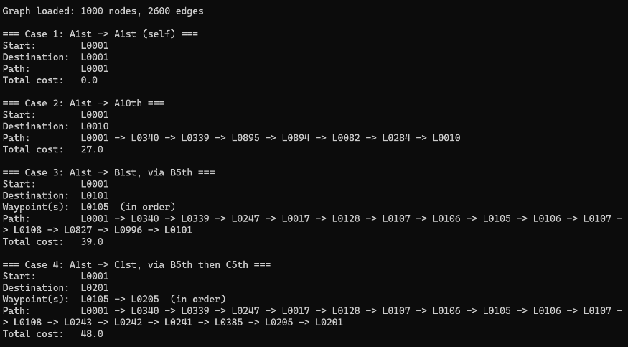

Fig.3. Console output of the four shortest-path query cases.

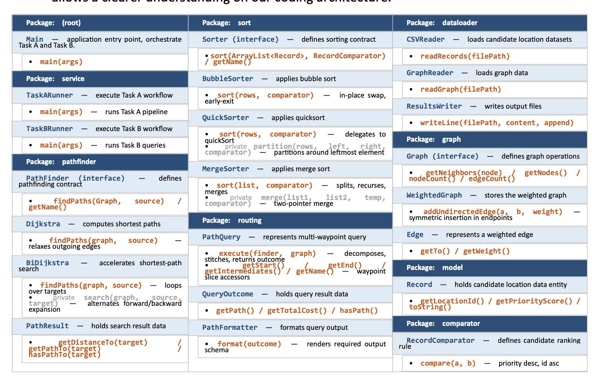
Fig.4. Classes and their responsibilities.

Chapter 7 — Contribution Form
Student ID | Contribution
2360908 | 50%
2360862 | 50%

