**Fear of Missing Out (FOMO) in Digital Spaces:**

**A Sentiment Analysis of Reddit and YouTube Discussions**

Wong Tsz Chun, Chris

**Abstract**

This study examines Fear of Missing Out (FOMO) discourse across Reddit and YouTube platforms from 2014-2024 through sentiment analysis and keyword frequency analysis. Using natural language processing techniques on 494 Reddit posts (with 2,105 comments) and 110,574 YouTube comments, we investigate how users express and cope with FOMO in digital spaces. Results reveal increased FOMO-related discussions post-2020, with sentiment patterns shifting from predominantly positive to more balanced emotional expressions. The study identifies distinct platform-specific characteristics and user roles in online FOMO discourse. These findings inform recommendations for platform design and digital well-being interventions, emphasizing the need for platform-specific support systems.

**Introduction**

Fear of Missing Out (FOMO) has emerged as a significant psychological concern in digital spaces, characterized by anxiety and loneliness in social interactions (Oberst et al., 2017). Social media platforms have transformed social connections (Turkle, 2005), intensifying FOMO through increased sharing and engagement (Alt, 2015; Przybylski et al., 2013). Each platform's unique architecture creates distinct environments for FOMO manifestation and management, necessitating platform-specific support mechanisms (Waqas et al., 2019; PEN America, 2023).

**Problem Statement and Research Gap**

Despite extensive FOMO research, understanding of platform-specific manifestations remains limited (Hendriks et al., 2020). Current literature lacks comparative analysis of cross-platform dynamics and their implications for digital well-being, particularly regarding temporal evolution of FOMO discourse (Vilk et al., 2021).

**Platform Selection Significance**

This study examines Reddit and YouTube for their contrasting structures: Reddit's anonymous, community-focused environment versus YouTube's content-creator-centered platform (Waqas et al., 2019). These differences provide insights into how platform architecture influences FOMO expression and management.

**Research Objectives**

Our study addresses four primary objectives: analyzing temporal FOMO trends (2014-2024), identifying emotional patterns and support mechanisms, comparing platform-specific characteristics, and examining user roles. We track discourse evolution, analyze sentiment distributions, evaluate platform-specific support systems, and assess interaction patterns between user types.

**Literature Review**

**Conceptual Framework of FOMO**

FOMO represents apprehension about missing rewarding experiences (Przybylski et al., 2013), with emotional dynamics transferring through social media (Kramer et al., 2014). This phenomenon encompasses both offline and online experiences, shaped by digital connectivity and platform dynamics.

**Digital Manifestations of FOMO**

Social media intensifies FOMO through constant exposure to others' experiences, leading to compulsive engagement (Alt, 2015; Ji et al., 2024). Platform algorithms and content curation contribute to heightened perceptions of missing out (Oberst et al., 2017).

**Platform-Specific Research**

Different platforms foster distinct FOMO expression patterns (Vilk et al., 2021). Reddit enables vulnerable expressions through anonymity, while YouTube generates diverse emotional responses and support mechanisms (Waqas et al., 2019; PEN America, 2023).

**User Behavior in Online Mental Health Discussions**

Research identifies key user roles: help-seekers, advisors, critics, and participating users (Hendriks et al., 2020; Waqas et al., 2019). Role effectiveness varies across platforms, with structured communities fostering more constructive support networks (PEN America, 2023; Vilk et al., 2021).

**Methodology**

**Data Collection and Sampling**

We collected data from Reddit (494 posts, 2,105 comments, 2014-2024) and YouTube (110,574 comments from ten videos), focusing on social aspects of FOMO. We employed stratified random sampling, ensuring temporal and thematic relevance while excluding automated content.

**Analysis Framework**

We used VADER sentiment analysis, a tool for measuring the emotional tone of text, NLTK content analysis to identify common themes, and statistical analysis for comprehensive understanding. This approach enabled examination of emotional expressions, thematic patterns, and cross-platform comparisons of FOMO manifestations and community responses.

**Results**

*Figure 1: Quarterly Post Count Trend Analysis, 2014-2024*

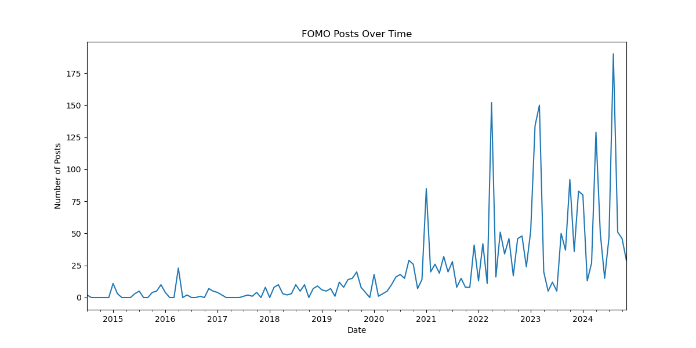

**Temporal Trends and User Engagement Patterns**

Our quarterly trend analysis reveals a significant evolution in FOMO-related discussions from 2014 to 2024. Drawing from online engagement literature (Hendriks et al., 2020), our analysis revealed distinct patterns of both individual and dialogic engagement. As shown in Figure 1, there was a marked increase in post frequency during the initial lockdown periods, with quarterly posts rising from 49 (2019 Autumn) to 131(2021 spring), then reached a peak of 288 posts (2024 Autumn) representing a 588 % surge. This unprecedented growth coincided with a shift from individual-focused narratives to community-oriented discussions.

*Figure 2: Quarterly Post Sentiment Analysis, 2014-2024*

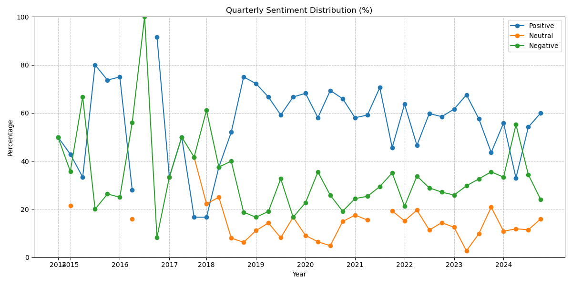

Our temporal sentiment analysis demonstrates a clear evolution in emotional expression. In 2019, discussions showed predominantly positive sentiment (76%). However, by 2024, the emotional expressions became more balanced, with positive sentiment decreasing to 56%. Throughout this period, neutral sentiment maintained a consistent baseline of approximately 20%, suggesting a stable foundation of objective discussion amid changing emotional dynamics. This transformation supports Hendriks et al.'s (2020) theory of online engagement with scientific information (OESI).

**Platform-Specific Analysis**

*Figure 3: Reddit Sentiment Distribution Figure 4: YouTube Sentiment Distribution*

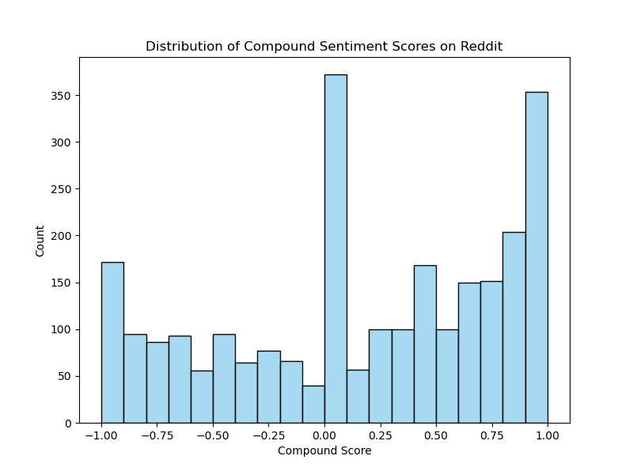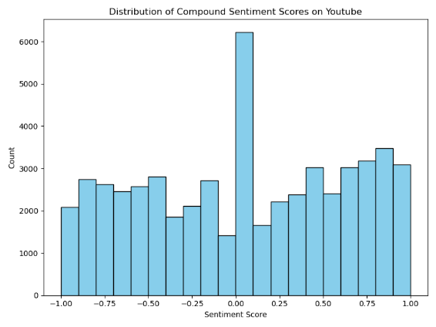

Our comparative analysis reveals distinct sentiment patterns across platforms (PEN America, 2023). Reddit demonstrated a tendency toward positive engagement, characterized by higher proportion of positive sentiments compared to YouTube, more consistent emotional tone across discussions, structured supportive dialogue patterns, and deeper, more elaborate personal narratives (Vilk et al., 2021).

YouTube exhibited more diverse sentiment distribution. Users showed a broader range of emotional expressions and higher variability in sentiment across comments. Their responses tended to be more spontaneous and reactive, with greater emotional intensity in shorter interactions. This platform-specific variation suggests that the architecture and community norms of each platform significantly influence how users express and engage with FOMO-related content (Waqas et al., 2019).

*Figure 5: Top 20 Keywords Analysis*

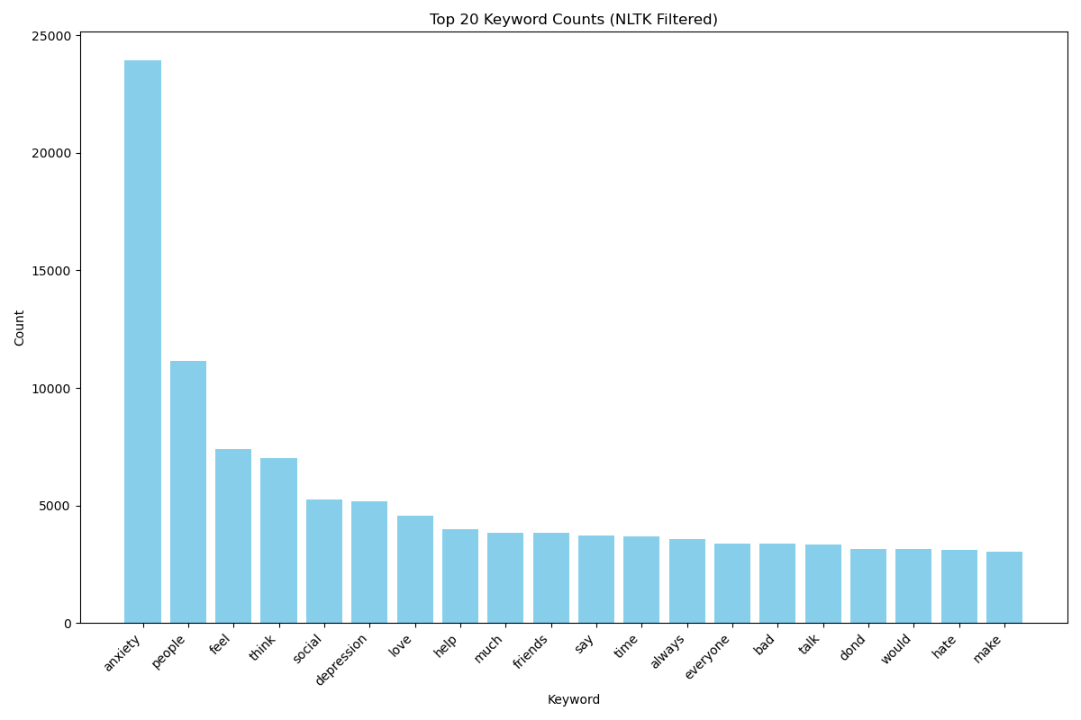

Our keyword analysis identified four primary themes in FOMO-related discussions across platforms: emotional/psychological states, social connections, support and coping, and daily life context (Hendriks et al., 2020).

Emotional/psychological terms dominated the discourse, with "anxiety" being most prevalent (24,142 mentions), followed by "feel" (7,462 mentions) and "depression" (5,254 mentions). The range of emotional expression was further evidenced through contrasting terms like "love" (4,582 mentions) and "hate" (3,148 mentions).

Social connection emerged as the second prominent theme, led by "people" (11,285 mentions), "friends" (3,885 mentions), and "social" (5,269 mentions). These terms, along with "everyone" (3,423 mentions), emphasized FOMO's inherently interpersonal nature (Vilk et al., 2021).

Support-seeking behaviors manifested through terms like "help" (4,063 mentions) and "better" (2,587 mentions), while reflective engagement appeared in "think" (7,080 mentions) and "talk" (3,358 mentions). Community support was evident through acknowledgment terms like "thank" (2,675 mentions).

Daily life contexts and triggers were captured through references to "school" (2,757 mentions), "life" (2,953 mentions), and "time" (3,753 mentions). Behavioral aspects emerged in action terms like "make" (3,042 mentions) and "going" (2,834 mentions), while temporal permanence was expressed through "always" (3,588 mentions) and "never" (2,666 mentions).

This distribution reveals FOMO discussions as multifaceted conversations encompassing emotional expression, practical support-seeking, and community building, with anxiety and social relationships at their core.

While the keyword and sentiment analyses reveal the content patterns of FOMO discussions, examining the individuals behind these interactions provides crucial insights into how different types of users shape these conversations. Our analysis identified distinct user roles that contribute to and influence FOMO-related discussions across both platforms.

**User Roles and Communication Patterns**

Drawing from frameworks by Waqas et al. (2019) and Hendriks et al. (2020), five distinct user roles emerged in FOMO discussions. Support Seekers express vulnerability through personal narratives (Vilk et al., 2021), while Community Supporters provide emotional guidance and practical wisdom (PEN America, 2023). Experience Sharers contribute through shared experiences, Critical Discussants offer analytical perspectives (Hendriks et al., 2020), and Disruptive Elements challenge community dynamics through dismissive behaviors (Vilk et al., 2021).

**Communication Pattern Analysis**

Three primary communication patterns shape FOMO discussions (Hendriks et al., 2020; PEN America, 2023). Emotional Support manifests through validation and empathy (Waqas et al., 2019), while Practical Support offers concrete coping strategies (Vilk et al., 2021). Community Building focuses on collective identity formation and shared meaning-making (Hendriks et al., 2020).

**Discussion**

**Platform-Specific Patterns**

The analysis highlights distinct FOMO manifestations across digital platforms. Reddit’s community-focused and anonymous environment fosters deeper connections, allowing users to share sincere, personal experiences. This suggests that platforms with anonymity features have the potential to enhance peer support networks and enable the design of targeted digital well-being tools. In contrast, YouTube’s content-creator-centered structure encourages broader emotional expressions, often characterized by spontaneous and reactive responses to content. These differences underscore the role of platform architecture in shaping user interactions and emotional engagement with FOMO-related discussions (Vilk et al., 2021).

**Emotional Dynamics**

Our findings indicate a concerning shift in sentiment patterns, transitioning from predominantly positive to more evenly distributed emotional expressions. This trend suggests potential deterioration in digital spaces' emotional climate. While community support systems exist, their effectiveness in maintaining positive sentiment appears to be diminishing. COVID-19's impact marks a significant shift in social connection perceptions, with increased ambivalence toward virtual experiences and digital community building (Hendriks et al., 2020).

**Implications for Digital Well-being**

The research findings indicate the need for platform-specific interventions. Reddit's community-focused environment requires features that enhance peer support systems and structured dialogue. YouTube's diverse interaction patterns necessitate different approaches, such as improved content filtering and emotional support integration within comment sections. Each platform's unique user behavior patterns and community dynamics demand tailored support mechanisms and guidelines that balance open expression with user protection (PEN America, 2023).

**Conclusion**

Our analysis reveals a concerning trend in social media's impact on FOMO experiences, with sentiment patterns shifting from predominantly positive to more evenly distributed emotions. The platform-specific analysis demonstrates that different social media environments require distinct intervention approaches. For instance, Reddit's community-centric nature suggests the need for enhanced peer support systems and community moderation tools, while YouTube's broader content-driven environment calls for improved content curation and comment section management features.

Study limitations include YouTube temporal clustering issues and sampling period constraints, particularly during COVID-19. Future research should explore cross-platform dynamics, cultural variations, and emotional content analysis methods, with specific focus on understanding and counteracting the factors contributing to declining positive sentiment. These findings emphasize the importance of developing platform-tailored design and digital well-being promotion strategies as social media continues to evolve.

(1438 words, exclude formatting and citation)

**Reference**

Alt, D. (2015). Fear of missing out (FOMO): A psychological perspective. Computers in Human Behavior, 57, 165–170. <https://doi.org/10.1016/j.chb.2015.12.034>

Ji, C., Li, K., & He, Q. (2024). Understanding users’ continuance intention of mobile social media apps: Fear of missing out (FoMO) and users’ desired value. Current Psychology, 43(21), 19330–19343. <https://doi.org/10.1007/s12144-024-05753-8>

Kramer, A. D. I., Guillory, J. E., & Hancock, J. T. (2014). Experimental evidence of massive-scale emotional contagion through social networks. Proceedings of the National Academy of Sciences of the United States of America, 111(24), 8788–8790. <https://doi.org/10.1073/pnas.1320040111>

Liu, B., & Zhang, J. (2012). Emotion and sentiment analysis in social media. In Proceedings of the International Conference on Web Intelligence (pp. 123-130). IEEE. <https://doi.org/10.1109/WI.2012.62>

Mayer-Schönberger, V., & Cukier, K. (2013). Big data: A revolution that will transform how we live, work, and think. Houghton Mifflin Harcourt.

Oberst, U., Weger, H., & Buxmann, P. (2017). The role of social media in the development of FOMO. Cyberpsychology, Behavior, and Social Networking, 20(3), 141-145. <https://doi.org/10.1089/cyber.2016.0159>

Przybylski, A. K., Murayama, K., DeHaan, C. R., & Gladwell, V. (2013). Motivational, emotional, and behavioral correlates of fear of missing out. Computers in Human Behavior, 29(4), 1841–1848. <https://doi.org/10.1016/j.chb.2013.02.014>

Turkle, S. (2005). The second self: *Computers and the human spirit* (20th anniversary ed.). MIT Press.

Hendriks, F., Mayweg-Paus, E., Felton, M., Iordanou, K., Jucks, R., & Zimmermann, M. (2020). Constraints and affordances of online engagement with scientific information—A literature review. Frontiers in Psychology, 11, 572744.

PEN America. (2023). Shouting into the void: Why reporting abuse to social media platforms is so hard and how to fix it. <https://pen.org/report/shouting-into-the-void/>

Vilk, V., Vialle, E., & Bailey, M. (2021). No excuse for abuse. PEN America. <https://pen.org/report/no-excuse-for-abuse>

Waqas, A., Salminen, J., Jung, S. G., Almerekhi, H., & Jansen, B. J. (2019). Mapping online hate: A scientometric analysis on research trends and hotspots in research on online hate. PLoS One, 14(9), e0222194.