# Assignment 2 Documentation

## Group 8

## Student Name: Wong Yui Hei, Hsin Tang, Jialing Liang

## Edit Date: 4-4-2024

### Wireframe:



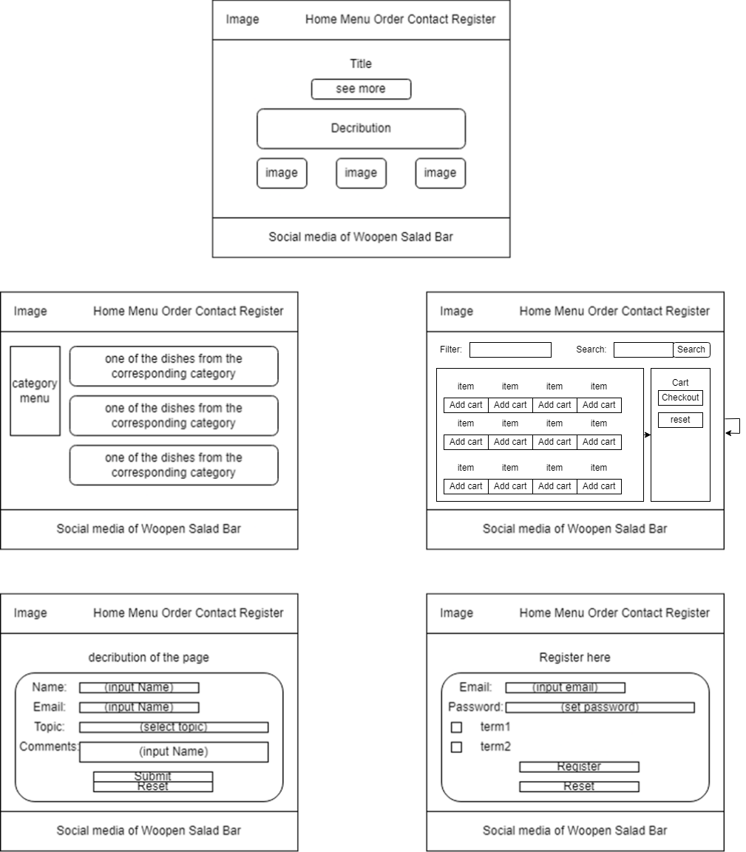

The navigation bar in every page can easy access to other pages



### Web map

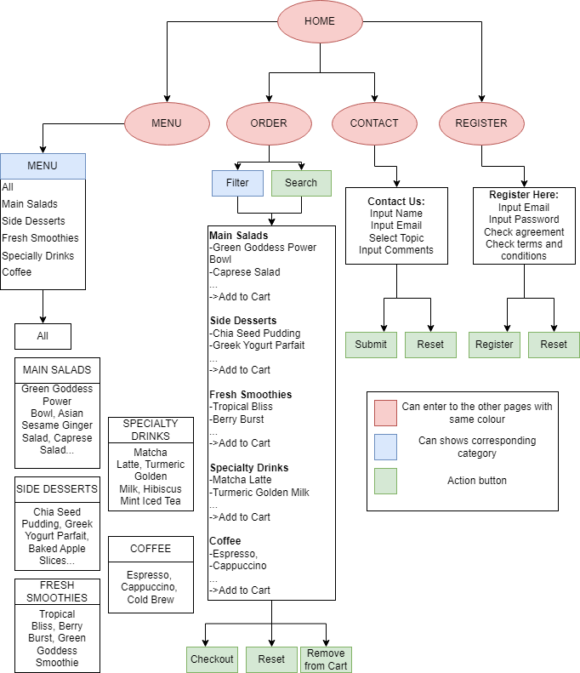

### Functionality Guide:

1. Home Page
   1. Header containing restaurant logo and navigation bar for easy access to other pages.
   2. Button “See More” leads the user to the Menu Page
   3. A brief description of the Woopen Salad Bar
   4. Footer containing social media links for additional engagement
2. Menu Page
   1. Header containing restaurant logo and navigation bar for easy access to other pages.
   2. Category Menu filter the category of items
   3. The dishes information bars allow users to read
   4. Footer containing social media links for additional engagement
3. Order Page
   1. Header containing restaurant logo and navigation bar for easy access to other pages.
   2. Category filter the category of items
   3. Input the specific food items into the Search Box
   4. Button “Search” search the specific food items inside the Search Box
   5. Button “Add to Cart” in each order cell accumulates and shows the item price to the total price in Your Cart
   6. Button “Checkout” to pop out the Total price of the orders
   7. Button ”Reset” to delete all the orders
   8. Footer containing social media links for additional engagement
4. Contact Page
   1. Header containing restaurant logo and navigation bar for easy access to other pages.
   2. The input bar of “Name” allows user to input their username
   3. The input bar of “Email” allows user to input their Email
   4. The input bar of “Select the topic” allows the user to choose the topic of the comment:
      1. In-store order
      2. On-line delivery order
      3. Feedback
   5. Comments area allows the user to input the comments
   6. Button “Submit” send comments to the Woopen Salad Bar
      1. All the information should be input correctly before submission, otherwise, there are validation alerts above the incorrect section.
   7. Button “Reset” clears all the input in the boxes in the Contact Page
   8. Footer containing social media links for additional engagement
5. Register Page
   1. Header containing restaurant logo and navigation bar for easy access to other pages.
   2. The input bar of “Email” allows user to input their Email
   3. The input bar of “Password” allows users to set their password
   4. Two checkboxes for the user to agree to receive a message and agree to the terms and conditions
   5. Button “Register” sends the information of the user to the Woopen Salad Bar
      1. All the information should be input correctly before submission, otherwise, there are validation alerts above the incorrect section.
   6. Button “Reset” clears all the input in the boxes in the Register Page
   7. Footer containing social media links for additional engagement

### Description of the database:

1. **DATABASE NAME: Assignment 2**
2. **Purpose of the database:**

To manage customer orders, including five categories of items, contact, menu item, and user information.

1. **Scope:**

Focuses on the interaction between customers, menu items, and orders within a restaurant.

1. **Entities and Tables**
   * **Table 1: Category**
     1. **category_id (INT)**
        1. Auto increment Primary key of Category table
     2. **category_name (VARCHAR (100))**
        1. Not null unique attribute of the category table
   * **Table 2: Contact**
     1. **contact_id (INT)**
        1. Auto increment Primary key of the Contact table
     2. **name (VARCHAR (50))**
        1. Not Null attribute of the Contact table
     3. **email (VARCHAR (100))**
        1. Not Null attribute of the Contact table
     4. **topic (VARCHAR (100))**
        1. Not Null attribute of the Contact table
     5. **message (VARCHAR (500))**
        1. Not Null attribute of the Contact table
   * **Table 3: MenuItem**
     1. **menuitem_id (INT)**
        1. Auto increment Primary key of MenuItem table
     2. **menuitem_name (VARCHAR (100))**
        1. Not Null attribute of the MenuItem table
     3. **item_price (DECIMAL (10, 2))**
        1. Not Null attribute of the MenuItem table
     4. **category_id (INT)**
        1. Foreign key references Category
   * **Table 4:Users**
     1. **user_id (INT)**
        1. Auto increment Primary key of Users table
     2. **email (VARCHAR (255))**
        1. Not Null attribute of the Users table
     3. **password (VARCHAR (255))**
        1. Not Null attribute of the Users table
     4. **agree_terms (BOOLEAN)**
        1. Not Null attribute of the Users table
2. **Relationship**
   * Relationship between Category and MenuItem is One-to-Many

### A breakdown of each team member:

|  |  |
| --- | --- |
| **Backend Database Functionality** | All member |
| **Website architecture** | All member |
| **Web page – Home** | Jialing Liang |
| **Web page – Menu** | Wong Yui Hei |
| **Web page – Contact** | Hsin Tang |
| **Web page – Order** | Hsin Tang |
| **Web page – Register** | Hsin Tang |
| **supporting documentation** | Wong Yui Hei |